**DAILY ONLINE ACTIVITIES SUMMARY**

|  |  |  |  |  |  |  |  |
| --- | --- | --- | --- | --- | --- | --- | --- |
| **Date:** | **06-06-20** | | | | **Name:** | **TANOJ M** | |
| **Sem & Sec** | **VI A** | | | | **USN:** | **4AL16CS113** | |
| **Online Test Summary** | | | | | | | |
| **Subject** | | **PAP IA** | | | | | |
| **Max. Marks** | | **30** | | **Score** | | **20** | |
| **Certification Course Summary** | | | | | | | |
| **Course** | Programming Essentials in Python | | | | | | |
| **Coding Challenges** 1)Write a program in C to rotate an array by N positions2) Write a Python program to perform Cyclic Redundancy Check 3) Write a Python program to count the number of strings, provided string length is 2 or more and the first and last character are same from a given list of strings. | | | | | | | |
| **Certificate Provider** | | | **Cisco -python institution** | **Duration** | | | **No limit** |
| **Status:on going** | | | | | | | |
| **Uploaded the report in Github** | | | | **Yes** | | | |
| **If yes Repository name** | | | | **https://github.com/Tanoj8296/DAILY-STATUS** | | | |
| **Uploaded the report in slack** | | | | **Yes** | | | |

**IA MARKS DETAILS:**

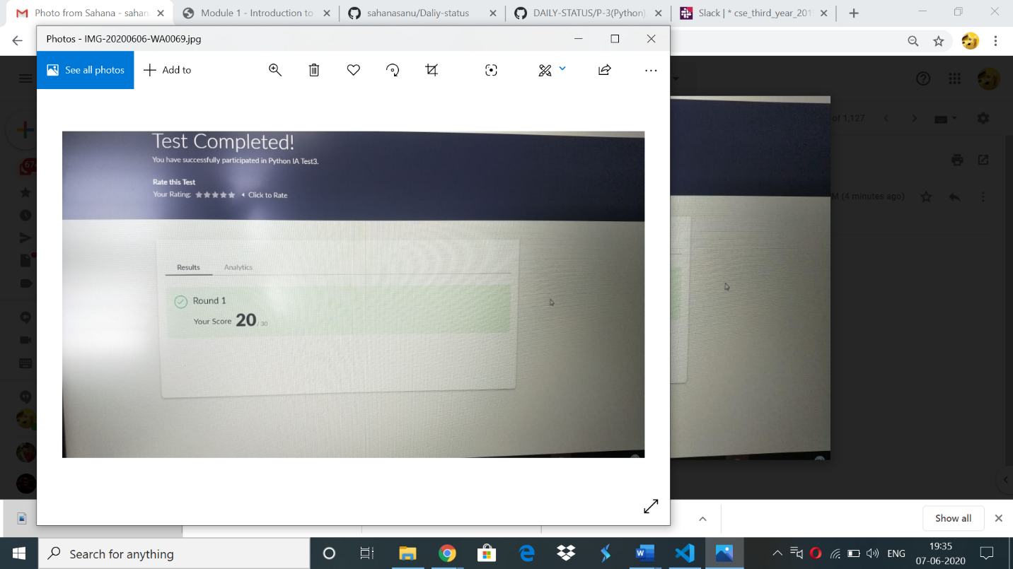

**Online Certification Details:**

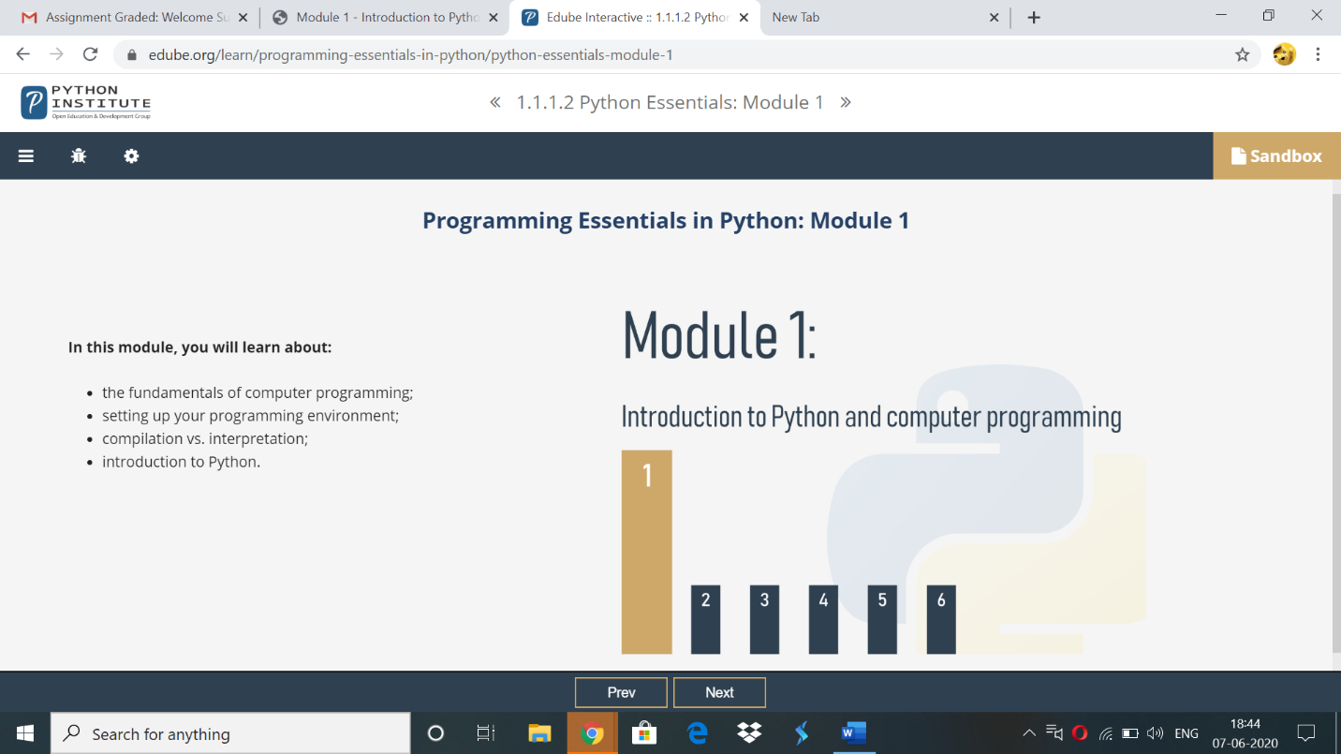

Topics covered:

1)How does computer program work?

2)Natural languages vs programming lanuages

3)what makes a languages?

4)compilation vs.interpretation

5)what does the interpreter acutally do?

6)compilation vs interpretation advantages and disadvantages

**Online coding:**

**1)** Write a program in C to rotate an array by N positions

#include <stdio.h>

void shiftArrayOnePosition(int *array, int size) {

int i, temp;

/*Save first element in a temporary variable and

shift remaining elements by one index left */

temp = array[0];

for(i = 0; i < size-1; i++) {

array[i] = array[i+1];

}

/* Now put the firt element of

original array to last index */

array[i] = temp;

}

/*

This function shifts array by N positions

*/

void rotateArray(int *array, int size, int N){

int i;

for(i = 0; i < N; i++){

shiftArrayOnePosition(array, size);

}

return;

}

int main(){

int i,n,N;

printf("enter the size of the array: ");

scanf("%d",&n);

int array[n];

printf("enter the array elements: ");

for(i=0;i<n;i++)

scanf("%d",&array[i]);

printf("Enter the Position N from where you want to rotate:");

scanf("%d",&N);

printf("Original Array\n");

for(i = 0; i<n; i++){

printf("%d ", array[i]);

}

rotateArray(array, n,N);

printf("\nRotated Array\n");

for(i = 0; i<n; i++){

printf("%d ", array[i]);

}

return 0;

}

OUTPUT

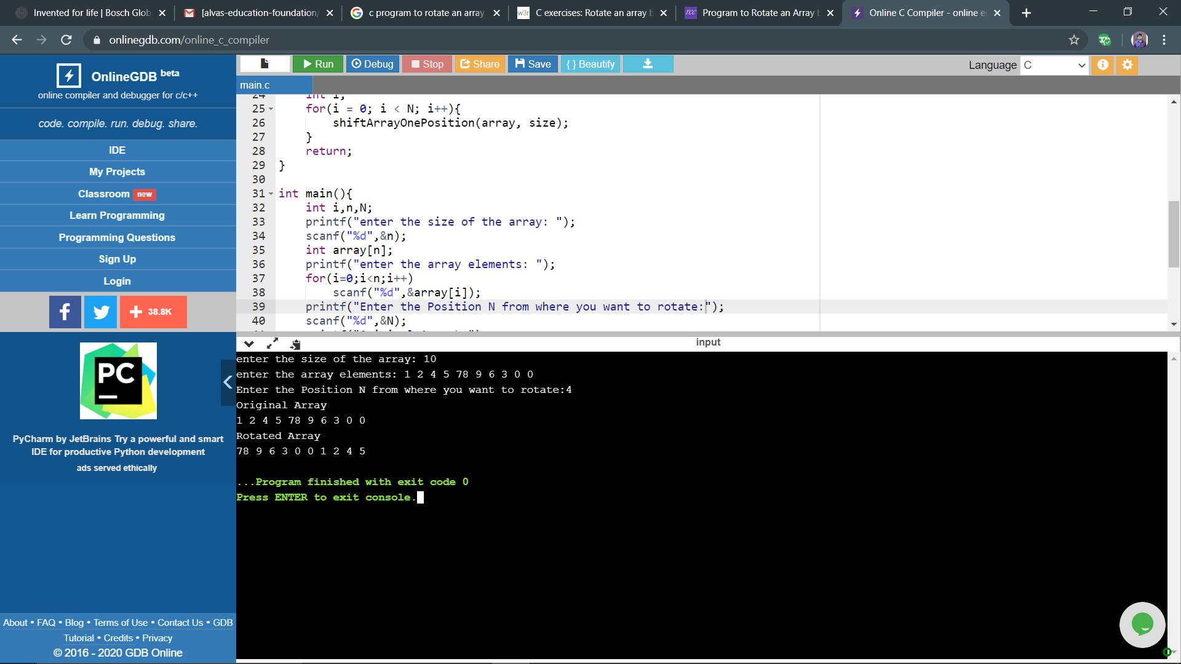

2)Write a Python program to perform Cyclic Redundancy Check

from math import log, ceil

def CRC(dataword, generator):

  dword = int(dataword, 2)

  l_gen = len(generator)

  dividend = dword << (l_gen - 1)

  shft = ceil(log(dividend + 1, 2)) - l_gen

  generator = int(generator, 2)

  while dividend >= generator or shft >= 0:

    rem = (dividend >> shft) ^ generator

    dividend = (dividend & ((1 << shft) - 1)) | (rem << shft)

    shft = ceil(log(dividend+1, 2)) - l_gen

  codeword = dword << (l_gen-1)|dividend

  print("Remainder:", bin(dividend).lstrip("-0b"))

  print("Codeword :", bin(codeword).lstrip("-0b"))

dataword = input("enter dataword\n")

generator = input("enter key\n")

CRC(dataword, generator)

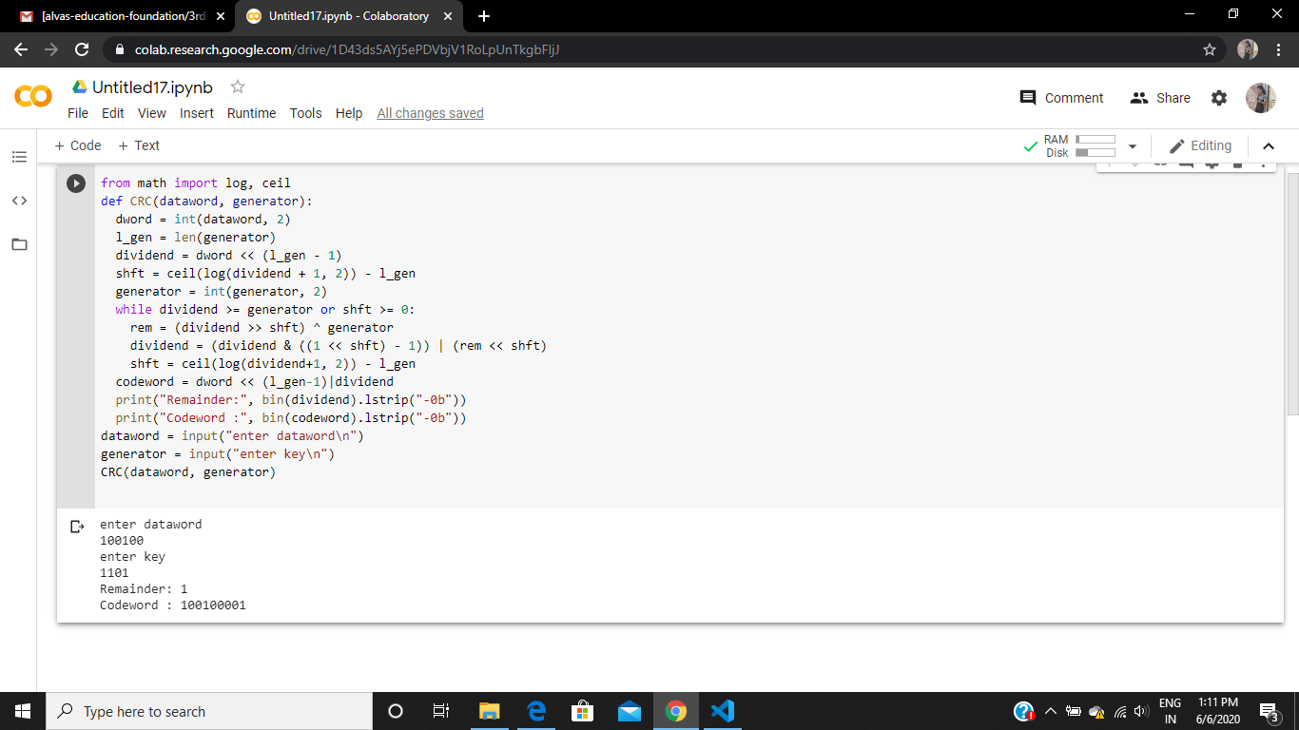

3) Write a Python program to count the number of strings, provided string length is 2 or more and the first and last character are same from a given list of strings.

def match_words(words):

  ctr = 0

  for word in words:

    if len(word) > 1 and word[0] == word[-1]:

      ctr += 1

  return ctr

l=[]

n=int(input("enter n value\n"))

print("list contents\n")

for i in range (0,n):

  e=input()

  l.append(e)

print("list: ",l)

print("output\n")

print(match_words(l))

