**DAILY ONLINE ACTIVITIES SUMMARY**

|  |  |  |  |  |  |  |  |
| --- | --- | --- | --- | --- | --- | --- | --- |
| **Date:** | **28-05-20** | | | | **Name:** | **Tanoj M** | |
| **Sem & Sec** | **VI A** | | | | **USN:** | **4AL17CS116** | |
| **Online Test Summary** | | | | | | | |
| **Subject** | | **OS 2 IA Test** | | | | | |
| **Max. Marks** | | **30** | | **Score** | | **20** | |
| **Certification Course Summary** | | | | | | | |
| **Course** | **Front end development in html** | | | | | | |
| **Coding Challenges**  JAVA PROGRM-BALANCED BRAKET  P11) | | | | | | | |
| **Certificate Provider** | | | **Great learning** | **Duration** | | | **6 days** |
| **Status:Completed** | | | | | | | |
| **Uploaded the report in Github** | | | | **Yes** | | | |
| **If yes Repository name** | | | | **https://github.com/Tanoj8296/DAILY-STATUS** | | | |
| **Uploaded the report in slack** | | | | **Yes** | | | |

**Online Certification Details**

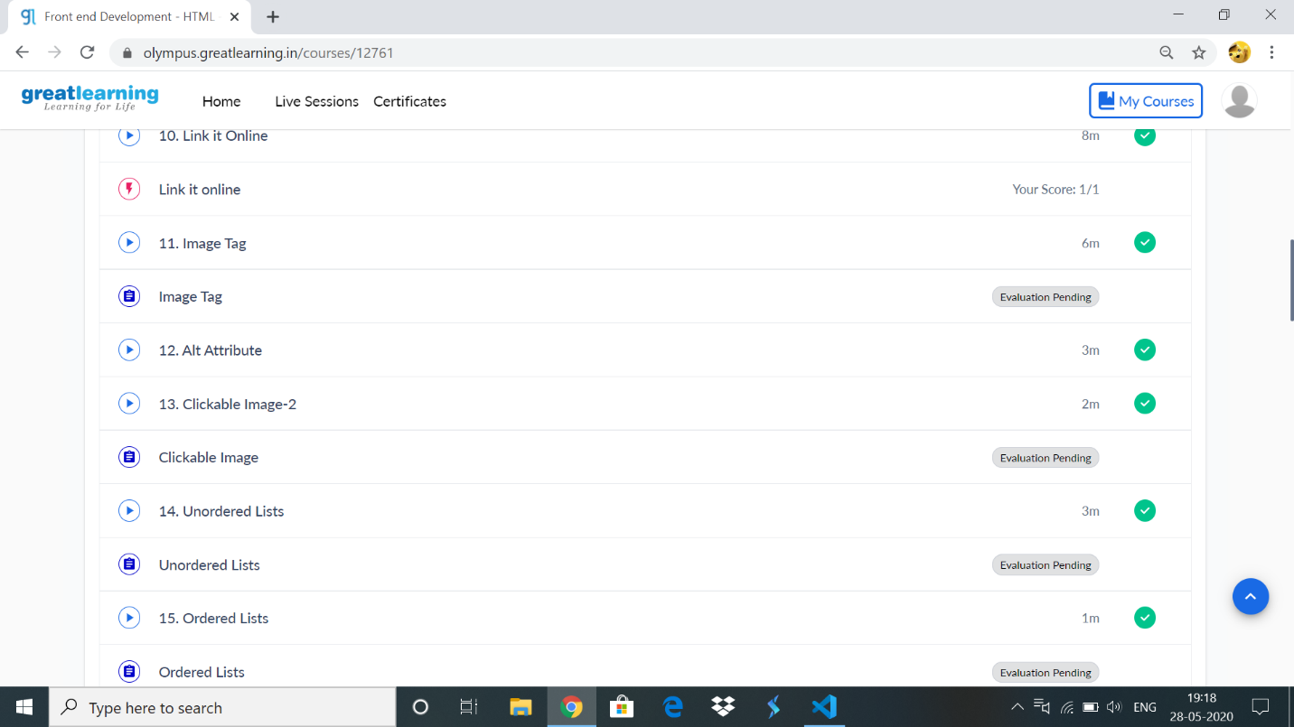

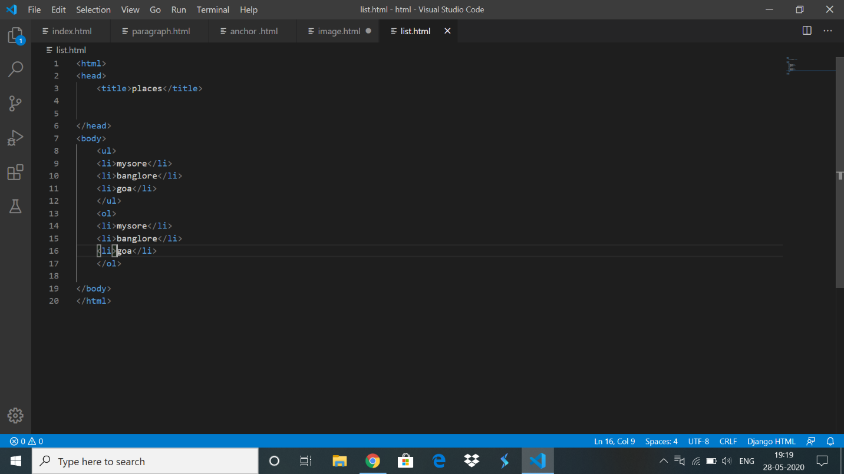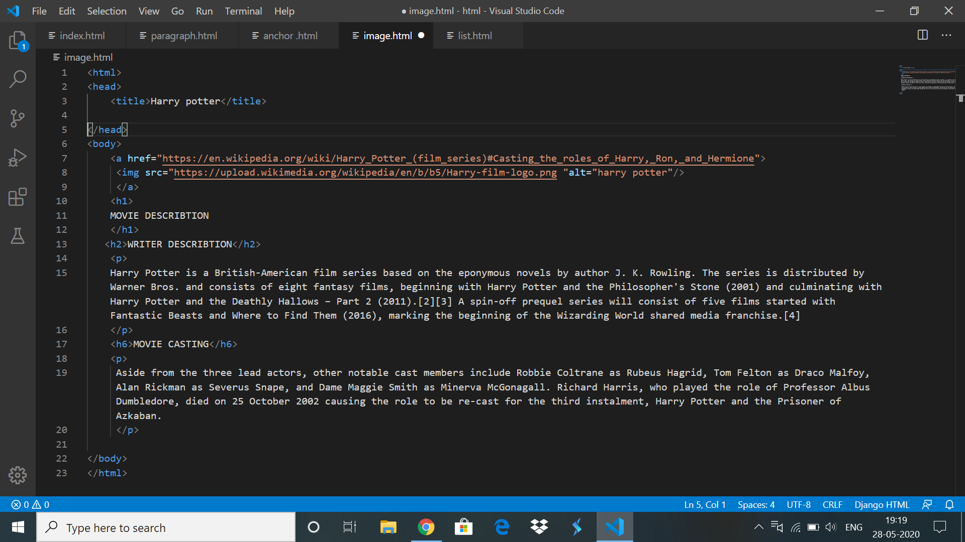

**Coding Challenge Details**

1) JAVA PROGRM-BALANCED BRAKET

**package** pppp;

**import** java.util.Scanner;

**import** java.util.Stack;

**public** **class** Expression {

**public** **static** **void** main(String[] args) {

**boolean** flag =**false**;

Stack<Character> input = **new** Stack<Character>();

System.***out***.println("Enter your String to check:");

Scanner scanner = **new** Scanner(System.***in***);

String sinput = scanner.nextLine();

**char**[] c = **new** **char**[15];

c = sinput.toCharArray();

**for** (**int** i = 0; i < c.length; i++) {

**if** (c[i] == '{' || c[i] == '(' || c[i] == '[')

input.push(c[i]);

**else** **if** (c[i] == ']') {

**if** (input.pop() == '[') {

flag = **true**;

**continue**;

} **else** {

flag = **false**;

**break**;

}

} **else** **if** (c[i] == ')') {

**if** (input.pop() == '(') {

flag = **true**;

**continue**;

} **else** {

flag = **false**;

**break**;

}

} **else** **if** (c[i] == '}') {

**if** (input.pop() == '{') {

flag = **true**;

**continue**;

} **else** {

flag = **false**;

**break**;

}

}

}

**if** (flag == **true**)

System.***out***.println("balanced");

**else**

System.***out***.println("Unbalanced");

scanner.close();

}

}

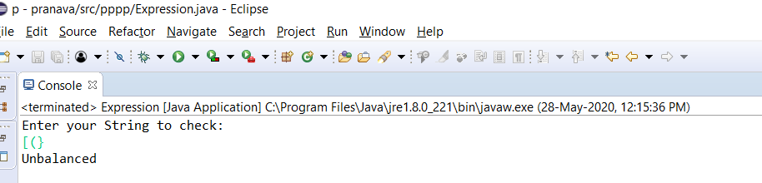Output

