**DAILY ONLINE ACTIVITIES SUMMARY**

|  |  |  |  |  |  |  |  |
| --- | --- | --- | --- | --- | --- | --- | --- |
| **Date:** | **03-06-20** | | | | **Name:** | **TANOJ M** | |
| **Sem & Sec** | **VI A** | | | | **USN:** | **4AL16CS113** | |
| **Online Test Summary** | | | | | | | |
| **Subject** | | **PAP ASSIGNMENT TEST** | | | | | |
| **Max. Marks** | | **20** | | **Score** | | **16** | |
| **Certification Course Summary** | | | | | | | |
| **Course** | **FRONT END DEVELOPMENT-CSS** | | | | | | |
| **Coding Challenges**  **1) Python Program to Find the Largest Number in a List without using sorting algorithm**  **2)Python Program to find different digits r from number n using combination.** | | | | | | | |
| **Certificate Provider** | | | **Great learning** | **Duration** | | | **3 days** |
| **Status:Completed** | | | | | | | |
| **Uploaded the report in Github** | | | | **Yes** | | | |
| **If yes Repository name** | | | | **https://github.com/Tanoj8296/DAILY-STATUS** | | | |
| **Uploaded the report in slack** | | | | **Yes** | | | |

**ASSIGNMENT MARKS DETAILS:**

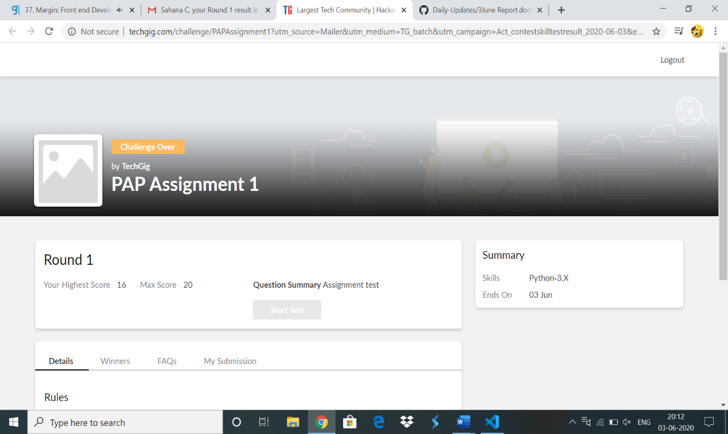

**Online Certification Details:**

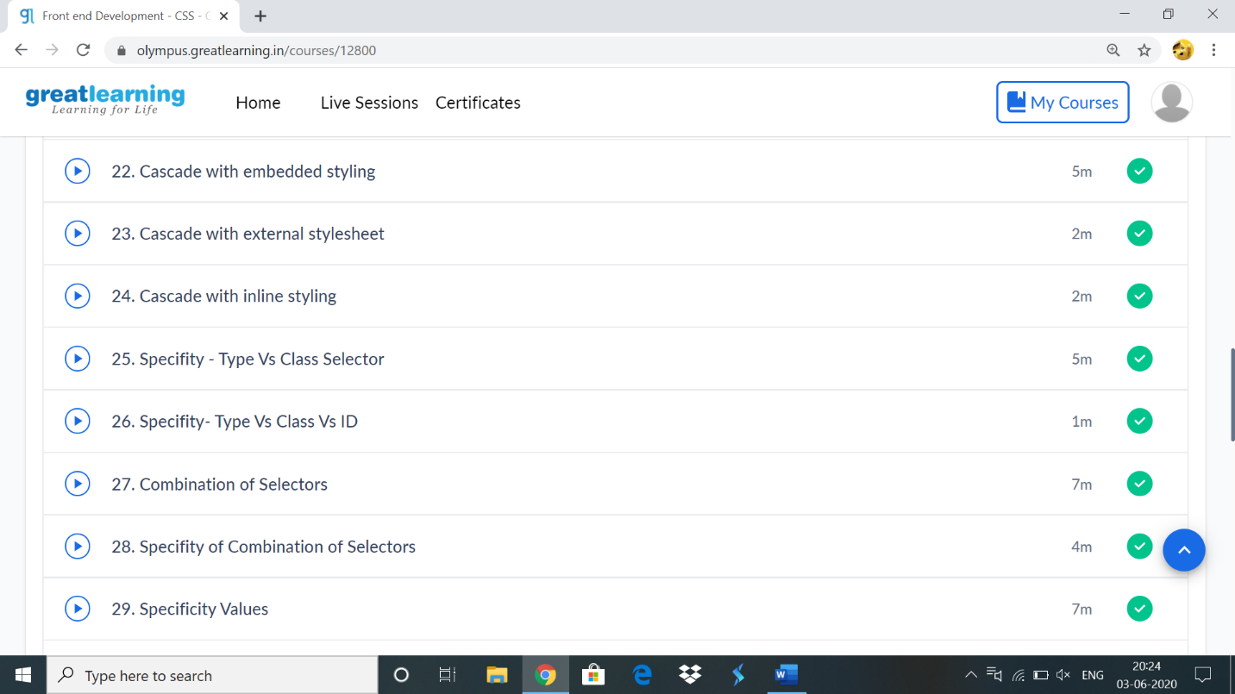

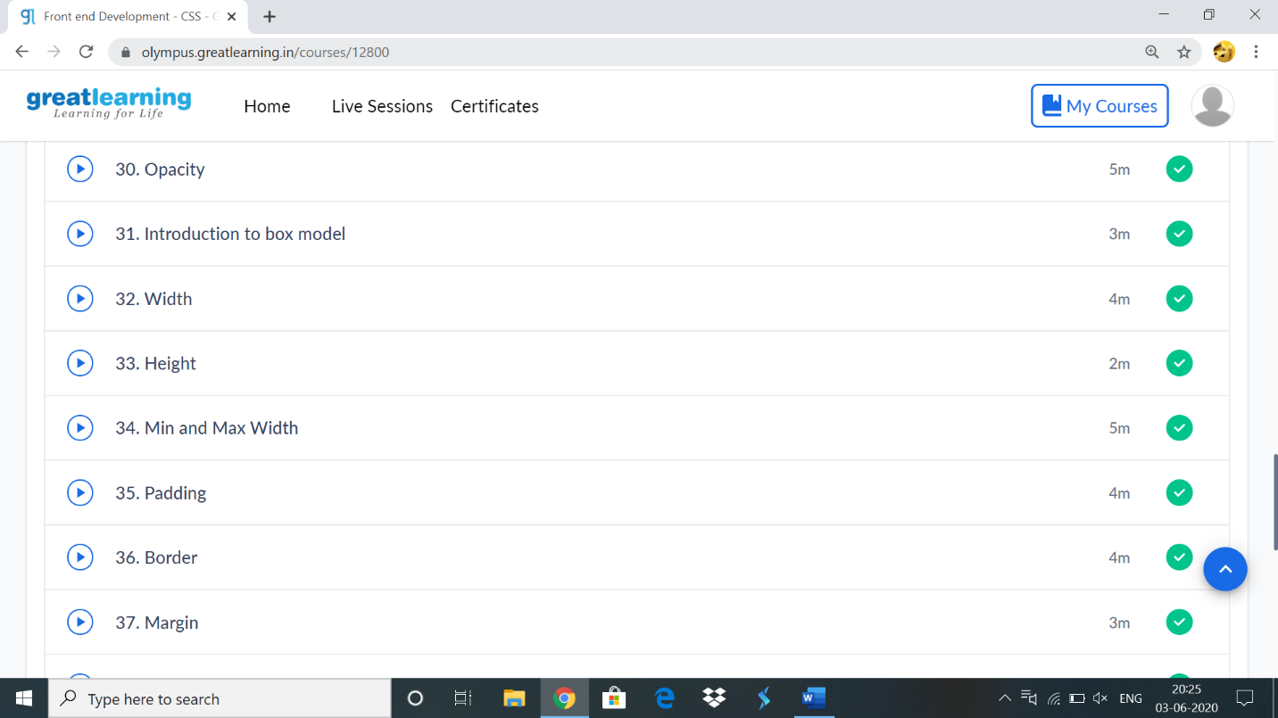

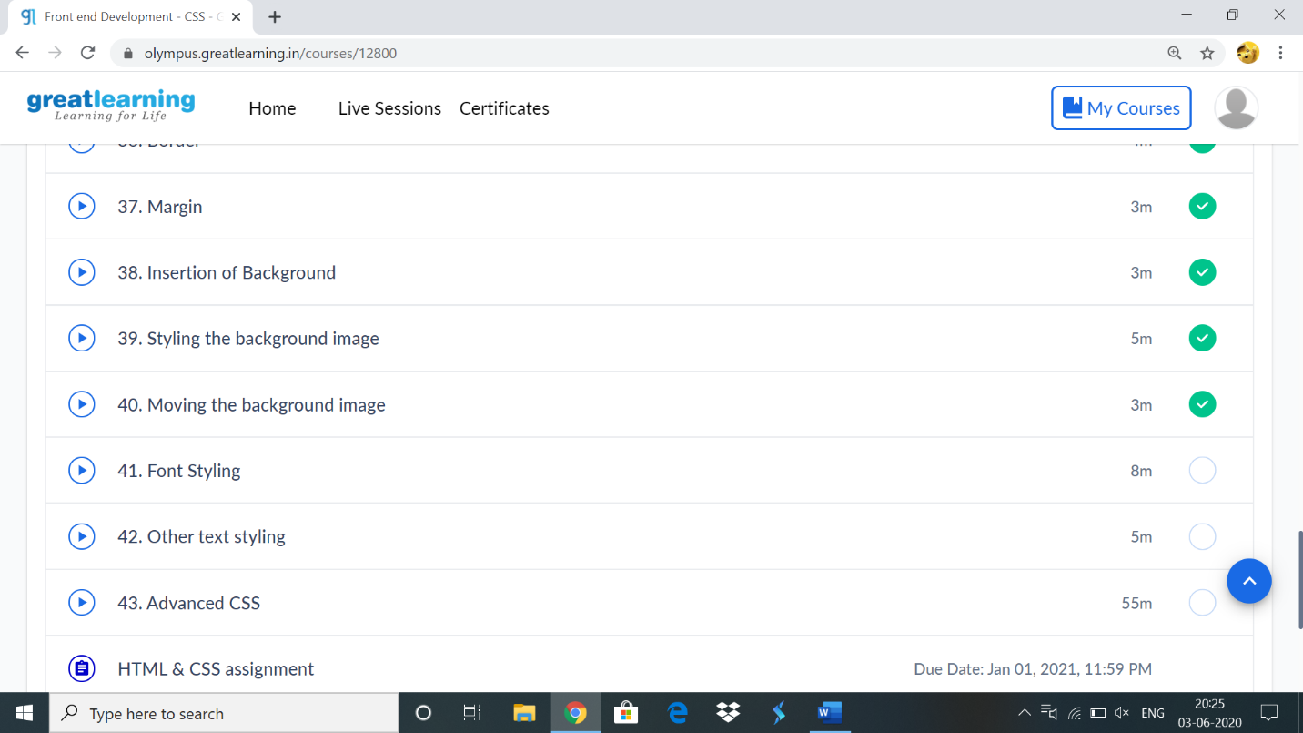

**Online coding:**

**1)**

**Python Program to Find the Largest Number in a List without using sorting algorithm.**

n = int(input("Enter The Number Of List Elements: "))  
a = []  
print("Enter The List Elements: ")  
for i in range(n):  
    a.append(int(input()))  
print("Largest Number In A Given List is:", max(a))

**Outout:**

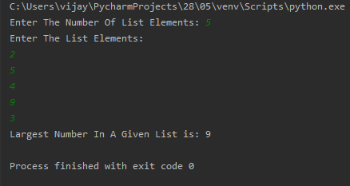

2) **Python Program to find different digits r from number n using combination.**

from itertools import combinations  
n = int(input("Enter The Number Of List Elements: "))  
a = []  
b = []  
for i in range(n):  
    a.append((int(input())))  
r = int(input("Enter The r Value: "))  
comb = combinations(a, r)  
for i in list(comb):  
    v = 0  
    for j in i:  
        v = v*10+j  
    b.append(v)  
print(str(b))

**Output:**

