**DAILY ONLINE ACTIVITIES SUMMARY**

|  |  |  |  |  |  |  |  |
| --- | --- | --- | --- | --- | --- | --- | --- |
| **Date:** | **31-05-20** | | | | **Name:** | **TANOJ M** | |
| **Sem & Sec** | **VI A** | | | | **USN:** | **4AL16CS113** | |
| **Online Test Summary** | | | | | | | |
| **Subject** | | **Sunday no test** | | | | | |
|  | |  | |  | |  | |
| **Certification Course Summary** | | | | | | | |
| **Course** | **FRONT END DEVELOPMENT HTML** | | | | | | |
| P11 | | | | | | | |
| **Certificate Provider** | | | **Great learning** | **Duration** | | | **6 DAYS** |
| **Status:Completed** | | | | | | | |
| **Uploaded the report in Github** | | | | **Yes** | | | |
| **If yes Repository name** | | | | **https://github.com/Tanoj8296/DAILY-STATUS** | | | |
| **Uploaded the report in slack** | | | | **Yes** | | | |

**Certification Details:**

**Topics covered:**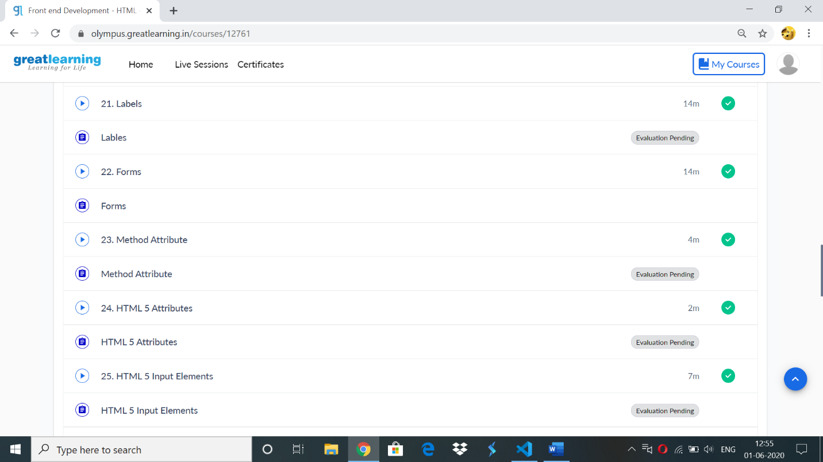

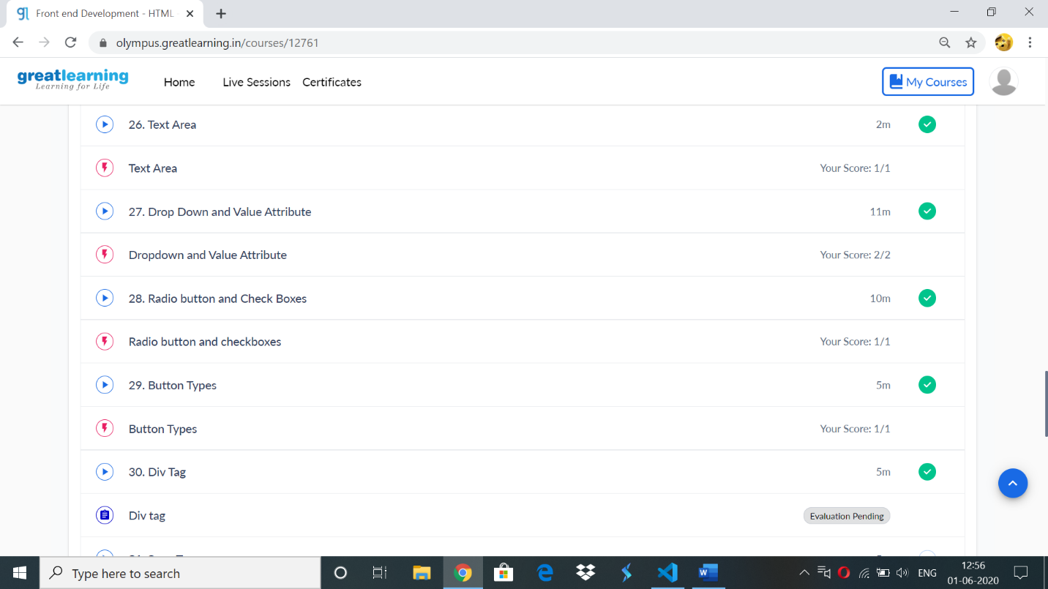

**Assisnments covered:**

**input :**

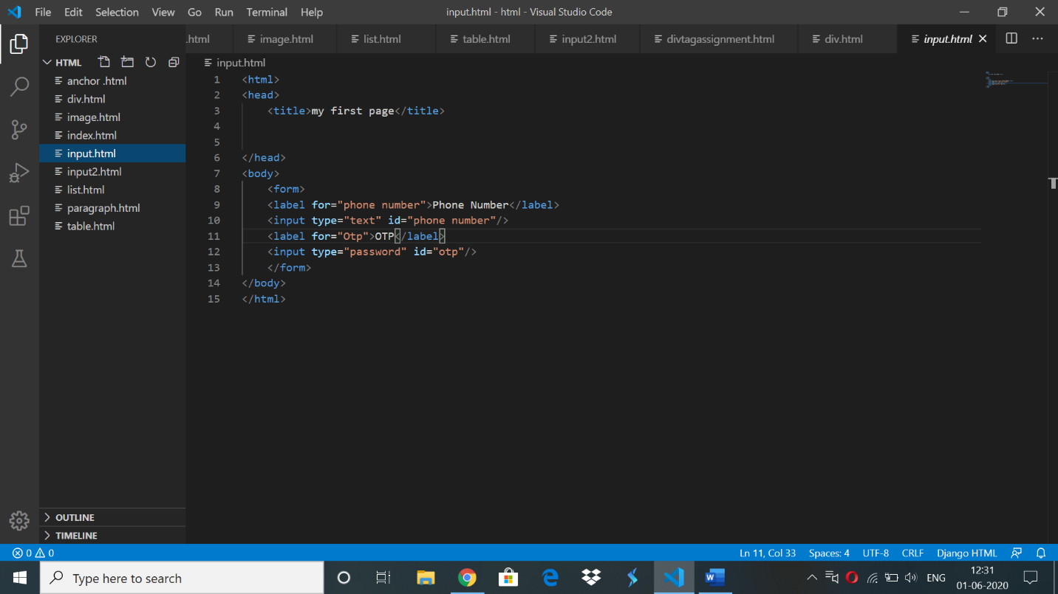

**Label tag:**

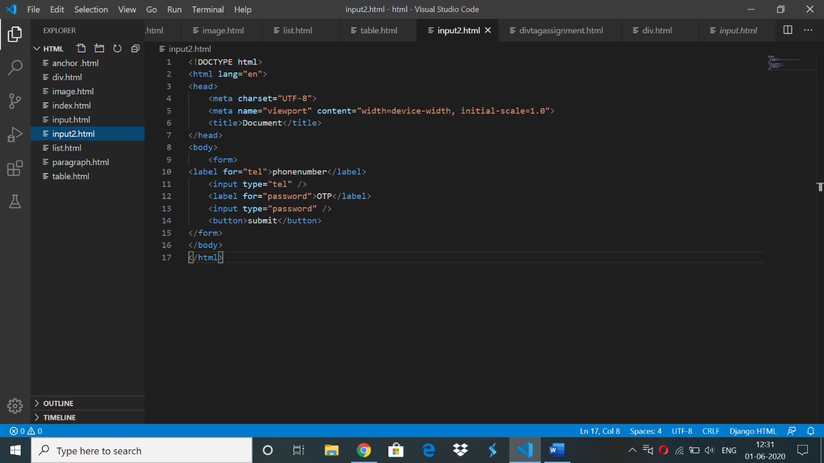

**Method attributes:**

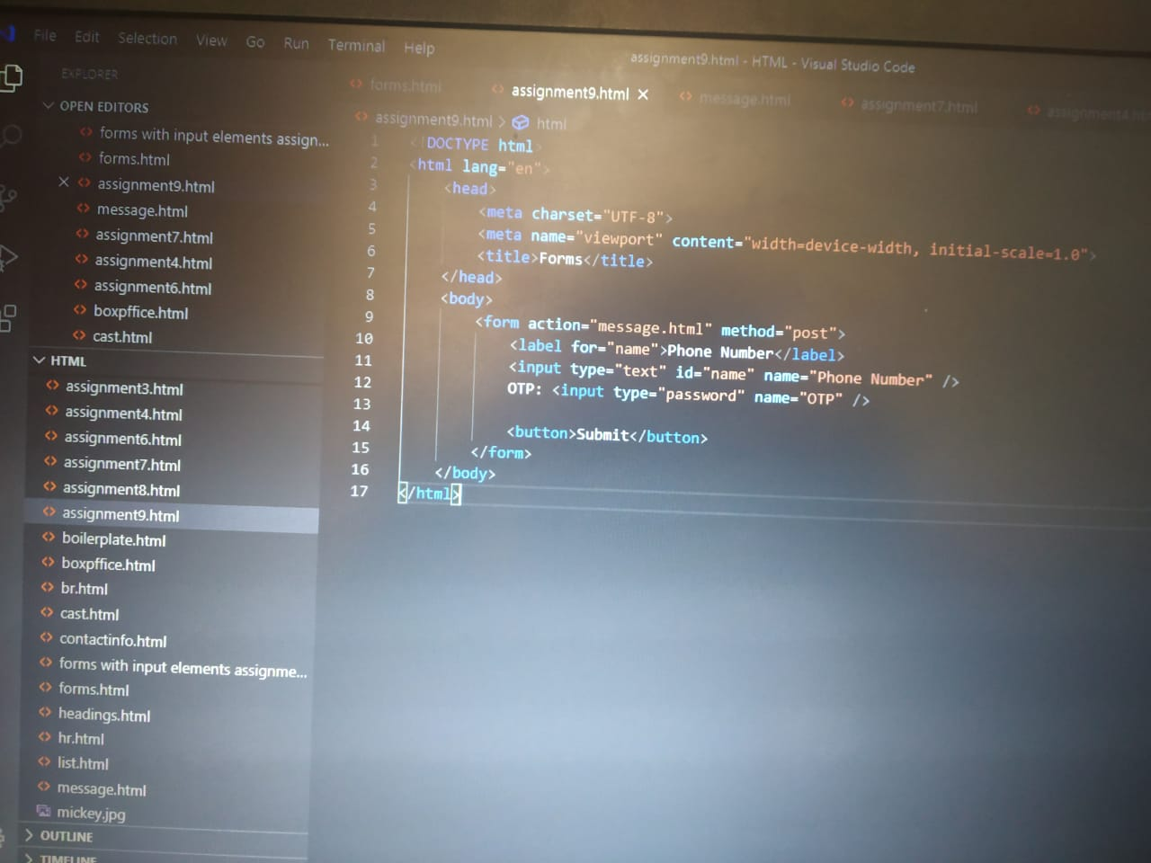

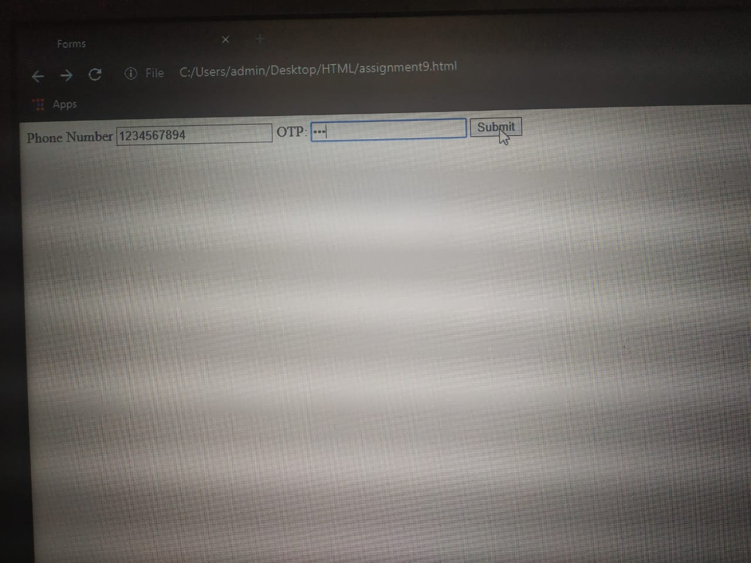

**HTML attributes:**

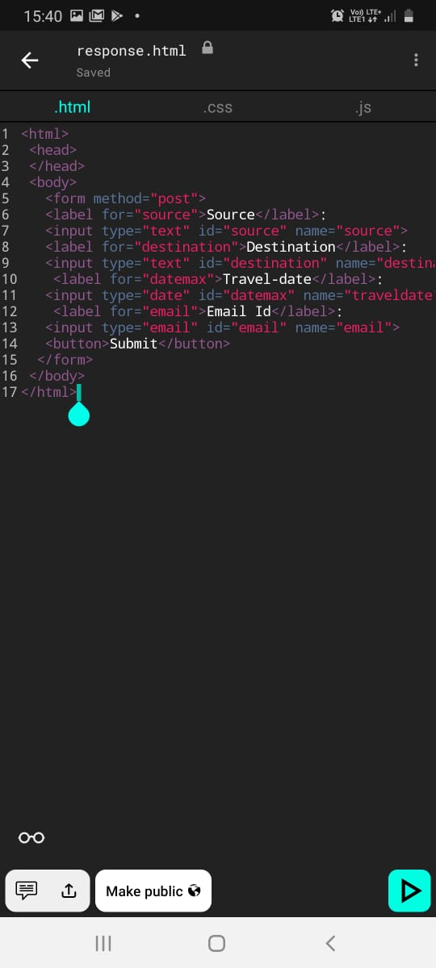

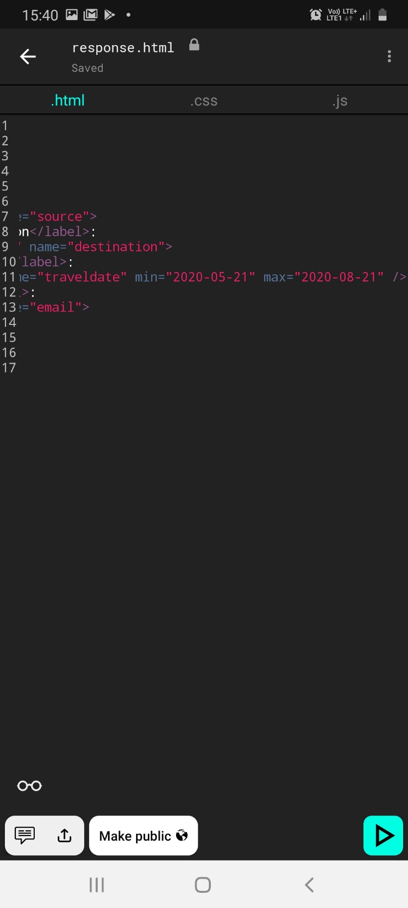

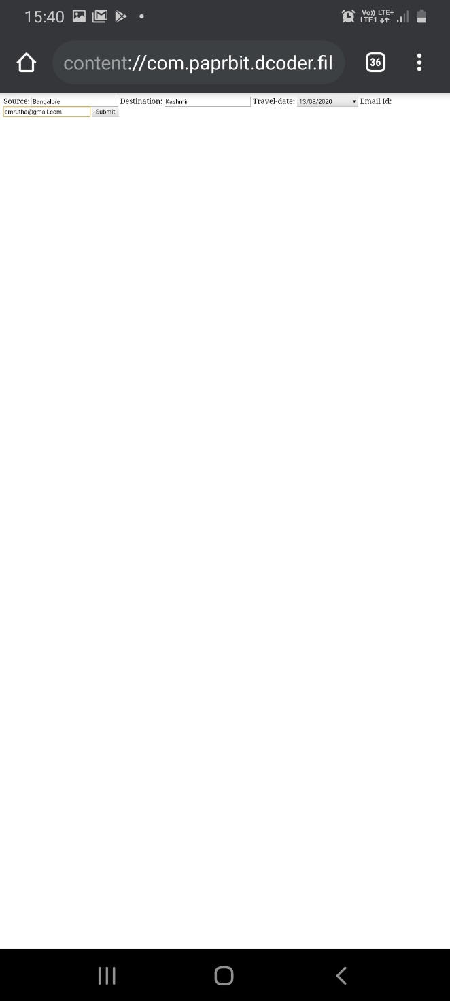

**DIV tag:**

