| **Crew list** | To: | Whom it may concern |
| --- | --- | --- |
| Date: |  |
| Subj: | Charter boat crew list |

| **Dates of charter:** 19/02/2022 – 26/02/2022 **Start and finish:**  **Boat type:**  **Boat name:** | **Charter company:**  **Address:**  **Phone:** |
| --- | --- |

| No | Role | Name | Nationality | Date of birth | Passport | Expiry date | Contacts |
| --- | --- | --- | --- | --- | --- | --- | --- |
| 1 | Skipper |  |  |  |  |  |  |

Yours faithfully,

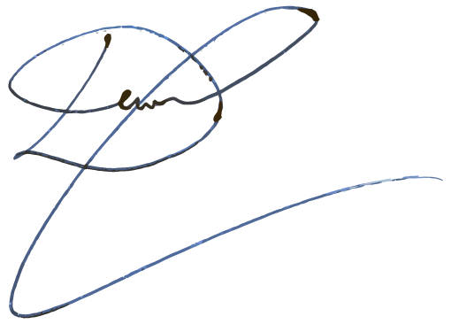

Daniil Simanov

General director