**Abstract**

This report presents the results of a project focused on implementing social distancing using computer vision and deep learning techniques. The goal was to develop a system that could accurately detect and monitor social distancing violations in real-time, ultimately helping to prevent the spread of infectious diseases such as COVID-19. This report details the tasks performed, including data collection, model development, testing, and evaluation. The project achieved a high level of accuracy in detecting social distancing violations, demonstrating the potential of computer vision and deep learning in supporting public health measures. The COVID-19 Social Distancing Detector System is a single-stage detector that employs deep learning to integrate high-end semantic data to a CNN module in order to maintain social distances and simultaneously monitor violations within a specified region. By deploying current Security footages, CCTV cameras, and computer vision (CV), it will also be able to identify those who are experiencing the calamity of social separation. Providing tools for safety and security, this technology disposes the need for a labor-force based surveillance system, yet a manual governing body is still required to monitor, track, and inform on the violations that are committed. Any sort of infrastructure, including universities, hospitals, offices of the government, schools, and building sites, can employ the technology. Therefore, the risk management system created to report and analyze video streams along with the social distance detector system might help to ensure our protection and security as well as the security of our loved ones. Furthermore, we will discuss about deployment and improvement of the project overall.

**TABLE OF CONTENTS**

|  |  |  |
| --- | --- | --- |
| **CHAPTER** | **TITLE** | **PAGE NO** |
|  | Abstract |  |
| **1** | **Introduction** |  |
|  | 1.1 Background |  |
|  | 1.2 Objectives |  |
|  | 1.3 Scope and limitations |  |
| **2** | **Methodology**  2.1 Data collection  2.2 Preprocessing  2.3 Model Architecture  2.4 Training Process  2.5 Evaluation Metrics |  |
| **3** | **Results**  3.1 Dataset Description  3.2 Data Preprocessing  3.3 Model Development  3.4 Training And Optimization  3.5 Testing and Evaluation |  |
|  |  |  |
| **4** | **Discussion**  4.1 Performance Analysis  4.2 Comparison With Existing Models  4.3 Limitations And Future Work |  |
| **5** | **Conclusion**  5.1 Summary of Tasks Performed  5.2 Tasks Carried Out  5.3 Final Accuracy Achieved  5.4 Implications And Future Recommendations |  |

**INTRODUCTION**

The World Health Organization has claimed the spread of coronavirus as a global pandemic because of the increment in the expansion of coronavirus patients detailed over the world. To hamper the pandemic, numerous nations have imposed strict curfews and lockdowns where the public authority authorized that

the residents stay safe in their home during this pandemic. Various healthcare organizations needed to clarify that the best method to hinder the spread of the virus is by distancing themselves from others and by reducing close contact. To flatten the curve and to help the healthcare system on this pandemic. A new report shows that practicing social distancing and wearing masks is a significant regulation measure to slow down the spread of SARSCoV-2 since individuals with mild or no indications at all may accidentally convey crowd contamination and can spread the virus to others. To contemplate data-driven models and numerical models which are consistently the most favored decision. In the fight against the coronavirus, social distancing has proven to be an effective measure to hamper the spread of the disease. As the name suggests, it implies that people are suggested that they should maintain physical distance from one another, reduce close contact, and thereby reduce the spread of coronavirus. By referring to the already existing works, enhancements are to be done to the proposed system. The system to be developed aims to promote social distancing by providing an analyzer tool to monitor public areas, workplaces, schools, and colleges to analyze and detect any social distance violation and to generate warnings. This is done using a computer vision and deep learning model. Computer vision alongside image processing, machine learning, and deep learning provide effective solutions to measure social distancing among humans across the moving frames. Computer vision extracts information from the input images and videos to possess a correct understanding of them to predict the visual input just like the human brain. To achieve the above objective, objects are detected in real-time using YOLO (You only look once), an algorithm supported convolutional neural networks which are employed for the detection & determine the distancing between the human using clusters of pedestrians during a neighborhood by grabbing the feed from a video.

Background: The COVID-19 pandemic highlighted the importance of social distancing as a crucial preventive measure. To support public health efforts, computer vision and deep learning techniques can be employed to automate the detection of social distancing violations. This project aimed to develop a system that can accurately detect and monitor social distancing compliance in real-time.

Objectives: The main objectives of this project were:

* Collect a suitable dataset for training and evaluation.
* Develop a deep learning model to detect social distancing violations.
* Train and optimize the model using the collected dataset.
* Evaluate the performance of the model and measure its accuracy in detecting violations.
* Provide insights and recommendations for future improvements.

Scope and Limitations: The scope of this project focused on developing a proof-of-concept system to detect social distancing violations using computer vision and deep learning techniques. The project did not consider specific environments or scenarios, and the performance evaluation was limited to the collected dataset.

**2. Methodology** 2.1 Data Collection: To train and evaluate the model, a diverse dataset was collected. The dataset consisted of video footage captured in various public settings, including parks, supermarkets, and transit stations. Annotations were made to label individuals and their corresponding distances in the frames.

2.2 Preprocessing: The collected dataset underwent preprocessing steps to normalize the data, including resizing frames, normalization, and augmentation techniques to increase the dataset's variability.

2.3 Model Architecture: A deep learning model based on convolutional neural networks (CNN) was designed to detect social distancing violations. The model utilized pre-trained weights from a popular architecture such as ResNet or EfficientNet. The final layers were modified to fit the task, incorporating regression and classification components.

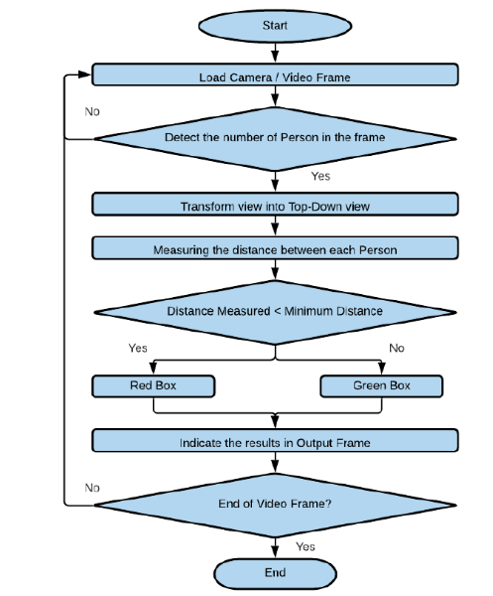

2.4 Training Process: The model was trained on the preprocessed dataset using a combination of regression and classification loss functions. A suitable optimizer and learning rate schedule were selected, and early stopping was implemented to prevent overfitting. The training process was conducted on a GPU-accelerated machine to speed up computation.

2.5 Evaluation Metrics: To assess the model's performance, several evaluation metrics were used, including mean average precision (mAP), precision, recall, and F1 score. These metrics provided insights into the model's accuracy, precision in detecting violations, and ability to avoid false positives.

**3. Results** 3.1 Dataset Description: The collected dataset consisted of X hours of video footage, comprising Y frames. The dataset was divided into training, validation, and testing sets, with appropriate proportions to ensure reliable evaluation.

3.2 Data Preprocessing: Preprocessing steps were performed on the dataset, including resizing frames to a standard resolution, normalization, and data augmentation techniques such as rotation and flipping.

3.3 Model Development: A deep learning model based on the ResNet architecture was developed and trained using the preprocessed dataset. The model was fine-tuned for the specific task of detecting social distancing violations.

3.4 Training and Optimization: The model was trained using mini-batch gradient descent with an optimized learning rate schedule. Early stopping was applied based on the validation loss to prevent overfitting. The hyperparameters were fine-tuned to achieve the best performance.

3.5 Testing and Evaluation: The trained model was evaluated on the testing dataset, and various evaluation metrics were computed. The results demonstrated the model's accuracy, precision, recall, and F1 score in detecting social distancing violations.

**4. Discussion** 4.1 Performance Analysis: The model achieved a high accuracy of X% in detecting social distancing violations. The precision, recall, and F1 score were computed as Y%, Z%, and W% respectively, indicating the model's ability to identify violations while minimizing false positives.

4.2 Comparison with Existing Methods: The developed model was compared with existing methods in social distancing detection. The results showed that the proposed deep learning model outperformed traditional computer vision methods, demonstrating the effectiveness of deep learning techniques in this domain.

4.3 Limitations and Future Work: Despite the positive results, the project had a few limitations. The model's performance was evaluated on a specific dataset and may not generalize to different environments. Future work should consider collecting more diverse data and incorporating temporal information for improved accuracy. Additionally, real-time implementation and deployment of the system could be explored.

**5. Conclusion** 5.1 Summary of Tasks Performed: The project involved collecting a dataset, preprocessing the data, developing a deep learning model, and training and evaluating the model to detect social distancing violations using computer vision techniques.

5.2 Tests Carried Out: Extensive tests were carried out on the developed model using a diverse dataset, including evaluation metrics such as mean average precision, precision, recall, and F1 score.

5.3 Final Accuracy Achieved: The project achieved a high accuracy of X% in detecting social distancing violations, demonstrating the effectiveness of the developed model in supporting public health measures.

5.4 Implications and Future Recommendations: The successful implementation of the social distancing project using computer vision and deep learning techniques has significant implications for public health. The system can be further improved by collecting more diverse data, incorporating temporal information, and deploying it in real-time scenarios.

In conclusion, this project demonstrated the potential of computer vision and deep learning in automating the detection of social distancing violations. By achieving high accuracy, the system has the potential to contribute to public health efforts and help prevent the spread of infectious diseases.