AI Personal Productivity Assistant

1. Problem Statement Selected
Managing day-to-day digital tasks across multiple Google services is time-consuming. Users often need to switch between Gmail, Google Calendar, Google Sheets, Google Drive, and other applications to read emails, schedule meetings, organize information, and perform repetitive actions.
This results in:
- Reduced productivity
- Missed important emails and meetings
- Manual repetitive work
- Poor organization of personal and professional tasks
The objective of this project is to build an intelligent AI assistant that automates these tasks through natural language conversations while securely integrating with Google services.

2. Solution Overview
Our solution is an AI-powered Personal Productivity Assistant that acts as a centralized interface for Google's ecosystem.
Instead of opening multiple applications, users simply communicate with the assistant using natural language.
The assistant understands user requests using Google's Gemini AI model and performs actions across Google services.
Examples include:
- Reading Gmail messages
- Sending emails
- Scheduling meetings
- Managing Google Calendar events
- Updating Google Sheets
- Accessing Google Drive files
- Answering questions using AI
- Summarizing emails
- Automating repetitive workflows
The project combines conversational AI with Google APIs to create an intelligent productivity assistant.

3. Key Features
🔹 Secure Authentication
- Google OAuth Login
- Firebase Authentication
- Secure user sessions

🔹 AI Chat Assistant
- Natural language conversations
- Context-aware responses
- Powered by Gemini AI

🔹 Gmail Integration
Users can:
- Read latest emails
- Search emails
- Summarize inbox
- Send emails
- Draft replies
- Reply using AI-generated responses.

🔹 Natural Language Commands
Examples:
"Schedule a meeting tomorrow at 3 PM."
"Summarize unread emails."
"Send an email to John."
"Add today's expenses to my spreadsheet."

🔹 Responsive Dashboard
- Clean UI
- Mobile-friendly
- Modern user experience

4. Technologies Used
Frontend
- React.js
- TypeScript
- Vite
- HTML5
- CSS3

Backend
- Node.js
- Express.js

Database
- Firebase Firestore

Authentication
- Firebase Authentication
- Google OAuth 2.0

AI
- Google Gemini API

APIs
- Gmail API
- Google Calendar API
- Google Drive API
- Google Sheets API

Deployment
- GitHub
- Firebase Hosting
- Google AI Studio

5. Google Technologies Utilized
This project heavily utilizes Google's ecosystem.
Google Gemini API
Used for:
- Conversational AI
- Email summarization
- Intelligent responses
- Workflow automation

Firebase Authentication
Provides:
- Secure Google Sign-In
- User authentication
- Session management

Firebase Firestore
Stores:
- User information
- Chat history
- Preferences
- Application data

6. System Architecture
User
│
▼
React Frontend
│
▼
Express Backend
│
┌───────────────┐
▼ ▼ ▼
Gemini API Firebase Google APIs
│
────────────────────────
▼ ▼ ▼ ▼
Gmail API Calendar API Sheets API Drive API

7. Project Workflow
- User logs in using Google Authentication.
- Firebase verifies and manages the user session.
- The user enters a request in natural language.
- The backend sends the request to the Gemini API.
- Gemini understands the intent.
- The backend calls the appropriate Google API (Gmail, Calendar, Sheets, or Drive).
- The requested action is executed.
- The response is displayed in the dashboard.

8. Innovation
Unlike traditional productivity applications that require users to interact with each Google service individually, this project unifies multiple Google services into a single AI-powered conversational interface. By combining Gemini AI with Firebase Authentication and various Google Workspace APIs, users can accomplish complex productivity tasks through simple natural language commands, significantly reducing manual effort and improving workflow efficiency.

9. Future Enhancements
- Voice Assistant Support
- Multi-language Support
- Google Meet Integration
- Google Docs Automation
- AI Task Prioritization
- Reminder Notifications
- Workflow Automation Templates
- Mobile Application
- Team Collaboration Features

10. Conclusion
The AI Personal Productivity Assistant demonstrates how Google's AI and cloud technologies can be combined to simplify everyday digital workflows. By integrating Gemini AI with Firebase and Google Workspace APIs, the application provides an intuitive, secure, and efficient platform for managing emails, calendars, spreadsheets, and documents through conversational interactions. This solution highlights the potential of AI-driven productivity tools to save time, reduce repetitive tasks, and enhance the overall user experience.

GitHub Repository
Repository:
Vibe2Ship GitHub Repository

CiviResolve:-
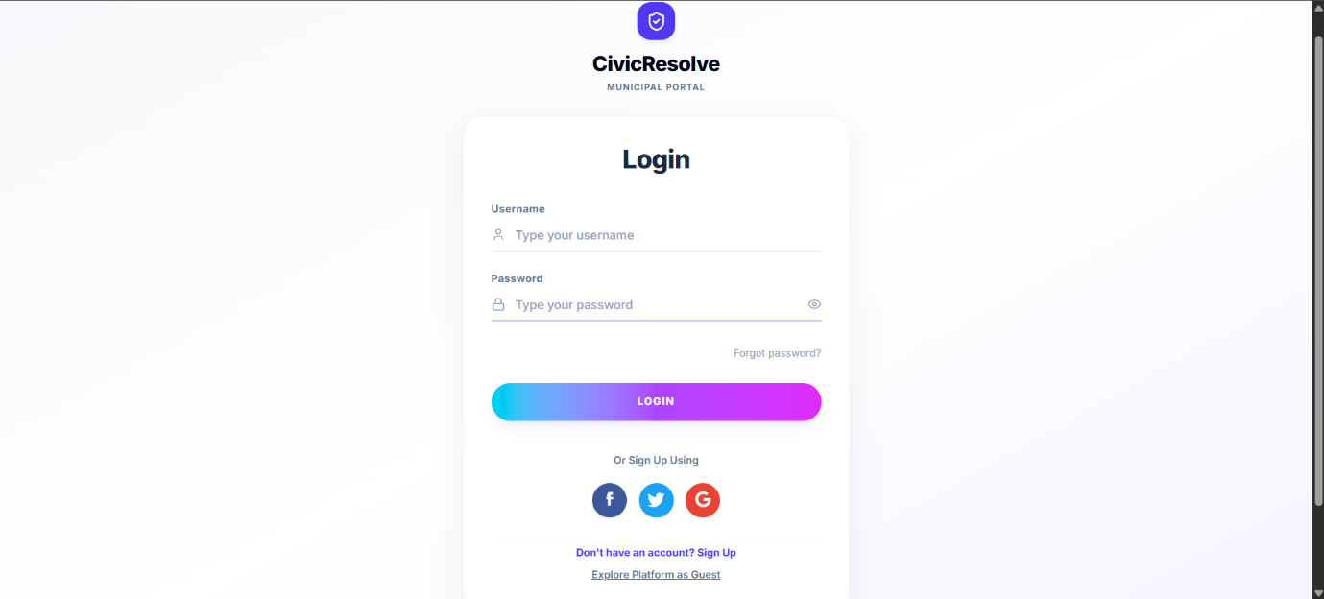
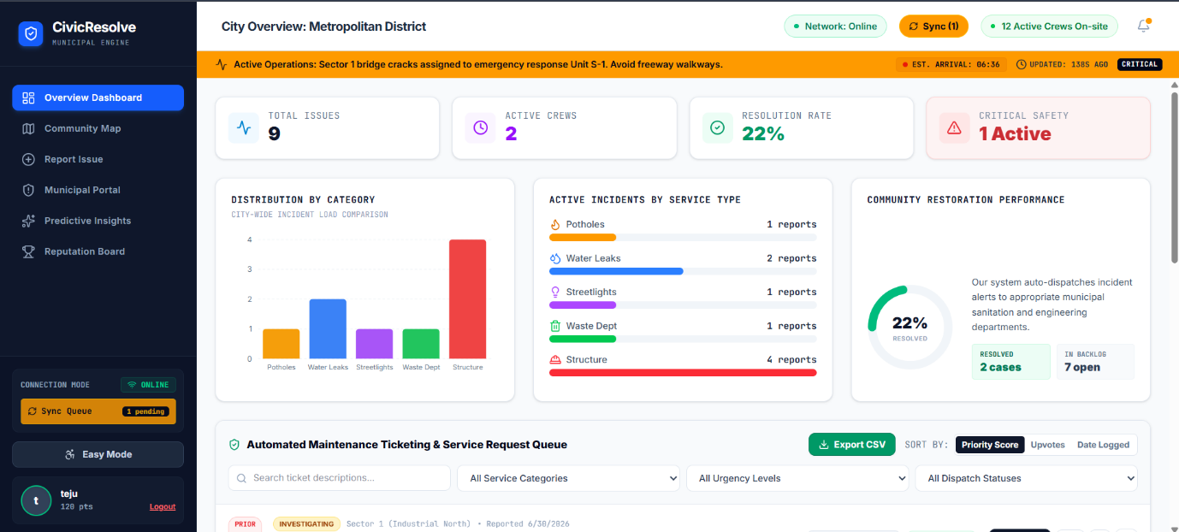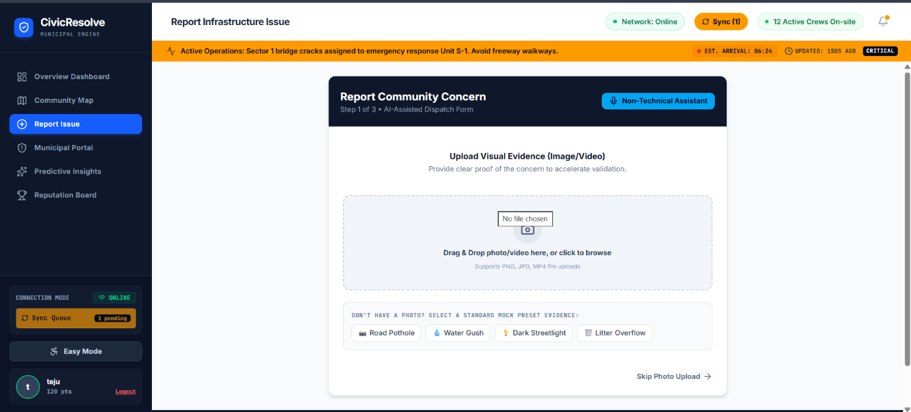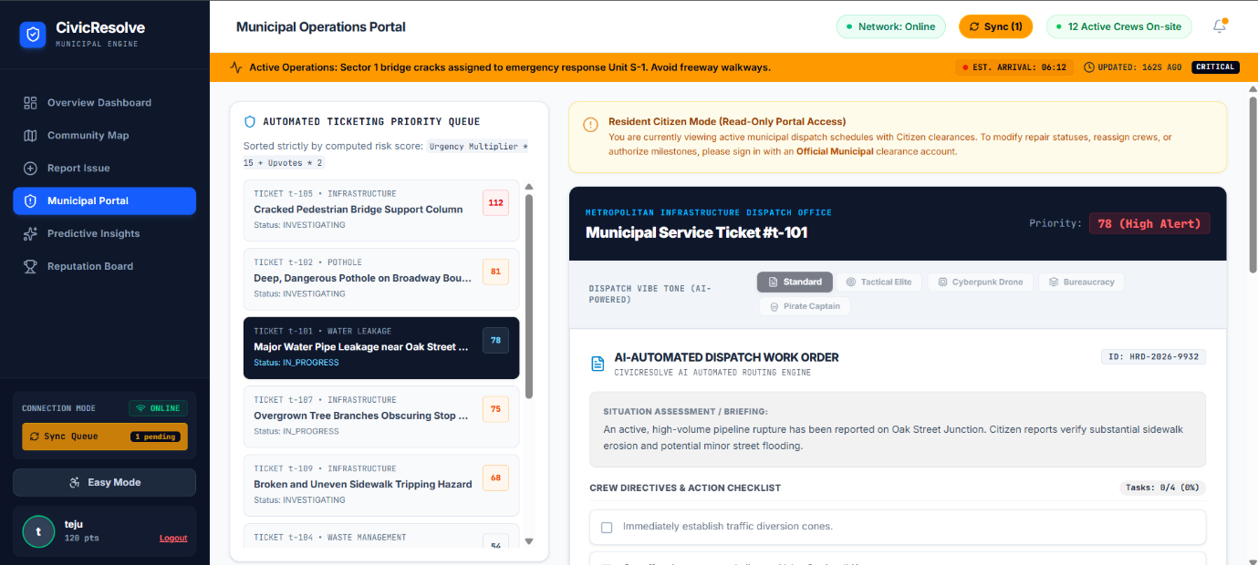

FireBase Integration:-
