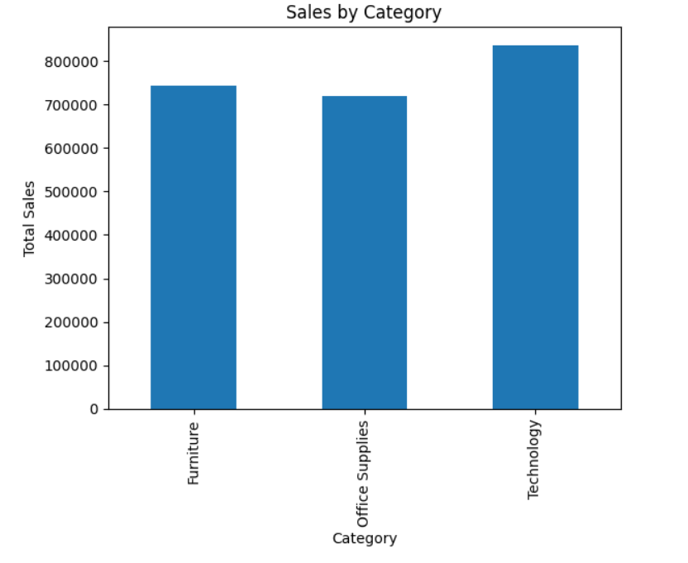

INSIGHTS:

1. Technology category generated the highest overall sales among all categories.

2. Office Supplies showed stable sales contribution but lower than Technology.

3. Furniture category contributed significant revenue but comparatively lower profitability.

4. Technology products are major revenue drivers for the business.
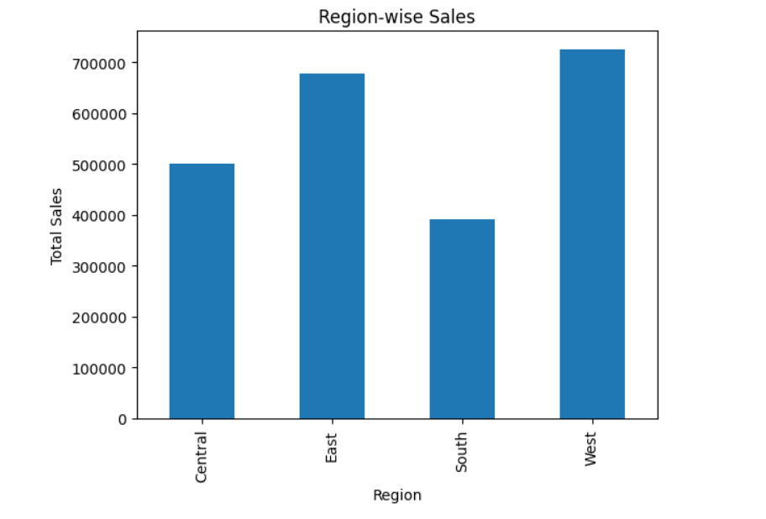
INSIGHTS:

1. West region achieved the highest sales performance.

2. East region also contributed strong sales revenue.

3. Central region showed comparatively lower sales performance.

4. Regional performance indicates stronger customer demand in West region markets.

Top 10 Customers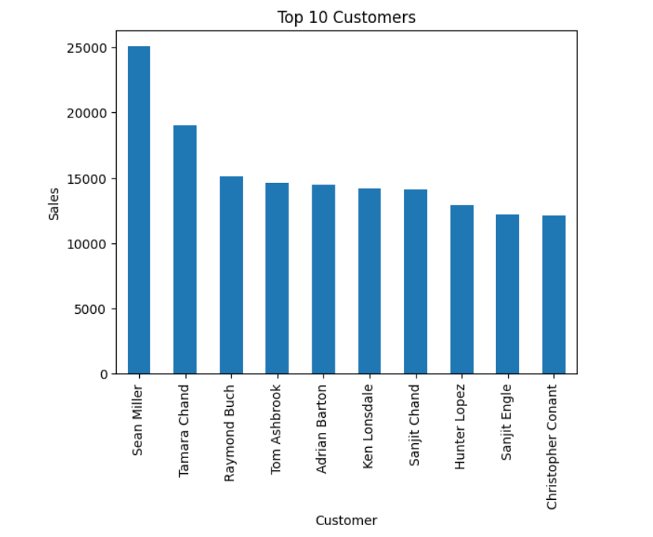
INSIGHTS:

1. A small group of customers contributed significantly high revenue.

2. Top customers play an important role in overall business sales.

3. Customer retention strategies can improve long-term profitability.

4. High-value customers should be targeted with personalized marketing strategies.

Monthly Sales trend
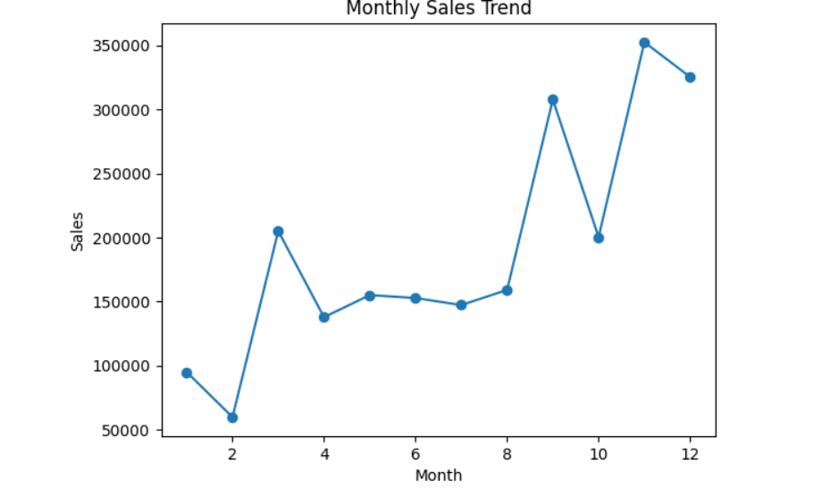
INSIGHTS:

1. Month 1 recorded the highest sales trend in the dataset.

2. Sales performance fluctuated across different months.

3. Certain months showed lower sales indicating possible seasonal variation.

4. Monthly trend analysis helps identify peak business periods.

Profit Distribution by Category

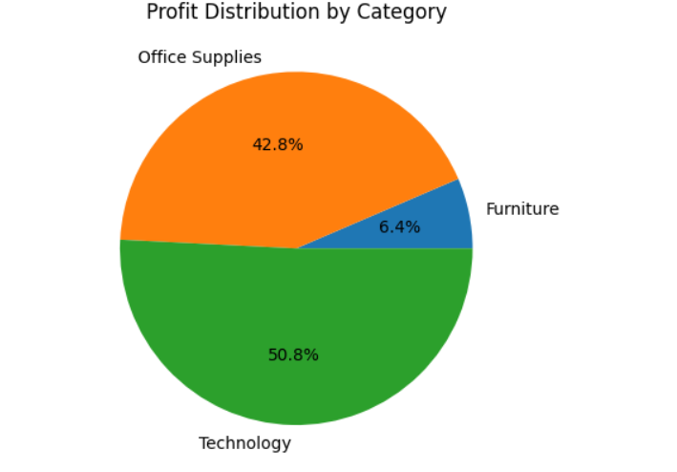
INSIGHTS:

1. Technology category contributed the highest share of profit.

2. Furniture category generated lower profit compared to sales contribution.

3. Profit distribution varies significantly across categories.

4. Business should focus on highly profitable categories for better growth.

