**Name - Tanu Singh Superset ID - 6362191**

**React Hands-On Exercises Solutions**

**Lab 9**

**/App.jsx**

import React from 'react';

function App() {

  const flag = false;

  const players = [

    { name: "Jack", score: 101 },

    { name: "Michael", score: 70 },

    { name: "John", score: 40 },

    { name: "Ann", score: 61 },

    { name: "Elisabeth", score: 61 },

    { name: "Sachin", score: 95 },

    { name: "Dhoni", score: 100 },

    { name: "Virat", score: 84 },

    { name: "Jadeja", score: 64 },

    { name: "Raina", score: 75 },

    { name: "Utsav", score: 6361856 }

  ];

  const T20Players = ["First Player", "Second Player", "Third Player"];

  const RanjiTrophyPlayers = ["Fourth Player", "Fifth Player", "Sixth Player"];

  const IndianPlayers = [...T20Players, ...RanjiTrophyPlayers];

  const IndianTeam = ["Sachin1", "Dhoni2", "Virat3", "Rohit4", "Yuvaraj5", "Raina6"];

  const OddPlayers = ([*first*, , *third*, , *fifth*]) => (

    <div>

      <li>First: {*first*}</li>

      <li>Third: {*third*}</li>

      <li>Fifth: {*fifth*}</li>

    </div>

  );

  const EvenPlayers = ([, *second*, , *fourth*, , *sixth*]) => (

    <div>

      <li>Second: {*second*}</li>

      <li>Fourth: {*fourth*}</li>

      <li>Sixth: {*sixth*}</li>

    </div>

  );

  if (flag) {

    const below70 = [];

    players.forEach(*item* => {

      if (*item*.score <= 70) below70.push(*item*);

    });

    return (

      <div>

        <h1>List of Players</h1>

        {players.map((*item*, *index*) => (

          <div key={*index*}>

            <li>Mr. {*item*.name} <span>{*item*.score}</span></li>

          </div>

        ))}

        <hr />

        <h1>List of Players having Scores Less than 70</h1>

        {below70.map((*item*, *index*) => (

          <div key={*index*}>

            <li>Mr. {*item*.name} <span>{*item*.score}</span></li>

          </div>

        ))}

      </div>

    );

  } else {

    return (

      <div>

        <h1>Indian Team</h1>

        <h2>Odd Players</h2>

        {OddPlayers(IndianTeam)}

        <hr />

        <h2>Even Players</h2>

        {EvenPlayers(IndianTeam)}

        <hr />

        <h2>List of Indian Players Merged:</h2>

        {IndianPlayers.map((*player*, *index*) => (

          <li key={*index*}>Mr. {*player*}</li>

        ))}

      </div>

    );

  }

}

export default App;

Output **-**

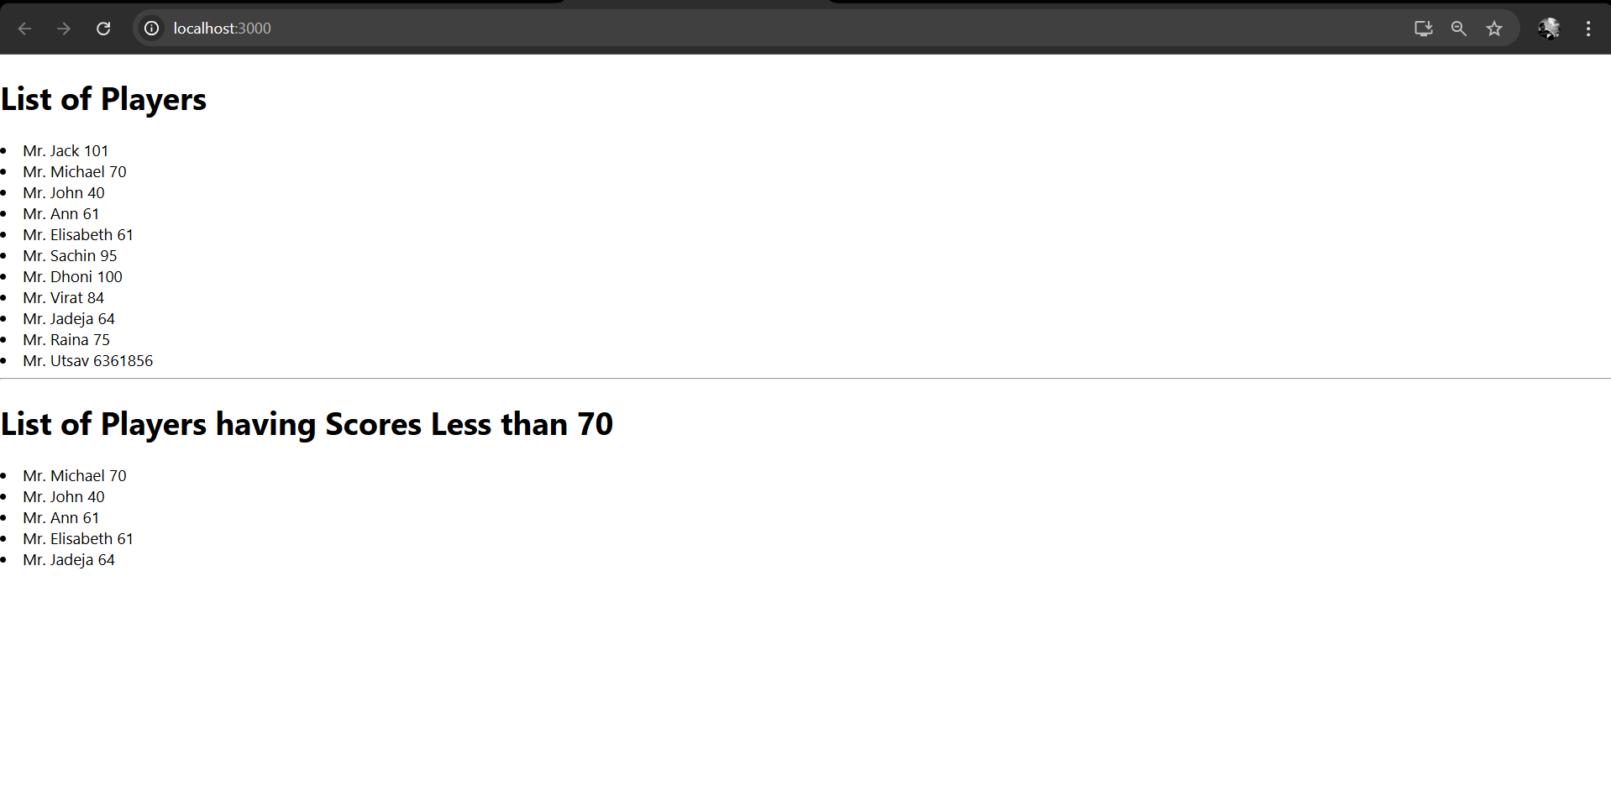

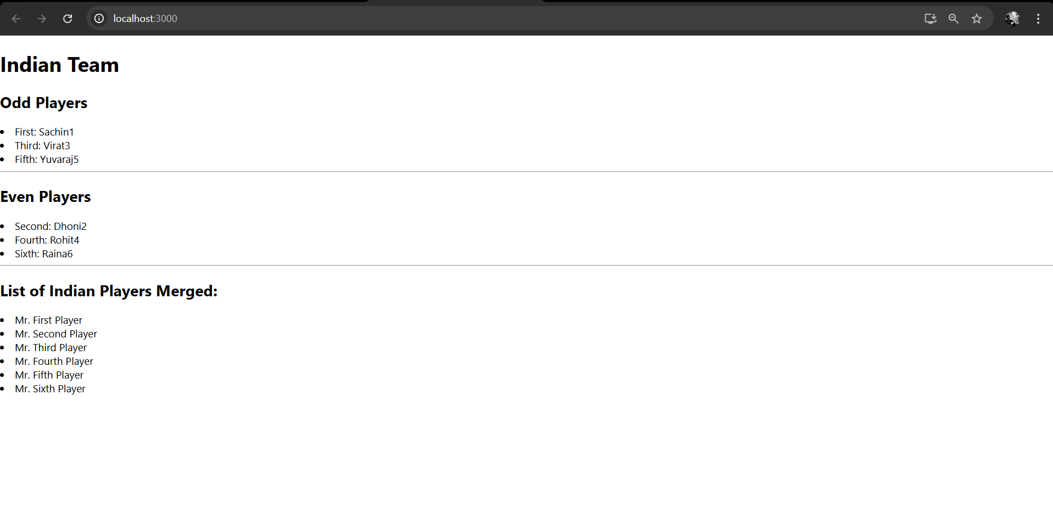

**Lab 10**

**/App.js**

import React from 'react';

function App() {

  const heading = "Office Space";

  const officeList = [

    { Name: "UtsavBuilders", Rent: 90000, Address: "Indore" },

    { Name: "95Home", Rent: 60000, Address: "Hyderabad" },

    { Name: "DBS", Rent: 50000, Address: "Chennai" }

  ];

  const getColor = (*rent*) => {

    return {

      color: *rent* <= 60000 ? 'red' : 'green'

    };

  };

  return (

    <div style={{ padding: "10px" }}>

      <h1 style={{ fontWeight: "bold" }}>

        {heading}, at Affordable Range

      </h1>

      <img src="office1.jpg" width="25%" height="25%" alt="Office Space" />

      <br /><br />

      {officeList.map((*item*, *index*) => (

        <div key={*index*} style={{ marginBottom: "30px" }}>

          <h2>Name: {*item*.Name}</h2>

          <h3 style={getColor(*item*.Rent)}>Rent: Rs. {*item*.Rent}</h3>

          <h3>Address: {*item*.Address}</h3>

        </div>

      ))}

    </div>

  );

}

export default App;

**Output -**

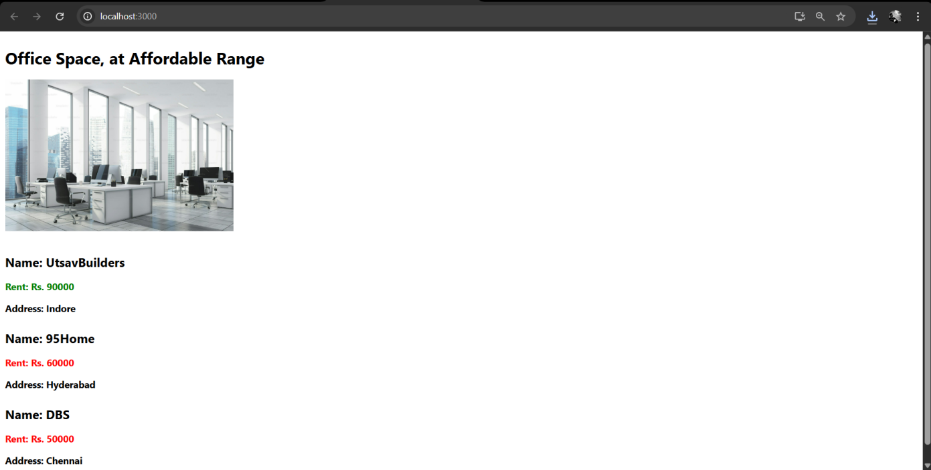

**Lab 11**

**/App.js**

import React from 'react';

import CurrencyConverter from './CurrencyConverter';

class App extends React.Component {

  constructor(*props*) {

**super**(*props*);

**this**.state = {

      count: 0,

      message: ''

    };

**this**.increment = **this**.increment.bind(**this**);

**this**.sayHello = **this**.sayHello.bind(**this**);

**this**.handleMultiple = **this**.handleMultiple.bind(**this**);

**this**.sayWelcome = **this**.sayWelcome.bind(**this**);

**this**.onPress = **this**.onPress.bind(**this**);

  }

  increment() {

**this**.setState({ count: **this**.state.count + 1 });

  }

  sayHello() {

    alert("Increment Pressed");

  }

  handleMultiple() {

**this**.increment();

**this**.sayHello();

  }

  decrement = () => {

**this**.setState({ count: **this**.state.count - 1 });

  };

  sayWelcome(*message*) {

    alert(`${*message*}`);

  }

  onPress(*e*) {

*e*.preventDefault();

    alert("I was clicked (Utsav Saxena 6361856)");

  }

  render() {

    return (

      <div style={{ padding: "10px" }}>

        <h2>Counter: {**this**.state.count}</h2>

        <button onClick={**this**.handleMultiple}>Increment</button>

        <br />

        <button onClick={**this**.decrement}>Decrement</button>

        <br />

        <button onClick={() => **this**.sayWelcome("Welcome my dear friend

")}>

          Say Welcome

        </button>

        <br />

        <button onClick={**this**.onPress}>Click Me</button>

        <p>{**this**.state.message}</p>

        <CurrencyConverter />

      </div>

    );

  }

}

export default App;

**/CurrencyConverter.js**

import React, { useState } from 'react';

const CurrencyConverter = () => {

  const [rupees, setRupees] = useState('');

  const handleSubmit = (*e*) => {

*e*.preventDefault();

    const converted = (parseFloat(rupees) / 90).toFixed(2);

    alert(`Euros : € ${converted}`);

  };

  return (

    <div style={{ marginTop: "40px", color:"navy" }}>

      <h2>Currency Converter</h2>

      <form onSubmit={handleSubmit}>

        <textarea

          type="number"

          placeholder="Enter amount in Rupees"

          value={rupees}

          onChange={(*e*) => setRupees(*e*.target.value)}

          rows={5}

        />

        <button type="submit">Convert into Euros</button>

      </form>

    </div>

  );

};

export default CurrencyConverter;

**Output -**

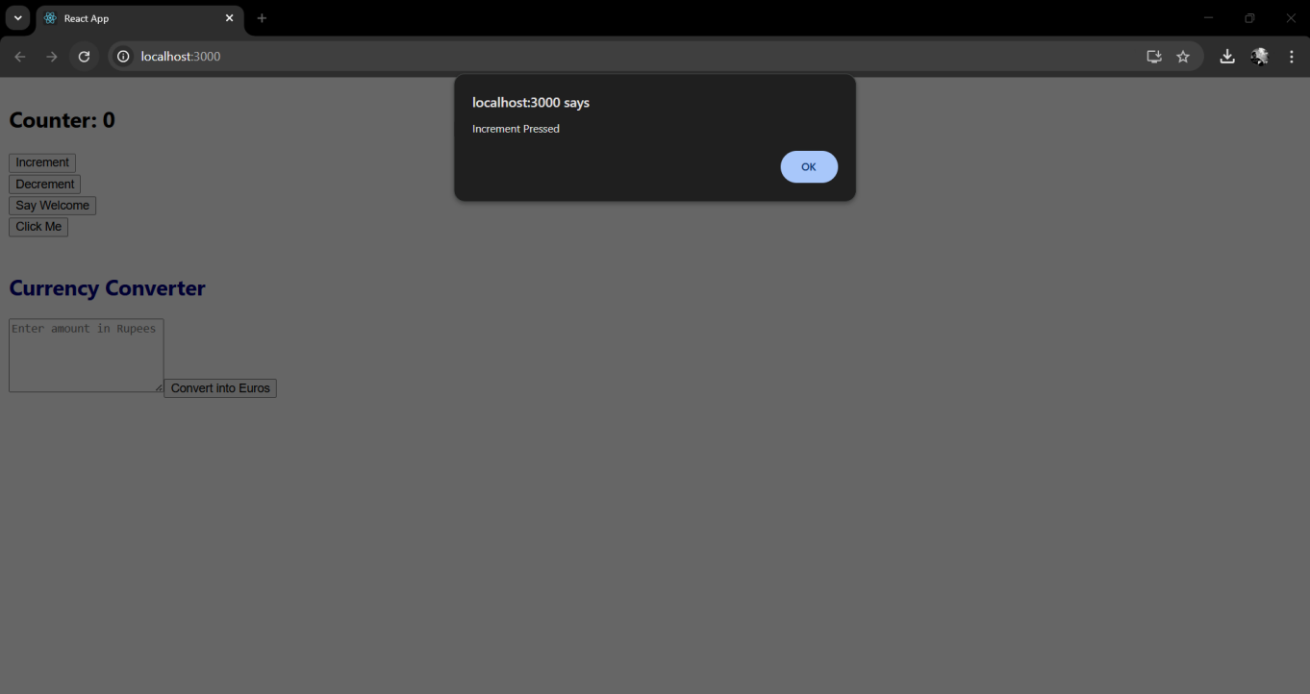

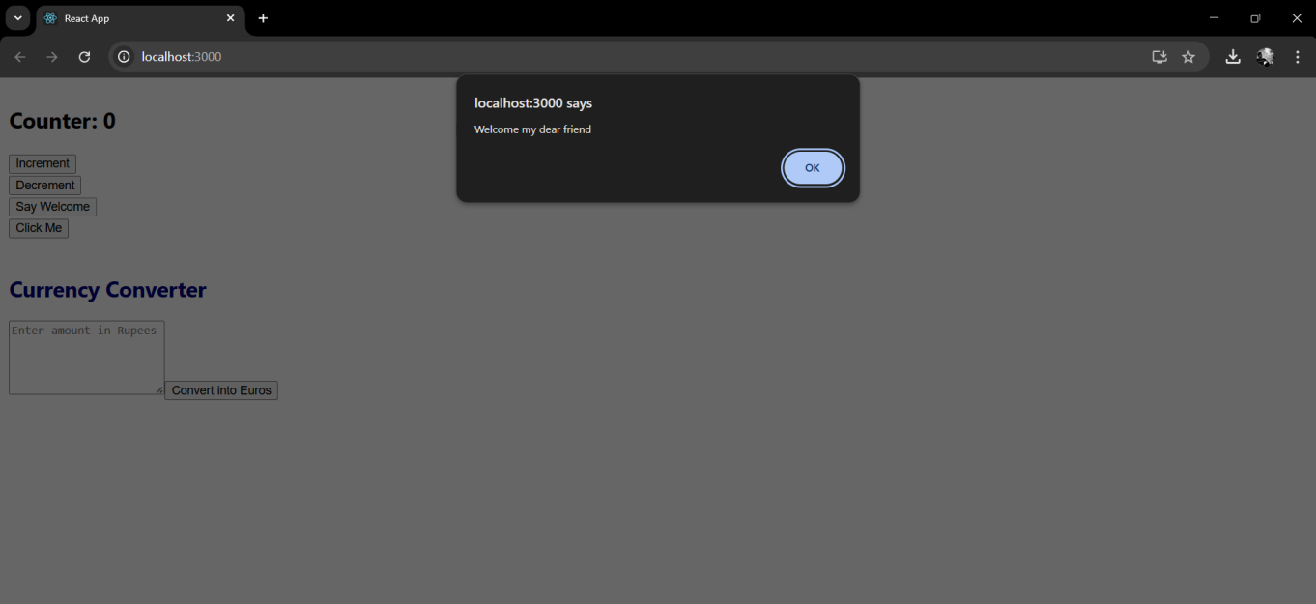

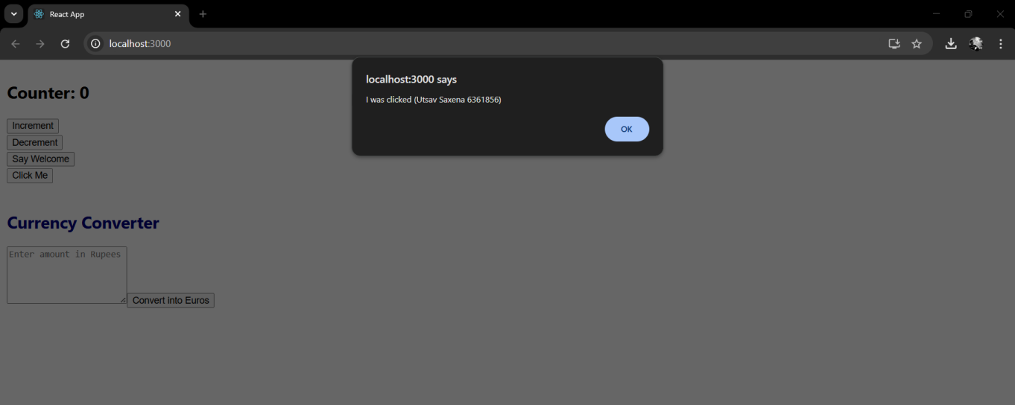

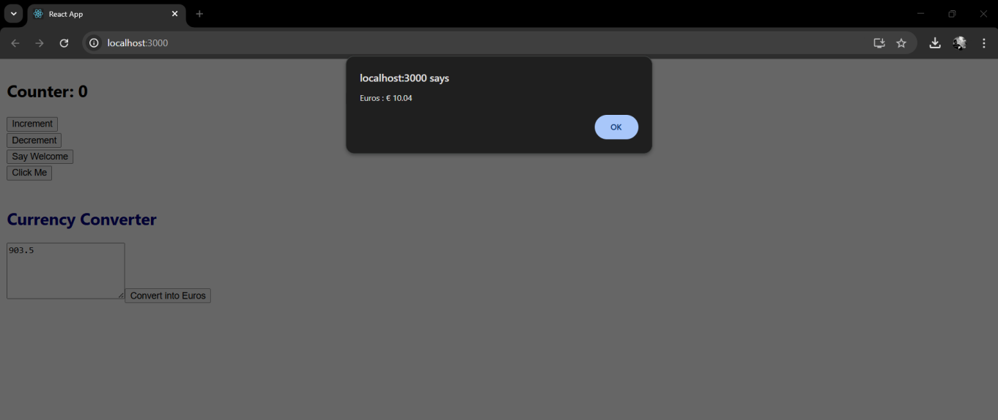

**Lab 12**

**/App.js**

import React from 'react';

function GuestGreeting() {

  return (

    <div>

      <h3>Welcome Guest</h3>

      <h2>Please Sign Up...</h2>

      <p>OR</p>

      <p>Click the Login Button</p>

    </div>

  );

}

function UserGreeting() {

  return (

    <div>

      <h2>Welcome Back, Utsav</h2>

      <p>You can Book your ticket</p>

    </div>

  );

}

function Greeting(*props*) {

  const isLoggedIn = *props*.isLoggedIn;

  if (isLoggedIn) {

    return <UserGreeting />;

  }

  return <GuestGreeting />;

}

function LoginButton(*props*) {

  return <button onClick={*props*.onClick}>Login</button>;

}

function LogoutButton(*props*) {

  return <button onClick={*props*.onClick}>Logout</button>;

}

class App extends React.Component {

  constructor(*props*) {

**super**(*props*);

**this**.state = { isLoggedIn: false };

**this**.handleLoginClick = **this**.handleLoginClick.bind(**this**);

**this**.handleLogoutClick = **this**.handleLogoutClick.bind(**this**);

  }

  handleLoginClick() {

**this**.setState({ isLoggedIn: true });

  }

  handleLogoutClick() {

**this**.setState({ isLoggedIn: false });

  }

  render() {

    const isLoggedIn = **this**.state.isLoggedIn;

    let button;

    if (isLoggedIn) {

      button = <LogoutButton onClick={**this**.handleLogoutClick} />;

    } else {

      button = <LoginButton onClick={**this**.handleLoginClick} />;

    }

    return (

      <div style={{ padding: '40px', fontFamily: 'Arial' }}>

        <Greeting isLoggedIn={isLoggedIn} />

        <br />

        {button}

      </div>

    );

  }

}

export default App;

**Output -**

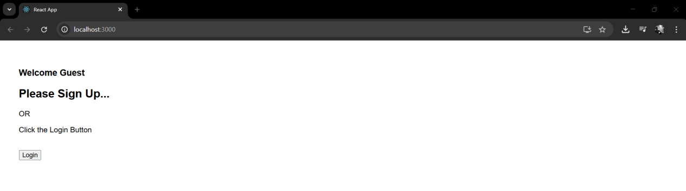

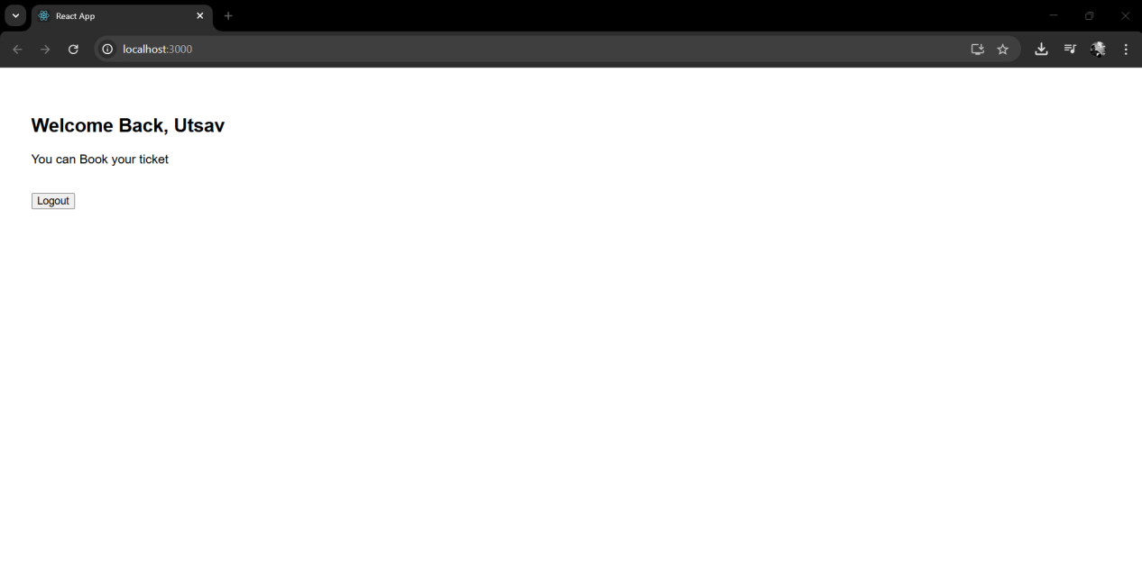

**Lab 13**

**/App.js**

import React from 'react';

import BookDetails from './BookDetails';

import BlogDetails from './BlogDetails';

import CourseDetails from './CourseDetails';

import './App.css'; *// Import CSS*

function App() {

  return (

    <div className="app-container">

      <CourseDetails />

      <BookDetails />

      <BlogDetails />

    </div>

  );

}

export default App;

**/BlogDetails.js**

import React from 'react';

const BlogDetails = () => {

  const blogs = [

    {

      id: 1,

      title: 'Machine Learning',

      author: 'Stephen Biz ',

      description: 'Welcome to the learning React!'

    },

    {

      id: 2,

      title: 'Installation',

      author: 'Utsav Saxena',

      description: 'You can install React from npm.'

    }

  ];

  return (

    <div className="column blog">

      <h2>Blog Details</h2>

      {blogs.map((*blog*) => (

        <div key={*blog*.id}>

          <h3>{*blog*.title}</h3>

          <p><strong>{*blog*.author}</strong></p>

          <p>{*blog*.description}</p>

        </div>

      ))}

    </div>

  );

};

export default BlogDetails;

**/BookDetails.js**

import React from 'react';

const BookDetails = () => {

  const books = [

    { id: 101, bname: 'Master React', price: 670 },

    { id: 102, bname: 'Deep Dive into Angular 11', price: 800 },

    { id: 103, bname: 'Mongo Essentials', price: 450 }

  ];

  return (

    <div className="column book">

      <h2>Book Details</h2>

      {books.map((*book*) => (

        <div key={*book*.id}>

          <h3>{*book*.bname}</h3>

          <p>{*book*.price}</p>

        </div>

      ))}

    </div>

  );

};

export default BookDetails;

**/Data.js**

export const books = [

  { id: 101, bname: 'Master React', price: 670 },

  { id: 102, bname: 'Deep Dive into Angular 11', price: 800 },

  { id: 103, bname: 'Mongo Essentials', price: 450 }

];

export const blogs = [

  { id: 1, title: 'React Best Practices', author: 'John' },

  { id: 2, title: 'Using Angular CLI', author: 'Mary' }

];

export const courses = [

  { id: 'c1', name: 'ReactJS', duration: '6 weeks' },

  { id: 'c2', name: 'NodeJS', duration: '4 weeks' }

];

**Output -**

