Tanu Singh Superset Id - 6362191
WEEK 4 - WEB-API HANDSON

Module - 1.WebApi HandsOn

Question 1:First Web Api using .Net core

CODE

/controllers/valueController.cs

[ApiController]
[Route("api/[controller]")]
public class ValuesController : ControllerBase
{
[HttpGet]
public IActionResult Get() => Ok(new[] { "Utsav", "6361856" });

[HttpPost]
public IActionResult Post([FromBody] string value) => Ok($"Received: {value}");
}

/program.cs
var builder = WebApplication.CreateBuilder(args);
builder.Services.AddControllers();
builder.Services.AddEndpointsApiExplorer();
builder.Services.AddSwaggerGen();
var app = builder.Build();
if (app.Environment.IsDevelopment())
{
app.UseSwagger();
app.UseSwaggerUI();
}
app.UseHttpsRedirection();
app.UseAuthorization();
app.MapControllers();
app.Run();

OUTPUT

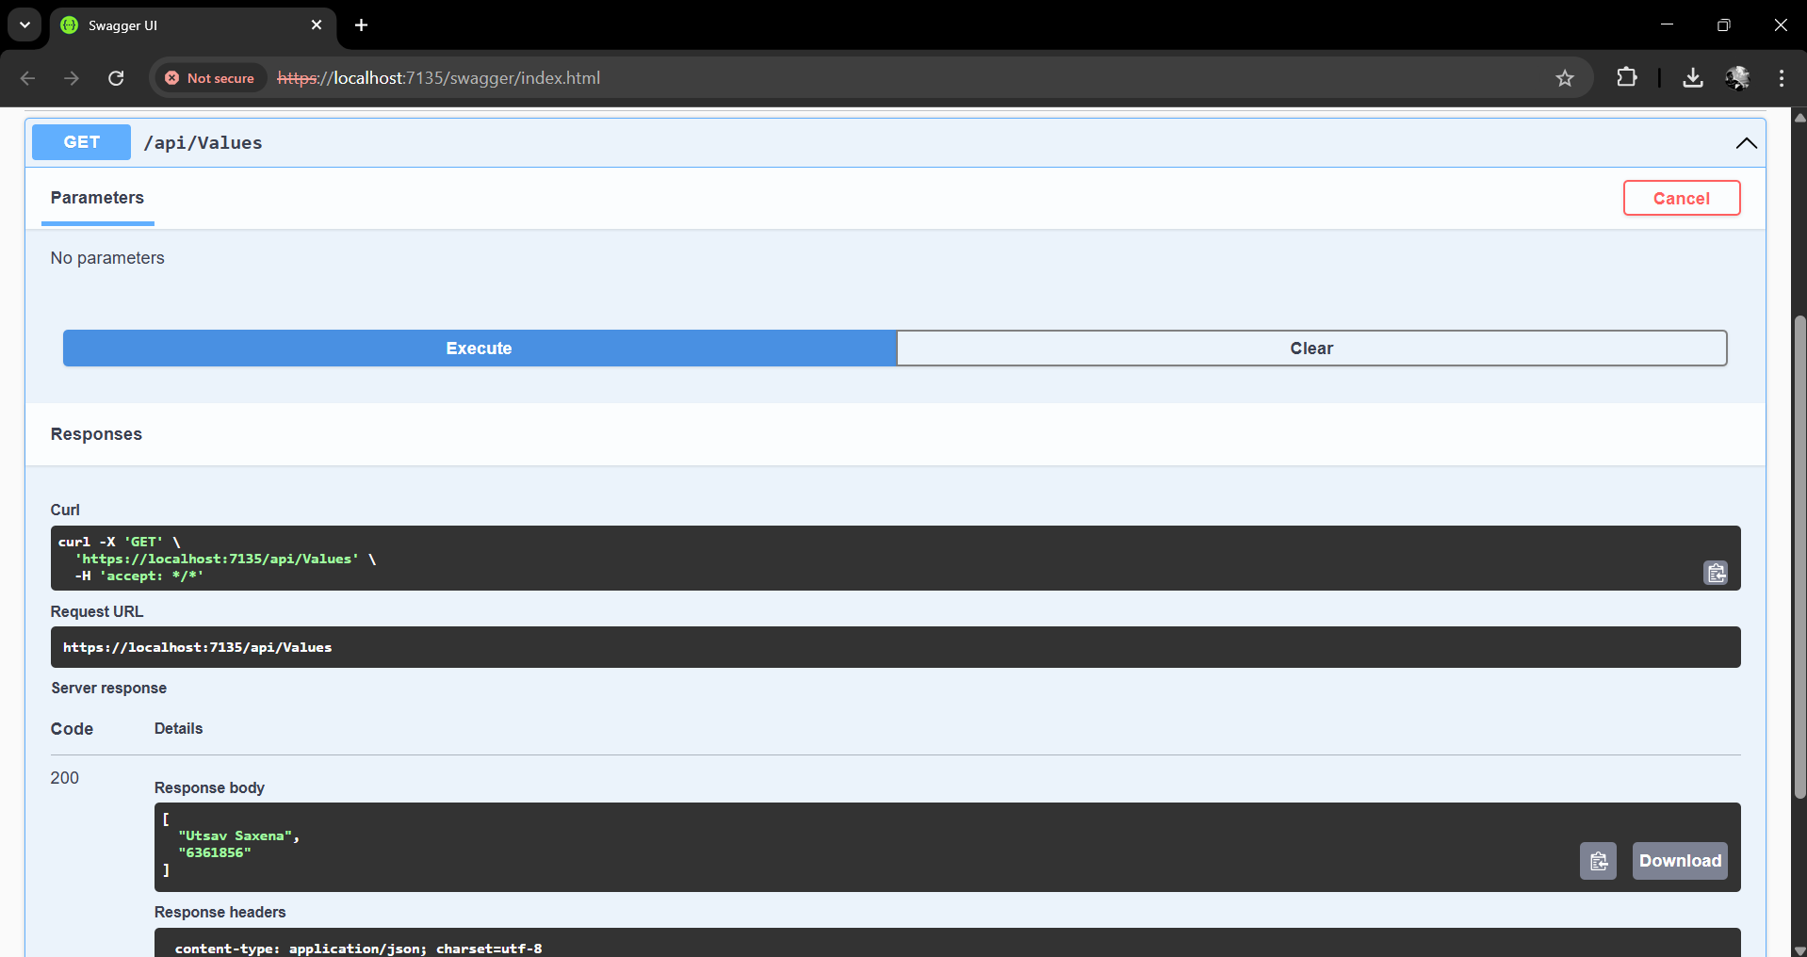

Module - 2.WebApi HandsOn

Question 1:Web Api using .Net core with Swagger

CODE

/program.cs
builder.Services.AddSwaggerGen(c =>
{
c.SwaggerDoc("v1", new Microsoft.OpenApi.Models.OpenApiInfo
{
Title = "Swagger Demo",
Version = "v1",
Description = "TBD",
TermsOfService = new Uri("https://example.com/terms"),
Contact = new Microsoft.OpenApi.Models.OpenApiContact
{
Name = "John Doe",
Email = "john@xyzmail.com",
Url = new Uri("https://www.example.com")
},
License = new Microsoft.OpenApi.Models.OpenApiLicense
{
Name = "License Terms",
Url = new Uri("https://www.example.com")
}
});
});

OUTPUT

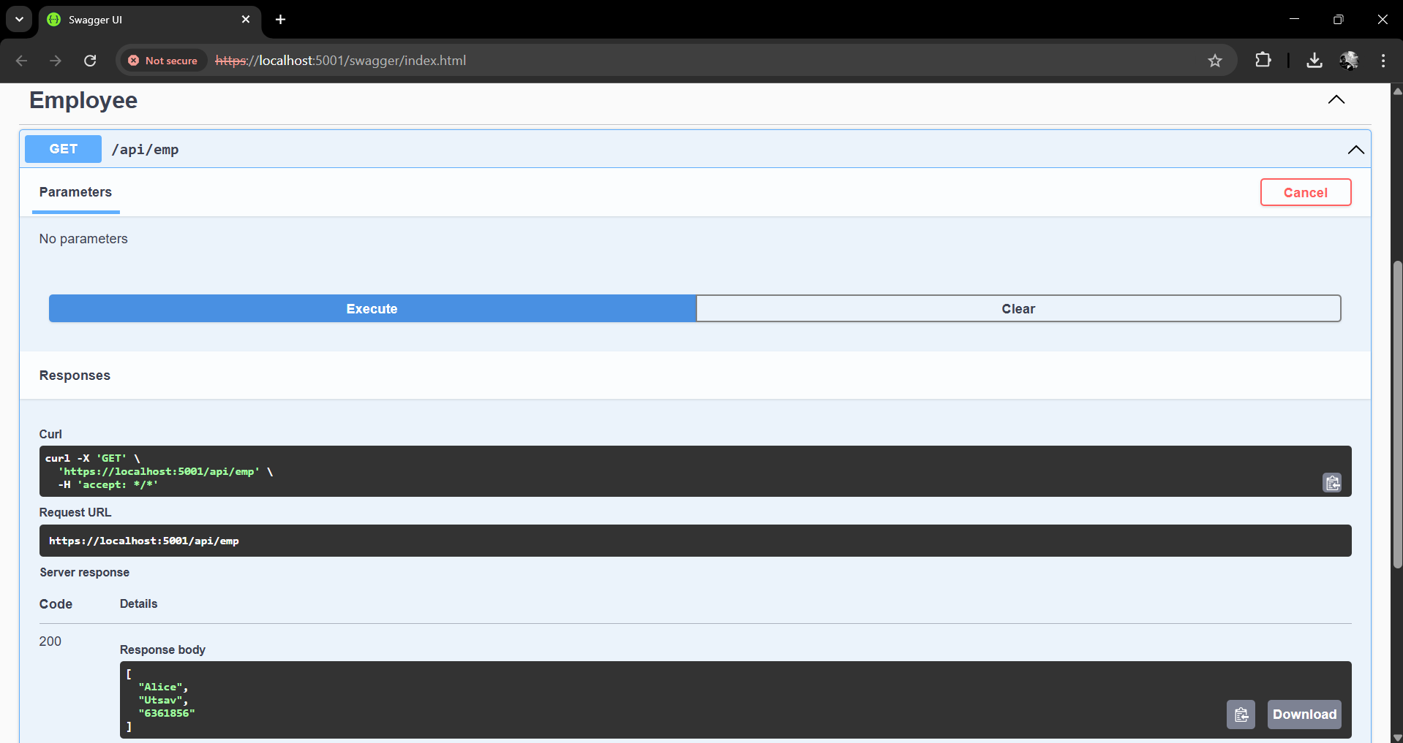

Question 2:Test the GET action method using POSTMAN

OUTPUT

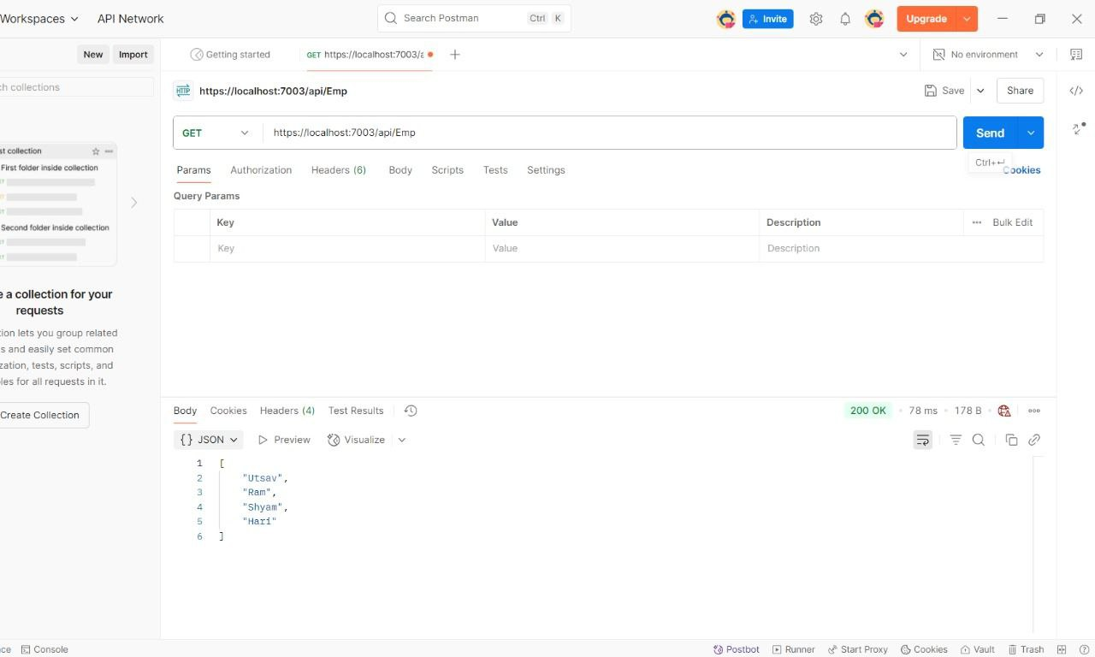

Question 3:Modify the Controller name in the Route attribute of the Employee controller to ‘Emp’ and check its access thru POSTMAN

Answer
Yes, if we use exact modified route.

Module - 3.WebApi HandsOn

Question 1:Web Api using custom model class

CODE

/Models/Employee.cs
namespace YourProject.Models
{
public class Employee
{
public int Id { get; set; }
public string Name { get; set; }
public int Salary { get; set; }
public bool Permanent { get; set; }
public Department Department { get; set; }
public List<Skill> Skills { get; set; }
public DateTime DateOfBirth { get; set; }
}

public class Department
{
public int Id { get; set; }
public string Name { get; set; }
}
public class Skill
{
public int Id { get; set; }
public string Name { get; set; }
}
}

/Controllers/EmployeeController.cs
using Microsoft.AspNetCore.Mvc;
using YourProject.Models;
using YourProject.Filters;
namespace YourProject.Controllers
{
[ApiController]
[Route("api/emp")]
[ServiceFilter(typeof(CustomAuthFilter))]
public class EmployeeController : ControllerBase
{
private static List<Employee> GetStandardEmployeeList()
{
return new List<Employee>
{
new Employee
{
Id = 1,
Name = "John Doe",
Salary = 50000,
Permanent = true,
DateOfBirth = new DateTime(1990, 1, 1),
Department = new Department { Id = 101, Name = "HR" },
Skills = new List<Skill>
{
new Skill { Id = 1, Name = "C#" },
new Skill { Id = 2, Name = "SQL" }
}
}
};
}
[HttpGet]
[ProducesResponseType(StatusCodes.Status200OK)]
[ProducesResponseType(StatusCodes.Status500InternalServerError)]
public ActionResult<List<Employee>> Get()
{
throw new Exception("Simulated Exception");
}
[HttpPost]
public ActionResult Post([FromBody] Employee emp)
{
return Ok($"Received: {emp.Name}");
}
}
}

OUTPUT
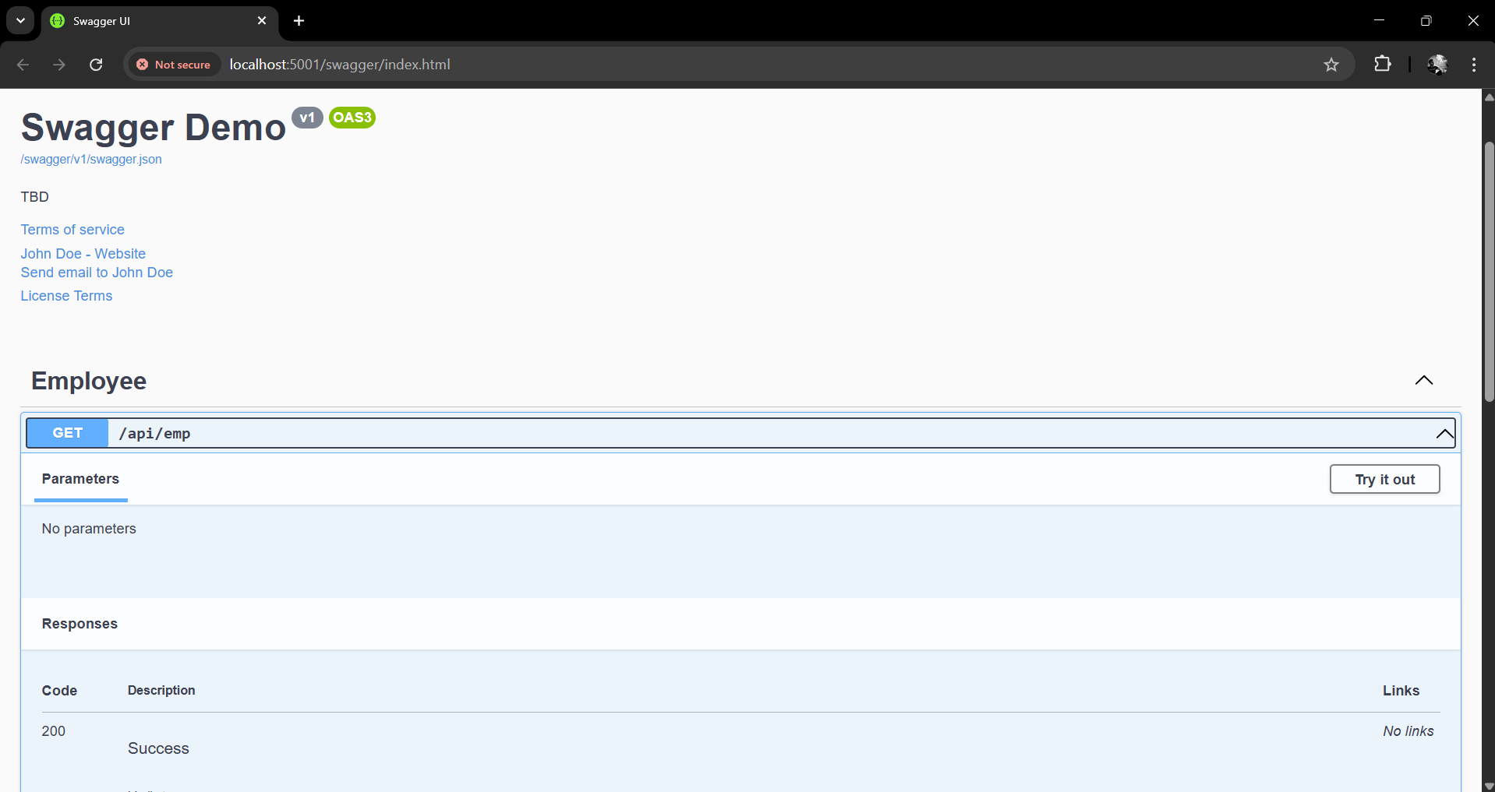

Question 2:Create a Custom action filter for Authorization.

CODE

/Filter/CustomActionFilter.cs
using Microsoft.AspNetCore.Mvc;
using Microsoft.AspNetCore.Mvc.Filters;
namespace YourProject.Filters
{
public class CustomAuthFilter : ActionFilterAttribute
{
public override void OnActionExecuting(ActionExecutingContext context)
{
var headers = context.HttpContext.Request.Headers;
if (!headers.ContainsKey("Authorization"))
{
context.Result = new BadRequestObjectResult("Invalid request - No Auth token");
return;
}
var token = headers["Authorization"].ToString();
if (!token.Contains("Bearer"))
{
context.Result = new BadRequestObjectResult("Invalid request - Token present but Bearer unavailable");
}
}
}
}

OUTPUT

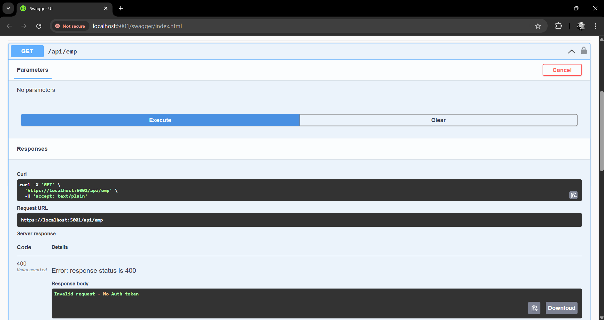

Question 3:Create a Custom Exception filter

CODE

/Filter/CustomExceptionFilter.cs

using Microsoft.AspNetCore.Mvc;
using Microsoft.AspNetCore.Mvc.Filters;
namespace YourProject.Filters
{
public class CustomExceptionFilter : IExceptionFilter
{
public void OnException(ExceptionContext context)
{
var exception = context.Exception;
File.AppendAllText("errors.txt", $"{DateTime.Now}: {exception.Message}{Environment.NewLine}");

context.Result = new ObjectResult("An unexpected error occurred.")
{
StatusCode = 500
};
}
}
}

OUTPUT

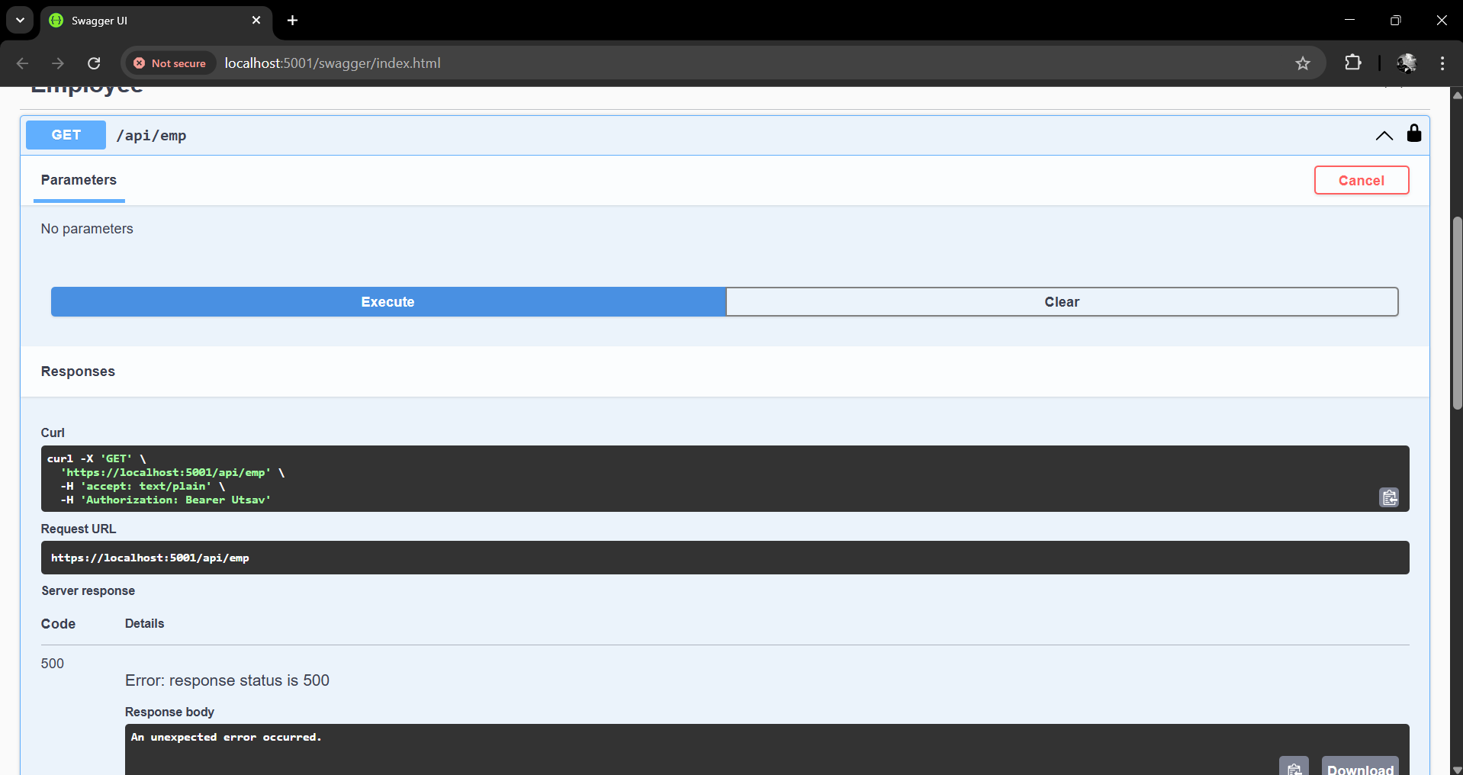

Module - 4.WebApi HandsOn

Question 1:Web Api CRUD operation

CODE

/Controller/EmployeeController.cs

using Microsoft.AspNetCore.Mvc;
using YourProject.Models;
using YourProject.Filters;
namespace YourProject.Controllers
{
[ApiController]
[Route("api/emp")]
[ServiceFilter(typeof(CustomAuthFilter))]
public class EmployeeController : ControllerBase
{
private static List<Employee> employees = new List<Employee>
{
new Employee
{
Id = 1,
Name = "John Doe",
Salary = 50000,
Permanent = true,
DateOfBirth = new DateTime(1990, 1, 1),
Department = new Department { Id = 101, Name = "HR" },
Skills = new List<Skill> { new Skill { Id = 1, Name = "C#" } }
},
new Employee
{
Id = 2,
Name = "Jane Smith",
Salary = 60000,
Permanent = false,
DateOfBirth = new DateTime(1992, 2, 2),
Department = new Department { Id = 102, Name = "Finance" },
Skills = new List<Skill> { new Skill { Id = 2, Name = "Excel" } }
}
};
[HttpGet]
[ProducesResponseType(StatusCodes.Status200OK)]
public ActionResult<List<Employee>> Get()
{
return Ok(employees);
}
[HttpPut("{id}")]
public ActionResult<Employee> Put(int id, [FromBody] Employee updatedEmp)
{
if (id <= 0)
return BadRequest("Invalid employee id");

var emp = employees.FirstOrDefault(e => e.Id == id);
if (emp == null)
return BadRequest("Invalid employee id");
emp.Name = updatedEmp.Name;
emp.Salary = updatedEmp.Salary;
emp.Permanent = updatedEmp.Permanent;
emp.DateOfBirth = updatedEmp.DateOfBirth;
emp.Department = updatedEmp.Department;
emp.Skills = updatedEmp.Skills;
return Ok(emp);
}
}
}

OUTPUT

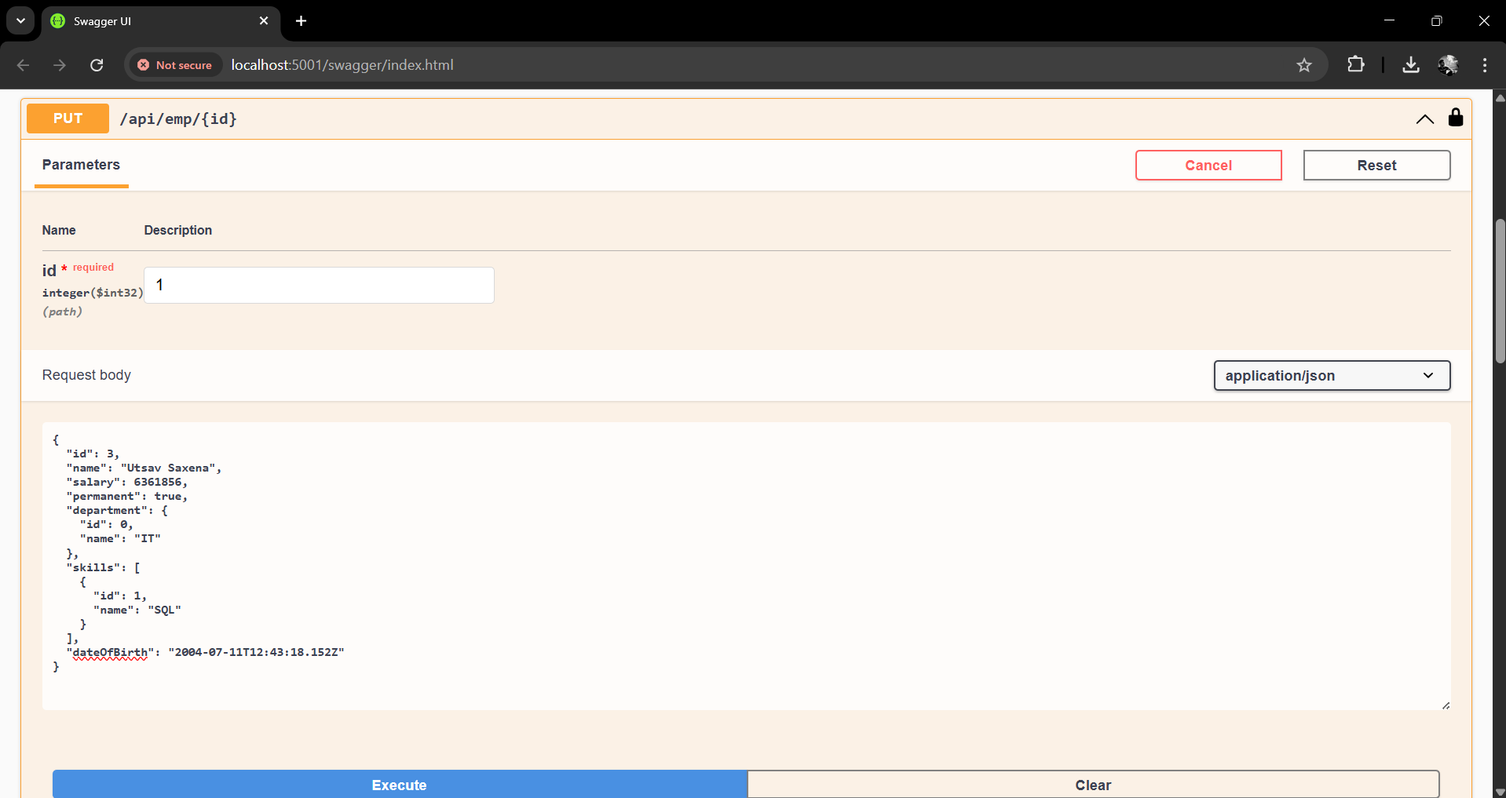
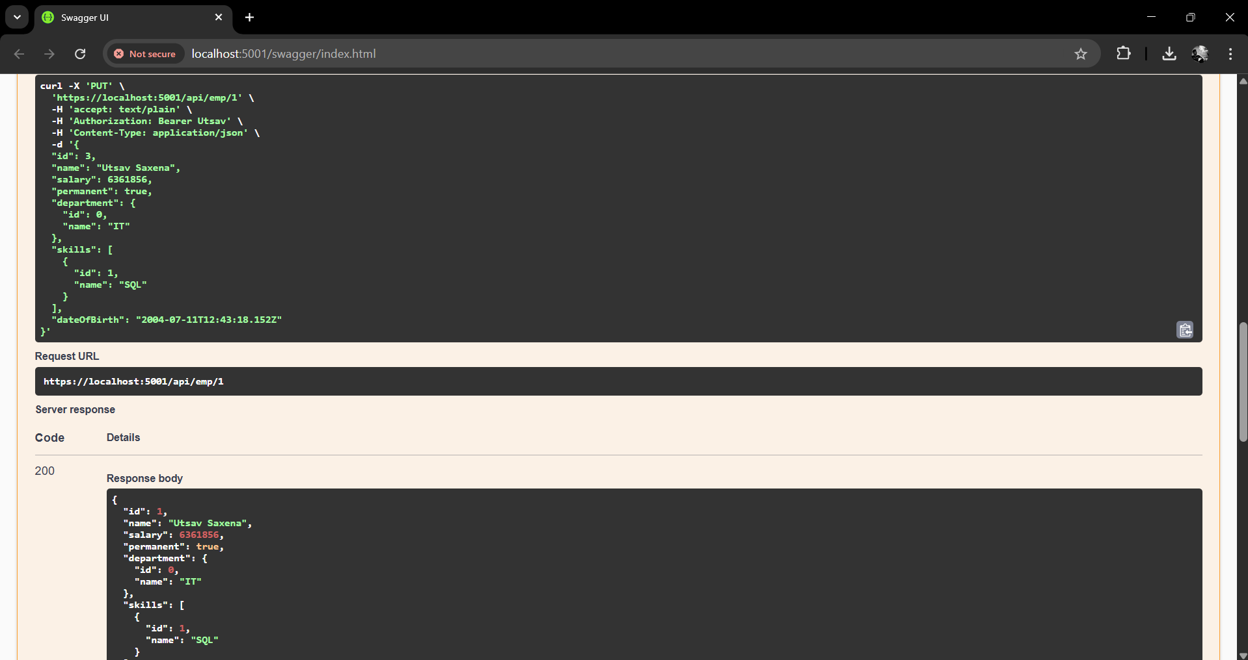

Module - 5.WebApi HandsOn

Question 1:JsonWebToken

CODE

/program.cs
using Microsoft.AspNetCore.Authentication.JwtBearer;
using Microsoft.IdentityModel.Tokens;
using System.Text;
string securityKey = "mysuperdupersecret";
var symmetricSecurityKey = new SymmetricSecurityKey(Encoding.UTF8.GetBytes(securityKey));

builder.Services.AddAuthentication(x =>
{
x.DefaultAuthenticateScheme = JwtBearerDefaults.AuthenticationScheme;
x.DefaultChallengeScheme = JwtBearerDefaults.AuthenticationScheme;
})
.AddJwtBearer(x =>
{
x.TokenValidationParameters = new TokenValidationParameters
{
ValidateIssuer = true,
ValidateAudience = true,
ValidateLifetime = true,
ValidateIssuerSigningKey = true,
ValidIssuer = "mySystem",
ValidAudience = "myUsers",
IssuerSigningKey = symmetricSecurityKey
};
});

/Controllers/AuthCOntroller.cs
using Microsoft.AspNetCore.Mvc;
using Microsoft.IdentityModel.Tokens;
using System.IdentityModel.Tokens.Jwt;
using System.Security.Claims;
using System.Text;
namespace YourProject.Controllers
{
[ApiController]
[Route("api/auth")]
[AllowAnonymous]
public class AuthController : ControllerBase
{
[HttpGet("token")]
public IActionResult GetToken()
{
var token = GenerateJSONWebToken(101, "Admin");
return Ok(token);
}
private string GenerateJSONWebToken(int userId, string userRole)
{
var securityKey = new SymmetricSecurityKey(Encoding.UTF8.GetBytes("mysuperdupersecret"));
var credentials = new SigningCredentials(securityKey, SecurityAlgorithms.HmacSha256);
var claims = new List<Claim>
{
new Claim(ClaimTypes.Role, userRole),
new Claim("UserId", userId.ToString())
};
var token = new JwtSecurityToken(
issuer: "mySystem",
audience: "myUsers",
claims: claims,
expires: DateTime.Now.AddMinutes(2),
signingCredentials: credentials
);
return new JwtSecurityTokenHandler().WriteToken(token);
}
}
}

OUTPUT

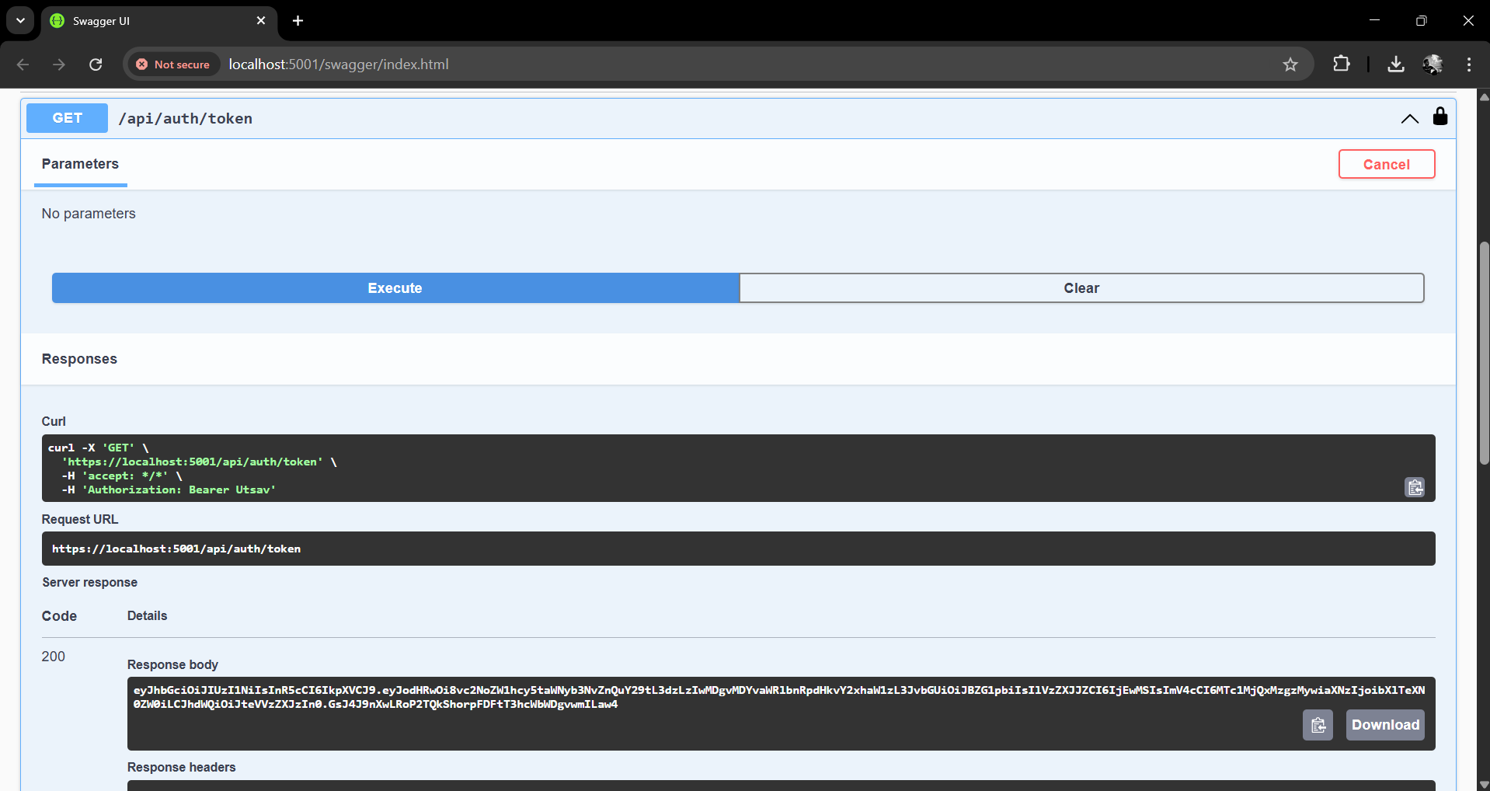

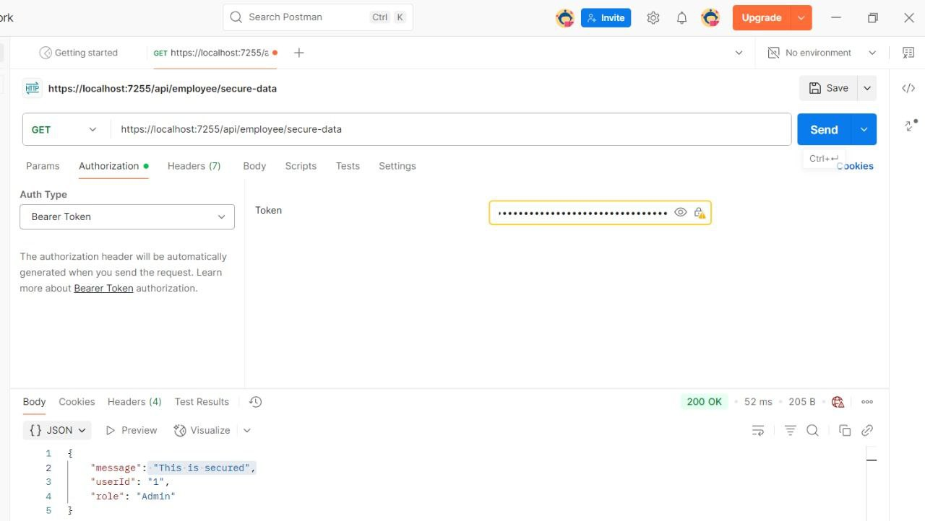

Question 2:Use the JWT generated thru the AuthController to be used in POSTMAN request.

OUTPUT

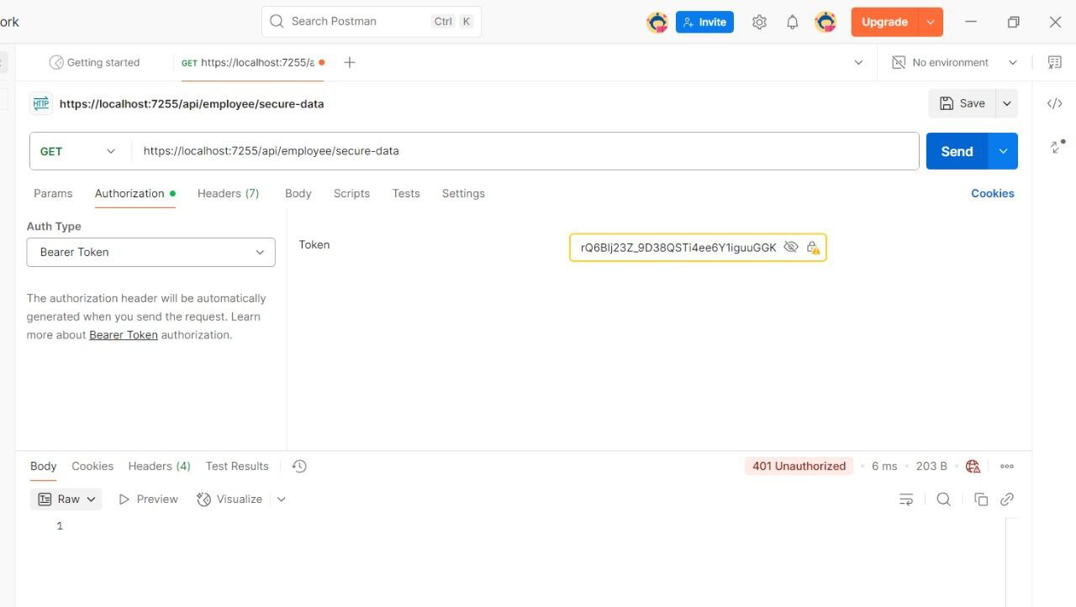

Question 3:Check for JWT expiration



***************

