# ABSTRACT

The “front-end languages” live in the browser. After you type an address into the address bar at the top and hit the enter/return key, my browser will receive at least an HTML file from the web server. That file will likely tell the browser to request a CSS file and a JavaScript file as well (probably many more than one, but we’ll keep it simple).

Each of these languages performs a separate but very important function and they work harmoniously together to determine how the web page is STRUCTURED (HTML), how it LOOKS (CSS), and how it FUNCTIONS (JavaScript). And keep in mind that my browser handles figuring out how to make these files into a functioning web page (not the server).

Front-end web development is NOT design (you won’t be playing around in Photoshop or anything), but a front-end developer does apply the work of designers to the web page by translating their well designed layouts into real code. The front-end developer stands between the designer on one end and the backend developer on the other, translating the design into code and plugging the data from the back-end developer into the right spots. He or she must also handle all the possible interactions that the user may need to make with the page.

In the following lessons, you’ll get a healthy understanding of each of the three front-end languages (the most popular JavaScript library). To get warmed up, we’ll start at a high level.

**Table of Contents**

**Contents**

* Certificate
* Declaration
* Acknowledgement
* Abstract

1. INTRODUCTION
   1. Motivation
   2. Problem Statement
   3. Objectives
2. COMPONENTS
   1. HTML
   2. CSS
   3. JavaScript
   4. jQuery
   5. PHP
   6. MySql
3. SYSTEM REQUIREMENTS
   1. Hardware Requirements
   2. Software Specifications
4. IMPLEMENTATION
   1. Source Code

4.1 Snapshots/ Output

1. FUTURE SCOPE
2. REFERENCES

# 1. INTRODUCTION

“India restaurant” is a restaurant located in Matara. They are handling food ordering process and daily routine of their restaurant manually. Customers cannot order food online in this hotel. In case of take away food or dining there, customer have to visit or call and order. Table reservation is also the same. This project is based on automating the above mentioned processes.

The problem that many businesses face today is to make sure that they attract new customers and also they keep their existing customers.

The cost to attract a new customer is costlier than retaining the old customer. Therefore, there is an argument that for a business, existing customer is worthier than a new customer. In this industry, a customer is likely to return to the restaurant in the future if they received an excellent customer service as well as appetizing food. However, if they had to wait for an unreasonable amount of time or there was a mistake in the order, it’s very unlikely the customer would return.

## 1.1 Motivation

The motivation of this project comes with observing their difficulties in busy situation while I was there as I usually visit the place to order food. Personally, I don’t have much time to wait in long queues. This restaurant is also very crowded during the lunch and dinner time. Although this restaurant is not very large the have to provide quality service to enormous number of customers. Without a system it is very difficult. Other than that, I value learning web designing and development because I have less experience in this area and it will helpful in future for my carrier.

New expectation is there for this project due to the past pandemic situation in the country Covid-19 virus. This kind of solution will help to make the restaurant less crowded.

## 1.2 Problem Statement

“India Restaurant” is a food store located in Matara. Their process is currently manual and time consuming. Customer cannot order food online, before they visit the restaurant. They have to visit the restaurant and place the order. Then they have to wait until the order is ready.

There is no visual confirmation that the order was placed correctly. Customers cannot ensure about the correctness of their order. Order customization is also difficult because it takes more time. Table reservation is also difficult. This restaurant is very busy in the morning and evening after 6 pm because the restaurant is located in a very attractive place, near Godagama expressway interchange. Therefore, the restaurant is always full. Currently customers have to come to the restaurant to reserve a table. Sometimes customers have to wait long time to reserve a table during busy times. Also, very long queues are there. It is difficult for the cashier to handle such a situation. On the other hand, this situation is difficult for the kitchen also. They are receiving orders one by one. Sometimes kitchen is receiving same food item within separate orders in same time. So kitchen has to make them separately. This is time consuming and inefficient costly method. It is better if the orders for same kind of food are grouped. It will help them to save time and attend to the next order quickly. At the end of the day, taking a summery is also difficult because there are so many orders and they are not recorded properly. This happens because they are not keep records properly. Taking this summary is important because they can review what the fast moving items are and what items are not ordered frequently. Sometimes customers do valuable suggestions. Usually staff is listening to them and try to do the improvements. But they are not keeping records of those suggestions and they may forget them at the end of the day. It is not good for the restaurant because it will break the trust of the customer and missing the opportunity for the improvement.

Currently, this restaurant uses least efficient methods such as paper-based or verbal method to communicate between the restaurant and kitchen. Even though this approach is implemented in successful profitable restaurants, there are several problems which could be seen as reducing the restaurant’s efficiency that can be identified using above scenario:

Sometimes handwriting can lead to miscommunication.

* Order logging is unmanageable.
* Inefficient restaurant-kitchen communication.
* Difficult order tracking and time management.
* Difficult stock management.
* Limited statistical output.

Online system that proposed here will simplify the ordering process and it will be helpful to both restaurant and customer. The proposed system will be developed with interactive menus, pop-up messages etc. for the easiness of the user. Customer can select the required food item with available customizations and the can change the order at any time before checking out online. If order is confirmed, it will display a pop-up message as confirmation to the customer. When the order is placed it’s recorded in the database and retrieved in real time manner. Through this option Restaurant Employees are allowed to quickly go through the orders which they have received. Therefore, they can process all orders efficiently and effectively with minimal delays and confusion.

## 1.3 Objectives

Maximizing the profit is one of main objectives of any business. This can achieve by increasing efficiency and decreasing overheads without compromising customer satisfaction. Through better application of daily operations restaurant can increase the efficiency and can offer improved services to the customers. Because almost all processes are manual and time consuming, all the processes should be automated.

The Main Objective: To build a web based restaurant management system for

“India Restaurant” Restaurant.

In order to fulfill the main objective following goals have to be achieved.

* Improve customer relationship management

Proposed system enables visual confirmation to the customers that the order was placed correctly and will decrease difficulties. When the order is ready, kitchen can update the food order status as ready. Same time, customer and the cashier will be notified. This will reduce miscommunication and workload of the cashier.

Reducing waiting time of the customer will improve the customer satisfaction. ➢ Avoid long queues

This solution will help to increase the efficiency of restaurant’s staff. It eliminates paper work and increase level of accuracy. Staff can handle more customers in little time because web based solution can improve speed of service, sales volume and customer satisfaction. 4

* Bulk Processing
* Order retrieval is simple and kitchen can see the order as bulks. Then kitchen can process more orders because they can complete several same type of orders at the same time.
* Customer feedback

Customers can give feedback which is very valuable for improvements of the restaurant.

* Stock Control

All the kitchen ingredient stock levels can be maintained through the system.

Proposed system will facilitate restaurant to maintain kitchen stock.

* Menu item management.

Kitchen can maintain possible meals and can update which item cannot be provided in relevant day.

* Discounts

Providing special discounts and promotions. They can assign,” Item of the Day” for special discount. System can identify whether the customer is new customer or regular customer. For the regular customer, system can provide special discounts.

Increase the customer satisfaction and make them retain with the restaurant.

# 2. COMPONENTS

**2.1 HTML: THE KEY FRONT-END TECHNOLOGY**

HTML is the standard markup language for making Site pages. HTML represents Hypertext Markup Language. It depicts the structure of Site pages utilizing markup. HTML components are the structure blocks of HTML pages. Its components are spoken to by labels. Its labels mark bits of substance, for example, "heading", "section", "table, etc.

HTML stands for Hyper Text Markup language. It is a standardized system for creating web pages. HTML creates the structure of a web page and uses “tags” to mark up a web page.

**Why do we use HTML?**

HTML code ensures the proper formatting of text and images so that your Internet browser may display them as they are intended to look. Without HTML, a browser would not know how to display text as elements or load images or other elements. HTML also provides a basic structure of the page, upon which Cascading Style Sheets are overlaid to change its appearance. One could think of HTML as the bones (structure) of a web page, and CSS as its skin (appearance).

**HTML5**

* Released in 2024
* It has added such features as offline media storage supports
* More precious content elements.

**2.2 CSS: STYLING YOUR FAÇADE**

Untruth proposed the idea of Falling Templates (CSS) in 1994 while with the W3C. CSS represents Falling Templates. CSS portrays how HTML components are to be shown on the screen, paper, or in other media. It spares a great deal of work. It can control the format of numerous website pages at the same time.

**2.3. JAVASCRIPT: MAKING THE WEB ALIVE**

JavaScript (JS) is one of the most popular scripting languages. It’s mostly renowned for providing a full stack of technologies for both front-end and backend development. As we talking about the first one, it’s applied to make pages dynamic **2.4. JQUERY:**

jQuery is a lightweight, "write less, do more", JavaScript library. The purpose of jQuery is to make it much easier to use JavaScript on your website. jQuery takes a lot of common tasks that require many lines of JavaScript code to accomplish, and wraps them into methods that you can call with a single line of code.

* 1. **PHP:**

The term PHP is an acronym for– Hypertext Preprocessor. PHP is a server-side scripting language designed specifically for web development. It is open-source which means it is free to download and use. It is very simple to learn and use.

The file extension of PHP is “.php”.

* 1. **MYSQL:**

MySQL is anopen-source, Relational Database Management System that stores data in a structured format using rows and columns. It’s software that enables users to create, manage, and manipulate databases. Developed by MySQL AB, which is now owned by Oracle Corporation, MySQL is renowned for its reliability, scalability, and ease of use.

# 3. SYSTEM REQUIREMENTS

**3.1 Hardware Requirements**

* **Processor:** 1 GHz; Recommended 2GHz or more, Intel® core™ Lenovo AMD-E2 CPU.
* **Hard Disk Size**: 32 GB approx.
* **RAM:** 4GB Minimum.

## 3.2 Software Specifications

* **Operating system:** windows 10
* **Front End:** VS code, Sublime text editor, search engine.
* **Server:** Window Server R2 – AMD.
* **Backend:** PHP, MySql
* **Programming languages:** HTML, CSS, JavaScript, jQuery, Bootstrap.

|  |
| --- |
| 1. **IMPLEMENTATIONS**     **4.1 SOURCE CODE**  **main.js**  $(document).ready(function ($) {  "use strict";    var book_table = new Swiper(".book-table-img-slider", { slidesPerView: 1, spaceBetween: 20, loop: true, autoplay: { delay: 3000, disableOnInteraction: false,  }, speed: 2000, effect: "coverflow", coverflowEffect: { rotate: 3, stretch: 2, depth: 100, modifier: 5,  slideShadows: false,  }, loopAdditionSlides: true, navigation: { nextEl: ".swiper-button-next", prevEl: ".swiper-button-prev",  }, pagination: {  el: ".swiper-pagination", clickable: true,  },  });  var team_slider = new Swiper(".team-slider", { slidesPerView: 3, spaceBetween: 30, loop: true, autoplay: { delay: 3000, disableOnInteraction: false,  },  speed: 2000,    navigation: {  16 |

|  |
| --- |
| nextEl: ".swiper-button-next", prevEl: ".swiper-button-prev",  }, pagination: { el: ".swiper-pagination", clickable: true,  }, breakpoints: { 0: { slidesPerView: 1.2,  }, 768: { slidesPerView: 2,  }, 992: { slidesPerView: 3,  }, 1200: { slidesPerView: 3,  },  },  }); jQuery(".filters").on("click", function () { jQuery("#menu-dish").removeClass("bydefault_show");  });  $(function () { var filterList = { init: function () {  $("#menu-dish").mixItUp({ selectors: { target: ".dish-box-wp", filter: ".filter",  }, animation: { effects: "fade", easing: "ease-in-out",  }, load: { filter: ".all, .breakfast, .lunch, .dinner",  },  });  }, }; filterList.init();  });  jQuery(".menu-toggle").click(function () {  17 |

|  |
| --- |
| jQuery(".main-navigation").toggleClass("toggled"); }); jQuery(".header-menu ul li a").click(function () { jQuery(".main-navigation").removeClass("toggled"); }); gsap.registerPlugin(ScrollTrigger);    var elementFirst = document.querySelector('.site-header'); ScrollTrigger.create({ trigger: "body", start: "30px top", end: "bottom bottom",  onEnter: () => myFunction(), onLeaveBack: () => myFunction(),  }); function myFunction() { elementFirst.classList.toggle('sticky_head'); } var scene = $(".js-parallax-scene").get(0); var parallaxInstance = new Parallax(scene);  });  jQuery(window).on('load', function () {  $('body').removeClass('body-fixed');  //activating tab of filter  let targets = document.querySelectorAll(".filter"); let activeTab = 0; let old = 0; let dur = 0.4; let animation;  for (let i = 0; i < targets.length; i++) { targets[i].index = i;  targets[i].addEventListener("click", moveBar); }    // initial position on first === All gsap.set(".filter-active", { x: targets[0].offsetLeft, width: targets[0].offsetWidth  18 |

|  |
| --- |
| }); function moveBar() { if (this.index != activeTab) { if (animation && animation.isActive()) { animation.progress(1);  } animation = gsap.timeline({ defaults: { duration: 0.4  } }); old = activeTab; activeTab = this.index; animation.to(".filter-active", { x: targets[activeTab].offsetLeft, width: targets[activeTab].offsetWidth });  animation.to(targets[old], { color: "#0d0d25", ease: "none" }, 0); animation.to(targets[activeTab], { color: "#fff", ease: "none" }, 0);    }    } });                    19 |

**4.2 SNAPSHOT/ OUTPUT**

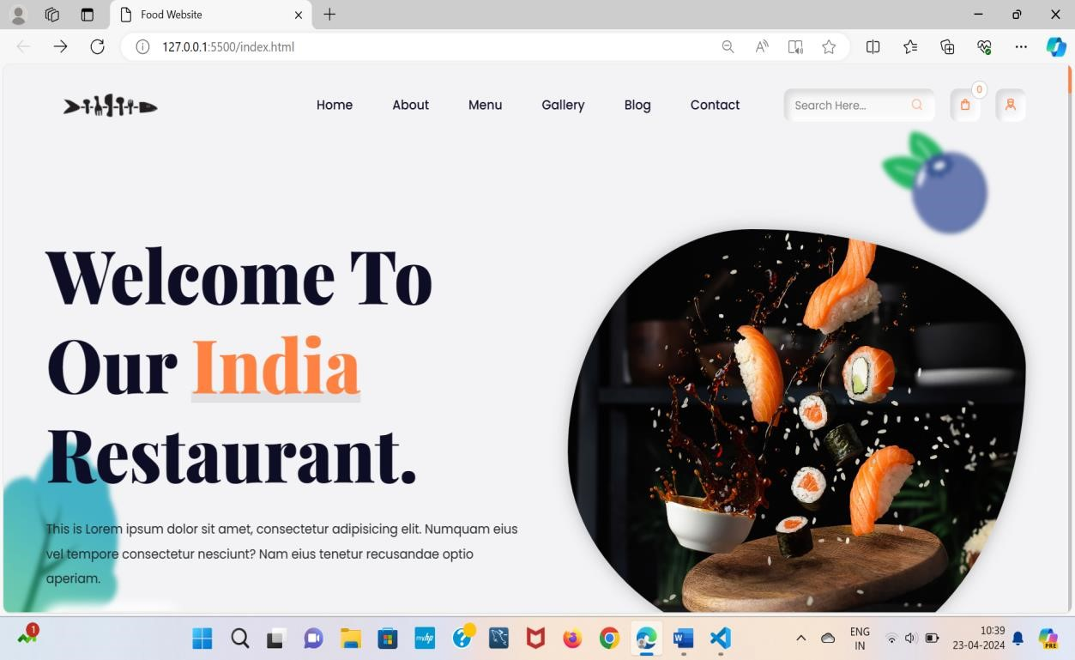

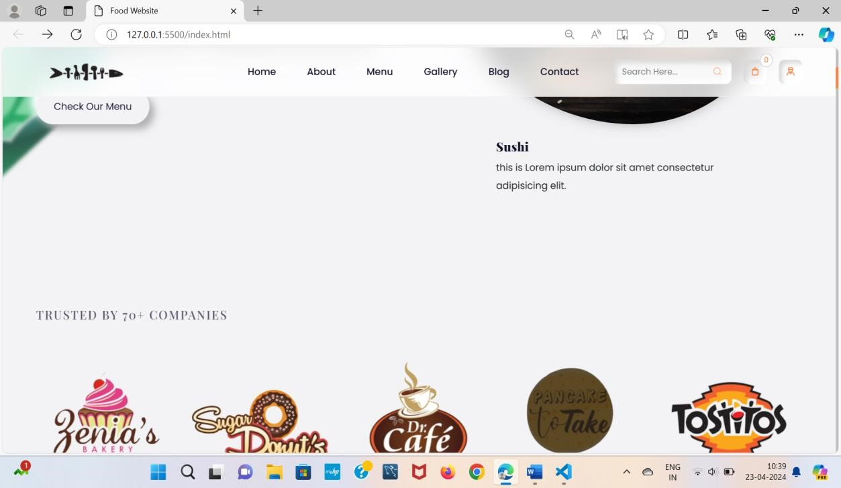

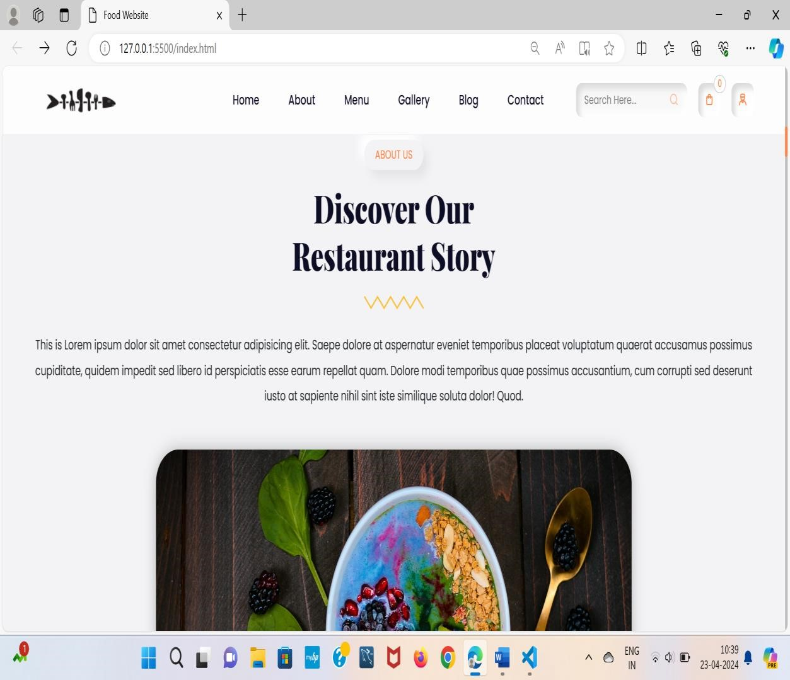

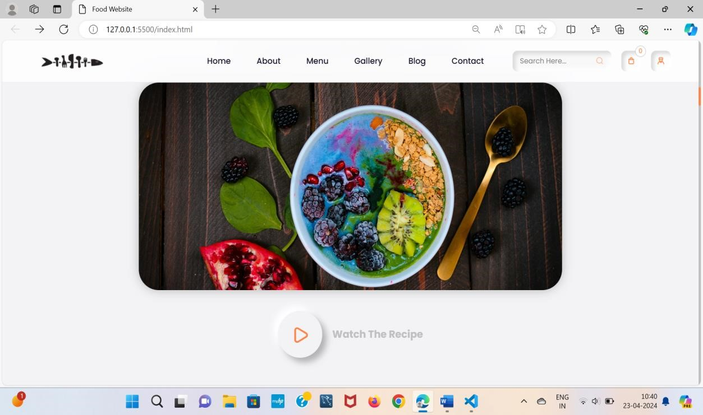

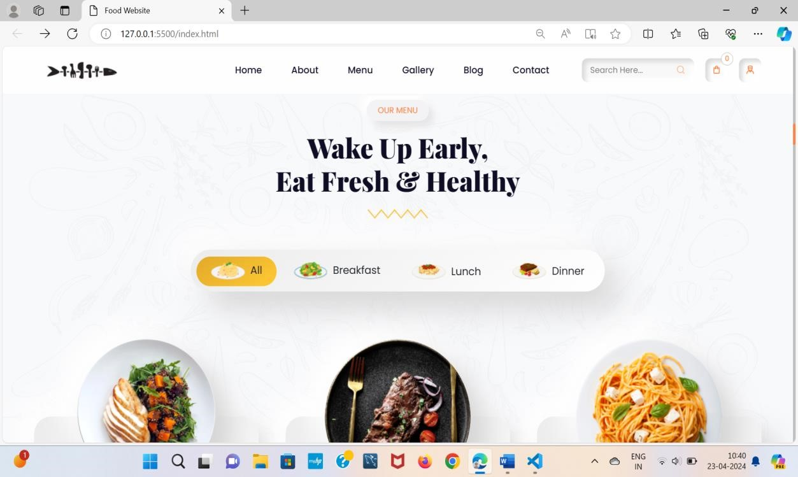

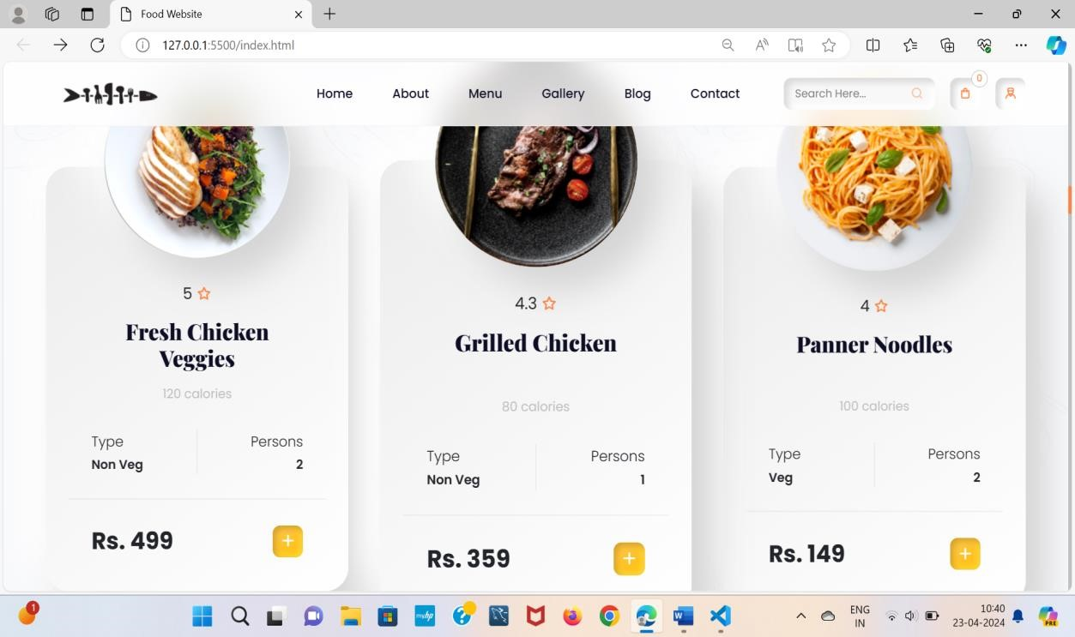

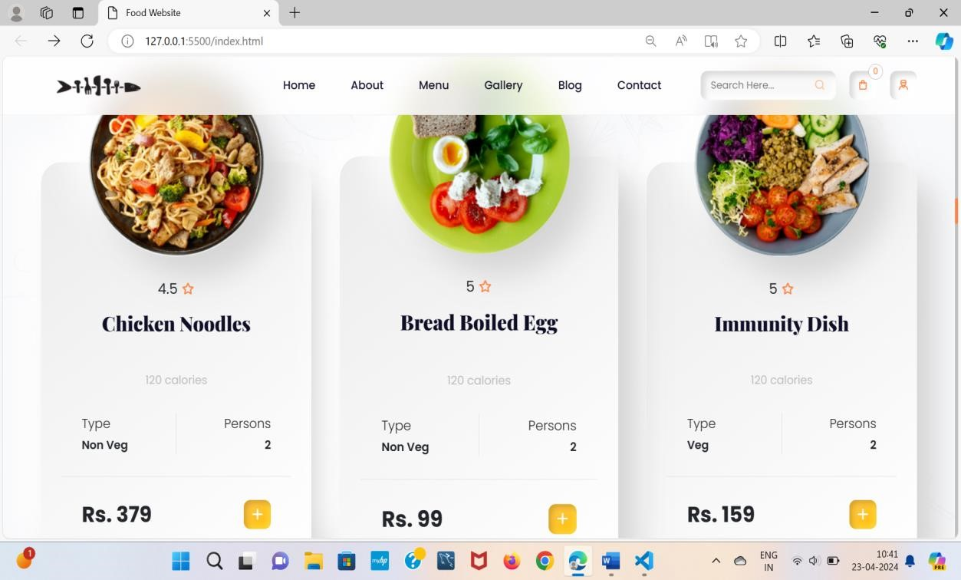

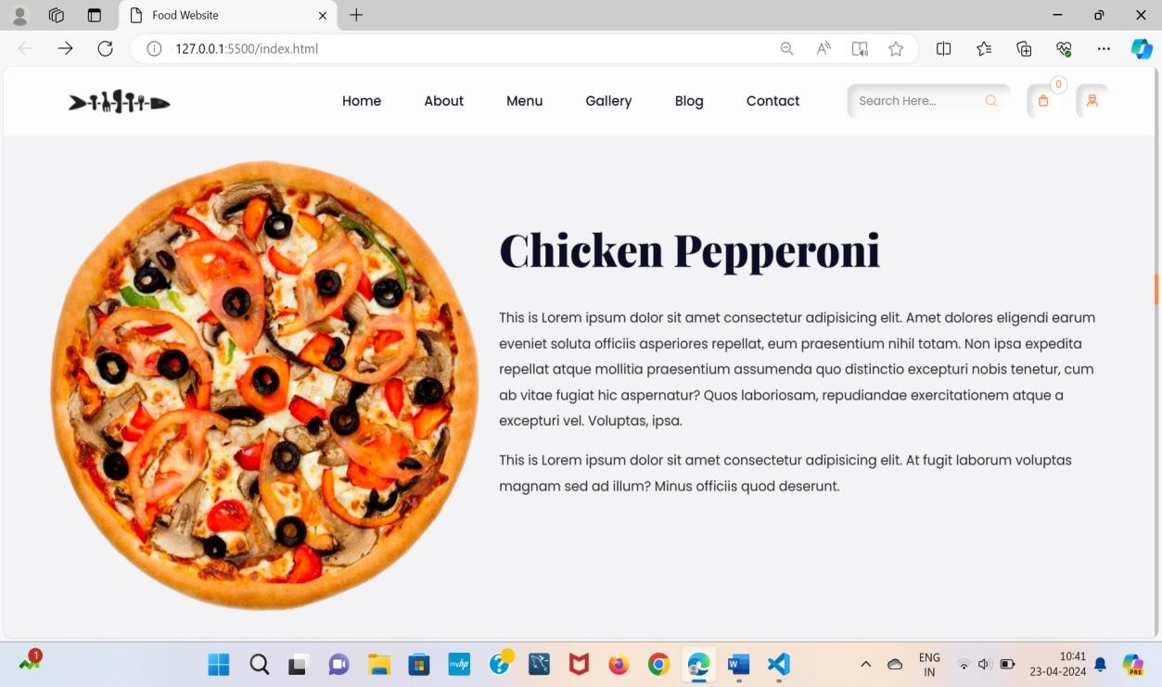

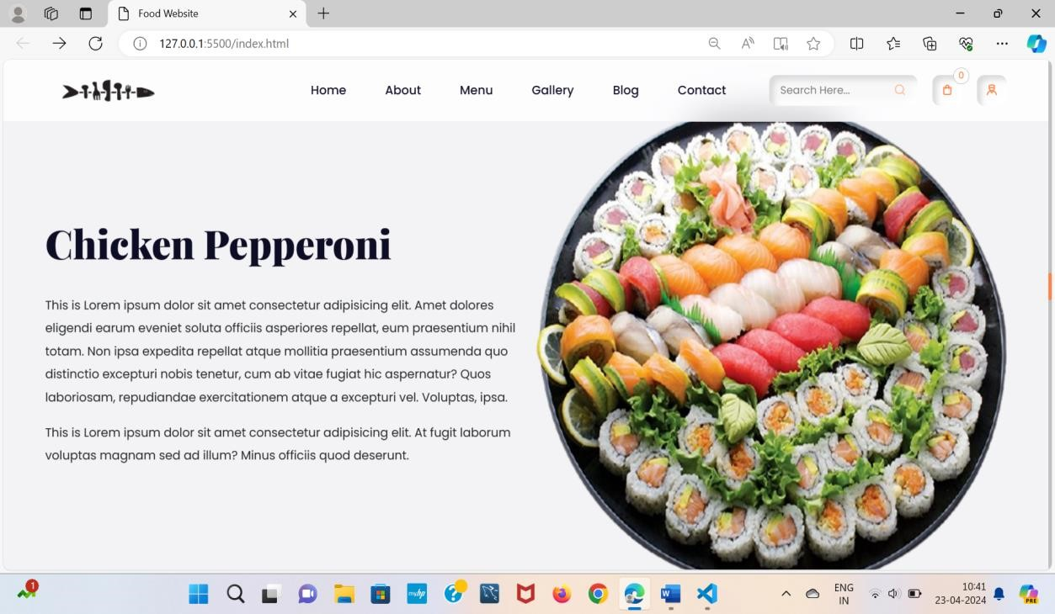

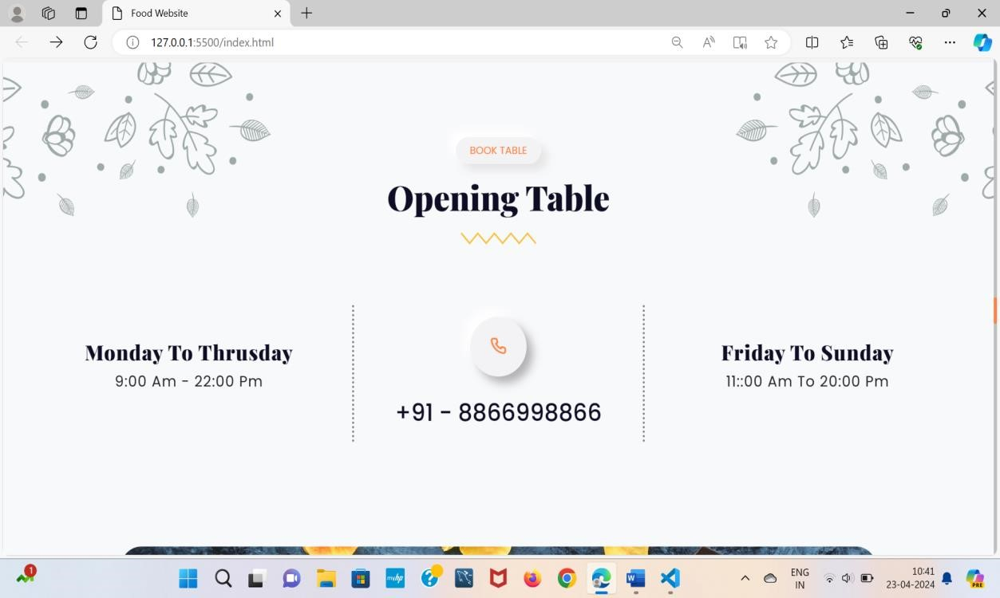

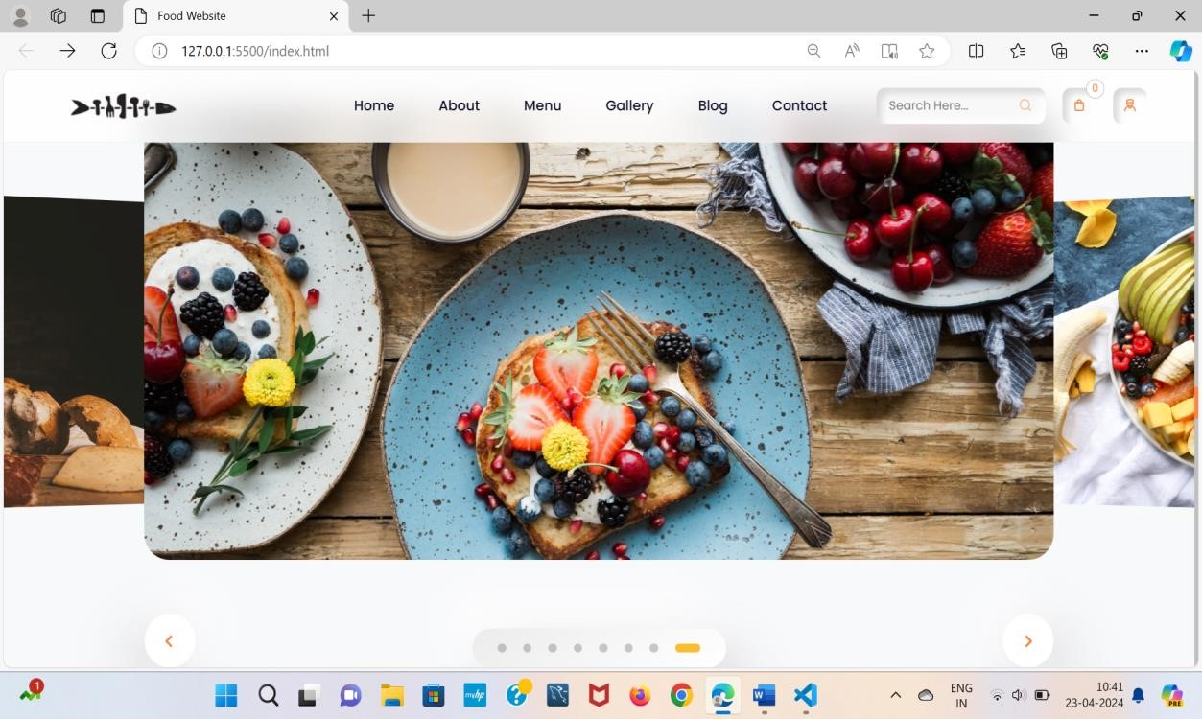

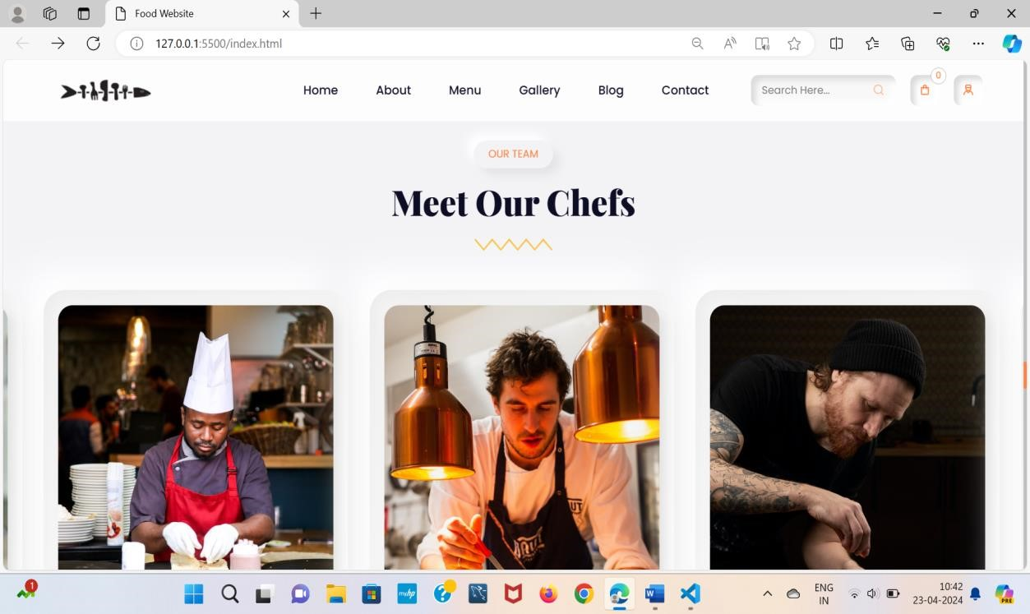

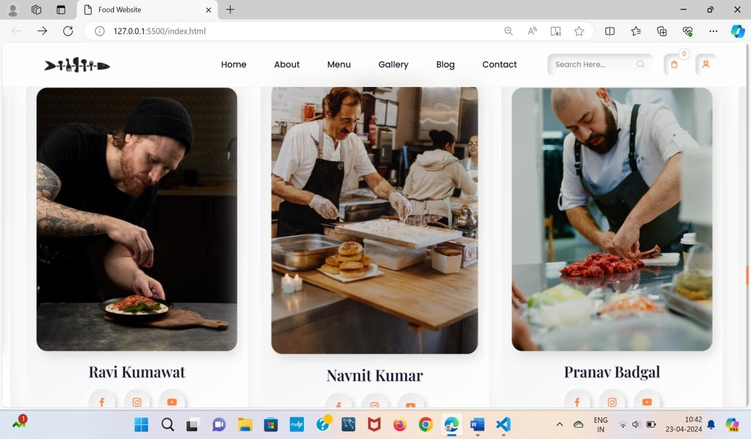

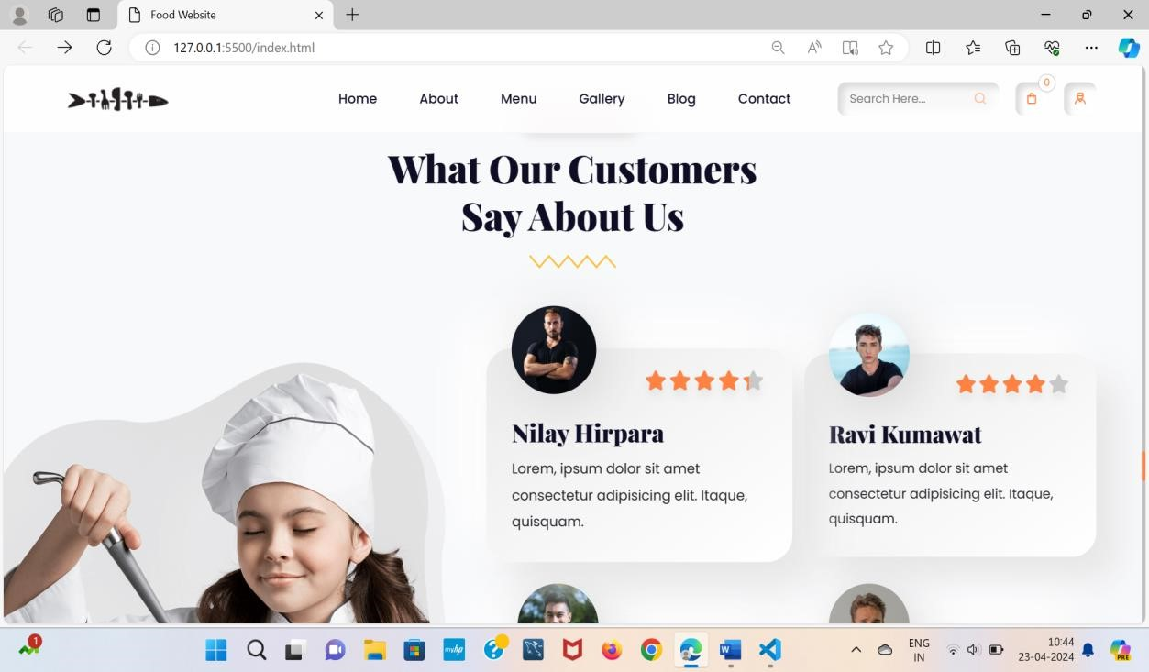

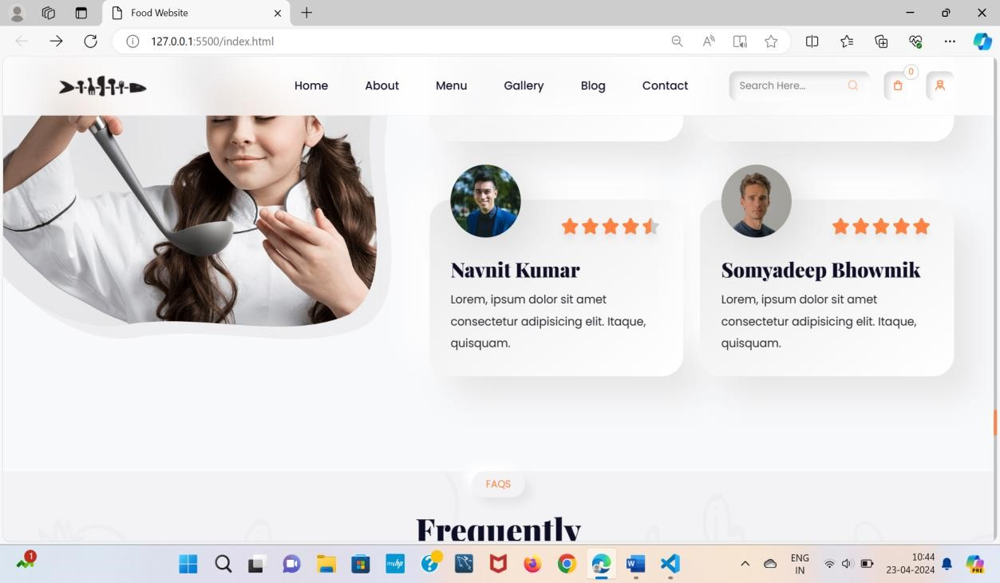

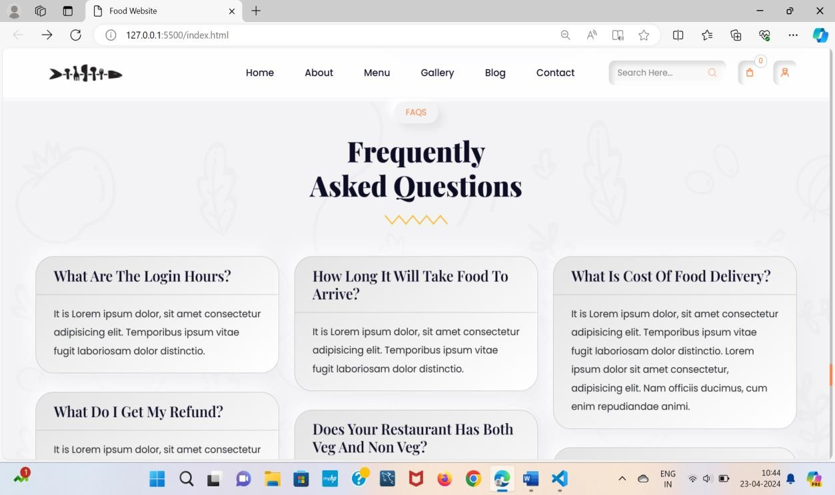

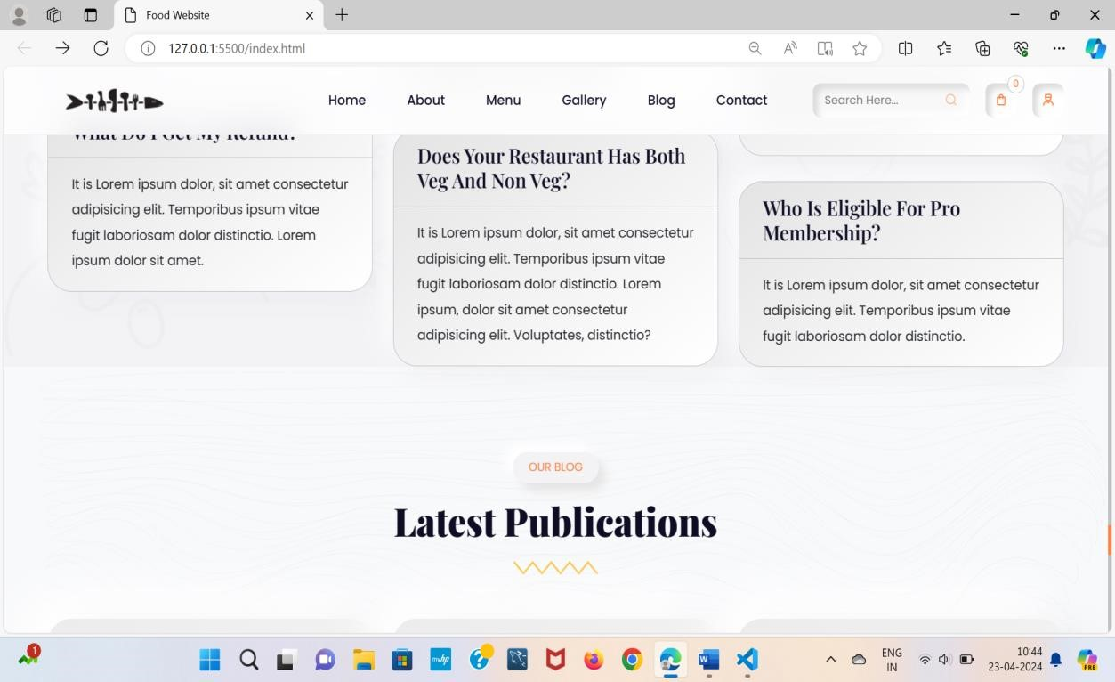

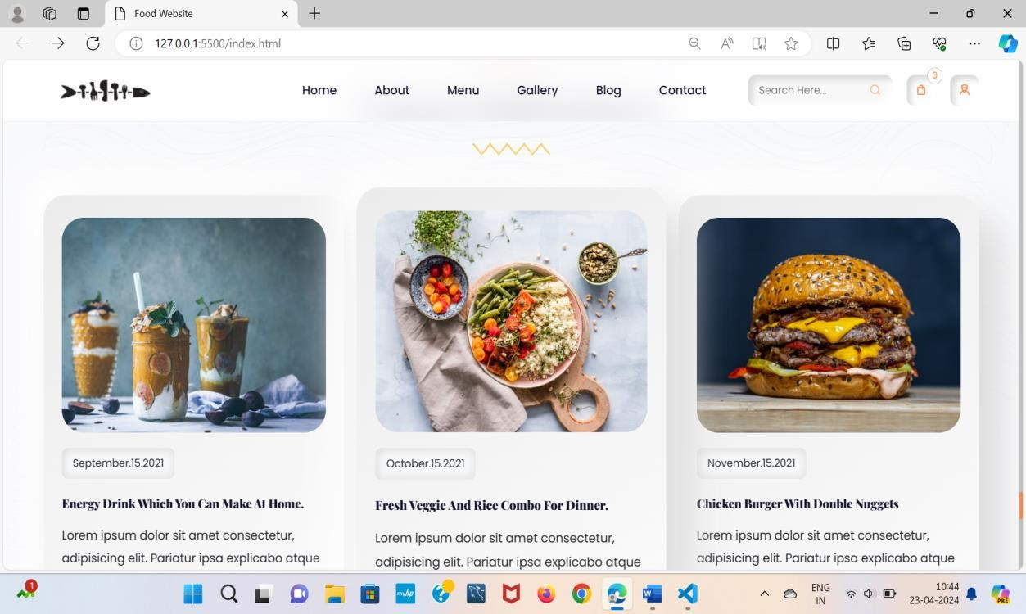

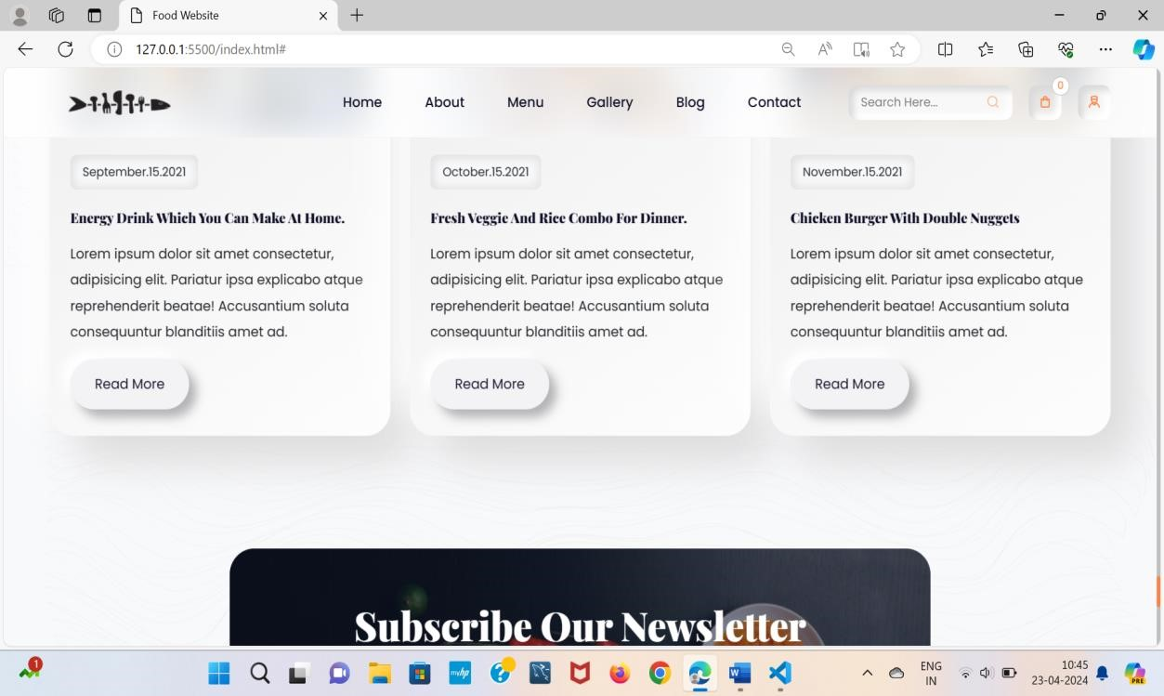

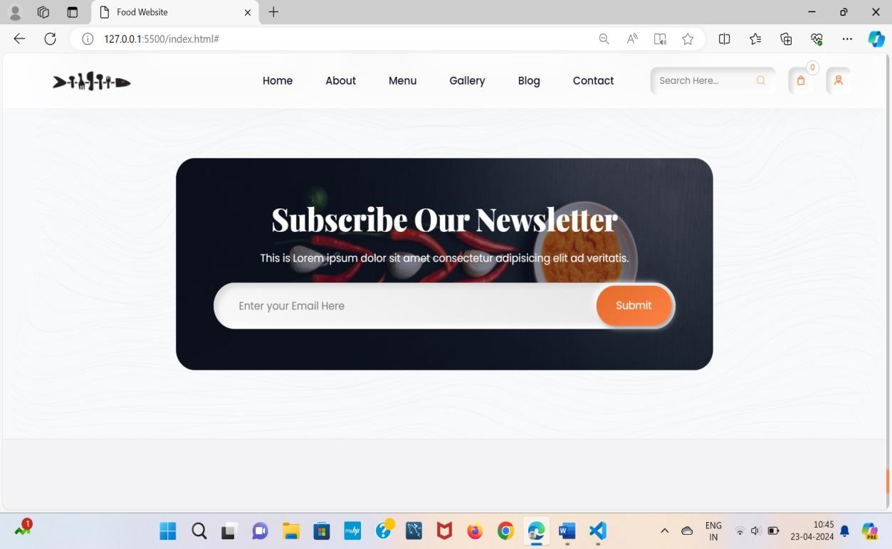

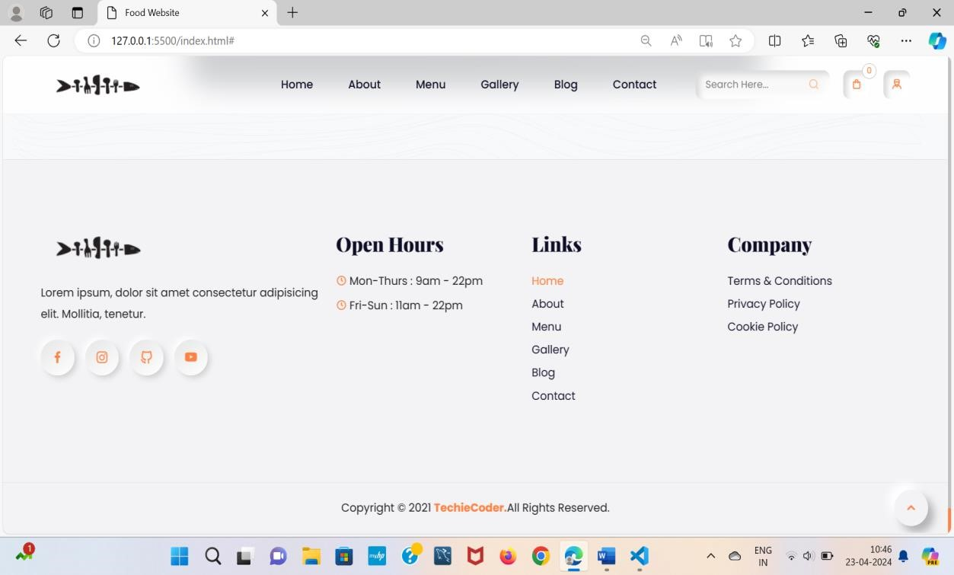

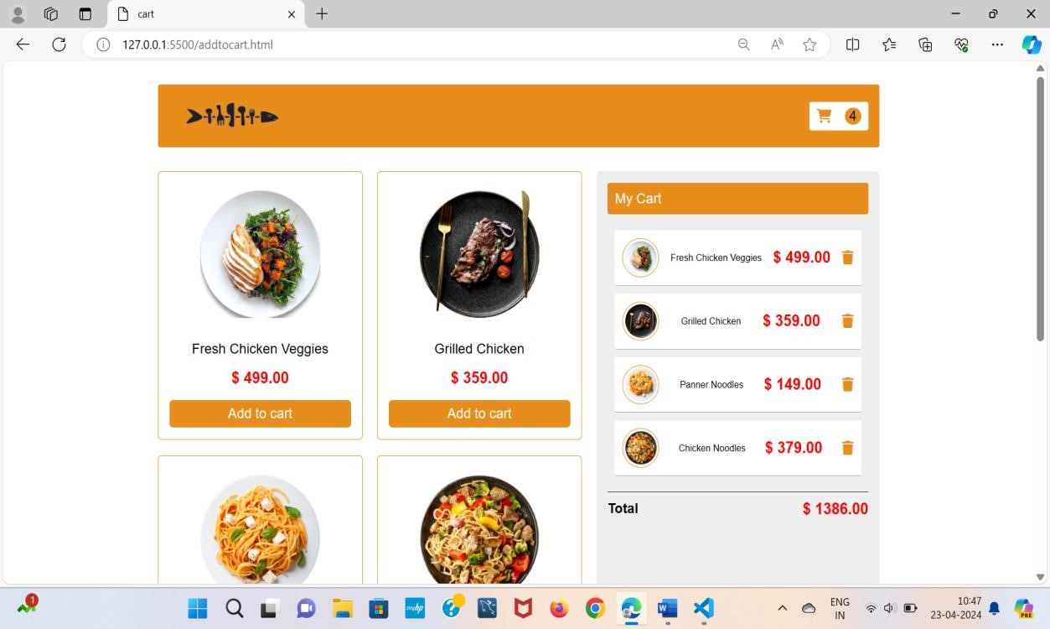

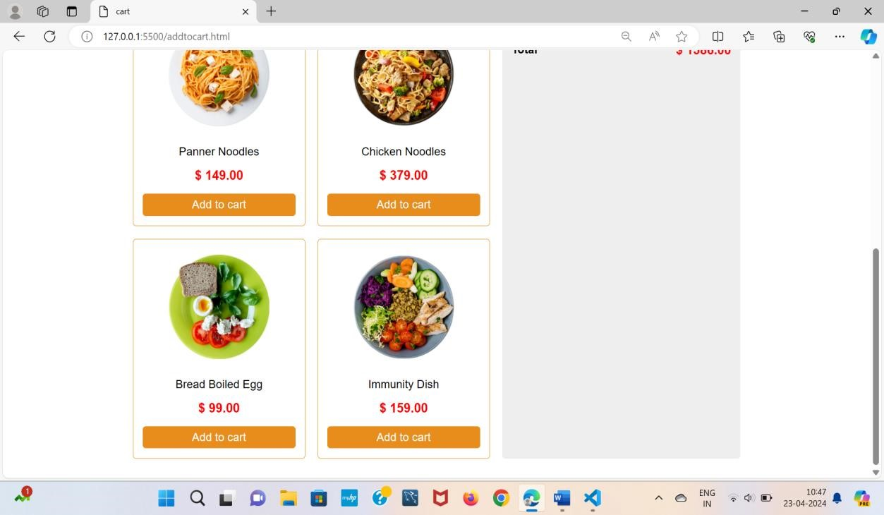

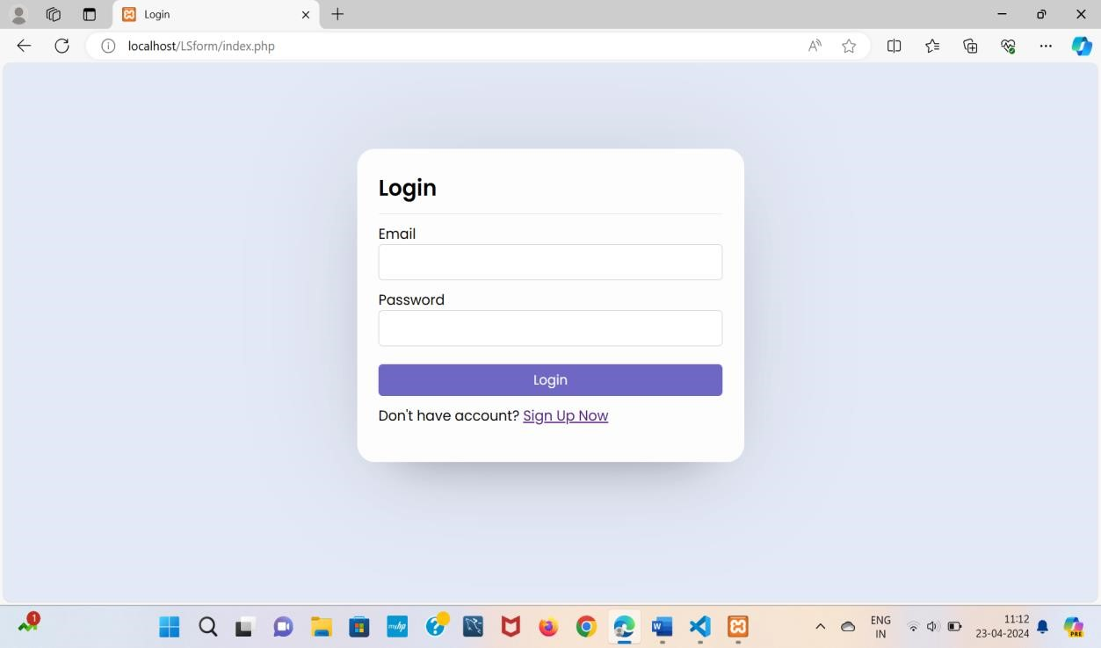

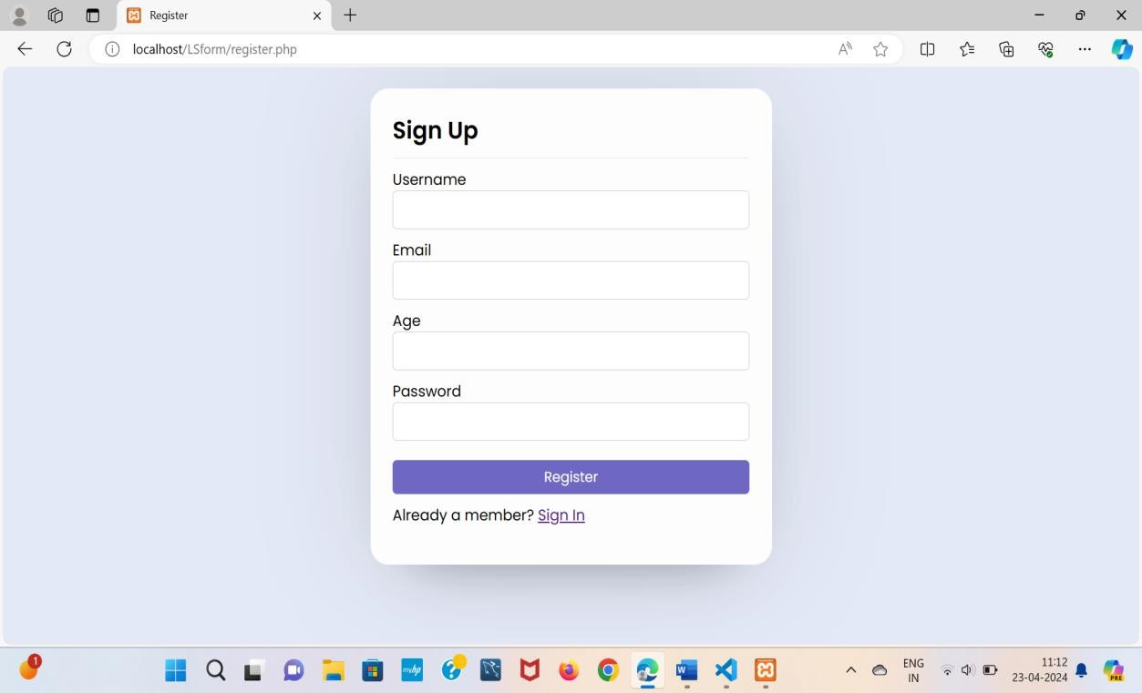

# 5. FUTURE SCOPE

Proposed system is valuable for both customer and the restaurant because it is simplifying the order processing process.

Customers have to create an account with valid phone number or email and can log-in to the system. The web page has up-to-date and interactive menu with all the available food items. When customer made a selection, items added to their order. Customer can review order at any time and change the selection before the payment. Online payment and cash on the collecting counter is possible. Confirmation is prompt to the customer. If it is required, customers can check the table availability and make a table reservation if necessary. Proposed system is not handling delivering food, due to restaurant is not having delivery team. After a customer placed an order, order details are visible to the kitchen. They can see what the quantity that is required from each item is and they can fulfill multiple orders with same food item in same time. This happens because proposed system can combine orders during allowed time period.

Stock of the ingredients should be always up to date. Otherwise, restaurant cannot fulfill the customer orders properly and may accept orders that cannot be fulfilled due to lack of ingredients. Real-time view of ingredient stock levels is very much important to so much necessary to any restaurant. Then only the meals with enough ingredient stock can be sold. The stock levels will be updated by the kitchen staff at the end of the day through the proposed system.

Restaurant should be able to control the menu items. This ensures that the customers can only order available food items. Only authorized employee can handle the menu. They can create and remove food categories, food items. When creating these categories and food items, employee can add photos and description also. Adding new food items also possible. Remove food items and change visibility of food items. Create and remove options of food items. They can edit und update prices of the food items. They can select “Food Item of the day” and allocate special discount to them.

# 6. REFERENCES

* www.google.com
* www.w3schools.com
* www.tutorialspoint.com
* www.geeksforgeeks.com
* www.codesandbox.io
* https://maxcdn.bootstrapcdn.com/bootstrap/3.4.1/css/bootstrap.min.css • https://fonts.googleapis.com/css?family=Raleway: 400,500,600