

Royal Education Society’s

**College of Computer Science and Information Technology, Latur.**

Affiliated to

**Swami Ramanand Teerth Marathwada University, Nanded.**

**A Project Report**

**on**

**Automobiles Management System**

Submitted for the award of degree of

|  |
| --- |
| **Bachelor of Computer Application** |

**By:**

(Times New Roman, Size14, Bold)

Full Name of Student Name1: Exam Seat No.

Full Name of Student Name2: Exam Seat No.

Full Name of Student Name3: Exam Seat No.

(Times New Roman, Size14)

In

Year: 2021 – 2022



**Royal Education Society’s**

###### COLLEGE OF COMPUTER SCIENCE AND INFORMATION TECHNOLOGY, LATUR.

###### CERTIFICATE

This is to certify that the project entitled **“<automobiles management system >”** has been carried out by <**Student Name1, Student Name2, Student Name3>**under my guidance in partial fulfillment of the degree i.e.<Bachelor or Master> of Computer <Application or Science> of SRTMU, Nanded during the academic year 2021-2022

|  |  |  |
| --- | --- | --- |
| Name of Guide  <Font Size 14, Times New Roman> |  | Name of Head of Department **HOD** |
| **Guide**  <Font Size 14, Times New Roman, Bold> |  |  |

###### ACKNOWLEDGEMENT

<Font size 18, Bold, Times New Roman, Uppercase>

<Font size 14, Times New Roman>

We would like to convey our gratitude to **Dr. N. S. Zulpe**, Principal of **College of Computer Science and Information Technology, Latur** who gave us necessary information and guidance for project.

We are grateful to **Swami Ramanand Teerth Marathwada University, Nanded** for giving an opportunity to deliver project.

We would like to thank Project In-Charge and Project Guide **<Name of project guide>**who guided us through doing these project development process, provided with invaluable advice, helped us in difficult periods and provided practical assistant for our project. Their willingness to motivate us contributed tremendously to the success of this project.

We would like to express our special thanks of gratitude to our Head of the Department of Computer Science **Dr. D. H. Mahamuni** who helped us a lot in finalizing this project.

Besides we would like to thank all staff members who helped us by giving advice and providing equipment which we needed.

Last but not in least we would like to thank all who helped and motivated us.

|  |
| --- |
| **With Sincere Thanks,**   1. **Full Name of Student with signature** 2. **Full Name of Student with signature** 3. **Full Name of Student with signature** |

**Index**

**Heading:**<Font Size 18, Times New Roman, Bold>

**Content:**<Font Size 16, Times New Roman >

|  |  |  |
| --- | --- | --- |
| **Sr. No.** | **Topic Name** | **Page No.** |
| **1** | **Abstract** |  |
| **2** | **Introduction:** |  |
|  | 2.1 Project Overview |  |
|  | 2.2 Project Plan(Gantt chart) |  |
| **3** | **Project Requirement:** |  |
|  | 3.1 Hardware Requirement |  |
|  | 3.2 Software Requirement |  |
|  | 3.3 Field Work |  |
|  | 3.4 Front End<IDE and Programming Lang.> |  |
|  | 3.5 Back End<Database> |  |
| **4** | **System Design:** |  |
|  | 4.1 Database Design (Tables Schema) |  |
|  | 4.2 E-R Diagram |  |
|  | 4.3 Data Flow Diagram (First Level) |  |
| **5** | **Designing:** |  |
| **6** | **Coding:** |  |
| **7** | **Future scope of project:** |  |
| **8** | **Conclusion:** |  |
| **9** | **Bibliography:** |  |
|  | 9.1 Book(s)<Use MLA referencing style> |  |
|  | 9.2 Website(s)<Use Full URL web references> |  |

**Abstract :**

Automobile system deals with the purchase and sales of the good and maintains the stock. It contains various forms and reports with different function. It has the menus created for different forms and reports. When you click the menu. It opens the related forms about the customer, vendor. Items and Transaction.

**Introduction of the Project:**

This is a software which can be used by automobile center for keeping the records of items which is to be transacted for purchase and sell. It helps to keep a record of all the transactions and a password login is created for security. In proposed system we do not have to maintain everything manually. Thought this system if any transaction occurs it is corresponding entries is done automatically because database management system gives facility of having relationship between the table. In proposed system we do not have to maintain different accounting books.

**Advantages of proposed System**

* Easy to generate report for any transaction.
* It is very much faster than manual system.
* Easy and fastest record finding technique.
* It is very much flexible to work.
* Man power required is very less.
* Data can be stored for a longer period.

**Objectives of the project**

* Easy to generate report for any transaction.
* It is very much faster than manual system.
* Easy and fastest record finding technique.
* It is very much flexible to work.
* Man power required is very less.
* Data can be stored for a longer record.

**Project Modules:**

These are the main modules of the project:

Delivery Module: We can create, read, update and delete Delivery from this module

Automobiles Module: All the operations related to Automobiles, is managed by this module

Charges Module: Charges Module is used to manage the Charges Payment Module: It has been developed for managing the Payment

• Customers Module: It manages the Customers

# Project Requirements:

**Hardware Requirements:**

1. Processor : p4 and above
2. RAM: 512 MB and above
3. Hard Disk :160 GB or above
4. Input device : keyboard , Mouse
5. Output device : Monitor or LCD/LED ,Printer

**Software Requirement:**

•Frontend-IDE: visual studio 2010 .

•Language: C# .

•Frame work: DOT NET 4.5

•Backend-Database : My SQL Server 2008

**Fieldwork:**

•We visited to XYZ College and COCSIT, Latur for information Gathering and to know how admission system works properly.

•We collect samples of admission form, prospectus, admission

**System Design**

**Database design**



**E-R Diagram**

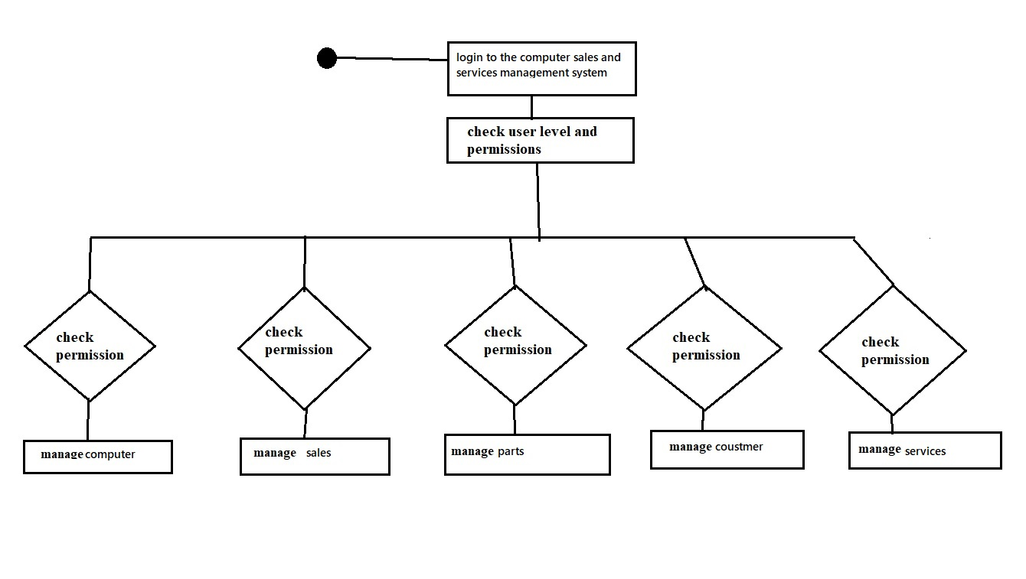

**DFD Diagram**

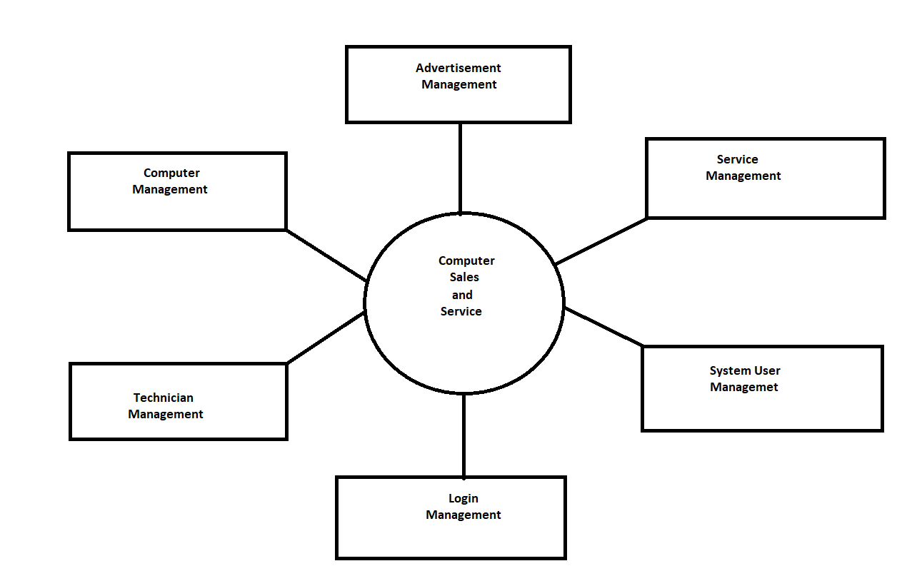

**Designing:**

**Login form:**

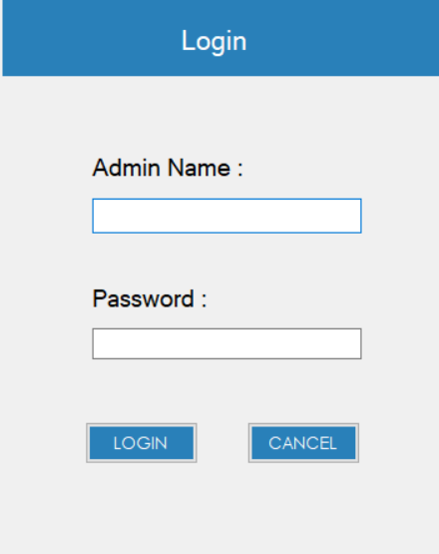

**Main menu form:**

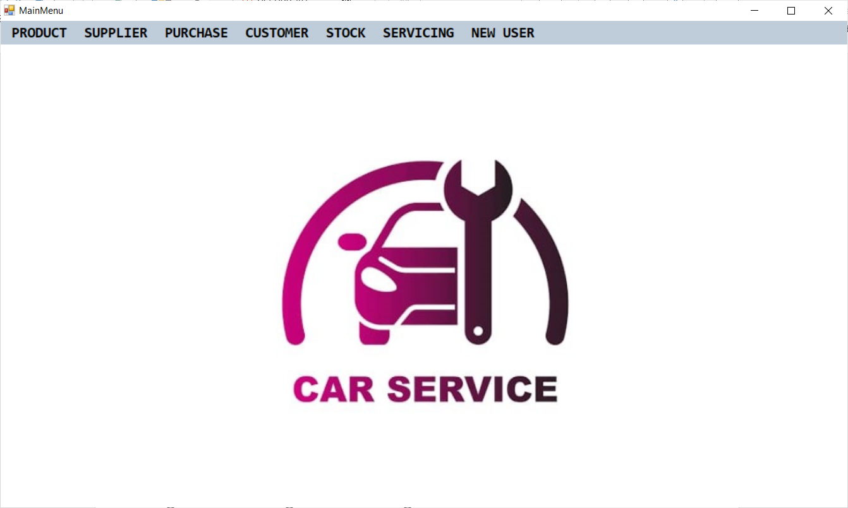

**Product:**

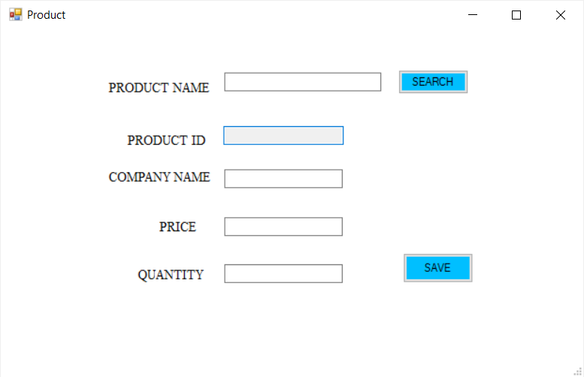

**Supplier:**

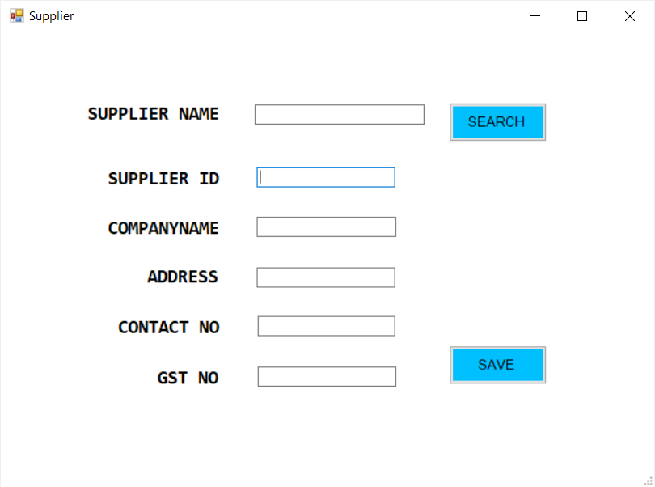

**Supplier Payment :**

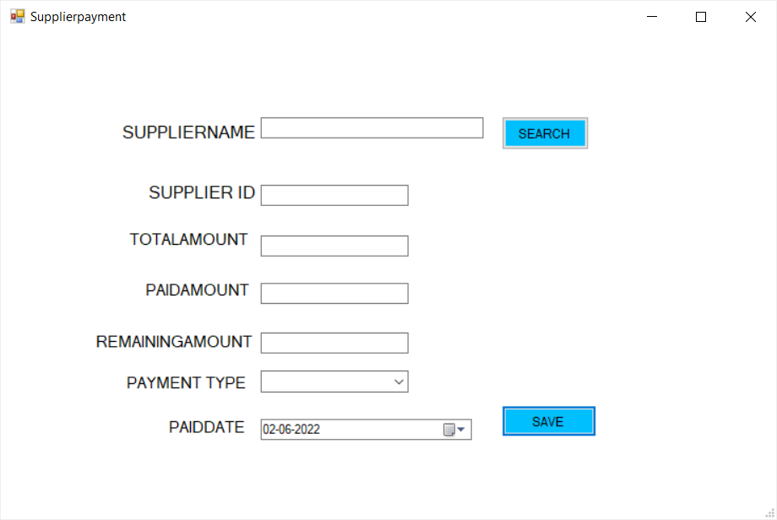

**Supplier wise Payment Details:**

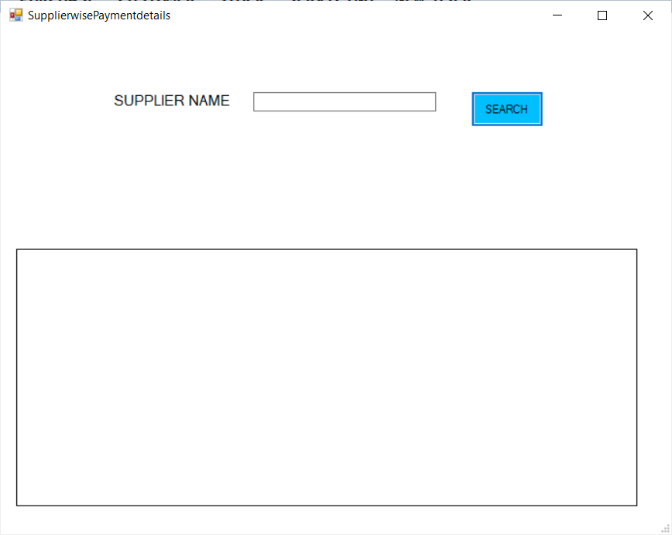

**Purchase:**

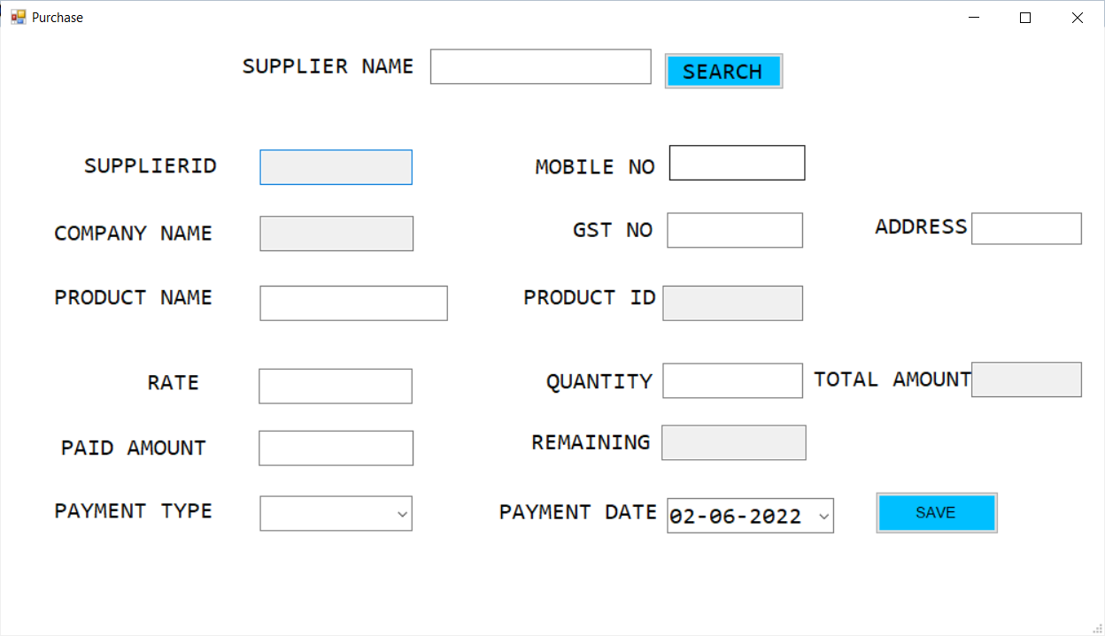

**All Purchase Details:**

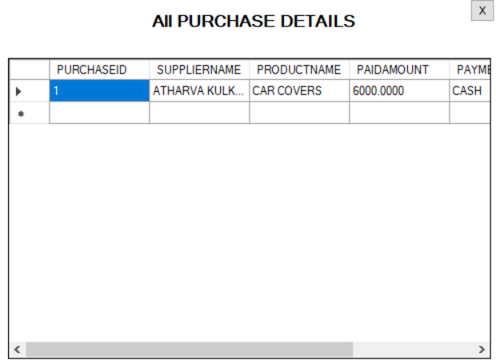

**Supplier wise Purchase Details:**

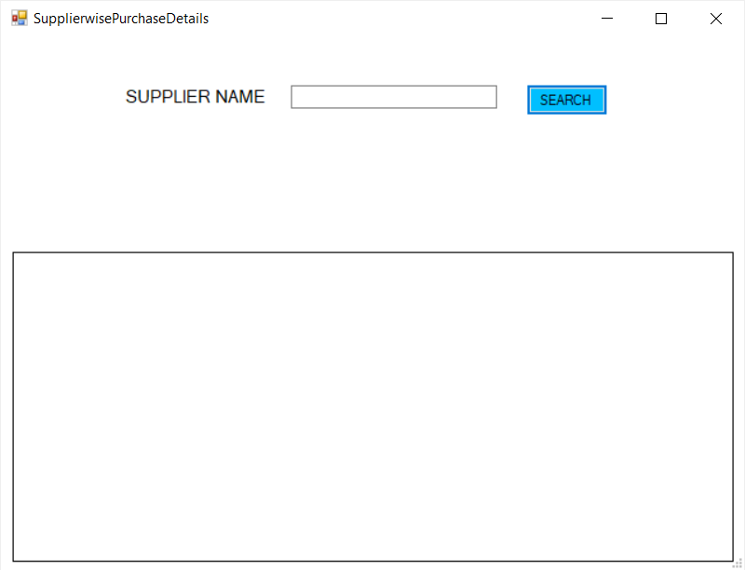

**Product wise Purchase:**

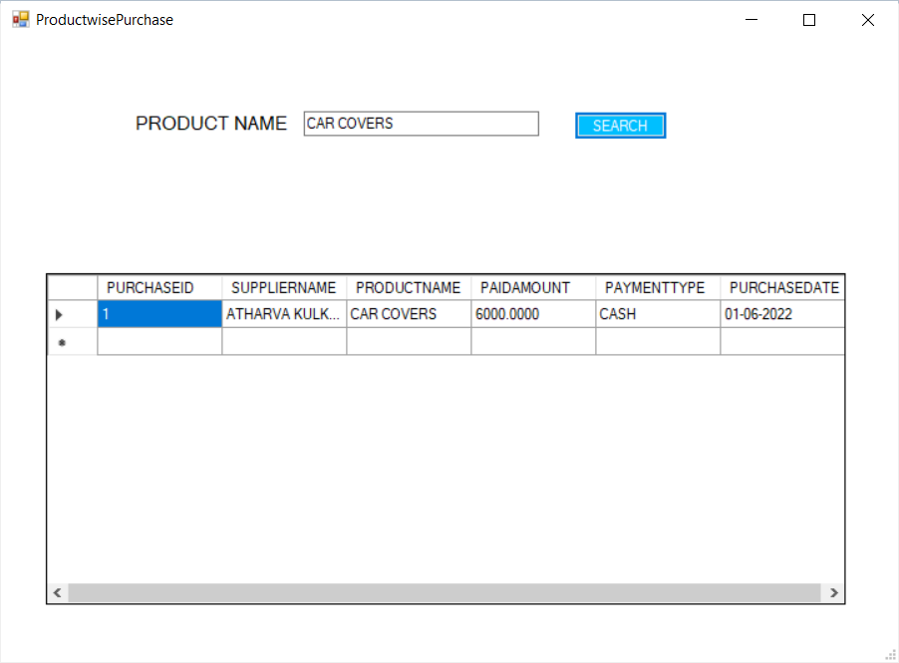

**New Customer:**

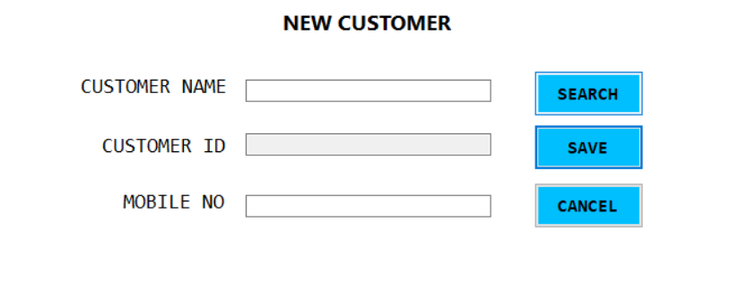

**Customer Payment:**

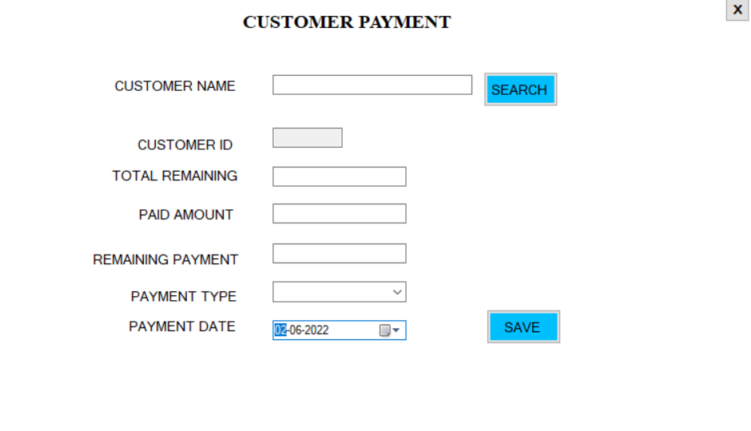

**All Customer Payment Details:**

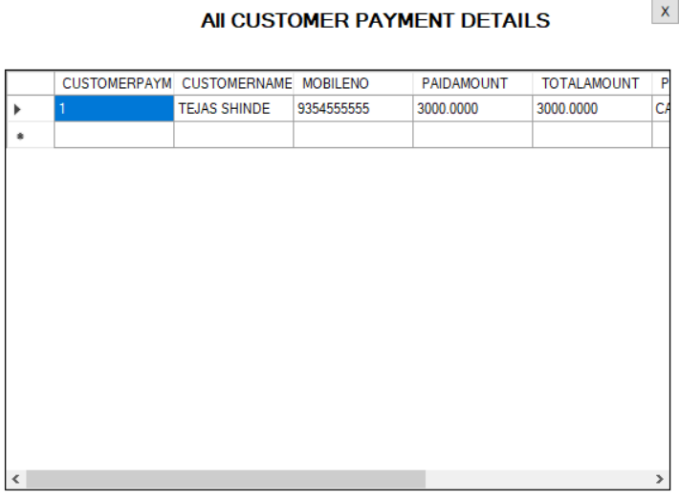

**Customer wise Payment Details:**

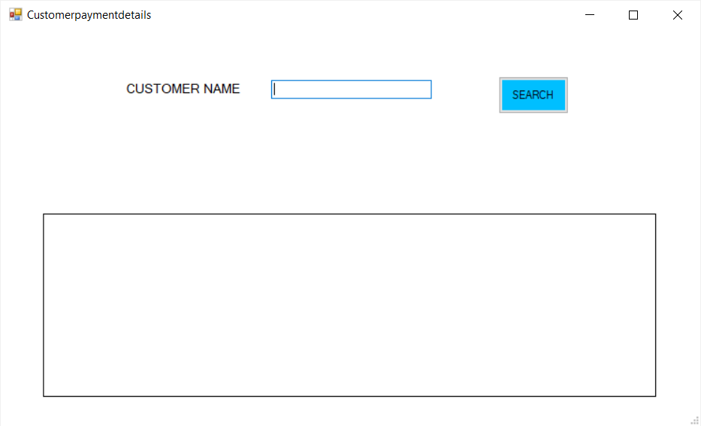

**All Stock Details:**

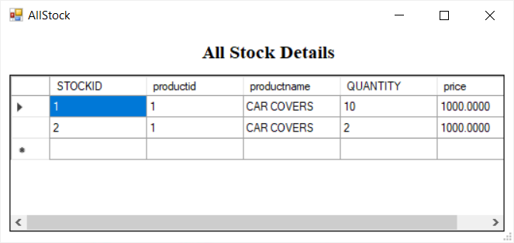

**Product wise Stock Details:**

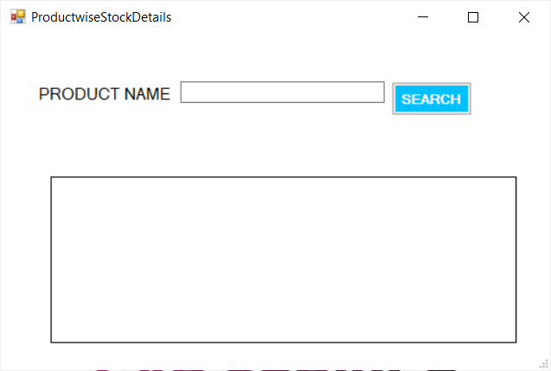

**Servicing:**

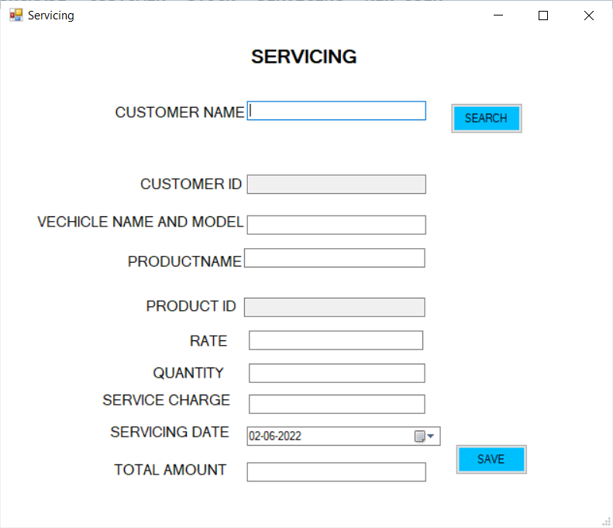

**All Servicing Details:**

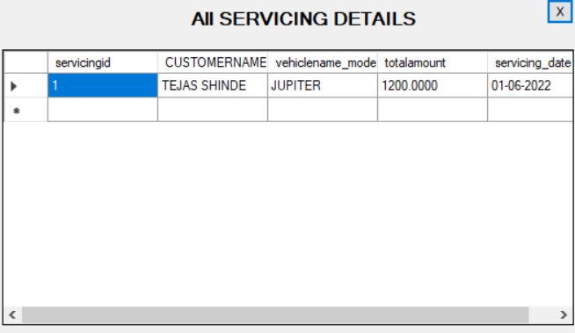

**Customer wise Servicing Details:**

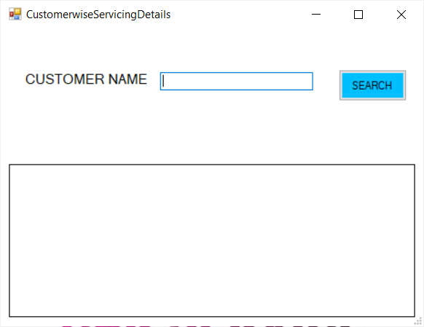

**New User:**

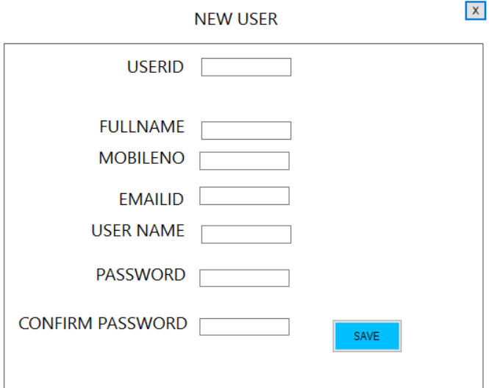

**Coding:**

**Login code:**

using System;

using System.Collections.Generic;

using System.ComponentModel;

using System.Data;

using System.Drawing;

using System.Linq;

using System.Text;

using System.Windows.Forms;

using System.Data.SqlClient;

using System.Configuration;

namespace Automobile_Management_System

{

public partial class LOGIN : Form

{

SqlConnection CON = new SqlConnection(System.Configuration.ConfigurationSettings.AppSettings["Auto"].ToString());

public LOGIN()

{

InitializeComponent();

}

private void CANCEL_Click(object sender, EventArgs e)

{

this.Close();

}

private Boolean valid()

{

if (user.Text == "")

{

MessageBox.Show("Enter the User Name");

return false;

}

if (password.Text == "")

{

MessageBox.Show("Enter the Password");

return false;

}

return true;

}

private void button2_Click(object sender, EventArgs e)

{

if (valid())

{

SqlDataAdapter ad = new SqlDataAdapter("select USERID,USERNAME,PASSWORD FROM NEWUSER WHERE USERNAME='" + user.Text + "'", CON);

DataSet ds = new DataSet();

ad.Fill(ds);

if (ds.Tables[0].Rows.Count > 0)

{

if (password.Text == ds.Tables[0].Rows[0]["PASSWORD"].ToString())

{

MainMenu fm = new MainMenu();

fm.Show();

this.Hide();

}

else

{

MessageBox.Show("Invalid Password");

}

}

else

{

MessageBox.Show("Invalid User Name");

}

}

}

}

}

**Main menu code:**

using System;

using System.Collections.Generic;

using System.ComponentModel;

using System.Data;

using System.Drawing;

using System.Linq;

using System.Text;

using System.Windows.Forms;

namespace Automobile_Management_System

{

public partial class MainMenu : Form

{

public MainMenu()

{

InitializeComponent();

}

private void pRODUCTToolStripMenuItem1_Click(object sender, EventArgs e)

{

Product A = new Product();

A.ShowDialog();

}

private void nEWSUPPLIERToolStripMenuItem_Click(object sender, EventArgs e)

{

Supplier A = new Supplier();

A.ShowDialog();

}

private void sUPPLIERPAYMENTToolStripMenuItem_Click(object sender, EventArgs e)

{

Supplierpayment A = new Supplierpayment();

A.ShowDialog();

}

private void aLLSUPPLIERPAYMENTDETAILSToolStripMenuItem_Click(object sender, EventArgs e)

{

AllSupplierPaymentDetails A = new AllSupplierPaymentDetails();

A.ShowDialog();

}

private void sUPPLIERWISEPAYMENTDETAILSToolStripMenuItem_Click(object sender, EventArgs e)

{

SupplierwisePaymentdetails A = new SupplierwisePaymentdetails();

A.ShowDialog();

}

private void nEWPURCHASEToolStripMenuItem_Click(object sender, EventArgs e)

{

Purchase A = new Purchase();

A.ShowDialog();

}

private void aLLSTOCKDETAILSToolStripMenuItem_Click(object sender, EventArgs e)

{

AllStock A = new AllStock();

A.ShowDialog();

}

private void aLLPAYMENTDETAILSToolStripMenuItem_Click(object sender, EventArgs e)

{

AllCustomerPaymentDetails A = new AllCustomerPaymentDetails();

A.ShowDialog();

}

private void cUSTOMERWISEPAYMENTDETAILSToolStripMenuItem_Click(object sender, EventArgs e)

{

Customerpaymentdetails A = new Customerpaymentdetails();

A.ShowDialog();

}

private void nEWUSERToolStripMenuItem1_Click(object sender, EventArgs e)

{

NewUser A = new NewUser();

A.ShowDialog();

}

private void nEWSERVICINGToolStripMenuItem_Click(object sender, EventArgs e)

{

Servicing A = new Servicing();

A.ShowDialog();

}

private void pRODUCTWISESTOCKDETAILSToolStripMenuItem_Click(object sender, EventArgs e)

{

ProductwiseStockDetails a = new ProductwiseStockDetails();

a.ShowDialog();

}

private void cUSTOMERPAYMENTToolStripMenuItem_Click(object sender, EventArgs e)

{

Customerpayment A = new Customerpayment();

A.ShowDialog();

}

private void pToolStripMenuItem_Click(object sender, EventArgs e)

{

SupplierwisePurchaseDetails a = new SupplierwisePurchaseDetails();

a.ShowDialog();

}

private void pRODUCTWISEDETAILSToolStripMenuItem_Click(object sender, EventArgs e)

{

ProductwisePurchase a = new ProductwisePurchase();

a.ShowDialog();

}

private void cUSTOMERWISESERVICINGDETAILSToolStripMenuItem_Click(object sender, EventArgs e)

{

CustomerwiseServicingDetails a = new CustomerwiseServicingDetails();

a.ShowDialog();

}

private void aLLSERVICINGDETAILSToolStripMenuItem_Click(object sender, EventArgs e)

{

ALLSERVICINGDETAILS A = new ALLSERVICINGDETAILS();

A.ShowDialog();

}

private void aLLSUPPLIERWISEDETAILSToolStripMenuItem_Click(object sender, EventArgs e)

{

ALLPURCHASEDETAILS A = new ALLPURCHASEDETAILS();

A.ShowDialog();

}

private void MainMenu_Load(object sender, EventArgs e)

{

}

private void X_Click(object sender, EventArgs e)

{

this.Close();

}

private void nEWCUSTOMERToolStripMenuItem_Click(object sender, EventArgs e)

{

Customer a = new Customer();

a.ShowDialog();

}

}

}

**Product code:**

using System;

using System.Collections.Generic;

using System.ComponentModel;

using System.Data;

using System.Drawing;

using System.Linq;

using System.Text;

using System.Windows.Forms;

using System.Data.SqlClient;

using System.Configuration;

namespace Automobile_Management_System

{

public partial class Product : Form

{

public Product()

{

InitializeComponent();

}

SqlConnection CON = new SqlConnection(System.Configuration.ConfigurationSettings.AppSettings["Auto"].ToString());

private Boolean valid()

{

if (PRODUCTNAME.Text == "")

{

MessageBox.Show("ENTER PRODUCTNAME");

return false;

}

if (COMPANYNAME.Text == "")

{

MessageBox.Show("ENTER COMPANYNAME");

return false;

}

if (PRICE.Text == "")

{

MessageBox.Show("ENTER PRICE");

return false;

}

if (QUANTITY.Text == "")

{

MessageBox.Show("ENTER QUANTITY");

return false;

}

return true;

}

private void PRODUCTNAME_TextChanged(object sender, EventArgs e)

{

if (PRODUCTNAME.Text != " ")

{

SqlDataAdapter AD = new SqlDataAdapter("SELECT PRODUCTNAME FROM PRODUCT WHERE PRODUCTNAME LIKE'" + PRODUCTNAME.Text + "%'", CON);

DataSet DS = new DataSet();

AD.Fill(DS);

listBox1.Items.Clear();

if (DS.Tables[0].Rows.Count > 0)

{

foreach (DataRow DR in DS.Tables[0].Rows)

{

listBox1.Visible = true;

listBox1.Items.Add(DR[0]);

}

}

else

{

listBox1.Items.Clear();

listBox1.Visible = false;

}

}

else

{

listBox1.Items.Clear();

listBox1.Visible = false;

}

}

private void PRODUCTNAME_KeyDown(object sender, KeyEventArgs e)

{

if (e.KeyCode == Keys.Down)

{

listBox1.Focus();

}

}

private void listBox1_KeyPress(object sender, KeyPressEventArgs e)

{

PRODUCTNAME.Text = listBox1.SelectedItem.ToString();

listBox1.Visible = false;

}

private void save_Click(object sender, EventArgs e)

{

try

{

if (valid())

{

SqlCommand cmd = new SqlCommand();

if (PRODUCTID.Text == "")

{

cmd.Parameters.AddWithValue("@productid", null);

}

else

{

cmd.Parameters.AddWithValue("@productid", PRODUCTID.Text);

}

cmd.Parameters.AddWithValue("@PRODUCTNAME", PRODUCTNAME.Text);

cmd.Parameters.AddWithValue("@COMPANY", COMPANYNAME.Text);

cmd.Parameters.AddWithValue("@PRICE", PRICE.Text);

cmd.Parameters.AddWithValue("@QUANTITY", QUANTITY.Text);

SqlParameter error = cmd.Parameters.Add("@ERRORMSG", SqlDbType.VarChar, 1000);

error.Direction = ParameterDirection.Output;

SqlParameter returnvalue =

cmd.Parameters.Add("@ret", SqlDbType.Int);

returnvalue.Direction =

ParameterDirection.ReturnValue;

cmd.Connection = CON;

cmd.CommandText = "SP_PRODUCTSTOCK";

cmd.CommandType = CommandType.StoredProcedure;

CON.Open();

cmd.ExecuteNonQuery();

int r = 0;

//r = (int)returnvalue.Value;

r = Convert.ToInt32(returnvalue.Value);

if (r > 0)

{

MessageBox.Show("DATA IS SAVED");

PRODUCTID.Clear();

PRODUCTNAME.Clear();

PRICE.Clear();

COMPANYNAME.Clear();

QUANTITY.Clear();

}

else

{

string str;

str = (string)error.Value;

MessageBox.Show(str);

}

}

}

catch (Exception ex)

{

MessageBox.Show(ex.Message);

}

finally

{

CON.Close();

}

}

private void search_Click(object sender, EventArgs e)

{

SqlDataAdapter AD = new SqlDataAdapter("SELECT*FROM PRODUCT WHERE PRODUCTNAME='" + PRODUCTNAME.Text + "'", CON);

DataSet DS = new DataSet();

AD.Fill(DS);

CON.Open();

if (DS.Tables[0].Rows.Count > 0)

{

PRODUCTID.Text = DS.Tables[0].Rows[0]["PRODUCTID"].ToString();

COMPANYNAME.Text = DS.Tables[0].Rows[0]["COMPANY"].ToString();

PRICE.Text = DS.Tables[0].Rows[0]["PRICE"].ToString();

QUANTITY.Text = DS.Tables[0].Rows[0]["QUANTITY"].ToString();

}

else

{

MessageBox.Show("RECORD NOT FOUND");

}

CON.Close();

}

}

}

**Supplier code:**

using System;

using System.Collections.Generic;

using System.ComponentModel;

using System.Data;

using System.Drawing;

using System.Linq;

using System.Text;

using System.Windows.Forms;

using System.Data.SqlClient;

using System.Configuration;

namespace Automobile_Management_System

{

public partial class Supplier : Form

{

public Supplier()

{

InitializeComponent();

}

SqlConnection CON = new SqlConnection(System.Configuration.ConfigurationSettings.AppSettings["Auto"].ToString());

private Boolean valid()

{

if (COMPANYNAME.Text == "")

{

MessageBox.Show("ENTER THE COMPANY NAME");

return false;

}

if (CONTACTNO.Text == "")

{

MessageBox.Show("ENTER THE CONTACT NUMBER");

return false;

}

if (SUPPLIERNAME.Text == "")

{

MessageBox.Show("ENTER THE SUPPLIER NAME");

return false;

}

if (ADDRESS.Text == "")

{

MessageBox.Show("ENTER THE ADDRESS");

return false;

}

if (GSTNO.Text == "")

{

MessageBox.Show("ENTER THE GST NO");

return false;

}

return true;

}

private void BTNSAVE_Click(object sender, EventArgs e)

{

try

{

if (valid())

{

SqlCommand cmd = new SqlCommand();

if (SUPPLIERID.Text == "")

{

cmd.Parameters.AddWithValue("@SUPPLIERID", null);

}

else

{

cmd.Parameters.AddWithValue("@SUPPLIERID", SUPPLIERID.Text);

}

cmd.Parameters.AddWithValue("@COMNPANYNAME", COMPANYNAME.Text);

cmd.Parameters.AddWithValue("@SUPPLIERNAME", SUPPLIERNAME.Text);

cmd.Parameters.AddWithValue("@CONTACTNUMBER", CONTACTNO.Text);

cmd.Parameters.AddWithValue("@ADDRESS", ADDRESS.Text);

cmd.Parameters.AddWithValue("@GSTNO", GSTNO.Text);

SqlParameter error = cmd.Parameters.Add("@ERRORMSG",

SqlDbType.VarChar, 1000);

error.Direction = ParameterDirection.Output;

SqlParameter returnvalue =

cmd.Parameters.Add("@ret", SqlDbType.Int);

returnvalue.Direction =

ParameterDirection.ReturnValue;

cmd.Connection = CON;

cmd.CommandText = "SP_SUPPLIER";

cmd.CommandType = CommandType.StoredProcedure;

CON.Open();

cmd.ExecuteNonQuery();

int r = 0;

//r = (int)returnvalue.Value;

r = Convert.ToInt32(returnvalue.Value);

if (r > 0)

{

MessageBox.Show("DATA IS SAVED");

SUPPLIERID.Clear();

COMPANYNAME.Clear();

SUPPLIERNAME.Clear();

CONTACTNO.Clear();

ADDRESS.Clear();

GSTNO.Clear();

}

else

{

string str;

str = (string)error.Value;

MessageBox.Show(str);

}

}

}

catch (Exception ex)

{

MessageBox.Show(ex.Message);

}

finally

{

CON.Close();

}

}

private void search_Click(object sender, EventArgs e)

{

SqlDataAdapter AD = new SqlDataAdapter("SELECT*FROM SUPPLIER WHERE SUPPLIERNAME='" + SUPPLIERNAME.Text + "'", CON);

DataSet DS = new DataSet();

AD.Fill(DS);

if (DS.Tables[0].Rows.Count > 0)

{

SUPPLIERID.Text = DS.Tables[0].Rows[0]["SUPPLIERID"].ToString();

SUPPLIERNAME.Text = DS.Tables[0].Rows[0]["SUPPLIERNAME"].ToString();

COMPANYNAME.Text = DS.Tables[0].Rows[0]["COMNPANYNAME"].ToString();

CONTACTNO.Text = DS.Tables[0].Rows[0]["CONTACTNUMBER"].ToString();

ADDRESS.Text = DS.Tables[0].Rows[0]["ADDRESS"].ToString();

GSTNO.Text = DS.Tables[0].Rows[0]["GSTNO"].ToString();

}

else

{

MessageBox.Show("RECORD NOT FOUND");

}

}

private void SUPPLIERNAME_TextChanged(object sender, EventArgs e)

{

if (SUPPLIERNAME.Text != "")

{

SqlDataAdapter AD = new SqlDataAdapter("SELECT SUPPLIERNAME FROM SUPPLIER WHERE SUPPLIERNAME LIKE'" + SUPPLIERNAME.Text + "%'", CON);

DataSet DS = new DataSet();

AD.Fill(DS);

listBox1.Items.Clear();

if (DS.Tables[0].Rows.Count > 0)

{

foreach (DataRow DR in DS.Tables[0].Rows)

{

listBox1.Visible = true;

listBox1.Items.Add(DR[0]);

}

}

else

{

listBox1.Items.Clear();

listBox1.Visible = false;

}

}

else

{

listBox1.Items.Clear();

listBox1.Visible = false;

}

}

private void SUPPLIERNAME_KeyDown(object sender, KeyEventArgs e)

{

if (e.KeyCode == Keys.Down)

{

listBox1.Focus();

}

}

private void listBox1_KeyPress(object sender, KeyPressEventArgs e)

{

SUPPLIERNAME.Text = listBox1.SelectedItem.ToString();

listBox1.Visible = false;

}

}

}

**Supplier Payment Code:**

using System;

using System.Collections.Generic;

using System.ComponentModel;

using System.Data;

using System.Drawing;

using System.Linq;

using System.Text;

using System.Windows.Forms;

using System.Data.SqlClient;

using System.Configuration;

namespace Automobile_Management_System

{

public partial class Supplierpayment : Form

{

public Supplierpayment()

{

InitializeComponent();

}

SqlConnection CON = new SqlConnection(System.Configuration.ConfigurationSettings.AppSettings["Auto"].ToString());

private void calculation()

{

double tamt = 0;

double paidamt = 0;

double r = 0;

if (TOTALAMOUNT.Text != "")

{

tamt = Convert.ToDouble(TOTALAMOUNT.Text);

}

if (PAIDAMOUNT.Text != "")

{

paidamt = Convert.ToDouble(PAIDAMOUNT.Text);

}

r = tamt - paidamt;

REMAININGAMOUNT.Text = r.ToString();

}

private void save_Click(object sender, EventArgs e)

{

try

{

SqlCommand cmd = new SqlCommand();

if (SUPPLIERID.Text == "")

{

cmd.Parameters.AddWithValue("@SUPPLIERID", null);

}

else

{

cmd.Parameters.AddWithValue("@SUPPLIERID", SUPPLIERID.Text);

}

cmd.Parameters.AddWithValue("@TOTALAMOUNT", TOTALAMOUNT.Text);

cmd.Parameters.AddWithValue("@PAIDAMOUNT", PAIDAMOUNT.Text);

cmd.Parameters.AddWithValue("@PAIDDATE", dateTimePicker1.Value);

cmd.Parameters.AddWithValue("@PAYMENTTYPE", comboBox1.SelectedItem);

cmd.Parameters.AddWithValue("@CHEQUENO", CHEQUENO.Text);

SqlParameter error = cmd.Parameters.Add("@ERRORMSG",

SqlDbType.VarChar, 1000);

error.Direction = ParameterDirection.Output;

SqlParameter returnvalue =

cmd.Parameters.Add("@ret", SqlDbType.Int);

returnvalue.Direction =

ParameterDirection.ReturnValue;

cmd.Connection = CON;

cmd.CommandText = "SP_SUPPLIERPAYMENT";

cmd.CommandType = CommandType.StoredProcedure;

CON.Open();

cmd.ExecuteNonQuery();

int r = 0;

//r = (int)returnvalue.Value;

r = Convert.ToInt32(returnvalue.Value);

if (r > 0)

{

double t = Convert.ToDouble(TOTALAMOUNT.Text);

double p = Convert.ToDouble(PAIDAMOUNT.Text);

if (t == p)

{

MessageBox.Show("DATA IS SAVED");

SUPPLIERID.Clear();

SUPPLIERNAME.Clear();

TOTALAMOUNT.Clear();

PAIDAMOUNT.Clear();

REMAININGAMOUNT.Clear();

//PAYMENTTYPE.Clear();

CHEQUENO.Clear();

}

else

{

MessageBox.Show("PAYMENT IS INCOMPLETE");

}

}

else

{

string str;

str = (string)error.Value;

MessageBox.Show(str);

}

}

catch (Exception ex)

{

MessageBox.Show(ex.Message);

}

finally

{

CON.Close();

}

}

private void search_Click(object sender, EventArgs e)

{

SqlDataAdapter AD = new SqlDataAdapter("SELECT * FROM SUPPLIER WHERE SUPPLIERNAME='" + SUPPLIERNAME.Text + "'", CON);

DataSet DS = new DataSet();

AD.Fill(DS);

if (DS.Tables[0].Rows.Count > 0)

{

SUPPLIERID.Text = DS.Tables[0].Rows[0]["SUPPLIERID"].ToString();

}

}

private void SUPPLIERNAME_TextChanged(object sender, EventArgs e)

{

if (SUPPLIERNAME.Text != "")

{

SqlDataAdapter AD = new SqlDataAdapter("SELECT SUPPLIERNAME FROM SUPPLIER WHERE SUPPLIERNAME LIKE'" + SUPPLIERNAME.Text + "%'", CON);

DataSet DS = new DataSet();

AD.Fill(DS);

listBox1.Items.Clear();

if (DS.Tables[0].Rows.Count > 0)

{

foreach (DataRow DR in DS.Tables[0].Rows)

{

listBox1.Visible = true;

listBox1.Items.Add(DR[0]);

}

}

else

{

listBox1.Items.Clear();

listBox1.Visible = false;

}

}

else

{

listBox1.Items.Clear();

listBox1.Visible = false;

}

}

private void SUPPLIERNAME_KeyDown(object sender, KeyEventArgs e)

{

if (e.KeyCode == Keys.Down)

{

listBox1.Focus();

}

}

private void listBox1_KeyPress(object sender, KeyPressEventArgs e)

{

SUPPLIERNAME.Text = listBox1.SelectedItem.ToString();

listBox1.Visible = false;

}

private void TOTALAMOUNT_TextChanged(object sender, EventArgs e)

{

calculation();

}

private void PAIDAMOUNT_TextChanged(object sender, EventArgs e)

{

calculation();

}

private void REMAININGAMOUNT_TextChanged(object sender, EventArgs e)

{

calculation();

}

private void comboBox1_SelectedIndexChanged(object sender, EventArgs e)

{

if (comboBox1.Text == "CASH")

{

lBCHEQUENO.Visible = false;

CHEQUENO.Visible = false;

}

else

{

lBCHEQUENO.Visible = true;

CHEQUENO.Visible = true;

}

}

}

}

**All Supplier Payment Details:**

using System;

using System.Collections.Generic;

using System.ComponentModel;

using System.Data;

using System.Drawing;

using System.Linq;

using System.Text;

using System.Windows.Forms;

using System.Data.SqlClient;

using System.Configuration;

namespace Automobile_Management_System

{

public partial class AllSupplierPaymentDetails : Form

{

public AllSupplierPaymentDetails()

{

InitializeComponent();

}

SqlConnection CON = new SqlConnection(System.Configuration.ConfigurationSettings.AppSettings["Auto"].ToString());

private void RUNTIMEBINDING()

{

SqlDataAdapter AD = new SqlDataAdapter("SELECT*FROM VW_SUPPLIERWISEPAYMENTDETAILS ", CON);

DataSet DS = new DataSet();

AD.Fill(DS);

CON.Open();

if (DS.Tables[0].Rows.Count > 0)

{

dataGridView1.DataSource = DS.Tables[0];

}

}

private void AllSupplierPaymentDetails_Load(object sender, EventArgs e)

{

RUNTIMEBINDING();

}

private void X_Click(object sender, EventArgs e)

{

this.Close();

}

}

}

**Supplier wise Payment Details:**

using System;

using System.Collections.Generic;

using System.ComponentModel;

using System.Data;

using System.Drawing;

using System.Linq;

using System.Text;

using System.Windows.Forms;

using System.Data.SqlClient;

using System.Configuration;

namespace Automobile_Management_System

{

public partial class SupplierwisePaymentdetails : Form

{

public SupplierwisePaymentdetails()

{

InitializeComponent();

}

SqlConnection CON = new SqlConnection(System.Configuration.ConfigurationSettings.AppSettings["Auto"].ToString());

private void search_Click(object sender, EventArgs e)

{

SqlDataAdapter AD = new SqlDataAdapter("SELECT * FROM VW_SUPPLIERWISEPAYMENTDETAILS WHERE SUPPLIERNAME='" + SUPPLIERNAME.Text + "'", CON);

DataSet DS = new DataSet();

AD.Fill(DS);

if (DS.Tables[0].Rows.Count > 0)

{

dataGridView1.DataSource = DS.Tables[0];

}

else

{

MessageBox.Show("RECORD NOT FOUND");

}

}

private void SUPPLIERNAME_TextChanged(object sender, EventArgs e)

{

if (SUPPLIERNAME.Text != "")

{

SqlDataAdapter AD = new SqlDataAdapter("SELECT SUPPLIERNAME FROM SUPPLIER WHERE SUPPLIERNAME LIKE'" + SUPPLIERNAME.Text + "%'", CON);

DataSet DS = new DataSet();

AD.Fill(DS);

listBox1.Items.Clear();

if (DS.Tables[0].Rows.Count > 0)

{

foreach (DataRow DR in DS.Tables[0].Rows)

{

listBox1.Visible = true;

listBox1.Items.Add(DR[0]);

}

}

else

{

listBox1.Items.Clear();

listBox1.Visible = false;

}

}

else

{

listBox1.Items.Clear();

listBox1.Visible = false;

}

}

private void SUPPLIERNAME_KeyDown(object sender, KeyEventArgs e)

{

if (e.KeyCode == Keys.Down)

{

listBox1.Focus();

}

}

private void listBox1_KeyPress(object sender, KeyPressEventArgs e)

{

SUPPLIERNAME.Text = listBox1.SelectedItem.ToString();

listBox1.Visible = false;

}

private void dataGridView1_CellContentClick(object sender, DataGridViewCellEventArgs e)

{

}

}

}

**New Purchase:**

using System;

using System.Collections.Generic;

using System.ComponentModel;

using System.Data;

using System.Drawing;

using System.Linq;

using System.Text;

using System.Windows.Forms;

using System.Data.SqlClient;

using System.Configuration;

namespace Automobile_Management_System

{

public partial class Purchase : Form

{

public Purchase()

{

InitializeComponent();

}

SqlConnection CON = new SqlConnection(System.Configuration.ConfigurationSettings.AppSettings["Auto"].ToString());

private void calculation()

{

double r = 0;

double q = 0;

double tamount = 0;

if (RATE.Text != "")

{

r = Convert.ToDouble(RATE.Text);

}

if (QUANTITY.Text != "")

{

q = Convert.ToDouble(QUANTITY.Text);

}

tamount = r * q;

TOTALAMOUNT.Text = tamount.ToString();

}

private void cal()

{

double tamt = 0;

double paidamt = 0;

double r = 0;

if (TOTALAMOUNT.Text != "")

{

tamt = Convert.ToDouble(TOTALAMOUNT.Text);

}

if (PAIDAMOUNT.Text != "")

{

paidamt = Convert.ToDouble(PAIDAMOUNT.Text);

}

r = tamt - paidamt;

REMAININGMOUNT.Text = r.ToString();

}

private void SUPPLIERNAME_TextChanged(object sender, EventArgs e)

{

if (SUPPLIERNAME.Text != "")

{

SqlDataAdapter AD = new SqlDataAdapter("SELECT SUPPLIERNAME FROM SUPPLIER WHERE SUPPLIERNAME LIKE'" + SUPPLIERNAME.Text + "%'", CON);

DataSet DS = new DataSet();

AD.Fill(DS);

listBox1.Items.Clear();

if (DS.Tables[0].Rows.Count > 0)

{

foreach (DataRow DR in DS.Tables[0].Rows)

{

listBox1.Visible = true;

listBox1.Items.Add(DR[0]);

}

}

else

{

listBox1.Items.Clear();

listBox1.Visible = false;

}

}

else

{

listBox1.Items.Clear();

listBox1.Visible = false;

}

}

private void SUPPLIERNAME_KeyDown(object sender, KeyEventArgs e)

{

if (e.KeyCode == Keys.Down)

{

listBox1.Focus();

}

}

private void listBox1_KeyPress(object sender, KeyPressEventArgs e)

{

SUPPLIERNAME.Text = listBox1.SelectedItem.ToString();

listBox1.Visible = false;

}

private void search_Click(object sender, EventArgs e)

{

SqlDataAdapter AD = new SqlDataAdapter("SELECT*FROM SUPPLIER WHERE SUPPLIERNAME='" + SUPPLIERNAME.Text + "'", CON);

DataSet DS = new DataSet();

AD.Fill(DS);

if (DS.Tables[0].Rows.Count > 0)

{

SUPPLIERID.Text = DS.Tables[0].Rows[0]["SUPPLIERID"].ToString();

SUPPLIERNAME.Text = DS.Tables[0].Rows[0]["SUPPLIERNAME"].ToString();

COMPANYNAME.Text = DS.Tables[0].Rows[0]["COMNPANYNAME"].ToString();

MOBILENO.Text = DS.Tables[0].Rows[0]["CONTACTNUMBER"].ToString();

ADDRESS.Text = DS.Tables[0].Rows[0]["ADDRESS"].ToString();

GSTNO.Text = DS.Tables[0].Rows[0]["GSTNO"].ToString();

}

}

private void PRODUCTNAME_TextChanged(object sender, EventArgs e)

{

if (PRODUCTNAME.Text != "")

{

SqlDataAdapter adptr = new SqlDataAdapter("select productname from product where productname like '" + PRODUCTNAME.Text + "%'", CON);

DataSet ds = new DataSet();

adptr.Fill(ds);

lbproductname.Items.Clear();

if (ds.Tables[0].Rows.Count > 0)

{

foreach (DataRow dr in ds.Tables[0].Rows)

{

lbproductname.Visible = true;

lbproductname.Items.Add(dr[0]);

}

}

else

{

lbproductname.Items.Clear();

lbproductname.Visible = false;

}

}

else

{

lbproductname.Items.Clear();

lbproductname.Visible = false;

}

}

private void PRODUCTNAME_KeyDown(object sender, KeyEventArgs e)

{

if (e.KeyCode == Keys.Down)

{

lbproductname.Focus();

}

}

private void lbproductname_KeyPress(object sender, KeyPressEventArgs e)

{

if (e.KeyChar == 13)

{

PRODUCTNAME.Text = lbproductname.SelectedItem.ToString();

lbproductname.Visible = false;

SqlDataAdapter ad = new SqlDataAdapter("select productid from product where productname='" + PRODUCTNAME.Text + "'", CON);

DataSet ds = new DataSet();

ad.Fill(ds);

if (ds.Tables[0].Rows.Count > 0)

{

PRODUCTID.Text = ds.Tables[0].Rows[0]["productid"].ToString();

}

}

}

private void RATE_TextChanged(object sender, EventArgs e)

{

calculation();

}

private void QUANTITY_TextChanged(object sender, EventArgs e)

{

calculation();

}

private void TOTALAMOUNT_TextChanged(object sender, EventArgs e)

{

calculation();

cal();

}

private void PAIDAMOUNT_TextChanged(object sender, EventArgs e)

{

cal();

}

private void REMAININGAMOUNT_TextChanged(object sender, EventArgs e)

{

cal();

}

private void BTNSAVE_Click(object sender, EventArgs e)

{

try

{

SqlCommand cmd = new SqlCommand();

cmd.Parameters.AddWithValue("@SUPPLIERID", SUPPLIERID.Text);

cmd.Parameters.AddWithValue("@PRODUCTID", PRODUCTID.Text);

cmd.Parameters.AddWithValue("@RATE", RATE.Text);

cmd.Parameters.AddWithValue("@QUANTITY", QUANTITY.Text);

cmd.Parameters.AddWithValue("@TOTALAMOUNT", TOTALAMOUNT.Text);

cmd.Parameters.AddWithValue("@PAIDAMOUNT", PAIDAMOUNT.Text);

cmd.Parameters.AddWithValue("@PAYMENTTYPE", comboBox2.Text);

cmd.Parameters.AddWithValue("@PURCHASEDATE", dateTimePicker1.Value);

SqlParameter error = cmd.Parameters.Add("@ERRORMSG", SqlDbType.VarChar, 1000);

error.Direction = ParameterDirection.Output;

SqlParameter returnvalue = cmd.Parameters.Add("@ret", SqlDbType.Int);

returnvalue.Direction = ParameterDirection.ReturnValue;

cmd.Connection = CON;

cmd.CommandText = "SP_PURCHASE";

cmd.CommandType = CommandType.StoredProcedure;

CON.Open();

cmd.ExecuteNonQuery();

int r = 0;

//r = (int)returnvalue.Value;

r = Convert.ToInt32(returnvalue.Value);

if (r > 0)

{

double t = Convert.ToDouble(TOTALAMOUNT.Text);

double p = Convert.ToDouble(PAIDAMOUNT.Text);

if (t == p)

{

MessageBox.Show("code is saved");

//CLEAR BOX QUEARY

SUPPLIERNAME.Clear();

SUPPLIERID.Clear();

MOBILENO.Clear();

COMPANYNAME.Clear();

GSTNO.Clear();

ADDRESS.Clear();

RATE.Clear();

QUANTITY.Clear();

TOTALAMOUNT.Clear();

PAIDAMOUNT.Clear();

REMAININGMOUNT.Clear();

PRODUCTNAME.Clear();

PRODUCTID.Clear();

}

else

{

MessageBox.Show("PAYMENT IS INCOMPLETE");

}

}

else

{

string str;

str = (string)error.Value;

MessageBox.Show(str);

}

}

catch (Exception ex)

{

MessageBox.Show(ex.Message);

}

finally

{

CON.Close();

}

}

}

}

**All Purchase Details:**

using System;

using System.Collections.Generic;

using System.ComponentModel;

using System.Data;

using System.Drawing;

using System.Linq;

using System.Text;

using System.Windows.Forms;

using System.Data.SqlClient;

using System.Configuration;

namespace Automobile_Management_System

{

public partial class ALLPURCHASEDETAILS : Form

{

SqlConnection CON = new SqlConnection(System.Configuration.ConfigurationSettings.AppSettings["Auto"].ToString());

public ALLPURCHASEDETAILS()

{

InitializeComponent();

}

private void ALLPURCHASEDETAILS_Load(object sender, EventArgs e)

{

SqlDataAdapter AD = new SqlDataAdapter("SELECT *FROM VW_PURCHASE ", CON);

DataSet DS = new DataSet();

AD.Fill(DS);

CON.Open();

if (DS.Tables[0].Rows.Count > 0)

{

dataGridView1.DataSource = DS.Tables[0];

}

}

private void X_Click(object sender, EventArgs e)

{

this.Close();

}

}

}

**Supplier wise Purchase Details:**

using System;

using System.Collections.Generic;

using System.ComponentModel;

using System.Data;

using System.Drawing;

using System.Linq;

using System.Text;

using System.Windows.Forms;

using System.Data.SqlClient;

using System.Configuration;

namespace Automobile_Management_System

{

public partial class SupplierwisePurchaseDetails : Form

{

public SupplierwisePurchaseDetails()

{

InitializeComponent();

}

SqlConnection CON = new SqlConnection(System.Configuration.ConfigurationSettings.AppSettings["Auto"].ToString());

private void SUPPLIERNAME_TextChanged(object sender, EventArgs e)

{

if (SUPPLIERNAME.Text != "")

{

SqlDataAdapter AD = new SqlDataAdapter("SELECT SUPPLIERNAME FROM VW_PURCHASE WHERE SUPPLIERNAME LIKE'" + SUPPLIERNAME.Text + "%'", CON);

DataSet DS = new DataSet();

AD.Fill(DS);

listBox1.Items.Clear();

if (DS.Tables[0].Rows.Count > 0)

{

foreach (DataRow DR in DS.Tables[0].Rows)

{

listBox1.Visible = true;

listBox1.Items.Add(DR[0]);

}

}

else

{

listBox1.Items.Clear();

listBox1.Visible = false;

}

}

else

{

listBox1.Items.Clear();

listBox1.Visible = false;

}

}

private void SUPPLIERNAME_KeyDown(object sender, KeyEventArgs e)

{

if (e.KeyCode == Keys.Down)

{

listBox1.Focus();

}

}

private void listBox1_KeyPress(object sender, KeyPressEventArgs e)

{

SUPPLIERNAME.Text = listBox1.SelectedItem.ToString();

listBox1.Visible = false;

}

private void search_Click(object sender, EventArgs e)

{

SqlDataAdapter AD = new SqlDataAdapter("SELECT * FROM VW_PURCHASE WHERE SUPPLIERNAME='" + SUPPLIERNAME.Text + "'", CON);

DataSet DS = new DataSet();

AD.Fill(DS);

if (DS.Tables[0].Rows.Count > 0)

{

dataGridView1.DataSource = DS.Tables[0];

}

else

{

MessageBox.Show("RECORD NOT FOUND");

}

}

}

}

**Product wise Purchase Details:**

using System;

using System.Collections.Generic;

using System.ComponentModel;

using System.Data;

using System.Drawing;

using System.Linq;

using System.Text;

using System.Windows.Forms;

using System.Data.SqlClient;

using System.Configuration;

namespace Automobile_Management_System

{

public partial class ProductwisePurchase : Form

{

SqlConnection CON = new SqlConnection(System.Configuration.ConfigurationSettings.AppSettings["Auto"].ToString());

public ProductwisePurchase()

{

InitializeComponent();

}

private void SEARCH_Click(object sender, EventArgs e)

{

SqlDataAdapter AD = new SqlDataAdapter("SELECT * FROM VW_PURCHASE WHERE PRODUCTNAME='" + PRODUCTNAME.Text + "'", CON);

DataSet DS = new DataSet();

AD.Fill(DS);

if (DS.Tables[0].Rows.Count > 0)

{

dataGridView1.DataSource = DS.Tables[0];

}

else

{

MessageBox.Show("RECORD NOT FOUND");

}

}

private void PRODUCTNAME_TextChanged(object sender, EventArgs e)

{

if (PRODUCTNAME.Text != "")

{

SqlDataAdapter AD = new SqlDataAdapter("SELECT PRODUCTNAME FROM VW_PURCHASE WHERE PRODUCTNAME LIKE'" + PRODUCTNAME.Text + "%'", CON);

DataSet DS = new DataSet();

AD.Fill(DS);

listBox1.Items.Clear();

if (DS.Tables[0].Rows.Count > 0)

{

foreach (DataRow DR in DS.Tables[0].Rows)

{

listBox1.Visible = true;

listBox1.Items.Add(DR[0]);

}

}

else

{

listBox1.Items.Clear();

listBox1.Visible = false;

}

}

else

{

listBox1.Items.Clear();

listBox1.Visible = false;

}

}

private void PRODUCTNAME_KeyDown(object sender, KeyEventArgs e)

{

if (e.KeyCode == Keys.Down)

{

listBox1.Focus();

}

}

private void listBox1_KeyPress(object sender, KeyPressEventArgs e)

{

PRODUCTNAME.Text = listBox1.SelectedItem.ToString();

listBox1.Visible = false;

}

}

}

**New Customer:**

using System;

using System.Collections.Generic;

using System.ComponentModel;

using System.Data;

using System.Drawing;

using System.Linq;

using System.Text;

using System.Windows.Forms;

using System.Data.SqlClient;

using System.Configuration;

namespace Automobile_Management_System

{

public partial class Customer : Form

{

SqlConnection con = new SqlConnection(System.Configuration.ConfigurationSettings.AppSettings["Auto"].ToString());

public Customer()

{

InitializeComponent();

}

private Boolean valid()

{

if (CUSTOMERNAME.Text == "")

{

MessageBox.Show("ENTER CUSTOMERNAME ");

return false;

}

if (MOBILENO.Text == "")

{

MessageBox.Show("ENTER MOBILE NUMBER");

return false;

}

return true;

}

private void INSERT_Click(object sender, EventArgs e)

{

try

{

if (valid())

{

SqlCommand cmd = new SqlCommand();

cmd.Parameters.AddWithValue("@CUSTOMERNAME", CUSTOMERNAME.Text);

cmd.Parameters.AddWithValue("@MOBILE", MOBILENO.Text);

SqlParameter error = cmd.Parameters.Add("@ERRORMSG",

SqlDbType.VarChar, 1000);

error.Direction = ParameterDirection.Output;

SqlParameter returnvalue =

cmd.Parameters.Add("@ret", SqlDbType.Int);

returnvalue.Direction =

ParameterDirection.ReturnValue;

cmd.Connection = con;

cmd.CommandText = "SP_CUSTOMER";

cmd.CommandType = CommandType.StoredProcedure;

con.Open();

cmd.ExecuteNonQuery();

int r = 0;

//r = (int)returnvalue.Value;

r = Convert.ToInt32(returnvalue.Value);

if (r > 0)

{

MessageBox.Show(" DATA IS SAVED");

CUSTOMERID.Clear();

CUSTOMERNAME.Clear();

MOBILENO.Clear();

}

else

{

string str;

str = (string)error.Value;

MessageBox.Show(str);

}

}

}

catch (Exception ex)

{

MessageBox.Show(ex.Message);

}

finally

{

con.Close();

}

}

private void SEARCH_Click(object sender, EventArgs e)

{

SqlDataAdapter AD = new SqlDataAdapter("SELECT*FROM CUSTOMER WHERE CUSTOMERNAME='" + CUSTOMERNAME.Text + "'", con);

DataSet DS = new DataSet();

AD.Fill(DS);

if (DS.Tables[0].Rows.Count > 0)

{

CUSTOMERID.Text = DS.Tables[0].Rows[0]["CUSTOMERID"].ToString();

CUSTOMERNAME.Text = DS.Tables[0].Rows[0]["CUSTOMERNAME"].ToString();

MOBILENO.Text = DS.Tables[0].Rows[0]["MOBILENO"].ToString();

}

else

{

MessageBox.Show("RECORD NOT FOUND");

}

}

private void button2_Click(object sender, EventArgs e)

{

this.Close();

}

private void CUSTOMERNAME_TextChanged(object sender, EventArgs e)

{

if (CUSTOMERNAME.Text != "")

{

SqlDataAdapter AD = new SqlDataAdapter("SELECT CUSTOMERNAME FROM CUSTOMER WHERE CUSTOMERNAME LIKE'" + CUSTOMERNAME.Text + "%'", con);

DataSet DS = new DataSet();

AD.Fill(DS);

listBox1.Items.Clear();

if (DS.Tables[0].Rows.Count > 0)

{

foreach (DataRow DR in DS.Tables[0].Rows)

{

listBox1.Visible = true;

listBox1.Items.Add(DR[0]);

}

}

else

{

listBox1.Items.Clear();

listBox1.Visible = false;

}

}

else

{

listBox1.Items.Clear();

listBox1.Visible = false;

}

}

private void CUSTOMERNAME_KeyDown(object sender, KeyEventArgs e)

{

if (e.KeyCode == Keys.Down)

{

listBox1.Focus();

}

}

private void listBox1_KeyPress(object sender, KeyPressEventArgs e)

{

if (e.KeyChar == 13)

{

CUSTOMERNAME.Text = listBox1.SelectedItem.ToString();

listBox1.Visible = false;

}

}

private void label3_Click(object sender, EventArgs e)

{

}

private void listBox1_SelectedIndexChanged(object sender, EventArgs e)

{

}

}

}

**Customer Payment:**

using System;

using System.Collections.Generic;

using System.ComponentModel;

using System.Data;

using System.Drawing;

using System.Linq;

using System.Text;

using System.Windows.Forms;

using System.Configuration;

using System.Data.SqlClient;

namespace Automobile_Management_System

{

public partial class Customerpayment : Form

{

SqlConnection CON = new SqlConnection(System.Configuration.ConfigurationSettings.AppSettings["Auto"].ToString());

public Customerpayment()

{

InitializeComponent();

}

private void calculation()

{

double tamt = 0;

double paidamt = 0;

double r = 0;

if (TOTALAMOUNT.Text != "")

{

tamt = Convert.ToDouble(TOTALAMOUNT.Text);

}

if (PAIDAMOUNT.Text != "")

{

paidamt = Convert.ToDouble(PAIDAMOUNT.Text);

}

r = tamt - paidamt;

REMAININGPAYMENT.Text = r.ToString();

}

private Boolean valid()

{

if (CUSTOMERNAME.Text == "")

{

MessageBox.Show("ENTER CUSTOMERNAME ");

return false;

}

if (TOTALAMOUNT.Text == "")

{

MessageBox.Show("ENTER TOTALAMOUNT");

return false;

}

if (PAIDAMOUNT.Text == "")

{

MessageBox.Show("ENTER PAIDAMOUNT");

return false;

}

if (paymenttype.Text == "")

{

MessageBox.Show("SELECT PAYMENTTYPE");

return false;

}

return true;

}

private void save_Click(object sender, EventArgs e)

{

try

{

if (valid())

{

SqlCommand cmd = new SqlCommand();

if (CUSTOMERID.Text == "")

{

cmd.Parameters.AddWithValue("@CUSTOMERID", null);

}

else

{

cmd.Parameters.AddWithValue("@CUSTOMERID", CUSTOMERID.Text);

}

cmd.Parameters.AddWithValue("@TOTALAMOUNT", TOTALAMOUNT.Text);

cmd.Parameters.AddWithValue("@PAIDAMOUNT", PAIDAMOUNT.Text);

cmd.Parameters.AddWithValue("@PAYMENTTYPE", paymenttype.SelectedItem);

cmd.Parameters.AddWithValue("@TRANSACTIONNO", TRANSACTIONNO.Text);

cmd.Parameters.AddWithValue("@PAYMENTDATE", dateTimePicker1.Value);

SqlParameter error = cmd.Parameters.Add("@ERRORMSG",

SqlDbType.VarChar, 1000);

error.Direction = ParameterDirection.Output;

SqlParameter returnvalue =

cmd.Parameters.Add("@ret", SqlDbType.Int);

returnvalue.Direction =

ParameterDirection.ReturnValue;

cmd.Connection = CON;

cmd.CommandText = "SP_CUSTOMERPAYMENT";

cmd.CommandType = CommandType.StoredProcedure;

CON.Open();

cmd.ExecuteNonQuery();

int r = 0;

//r = (int)returnvalue.Value;

r = Convert.ToInt32(returnvalue.Value);

if (r > 0)

{

double t = Convert.ToDouble(TOTALAMOUNT.Text);

double p = Convert.ToDouble(PAIDAMOUNT.Text);

if (t == p)

{

MessageBox.Show("code is saved");

CUSTOMERNAME.Clear();

CUSTOMERID.Clear();

TOTALAMOUNT.Clear();

PAIDAMOUNT.Clear();

REMAININGPAYMENT.Clear();

TRANSACTIONNO.Clear();

}

else

{

MessageBox.Show("PAYMENT IS INCOMPLETE");

}

}

else

{

string str;

str = (string)error.Value;

MessageBox.Show(str);

}

}

}

catch (Exception ex)

{

MessageBox.Show(ex.Message);

}

finally

{

CON.Close();

}

}

private void CUSTOMERNAME_TextChanged(object sender, EventArgs e)

{

if (CUSTOMERNAME.Text != "")

{

SqlDataAdapter AD = new SqlDataAdapter("SELECT CUSTOMERNAME FROM CUSTOMER WHERE CUSTOMERNAME LIKE'" + CUSTOMERNAME.Text + "%'", CON);

DataSet DS = new DataSet();

AD.Fill(DS);

listBox1.Items.Clear();

if (DS.Tables[0].Rows.Count > 0)

{

foreach (DataRow DR in DS.Tables[0].Rows)

{

listBox1.Visible = true;

listBox1.Items.Add(DR[0]);

}

}

else

{

listBox1.Items.Clear();

listBox1.Visible = false;

}

}

else

{

listBox1.Items.Clear();

listBox1.Visible = false;

}

}

private void CUSTOMERNAME_KeyDown(object sender, KeyEventArgs e)

{

if (e.KeyCode == Keys.Down)

{

listBox1.Focus();

}

}

private void listBox1_KeyPress(object sender, KeyPressEventArgs e)

{

CUSTOMERNAME.Text = listBox1.SelectedItem.ToString();

listBox1.Visible = false;

}

private void search_Click(object sender, EventArgs e)

{

SqlDataAdapter AD = new SqlDataAdapter("SELECT * FROM CUSTOMER WHERE CUSTOMERNAME='" + CUSTOMERNAME.Text + "'", CON);

DataSet DS = new DataSet();

AD.Fill(DS);

if (DS.Tables[0].Rows.Count > 0)

{

CUSTOMERID.Text = DS.Tables[0].Rows[0]["CUSTOMERID"].ToString();

}

}

private void TOTALAMOUNT_TextChanged(object sender, EventArgs e)

{

calculation();

}

private void PAIDAMOUNT_TextChanged(object sender, EventArgs e)

{

calculation();

}

private void REMAININGPAYMENT_TextChanged(object sender, EventArgs e)

{

calculation();

}

private void X_Click(object sender, EventArgs e)

{

this.Close();

}

private void paymenttype_SelectedIndexChanged(object sender, EventArgs e)

{

if (paymenttype.Text == "CASH")

{

lbtranno.Visible = false;

TRANSACTIONNO.Visible = false;

}

else

{

lbtranno.Visible = true;

TRANSACTIONNO.Visible = true;

}

}

}

}

**All Customer Payment Details:**

using System;

using System.Collections.Generic;

using System.ComponentModel;

using System.Data;

using System.Drawing;

using System.Linq;

using System.Text;

using System.Windows.Forms;

using System.Data.SqlClient;

using System.Configuration;

namespace Automobile_Management_System

{

public partial class AllCustomerPaymentDetails : Form

{

public AllCustomerPaymentDetails()

{

InitializeComponent();

}

SqlConnection CON = new SqlConnection(System.Configuration.ConfigurationSettings.AppSettings["Auto"].ToString());

private void AllCustomerPaymentDetails_Load(object sender, EventArgs e)

{

SqlDataAdapter AD = new SqlDataAdapter("SELECT *FROM VW_CUSTOMERDETAILS", CON);

DataSet DS = new DataSet();

AD.Fill(DS);

CON.Open();

if (DS.Tables[0].Rows.Count > 0)

{

dataGridView1.DataSource = DS.Tables[0];

}

}

private void X_Click(object sender, EventArgs e)

{

this.Close();

}

}

}

**Customer wise Payment Details:**

using System;

using System.Collections.Generic;

using System.ComponentModel;

using System.Data;

using System.Drawing;

using System.Linq;

using System.Text;

using System.Windows.Forms;

using System.Data.SqlClient;

using System.Configuration;

namespace Automobile_Management_System

{

public partial class Customerpaymentdetails : Form

{

SqlConnection CON = new SqlConnection(System.Configuration.ConfigurationSettings.AppSettings["Auto"].ToString());

public Customerpaymentdetails()

{

InitializeComponent();

}

private void button1_Click(object sender, EventArgs e)

{

SqlDataAdapter AD = new SqlDataAdapter("SELECT * FROM VW_CUSTOMERDETAILS WHERE CUSTOMERNAME='" + textBox1.Text + "'", CON);

DataSet DS = new DataSet();

AD.Fill(DS);

if (DS.Tables[0].Rows.Count > 0)

{

dataGridView1.DataSource = DS.Tables[0];

}

else

{

MessageBox.Show("RECORD NOT FOUND");

}

}

private void button2_Click(object sender, EventArgs e)

{

this.Close();

}

private void textBox1_TextChanged(object sender, EventArgs e)

{

if (textBox1.Text != "")

{

SqlDataAdapter AD = new SqlDataAdapter("SELECT CUSTOMERNAME FROM CUSTOMER WHERE CUSTOMERNAME LIKE'" + textBox1.Text + "%'", CON);

DataSet DS = new DataSet();

AD.Fill(DS);

listBox1.Items.Clear();

if (DS.Tables[0].Rows.Count > 0)

{

foreach (DataRow DR in DS.Tables[0].Rows)

{

listBox1.Visible = true;

listBox1.Items.Add(DR[0]);

}

}

else

{

listBox1.Items.Clear();

listBox1.Visible = false;

}

}

else

{

listBox1.Items.Clear();

listBox1.Visible = false;

}

}

private void textBox1_KeyDown(object sender, KeyEventArgs e)

{

if (e.KeyCode == Keys.Down)

{

listBox1.Focus();

}

}

private void listBox1_KeyPress(object sender, KeyPressEventArgs e)

{

if (e.KeyChar == 13)

{

textBox1.Text = listBox1.SelectedItem.ToString();

listBox1.Visible = false;

}

}

}

}

**All Stock Code:**

using System;

using System.Collections.Generic;

using System.ComponentModel;

using System.Data;

using System.Drawing;

using System.Linq;

using System.Text;

using System.Windows.Forms;

using System.Data.SqlClient;

using System.Configuration;

namespace Automobile_Management_System

{

public partial class AllStock : Form

{

public AllStock()

{

InitializeComponent();

}

SqlConnection CON = new SqlConnection(System.Configuration.ConfigurationSettings.AppSettings["Auto"].ToString());

private void AllStock_Load(object sender, EventArgs e)

{

SqlDataAdapter AD = new SqlDataAdapter("SELECT *FROM VW_STOCK ", CON);

DataSet DS = new DataSet();

AD.Fill(DS);

CON.Open();

if (DS.Tables[0].Rows.Count > 0)

{

dataGridView1.DataSource = DS.Tables[0];

}

}

private void dataGridView1_CellContentClick(object sender, DataGridViewCellEventArgs e)

{

}

private void label1_Click(object sender, EventArgs e)

{

}

}

}

**Product wise Stock:**

using System;

using System.Collections.Generic;

using System.ComponentModel;

using System.Data;

using System.Drawing;

using System.Linq;

using System.Text;

using System.Windows.Forms;

using System.Data.SqlClient;

using System.Configuration;

namespace Automobile_Management_System

{

public partial class ProductwiseStockDetails : Form

{

SqlConnection CON = new SqlConnection(System.Configuration.ConfigurationSettings.AppSettings["Auto"].ToString());

public ProductwiseStockDetails()

{

InitializeComponent();

}

private void PRODUCTNAME_TextChanged(object sender, EventArgs e)

{

if (PRODUCTNAME.Text != "")

{

SqlDataAdapter AD = new SqlDataAdapter("SELECT PRODUCTNAME FROM VW_STOCK WHERE PRODUCTNAME LIKE'" + PRODUCTNAME.Text + "%'", CON);

DataSet DS = new DataSet();

AD.Fill(DS);

listBox1.Items.Clear();

if (DS.Tables[0].Rows.Count > 0)

{

foreach (DataRow DR in DS.Tables[0].Rows)

{

listBox1.Visible = true;

listBox1.Items.Add(DR[0]);

}

}

else

{

listBox1.Items.Clear();

listBox1.Visible = false;

}

}

else

{

listBox1.Items.Clear();

listBox1.Visible = false;

}

}

private void PRODUCTNAME_KeyDown(object sender, KeyEventArgs e)

{

if (e.KeyCode == Keys.Down)

{

listBox1.Focus();

}

}

private void listBox1_KeyPress(object sender, KeyPressEventArgs e)

{

PRODUCTNAME.Text = listBox1.SelectedItem.ToString();

listBox1.Visible = false;

}

private void SEARCH_Click(object sender, EventArgs e)

{

SqlDataAdapter AD = new SqlDataAdapter("SELECT *FROM VW_STOCK ", CON);

DataSet DS = new DataSet();

AD.Fill(DS);

if (DS.Tables[0].Rows.Count > 0)

{

dataGridView1.DataSource = DS.Tables[0];

}

}

}

}

**New Servicing:**

using System;

using System.Collections.Generic;

using System.ComponentModel;

using System.Data;

using System.Drawing;

using System.Linq;

using System.Text;

using System.Windows.Forms;

using System.Data.SqlClient;

using System.Configuration;

namespace Automobile_Management_System

{

public partial class Servicing : Form

{

public Servicing()

{

InitializeComponent();

}

private void calculation()

{

double r = 0;

double q = 0;

double tamount = 0;

double s = 0;

if (RATE.Text != "")

{

r = Convert.ToDouble(RATE.Text);

}

if (QUANTITY.Text != "")

{

q = Convert.ToDouble(QUANTITY.Text);

}

if (SERVICECHARGE.Text != "")

{

s = Convert.ToDouble(SERVICECHARGE.Text);

}

tamount = r * q+s;

TOTALAMOUNT.Text = tamount.ToString();

}

SqlConnection CON = new SqlConnection(System.Configuration.ConfigurationSettings.AppSettings["Auto"].ToString());

private void search_Click(object sender, EventArgs e)

{

SqlDataAdapter AD = new SqlDataAdapter("SELECT * FROM CUSTOMER WHERE CUSTOMERNAME='" + CUSTOMERNAME.Text + "'", CON);

DataSet DS = new DataSet();

AD.Fill(DS);

if (DS.Tables[0].Rows.Count > 0)

{

CUSTOMERID.Text = DS.Tables[0].Rows[0]["CUSTOMERID"].ToString();

}

}

private void CUSTOMERNAME_TextChanged(object sender, EventArgs e)

{

if (CUSTOMERNAME.Text != "")

{

SqlDataAdapter AD = new SqlDataAdapter("SELECT CUSTOMERNAME FROM CUSTOMER WHERE CUSTOMERNAME LIKE'" + CUSTOMERNAME.Text + "%'", CON);

DataSet DS = new DataSet();

AD.Fill(DS);

listBox1.Items.Clear();

if (DS.Tables[0].Rows.Count > 0)

{

foreach (DataRow DR in DS.Tables[0].Rows)

{

listBox1.Visible = true;

listBox1.Items.Add(DR[0]);

}

}

else

{

listBox1.Items.Clear();

listBox1.Visible = false;

}

}

else

{

listBox1.Items.Clear();

listBox1.Visible = false;

}

}

private void CUSTOMERNAME_KeyDown(object sender, KeyEventArgs e)

{

if (e.KeyCode == Keys.Down)

{

listBox1.Focus();

}

}

private void listBox1_KeyPress(object sender, KeyPressEventArgs e)

{

CUSTOMERNAME.Text = listBox1.SelectedItem.ToString();

listBox1.Visible = false;

}

private void Servicing_Load(object sender, EventArgs e)

{

// TODO: This line of code loads data into the 'aUTOMOBILEDataSet1.product' table. You can move, or remove it, as needed.

//this.productTableAdapter.Fill(this.aUTOMOBILEDataSet1.product);

}

private void search_Click_1(object sender, EventArgs e)

{

SqlDataAdapter AD = new SqlDataAdapter("SELECT * FROM CUSTOMER WHERE CUSTOMERNAME='" + CUSTOMERNAME.Text + "'", CON);

DataSet DS = new DataSet();

AD.Fill(DS);

if (DS.Tables[0].Rows.Count > 0)

{

CUSTOMERID.Text = DS.Tables[0].Rows[0]["CUSTOMERID"].ToString();

}

}

private void SAVE_Click(object sender, EventArgs e)

{

try

{

SqlCommand cmd = new SqlCommand();

/*if (SERVICINGID.Text == "")

{

cmd.Parameters.AddWithValue("@SERVICINGID", null);

}

else

{

cmd.Parameters.AddWithValue("@SERVICINGID", SERVICINGID.Text);

}*/

cmd.Parameters.AddWithValue("@CUSTOMERID", CUSTOMERID.Text);

cmd.Parameters.AddWithValue("@VEHICLENAME_MODEL", VNAMEANDMODEL.Text);

cmd.Parameters.AddWithValue("@RATE", RATE.Text);

cmd.Parameters.AddWithValue("@PRODUCTID", PRODUCTID.Text);

cmd.Parameters.AddWithValue("@QUANTITY", QUANTITY.Text);

cmd.Parameters.AddWithValue("@SERVICE_CHARGE", SERVICECHARGE.Text);

cmd.Parameters.AddWithValue("@SERVICING_DATE", dateTimePicker1.Value);

cmd.Parameters.AddWithValue("@TOTALAMOUNT", TOTALAMOUNT.Text);

SqlParameter error = cmd.Parameters.Add("@ERRORMSG",

SqlDbType.VarChar, 1000);

error.Direction = ParameterDirection.Output;

SqlParameter returnvalue =

cmd.Parameters.Add("@ret", SqlDbType.Int);

returnvalue.Direction =

ParameterDirection.ReturnValue;

cmd.Connection = CON;

cmd.CommandText = "SP_SERVICING";

cmd.CommandType = CommandType.StoredProcedure;

CON.Open();

cmd.ExecuteNonQuery();

int r = 0;

//r = (int)returnvalue.Value;

r = Convert.ToInt32(returnvalue.Value);

if (r > 0)

{

MessageBox.Show("DATA IS SAVED");

CUSTOMERNAME.Clear();

CUSTOMERID.Clear();

TOTALAMOUNT.Clear();

VNAMEANDMODEL.Clear();

RATE.Clear();

QUANTITY.Clear();

SERVICECHARGE.Clear();

ProductName.Clear();

PRODUCTID.Clear();

}

else

{

string str;

str = (string)error.Value;

MessageBox.Show(str);

}

}

catch (Exception ex)

{

MessageBox.Show(ex.Message);

}

finally

{

CON.Close();

}

}

private void textBox1_KeyDown(object sender, KeyEventArgs e)

{

if (e.KeyCode == Keys.Down)

{

LBPRODUCTNAME.Focus();

}

}

private void listBox2_KeyPress(object sender, KeyPressEventArgs e)

{

if (e.KeyChar == 13)

{

ProductName.Text = LBPRODUCTNAME.SelectedItem.ToString();

LBPRODUCTNAME.Visible = false;

SqlDataAdapter ad = new SqlDataAdapter("select productid from product where productname='" + ProductName.Text + "'", CON);

DataSet ds = new DataSet();

ad.Fill(ds);

if (ds.Tables[0].Rows.Count > 0)

{

PRODUCTID.Text = ds.Tables[0].Rows[0]["productid"].ToString();

}

}

}

private void ProductName_TextChanged(object sender, EventArgs e)

{

if (ProductName.Text != "")

{

SqlDataAdapter adptr = new SqlDataAdapter("select productname from product where productname like '" + ProductName.Text + "%'", CON);

DataSet ds = new DataSet();

adptr.Fill(ds);

LBPRODUCTNAME.Items.Clear();

if (ds.Tables[0].Rows.Count > 0)

{

foreach (DataRow dr in ds.Tables[0].Rows)

{

LBPRODUCTNAME.Visible = true;

LBPRODUCTNAME.Items.Add(dr[0]);

}

}

else

{

LBPRODUCTNAME.Items.Clear();

LBPRODUCTNAME.Visible = false;

}

}

else

{

LBPRODUCTNAME.Items.Clear();

LBPRODUCTNAME.Visible = false;

}

}

private void RATE_TextChanged(object sender, EventArgs e)

{

calculation();

}

private void QUANTITY_TextChanged(object sender, EventArgs e)

{

calculation();

}

private void SERVICECHARGE_TextChanged(object sender, EventArgs e)

{

calculation();

}

private void TOTALAMOUNT_TextChanged(object sender, EventArgs e)

{

calculation();

}

}

}

**All Servicing Details:**

using System;

using System.Collections.Generic;

using System.ComponentModel;

using System.Data;

using System.Drawing;

using System.Linq;

using System.Text;

using System.Windows.Forms;

using System.Data.SqlClient;

using System.Configuration;

namespace Automobile_Management_System

{

public partial class ALLSERVICINGDETAILS : Form

{

SqlConnection CON = new SqlConnection(System.Configuration.ConfigurationSettings.AppSettings["Auto"].ToString());

public ALLSERVICINGDETAILS()

{

InitializeComponent();

}

private void RUNTIMEBINDING()

{

SqlDataAdapter AD = new SqlDataAdapter("SELECT *FROM VW_CUSTOMERWISESERVICING ", CON);

DataSet DS = new DataSet();

AD.Fill(DS);

if (DS.Tables[0].Rows.Count > 0)

{

dataGridView1.DataSource = DS.Tables[0];

}

}

private void ALLSERVICINGDETAILS_Load(object sender, EventArgs e)

{

RUNTIMEBINDING();

}

private void X_Click(object sender, EventArgs e)

{

this.Close();

}

private void dataGridView1_CellContentClick(object sender, DataGridViewCellEventArgs e)

{

RUNTIMEBINDING();

}

}

}

**Customer wise Servicing Details Code:**

using System;

using System.Collections.Generic;

using System.ComponentModel;

using System.Data;

using System.Drawing;

using System.Linq;

using System.Text;

using System.Windows.Forms;

using System.Data.SqlClient;

using System.Configuration;

namespace Automobile_Management_System

{

public partial class CustomerwiseServicingDetails : Form

{

SqlConnection CON = new SqlConnection(System.Configuration.ConfigurationSettings.AppSettings["Auto"].ToString());

public CustomerwiseServicingDetails()

{

InitializeComponent();

}

private void search_Click(object sender, EventArgs e)

{

SqlDataAdapter AD = new SqlDataAdapter("SELECT *FROM VW_CUSTOMERWISESERVICING where customername like '" + CUSTOMERNAME.Text + "%'", CON);

DataSet DS = new DataSet();

AD.Fill(DS);

CON.Open();

if (DS.Tables[0].Rows.Count > 0)

{

dataGridView1.DataSource = DS.Tables[0];

}

}

private void CUSTOMERNAME_TextChanged(object sender, EventArgs e)

{

if (CUSTOMERNAME.Text != "")

{

SqlDataAdapter AD = new SqlDataAdapter("SELECT CUSTOMERNAME FROM VW_CUSTOMERWISESERVICING WHERE CUSTOMERNAME LIKE'" + CUSTOMERNAME.Text + "%'", CON);

DataSet DS = new DataSet();

AD.Fill(DS);

listBox1.Items.Clear();

if (DS.Tables[0].Rows.Count > 0)

{

foreach (DataRow DR in DS.Tables[0].Rows)

{

listBox1.Visible = true;

listBox1.Items.Add(DR[0]);

}

}

else

{

listBox1.Items.Clear();

listBox1.Visible = false;

}

}

else

{

listBox1.Items.Clear();

listBox1.Visible = false;

}

}

private void CUSTOMERNAME_KeyDown(object sender, KeyEventArgs e)

{

if (e.KeyCode == Keys.Down)

{

listBox1.Focus();

}

}

private void listBox1_KeyPress(object sender, KeyPressEventArgs e)

{

CUSTOMERNAME.Text = listBox1.SelectedItem.ToString();

listBox1.Visible = false;

}

}

}

**New User:**

using System;

using System.Collections.Generic;

using System.ComponentModel;

using System.Data;

using System.Drawing;

using System.Linq;

using System.Text;

using System.Windows.Forms;

using System.Data.SqlClient;

using System.Configuration;

namespace Automobile_Management_System

{

public partial class NewUser : Form

{

public NewUser()

{

InitializeComponent();

}

SqlConnection CON = new SqlConnection(System.Configuration.ConfigurationSettings.AppSettings["Auto"].ToString());

private Boolean valid()

{

if (fullname.Text == "")

{

MessageBox.Show("ENTER FULLNAME");

return false;

}

if (mobileno.Text == "")

{

MessageBox.Show("ENTER MOBILE NUMBER ");

return false;

}

if (emailid.Text == "")

{

MessageBox.Show("ENTER EMAILID");

return false;

}

if (username.Text == "")

{

MessageBox.Show("ENTER USERID");

return false;

}

if (PASSWORD.Text == "")

{

MessageBox.Show("ENTER PASSWORD");

return false;

}

if (confirmpassword.Text == "")

{

MessageBox.Show("ENTER CONFIRM PASSWORD");

return false;

}

return true;

}

private void save_Click(object sender, EventArgs e)

{

try

{

if (valid())

{

SqlCommand cmd = new SqlCommand();

if (USERID.Text == " ")

{

cmd.Parameters.AddWithValue("@USERID", null);

}

else

{

cmd.Parameters.AddWithValue("@USERID", USERID.Text);

}

cmd.Parameters.AddWithValue("@USERNAME", username.Text);

cmd.Parameters.AddWithValue("@PASSWORD", PASSWORD.Text);

cmd.Parameters.AddWithValue("@CONFIRMPASSWORD", confirmpassword.Text);

cmd.Parameters.AddWithValue("@FULLNAME", fullname.Text);

cmd.Parameters.AddWithValue("@MOBILENO", mobileno.Text);

cmd.Parameters.AddWithValue("@EMAILID", emailid.Text);

SqlParameter error = cmd.Parameters.Add("@ERRORMSG",

SqlDbType.VarChar, 1000);

error.Direction = ParameterDirection.Output;

SqlParameter returnvalue =

cmd.Parameters.Add("@ret", SqlDbType.Int);

returnvalue.Direction =

ParameterDirection.ReturnValue;

cmd.Connection = CON;

cmd.CommandText = "SP_NEWUSER";

cmd.CommandType = CommandType.StoredProcedure;

CON.Open();

cmd.ExecuteNonQuery();

int r = 0;

//r = (int)returnvalue.Value;

r = Convert.ToInt32(returnvalue.Value);

if (r > 0)

{

MessageBox.Show("DATA IS SAVED");

emailid.Clear();

fullname.Clear();

mobileno.Clear();

USERID.Clear();

username.Clear();

PASSWORD.Clear();

confirmpassword.Clear();

}

else

{

string str;

str = (string)error.Value;

MessageBox.Show(str);

}

}

}

catch (Exception ex)

{

MessageBox.Show(ex.Message);

}

finally

{

CON.Close();

}

}

private void X_Click(object sender, EventArgs e)

{

this.Close();

}

}

}

**Future Scope Of Project:**

Project scope is the part of project planning that involves determining and documenting a list of specific project goals, deliverables, features, functions, tasks, deadlines, and ultimately costs. In other words, it is what needs to be achieved and the work that must be done to deliver a project.

**Conclusion**

The goal of this Case study is to produce an interactive system for the Service Centers. Automobile Service Center Management system is designed to provide features of all the vehicles, services provided by the service centers, locations of all the service centers in the vicinity etc. The above proposed model is easy to implement considering the available technology infrastructure. The models is simple, secure and scalable. The proposed model is based on connectionless system. But for future scope in enlarging the system we can use connection system. We can even start online for registration and information based website.

So

the proposed system can be used to reduce human efforts and luxuriate human lives with the modern technology.

**Bibliography**

**Books**

Visual Basic 6.0

-Paul Sherrif

**Websites**

www.cars.co.in

www.automobilesparts.co.in