PROJECT MANAGEMENT WITH GIT

1.Setting Up and Basic Commands :

* Initialize a new Git repository in a directory. Create a new file and add it to the staging area and commit the changes with an appropriate commit message.

Step 1:

* mkdir Git -> Creates a folder/directory in the present working directory.
* cd Git ->Changes the directory to the git folder which was created.

Step 2:

* git init ->Initializes a empty git repository.
* We can see the .git folder created in the git folder, in some cases the file is hidden and to see that hidden file we need to click on view the hidden files.

Step 3:

* Vim file.txt->Creates a empty file of txt extension in the current directory.
* Writing or adding content to the file.
* Git add ./ git add <file name> ->Stage the file with add . or add <file name>. add .will stage the whole files in the current directory and are ready to commit
* Commit the file with appropriate commit message.

Step 4:

* git log ->Displays all the history of commits with commit messages along with the author name and email.
* Every commits has a unique commit ID.

Step 5:

* If we want to add anything else to exitsting file, then we open it add or write the contents.
* Then again stage the file and commit it with appropriate commit message.

Step 6:

* git status ->It checks the status ,like on which branch we are and is there any changes made which are not committed.
* If no any other changes has been made after recent commit, it displays the working tree is clean.

Step 7:

* git log->This will display the history of the commit.

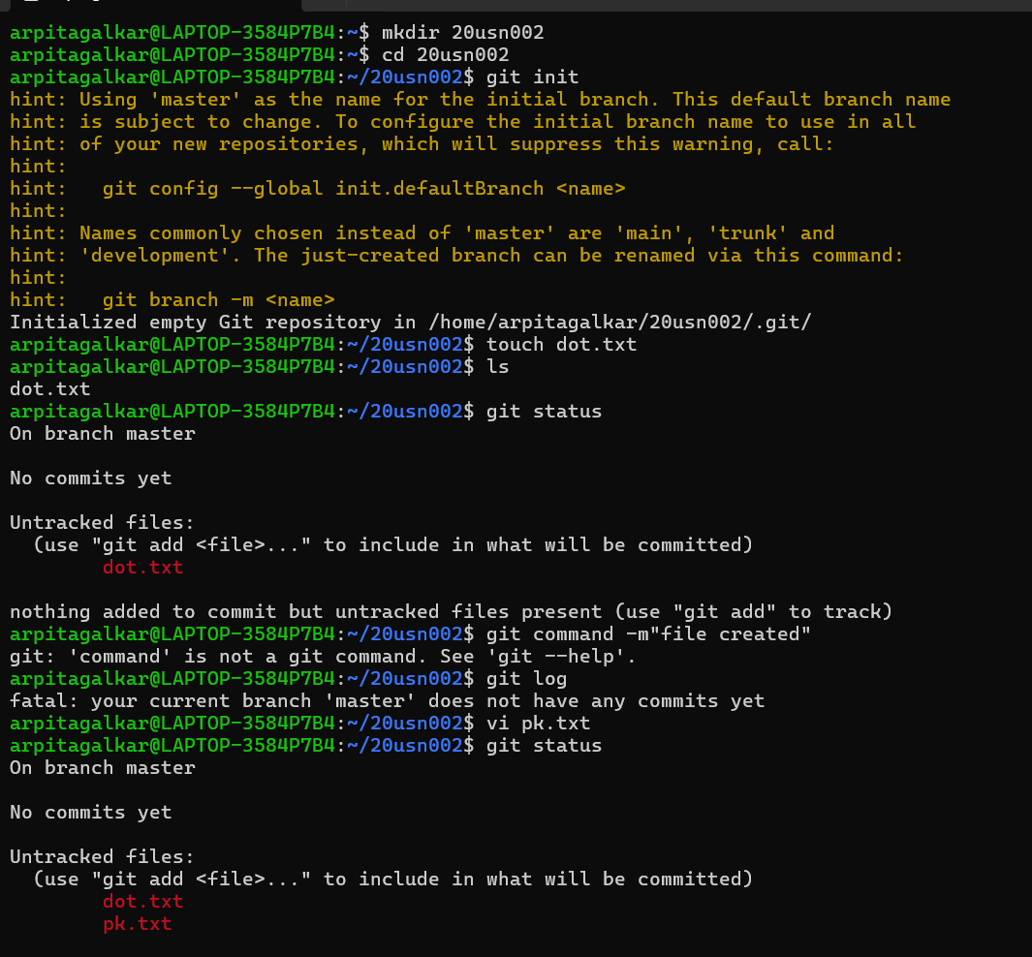

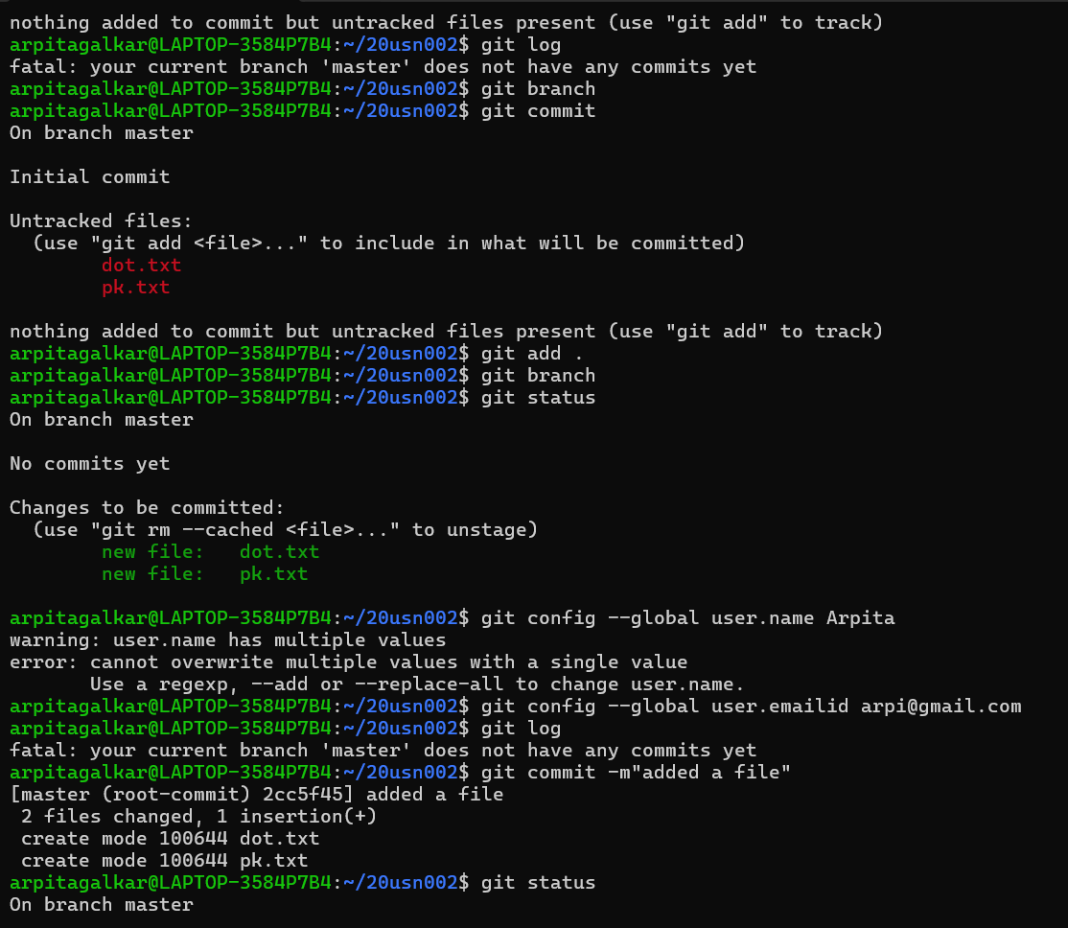

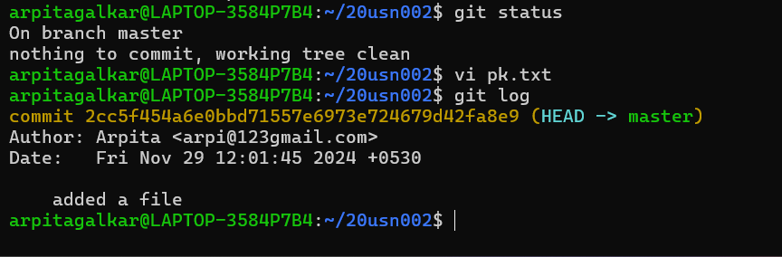

2.Creating and Managing Branches:

* Creating a new branch named “feature-branch.” Switch to the “master “ branch. Merge the “feature -branch” into “master.

Step 1:

* git branch feature-branch ->This will create a new branch of the master branch in which the contents and files are copied from the master branch.
* git branch->This command will show all the branches which we have made and the current branch will be in green colour.

Step 2:

* git checkout <branch name>-> It is used to switch one branch to another branch, Here we are moving from branch master to the feature-branch.
* And also we can edited the file(file.txt).

Step 3:

* Here in the feature-branch we staged the file and commit with appropriate message that “1st line of FB(v1)”.
* So here the file has been changed, but in the master branch it will be as it is until we merge the feature-branch with the master branch.

Step 4:

* For merging the file to the master branch we first need to move to the main /master branch using “git checkout master” command.
* Then we can merge the branch with “git merge feature-branch” command.
* So, now the files will be merged ,the changes or the edits in the feature-branch will be merged.

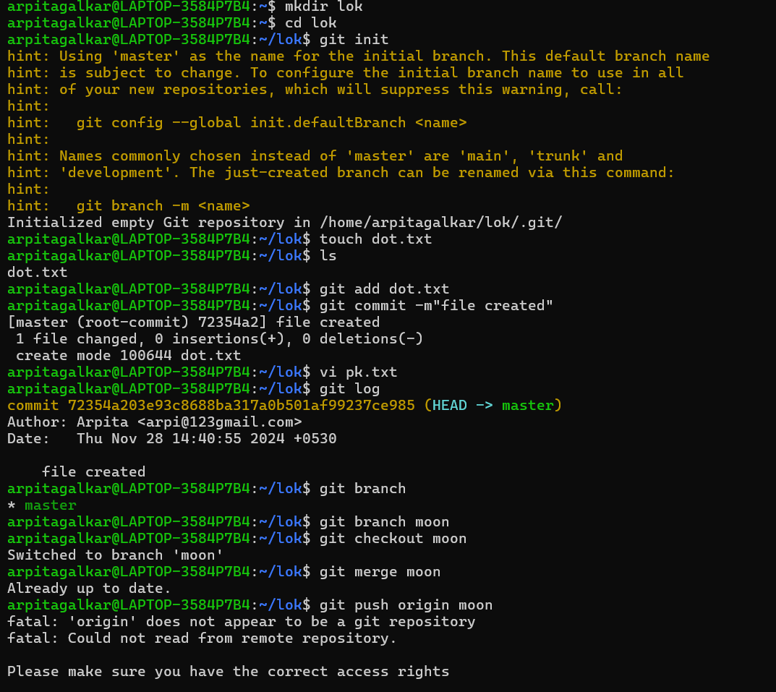

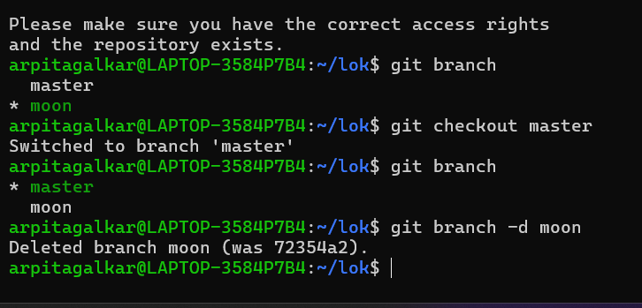

3.Creating and Managing Branches:

* Write the commands to stash your changes, switch branches , and then apply the stashed changes.

Step 1:

* Moving to the feature branch and have made the changes in the file(file .txt) using the commands git checkout feature branch and vi file.txt for the changing the branch and editing the file respectively.
* Here we have not staged and committed the changes in the file(file.txt).

Step 2:

* In this step we have stashed the changes which have been made in the file.txt file in the feature branch .
* Here we have not added / staged the file and committed the changes .
* The changes will be saved in the branch without the committing the changes.
* The command used for stashing the changes is “git stash”.

Step 3:

* Before applying the changes made in the feature branch, first we need move to the master branch.
* Then in the master branch we applied the stash using “git stash apply” where changes made in the feature branch.
* After applying the stash to the master .It will give us a message saying that the applied stash is not staged and committed in the master branch.

Step 4:

* After stashing we check status using “git status” ,there it shows that the file(file.txt) is modified but not staged yet.
* After staging ,if we check the status again it shows that changes to be committed yet.
* Committed with appropriate message that “FB code & stash code”.
* After committing the changes we can see the log of the repository.

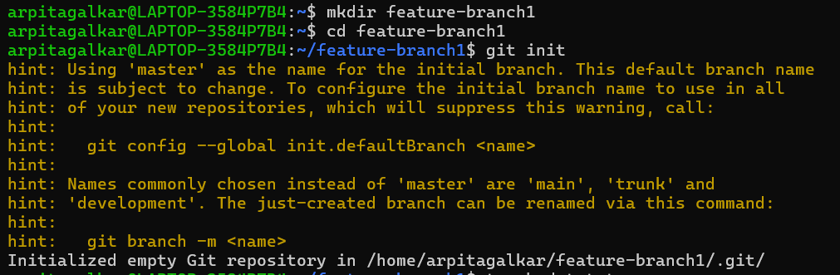

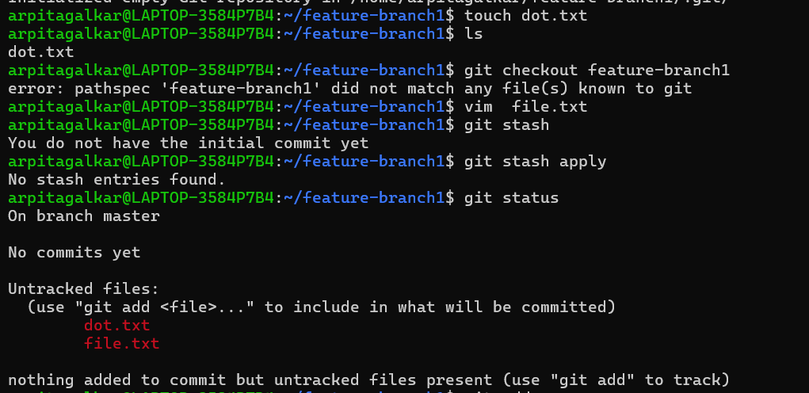

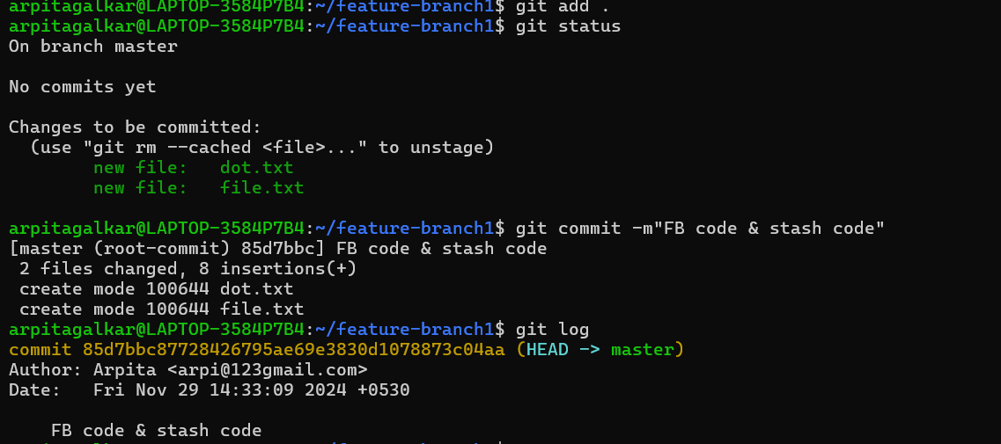

4.Collaboration And Remote Repositories:

* Clone a remote Git repository to your local machine.

Step 1:

* To clone a remote git repository, first we need to open the github.com and open any one of the account on the github.com.
* After that we have choosen the repository which we want to clone into our local machine.
* After choosing the repository, in that repository we cliked on the green botton “code” , which open a drop down list of links in that ,we copied the “HTTPS” link from that -><http://github.com/ArpitaGalkar/Arpita.git>

Step 2:

* In the second step we want to open our git bash and in some directory where you need to clone the remote repository we need to move to that location using “cd<path name>” command.
* Here we want to copy the repository to the folder clone in the c so we move to that location.
* git clone <http://github.com/ArpitaGalkar/Arpita.git> ->This command will copy the repository from remote to the local machine in the working directory.
* You can see above the “Arpita “ repository is successfully copied in the clone directory/folder.

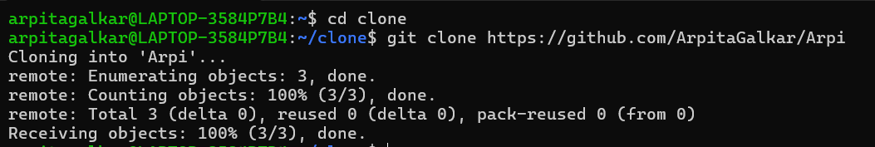

5.Collaboration And Remote Repositories:

* Fetch the latest changes from a remote repository and rebase your local branch onto the updated remote branch.

Step 1:

* To fetch and rebase the remote repository to local repository, we will move to the already cloned repo.
* Initially before fetching the changes from the remote repo the last commit was “created onefile” after logging the commits.

Step 2:

* git fetch origin/ git fetch ->This will fetch the latest changes from the remote repo that is the file named “special_note” which was created and committed.
* These changes after fetching will not be available in the working directory.

Step 3:

* git rebase origin -> This command is used to bring the changes which are fetched and present in the local repo to the working directory.
* After rebasing the remote branch to local branch, the commit which are made in the remote repo that will added to local branch.

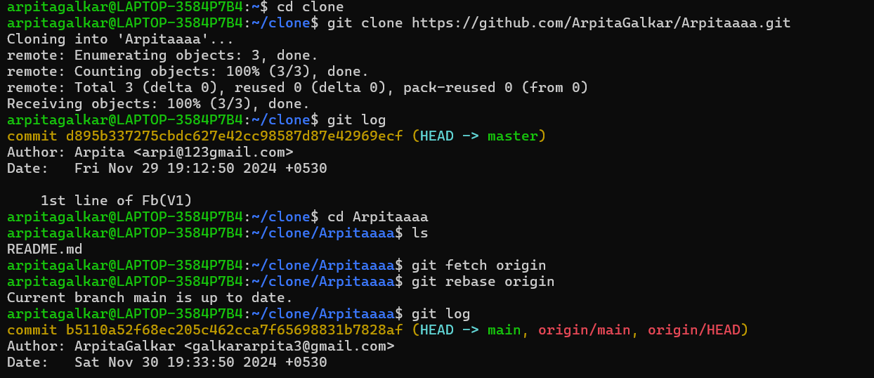

6.Collaboration and Remote Repositories:

* Write the command to merge "feature-branch" into "master" while providing a custom commit message for the merge.
* Move to the feature branch and make some changes in the that branch ,stage and commit the changes.
* For committing we can use additional/optional → -m “message” , will commit the state with appropriate message.
* Then checkout to the master branch and merge the branch.

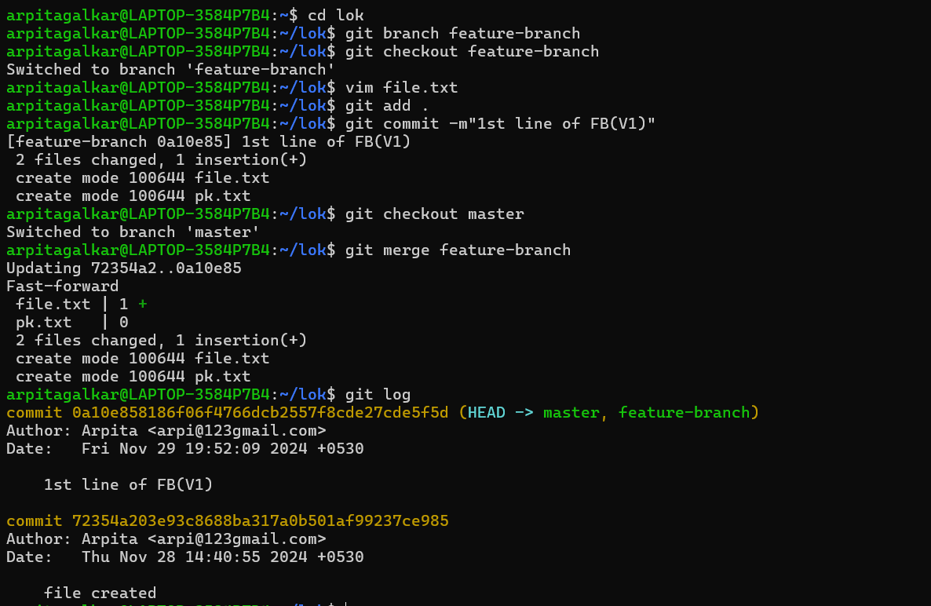

7. Git Tags and Releases:

* Write the command to create a lightweight Git tag named "v1.0" for a commit in your local repository.

Step1:

* git tag v1.0 ->this will create a tag of the latest commit (or we can specify the particular commit with commit ID) or we can also add a tag message using -> -m “message”.
* git tag-> this command will show the all tags made i.e , v1.0 created.
* git show v1.0 -> this will show details in that tag(v1.0) with full description.

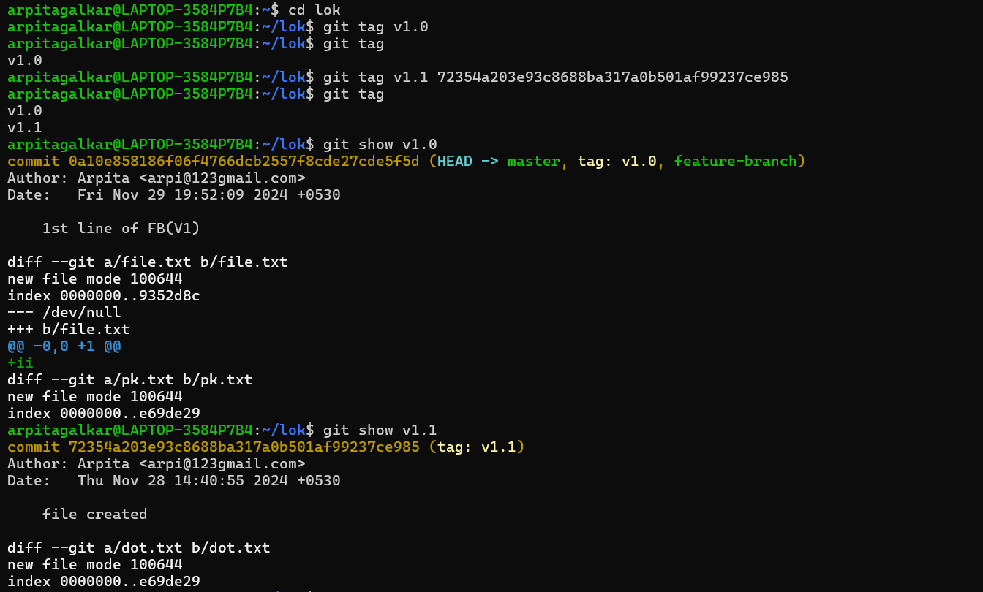

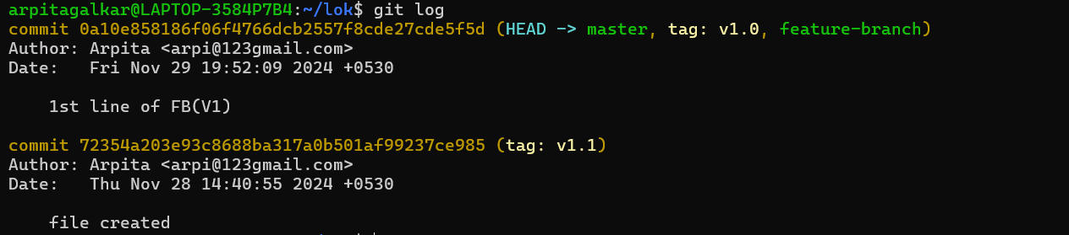

8. Advanced Git Operations:

* Write the command to cherry-pick a range of commits from "source-branch" to the current branch.
* Create a branch named source branch and check out to the source branch.
* And make the first some change in thefile.txt file.
* Stage and commit the changes with commit message saying “first commit in the source branch.
* Again make some changes in the file or add few more line in the file.txt file.
* Stage and commit the changes with message saying “SB edited”
* Here we want copy the commit ID to cherry-pick the specific state from the git log
* Now move to the master branch.
* Git cherry-pick <commit ID> -> this will take the mentioned commit ID stage and merge to the master branch.
* Main advantage of using cherry pick is we can pick the required snapshot from the branches and add to the master branch.
* Here we can see the content of the file.txt file at that snapshot is added to the master.

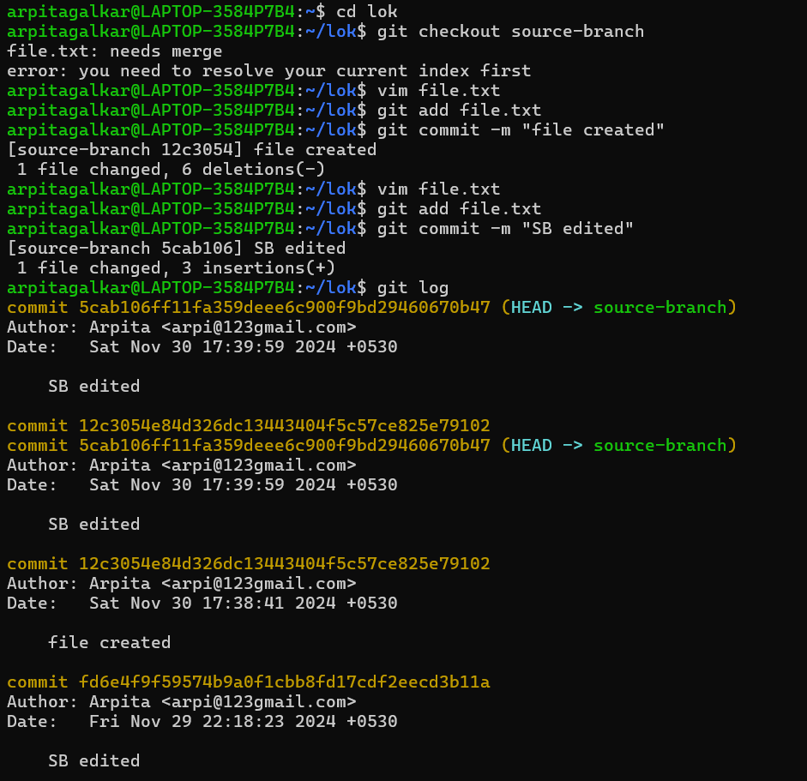

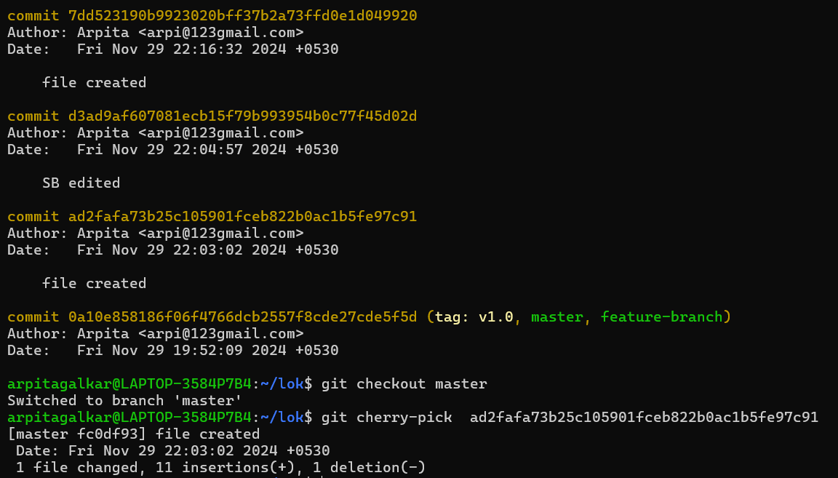

9. Analyzing and Changing Git History:

* Given a commit ID, how would you use Git to view the details of that specific

commit, including the author, date, and commit message?

Step1:

* To view the details of the specific commit including author, date and commit message

we should copy the specific commit which you want to view in detail.

* git show <commit ID> -> this will show the full detail of the commit ID

mentioned ,added changes will be shown in green colour and deleted changes will be

shown in red colour.

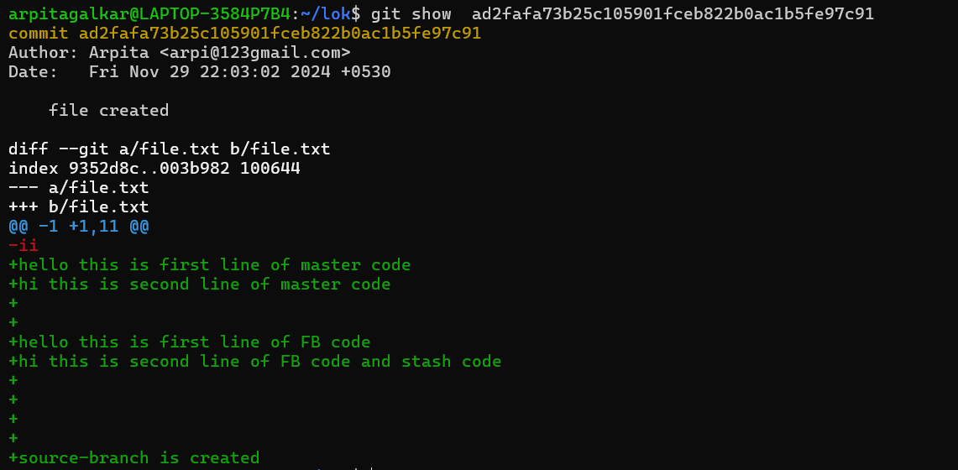

10. Analysing and Changing Git History:

* Write the command to list all commits made by the author "John Doe"

between "2024-01-27" and "2023-01-28."

* git log --author="Sakshi" --since="2024-02-09" --until="2024-02-11" ->this will show all

the commits made by the author “Sakshi” b/w dated “2024-02-09" and "2024-02-11"

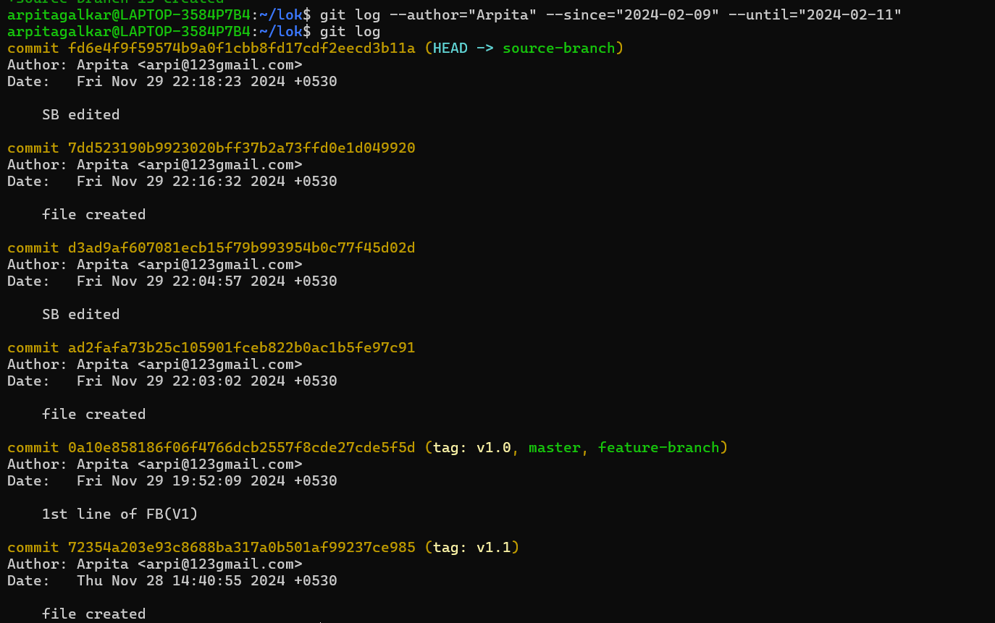

11. Analyzing And Changing Git History:

* Write the command to display the last five commits in the repository's history.
* git log –n ->this will display last n no. of commits. Here n is 5.

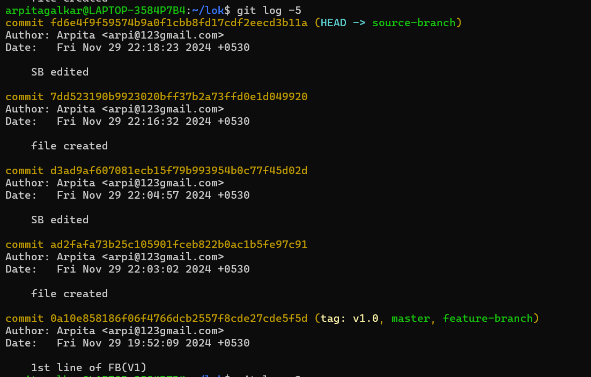

12. Analyzing and Changing Git History:

* Write the command to undo the changes introduced by the commit with

the ID "abc123".

Step 1:

* The above image is before reverting.
* git revert <commit ID> ->this will revert to the that stage of commit.
* The above image is after reverting.



