|  |  |
| --- | --- |
| Name: | Tanu Choudhary |
| UID: | 23BCS13560 |
| Subject: | ADBMS |
| Section: | 620-B |

# Part A: Insert Multiple Fee Payments in a Transaction

Ans:

# Code:

-- Make sure table exists

CREATE TABLE IF NOT EXISTS FeePayments (

payment_id INT PRIMARY KEY, student_name VARCHAR(100) NOT NULL,

amount DECIMAL(10,2) CHECK (amount > 0), payment_date DATE NOT NULL

) ENGINE=InnoDB;

-- Start transaction START TRANSACTION;

INSERT INTO FeePayments (payment_id, student_name, amount, payment_date) VALUES

(1, 'Bhumi', 5000.00, '2024-06-01'),

(2, 'Smaran', 4500.00, '2024-06-02'),

(3, 'Vaibhav', 5500.00, '2024-06-03'); COMMIT;

SELECT * FROM FeePayments;

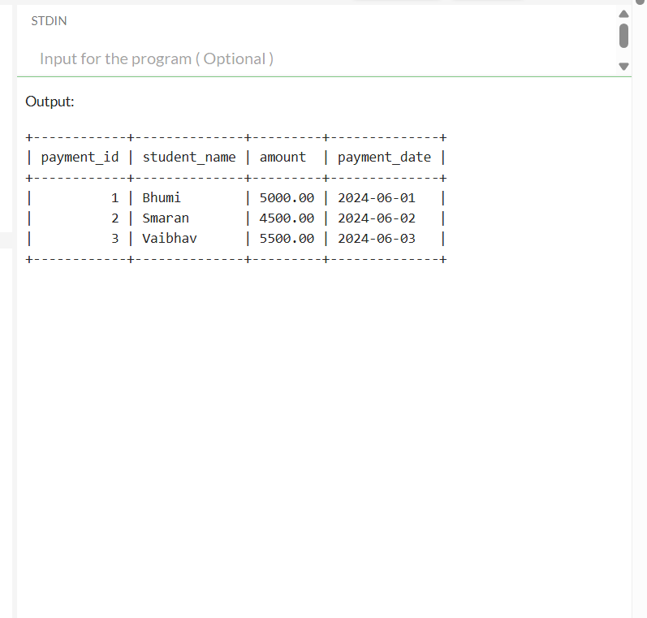

# Part B: Demonstrate ROLLBACK for Failed Payment Insertion

IF OBJECT_ID('FeePayments', 'U') IS NOT NULL

DROP TABLE FeePayments; GO

CREATE TABLE FeePayments ( payment_id INT PRIMARY KEY,

student_name VARCHAR(100) NOT NULL, amount DECIMAL(10,2) CHECK (amount > 0), payment_date DATE NOT NULL

); GO

BEGIN TRANSACTION;

INSERT INTO FeePayments (payment_id, student_name, amount, payment_date) VALUES

(1, 'Ashish', 5000.00, '2024-06-01'),

(2, 'Smaran', 4500.00, '2024-06-02'),

(3, 'Vaibhav', 5500.00, '2024-06-03');

COMMIT; GO

SELECT * FROM FeePayments; GO

BEGIN TRANSACTION;

INSERT INTO FeePayments (payment_id, student_name, amount, payment_date) VALUES (4, 'Kiran', 4800.00, '2024-06-04');

-- Invalid insert (duplicate payment_id and negative amount)

INSERT INTO FeePayments (payment_id, student_name, amount, payment_date) VALUES (1, 'Ashish', -500.00, '2024-06-05');

ROLLBACK;

GO

SELECT * FROM FeePayments;

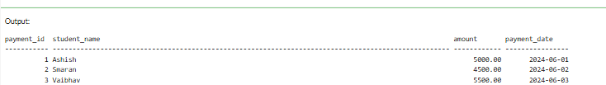

# Part C: Simulate Partial Failure and Ensure Consistent State

IF OBJECT_ID('FeePayments', 'U') IS NOT NULL

DROP TABLE FeePayments; GO

CREATE TABLE FeePayments ( payment_id INT PRIMARY KEY,

student_name VARCHAR(100) NOT NULL, amount DECIMAL(10,2) CHECK (amount > 0), payment_date DATE NOT NULL

); GO

BEGIN TRANSACTION;

INSERT INTO FeePayments (payment_id, student_name, amount, payment_date)

VALUES

(1, 'Ashish', 5000.00, '2024-06-01'),

(2, 'Smaran', 4500.00, '2024-06-02'),

(3, 'Vaibhav', 5500.00, '2024-06-03');

COMMIT; GO

-- Verify initial records

SELECT * FROM FeePayments; GO

BEGIN TRANSACTION;

-- Valid insert

INSERT INTO FeePayments (payment_id, student_name, amount, payment_date) VALUES (4, 'Kiran', 4800.00, '2024-06-04');

-- Invalid insert (student_name is NULL)

INSERT INTO FeePayments (payment_id, student_name, amount, payment_date) VALUES (5, NULL, 4600.00, '2024-06-05');

-- Rollback entire transaction due to failure ROLLBACK;

GO

SELECT * FROM FeePayments; GO

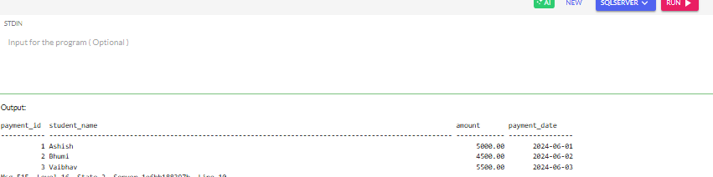

Part D: Verify ACID Compliance with Transaction Flow CREATE TABLE FeePayments (

payment_id INT PRIMARY KEY, student_name VARCHAR(100) NOT NULL,

amount DECIMAL(10,2) CHECK (amount > 0), payment_date DATE NOT NULL

); GO

BEGIN TRANSACTION;

INSERT INTO FeePayments (payment_id, student_name, amount, payment_date) VALUES

(1, 'Ashish', 5000.00, '2024-06-01'),

(2, 'Smaran', 4500.00, '2024-06-02'),

(3, 'Vaibhav', 5500.00, '2024-06-03'); COMMIT;

GO

BEGIN TRANSACTION;

INSERT INTO FeePayments (payment_id, student_name, amount, payment_date) VALUES (4, 'Kiran', 4800.00, '2024-06-04'); -- valid

INSERT INTO FeePayments (payment_id, student_name, amount, payment_date) VALUES (1, 'Ashish', -500.00, '2024-06-05'); -- invalid: duplicate + negative ROLLBACK;

GO

BEGIN TRANSACTION;

INSERT INTO FeePayments (payment_id, student_name, amount, payment_date) VALUES (5, 'Neha', 5000.00, '2024-06-05'); -- valid

INSERT INTO FeePayments (payment_id, student_name, amount, payment_date) VALUES (6, NULL, 4600.00, '2024-06-06'); -- invalid: student_name NULL ROLLBACK;

GO

BEGIN TRANSACTION;

INSERT INTO FeePayments (payment_id, student_name, amount, payment_date) VALUES (7, 'Rohit', 4700.00, '2024-06-06');

COMMIT; GO

BEGIN TRANSACTION;

INSERT INTO FeePayments (payment_id, student_name, amount, payment_date) VALUES (8, 'Simran', 4800.00, '2024-06-07'); -- valid

INSERT INTO FeePayments (payment_id, student_name, amount, payment_date) VALUES (1, 'Ashish', 5000.00, '2024-06-01'); -- invalid

ROLLBACK;

GO

BEGIN TRANSACTION;

INSERT INTO FeePayments (payment_id, student_name, amount, payment_date) VALUES (9, 'Ankit', 4600.00, '2024-06-08');

COMMIT; GO

SELECT 'Final ACID-Compliant Table' AS Stage; SELECT * FROM FeePayments ORDER BY payment_id; GO

