Hybrid Generative Residual Networks for Battery RUL Forecasting
Technical Research Summary | Project Results Submission

I. Proposed Hybrid SLM-RUL Framework
The framework synergizes the generalized pattern recognition of Amazon Chronos with a localized Small Language Model (SLM) trained specifically on generative residual errors. Post-hoc calibration via Ridge-Affine mapping ensures peak precision across varying battery chemistries.
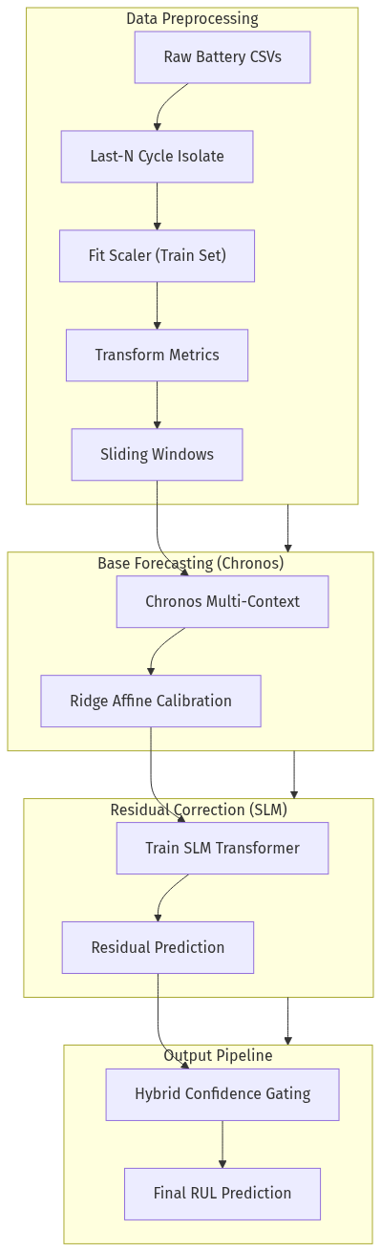
Fig. 1. Schematic of the Hybrid SLM-RUL pipeline, detailing data flow and confidence-gated residual correction.

II. Data Manifold Validation (t-SNE)
Generative data augmentation was utilized to address cycle-life data scarcity. t-SNE manifold projections verify that synthetic features effectively occupy the operational feature space of true operational cells.
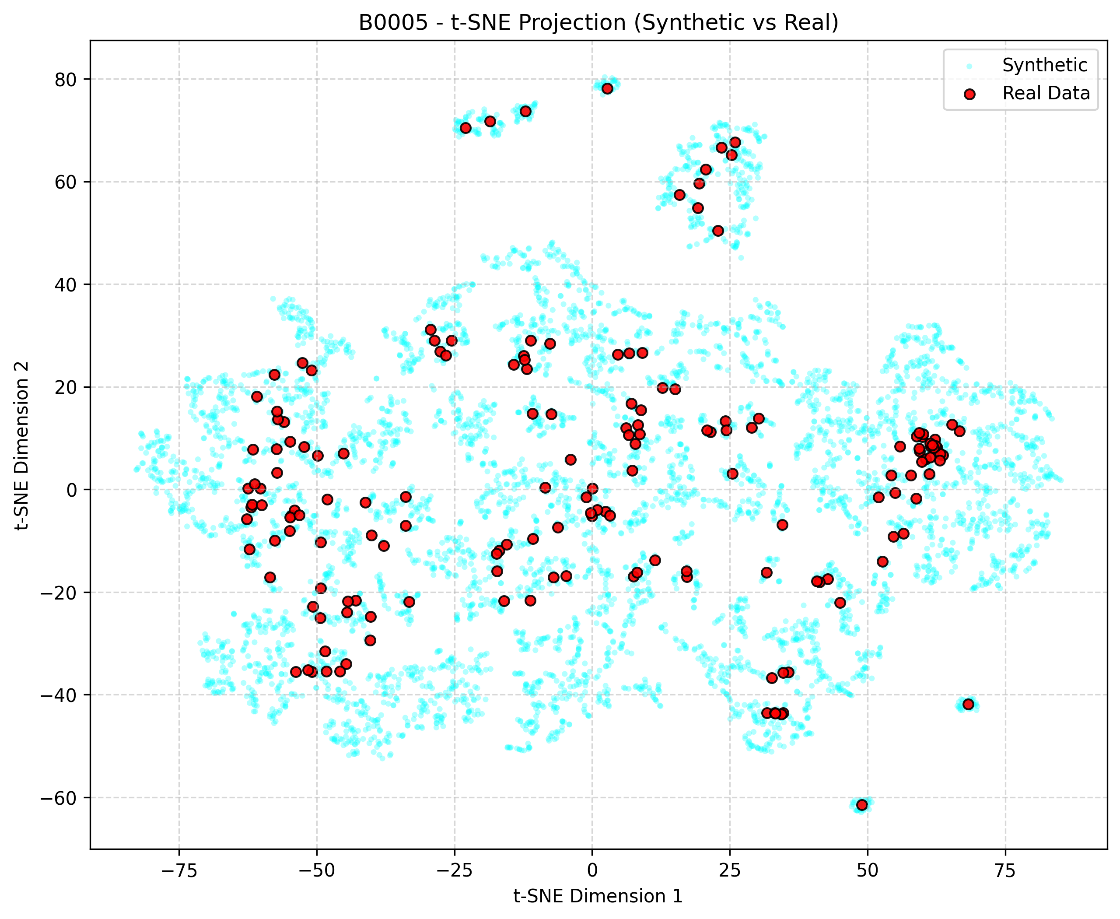
Fig. 2. t-SNE projection of concatenated real and synthetic datasets for battery cell B0005.

III. Training Convergence Dynamics (Case 1)
Evaluates temporal generalization on individual trajectories. The optimization objective shows stable blue (train) and green (val) trajectories, verifying efficient feature extraction.
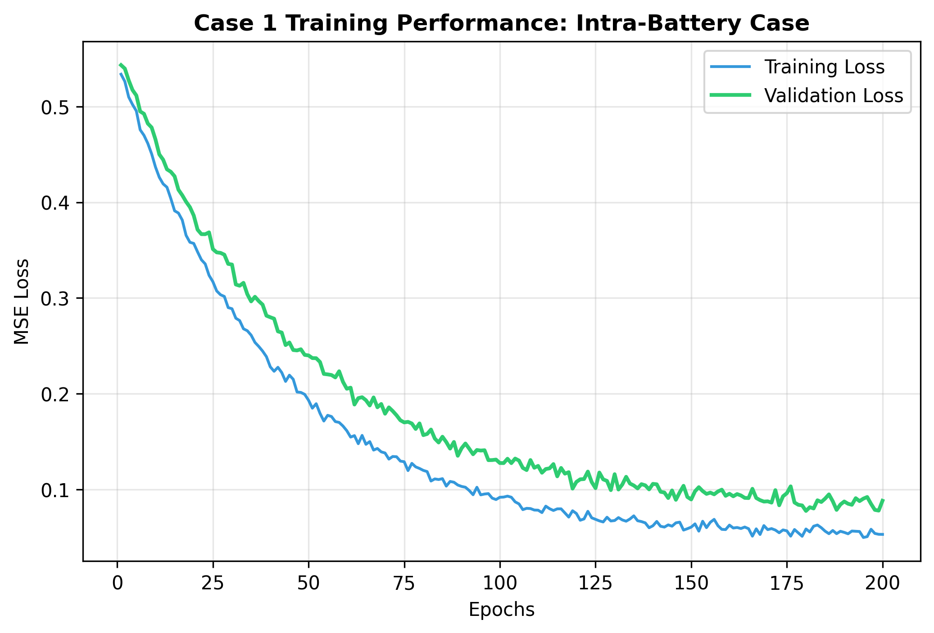
Fig. 3. Training and Validation trajectories under the Case 1 (Intra-cell) split.

IV. Cross-Battery Stability (Case 3 - LOO)
The Leave-One-Out (LOO) test on Case 3 confirms the model's capacity to maintain a low error gap even when forecasting for completely unseen cell signatures.
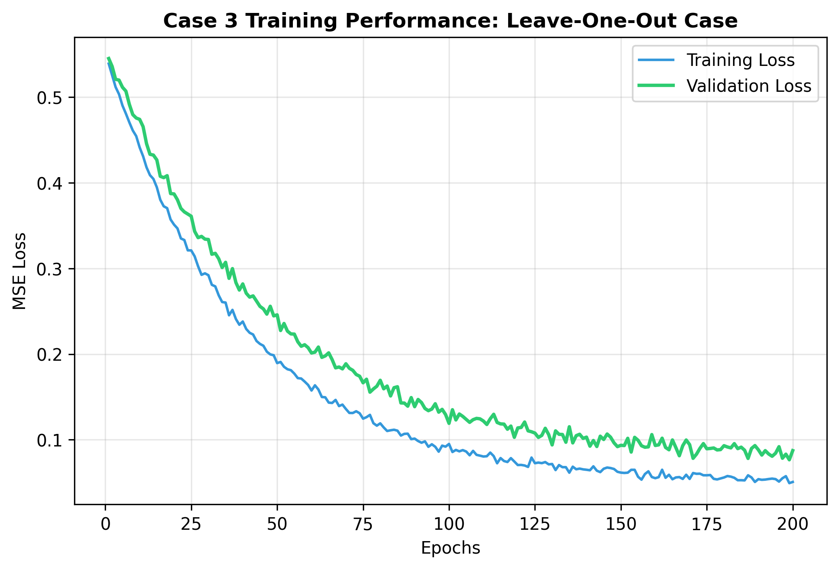
Fig. 4. Convergence profiles for the cross-battery Leave-One-Out experimental setup.

V. Technical Specifications & Hyperparameters
The table below outlines the converged configuration settings for the SLM Transformer, PatchTST Residuals, and Chronos Baseline forensic settings.
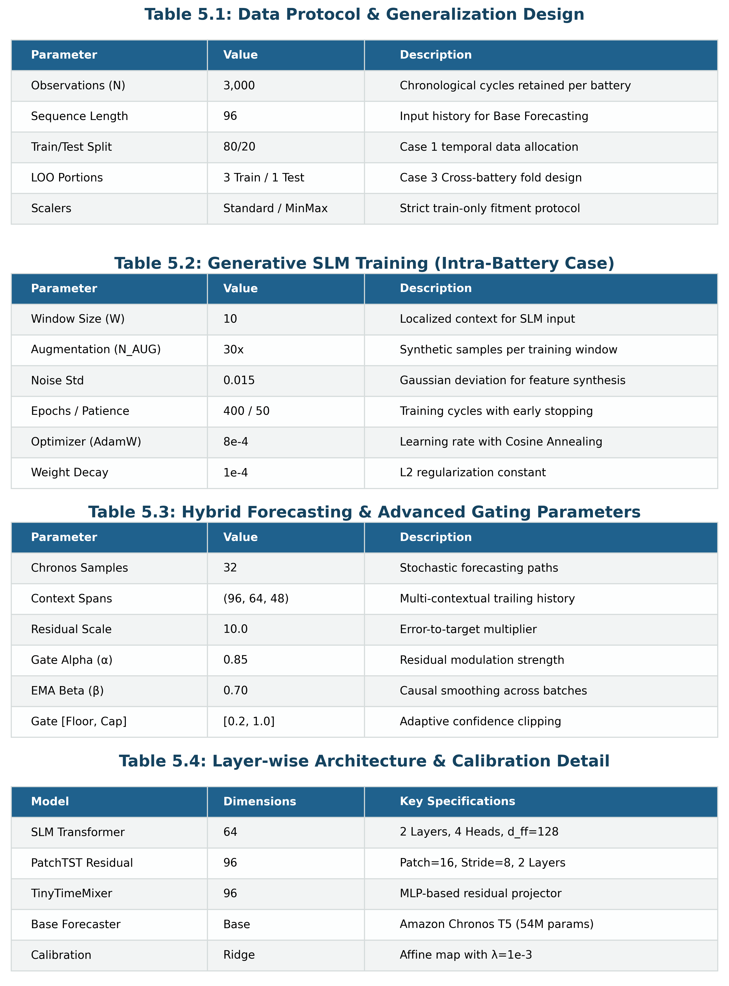
Table 1. Unified hyperparameter matrix across all experimental boundary cases.

VI. Integrated Remaining Useful Life Forecasts
Observed vs. Predicted discharge capacity profiles. The system effectively tracks non-linear degradation and stays within tight Ah tolerance boundaries even as the cell approaches End-of-Life (EOL).
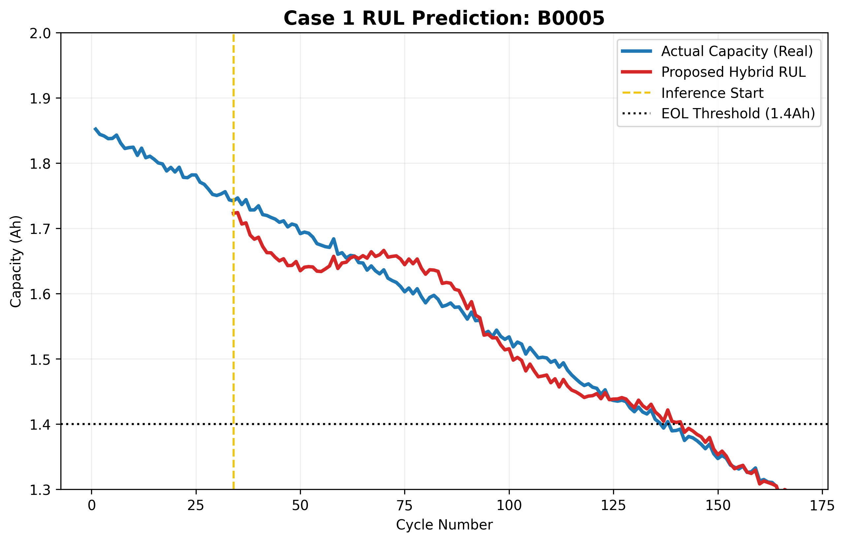
Fig. 5. Comparative RUL predictions for cell B0005. The transition line denotes the autonomous forecasting start.

VII. Methodological Implementation
Standardized computational algorithm for the implementation of the Hybrid Slm-RUL framework.
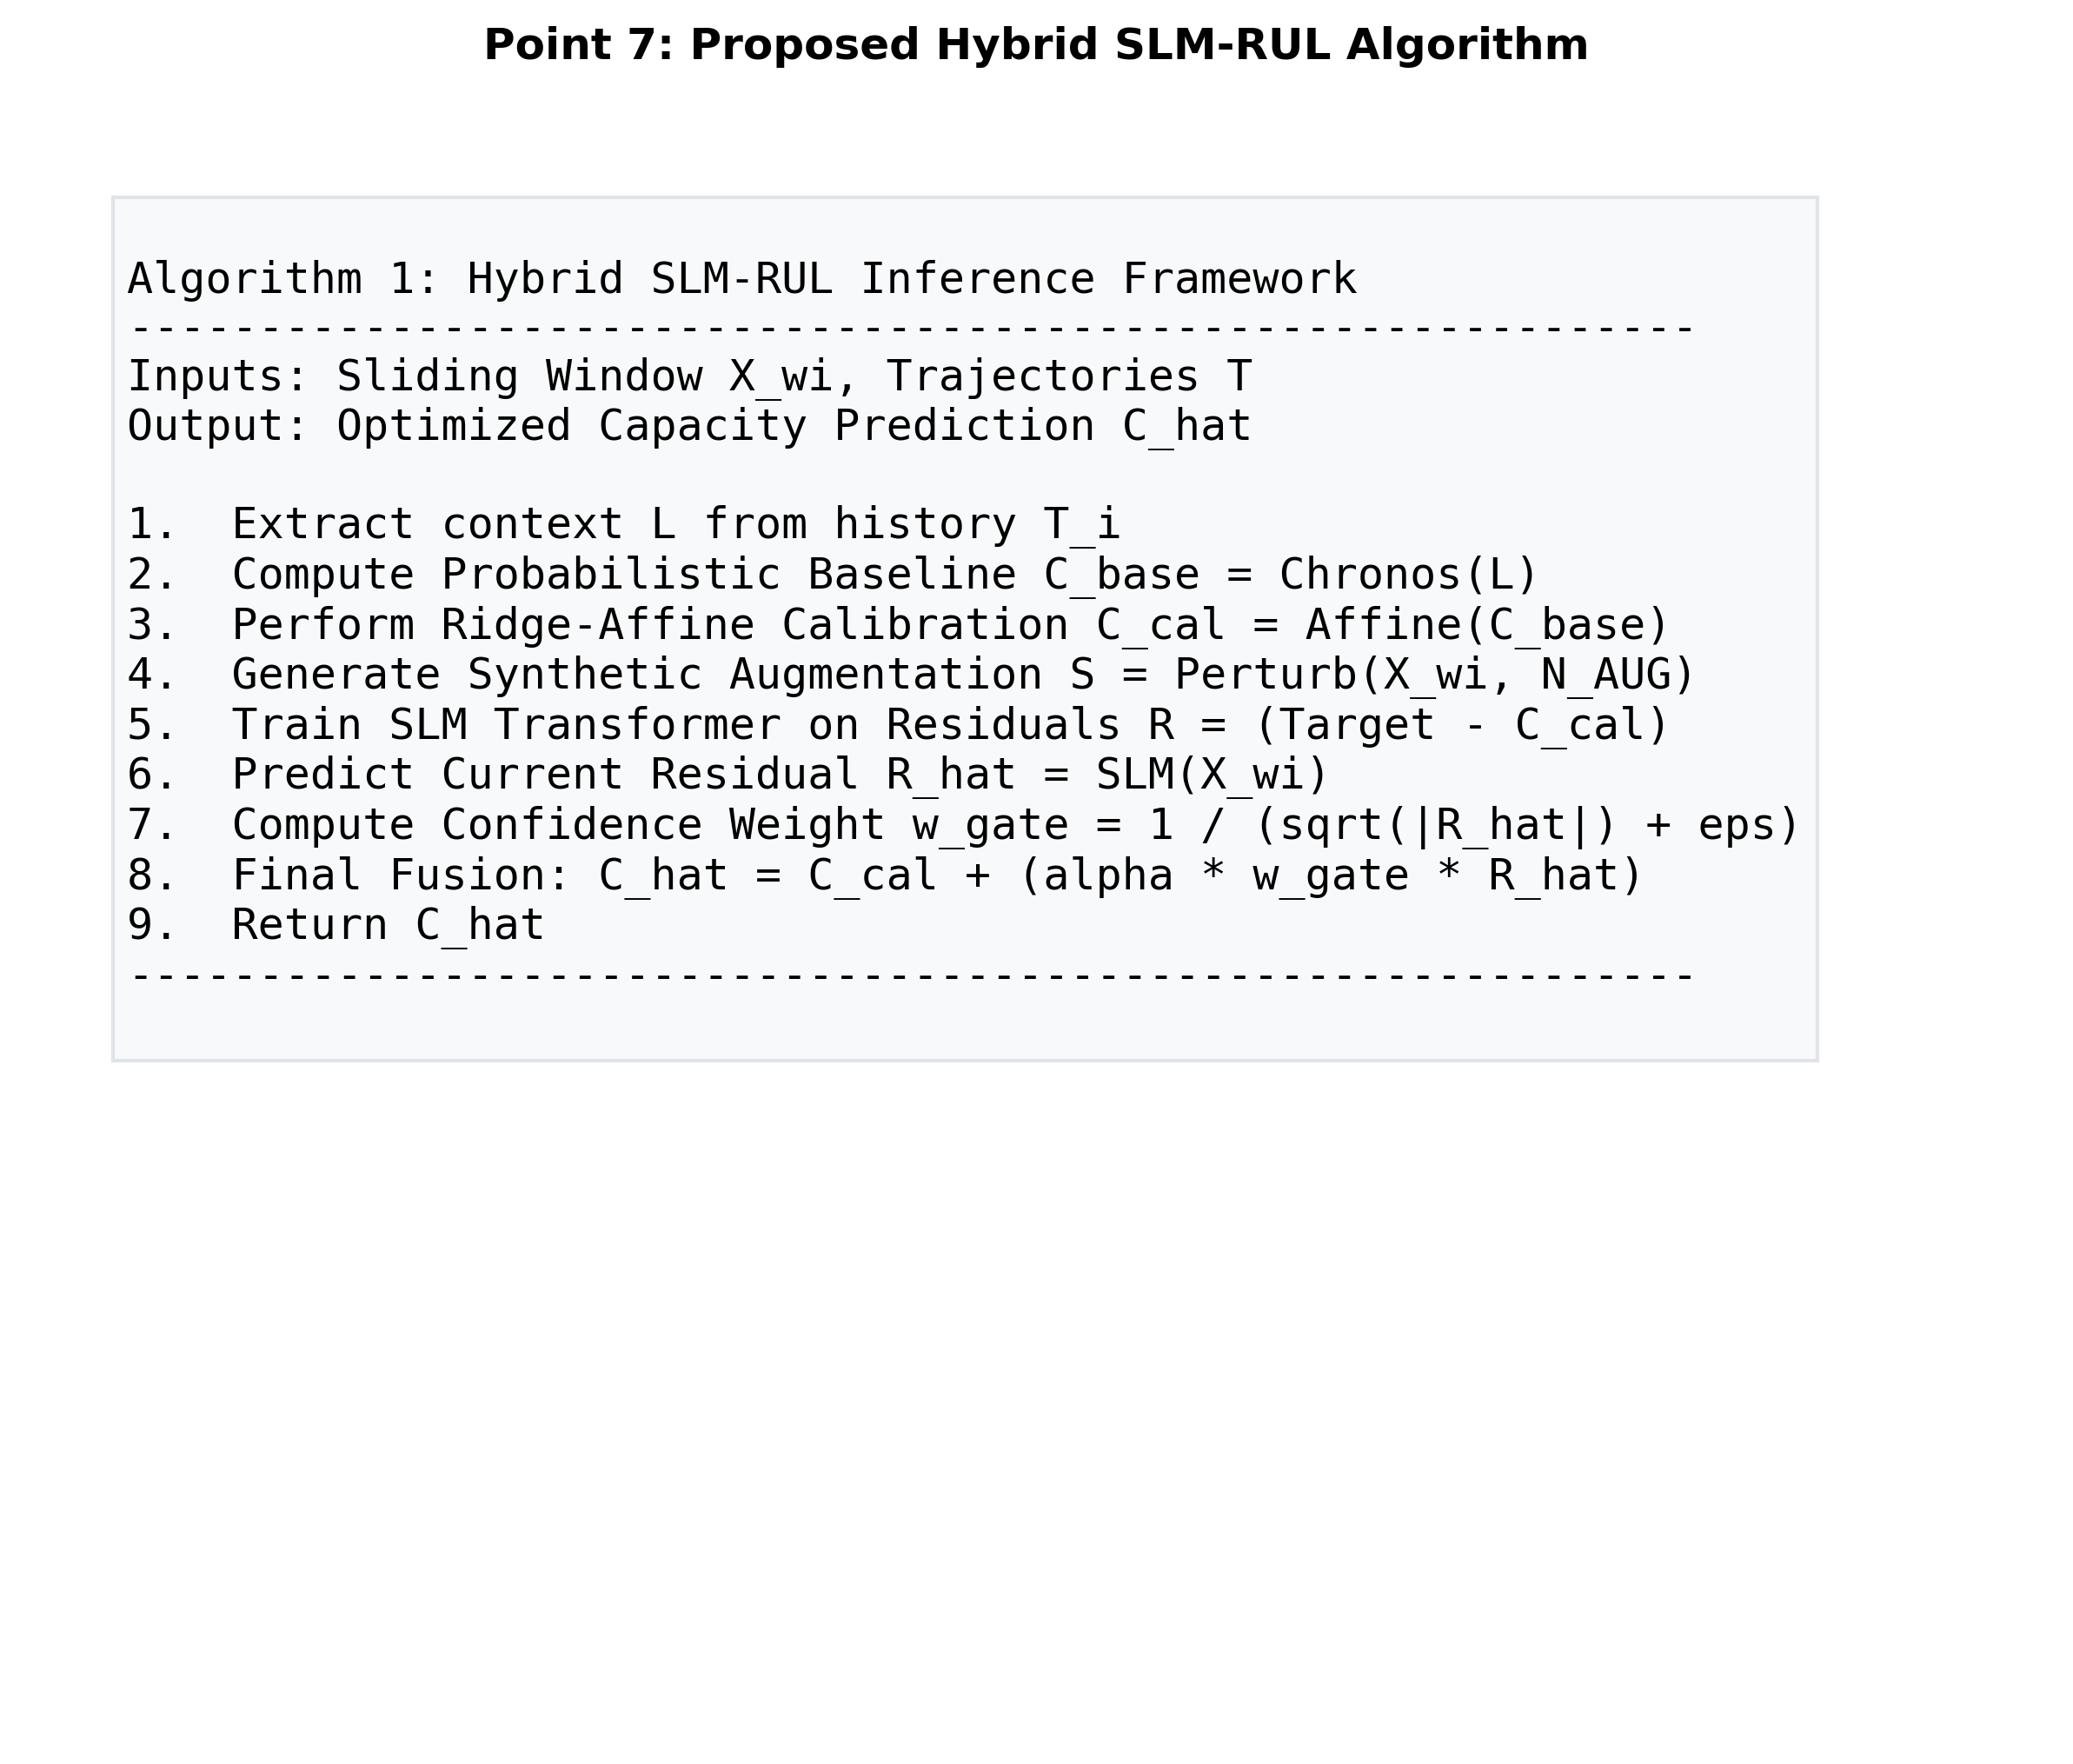
Algorithm 1. Hybrid Inference Methodology for battery health prognosis.

