|  |
| --- |
| **BATCH AND ROLL NO: Q7 42430** |
| **EXPERIMENT NO.6** |
| **TITLE:** Design a mobile application to Show any website using web view. |
| **DATE OF PERFORMANCE:** |
| **DATE OF SUBMISSION:** |

**Title:** Design a mobile application to Show any website using web view.

**Requirements:**

1 Android studio

**Theory:**

**Introduction**

The integration of web content into mobile applications has become an integral aspect of enhancing user experiences. In this lab, we will focus on designing a mobile application that incorporates a WebView component. The WebView allows the seamless display of web content within the application, providing users with the convenience of accessing external websites without leaving the app environment.

**Objective of the Lab:** The primary objective of this lab is to guide you through the process of designing a mobile application that utilizes a WebView to showcase content from external websites. By the end of this lab, you should be adept at implementing and customizing the WebView component, offering users a cohesive experience as they navigate web content within the confines of your mobile application.

**Components of the Application:** 1. **WebView Component:**

o The WebView is a versatile component that allows the embedding of web content directly into a mobile application. o It enables users to interact with and view external websites seamlessly, enhancing the overall application functionality.

**Lab Prerequisites:**

* Basic understanding of mobile application development concepts.
* Familiarity with the chosen development environment (e.g., Android Studio, Xcode).
* Prior knowledge of programming languages such as Java or Kotlin (for Android) or Swift (for iOS).

**Steps:**

**Step 1: Set Up Your Development Environment**

* Ensure that you have Android Studio installed and configured on your machine.

**Step 2: Create a New Project**

* Open Android Studio and create a new project.
* Choose an appropriate project template, such as "Empty Activity" or "Basic Activity."

**Step 3: Design the Main Activity Layout**

* Open the XML layout file associated with your main activity (e.g., activity_main.xml).
* Add a WebView component to your layout. You can use the WebView element in your XML file.

**Step 4: Implement the Java Code**

* Open the Java file associated with your main activity (e.g., MainActivity.java).
* In the onCreate method, retrieve the reference to the WebView from the XML layout using findViewById.
* Configure the WebView settings, such as enabling JavaScript, if required.

**Step 5: Test Your Application**

* Run your application on an emulator or a physical device.
* Verify that the WebView displays the content from the specified website.

**Step 6: Enhance WebView Functionality (Optional)**

* Implement additional features, such as handling WebView events (e.g., page loading), managing navigation, or enabling WebView controls.

**XML Code:**

**<?xml version="1.0" encoding="utf-8"?>**

**<RelativeLayout xmlns:android="http://schemas.android.com/apk/res/android" xmlns:app="http://schemas.android.com/apk/res-auto" xmlns:tools="http://schemas.android.com/tools" android:layout_width="match_parent" android:layout_height="match_parent" tools:context=".MainActivity" >**

**<WebView android:layout_width="match_parent" android:layout_height="match_parent" android:id="@+id/webview1"/>**

**</RelativeLayout>**

**Java Code:**

**package com.example.expt6AD;**

**import androidx.appcompat.app.AppCompatActivity;**

**import android.os.Bundle; import android.webkit.WebSettings; import android.webkit.WebView;**

**import android.webkit.WebViewClient;**

**public class MainActivity extends AppCompatActivity {**

**WebView webView; @Override**

**protected void onCreate(Bundle savedInstanceState) { super.onCreate(savedInstanceState);**

**setContentView(R.layout.activity_main);**

**WebView webview = findViewById(R.id.webview1); WebSettings webSettings = webview.getSettings(); webSettings.setJavaScriptEnabled(true); webview.setWebViewClient(new WebViewClient());**

**webview.loadUrl("https://www.pict.edu");**

**}**

**@Override public void onBackPressed() { if(webView.canGoBack()) webView.goBack(); else super.onBackPressed();**

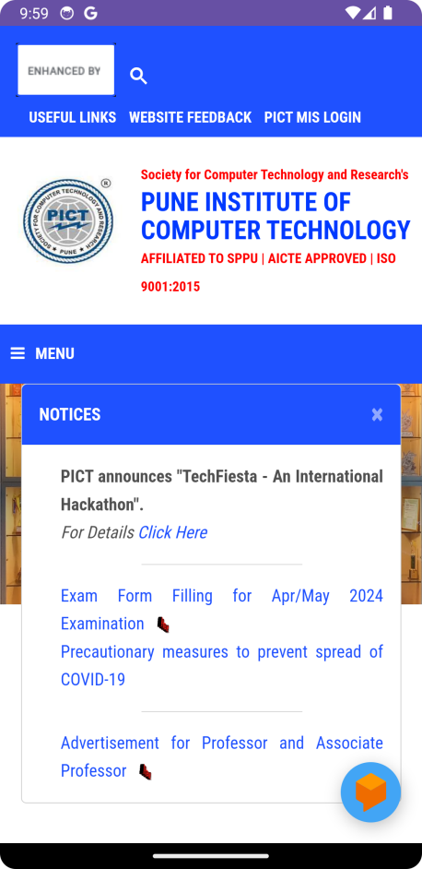

**Conclusion:**

**……………………………………………………………………………………………**

**……………………………………………………………………………………………**

**……………………………………………………………………………………………**

**……………………………………………………………………………………………**

**……………………………………………………………………………………………**

**……………………………………………………………………………………………**