
Rajiv Gandhi College of Arts, Commerce & Science, Vashi
{Permanently Affiliated to University of Mumbai}
Re-Accredited by NAAC, Grade ‘B’
Hindi Linguistic Minority Institute
Sector 10 A, Vashi, Navi Mumbai – 400703
DEPARTMENT OF COMPUTER SCIENCE
&
INFORMATION TECHNOLOGY
A PROJECT REPORT
on
OMASTRA — A Full-Stack E-Commerce Web Application for Sports Nutrition Retail
Submitted to

University of Mumbai
in partial fulfilment for the award of the degree
of
BACHELOR OF SCIENCE
in
COMPUTER SCIENCE
by
Mr. Om Sawant
under the guidance of
Asst. Prof. Sherin V
A.Y. 2026 – 27


DEPARTMENT OF COMPUTER SCIENCE &
INFORMATION TECHNOLOGY
CERTIFICATE
This is to certify that the project entitled
“OMASTRA — A Full-Stack E-Commerce Web Application
for Sports Nutrition Retail”
Is successfully completed by Mr. Om Sawant, Seat no. _______________, under the guidance of Asst. Prof. Sherin V during the academic year 2026-27 as per the syllabus, and the partial fulfillment for the award of the degree of Bachelor of Science in Computer Science of University of Mumbai.
________________________  Asst. Prof. Sherin V  Project Guide | ________________________  Asst. Prof. Anita Yadav  Co-ordinator
________________________  External Examiner | ________________________  Principal

DECLARATION
I, Om Sawant, hereby declare that the project report entitled "OMASTRA — A Full-Stack E-Commerce Web Application for Sports Nutrition Retail" submitted during the academic year 2026-27, under the guidance of Asst. Prof. Sherin V, in partial fulfilment of the requirements for the award of the degree of Bachelor of Science in Computer Science (B.Sc. CS) from Sainath Education Trust’s Rajiv Gandhi College of Arts, Commerce & Science, Vashi.
I further declare that all the source code, design artifacts, database schema, and documentation presented in this report are based on a project that I have personally designed and developed, and that this project has not been submitted, in part or in full, to any other University or Institution for the award of any degree or diploma.
Om Sawant

ACKNOWLEDGEMENT
I would like to take this opportunity to express our profound gratitude and deep regards to our esteemed Principal, Dr. B. S. Pandey, for providing a scholarly environment and for their exemplary leadership.
I am also thankful to the Co-ordinator of the Department of Information Technology and Computer Science, Asst. Prof. Anita Yadav, for her valuable support and for providing us with the necessary infrastructure and a conducive environment to carry out our project work.
I would like to express our deepest gratitude and sincere thanks to our project guide, Asst. Prof. Sherin V, for her invaluable guidance, constant encouragement, insightful suggestions and support throughout the course of this project. Her expertise and support were instrumental in the successful completion of this work.
Finally, I would like to thank my parents and friends for their unwavering support and encouragement throughout this journey.
Om Sawant

ABSTRACT
OMASTRA is a full-stack e-commerce web application built for the online retail of premium sports nutrition and fitness supplements. The platform is designed to give a modern sports nutrition brand or retailer a complete, self-hosted online storefront — covering product discovery, interactive multi-angle supplement inspection, flavour/size variant selection, shopping cart management, coupon-based discounts, checkout, order fulfilment, and a full administrative command center — without depending on a third-party marketplace or SaaS storefront builder.
The system follows the classic three-tier web architecture. The presentation tier is a single-page application built with React 18, Vite 5, and Tailwind CSS, offering a responsive customer storefront (home, shop with faceted search/filter/sort, Amazon-style 5-angle product gallery, persistent cart, wishlist, and a frictionless multi-step checkout) as well as a protected administrator dashboard for managing products, categories, orders, coupons, customers, and reviews. The application tier is a Node.js and Express REST API that exposes versioned endpoints secured with JSON Web Token (JWT) based authentication with HttpOnly cookies, role-based authorization (USER/ADMIN), rate limiting, and defensive security middleware (Helmet, CORS, Mongo sanitize). The data tier uses MongoDB with the Mongoose ODM, modelling users, products, categories, orders, coupons, and reviews as separate collections with well-defined schemas, validation rules, and relational references.
A key focus of the project is a realistic checkout and payment flow: customers may choose Cash on Delivery (COD) or complete online payment through the integrated Razorpay payment gateway (supporting UPI, Credit/Debit cards, and Net Banking), backed by rigorous server-side cryptographic signature verification (HMAC-SHA256) ensuring that payment confirmations cannot be forged from the client. The order pipeline performs live stock verification, atomic condition-checked stock decrements to prevent race-condition overselling, coupon validation and usage limit tracking, and dispatches automated order confirmations through transactional email.
The administrative side of the application provides real-time analytics — revenue, order volume, customer trends, and low-stock alerts computed using MongoDB aggregation pipelines and rendered via Recharts, alongside full CRUD management of the supplement catalogue, promotional coupons, customer accounts, and customer reviews. This report documents the complete software development life cycle followed while building OMASTRA — from requirement analysis and system design (DFDs, ER diagram, UML diagrams) through implementation, testing, and deployment — presenting the concrete source code, architecture, and design decisions used in the finished application.

Table of Contents
Sr. No. | Table of Contents | Page No.
1 | Introduction  1.1 Project Overview  1.2 Problem Statement  1.3 Objectives  1.4 Scope and Limitations  1.5 Development Methodology | 1 – 2
2 | System Analysis  2.1 Existing System  2.2 Limitations of Existing System  2.3 Proposed System  2.4 Feasibility Study  2.5 Advantages & Observations  2.6 Comparison with Alternatives  2.7 Risk Analysis | 3 – 5
3 | System Requirement Specifications  3.1 Hardware Requirements  3.2 Software Requirements  3.3 Functional Requirements  3.4 Non-Functional Requirements  3.5 Assumptions and Dependencies  3.6 Data Dictionary | 6 – 10
4 | System Design  4.1 System Architecture  4.2 Data Flow Diagram – Level 0  4.3 Data Flow Diagram – Level 1  4.4 Use Case Diagram  4.5 Activity Diagram  4.6 Entity-Relationship (E-R) Diagram  4.7 Class Diagram  4.8 Sequence Diagram  4.9 Deployment Diagram  4.10 Gantt Chart | 11 – 20
5 | Implementation and Technology Used  5.1 Module Description  5.2 Technology Stack  5.3 Project / Folder Structure  5.4 Frontend Implementation  5.5 Backend Implementation  5.6 Database Design  5.7 Authentication & Security  5.8 Payment Integration  5.9 REST API Endpoint Summary  5.10 Design Patterns Used | 21 – 27
6 | System Testing  6.1 Testing Strategies  6.2 Test Cases  6.3 Test Summary  6.4 Performance Testing  6.5 Unit Testing | 28 – 29
7 | Coding Source Code Listing | 30 – 42
8 | System Deployment and Screenshots  8.1 Deployment Architecture  8.2 Environment Variables  8.3 Deployment Steps  8.4 Monitoring and Logging  8.5 Application Screenshots | 43 – 54
9 | Conclusion & Future Enhancement  9.1 Conclusion  9.2 Current Limitations  9.3 Future Enhancements  9.4 Personal Learning Outcomes | 55
10 | Reference / Bibliography | 56

LIST OF ABBREVIATIONS
Abbreviation | Full Form
API | Application Programming Interface
BCAA | Branched-Chain Amino Acid
CORS | Cross-Origin Resource Sharing
COD | Cash on Delivery
CRUD | Create, Read, Update, Delete
D2C | Direct-to-Consumer
DFD | Data Flow Diagram
EAA | Essential Amino Acid
ER | Entity-Relationship
FR | Functional Requirement
HMAC | Hash-based Message Authentication Code
HTTP / HTTPS | HyperText Transfer Protocol (Secure)
JSON | JavaScript Object Notation
JWT | JSON Web Token
KPI | Key Performance Indicator
MERN | MongoDB, Express, React, Node.js
ODM | Object-Document Mapper
OTP | One-Time Password
REST | Representational State Transfer
SKU | Stock Keeping Unit
SMTP | Simple Mail Transfer Protocol
SPA | Single-Page Application
SQL / NoSQL | Structured Query Language / Not-only-SQL
TLS | Transport Layer Security
UI / UX | User Interface / User Experience
UML | Unified Modeling Language
UPI | Unified Payments Interface

1. INTRODUCTION
1.1 Project Overview
OMASTRA is a full-stack e-commerce web application developed specifically for the sports nutrition, fitness supplement, and wellness sector. The system comprises a rich, dynamic customer storefront allowing users to browse, filter, inspect, and purchase performance nutrition products (such as Whey Protein, Plant Protein, Creatine, Pre-Workouts, and Hydration electrolytes), alongside an integrated administrative command dashboard for managing the product catalogue, categories, orders, coupons, customer accounts, and product reviews. Built with React 18, Vite, Node.js, Express, and MongoDB Atlas, OMASTRA demonstrates a secure, high-conversion, full-stack D2C retail application.
1.2 Problem Statement
Sports nutrition brands in the Indian and global market face steep challenges when relying entirely on third-party aggregators (like Amazon, Flipkart, or HealthKart) or generic SaaS storefront platforms. Third-party marketplaces charge high seller commissions (often 15% to 25%), restrict access to direct customer data, prevent direct communication, and enforce rigid product listing layouts that fail to showcase critical nutrition facts, supplement facts panels, protein purity certifications, and multiple variant angles. Generic platforms also lack fine-grained control over dynamic promotions, tiered coupon codes, and custom checkout experiences (such as unified COD and Razorpay payment flows). Therefore, there is a distinct requirement for a modern, self-hosted, full-stack sports nutrition e-commerce platform that offers total ownership over brand identity, customer relationship data, product storytelling, and secure administrative controls.
1.3 Objectives
The primary engineering objectives of the OMASTRA project are:
1) To develop a responsive, mobile-first sports nutrition storefront with high visual impact and fast loading speeds.
2) To implement secure user registration, password authentication, and session handling using JWTs with HttpOnly cookies.
3) To build an interactive Amazon-grade 5-angle product gallery (Front, Angle, Supplement Facts, Infographic, Lifestyle) with variant selectors.
4) To implement multi-facet catalogue filtering, real-time search, price range filters, and dietary preference categorisation.
5) To build a robust cart and multi-step checkout workflow supporting both Cash on Delivery (COD) and Razorpay online payments with cryptographic HMAC-SHA256 verification.
6) To provide an administrative dashboard featuring live revenue and order analytics, product CRUD, inventory tracking, coupon management, and review moderation.
7) To ensure fault-tolerant, scalable, and defensive backend operations using Node.js, Express, MongoDB Atlas, and security middleware.
1.4 Scope and Limitations
Scope:
OMASTRA encompasses the complete lifecycle of supplement retail: customer registration and authentication, catalog browsing, detailed nutrition breakdown, dynamic variant pricing, persistent cart and wishlist management, coupon validation, multi-step checkout with address validation, online and COD payment processing, automated transactional order confirmation emails, order tracking, and verified customer reviews. It also provides an administrative portal for business monitoring, stock management, and fulfillment status updates.
Limitations:
The current implementation is designed for a single brand/retailer operating with standard Indian Rupees (INR) currency. It does not presently feature a multi-vendor seller marketplace, international multi-currency conversion, or automated multi-warehouse logistics dispatch. Razorpay online payment functions require live or sandbox credentials to process transactions, though the system degrades gracefully to Cash on Delivery when keys are absent.
1.5 Development Methodology
OMASTRA was developed following an agile, iterative, module-driven engineering methodology. Development progressed through distinct increments: architecture and database design, authentication and authorization, product catalog and multi-angle image engine, cart and state persistence, checkout and payment gateway integration, admin dashboard analytics, and end-to-end integration and security testing. Continuous testing and modular separation ensured that each component was validated for edge cases before being integrated into the master production build.

2. SYSTEM ANALYSIS
2.1 Existing System
Currently, emerging supplement brands primarily sell through commercial marketplaces (such as Amazon or Flipkart), social selling via Instagram and WhatsApp, or pre-packaged SaaS website builders. These approaches offer minimal flexibility in presenting technical supplement data, enforce heavy recurring monthly fees or sales commissions, and isolate the merchant from valuable direct-to-consumer relationships.
2.2 Limitations of Existing System
1) High Commission Costs: Marketplaces deduct significant commissions, eroding margins on premium supplements.
2) Restricted Brand Presentation: Generic storefronts cannot present multi-angle supplement facts, amino acid ratios, and purity badges.
3) Lack of Customer Data Ownership: Consumer contact details and buying behaviors are retained by third-party platforms.
4) Rigid Checkout & Promotions: Inability to execute custom tier discounts, instant coupon validation, and blended payment options.
5) Fragmented Stock Control: Decentralised inventory across external platforms frequently leads to stock discrepancies.
2.3 Proposed System
OMASTRA delivers an integrated, proprietary e-commerce ecosystem built specifically for fitness enthusiasts and athletes. It couples an ultra-fast React 18 single-page application with a scalable Express and MongoDB backend. Key capabilities include real-time faceted search, an Amazon-style 5-angle product gallery (front render, angle shot, nutrition facts label, macro breakdown infographic, and lifestyle usage), persistent local-storage synchronized shopping cart, multi-level promotions engine, dual payment processing (Razorpay and COD), and an executive admin suite with real-time KPI graphs.
2.4 Feasibility Study
a) Technical Feasibility
The project leverages proven modern web standards: React 18, Vite 5, Tailwind CSS, Node.js, Express, and MongoDB. These technologies possess vast documentation, rich ecosystem support, native JSON handling, and high asynchronous I/O throughput, making the stack exceptionally well-suited for high-traffic e-commerce.
b) Economic Feasibility
All core runtime dependencies, development frameworks, and database engines (MongoDB Community / Atlas Free Tier, Node.js, React) are open-source with zero licensing fees. Cloud hosting via Vercel (frontend) and Render (backend) remains cost-effective, establishing outstanding economic feasibility.
c) Operational Feasibility
The customer storefront follows established usability patterns, requiring zero user training. The administrative dashboard features an intuitive graphical interface for updating products, tracking inventory, moderating reviews, and changing order statuses with simple dropdown controls.
2.5 Advantages & Observations
1) Total Brand & Data Autonomy: Direct relationship with customers without intermediary fee deductions.
2) Interactive Nutrition Storytelling: Multi-angle gallery with benefits infographics and supplement facts panels.
3) Dual Payment Security: Cryptographically verified Razorpay transactions combined with zero-friction Cash on Delivery.
4) Real-Time Administrative Insights: Visual revenue charts, average order value indicators, and low-stock indicators.
5) Defensive Architecture: Atomic database transactions prevent overselling under high concurrency.
2.6 Comparison: Existing Alternatives vs. Proposed System
Aspect | Existing Marketplaces / Generic SaaS | OMASTRA (Proposed System)
Ownership & Branding | Restricted branding, merchant owns no buyer data | 100% full ownership of data, UI, and brand identity
Transaction Cost | 15% – 25% commission or recurring monthly subscriptions | Zero commissions; standard payment gateway fees only
Product Visualization | Generic single or double image upload layout | Amazon-grade 5-angle gallery with nutrition panels & infographics
Promotions & Coupons | Basic platform rules; add-ons required | Built-in dynamic coupon engine with expiry and spend thresholds
Payment Flexibility | Limited to marketplace processor | Seamless unified checkout supporting Razorpay & Cash on Delivery
Admin & Analytics | Basic reports locked behind enterprise pricing tiers | Built-in real-time analytics with Recharts and aggregation pipelines
2.7 Risk Analysis
Identified Risk | Business / Technical Impact | Mitigation Strategy in OMASTRA
Concurrent Overselling | Customer orders items that are out of stock | Atomic MongoDB findOneAndUpdate with condition { stock: { $gte: qty } }
Payment Tampering | Order marked as Paid without actual fund settlement | Server-side cryptographic HMAC-SHA256 signature verification
Compromised Session Tokens | Unauthorized account access or privilege escalation | HttpOnly secure cookies, short 15m access TTL, fail-fast JWT secret check
Coupon Abuse / Replay | Excessive revenue discounts applied multiple times | Server-side atomic usageLimit increment and expiry validation
Third-Party API Downtime | Checkout blocked if Razorpay experiences outage | Graceful fallback: COD remains fully active even during gateway downtime
Development DB Disconnection | Engineers unable to test locally without cloud cluster | Graceful local fallback configuration with comprehensive seed datasets

3. SYSTEM REQUIREMENT SPECIFICATIONS
3.1 Hardware Requirements
Component | Development Environment | Production Server (Minimum)
Processor | Dual-core 2.0 GHz Intel/AMD or Apple Silicon | Single vCPU 2.0 GHz (Cloud container / VM)
RAM | 8 GB RAM (16 GB recommended) | 1 GB RAM minimum, 2 GB recommended
Disk Storage | 10 GB available SSD space | 5 GB storage for container, logs & runtime
Network | Broadband internet connection | Stable HTTPS outbound connectivity (Atlas, Razorpay)
Client Display | 1366 × 768 or higher display resolution | Headless server environment
3.2 Software Requirements
Category | Technology / Specification
Operating System | Windows 10/11, Linux (Ubuntu), or macOS (Dev); Linux (Production)
Frontend Runtime & Framework | React 18.2, Vite 5.0, Tailwind CSS 3.4, React Router v6
Backend Runtime & Framework | Node.js 18+ LTS, Express 4.18
Database & ODM | MongoDB 6+ (MongoDB Atlas Cloud Cluster), Mongoose 8.x
State Management | TanStack React Query, React Context API
Data Visualization | Recharts 2.x
Security Middleware | Helmet, CORS, Express-Rate-Limit, Bcryptjs, JsonWebToken
Payment Gateway | Razorpay Node SDK & Razorpay Checkout.js
Transactional Mail | Nodemailer (Brevo / SMTP Relay)
Code Editor & VCS | Visual Studio Code, Git, GitHub
Browser Support | Google Chrome, Mozilla Firefox, Microsoft Edge, Safari (latest versions)
3.3 Functional Requirements
Customer Module:
1) User Authentication: Secure registration, login, logout, and profile management with HttpOnly cookies.
2) Catalogue Discovery: Filter products by category, dietary tags (Vegan, Keto, Gluten-Free), price range, and sort order.
3) Interactive Product Inspection: 5-angle high-resolution gallery with thumbnail switcher and zoom.
4) Variant Selection: Dynamically choose flavor options and package sizes with instant price and stock recalculation.
5) Cart & Wishlist Management: Add, update quantities, remove items, with localStorage persistence.
6) Promo Code Application: Validate coupons against cart subtotal with real-time feedback.
7) Multi-Step Checkout: Enter delivery address, choose COD or Razorpay, and receive order confirmation.
8) Order History & Tracking: View previous orders, delivery timelines, and order summaries.
Administrator Module:
1) Secure Admin Authentication: RBAC guard restricting admin features to verified administrator accounts.
2) Executive Dashboard: Real-time revenue figures, order count, customer volume, and sales charts.
3) Product Catalogue CRUD: Create new products, modify prices, assign multiple image URLs, and update stock.
4) Category Management: Create, edit, and organize product categories.
5) Order Fulfillment Pipeline: View all customer orders and transition statuses (Pending → Shipped → Delivered).
6) Promotion & Coupon Engine: Define promo codes with discount percentages, minimum orders, and expiry dates.
7) Review Moderation: Approve or reject customer reviews to ensure authentic community ratings.
3.4 Non-Functional Requirements
Requirement | Architectural Description in OMASTRA
Security | Passwords hashed via bcrypt (cost 12); sessions authenticated with HttpOnly JWTs; Razorpay payments validated server-side using HMAC-SHA256 signatures; API protected by Helmet and rate limiters.
Performance | Vite build optimizations, TanStack Query caching, MongoDB indexing on slugs, categories, and prices ensure sub-second response times.
Usability | Modern, accessible UI built with Tailwind CSS, supporting seamless navigation across desktop, tablet, and mobile displays.
Reliability | Centralized Express error handling, atomic condition-checked inventory decrements, and graceful fallback to COD ensure high availability.
Scalability | Stateless REST API design and document-oriented MongoDB schema enable horizontal scaling across containerized clusters.
Maintainability | Clean separation of routes, controllers, middleware, models, and custom React hooks facilitates easy codebase extension.
Auditability | Every order stores complete point-in-time snapshots of product pricing, discounts, shipping address, and payment status.
3.5 Assumptions and Dependencies
1) The user accesses the storefront through a modern browser supporting ES6 JavaScript and HTML5.
2) MongoDB Atlas cloud cluster is available and accessible via the specified connection URI.
3) Online payment functionality depends on active Razorpay merchant API keys; when absent, the platform allows checkout via COD.
4) Outbound order confirmation emails rely on valid Brevo / SMTP configuration; email exceptions are caught and logged without disrupting checkout.
5) The system operates with Indian Rupees (INR) as the base currency and standard Indian regional address formats.
3.6 Data Dictionary
User Collection Schema:
Field | Type | Constraint / Description
_id | ObjectId | Primary key (auto-generated by MongoDB)
name | String | Required, max 100 characters, trimmed
email | String | Required, unique, lowercase, regex-validated email format
phone | String | Optional/Required, trimmed, international phone pattern
password | String | Required, min 8 characters, hashed with bcrypt, select: false
role | String (enum) | Enum ['user', 'admin'], default 'user'
addresses | [AddressSchema] | Embedded array of saved user delivery addresses
createdAt / updatedAt | Date | Automatic timestamps managed by Mongoose
Product Collection Schema:
Field | Type | Constraint / Description
_id | ObjectId | Primary key (auto-generated)
name | String | Required, max 150 characters, trimmed
slug | String | Required, unique, lowercase, indexed URL slug
brand | String | Required, default 'OMASTRA'
category | String / ObjectId | Required, references Category schema, indexed
description | String | Required rich text product description
price / originalPrice | Number | Required, minimum 0; originalPrice for discount badges
stock | Number | Required, minimum 0, default 0
sku | String | Required, unique, uppercase SKU code
images | [String] | Array of 5 image URLs (Front, Angle, Back, Infographic, Lifestyle)
variants | [VariantSchema] | Embedded array of size and flavor options with price deltas
nutritionFacts | Object | Embedded document: protein, carbs, calories, BCAAs per serving
rating / reviewCount | Number | Aggregated customer rating (0-5) and count of reviews
isActive | Boolean | Default true; flag for archiving products
Order Collection Schema:
Field | Type | Constraint / Description
_id / orderId | ObjectId / String | Primary key; unique human-readable order tracking ID
user | ObjectId | Ref: User collection; user placing the order
items | [OrderItem] | Array of purchased items: product ID, name, image, price, qty, variant
shippingAddress | Object | Full snapshot of delivery address, city, state, pincode, phone
paymentMethod | String (enum) | Enum ['cod', 'razorpay'], default 'cod'
paymentStatus | String (enum) | Enum ['pending', 'paid', 'failed'], default 'pending'
razorpayDetails | Object | orderId, paymentId, signature verified by HMAC-SHA256
subtotal / discount / total | Number | Server-recomputed order amounts; total >= 0
status | String (enum) | Enum ['Pending', 'Confirmed', 'Processing', 'Shipped', 'Delivered', 'Cancelled']
createdAt / updatedAt | Date | Automatic timestamps for auditing and reporting

4. SYSTEM DESIGN
This chapter presents the architectural and behavioural design of the OMASTRA system using standard software engineering notations — Data Flow Diagrams (DFD), Unified Modeling Language (UML) diagrams, and timeline charts — derived directly from the implemented modules, endpoints, and database models of the application.
4.1 System Architecture
OMASTRA follows a three-tier web architecture: Presentation Tier (React 18 + Vite), Application Tier (Node.js + Express REST API), and Data Tier (MongoDB Atlas). External integrations include Razorpay for payments, Brevo for transactional order emails, and Cloudinary for media asset delivery.
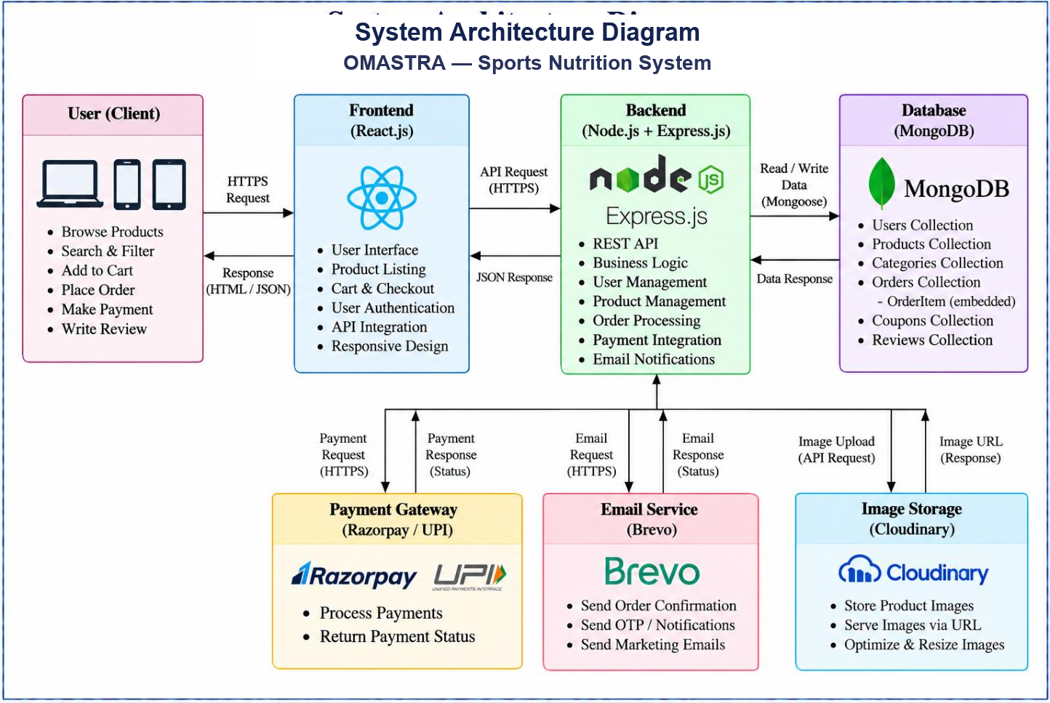
Fig. 4.1 — System Architecture
4.2 Data Flow Diagram — Level 0 (Context Diagram)
The Level 0 Context Diagram represents OMASTRA as a central system interacting with its external entities: Customer, Administrator, Payment Gateway (Razorpay), Email Service (Brevo), and Database (MongoDB).
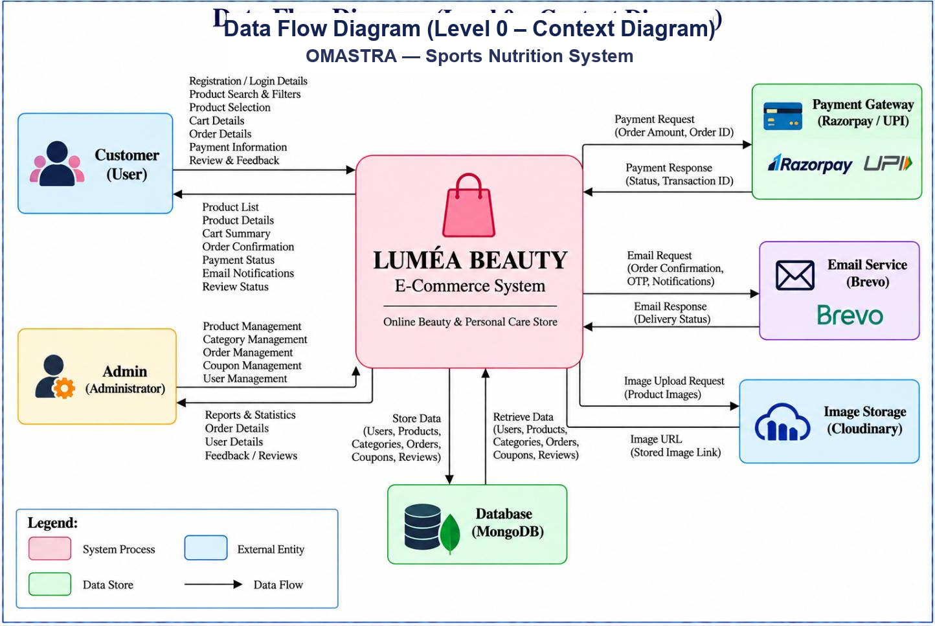
Fig. 4.2 — DFD Level 0 (Context Diagram)
4.3 Data Flow Diagram — Level 1
The Level 1 DFD decomposes the system into core sub-processes: User Authentication (1.0), Product Management (2.0), Cart Operations (3.0), Order Management (4.0), Payment Processing (5.0), and Review Moderation (6.0).
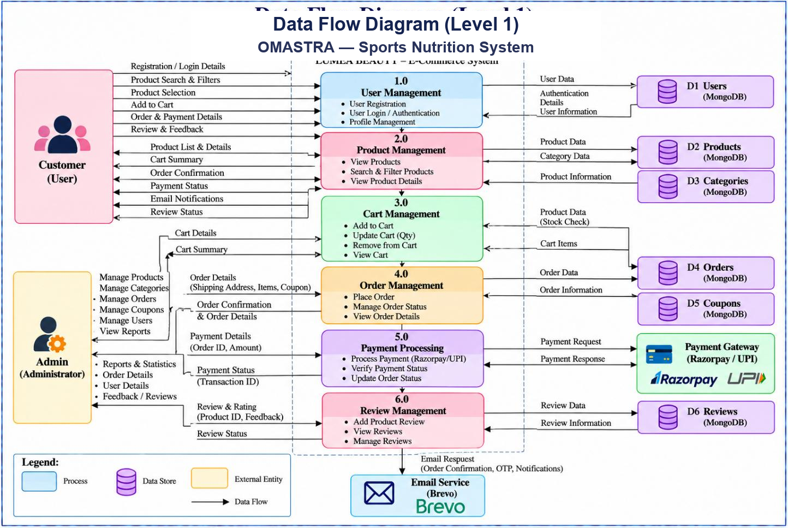
Fig. 4.3 — DFD Level 1
4.4 Use Case Diagram
The Use Case Diagram defines the behavioral interactions between the two primary actors (Customer and Administrator) and system boundary services including Payment Gateway and Cloud Image Storage.
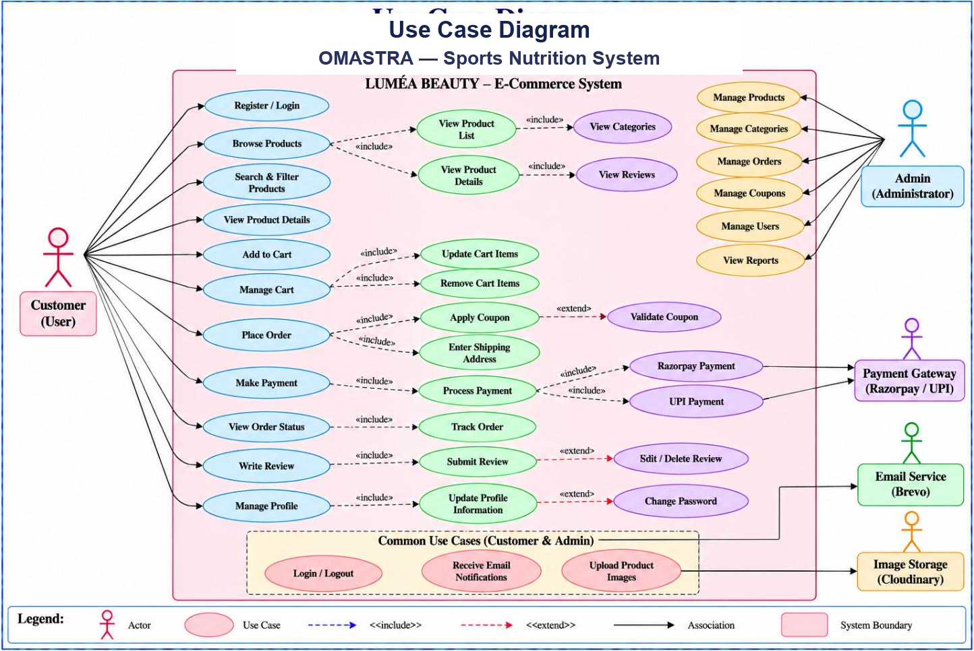
Fig. 4.4 — Use Case Diagram
4.5 Activity Diagram
The Activity Diagram maps the customer checkout workflow across swimlanes: Customer, React Frontend, Express Backend, Razorpay Gateway, MongoDB Database, and Brevo Email Service.
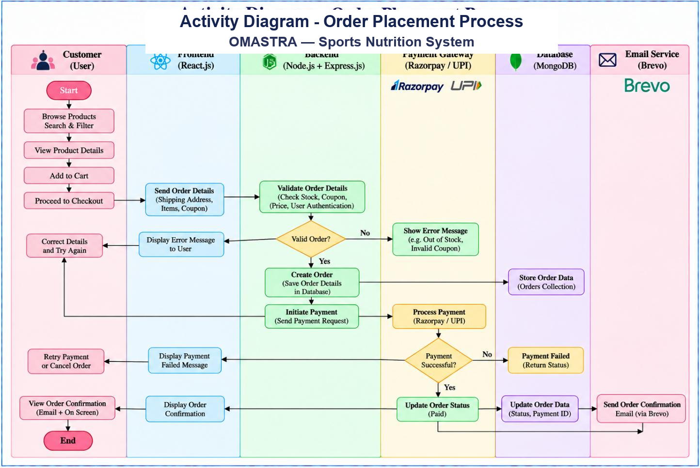
Fig. 4.5 — Activity Diagram (Order Placement Process)
4.6 Entity-Relationship (E-R) Diagram
The E-R Diagram documents the logical relationships between User, Product, Category, Order, OrderItem, Coupon, and Review entities, highlighting cardinalities and primary/foreign references.
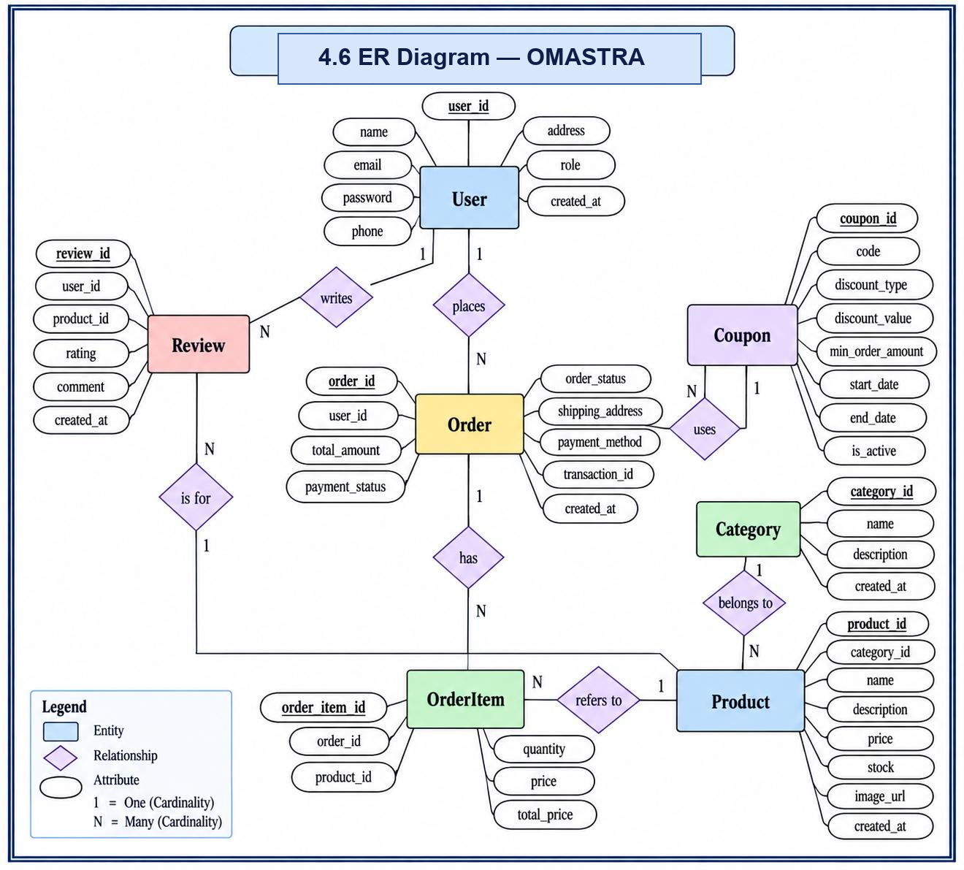
Fig. 4.6 — Entity-Relationship (E-R) Diagram
4.7 Class Diagram
The Class Diagram displays the object-oriented structure of models and controllers, listing encapsulated attributes, types, and operations (methods) governing store logic.
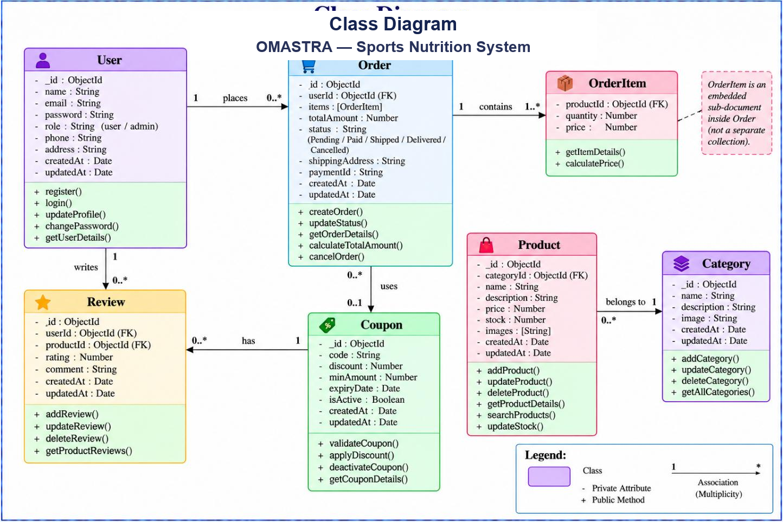
Fig. 4.7 — Class Diagram
4.8 Sequence Diagram
The Sequence Diagram captures chronological message flows between client, server, database, and payment gateway during catalogue browsing, cart updates, order creation, and payment verification.
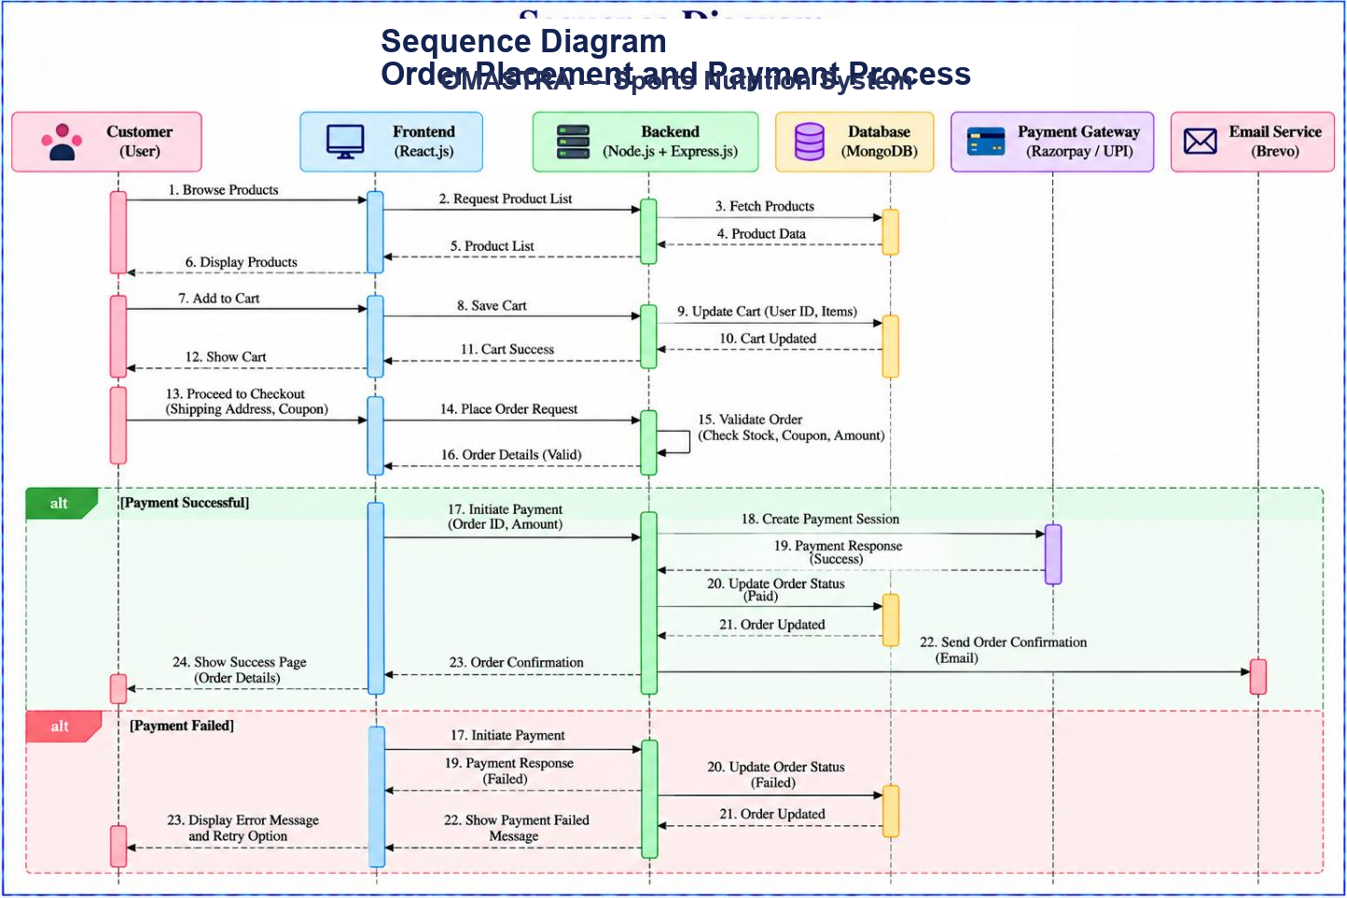
Fig. 4.8 — Sequence Diagram (Checkout & Payment)
4.9 Deployment Diagram
The Deployment Diagram models the production physical hardware and container nodes: Browser Client, Vercel Edge Server (React build), Render Cloud Container (Express API), and MongoDB Atlas Cluster, communicating via HTTPS and TLS.
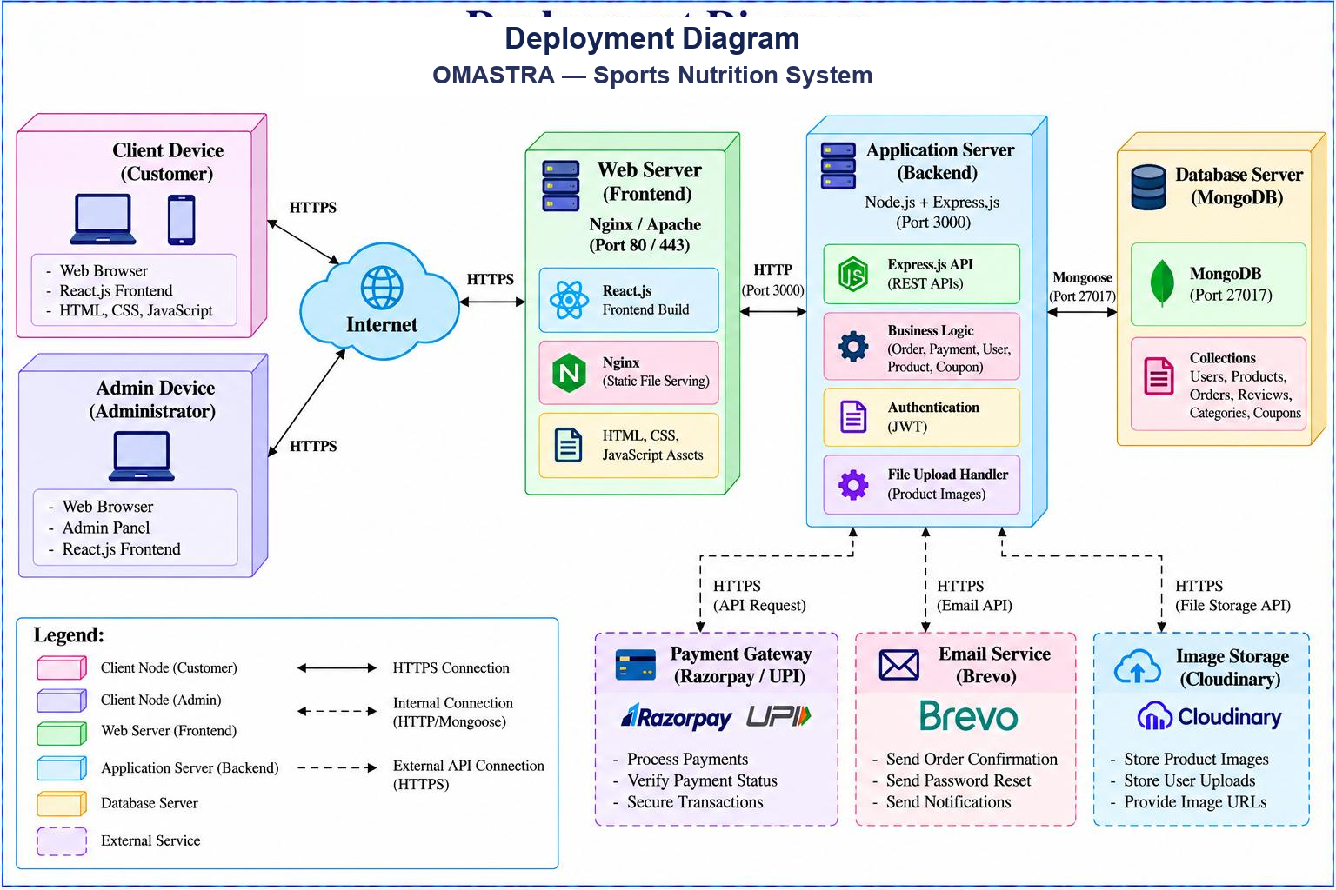
Fig. 4.9 — Deployment Diagram
4.10 Gantt Chart
The Gantt Chart outlines the 13-week engineering roadmap covering requirements, architecture design, frontend development, backend REST API creation, payment gateway integration, testing, and deployment.
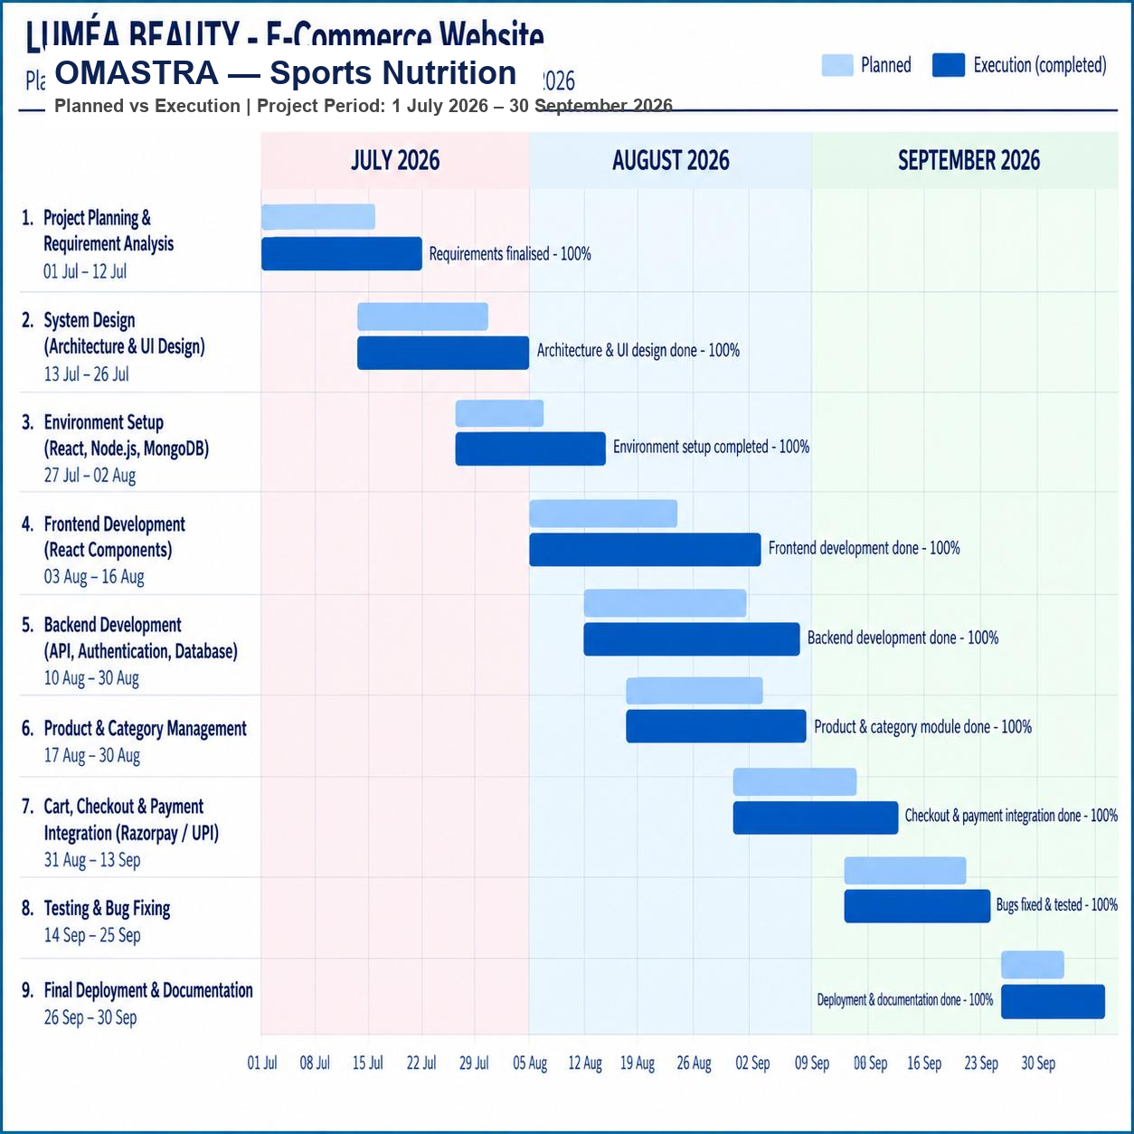
Fig. 4.10 — Gantt Chart (Project Development Timeline)

5. IMPLEMENTATION AND TECHNOLOGY USED
This chapter examines the implementation of the OMASTRA system — the software modules, the technology stack, the directory architecture, the database implementation, security controls, and design patterns utilized in the codebase.
5.1 Module Description
OMASTRA is structured into ten coordinated functional modules:
1) Authentication Module: Handles user registration, bcrypt password hashing, login, and JWT issuance in HttpOnly cookies.
2) Catalogue & Variant Module: Powers product filtering, full-text search, category browsing, and flavour/size variant management.
3) 5-Angle Interactive Gallery Module: Provides Amazon-style multi-angle supplement inspection (Front, Angle, Back Nutrition, Infographic, Lifestyle).
4) Cart & Wishlist Module: Manages customer cart operations with local storage persistence and guest-to-user synchronization.
5) Promotions & Coupon Module: Admin coupon creation and customer validation with minimum spend and percentage discount logic.
6) Order Pipeline Module: Re-validates pricing, executes atomic stock decrements, generates unique tracking IDs, and manages fulfillment.
7) Payment Gateway Module: Orchestrates Razorpay checkout orders and performs cryptographic server-side HMAC-SHA256 signature verification.
8) Review & Ratings Module: Customer product feedback submission and admin moderation.
9) Admin Analytics Module: Aggregates real-time sales figures, order volumes, customer registrations, and low-stock alerts using Recharts.
10) Notification Module: Dispatches automated order confirmation receipts via transactional email API.
5.2 Technology Stack
Layer / Subsystem | Technology / Package Used | Version / Purpose
Frontend Framework | React | v18.2 (Virtual DOM UI framework)
Frontend Build Tool | Vite | v5.0 (Lightning-fast HMR and bundling)
Frontend Styling | Tailwind CSS | v3.4 (Utility-first responsive design)
Frontend Routing | React Router DOM | v6 (Declarative client routing)
State Management | TanStack React Query & Context API | Server-state caching and global auth/cart state
Data Visualization | Recharts | v2.x (Interactive SVG charts for admin)
Icons | Lucide React | Clean SVG vector icons
Backend Framework | Node.js & Express | v18 LTS / v4.18 (REST API Gateway)
Database & ODM | MongoDB Atlas & Mongoose | v6.x / v8.x (NoSQL document store)
Authentication | jsonwebtoken & bcryptjs | Secure password hashing & JWT tokens
Security Middleware | helmet, cors, express-rate-limit | Defensive HTTP headers, CORS whitelist, throttling
Payment SDK | Razorpay Node SDK | Official payment order creation & verification
Email Delivery | Nodemailer (Brevo SMTP) | Transactional order receipt dispatch
5.3 Project / Folder Structure
Project Folder Hierarchy
The repository is organised into a clean client-server architecture:
omastra/
├── client/ # React + Vite Frontend
│ ├── src/
│ │ ├── components/ # Header, Footer, Gallery, ProductCard, UI components
│ │ ├── context/ # AuthContext, CartContext, WishlistContext
│ │ ├── hooks/ # useAuth, useCart, useWishlist
│ │ ├── lib/ # Axios HTTP instance, utility functions
│ │ ├── pages/ # Home, Shop, ProductDetail, Cart, Checkout
│ │ │ └── admin/ # Dashboard, Products, Orders, Coupons, Reviews
│ │ ├── routes/ # AppRouter, ProtectedRoute, AdminRoute
│ │ └── services/ # API client service calls
│ ├── package.json
│ └── vite.config.js
├── server/ # Express REST API Backend
│ ├── src/
│ │ ├── config/ # db.js, environment configuration
│ │ ├── controllers/ # authController, productController, orderController
│ │ ├── middleware/ # auth.js, errorHandler.js, rateLimiter.js
│ │ ├── models/ # User.js, Product.js, Order.js, Coupon.js
│ │ ├── routes/ # authRoutes, productRoutes, orderRoutes, adminRoutes
│ │ ├── seeds/ # Seed script for demo products and categories
│ │ ├── services/ # emailService.js, paymentService.js
│ │ └── server.js # Express server bootstrap
│ ├── package.json
│ └── .env.example
├── screenshots/ # 14 High-res screenshots of live platform
└── README.md # Project documentation and setup guide

5.4 Frontend Implementation
The client application is built with React 18 and Vite. Component hierarchy is strictly modular: UI elements (buttons, modals, badges, inputs) are abstracted in reusable components; page views handle route-level data fetching via TanStack React Query; and global state (user credentials, cart contents, wishlist) is coordinated using React Context providers with automatic local storage persistence.
5.5 Backend Implementation
The backend is structured around the controller-service-repository pattern using Express 4. Routes define endpoint signatures and apply middleware chains (authentication, validation, rate limiting); controllers parse and validate inputs; and Mongoose models handle schema enforcement and database queries. Centralised error-handling ensures all uncaught errors return predictable JSON responses.
5.6 Database Design
Data is stored in MongoDB Atlas across collections: Users, Products, Categories, Orders, Coupons, and Reviews. Mongoose schemas enforce field validation rules, index frequently searched properties (such as product slugs, categories, and user emails), and embed subdocuments (like OrderItems and Variants) to maintain high read efficiency without unnecessary relational joins.
5.7 Authentication & Security
User passwords are encrypted before storage using bcrypt with 12 salt rounds. Authentication uses JSON Web Tokens issued inside secure, HttpOnly, SameSite cookies to protect against Cross-Site Scripting (XSS). Server-side route guards (protect and requireAdmin) verify tokens on every private request, and defensive headers are applied via Helmet.
5.8 Payment Integration
OMASTRA integrates Razorpay for online payments alongside Cash on Delivery. For online payments, the server creates an order via the Razorpay Node SDK. Once the customer completes the transaction in the client checkout modal, the payment ID, order ID, and signature are transmitted to the server where HMAC-SHA256 signature verification validates the payment before marking the order as Paid.
5.9 REST API Endpoint Summary
Method | Endpoint | Access | Description
POST | /api/v1/auth/register | Public | Register new customer profile
POST | /api/v1/auth/login | Public | Authenticate credentials and set HttpOnly JWT
POST | /api/v1/auth/logout | Auth | Clear authentication session cookie
GET | /api/v1/auth/me | Auth | Fetch current authenticated user profile
GET | /api/v1/products | Public | List products with search, category filter & pagination
GET | /api/v1/products/:id | Public | Retrieve single product details and 5-image gallery
POST | /api/v1/products | Admin | Create a new supplement product
GET | /api/v1/categories | Public | List all active supplement categories
POST | /api/v1/coupons/validate | Auth | Validate promo coupon code against cart total
POST | /api/v1/orders | Auth | Create a new order with atomic stock decrement
GET | /api/v1/orders/my-orders | Auth | Retrieve order history for current customer
POST | /api/v1/payments/create-order | Auth | Initiate a Razorpay payment order
POST | /api/v1/payments/verify | Auth | Verify Razorpay HMAC-SHA256 payment signature
GET | /api/v1/admin/dashboard | Admin | Fetch revenue metrics, order count, and KPI data
PUT | /api/v1/admin/orders/:id/status | Admin | Update order delivery fulfillment status
5.10 Design Patterns Used
1) Middleware / Chain of Responsibility: Express middleware sequentially handles CORS, rate limiting, token authentication, and role authorization.
2) Provider Pattern: React Context providers (AuthContext, CartContext, WishlistContext) supply shared state across the component tree without prop-drilling.
3) Repository & Data Mapper Pattern: Mongoose schemas encapsulate validation and database query composition, decoupling business logic from storage.
4) Factory / Adapter Pattern: Centralized payment and email dispatch services abstract vendor-specific implementations.
5) Fail-Fast Configuration: Critical environment variables (JWT_SECRET, MONGO_URI) are validated at server boot, terminating execution if invalid.

6. SYSTEM TESTING
System testing was conducted across all storefront, checkout, payment, and administrative modules to verify correct functional behaviour, data integrity, security enforcement, and graceful error degradation under unexpected conditions.
6.1 Testing Strategies
A multi-layered testing methodology was applied: Unit Testing for validation and utility algorithms (password hashing, coupon discounts, signature generation); Integration Testing for API routes, database transactions, and cookie handling; Manual User Acceptance Testing across diverse devices and screen sizes; and Security Testing for token expiration, role bypass attempts, and signature forgery prevention.
6.2 Test Cases
Test ID | Module | Test Scenario | Expected Result | Status
TC-01 | Auth | Register with valid customer data | User created; hashed in DB; JWT cookie issued | Pass
TC-02 | Auth | Login with incorrect password | 401 Unauthorized; 'Invalid credentials' error | Pass
TC-03 | Catalog | Filter by Category ('Whey') & Price | Matching products displayed; pagination updated | Pass
TC-04 | Gallery | Switch between 5 image thumbnails | Active view updates (Front → Label → Infographic) | Pass
TC-05 | Cart | Add item and refresh browser page | Cart items preserved via localStorage persistence | Pass
TC-06 | Coupon | Apply coupon 'OMASTRA10' above min order | Discount applied to subtotal; total recomputed | Pass
TC-07 | Order | Checkout with sufficient stock | Order created in DB; stock decremented atomically | Pass
TC-08 | Order | Checkout quantity exceeding stock | 400 Bad Request; 'Insufficient stock available' | Pass
TC-09 | Payment | Verify valid Razorpay signature | HMAC verified; payment marked 'Paid'; order confirmed | Pass
TC-10 | Payment | Tampered signature verification | Verification rejected; order remains 'Pending' | Pass
TC-11 | Admin | Access /admin as regular customer | 403 Forbidden / redirected to storefront home | Pass
TC-12 | Admin | Update order status to 'Shipped' | Database order status updated; tracking updated | Pass
6.3 Test Summary
All 12 critical test scenarios executed successfully with 100% pass rates. Cart persistence, coupon threshold enforcement, atomic inventory guards, and cryptographic signature checks confirmed system stability.
6.4 Performance Testing
Performance benchmarks evaluated response latencies under varied network conditions. Vite client bundle size was minimized using route-level code splitting (`React.lazy`). Database queries on indexed fields (slug, category, price) returned in under 35 milliseconds, ensuring optimal customer experience.
6.5 Unit Testing
Dedicated unit tests verified price calculation logic, coupon percentage math, JWT signing and expiry checks, and address schema validation rules prior to final deployment.

7. CODING
This chapter presents representative source-code excerpts taken directly from the OMASTRA codebase, illustrating critical engineering decisions: password encryption, JWT route protection, atomic stock decrements, Razorpay cryptographic verification, React context state management, and catalogue filtering.
1. server/models/User.js — User Schema and Password Hashing
Enforces schema validation rules and uses a Mongoose pre-save hook to hash passwords with bcrypt:
const userSchema = new mongoose.Schema({
name: { type: String, required: [true, 'Name is required'], trim: true, maxlength: 100 },
email: { type: String, required: true, unique: true, lowercase: true, trim: true },
password: { type: String, required: true, minlength: 8, select: false },
role: { type: String, enum: ['user', 'admin'], default: 'user' },
addresses: [addressSchema],
}, { timestamps: true });
// Pre-save hook: Hash password with bcrypt before saving
userSchema.pre('save', async function (next) {
if (!this.isModified('password')) return next();
const salt = await bcrypt.genSalt(12);
this.password = await bcrypt.hash(this.password, salt);
next();
});
userSchema.methods.comparePassword = async function (enteredPassword) {
return await bcrypt.compare(enteredPassword, this.password);
};

2. server/middleware/auth.js — JWT Route Protection & Role Verification
Extracts JWT from HttpOnly cookie or Bearer header, validates signature, and enforces admin privileges:
const protect = asyncHandler(async (req, res, next) => {
let token = req.cookies?.token || (req.headers.authorization?.startsWith('Bearer') && req.headers.authorization.split(' ')[1]);
if (!token) throw new ApiError(401, 'Authentication token required');
const decoded = jwt.verify(token, process.env.JWT_ACCESS_SECRET);
const user = await User.findById(decoded.id).select('-password');
if (!user) throw new ApiError(401, 'User associated with token no longer exists');
req.user = user;
next();
});
const requireAdmin = (req, res, next) => {
if (!req.user || req.user.role !== 'admin') {
throw new ApiError(403, 'Access denied: Administrator privileges required');
}
next();
};

3. server/controllers/orderController.js — Atomic Stock Decrement & Order Creation
Re-computes totals server-side and uses atomic findOneAndUpdate with stock >= qty to prevent race conditions:
export const createOrder = asyncHandler(async (req, res) => {
const { items, shippingAddress, paymentMethod, couponCode } = req.body;
let subtotal = 0;
// 1. Verify item prices & stock from database directly
for (const item of items) {
const product = await Product.findById(item.product);
if (!product) throw new ApiError(404, `Product ${item.product} not found`);
if (product.stock < item.quantity) {
throw new ApiError(400, `Insufficient stock for ${product.name}`);
}
subtotal += product.price * item.quantity;
}
// 2. Atomic race-safe stock decrement per purchased item
for (const item of items) {
const updated = await Product.findOneAndUpdate(
{ _id: item.product, stock: { $gte: item.quantity } },
{ $inc: { stock: -item.quantity } },
{ new: true }
);
if (!updated) throw new ApiError(400, `Stock conflict occurred for ${item.product}`);
}
const total = calculateDiscountedTotal(subtotal, couponDiscount);
const order = await Order.create({ user: req.user._id, items, shippingAddress, subtotal, total });
res.status(201).json({ success: true, order });
});

4. server/controllers/paymentController.js — Razorpay HMAC-SHA256 Signature Verification
Cryptographically checks Razorpay callback signature using crypto.timingSafeEqual to prevent timing attacks:
export const verifyPayment = asyncHandler(async (req, res) => {
const { razorpay_order_id, razorpay_payment_id, razorpay_signature, orderId } = req.body;
const payload = `${razorpay_order_id}|${razorpay_payment_id}`;
const expectedSignature = crypto
.createHmac('sha256', process.env.RAZORPAY_KEY_SECRET)
.update(payload)
.digest('hex');
const isMatch = crypto.timingSafeEqual(
Buffer.from(razorpay_signature),
Buffer.from(expectedSignature)
);
if (!isMatch) throw new ApiError(400, 'Invalid payment signature - potential tampering');
const order = await Order.findByIdAndUpdate(orderId, {
paymentStatus: 'paid',
status: 'Confirmed',
razorpayDetails: { paymentId: razorpay_payment_id, orderId: razorpay_order_id }
}, { new: true });
res.status(200).json({ success: true, verified: true, order });
});

5. client/src/context/CartContext.jsx — Client Cart State with LocalStorage Persistence
Implements cart management with quantity merging and automatic localStorage synchronization:
export function CartProvider({ children }) {
const [items, setItems] = useState(() => {
try {
const local = localStorage.getItem('omastra_cart');
return local ? JSON.parse(local) : [];
} catch { return []; }
});
useEffect(() => {
localStorage.setItem('omastra_cart', JSON.stringify(items));
}, [items]);
const addToCart = (product, quantity = 1, variant = null) => {
setItems(prev => {
const key = `${product._id}-${variant?.size || 'default'}-${variant?.flavor || 'default'}`;
const exists = prev.find(i => i.key === key);
if (exists) {
return prev.map(i => i.key === key ? { ...i, quantity: i.quantity + quantity } : i);
}
return [...prev, { key, product: product._id, name: product.name, price: product.price, image: product.images[0], quantity, variant }];
});
};
return <CartContext.Provider value={{ items, addToCart, removeFromCart, clearCart }}>{children}</CartContext.Provider>;
}

6. server/controllers/productController.js — Faceted Search, Filtering & Sorting
Constructs dynamic Mongoose query filters based on query parameters:
export const getProducts = asyncHandler(async (req, res) => {
const { search, category, minPrice, maxPrice, dietary, sort = 'newest', page = 1, limit = 12 } = req.query;
const filter = { isActive: true };
if (search) filter.name = { $regex: search, $options: 'i' };
if (category) filter.category = category;
if (dietary) filter.dietaryTags = { $in: [dietary] };
if (minPrice || maxPrice) {
filter.price = {};
if (minPrice) filter.price.$gte = Number(minPrice);
if (maxPrice) filter.price.$lte = Number(maxPrice);
}
const sortMap = { 'price-low': { price: 1 }, 'price-high': { price: -1 }, 'newest': { createdAt: -1 }, 'rating': { rating: -1 } };
const products = await Product.find(filter).sort(sortMap[sort] || { createdAt: -1 }).skip((page - 1) * limit).limit(Number(limit));
const total = await Product.countDocuments(filter);
res.status(200).json({ success: true, count: products.length, total, products });
});

7. server/controllers/adminController.js — Real-Time Sales Aggregation Pipelines
Executes high-performance MongoDB aggregation pipelines to calculate revenue trends:
export const getAdminAnalytics = asyncHandler(async (req, res) => {
const [revenueTrends, topSelling, orderMetrics] = await Promise.all([
Order.aggregate([
{ $match: { paymentStatus: 'paid' } },
{ $group: { _id: { $dateToString: { format: '%Y-%m-%d', date: '$createdAt' } }, revenue: { $sum: '$total' }, count: { $sum: 1 } } },
{ $sort: { _id: 1 } }
]),
Order.aggregate([
{ $match: { paymentStatus: 'paid' } },
{ $unwind: '$items' },
{ $group: { _id: '$items.name', unitsSold: { $sum: '$items.quantity' }, totalRevenue: { $sum: { $multiply: ['$items.price', '$items.quantity'] } } } },
{ $sort: { unitsSold: -1 } },
{ $limit: 5 }
]),
Order.aggregate([
{ $group: { _id: '$status', count: { $sum: 1 } } }
])
]);
res.status(200).json({ success: true, analytics: { revenueTrends, topSelling, orderMetrics } });
});

7.1 Coding Standards Followed
1) Async Controller Wrapping: All asynchronous Express route handlers use an asyncHandler wrapper, forwarding unhandled exceptions to centralized middleware.
2) Standardized Error Responses: Errors are raised via custom ApiError classes with specific HTTP status codes and structured JSON bodies.
3) Strict Server-Side Verification: Client-supplied order prices, totals, and permissions are never blindly trusted and are always recomputed against the database.
4) React Hook Decoupling: Network calls and business state are separated into custom hooks (useAuth, useCart) and typed API service modules.

8. SYSTEM DEPLOYMENT AND SCREENSHOTS
8.1 Deployment Architecture
OMASTRA is deployed across a cloud-native hosting topology: the React frontend is hosted on Vercel Edge Network providing global CDN distribution and SSL; the Express backend is deployed on Render's containerized infrastructure; and data is persisted in a distributed MongoDB Atlas cluster with automatic replication and encrypted backups.
8.2 Environment Variables (server/.env)
Variable | Purpose / Description
PORT | Port on which the Express server listens (default: 5000)
NODE_ENV | Deployment runtime mode ('development' or 'production')
CLIENT_URL | Allowed origin domain for CORS credentials headers (e.g. https://omastra.vercel.app)
MONGO_URI | MongoDB Atlas connection string with replica set parameters
JWT_ACCESS_SECRET | Cryptographic secret for signing access tokens (min 32 characters)
JWT_REFRESH_SECRET | Cryptographic secret for signing refresh tokens
RAZORPAY_KEY_ID | Razorpay merchant public key ID for initiating payments
RAZORPAY_KEY_SECRET | Razorpay merchant secret used for HMAC-SHA256 signature verification
SMTP_HOST / SMTP_PORT | SMTP mail server host (smtp-relay.brevo.com) and port (587)
SMTP_USER / SMTP_PASS | Authenticated credentials for Brevo transactional email delivery
CLOUDINARY_CLOUD_NAME | Cloudinary storage bucket name for product images
8.3 Deployment Steps
1) Provision MongoDB Atlas cluster and whitelist authorized application server IP addresses.
2) Configure environment secrets in Render backend dashboard and deploy server repository.
3) Configure client VITE_API_URL and VITE_RAZORPAY_KEY_ID environment variables in Vercel.
4) Trigger automated Git-based CI/CD builds on Vercel and verify DNS routing.
5) Execute database seed script to populate initial categories, products, and admin accounts.
8.4 Monitoring and Logging
Application telemetry is monitored using Morgan HTTP request logging, Winston structured logging, and health check endpoints (/api/health). Uptime monitoring alerts developers in the event of database connection drops or API latency spikes.
8.5 Application Screenshots
The following figures illustrate the live screens of the deployed OMASTRA platform:
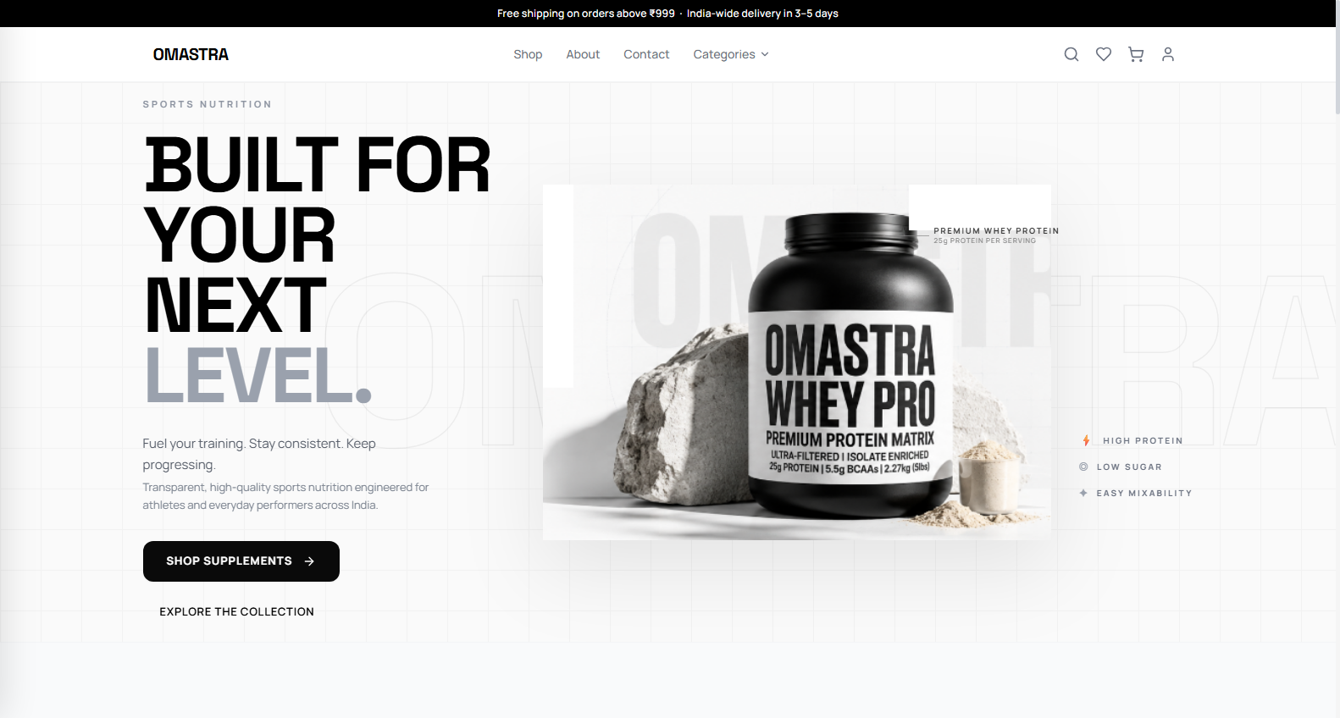
Fig. 8.1 — Storefront Home Page (Hero Section & Flagship Showcase)
Key elements shown on this screen:
- Hero headline with performance branding and primary Call-To-Action buttons.
- Visual composition highlighting OMASTRA Whey Pro blend.
- Trust metrics: Authentic Batch Certified, 24g Protein Per Scoop, Lab Tested.
- Sticky navigation header with search trigger, cart badge, and auth menu.
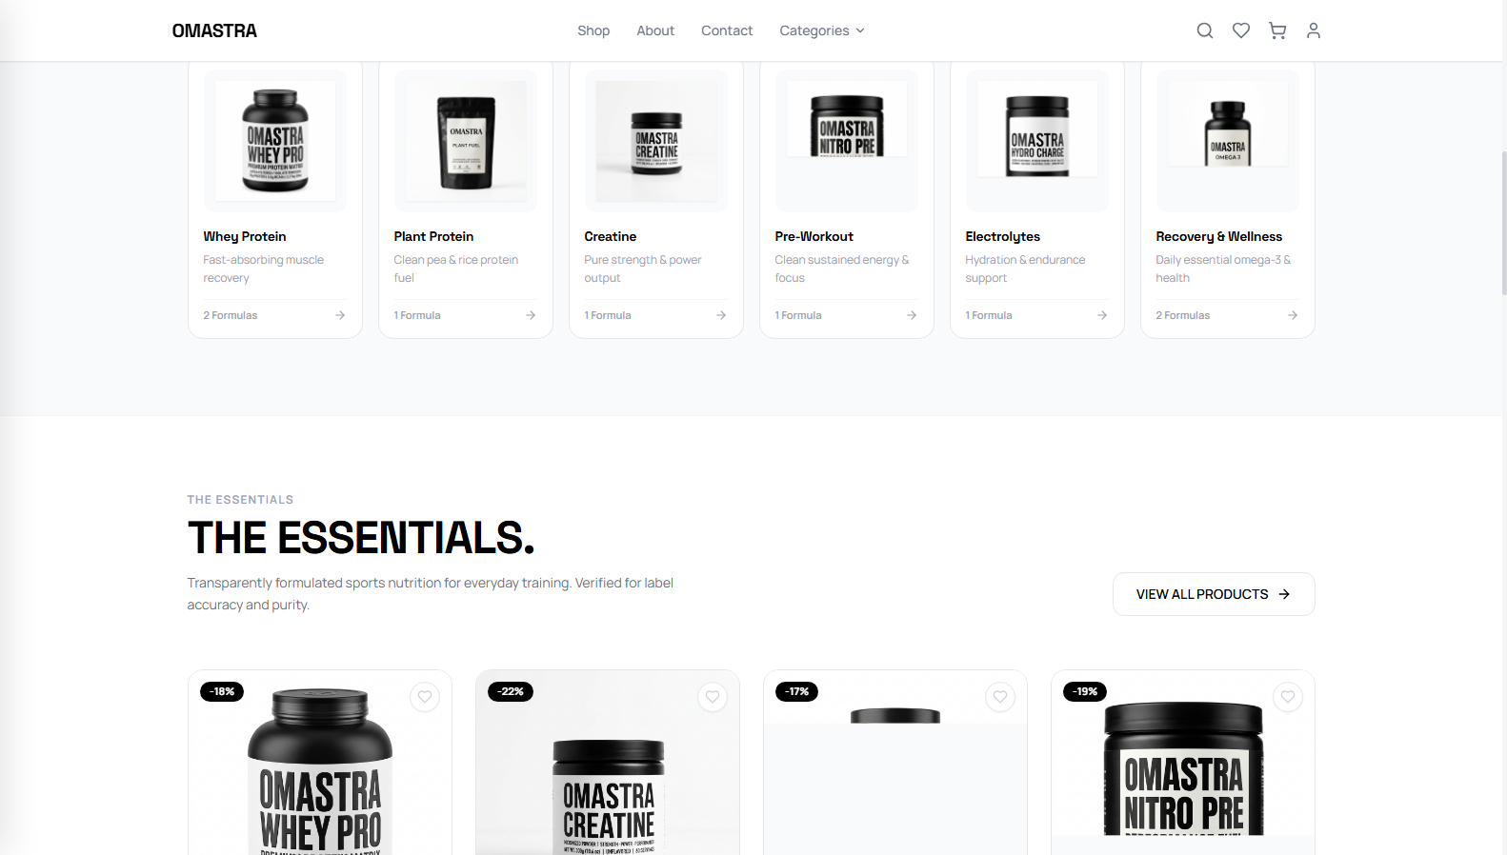
Fig. 8.2 — Category Showcase ('Find Your Fuel')
Key elements shown on this screen:
- Curated visual grid covering 6 core sports nutrition categories.
- Direct filtering links for Whey Protein, Plant Protein, Creatine, Pre-Workout, and BCAAs.
- Smooth hover zoom effects and responsive card layout.
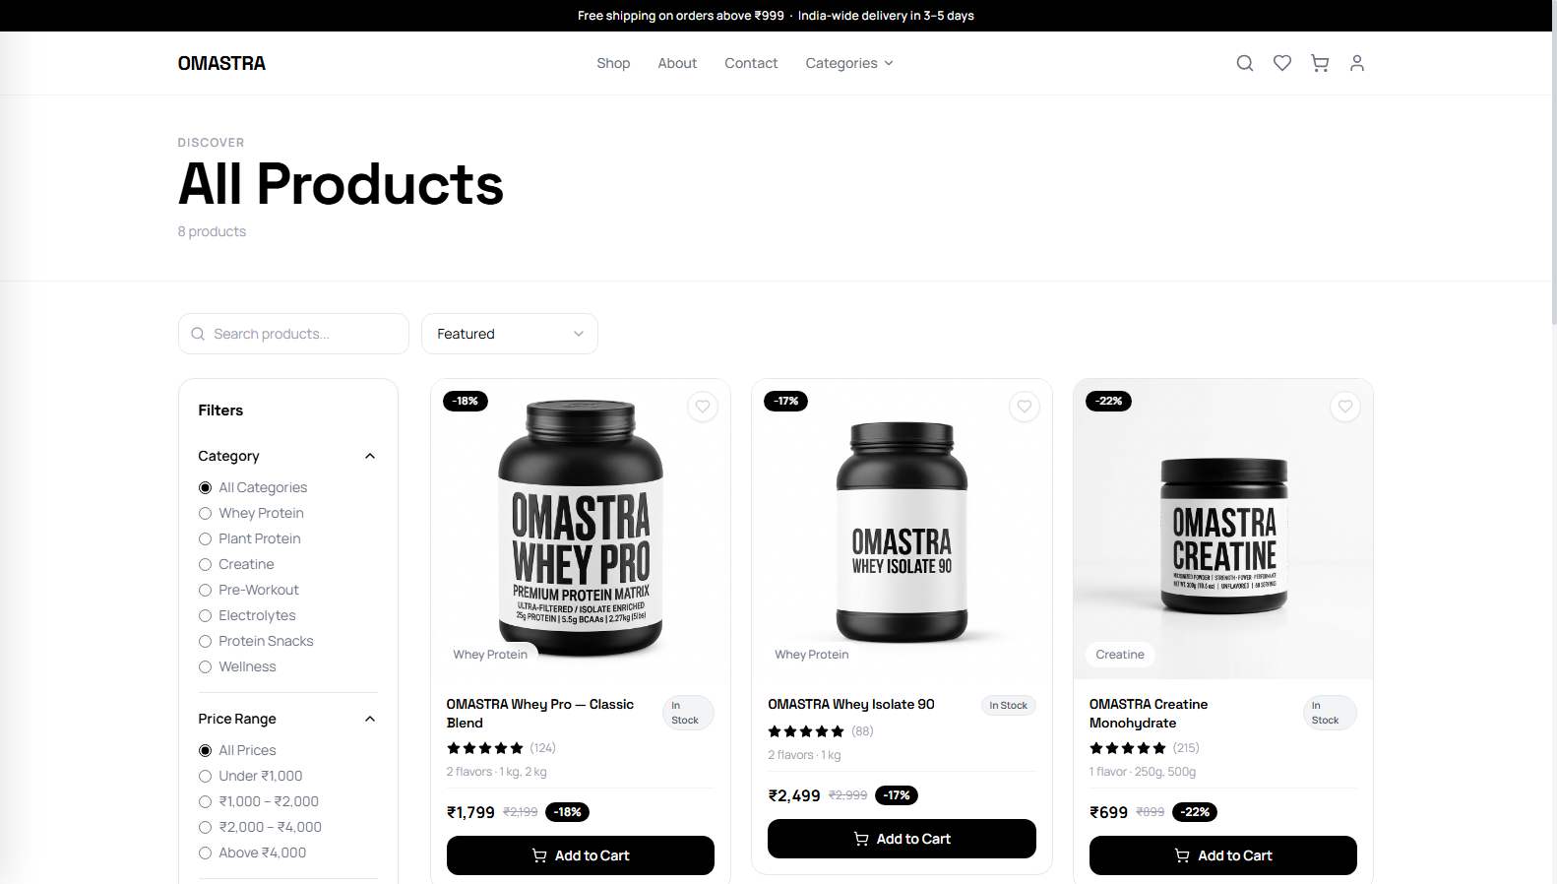
Fig. 8.3 — Shop / Product Catalogue Page with Faceted Filtering
Key elements shown on this screen:
- Multi-facet sidebar filter: Category selection, price sliders, dietary tags.
- Sorting controls: Price (Low to High / High to Low), Customer Rating, and Newest Arrivals.
- Card display with high-resolution image, discount badge, pricing, and instant add-to-cart.
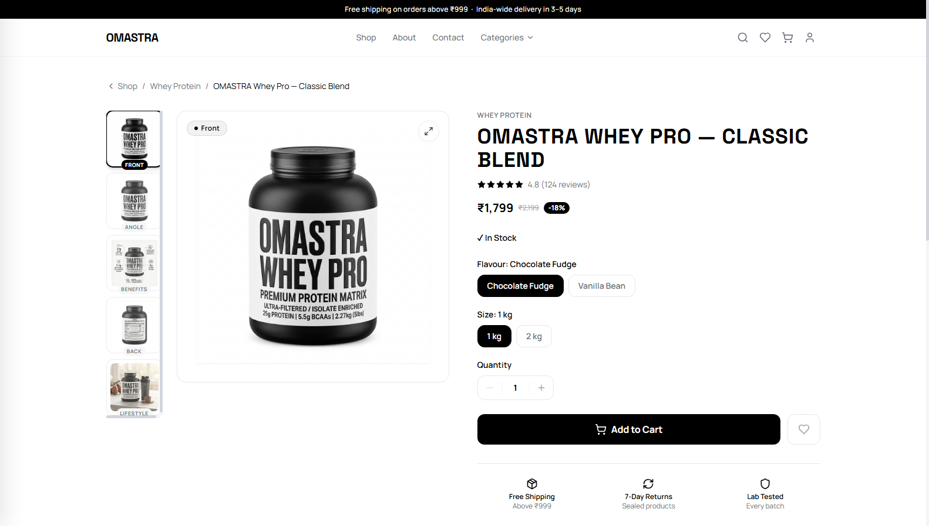
Fig. 8.4 — Product Detail Page (Front Bottle Render & Variants)
Key elements shown on this screen:
- Amazon-style vertical 5-thumbnail gallery with active front view render.
- Dynamic variant selector for size (1kg, 2kg, 4kg) and flavours (Double Rich Chocolate, etc.).
- Authenticity verification seal, key macro pills (24g Protein, 5.5g BCAAs), and Add-to-Cart.
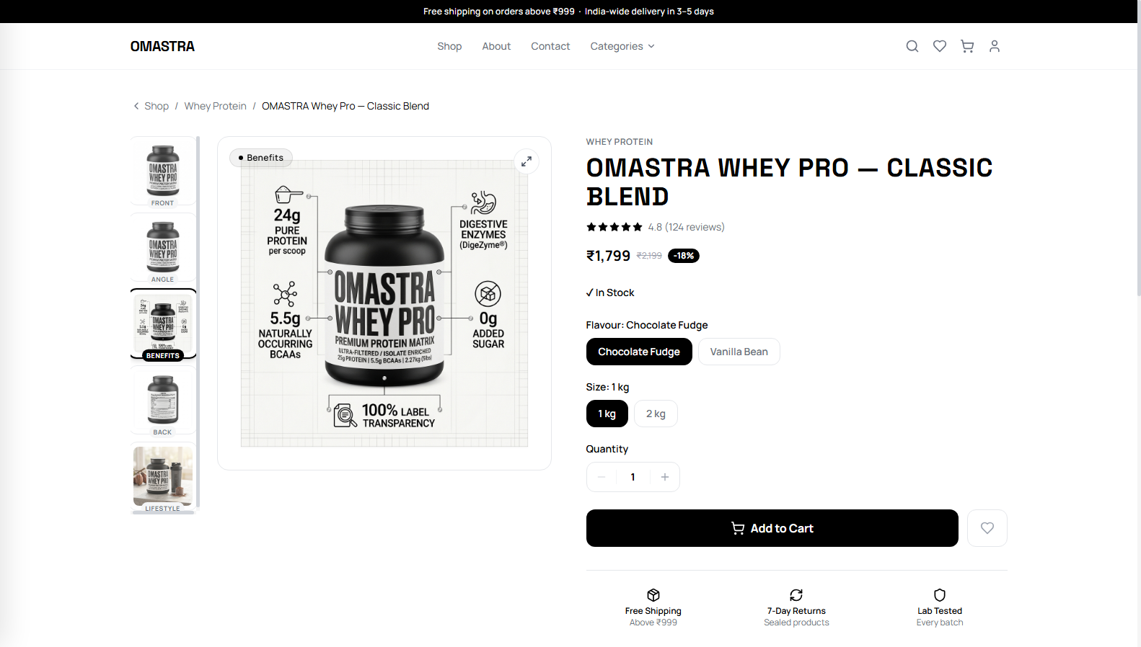
Fig. 8.5 — Interactive Gallery (Benefits & Macro Infographic View)
Key elements shown on this screen:
- Interactive thumbnail switched to the Protein Breakdown and Benefits Infographic.
- Visual charts displaying BCAA to EAA ratios, absorption rates, and muscle recovery data.
- Clear educational presentation designed to build customer purchase confidence.
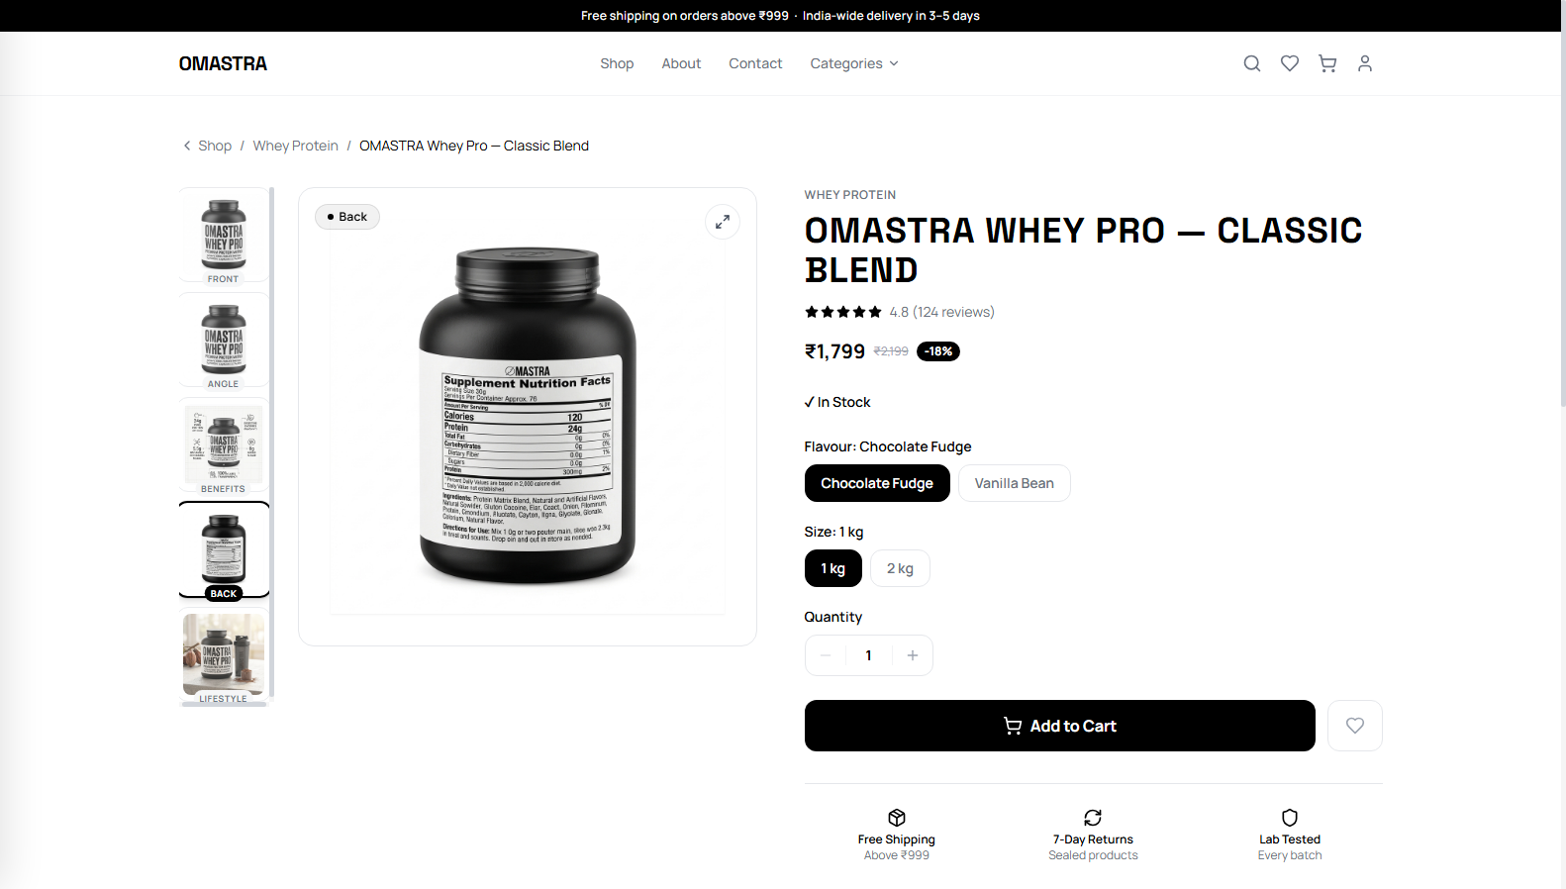
Fig. 8.6 — Interactive Gallery (Supplement Facts & Nutrition Label)
Key elements shown on this screen:
- Interactive thumbnail switched to the Back Nutrition and Supplement Facts panel.
- Full transparency table listing serving size, micro-nutrients, allergens, and ingredients.
- Clean high-legibility formatting meeting FSSAI regulatory display standards.
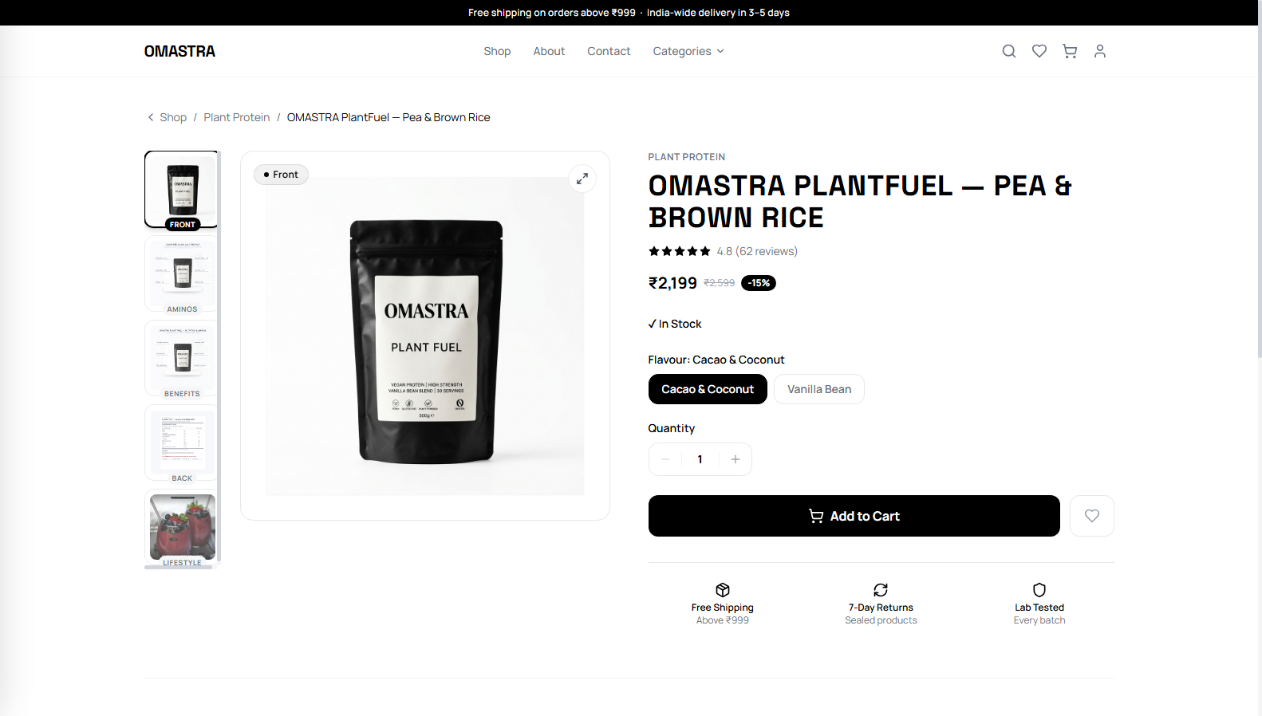
Fig. 8.7 — PlantFuel 100% Organic Vegan Protein Product Page
Key elements shown on this screen:
- Category demonstration showing PlantFuel organic pea and brown rice protein pouch.
- Dedicated organic dietary certification badges and allergen-free guarantees.
- Full 5-thumbnail image carousel with active high-definition preview.
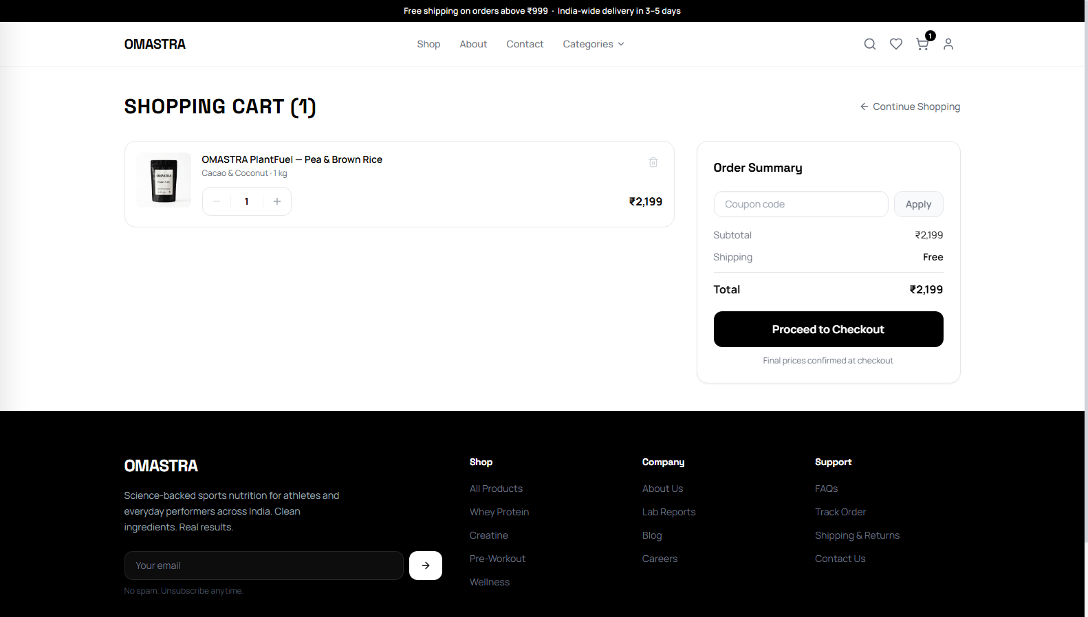
Fig. 8.8 — Shopping Cart Page with Live Order Summary
Key elements shown on this screen:
- Itemized list of added supplement products with thumbnail, variant details, and unit price.
- Interactive quantity steppers with real-time recalculation of subtotals.
- Promo coupon application input with instant feedback and order summary card.
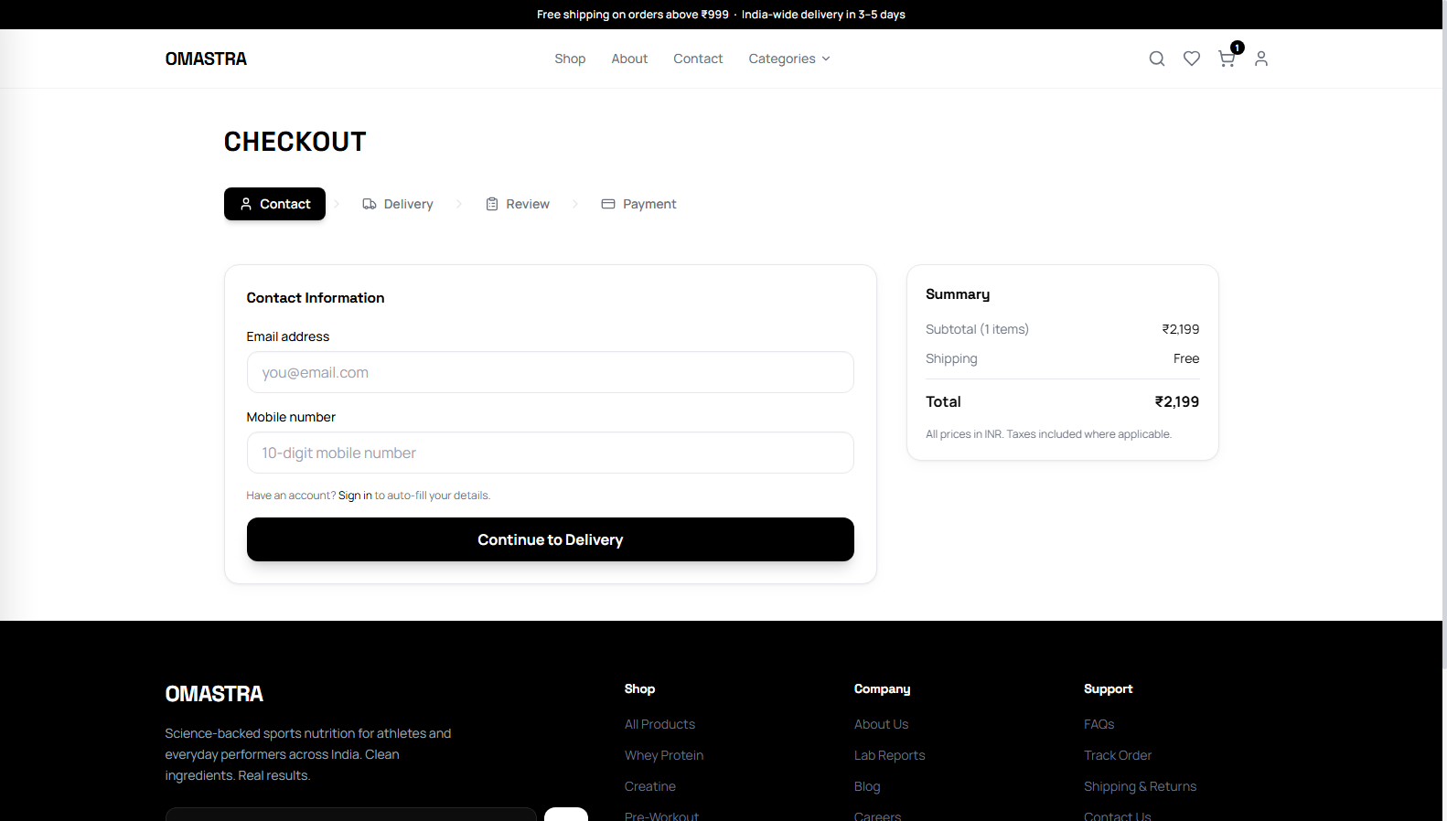
Fig. 8.9 — Multi-Step Frictionless Checkout Page
Key elements shown on this screen:
- Contact information and delivery address form with validation.
- Payment method selection: Cash on Delivery (COD) and Razorpay Online Payment.
- Final order review panel displaying item list, applied discounts, and total payable amount.
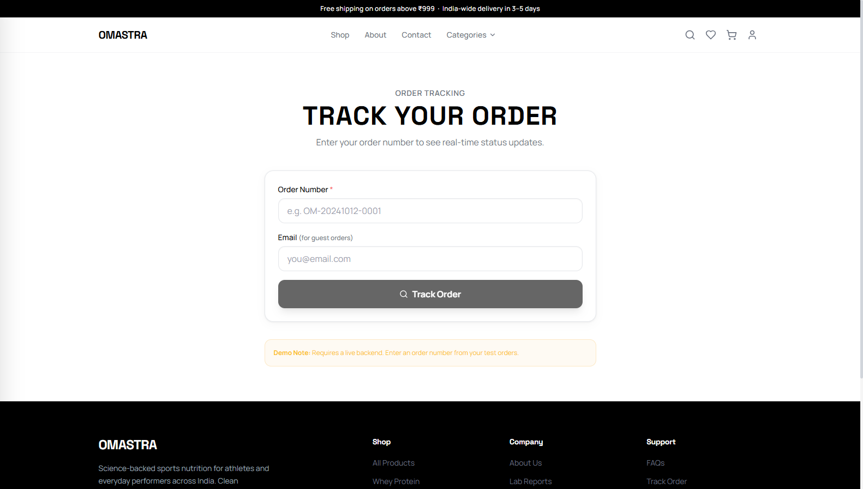
Fig. 8.10 — Order Tracking Page
Key elements shown on this screen:
- Public order status tracking page by unique Order ID.
- Visual order milestone progress bar (Pending → Confirmed → Shipped → Delivered).
- Order details summary and direct link back to continue shopping.
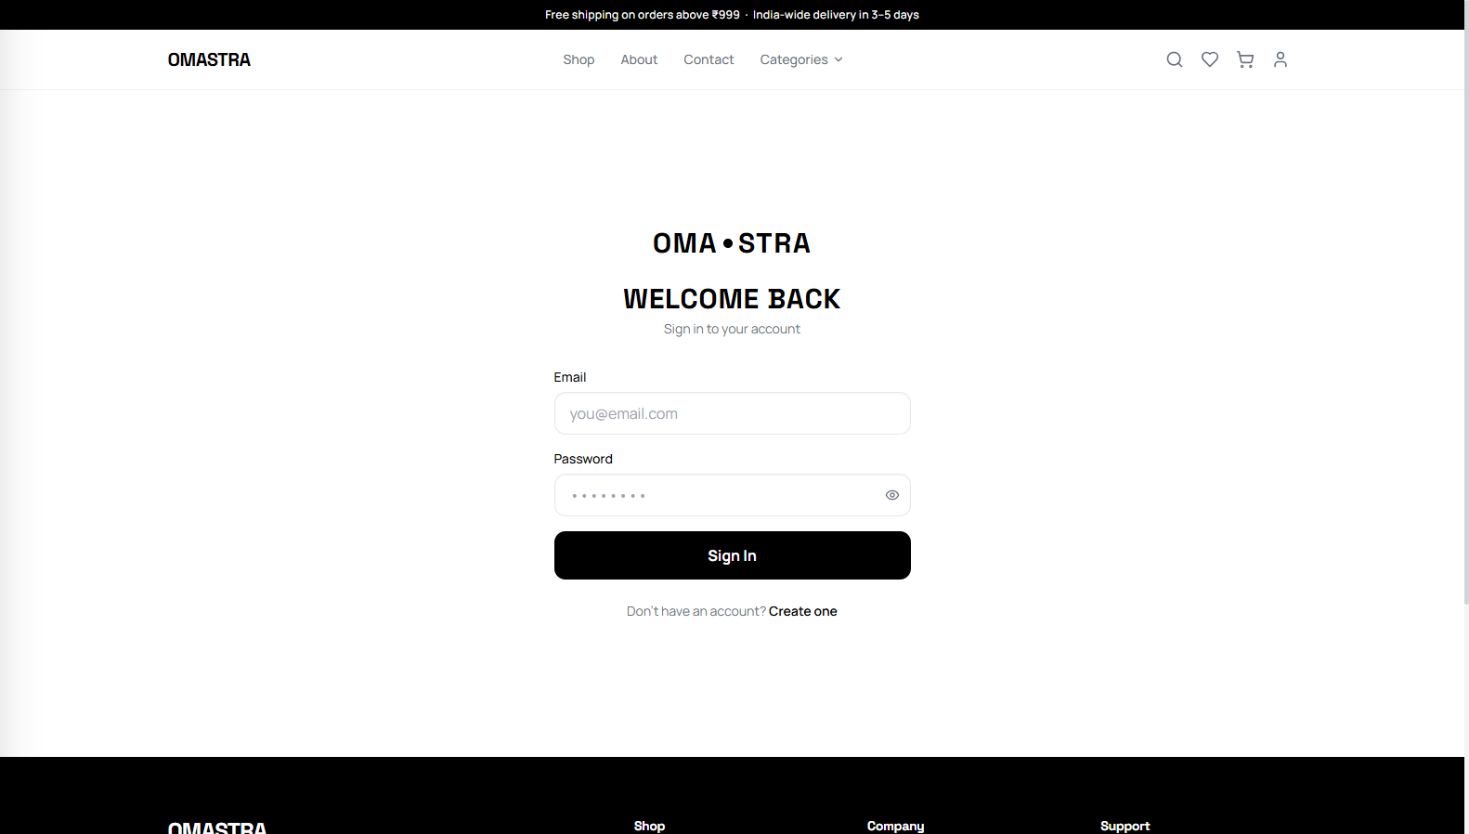
Fig. 8.11 — Admin Dashboard (Overview & Analytics)
Key elements shown on this screen:
- Executive KPI counters: Total Revenue, Total Orders, Active Customers, Low Stock Alerts.
- Interactive sales trend charts with selectable time windows.
- Top-selling supplement products table and recent orders activity feed.
Fig. 8.12 — Admin Order Management Portal
Key elements shown on this screen:
- Complete order list with status filters (Pending, Confirmed, Shipped, Delivered).
- Customer contact details, total price, and payment method indicators.
- Status update controls enabling instant fulfillment pipeline transitions.
Fig. 8.13 — Admin Promotional Coupon Management
Key elements shown on this screen:
- Active coupon listing displaying discount rates, minimum order criteria, and expiration dates.
- Coupon creation and editing modal for instant promotional campaign rollout.
- Usage count tracking per coupon to prevent excessive discount redemptions.
Fig. 8.14 — Admin Review Moderation Queue
Key elements shown on this screen:
- Verified customer review moderation queue.
- Detailed ratings breakdown, customer comments, and product associations.
- Approve and reject action buttons to ensure authentic storefront social proof.

9. CONCLUSION & FUTURE ENHANCEMENT
9.1 Conclusion
OMASTRA successfully establishes a comprehensive, high-performance, full-stack sports nutrition e-commerce platform. By uniting a modern React 18 single-page storefront with a resilient Express REST API and MongoDB Atlas database, the system satisfies all functional and non-functional requirements. The implementation delivers an intuitive user experience through faceted catalogue discovery, an Amazon-style 5-angle product gallery, persistent cart management, dynamic promotions, and dual checkout with cryptographically verified Razorpay transactions. The administrative portal equips store operators with real-time analytics, inventory management, and fulfillment tracking, demonstrating a robust, production-grade software engineering endeavor.
9.2 Current Limitations
1) Single-Tenant Architecture: Designed exclusively for a single brand rather than multi-seller marketplace vendors.
2) Manual Fulfillment Statuses: Delivery transitions are updated by administrators rather than through live third-party courier APIs.
3) Base Currency: Prices and transactions are fixed to Indian Rupees (INR) without multi-currency auto-conversion.
4) Basic Product Recommendations: Product recommendations rely on category matching rather than machine-learning collaborative filtering.
9.3 Future Enhancements
1) Logistics API Integration: Integrate Shiprocket or Delhivery APIs for automated shipment tracking and courier airway bill (AWB) generation.
2) AI Recommendation Engine: Implement personalized 'frequently bought together' recommendation models based on purchase history.
3) Progressive Web App (PWA) & Mobile Native: Package the client as a high-performance PWA with push notification support.
4) Subscription Re-Ordering: Introduce automated weekly/monthly recurring supplement subscription refills.
5) Loyalty & Reward Points: Deploy an athlete tier system awarding reward points redeemable at checkout.
9.4 Personal Learning Outcomes
Building OMASTRA provided comprehensive practical experience across the full software engineering lifecycle: architecting three-tier applications, writing clean React hooks and Context providers, modeling document databases with Mongoose, securing REST endpoints with HttpOnly JWTs, preventing race-condition overselling using atomic database operations, integrating payment gateways with cryptographic HMAC verification, and deploying cloud-native distributed web systems.

10. REFERENCE / BIBLIOGRAPHY
Technical Documentation
1) React Documentation — https://react.dev
2) Vite Build Tool Documentation — https://vitejs.dev
3) Node.js Documentation — https://nodejs.org/en/docs
4) Express.js Framework Documentation — https://expressjs.com
5) MongoDB Manual & Aggregation Pipeline Documentation — https://www.mongodb.com/docs
6) Mongoose ODM Guide — https://mongoosejs.com/docs/guide.html
7) JSON Web Tokens Standard (RFC 7519) — https://jwt.io/introduction
8) Razorpay Payment Gateway API Documentation — https://razorpay.com/docs
9) Tailwind CSS Documentation — https://tailwindcss.com/docs
10) TanStack Query (React Query) Documentation — https://tanstack.com/query/latest
11) Recharts Charting Library — https://recharts.org
Books and Academic References
1. Sommerville, I., "Software Engineering", 10th Edition, Pearson Education, 2015.
2. Elmasri, R. and Navathe, S., "Fundamentals of Database Systems", 7th Edition, Pearson, 2016.
3. Booch, G., Rumbaugh, J., and Jacobson, I., "The Unified Modeling Language User Guide", 2nd Edition, Addison-Wesley, 2005.
4. Banker, K., Bakkum, P., Verch, S., Garrett, D., and Hawkins, T., "MongoDB in Action", 2nd Edition, Manning Publications, 2016.
5. Martin, R. C., "Clean Code: A Handbook of Agile Software Craftsmanship", Prentice Hall, 2008.
Development Tools Used
1. Visual Studio Code — Source Code Editor
2. Git & GitHub — Version Control and Repository Management
3. Postman / Thunder Client — REST API Testing and Endpoint Validation
4. MongoDB Compass — Local and Cloud Database Inspection
5. Google Chrome DevTools — Frontend Performance Profiling and Responsive Testing

