**GIT HANDSON-4**

**Checkout my Gitlab:** [**https://gitlab.com/Tanuja-45/gitlab-1/-/tree/master?ref_type=he ads**](https://gitlab.com/Tanuja-45/gitlab-1/-/tree/master?ref_type=he%09ads)

**How to resolve conflicts during a merge**

Step one: Merge

Step two: Identify the files having merge conflicts

Step three: Open the conflicted file

Step four: Edit the file to fix it.

Step five: Add the fixed

Step six: Complete the merge.

Step seven: Push the result to the end.

**LAB HANDSON:**

Verify if master is in clean state

Create a new branch GitWork and switch to it

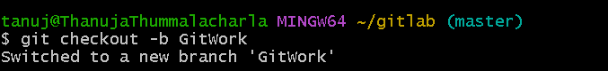  
  
Add a file hello.xml with some content



Check status and commit the change

Switch to master

Add a different hello.xml in master  
  
Commit the file in master  
  
View logs with graph

Check the differences between master and GitWork

Merge GitWork branch into master  
  
Stage and commit the resolved file

Add backup merge file to .gitignore

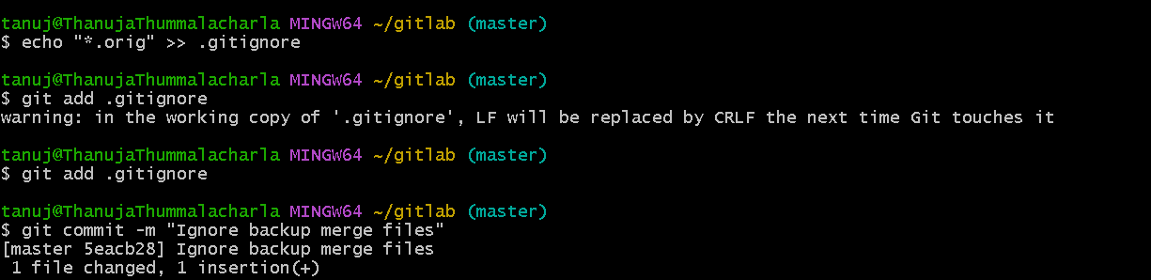  
  
List all branches

Delete the GitWork branch

Final log graph

