Project Design Phase-II
Data Flow Diagram & User Stories

Date | 31 January 2025
Team ID
Project Name
Maximum Marks | 4 Marks

Data Flow Diagrams:
A Data Flow Diagram (DFD) is a traditional visual representation of the information flows within a system. A neat and clear DFD can depict the right amount of the system requirement graphically. It shows how data enters and leaves the system, what changes the information, and where data is stored.
Example: DFD Level 0 (Industry Standard)
Example: (Simplified)
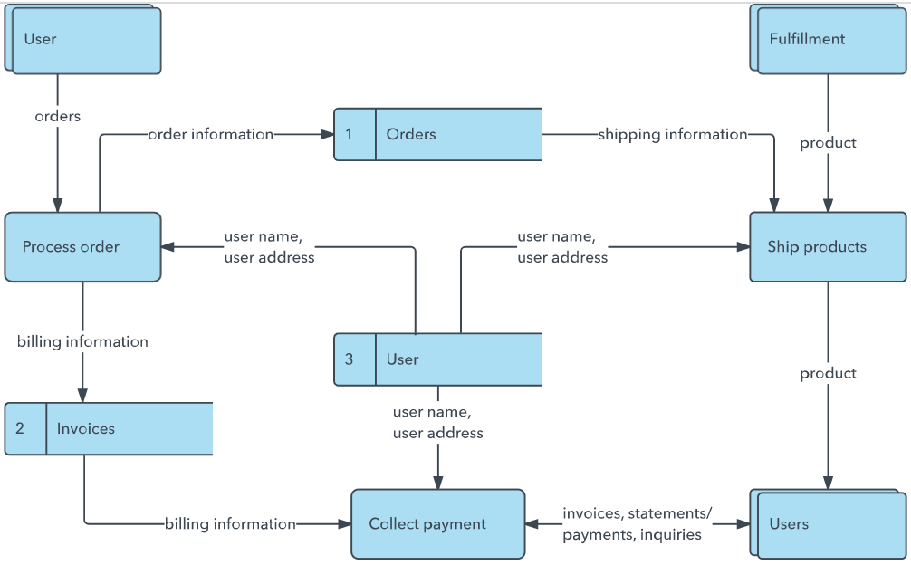


User Stories
Use the below template to list all the user stories for the product.
User Type | Functional Requirement (Epic) | User Story Number | User Story / Task | Acceptance criteria | Priority | Release
Customer (Mobile user) | Registration | USN-1 | As a user, I can register for the application by entering my email, password, and confirming my password. | I can access my account / dashboard | High | Sprint-1
 |  | USN-2 | As a user, I will receive confirmation email once I have registered for the application | I can receive confirmation email & click confirm | High | Sprint-1
 |  | USN-3 | As a user, I can register for the application through Facebook | I can register & access the dashboard with Facebook Login | Low | Sprint-2
 |  | USN-4 | As a user, I can register for the application through Gmail |  | Medium | Sprint-1
 | Login | USN-5 | As a user, I can log into the application by entering email & password | I can access the plant disease detection upload page | High | Sprint-1
 | Image Upload & Disease Detection | USN-6 | As a farmer, I can upload a photo of my plant leaf and receive an instant disease prediction with a confidence score | The disease name and confidence percentage are displayed clearly on the result card after upload | High | Sprint-1
Farmer / End User (Web)
Farmer / End User (Web)
Farmer / End User (Web) | Image Upload & Detection | USN-7 | As a user, I can see a live image preview of the leaf I selected before clicking Submit | A thumbnail of the selected image is rendered below the file input field | High | Sprint-1
Farmer / End User (Web) | Image Upload & Detection | USN-8 | As a user, I can retake / re-upload a new image and get a fresh prediction without refreshing the page | Clicking Upload again clears the previous result and allows a new submission | Medium | Sprint-2
Farmer / End User (Web) | Disease Result Display | USN-9 | As a user, I can see which disease my plant has, the confidence %, and a brief description on the result card | Result card shows: disease label, confidence score, class index; response time under 3s | High | Sprint-1
Administrator | Model Management | USN-10 | As an admin, I can retrain the model with a new dataset by running train.py and replacing plant_model.h5 | New model loads correctly on next Flask server start and returns accurate predictions | High | Sprint-2
Administrator | Class Management | USN-11 | As an admin, I can update the class_names list in app.py to add or rename disease classes after retraining | Updated class names appear correctly in prediction results after server restart | Medium | Sprint-2
Customer Care Executive |  |  |  |  |  | N/A
Administrator
Administrator

