Pre-Sales AI Agent — Data Flow Diagrams

1. End-to-end system data flow
What moves: The browser sends files and JSON over HTTPS (proxied to :8000). The API writes uploads to disk, runs the orchestrator, and keeps live state in memory while mirroring to SQLite. LLM calls return structured JSON that becomes requirements, summary, questions, and eventually the proposal. Email is optional via SMTP or saved to the outbox.
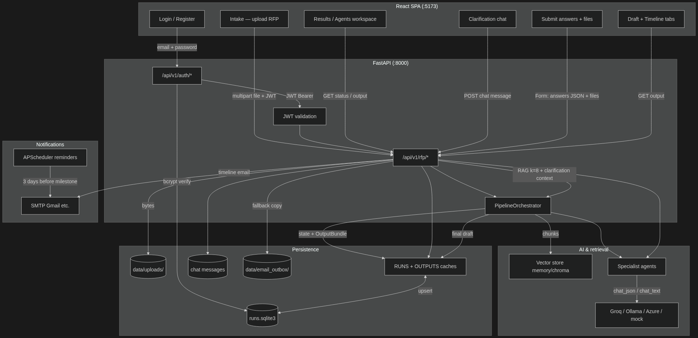

2. Phase 1 — automatic pipeline (upload → 100%, no draft)
Explanation: Phase 1 is fully automatic after upload. Each agent step updates progress, writes events, and persists to SQLite. Chunks go into the vector store for later RAG. The pipeline stops at 100% without a proposal so the final draft can use human clarifications.
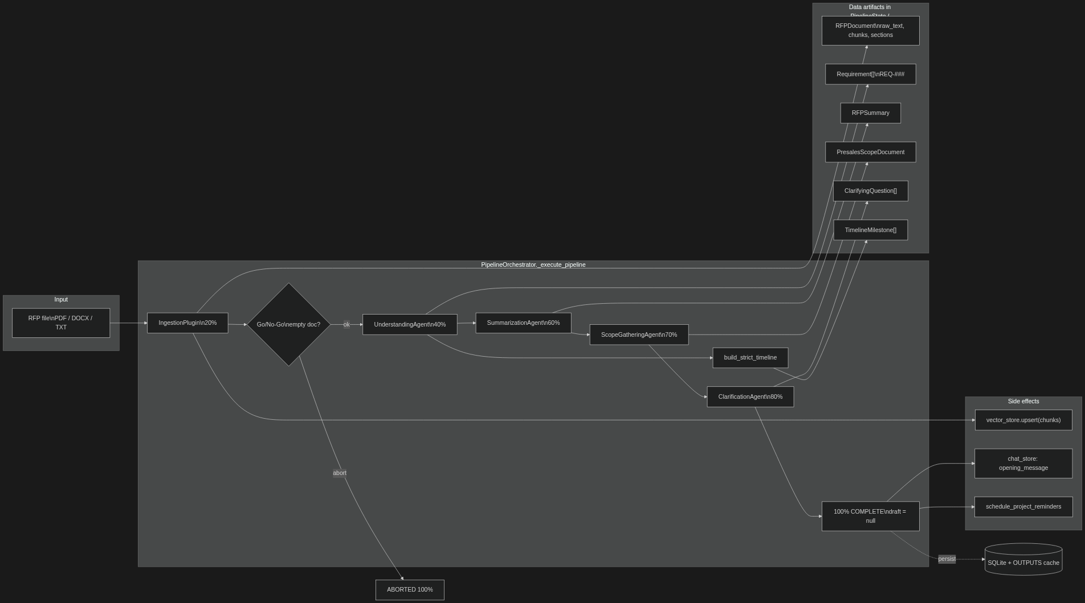

3. Phase 2 — clarifications → final draft → email
Explanation: Phase 2 only starts when the user submits clarifications. The system merges form answers, chat history, and uploaded file text into one prompt context, pulls top-8 RAG chunks, and generates the integrated proposal. A timeline email fires on success.
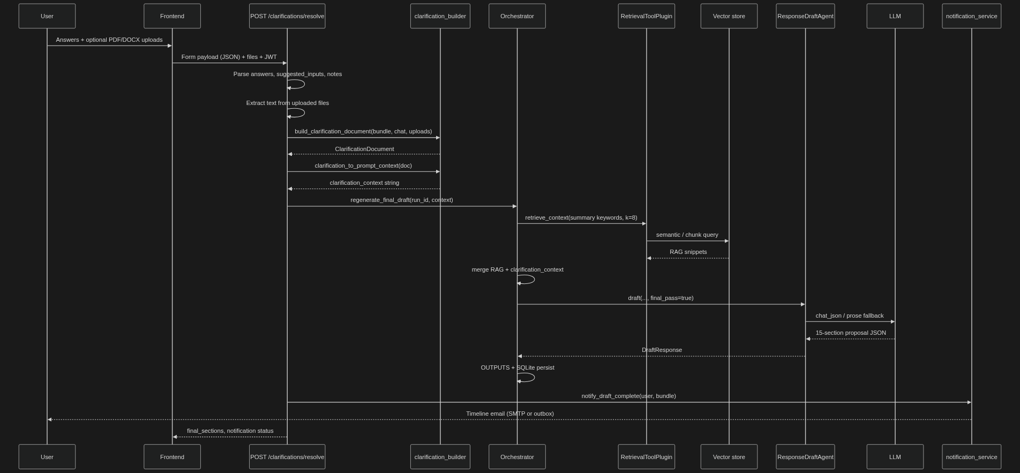

4. LLM request path (every agent call)
Explanation: All specialist agents share one LLM client. Responses must parse as JSON into typed models. Groq runs use cooldown delays between steps to avoid TPM limits. On failure, the run is marked failed with a user-visible error.
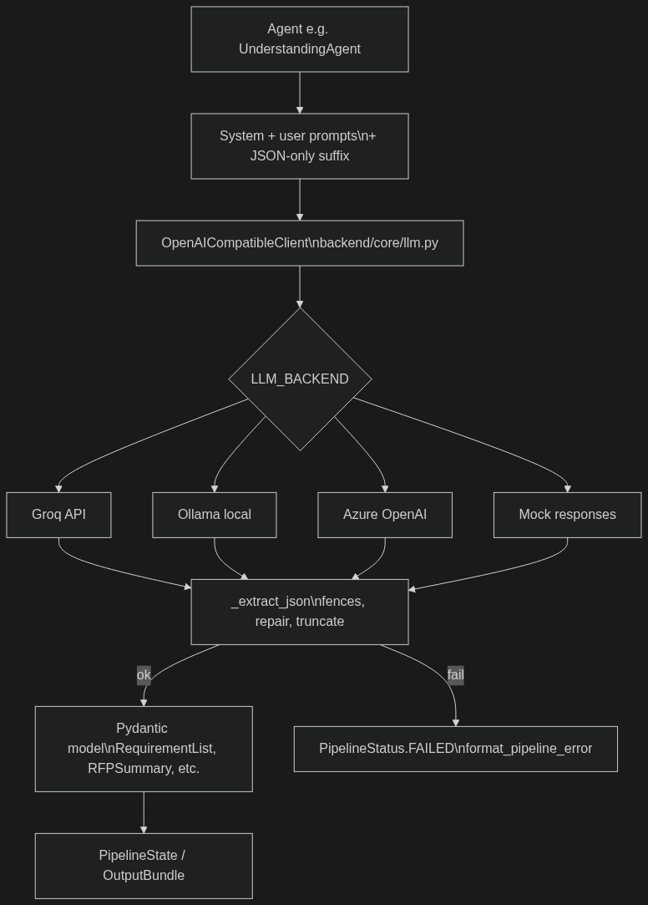

5. Persistence & cache hydration
Explanation: Hot path uses in-memory dicts for fast polling (GET /status, WebSocket stream). SQLite is the source of truth across restarts. Upload binaries stay on disk; metadata references stored_file UUID names.
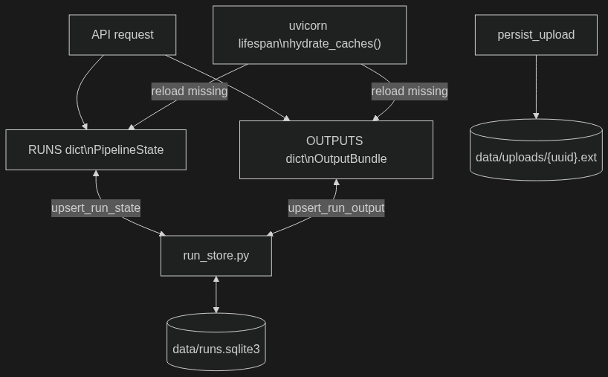

6. Auth data flow
Explanation: Each RFP run is tied to user_id. Users only see their own runs. JWT is required for every RFP endpoint.
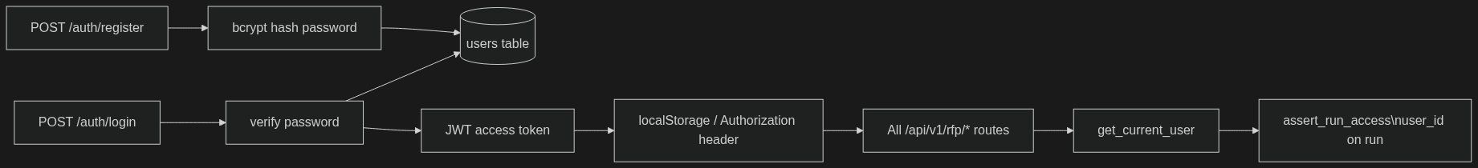

Quick summary
High-level stages from upload through automated analysis, human clarification, final draft generation, and scheduled reminders.
Stage | Trigger | Main data produced
Upload | POST /rfp/analyze | File on disk, run_id, async task
Phase 1 | Automatic | Requirements, summary, scope, questions, timeline
Human loop | Chat + form | Chat messages, clarification document
Phase 2 | POST /clarifications/resolve | Final 15-section draft + timeline email
Background | APScheduler | Deadline reminder emails

