Name:-Tanuja Dilip Khandve
Roll No:-25101711
Subject:- Java programming (Project)

To-Do List Application in Java

1. PROJECT TITLE
To-Do List Management System (Console-Based Application)

2. OBJECTIVE
The main objective of this project is to create a simple and efficient task management system using Java.
It allows users to:
- Add tasks
- View all tasks
- Mark tasks as completed
- Delete tasks
This project helps users organize their daily activities and manage tasks effectively.

3. TECHNOLOGIES/TOOLS USED
- Java SE – Core Java language
- VS Code – Code editor
- Java Compiler (javac) – Converts source code to bytecode
- Java Virtual Machine (JVM) – Executes bytecode
- ArrayList – For storing tasks dynamically
- Scanner – To take input from the user
Note: No frameworks or GUI were used to keep it simple and easy to understand.

4. PROJECT STRUCTURE
ToDoListProject
│
├─ Main.java // Entry point: shows menu and handles user input
├─ ToDoList.java // Manages list of tasks (add, view, delete, mark done)
├─ Task.java // Task blueprint (id, name, status)
5. HOW THE PROJECT WORKS:-

Step 1: COMPILATION
Before running the program, all Java files are compiled using:
javac *.java
- javac = Java compiler converts .java files into bytecode .class files.
- *.java = wildcard for compiling all files in the folder.
- Output: Main.class, ToDoList.class, Task.class
Step 2: EXECUTION
java Main
- JVM runs the Main.class file and starts the program.
- Displays a menu for the user to interact with.
6. MENU OPTIONS
--- To-Do List Menu ---
1. Add Task
2. View Tasks
3. Mark Task as Done
4. Delete Task
5. Exit
- Add Task: User enters task name, stored in list
- View Tasks: Displays all tasks with their status (Pending/Done)
- Mark Task as Done: Changes task status to completed
- Delete Task: Removes task from list
- Exit: Ends the program

7. EXPLAINATION OF FILES
Task.java
- Represents one task.
- Fields: id, name, isDone
- Methods:
  - markDone() → Marks task as completed
  - toString() → Displays task in readable format
ToDoList.java
- Manages all tasks in the ArrayList.
- Methods:
  - addTask(String name) → Add a new task
  - viewTasks() → Display all tasks
  - markTaskDone(int id) → Mark specific task as done
  - deleteTask(int id) → Delete task by ID
- Interaction: Uses Task class to create objects → Main calls these methods.
Main.java
- Entry point of the program.
- Handles user input using Scanner.
- Calls ToDoList methods based on user menu choice.
- Loop keeps menu active until user chooses Exit.
- Interaction: Main talks to ToDoList, ToDoList talks to Task.

8. HOW FILES IN
Main.java → ToDoList.java → Task.java
- Main.java → Entry point & user interface
- ToDoList.java → Handles all task operations
- Task.java → Stores task data
ANALOGY:
- Task = Employee
- ToDoList = Manager
- Main = CEO giving instructions

9. SAMPLE OUTPUT
--- To-Do List Menu ---
1. Add Task
2. View Tasks
3. Mark Task as Done
4. Delete Task
5. Exit
Choose an option: 1
Enter task name: Finish assignment
Task added successfully!

--- To-Do List Menu ---
Choose an option: 2
Tasks:
1. Finish assignment [Pending]

--- To-Do List Menu ---
Choose an option: 3
Enter task ID to mark done: 1
Task marked as done!

--- To-Do List Menu ---
Choose an option: 2
Tasks:
1.Finish assignment [Done]

10. FLOW DIAGRAM:-
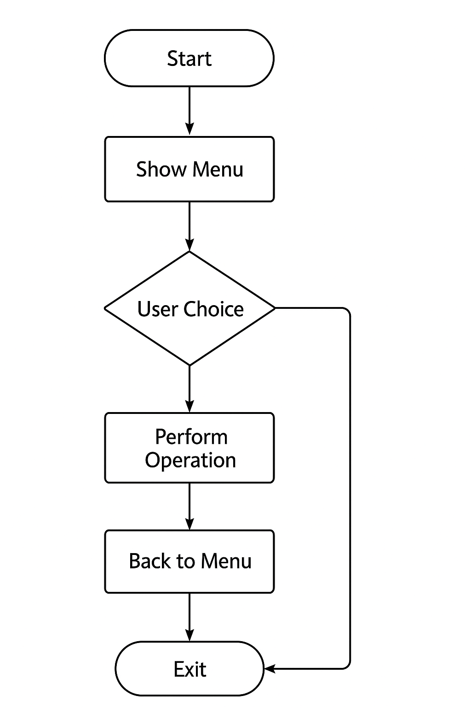
- Explanation: Main creates one instance of ToDoList. ToDoList manages multiple Task objects. Arrows show the “has-a” or “uses” relationship.

11.CLASS DIAGRAM:-
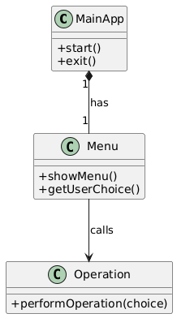
11. CONCLUSION
- Demonstrates object-oriented programming using Java.
- Modular design makes it easy to maintain and scale.
- Console-based program mimics real-world application architecture.
- Can be extended to GUI or database-based application in the future.
12.SCREENSHOTS:-
Code Snippet:-
1)Task.java File:-

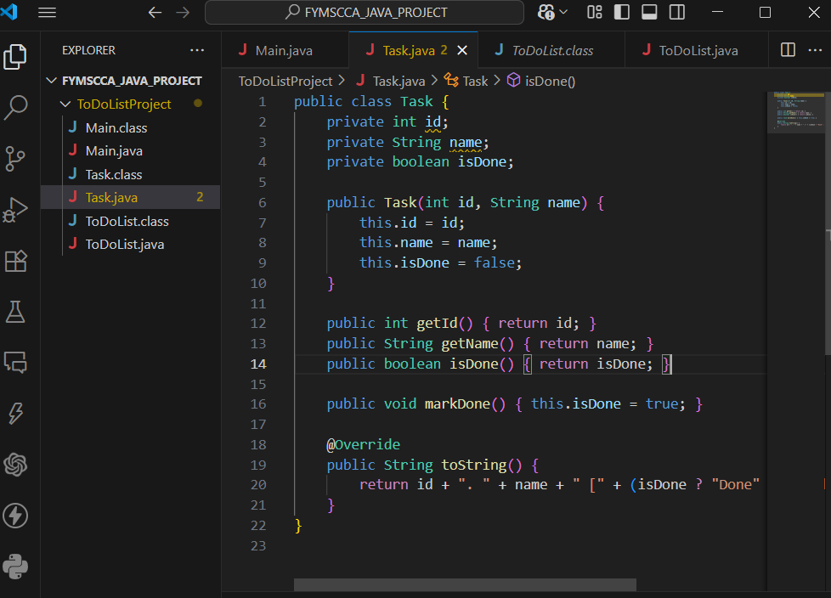

2)ToDoList.java File:-
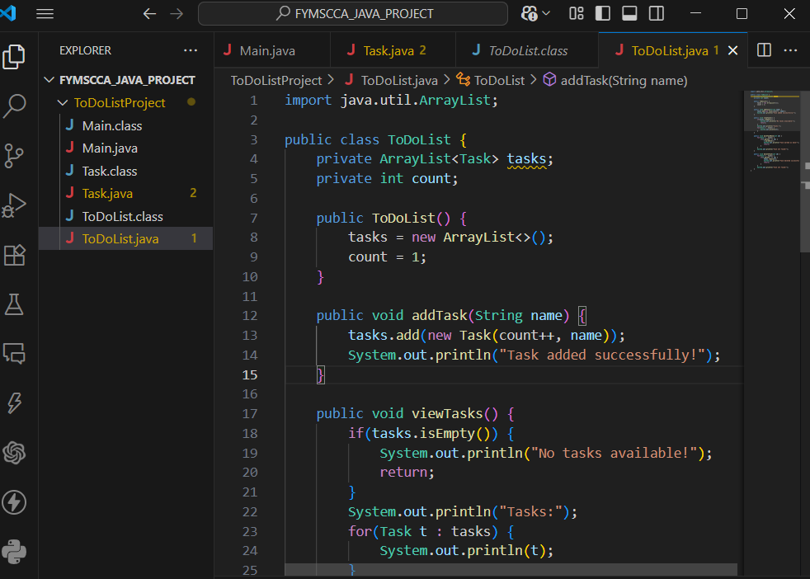
3)Main.java:-
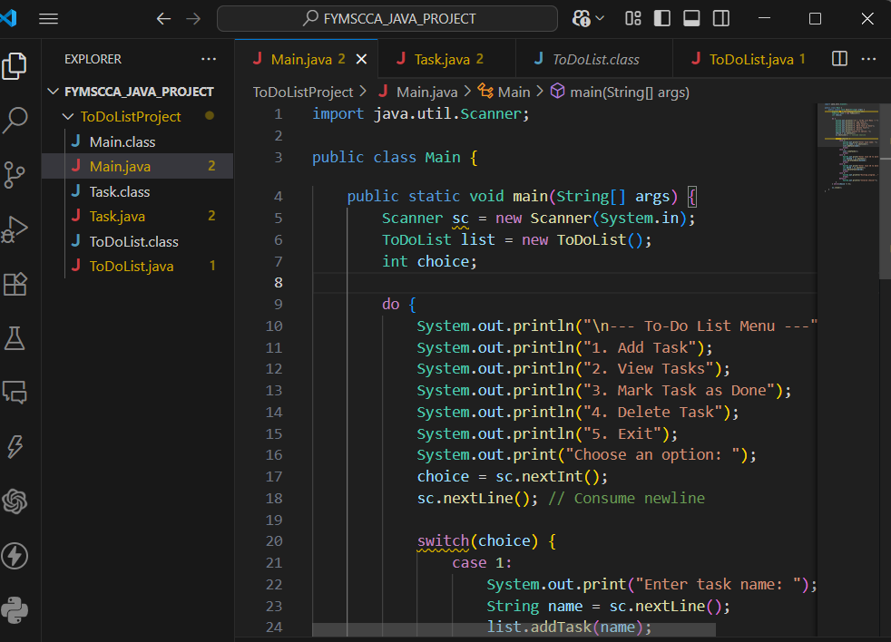
OUTPUT Screen :-
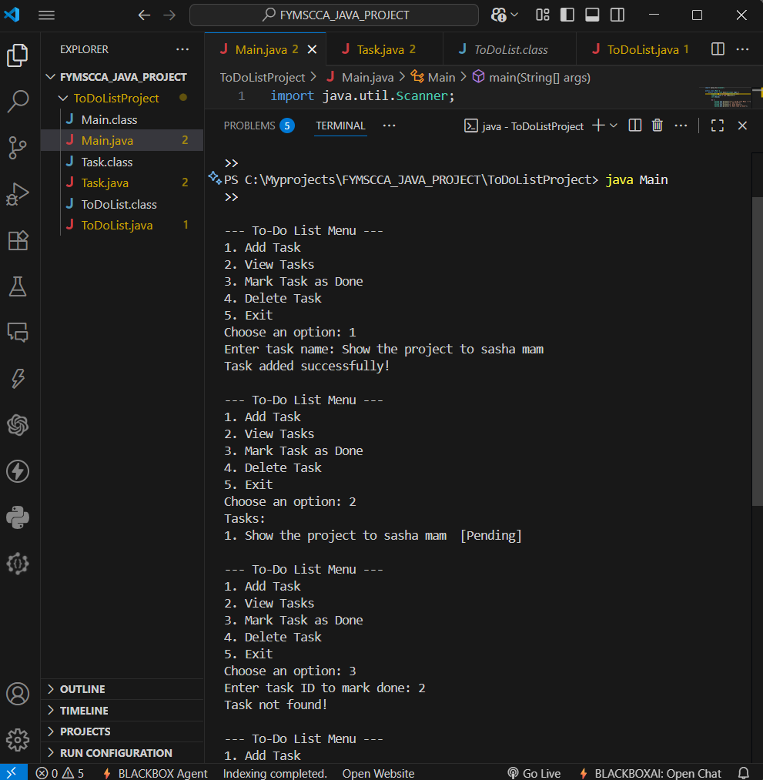

-------THANK YOU--------

