Sarhad College of Arts Commerece & Science Katraj Pune-46
NAAC Accrediated with B+ Grade

(FACULTY OF SCIENCE & TECHNOLOGY)
Subject: Python Programming and Data Structure
MSc CA Sem-I
Name of the Student :- Tanuja Dilip Khandve
Roll No:- 2517011 Exam Seat No:-

SARHAD COLLEGE OF ARTS, COMMERCE AND SCIENCE KATRAJ, PUNE-46 (FACULTY OF SCIENCE & TECHNOLOGY)
Seat No :-

CERTIFICATE
This is informed that Miss /Mr/Mrs. ___________________

Roll No. ___________ From _____________ class has satisfactorily completed the laboratory course in ________ subject during the year __________ as per the requirement of the university of Pune.
Date:-
Teacher In-charge HOD Principal

Internal Examiner External Examiner

ASSIGNMENT NO 1:-
Q1: Write a Python Program to Calculate the Average of Numbers in a Given List.
Code Snippet:-
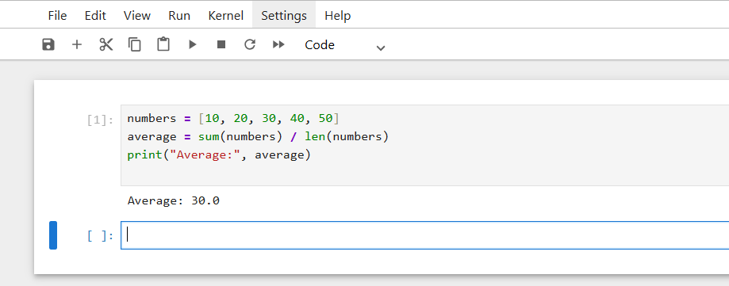
Q2: Write a program which accepts 6 integer values and prints "DUPLICATES" if any of the values entered are duplicates otherwise it prints "ALL UNIQUE".
Code Snippet:-
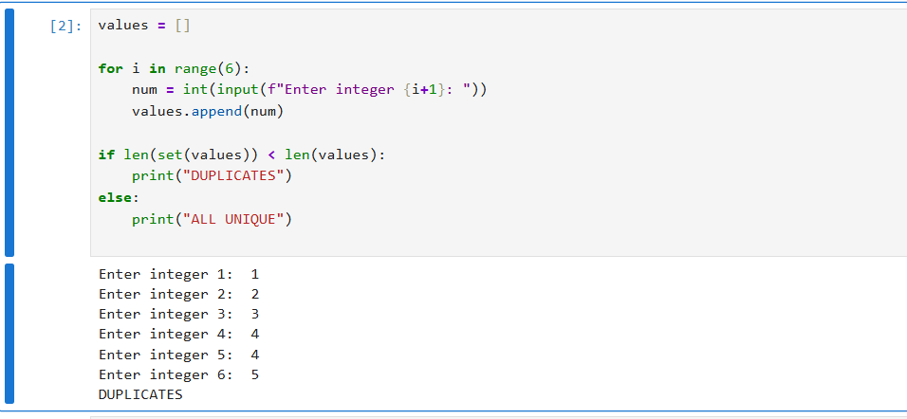

Q3: Write a program to display the following pattern:
1
2 3
4 5 6
7 8 9 10
Code Snippet:-
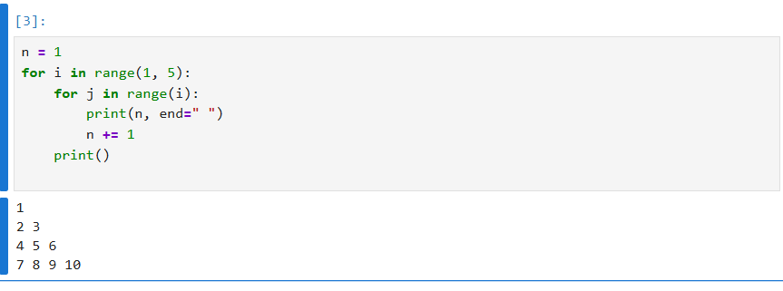

ASSIGNMENT NO 2 : - PYTHON TUPLES
Q1: Reverse the following tuple a Tup = (10, 20, 30, 40, 50)
python
Code Snippet:-
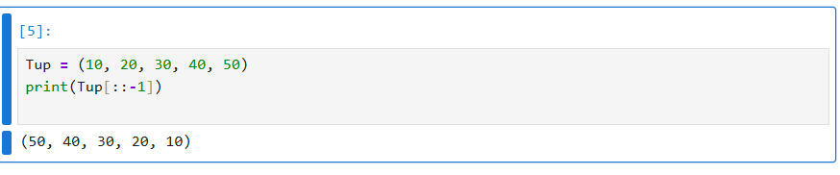

Q2: Write a Python program to Create a list of tuples with the first element as the number and second element as the square of the number.
Code snippet:-
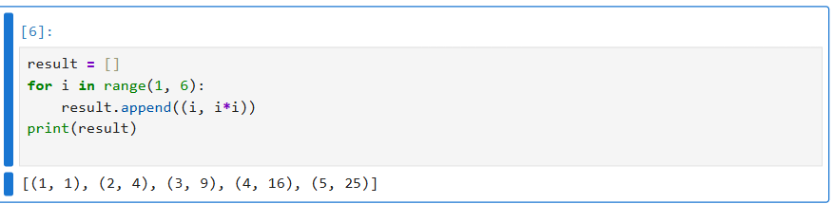

Q3.Copy element 44 and 55 from the following tuple into a new tuple tuple1 = (11, 22, 33, 44,
55, 66)
Code snippet:-
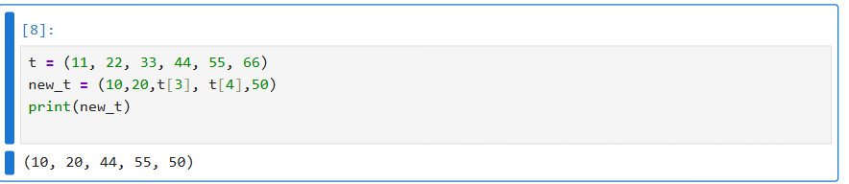

Q4: .Write a Python program to get the 5th element from front and 5th element from last of a tuple.
Code Snippet:-
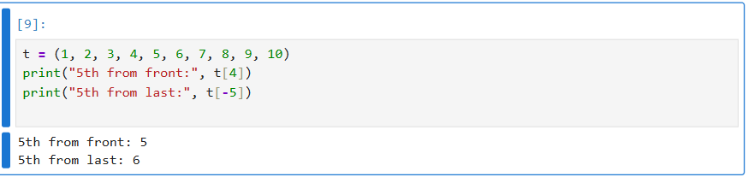
Q5. Write a Python program to find the repeated items of a tuple.
Code Snippet:
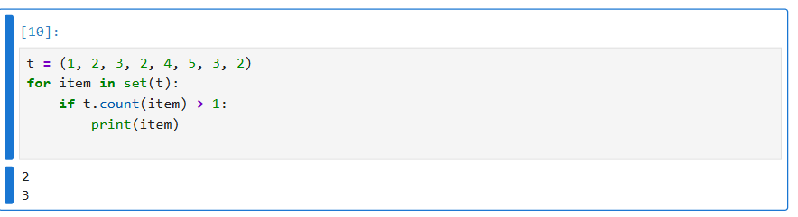
Q6. Write a Python program to check whether an element exists within a tuple.
Code snippet:
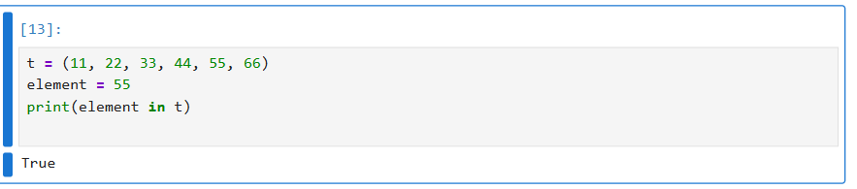

ASSIGNMENT NO 3 : - PYTHON SETS
Q1: What is the output of following program: sets = {1, 2, 3, 4, 4} print(sets)
Code snippet:-
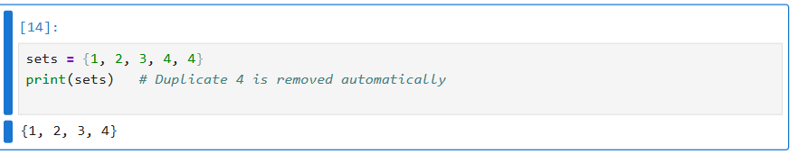

Q2:Write a Python program to do iteration over sets.
Code snippet:-
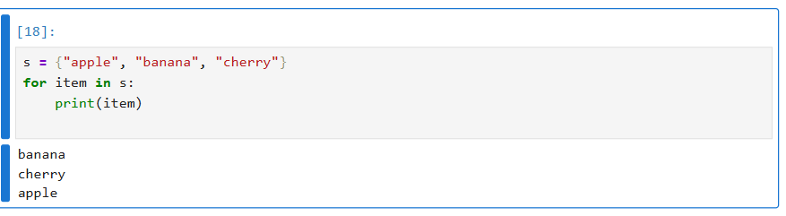
Q3: Write a Python program to add and remove operation on set.
Code Snippet:
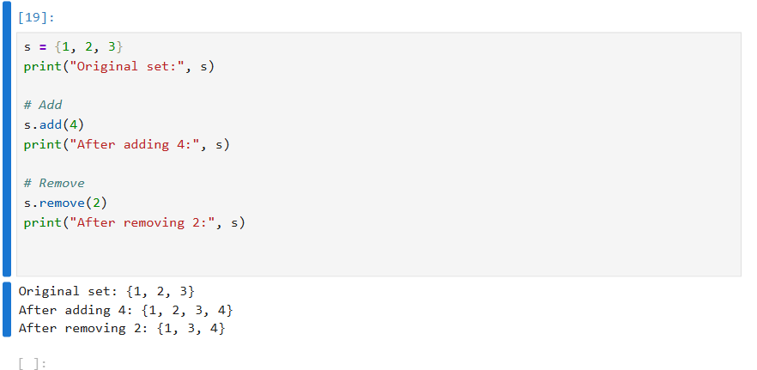

Q4: Write a Python program to find maximum and the minimum value in a set.
Code snippet:
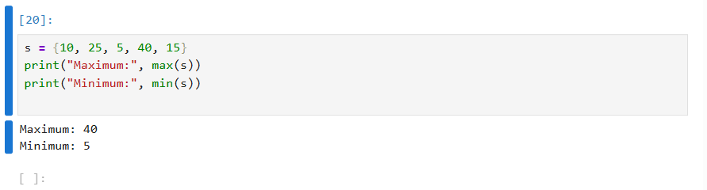

ASSIGNMENT NO 4 : - PYTHON DICTIONARY

Q1. Write a Python program to combine two dictionary adding values for common keys.
Sample Dictionary:
d1={'a':100,'b':200,'c':300}
d2={'a':300,'b':200,'d':400}
Code snippet:
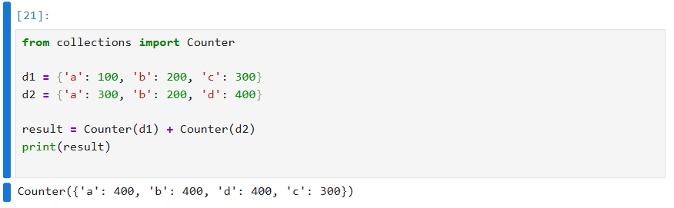

Q2. Write a Python script to generate and print a dictionary that contains a number (Between 1 and n) in the form (x, x*x).
Sample Dictionary (n = 5)
Expected Output : {1: 1, 2: 4, 3: 9, 4: 16, 5: 25}
Code snippet:
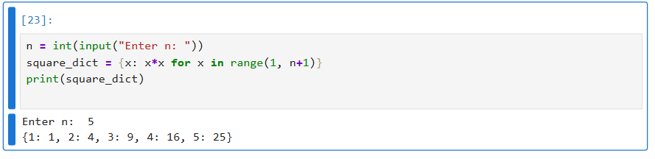
Q3: Write a Python program to create a dictionary from a string.
Sample-String: 'W3resource'
Expected output: {'3': 1, 's': 1, 'r': 2, 'u': 1, 'w': 1, 'c': 1, 'e': 2, 'o': 1}
Code snippet:
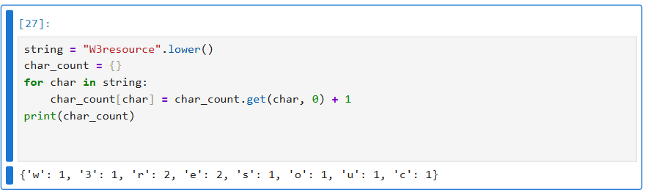

ASSIGNMENT NO 4 : - PYTHON ARRAY
Q1: Write a python program to create an array of 5 integers and display the array elements. Access individual elements through indexes.
Code snippet:
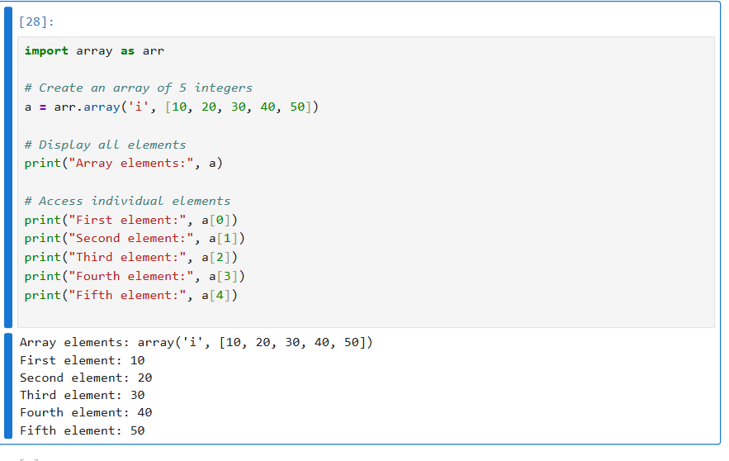
Q2: Write a python program to get the number of occurrences of specified elements in an array.
Code snippet:
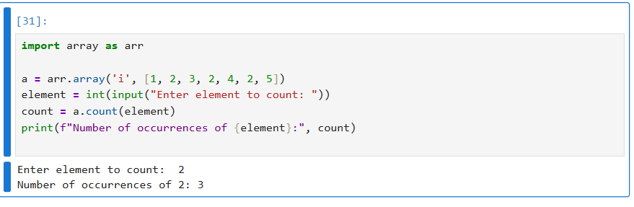
Q3: Write a python program to reverse the order of the items in the array.
Code snippet:
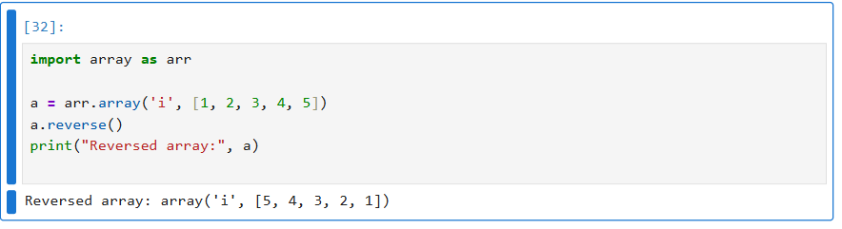

ASSIGNMENT NO 4 : - PYTHON FUNCTIONS
Q1: Write a python function to sum of all the elements in a list.
Code snippet:
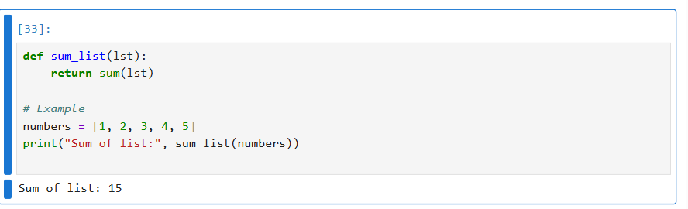
Q2: Write a python function to calculate the factorial of a number. The function accept the number as an argument.
Code snippet:
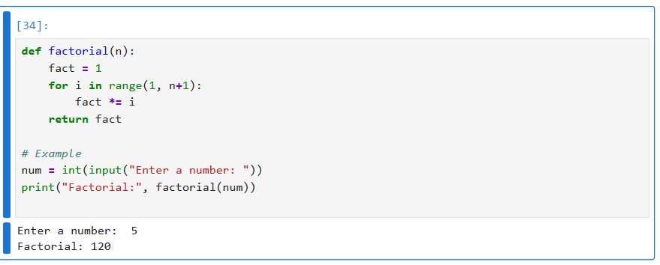
Q3: Write a python function to check whether a number falls within a given range.
Code snippet:
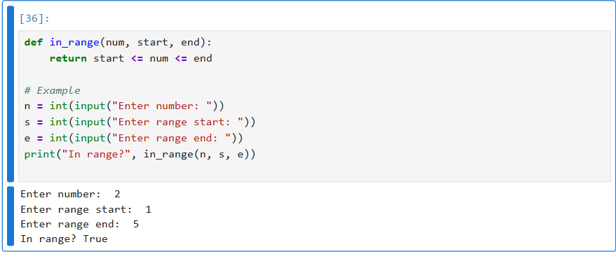
Q4: Write a python function that takes a list and returns a new list with distinct elements from the first list
Sample list: [1, 2 , 2, 3, 3, 3, 3, 4, 5]
Unique list: [1, 2, 3, 4, 5]
Code snippet:
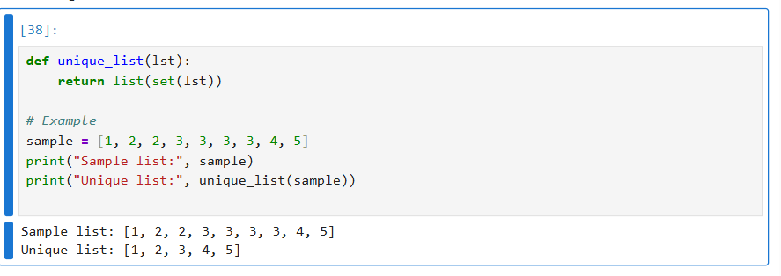

DATA STRUCTURES ASSIGNMENTS

ASSIGNMENT NO 1: SEARCHING ALGORITHMS
- Implementation of searching algorithms to search an element using: Linear Search, Binary Search.
Code snippet
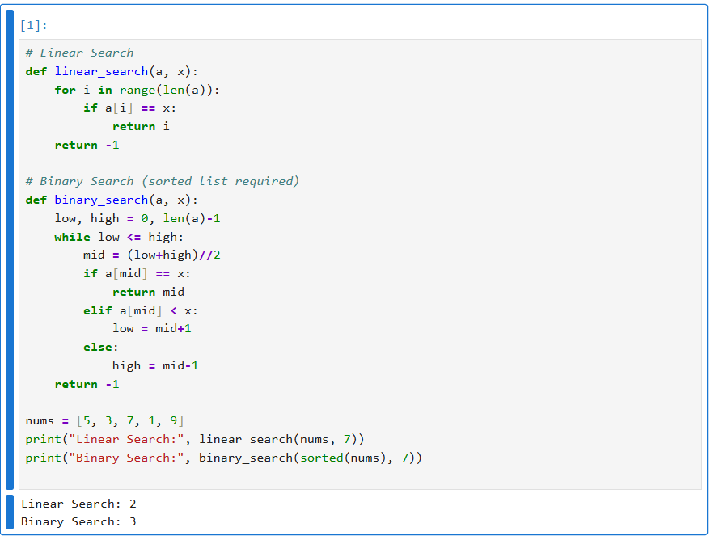

ASSIGNMENT NO 2: SORTING ALGORITHMS

Q1: Implement Bubble Sort, Insertion Sort, Quick Sort, Merge Sort.
Code snippet:
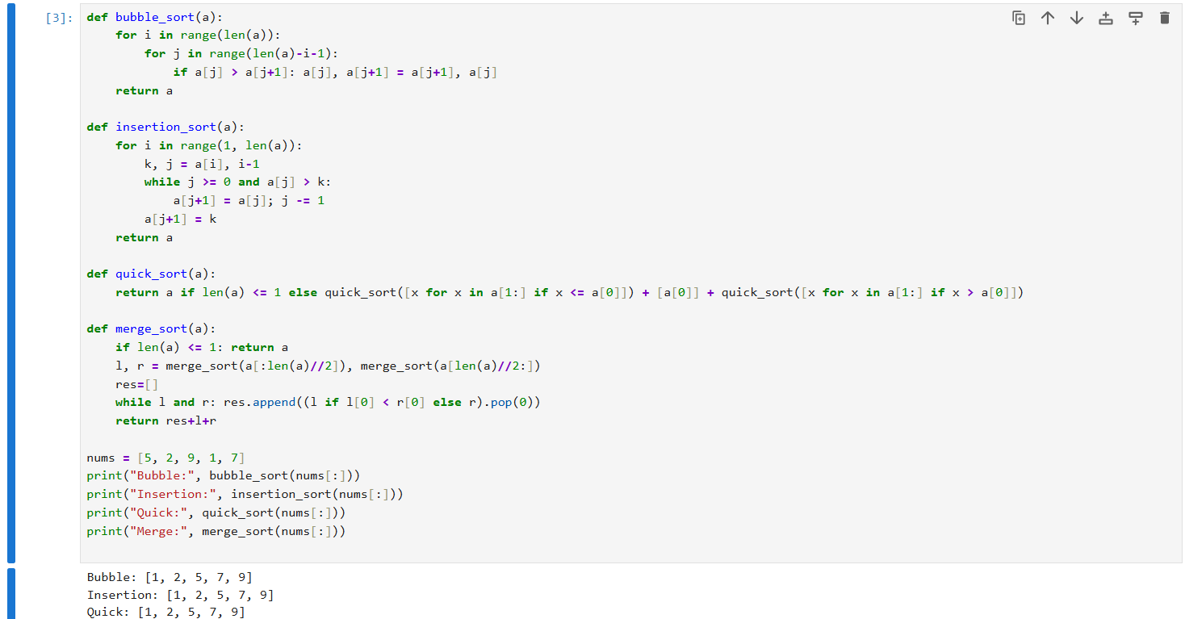

ASSIGNMENT NO 3:

Q1: Singly Linked List -1. Dynamic implementation of Singly Linked List to
perform following operations:
1.Create, Insert, Delete, Display, Search, Reverse
2. Create a list in the sorted order.
Code snippet :
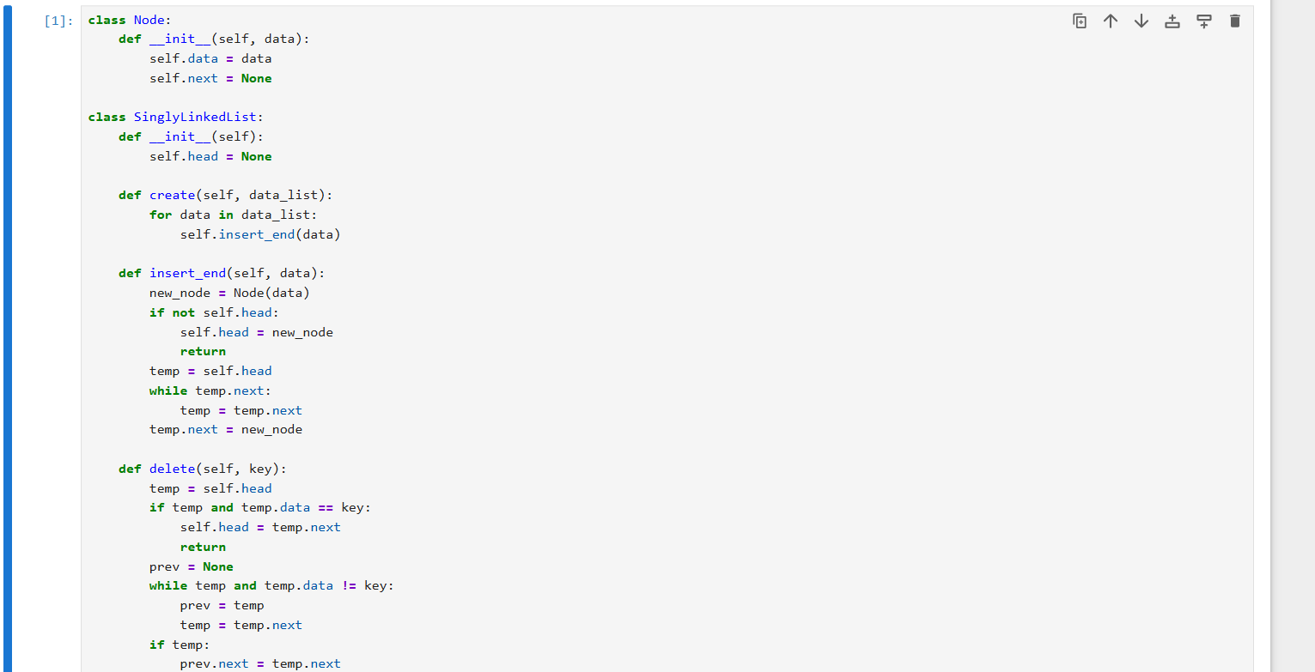
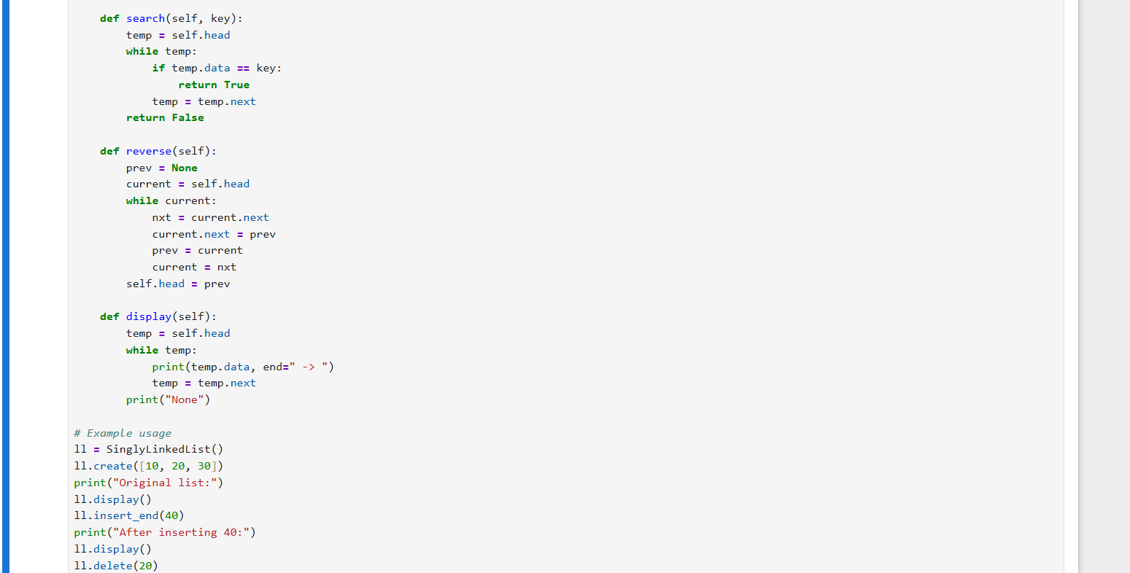
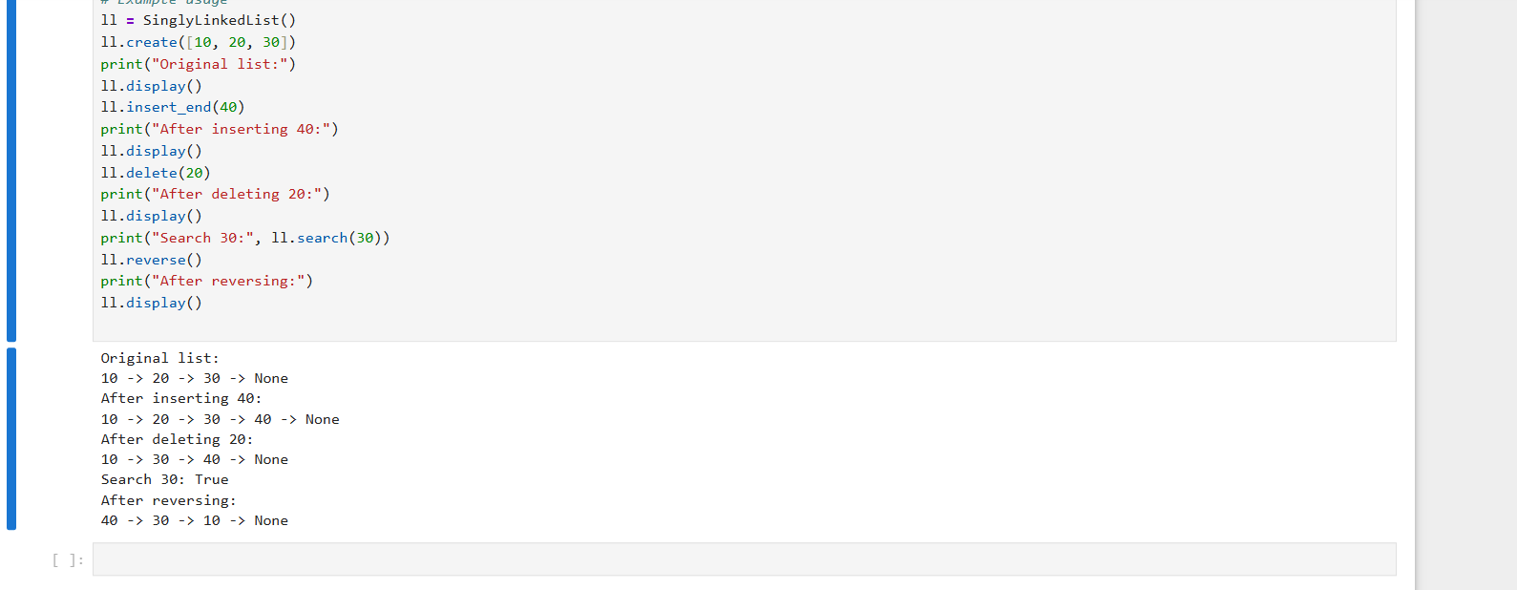

Assignment 4:

Doubly Linked List - Dynamic implementation of Doubly circular Linked List to perform following operations: Create, Insert, Delete, Display, Search
Code snippet:
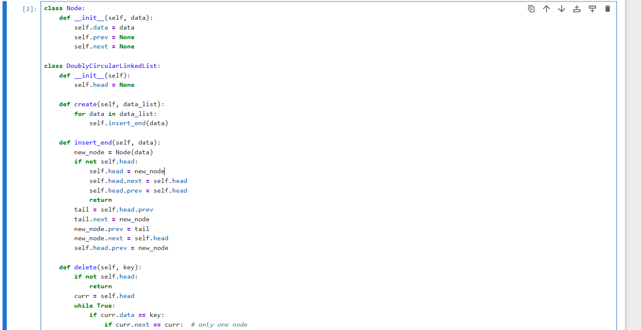

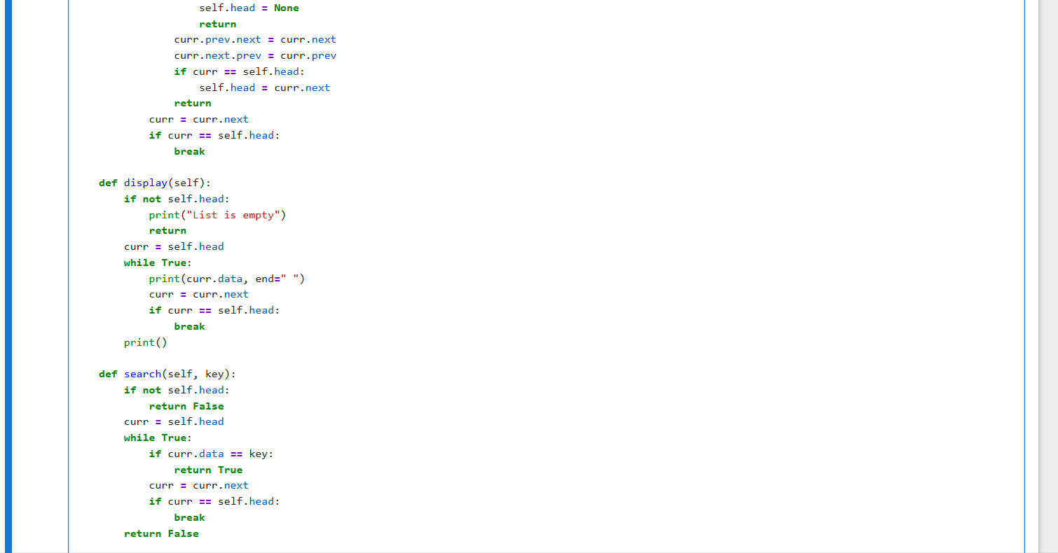
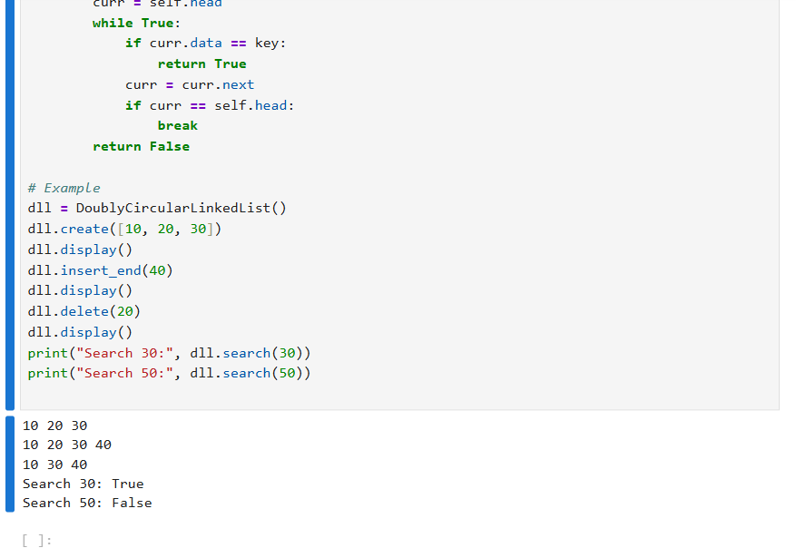

ASSIGNMENT 5:
Linked List Applications - Merge two sorted lists.
Code Snippet:
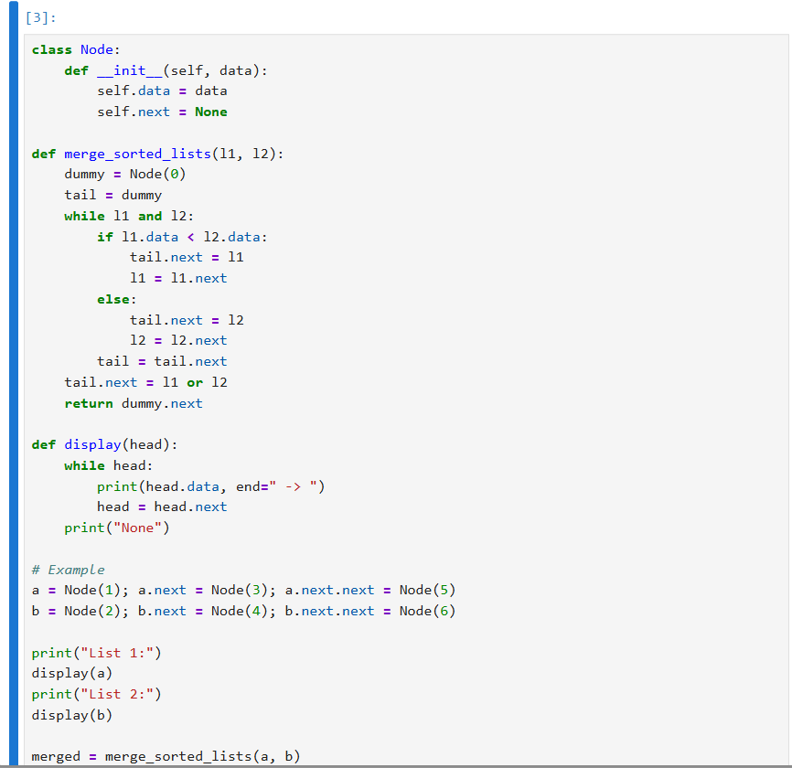
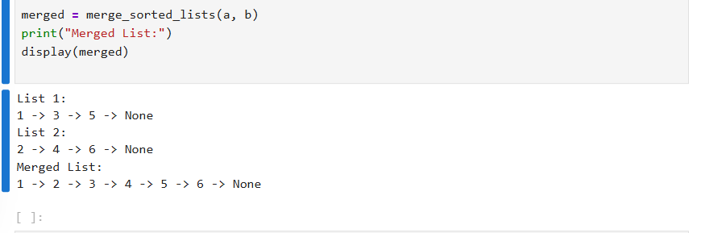
ASSIGNMENT 6:

Stack - Static and Dynamic implementation of Stack to perform following
operations: Init, Push, Pop, Isempty, Isfull

Code snippet:

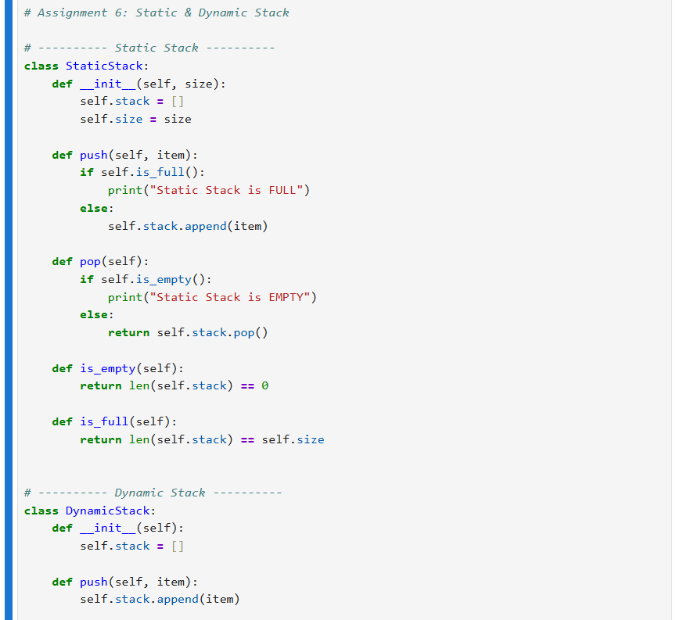
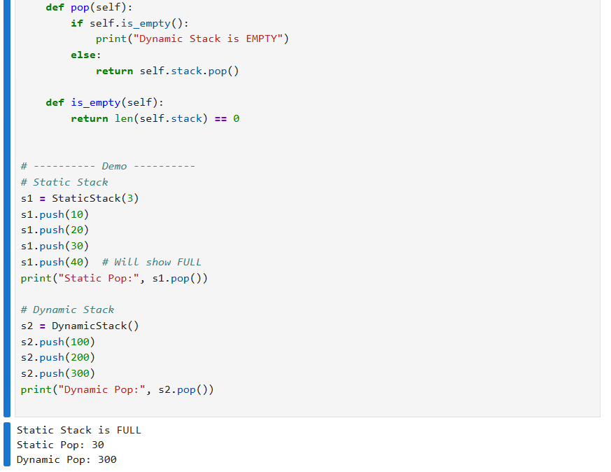

Assignment 7:
Applications of Stack –
1. Implementation of an algorithm that reverses string of characters using stack and checks whether a string is a palindrome.
2. Infix to Postfix conversion. Evaluation of postfix expression
Code snippet:
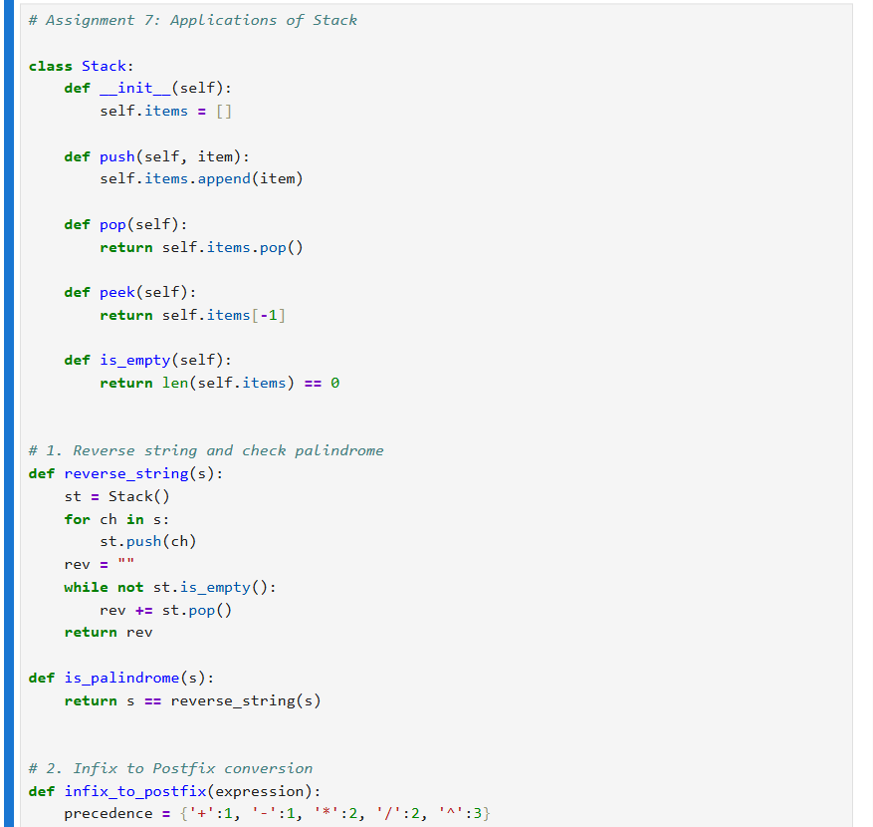
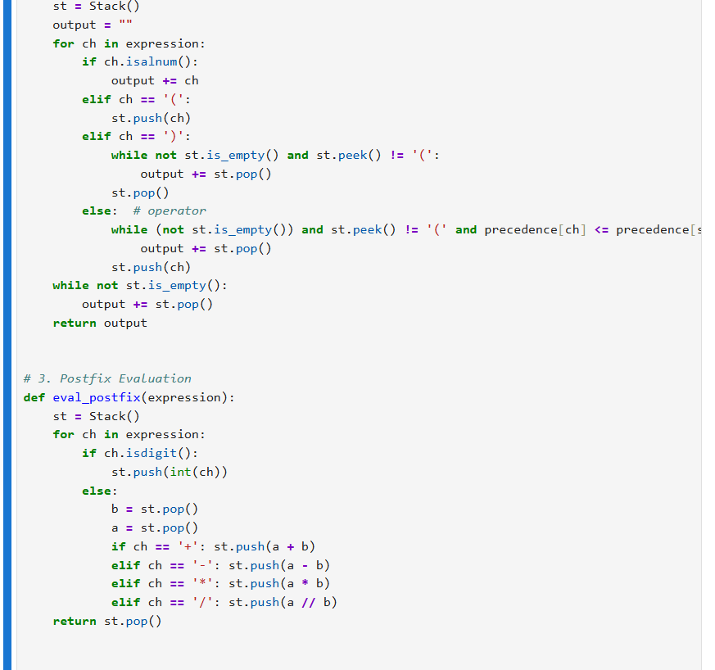
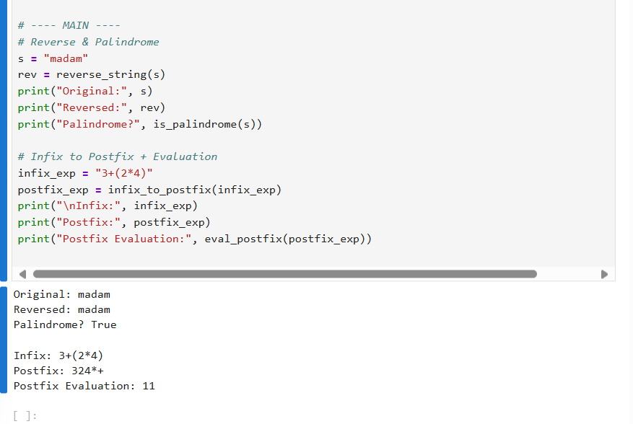

Assignment 8:

Linear Queue - Static and Dynamic implementation of linear Queue to perform following operations: Init, enqueue, dequeue, IsEmpty, IsFull.
Code snippet:
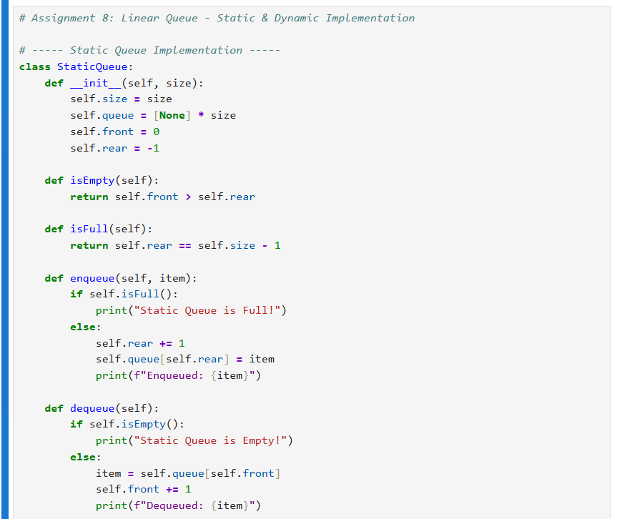
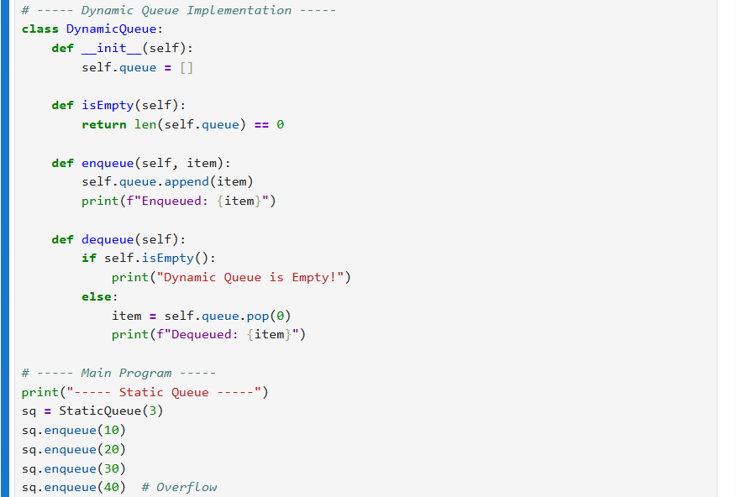
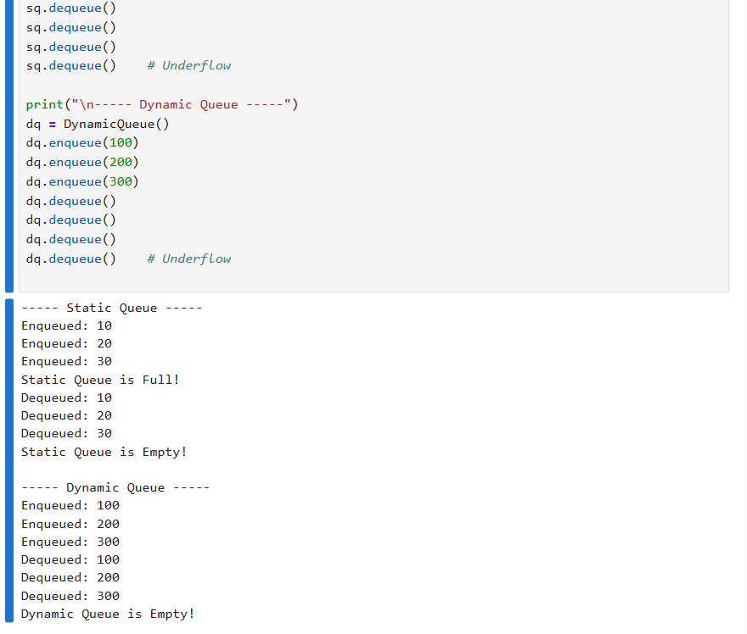

Assignment 9:

Circular and Priority Queue
1. Implementation of circular queue
2. Implementation of priority queue
Code snippet:
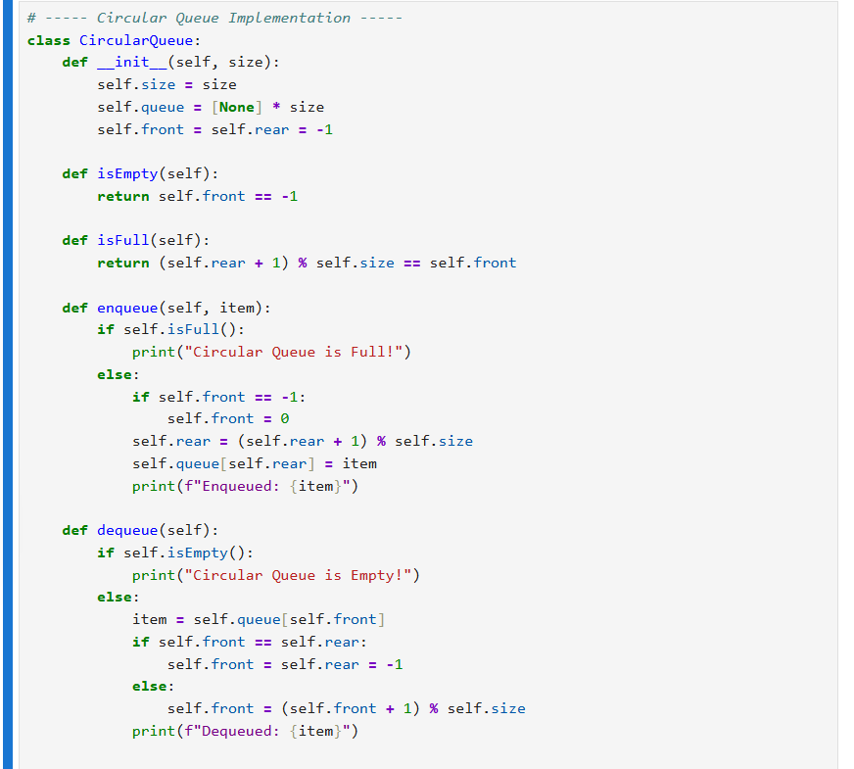
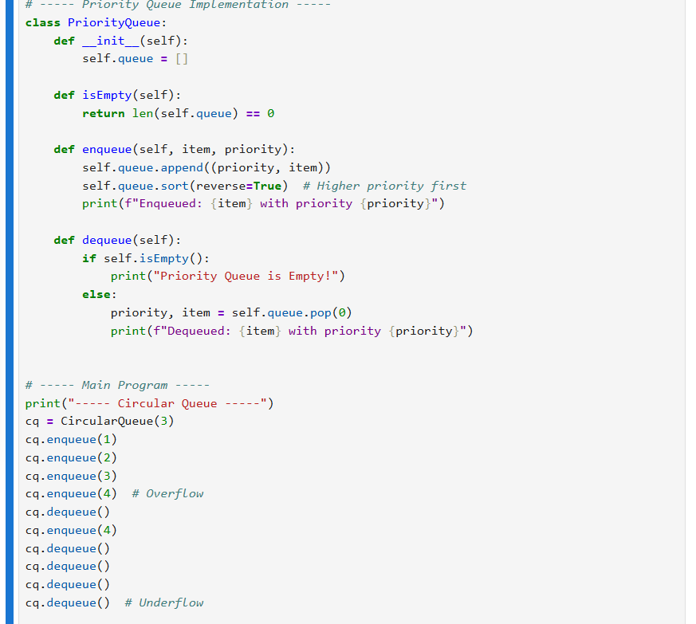
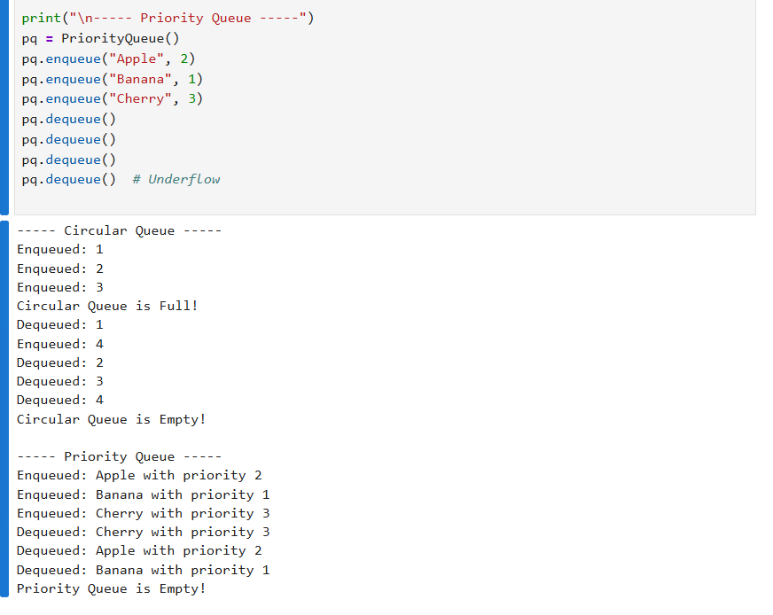

Assignment 10:

Tree Travarsals, operations etc
Code snippet:
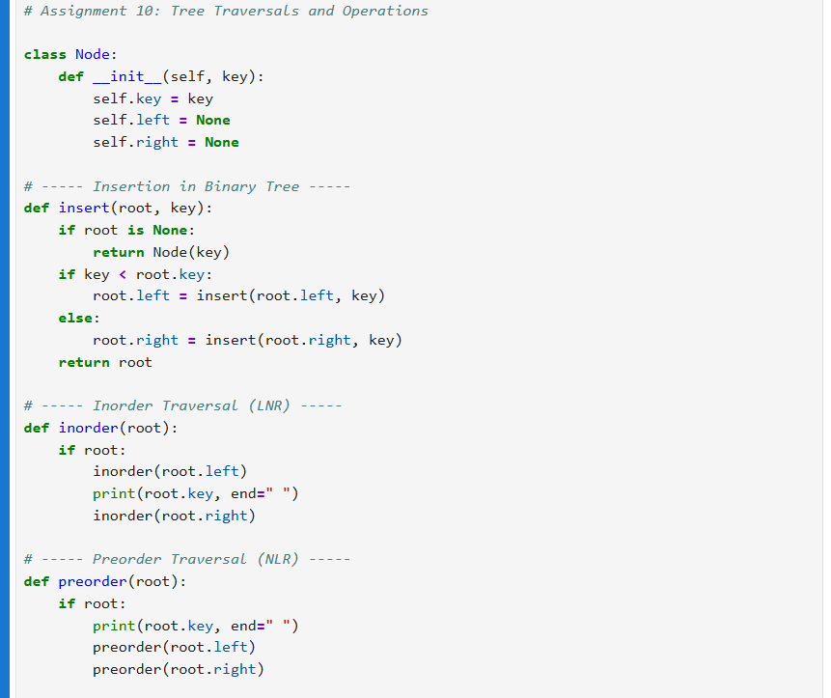
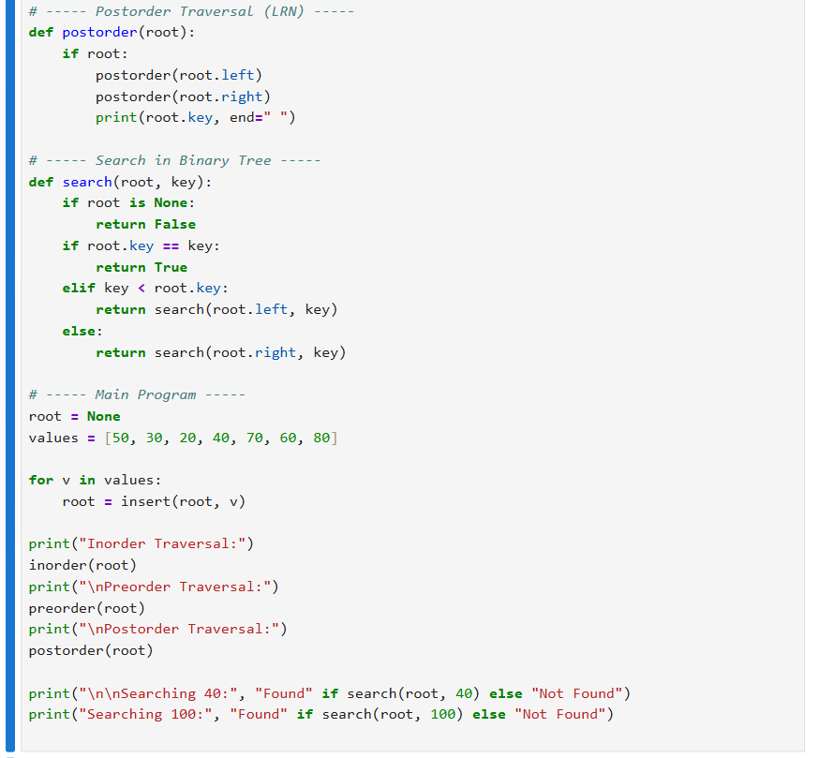
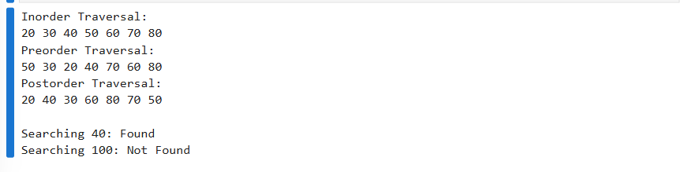

Assignment 11 :
Calculate indegree and out degree of a given graph
Code snippet:
