
Project Report
On

" DailySpendPlus – Expense Tracker "

Submitted to
THE SAVITRIBAI PHULE PUNE UNIVERSITY

In Partial
fulfilment Of

M.Sc. (COMPUTER APPLICATION)
(SEM II)

Submitted By
Ms. Tanuja Khandve

Under The Guidance Of
Asst. Prof. Sonali Gholave

Through
SARHAD COLLEGE OF ARTS, COMMERCE &
SCIENCE, PUNE-411043

UNIVERSITY OF PUNE 2025-2026

Acknowledgement

We would like to express our wholehearted thanks to all those who directly and indirectly helped me during the project. Honestly, it was only possible to complete this project with valuable guidance from various sources. We'd like to thank Asst. Prof. Sonali Gholave ma'am for their constant encouragement and support throughout the project.

A project is an attempt by every student to put his skills to use and produce something he desires. It is the first time that I have come to know the real difficulties of developing the system, which will be tested and implemented. We had a similar dream that has now come true. On the successful completion of our project work, we take this opportunity to thank every person associated with it.

I am also grateful to Goanny Technologies Pvt. Ltd. for providing me the opportunity to work as a Full Stack Developer Intern and contribute to full-stack web development projects using the MERN stack.

Last but not least, a special thanks to all our friends for their great support and guidance throughout the project.

Thanking You
Ms. Tanuja Khandve

Abstract

DailySpendPlus is a modern full-stack MERN web application designed to offer users a seamless and secure platform to track, categorize, and analyze their daily spending online.
The project aims to simplify traditional manual expense management by providing features like expense entry with category selection, monthly and category-wise visual reports, budget tracking with alerts, settings management, and PDF export of expense reports.
With an intuitive interface built using React.js and Tailwind CSS, and a secure backend powered by Node.js, Express.js, and MongoDB, the system bridges the gap between traditional manual bookkeeping and digital convenience.
Future enhancements include AI-based spending recommendations, recurring expense automation, and a mobile application, making DailySpendPlus a scalable and innovative solution for personal finance management.

Index

Sr. No | Title | Page No
1 | 1 Chapter: Introduction
 | 1.1 Company Profile | 10
 | 1.2 Existing System | 11
 | 1.3 Scope of Work | 12
 | 1.4 Operating Environment – Hardware and Software | 13
2 | 2 Chapter: Proposed System
 | 2.1 Proposed System | 14
 | 2.2 Objective of System | 15
 | 2.3 User Requirements | 15
 | 2.4 Feasibility Study | 16
 | 2.5 Module Specifications | 17
3 | 3 Chapter: Analysis And Design
 | 3.1 Use Case Diagram | 18
 | 3.2 State Diagram | 19
 | 3.3 Class Diagram | 20
 | 3.4 Sequence Diagram | 21
 | 3.5 Flow Chart | 22
 | 3.6 ER Diagram | 27
 | 3.7 Table Specifications | 28
4 | 4 Chapter: Implementation
 | 4.1 Input Screens | 32
5 | 5 Chapter: Testing
 | 5.1 Test Procedures and Implementation | 36
 | 5.2 Test Cases | 37
6 | 6 Chapter: User Manual | 38
7 | 7 Chapter: Conclusion | 39
8 | 8 Chapter: Annexure – Technology Used | 40
9 | 9 Chapter: Bibliography | 41

1. INTRODUCTION
1.1 Company Profile
Goanny Technologies Pvt. Ltd. is a software development company located at U-7, 1st Floor, Inspira Mall, Nigdi, Pune-44 (MH). The company specializes in providing innovative technology solutions to businesses and individuals through modern full-stack web development.

The company developed DailySpendPlus as part of their internship project portfolio — a personal finance and expense tracking web application aimed at helping individuals manage their daily finances digitally and efficiently. The name 'DailySpendPlus' reflects the brand's core value of tracking every daily spend, and going a step further (Plus) with analytics and smart insights.

The platform aims to offer:
- Easy daily expense entry with category-wise tagging (Food, Travel, Shopping, Bills, Health, etc.)
- Monthly and category-wise spending reports with Pie and Bar charts
- Budget setting and overspending alert notifications per category
- User-friendly dashboard with summary cards and quick filters
- Secure JWT-based authentication and personal data management
- PDF export of expense reports with charts and data tables

1.2 Existing System
Currently, most people manage personal expenses through:
- Manual diaries or paper-based expense registers
- Generic spreadsheets with no visual analytics or budget tracking
- Non-specialized apps with limited features and no personalization

Problems in the existing system include:
- Lack of real-time spending visibility and category-wise analysis
- No budget tracking or overspending alerts
- Manual calculation errors in monthly totals
- No visual charts or reports for spending trends
- Limited accessibility — not available across all devices

This makes it difficult for users to manage their personal finances effectively and make informed spending decisions.

1.3 Scope of Work
The scope of DailySpendPlus includes:
- Designing a responsive full-stack MERN web application for personal expense tracking
- User authentication module with JWT-based secure login and registration
- Expense module: Add, Edit, Delete expenses with category dropdown and date picker
- Dashboard with summary cards: Total Spent, This Month, Top Category, Total Entries
- Search and filter expenses by description and category
- Reports module: Monthly Pie chart, Daily Bar chart, category summary cards
- Budget module: Set budget per category with progress bar and alerts
- Settings module: Update profile (name, email) and change password
- PDF export of expense reports with charts and detailed data tables

Future expansions may include AI-based spending recommendations, recurring expense automation, and a dedicated mobile application.

1.4 Operating Environment – Hardware and Software
Hardware Requirements
Component | Specification
Server | Intel i5 or higher, 8 GB RAM, SSD Storage
Client System | Dual-core processor, 4 GB RAM, Internet-ready
Display | Minimum 1280x720 resolution
Network | High-speed internet connection
Storage | Minimum 256 GB SSD

Software Requirements
Category | Technology / Tool
Frontend | React.js, Tailwind CSS, HTML5, CSS3
Backend | Node.js, Express.js
Database | MongoDB (Atlas)
Authentication | JWT (JSON Web Tokens), bcrypt
Charts | Chart.js (Pie, Bar)
PDF Export | jsPDF, jsPDF-AutoTable
HTTP Client | Axios (with Interceptors)
Icons | React Icons (Feather Icons)
Notifications | React Toastify
IDE / Editor | Visual Studio Code
Version Control | Git / GitHub
Operating System | Windows (developer-side)

2. PROPOSED SYSTEM
2.1 Proposed System
The proposed system is a fully responsive MERN stack personal expense tracking web application with:
- Dynamic dashboard with real-time summary cards (Total Spent, This Month, Top Category, Total Entries)
- Search and filter functionality for quick expense lookup
- Category dropdown for consistent expense tagging
- Inline edit and delete for expense management
- Visual reports with Pie chart and Bar chart
- Budget tracking per category with progress bar and alerts
- Settings page for profile and password management
- PDF export with professional layout, charts, and data tables

Key modules:
- Authentication Module: Register, Login, JWT session, Protected routes
- Dashboard Module: Summary cards, Search/Filter, Add Expense, Expense List with Edit/Delete
- Reports Module: Monthly Pie chart, Daily Bar chart, Category summary, PDF export
- Budget Module: Set budget per category, progress bar, over-budget and near-limit alerts
- Settings Module: Update profile name/email, Change password

2.2 Objective of System
- To provide an accessible online platform for personal daily expense tracking
- To allow users to add, categorize, edit, and delete their expenses easily
- To provide visual monthly and category-wise reports for better financial decisions
- To enable budget setting per category with real-time alert notifications
- To ensure secure user data management with JWT authentication and bcrypt encryption
- To support PDF export of reports for offline reference and documentation

2.3 User Requirements
Functional Requirements:
- Users should be able to register and login securely
- Add expense with amount, category (dropdown), description, and date
- Edit and delete existing expenses inline
- Search expenses by description or category
- Filter expenses by category dropdown
- View dashboard summary cards with real-time totals
- View monthly Pie chart and daily Bar chart in Reports
- Set monthly budget per category and receive alerts
- Update profile name, email, and change password in Settings
- Export expense report as PDF with charts and tables

Non-functional Requirements:
- System should be fast, secure, and responsive on all devices
- Compatible with all modern browsers (Chrome, Firefox, Edge)
- JWT tokens stored securely in localStorage with auto-expiry
- Clean and intuitive UI with Tailwind CSS styling

2.4 Feasibility Study
Technical Feasibility:
The technology required — MongoDB, Express.js, React.js, Node.js (MERN stack) — is readily available and open-source. The developer has hands-on experience in full-stack MERN development through internship at Goanny Technologies Pvt. Ltd.

Economic Feasibility:
The cost of development is minimal as all core technologies are free and open-source. MongoDB Atlas provides a free cloud tier for database hosting. Expected ROI is high given the growing demand for personal finance management tools.

Operational Feasibility:
Users are familiar with web-based applications and expense tracking concepts. The system interface is clean and intuitive, requiring minimal training for daily use.

2.5 Module Specifications
- Authentication Module: Register (name, email, password with strength indicator), Login (JWT token generation), Protected routes with PrivateRoute component, Auto-redirect on 401
- Dashboard Module: 4 Summary cards (Total Spent, This Month, Top Category, Total Entries), Search bar with description/category search, Category filter dropdown, Add Expense form with category dropdown, Expense list with inline edit (amount, category, description, date) and delete
- Reports Module: Month/Year filter, Pie chart (category breakdown), Bar chart (daily spending trend), Category summary cards with percentage, PDF export with header, summary cards, charts, and detailed table
- Budget Module: 8 category budgets (Food, Travel, Shopping, Bills, Health, Education, Entertainment, Other), Progress bar per category, Green/Yellow/Red status indicators, Set/Update/Remove budget options
- Settings Module: Update profile name and email, Change password with minimum 6 character validation, Success/error toast notifications

3. ANALYSIS AND DESIGN
3.1 Use Case Diagram
The Use Case Diagram represents the interaction between the User actor and the DailySpendPlus system:
- Login / Register with secure credentials
- View Dashboard with summary cards and recent expenses
- Add / Edit / Delete Expense entries
- Search and Filter expenses by description and category
- View Reports: Pie chart, Bar chart, Category summary
- Set Budget per category, receive over-budget alerts
- Export Report as PDF
- Update Profile and Change Password in Settings
- Logout

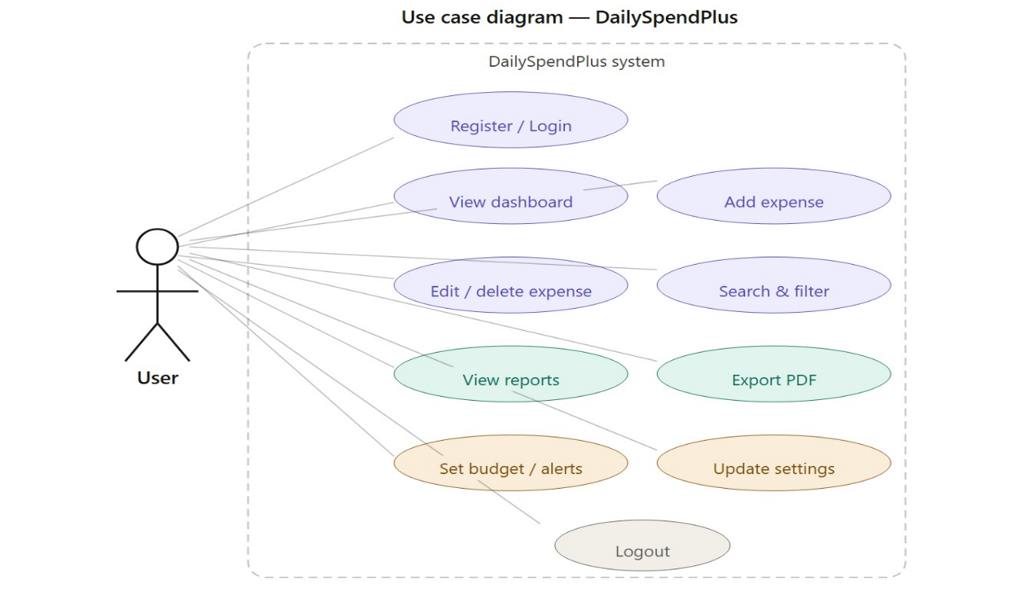

3.2 State Diagram

The State Diagram represents the lifecycle of key entities:
- User: Unregistered → Registered → Logged In → Active Session → Logged Out
- Expense: Created → Saved → Edited → Deleted
- Budget: Not Set → Set → On Track (green) → Near Limit (yellow) → Over Budget (red) → Reset
- Report: Month Selected → Data Filtered → Charts Rendered → PDF Exported

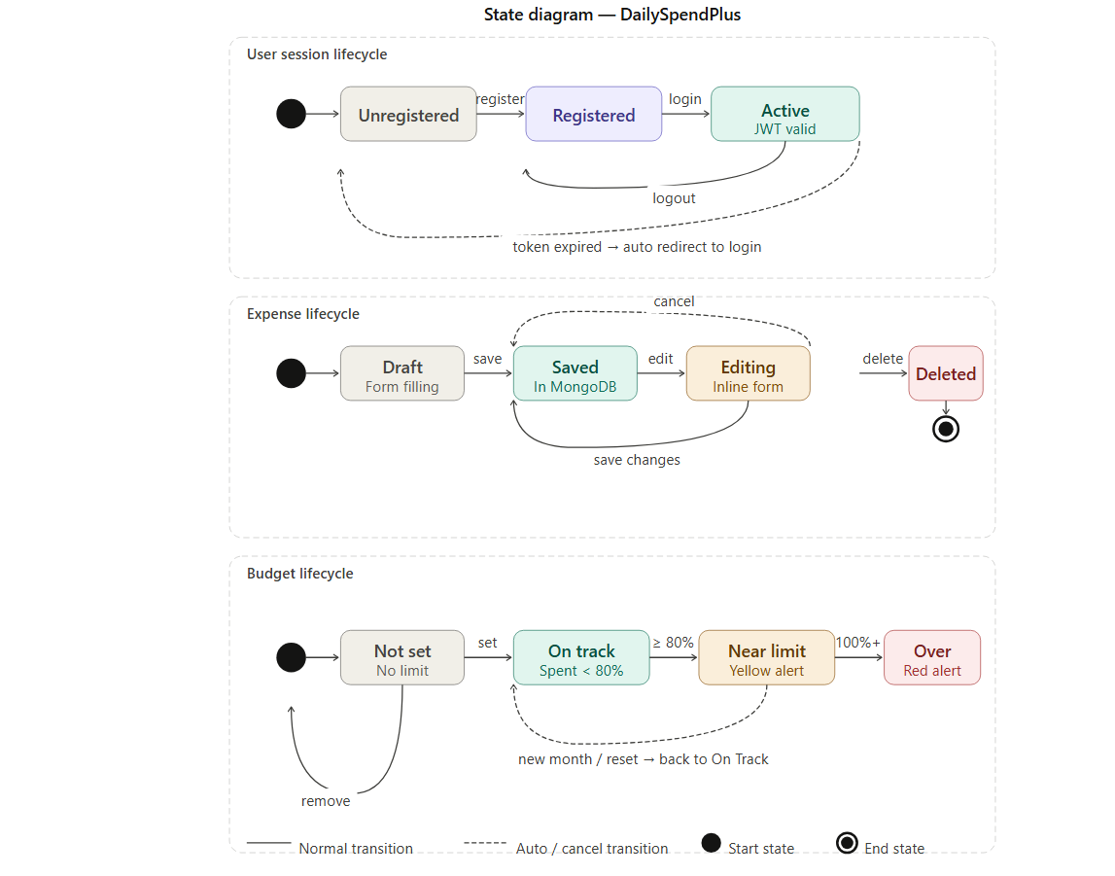

3.3 Class Diagram
Key classes and their relationships in DailySpendPlus:
- User (userId, name, email, passwordHash, createdAt) – registers, logs in, manages expenses
- Expense (expenseId, userId, amount, category, description, date, createdAt)
- Budget (budgetId, userId, category, monthlyLimit, month) – stored in localStorage
- Category (name, icon, color) – predefined: Food, Travel, Shopping, Bills, Health, Education, Entertainment, Other
- Report (userId, month, year, totalSpend, categoryBreakdown, dailyBreakdown)

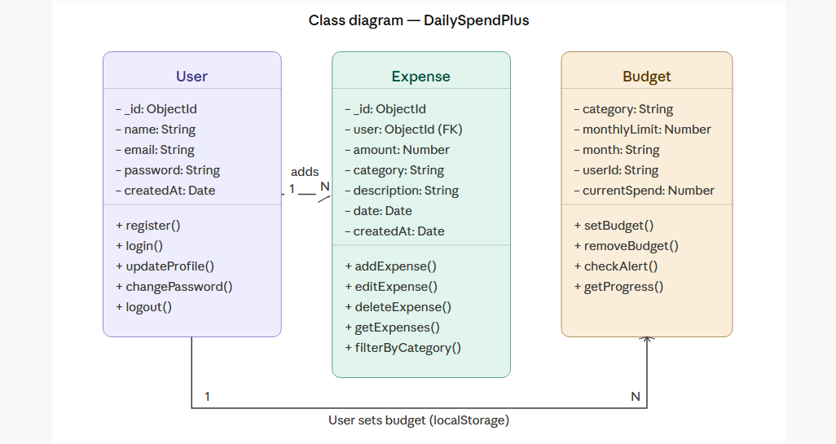

3.4 Sequence Diagram
Key sequence flows in DailySpendPlus:
- Login: User → React Login Page → POST /api/auth/login → Express → MongoDB check → JWT token → localStorage → Dashboard
- Add Expense: User → Add Expense Form → POST /api/expenses/add-expense → authMiddleware → MongoDB insert → Expense List refresh → Dashboard totals update
- Edit Expense: User → Edit button → Inline form → PUT /api/expenses/update-expense/:id → authMiddleware → MongoDB findOneAndUpdate → List refresh
- Export PDF: User → Export button → jsPDF → Chart canvas capture → autoTable → PDF download

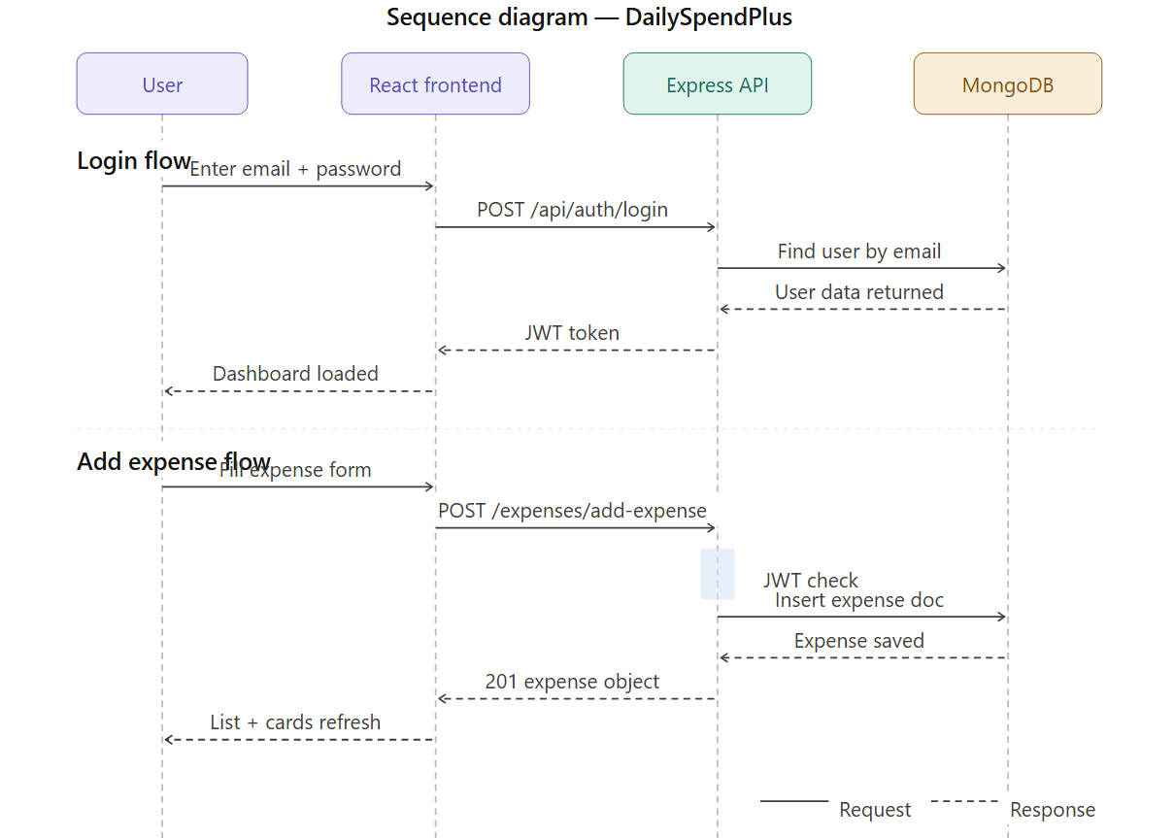

3.5 Flow Chart
The main application flow for DailySpendPlus:
- User visits DailySpendPlus application
- Register with name, email, password (strength indicator shown)
- Login with credentials → JWT token stored in localStorage
- Dashboard loads: Summary cards, Search/Filter bar, Add Expense form, Expense List
- User adds expense: selects category from dropdown, enters amount, description, date → Save
- System saves to MongoDB via Express API → List refreshes → Dashboard totals update
- User navigates to Reports: selects month/year → Pie chart and Bar chart render
- User clicks Export PDF → professional PDF with charts and tables downloaded
- User sets budget in Budget page → progress bar shows spending vs limit
- Alert shown if spending exceeds 80% or 100% of budget
- User updates profile/password in Settings → toast notification shown
- Logout → token removed → redirect to Login

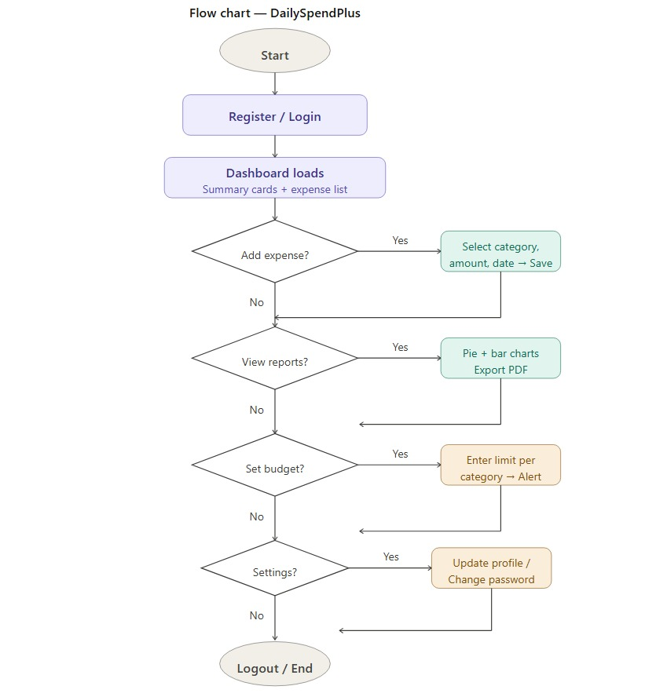

3.6 ER Diagram
The ER Diagram shows database entities and their relationships:
- users ↔ expenses (one-to-many via user ObjectId)
- expenses ↔ categories (many-to-one: each expense has one category)
- users — budgets (one-to-many: stored in localStorage per user session)

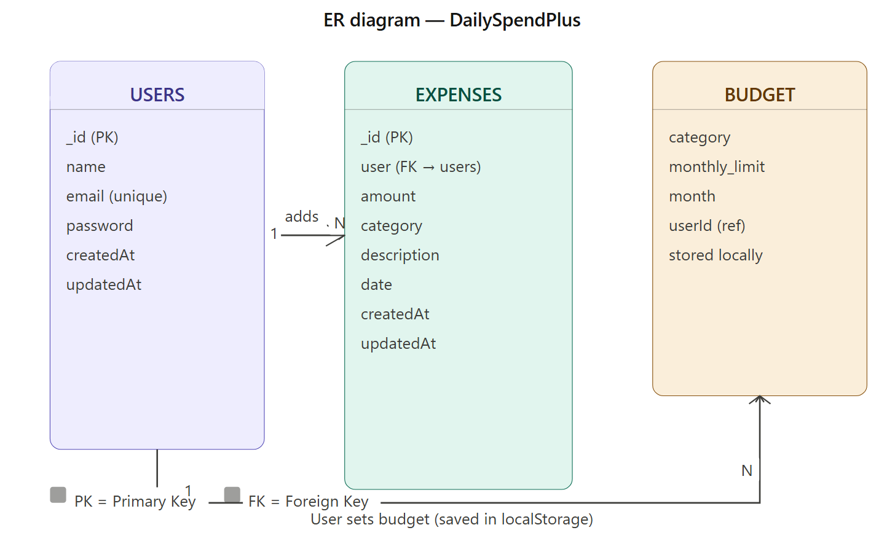
3.7 Table Specifications
1. Users Collection
Stores all registered user account details.
Field Name | Data Type | Description
_id | ObjectId (PK) | Auto-generated unique user ID
name | String (required) | Full name of the user
email | String (unique) | Email address — used for login
password | String (required) | bcrypt hashed password
createdAt | Date | Account creation timestamp (auto)
updatedAt | Date | Last update timestamp (auto)

2. Expenses Collection
Stores all expense records entered by users.
Field Name | Data Type | Description
_id | ObjectId (PK) | Auto-generated unique expense ID
user | ObjectId (FK → users) | Linked user — from JWT token
amount | Number (required) | Expense amount in INR (₹)
category | String (required) | Food / Travel / Shopping / Bills / Health / Education / Entertainment / Other
description | String (optional) | Short description of expense
date | Date (required) | Date when expense occurred
createdAt | Date | Record creation timestamp (auto)
updatedAt | Date | Last update timestamp (auto)

4. IMPLEMENTATION
4.1 Input Screens / Features Implemented
Register Page
Secure user registration with full-stack validation:
- Purple-indigo gradient background with app logo and name
- Full Name, Email, Password fields with proper labels
- Password strength indicator (Weak / Good / Strong) with color-coded bars
- On success: toast notification and auto-redirect to Login
- On error: inline error message displayed
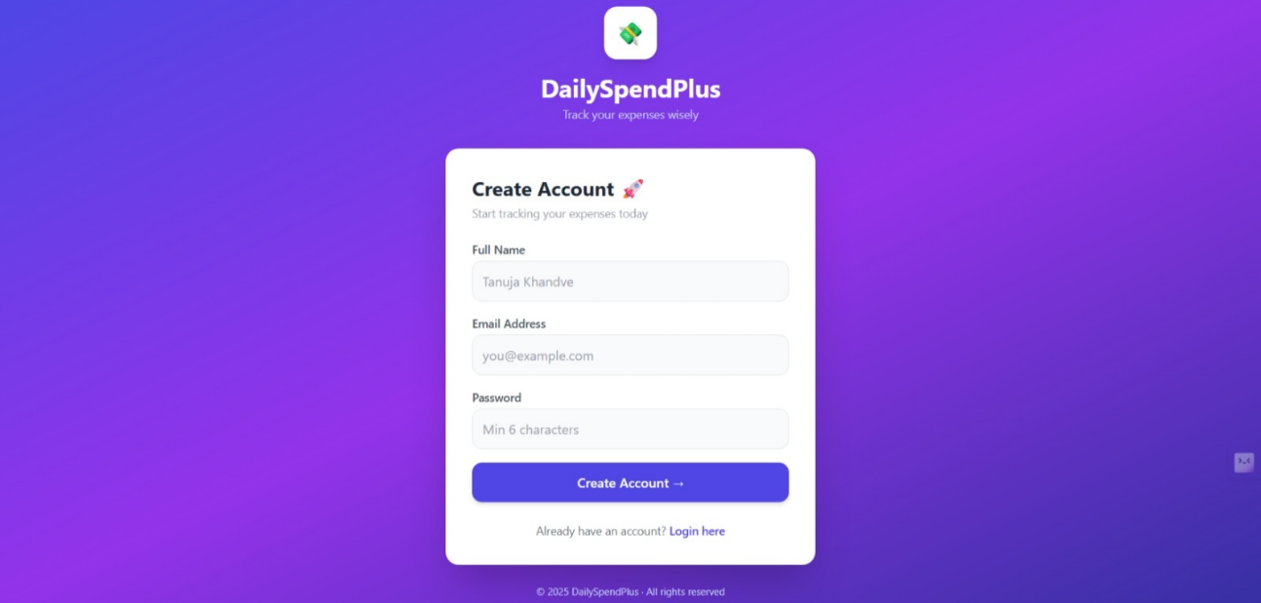

Login Page
Clean and professional login interface:
- Same gradient design as Register for consistent UI
- Email and password fields with loading spinner on submit
- JWT token stored in localStorage on successful login
- Auto-redirect to Dashboard after login

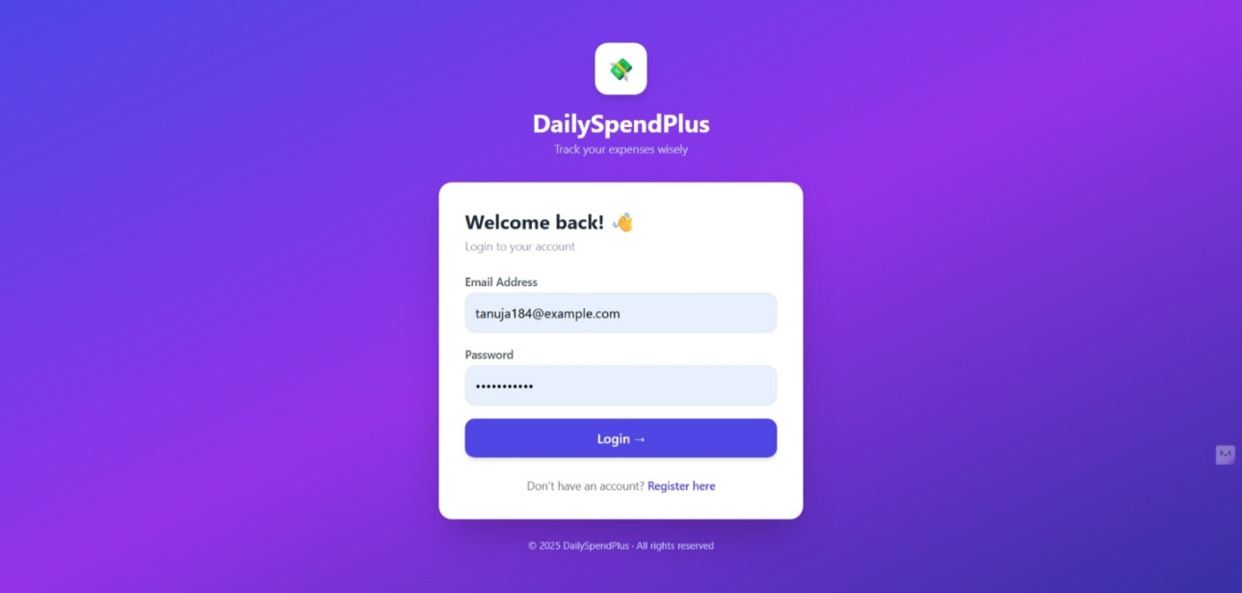

Dashboard – Summary Cards + Add Expense
The main dashboard provides a complete spending overview:
- 4 colorful summary cards: Total Spent (indigo), This Month (green), Top Category (yellow), Total Entries (purple)
- Search bar — search expenses by description or category in real-time
- Category filter dropdown — filter list by specific category
- Clear Filters button when filters are active
- Add Expense form: Amount, Category dropdown (8 options), Description, Date picker

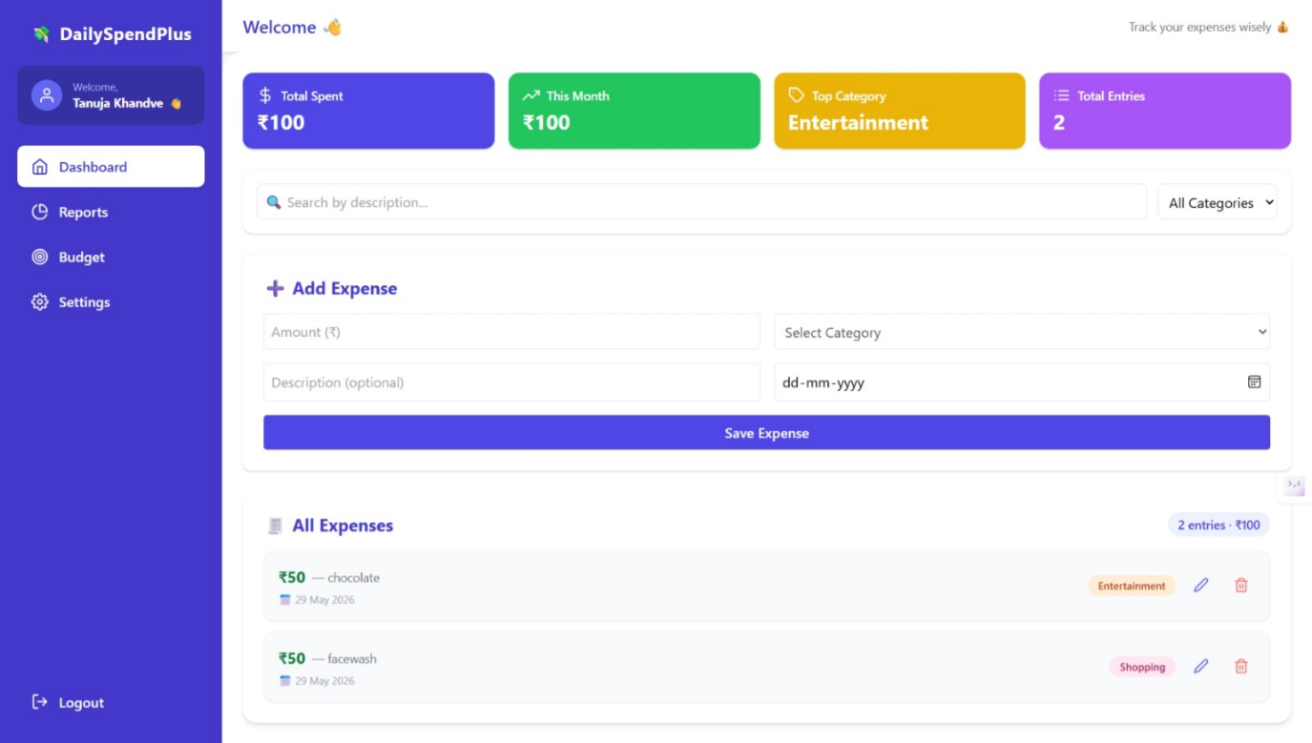
Expense List – Edit & Delete
Full expense management with inline editing:
- Each expense shows: Amount (red if >₹1000, green otherwise), Description, Date, Category badge
- Edit button (pencil icon) — opens inline edit form with all fields
- Inline edit: Amount, Category dropdown, Description, Date — Save Changes / Cancel
- Delete button (trash icon) — confirmation dialog then removes from DB
- Entry count and total shown in header

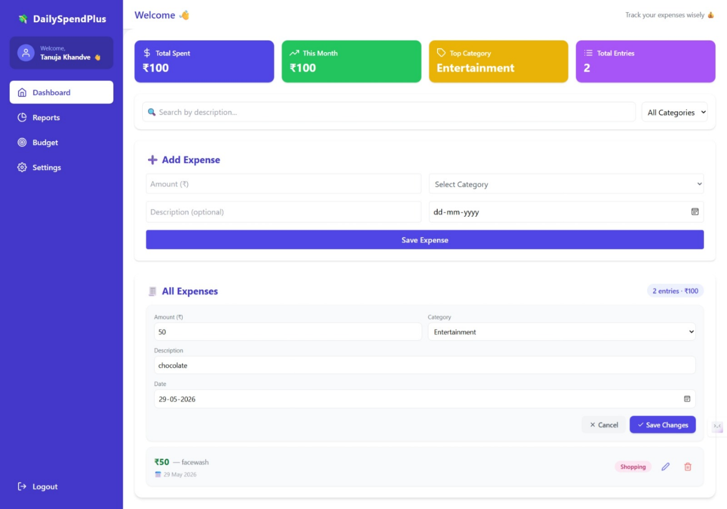

Reports Module
Visual analytics for spending analysis:
- Month and Year filter dropdowns
- Pie chart: Category-wise spending breakdown with color coding
- Bar chart: Daily spending trend for selected month
- Category summary cards: Amount + percentage of total
- Export PDF button: Downloads professional PDF with header, summary, charts, and detailed table

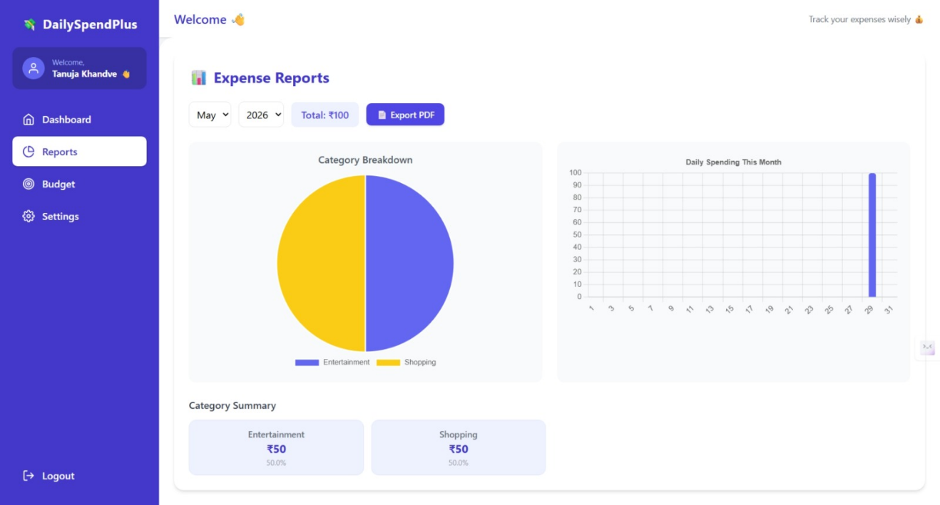
Budget Module
Smart budget management per category:
- 8 category budget cards (Food, Travel, Shopping, Bills, Health, Education, Entertainment, Other)
- Set monthly budget per category with input field
- Color-coded progress bar: Green (on track), Yellow (≥80% spent), Red (over budget)
- Status badges: 'On Track', 'Near Limit', 'Over Budget!'
- Update and Remove budget options

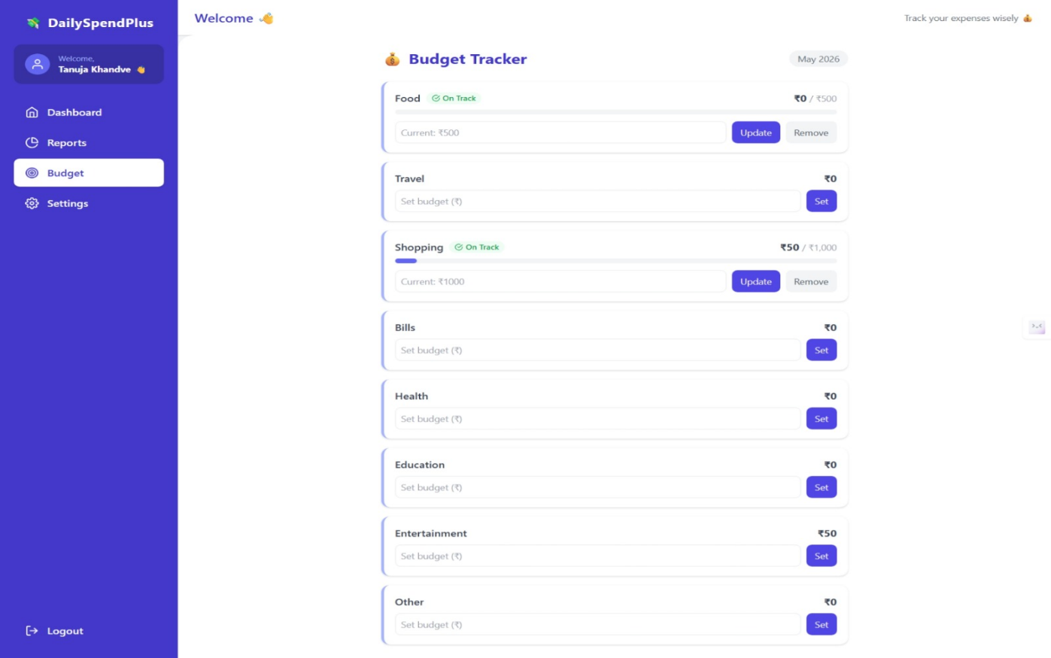

Settings Module
User profile and security management:
- Update Profile: Edit name and email, Save Profile button
- Change Password: New password with minimum 6 character validation, Confirm password match check
- Success and error toast notifications for all actions

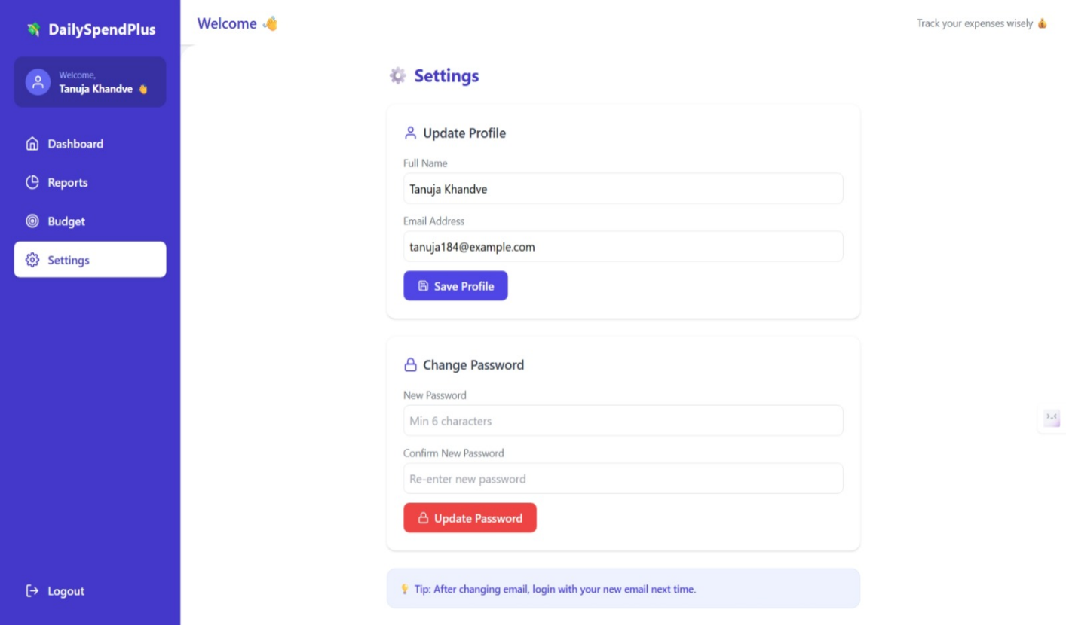

5. TESTING
5.1 Test Procedures and Implementation
Types of Testing:
- Unit Testing: Individual modules tested — login logic, expense CRUD, budget alert logic, password validation
- Integration Testing: Combined behavior — frontend React + Express API + MongoDB, JWT middleware with all routes
- System Testing: Complete DailySpendPlus application flow verified end-to-end
- Security Testing: JWT token verification, bcrypt password hashing, protected route access control
- Responsiveness Testing: Mobile, tablet, and desktop layouts verified for all pages

Tools Used: Postman (API testing), Browser DevTools, Manual Testing, MongoDB Compass

5.2 Test Cases
Test Case | Expected Result | Status
Register with valid name, email, password | Account created, redirect to login | Pass
Register with existing email | Error: User already exists | Pass
Register with password < 6 chars | Validation error shown | Pass
Login with valid credentials | JWT token generated, dashboard loaded | Pass
Login with wrong password | Error: Invalid password | Pass
Access dashboard without login | Redirect to login page | Pass
Add expense with all fields | Expense saved, list and cards updated | Pass
Add expense without category | Validation error shown | Pass
Edit expense — change amount and category | Expense updated correctly in list | Pass
Delete expense | Expense removed, total recalculated | Pass
Search expense by description | Matching expenses shown in real-time | Pass
Filter by category dropdown | Only selected category expenses shown | Pass
View Reports — Pie and Bar charts | Charts render with correct data | Pass
Export PDF report | PDF downloaded with charts and tables | Pass
Set monthly budget for Food | Budget saved, progress bar shown | Pass
Spend more than budget limit | Over Budget! alert shown in red | Pass
Update profile name and email | Profile updated, toast shown | Pass
Change password (passwords match) | Password updated successfully | Pass
Change password (passwords don't match) | Error: Passwords do not match | Pass
Logout | Token removed, redirect to login | Pass

6. USER MANUAL
For End Users:
- Visit DailySpendPlus web application in any modern browser (Chrome recommended)
- Click 'Register here' → Enter your Full Name, Email, and Password (min 6 characters) → Submit
- Login with your email and password → Dashboard loads automatically
- Dashboard: View your spending summary in 4 cards at the top
- Add Expense: Enter Amount → Select Category from dropdown → Add Description (optional) → Select Date → Save
- Edit Expense: Click pencil icon on any expense → Edit fields inline → Save Changes
- Delete Expense: Click trash icon → Confirm deletion
- Search: Type in search bar to find expenses by description or category
- Filter: Use category dropdown to filter expenses by specific category
- Reports: Click 'Reports' in sidebar → Select Month and Year → View Pie and Bar charts
- Export PDF: Click 'Export PDF' button in Reports page → PDF downloads automatically
- Budget: Click 'Budget' in sidebar → Enter monthly limit for each category → Click Set
- Settings: Click 'Settings' → Update name/email → Save Profile, OR change password
- Logout: Click Logout in sidebar → Redirects to Login page

7. CONCLUSION

The DailySpendPlus – Expense Tracker project successfully demonstrates a modern full-stack MERN web application that combines an intuitive and visually appealing UI with robust backend functionality. With a clean interface, secure transaction flow, and scope for future growth, it offers a solid foundation for further development and commercialization as a complete personal finance management solution.

The project covers a complete user journey — from registration and secure login, to adding and managing daily expenses, visualizing spending patterns through interactive charts, setting category-wise budgets with smart alerts, and exporting professional PDF reports. The system is built using industry-standard technologies: React.js and Tailwind CSS for the frontend, Node.js and Express.js for the backend, and MongoDB Atlas for cloud database management.

This project has provided invaluable hands-on experience in full-stack MERN development, JWT authentication, RESTful API design, chart integration, PDF generation, and responsive UI design — skills that are directly applicable to real-world software development roles.

8.1 Technology Used
- Frontend: React.js, Tailwind CSS, HTML5, CSS3
- Backend: Node.js, Express.js
- Database: MongoDB (Atlas Cloud)
- Authentication: JSON Web Tokens (JWT), bcrypt.js
- Charts: Chart.js (Pie Chart, Bar Chart)
- PDF Export: jsPDF, jsPDF-AutoTable
- HTTP Client: Axios with Request/Response Interceptors
- Icons: React Icons (Feather Icons set)
- Notifications: React Toastify
- Date Formatting: date-fns
- Version Control: Git / GitHub
- IDE: Visual Studio Code
- API Testing: Postman
- Hosting: Vercel (Frontend), Render (Backend)

9.0 Chapter: Bibliography
- React.js Official Documentation – https://react.dev
- Node.js Official Documentation – https://nodejs.org/docs
- Express.js Documentation – https://expressjs.com
- MongoDB Documentation – https://www.mongodb.com/docs
- Mongoose Documentation – https://mongoosejs.com/docs
- JWT Documentation – https://jwt.io
- bcrypt.js Documentation – https://www.npmjs.com/package/bcryptjs
- Chart.js Documentation – https://www.chartjs.org/docs
- jsPDF Documentation – https://rawgit.com/MrRio/jsPDF/master/docs
- Tailwind CSS Documentation – https://tailwindcss.com/docs
- Axios Documentation – https://axios-http.com/docs
- W3Schools – https://www.w3schools.com
- Stack Overflow – https://stackoverflow.com
- MDN Web Docs – https://developer.mozilla.org

