**Principles of Data Science (5530-0001)-Assignment 1**

**Name: Tanuja Ramani Paricherla**

**ID: 16355123**

**As per the question, I have done this question in 3 stages**

1. **Data Collection**

**As per given question , I have created a raw_csv file .**

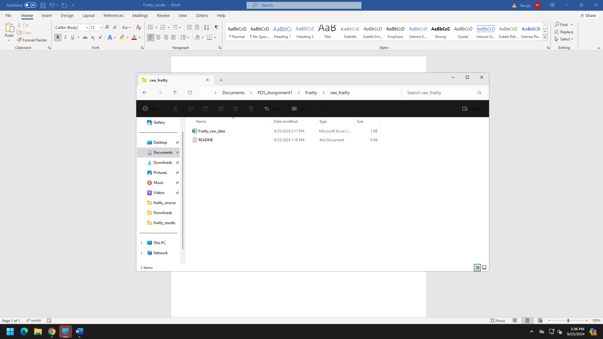

1. **Data Processing**

**In this processing phase I have seen that column names can be much more meaning full name and changed them and also changed the categorical values of frailty to numerical for better analysis.**

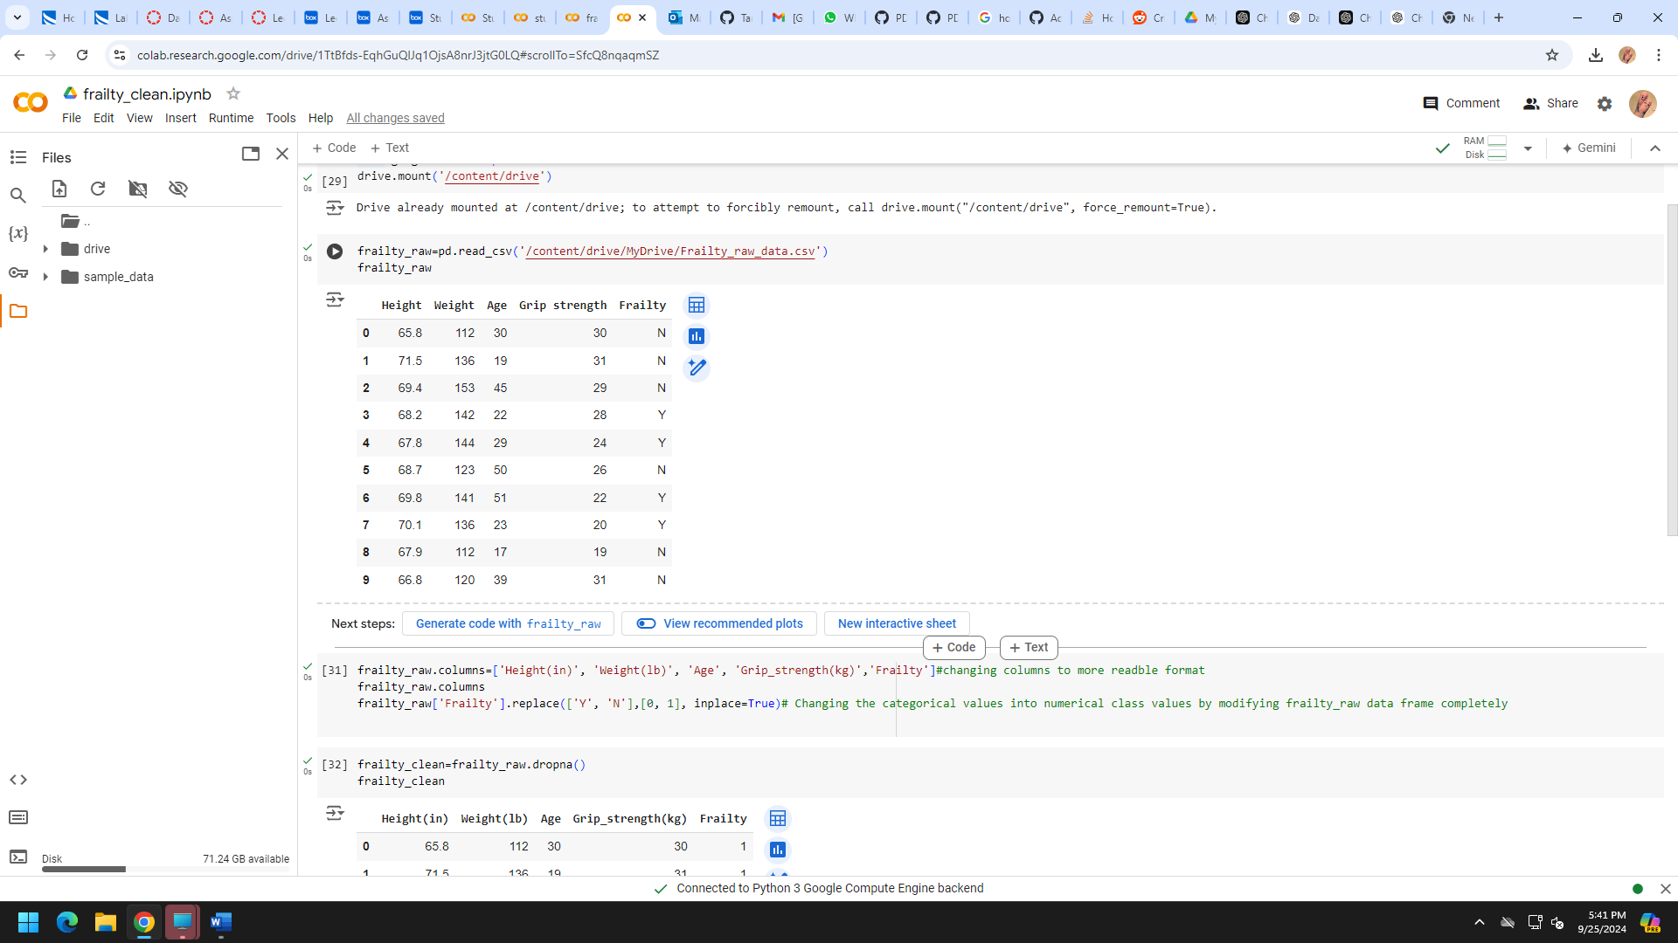

1. **Data Analysis**

**In this phase , I have done data analysis .**

**I have used plotly package and performed the below two visualizations**

**1.Scatter plot --correlations between height, weight, and frailty while factoring in age**

There might be a trend where individuals at certain heights and weights are more likely to exhibit higher frailty levels.

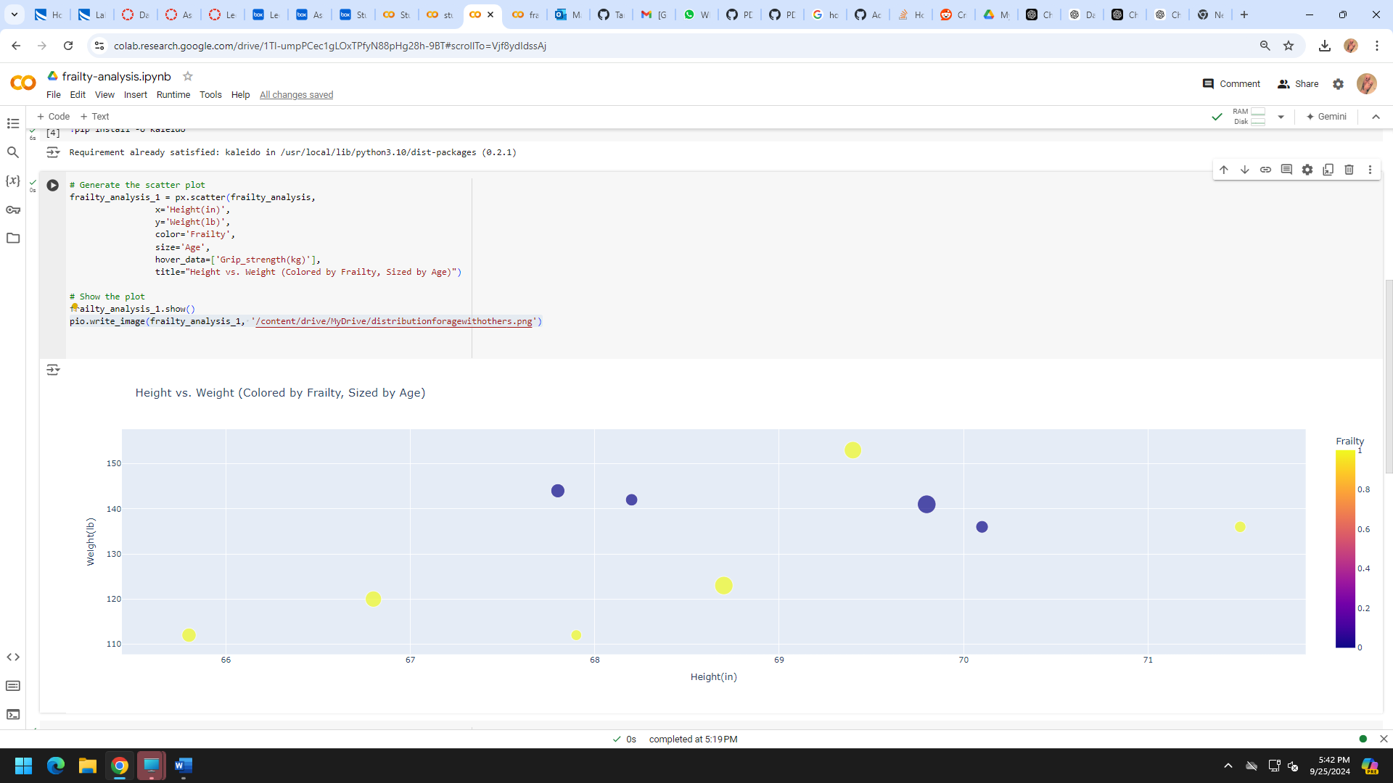

**2.Boxplot--** **Grip Strength by Frailty**

We can see that non-frail group has a slightly larger range of grip strengths compared to the frail group.

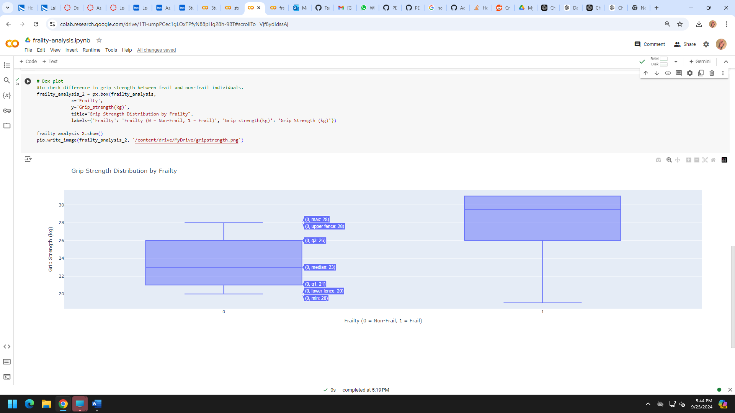

**Project Structure:**

