**Principles of Data Science (5530-0001)-Assignment 1**

**Name: Tanuja Ramani Paricherla**

**ID: 16355123**

**As per the question, I have done this question in 3 stages**

1. **Data Collection**

**As per given question, I have created a raw_csv file.**

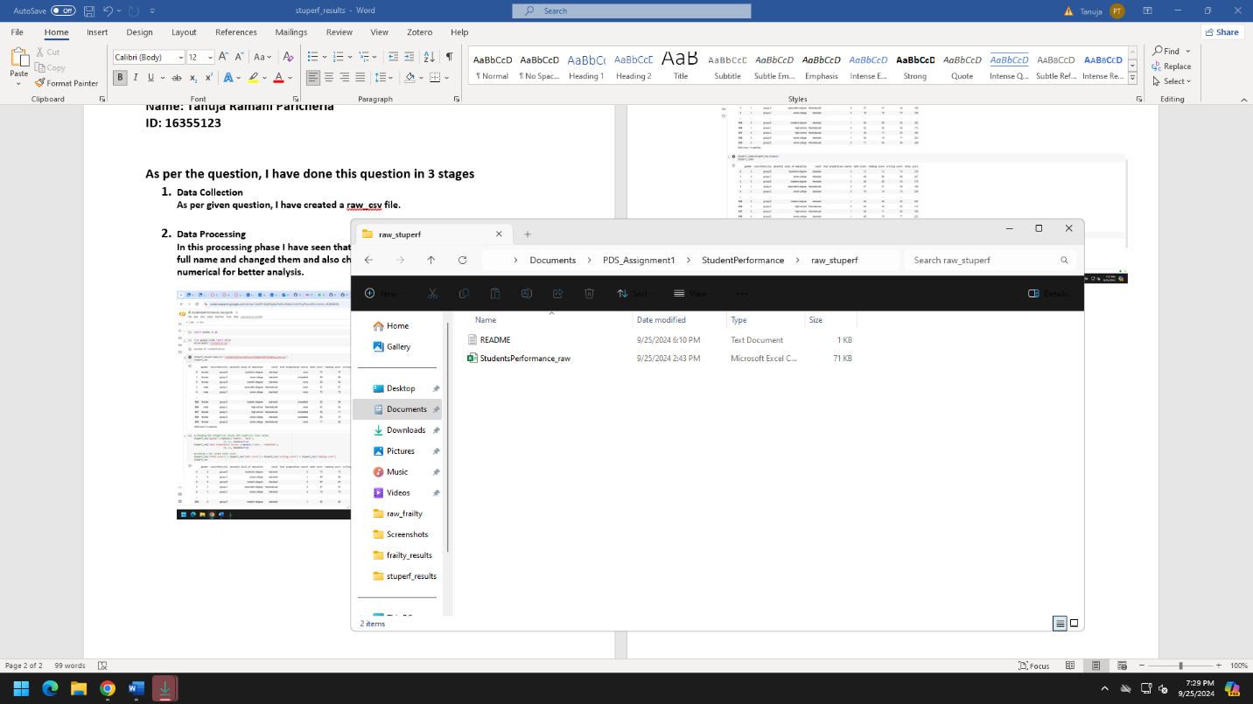

1. **Data Processing**

**In this processing phase I have seen that column names can be much more meaning full name and changed them and also changed the categorical values of frailty to numerical for better analysis.**

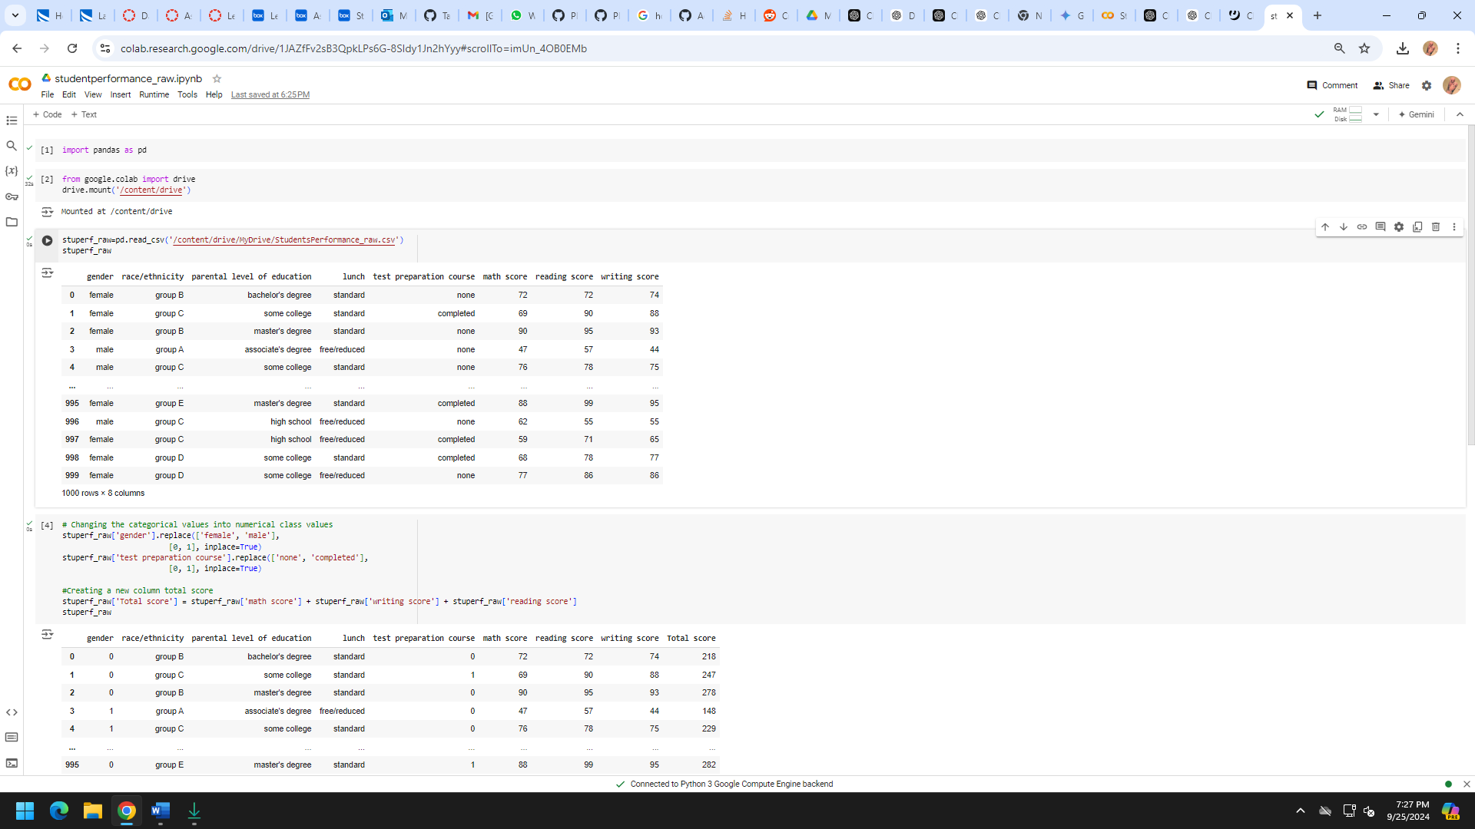

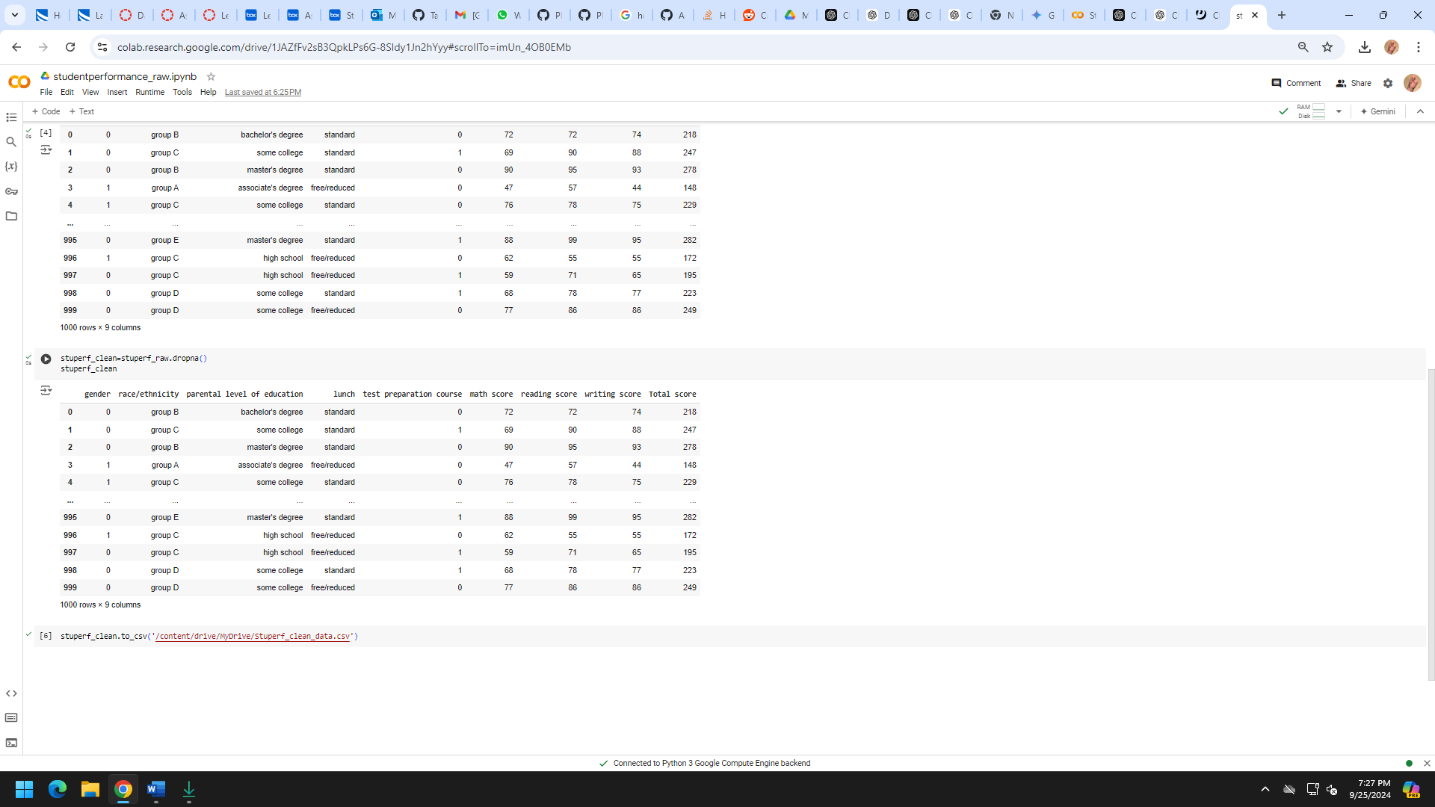

1. **Data Analysis**

**In this phase, I have done data analysis.**

**I have used matplot lib and seaborn packages**

1. **Distribution of Scores by Gender- Box Plot**

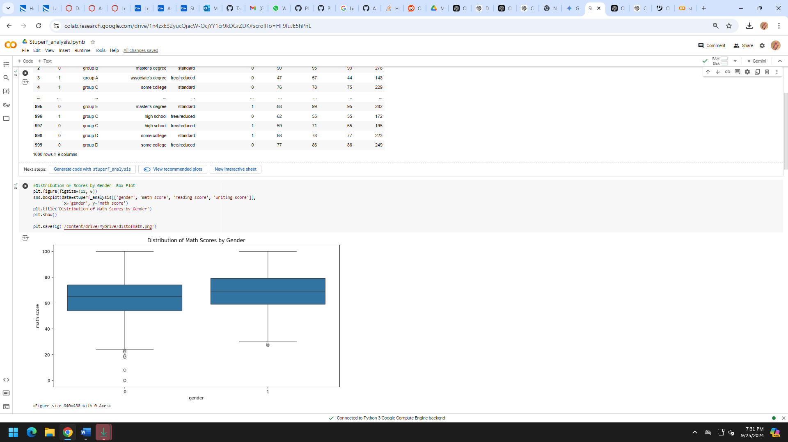

**2.**

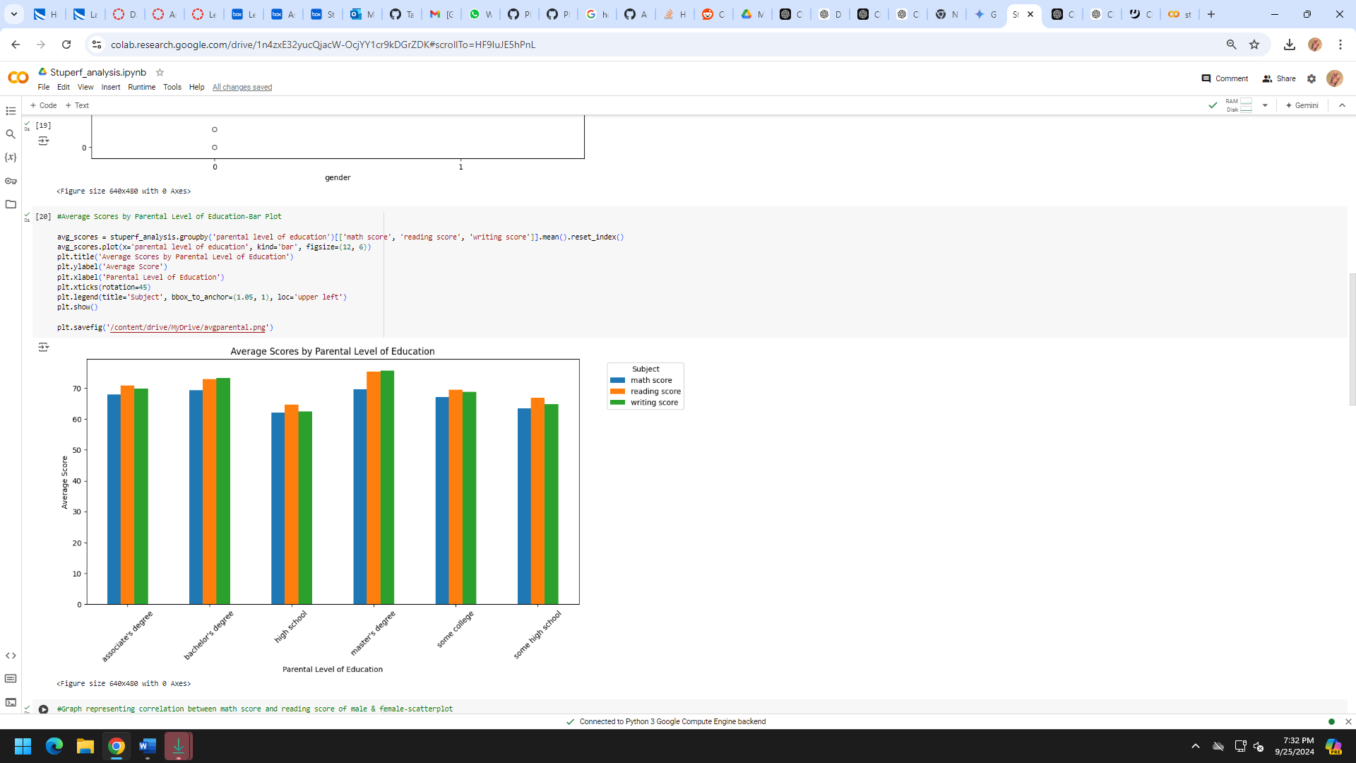

**3.**

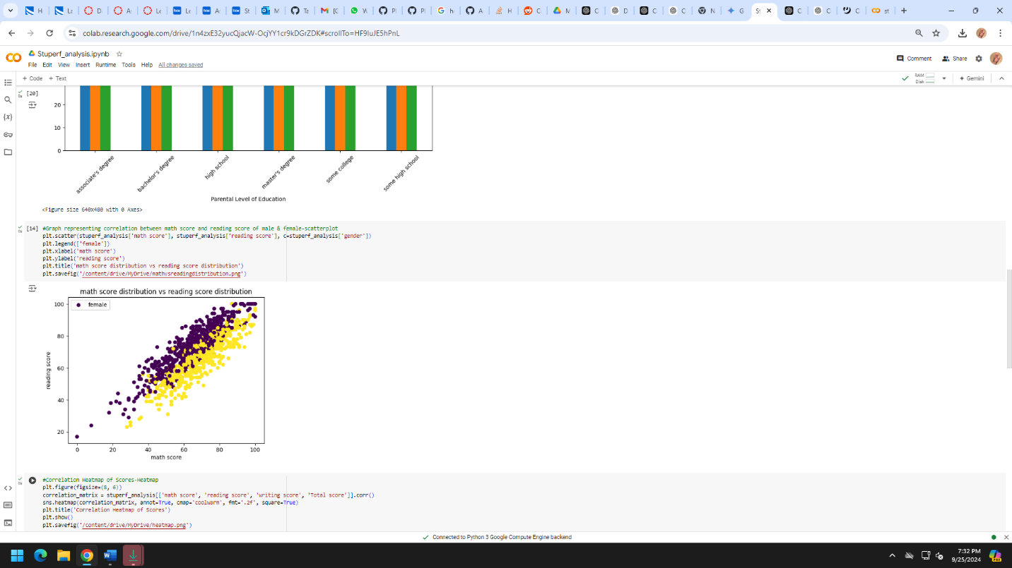

**4.**

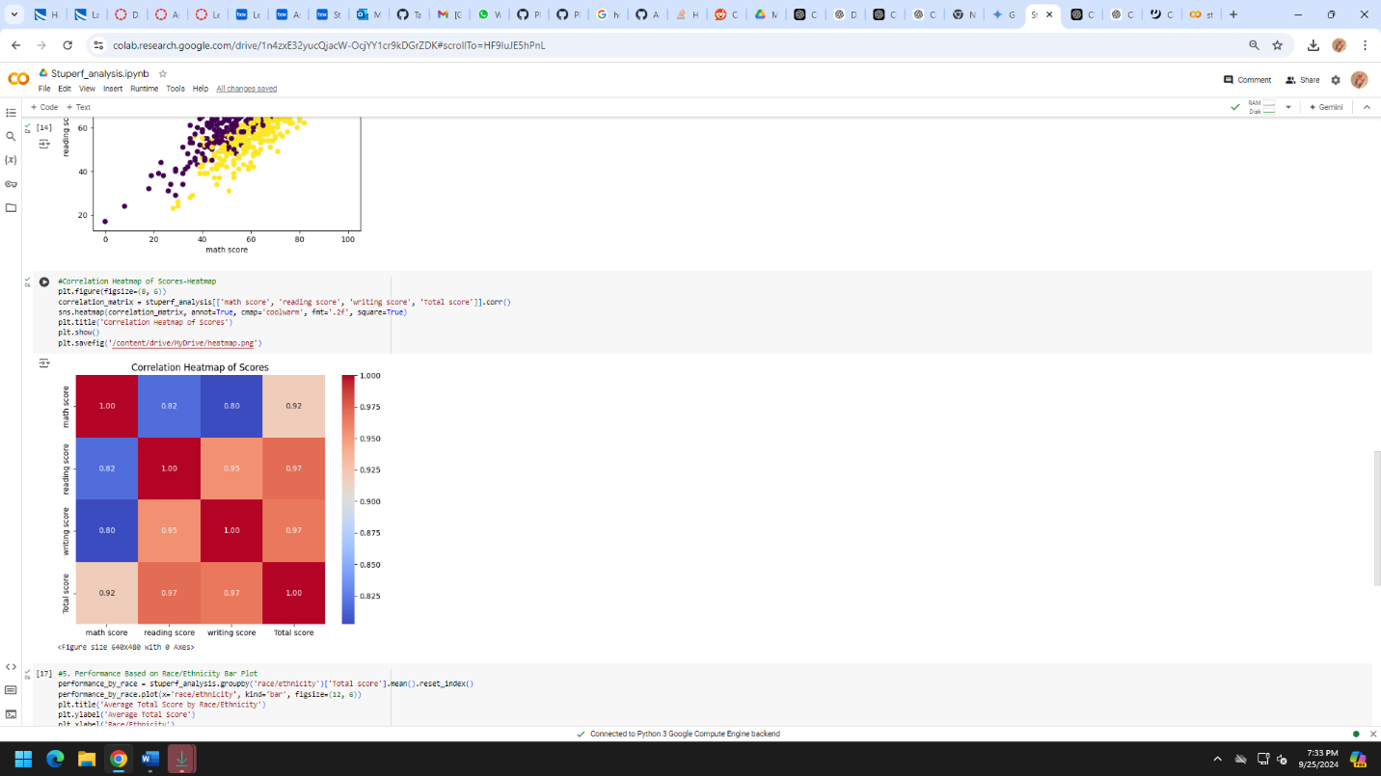

**5.**

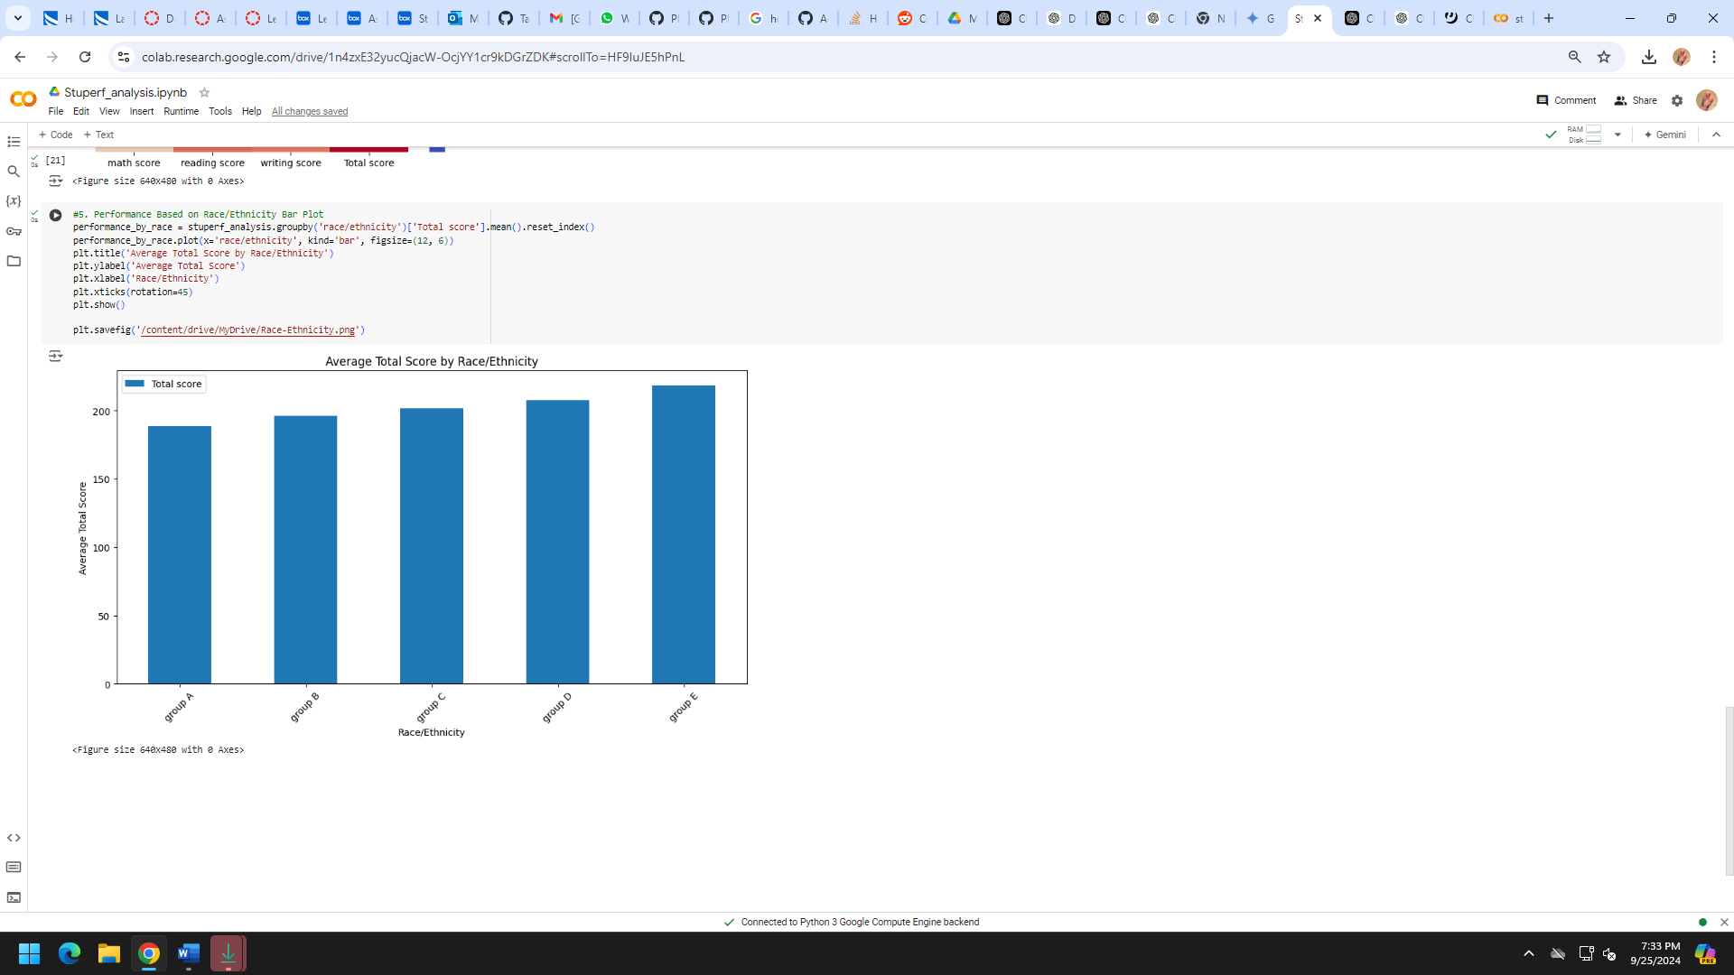

**Project Structure:**

