**Setup Development Instruction**

# Setup & Tools

1. IDE Development tool: Eclipse Juno 4.2
2. Maven Plugin for Eclipse (m2eclipse) ( <http://www.eclipse.org/m2e/download> )
3. Apache Maven 3.0.5 (<http://maven.apache.org> )
4. FileVault ( <http://daycq.blogspot.com/2012/02/installing-filevault-vlt.html> )
5. Bitbucket window application: Source Tree (Version 1.6.8.0) ( <http://www.sourcetreeapp.com> )

# Configuration:

1. Import Maven Projects:
   1. File>Import>Maven>Existing Maven Projects
   2. Browse to the source code at local machine and select the parent pom file

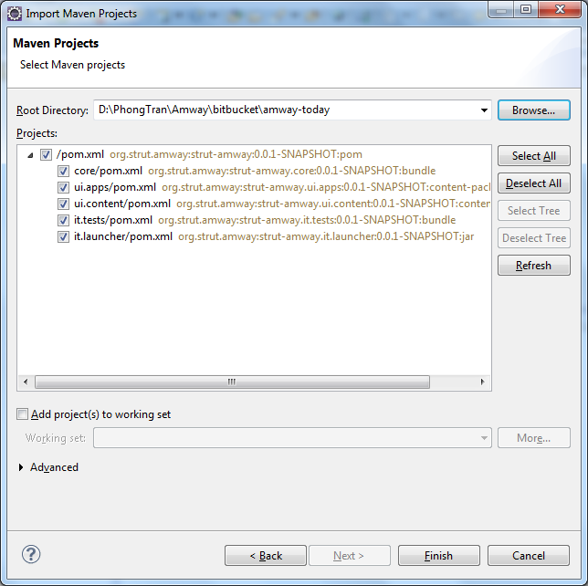

1. Work on code in Eclipse
2. Build code and deploy to AEM using Maven: in command line, navigate to local root folder of source code use the command: mvn –PautoInstallPackage clean install

***NOTE****: Make sure you are running Author Instance on your machine*

1. Packages will be installed to AEM Author Instance. Check Package Manager (http://localhost:4502/crx/packmgr/index.jsp) , you should see 2 packages installed

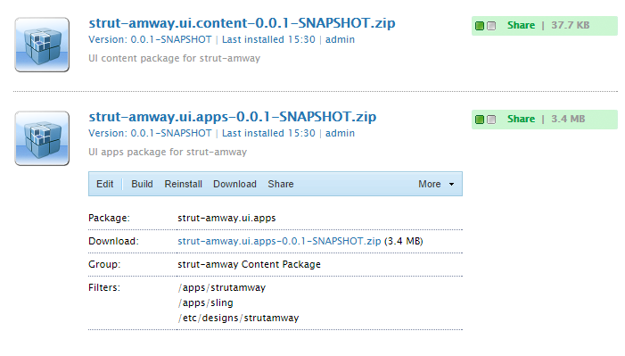

1. Replicate the packages to Publish instances (Make sure you are running AEM Publish instances on your machine)

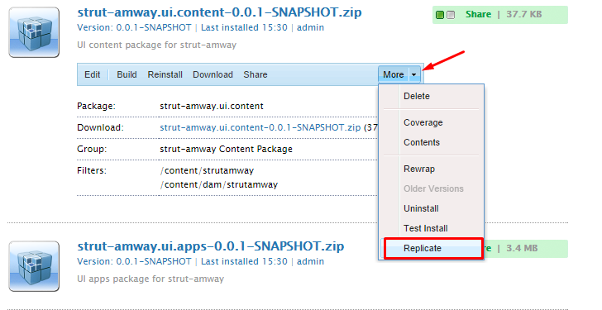

* Example : to check out the content from AEM server. You can use the command as below:

vlt co --credentials admin:admin --force http://localhost:4502/

1. Using FileVault to sync source between AEM CRX and Local Source:
   1. In the command line, navigate to content/jcr_root.
   2. Check out the repository by typing the following (substituting your port number for 4502 and your admin passwords):

vlt co --credentials admin:admin --force <http://localhost:4502/>crx

* 1. Commit local source to AEM Repository:
     1. Edit something in test.jsp.
     2. See the modified files by typing:   vlt st
     3. See the changes by typing:   vlt diff test.jsp
     4. Commit the changes:   vlt ci test.jsp.
     5. Reload a page containing a text component and see whether your changes are there.
     6. You can also commit a folder with all changes

More details of using FileVault for other commands, please refer to the link: <http://docs.adobe.com/docs/en/cq/current/core/how_to/how_to_use_the_vlttool.html>