1> Write a program for matrix multiplication.

Code:
import java.util.*;

public class hello {

public static void main(String[] args) {
int m,n;
Scanner sc = new Scanner(System.in);
System.out.println("Enter Number of rows and columns");
m= sc.nextInt();
n=sc.nextInt();
int[][] arr1 = new int[m][n];
int[][] arr2 = new int[m][n];
int[][] res= new int[m][n];

System.out.println("Enter array1 elements:");
for(int i=0;i<m;i++)
{
for(int j=0;j<n;j++)
{
arr1[i][j]= sc.nextInt();
}
}
System.out.println("Enter array2 elements:");
for(int i=0;i<m;i++)
{
for(int j=0;j<n;j++)
{
arr2[i][j]= sc.nextInt();
}
}

for (int i = 0; i < m; i++)
{
for (int j = 0; j < n; j++)
{
res[i][j] = 0;
for (int k = 0; k < n; k++)
res[i][j] += arr1[i][k] * arr2[k][j];
}
}
System.out.println("Multiplication of matrix is: ")
for(int i=0;i<m;i++)
{
for(int j=0;j<n;j++)
{
System.out.print(res[i][j] + " ");
}
System.out.print("\n");
}

}

}

Output:

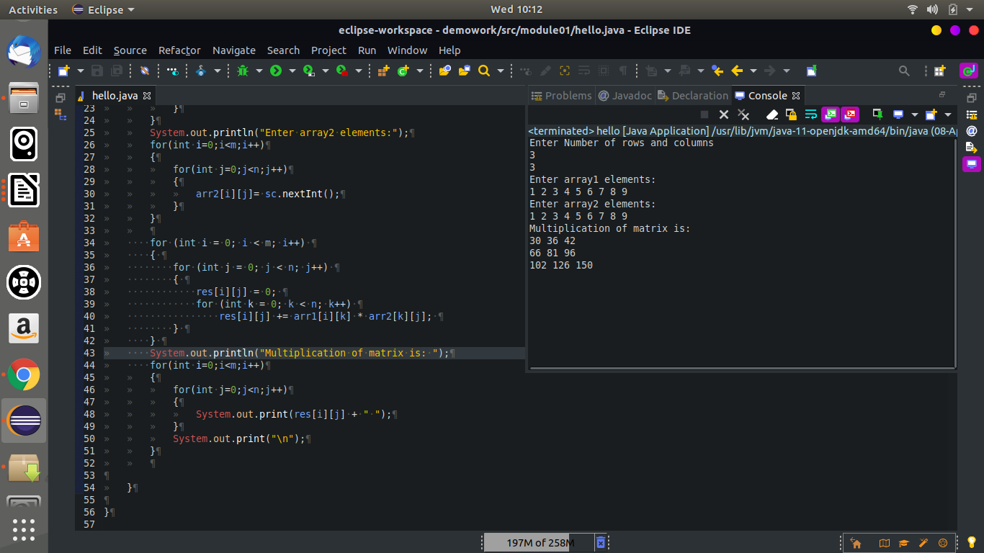

2> Write a program for matrix addition.

package module01;

import java.util.*;

public class hello {

public static void main(String[] args) {
int m,n;
Scanner sc = new Scanner(System.in);
System.out.println("Enter Number of rows and columns");
m= sc.nextInt();
n=sc.nextInt();
int[][] arr1 = new int[m][n];
int[][] arr2 = new int[m][n];
int[][] res= new int[m][n];

System.out.println("Enter array1 elements:");
for(int i=0;i<m;i++)
{
for(int j=0;j<n;j++)
{
arr1[i][j]= sc.nextInt();
}
}
System.out.println("Enter array2 elements:");
for(int i=0;i<m;i++)
{
for(int j=0;j<n;j++)
{
arr2[i][j]= sc.nextInt();
}
}

for (int i = 0; i < m; i++)
{
for (int j = 0; j < n; j++)
{
res[i][j]= arr1[i][j]+arr2[i][j];
}
}
System.out.println("Addition of matrix is: ");
for(int i=0;i<m;i++)
{
for(int j=0;j<n;j++)
{
System.out.print(res[i][j] + " ");
}
System.out.print("\n");
}

}

}

output:
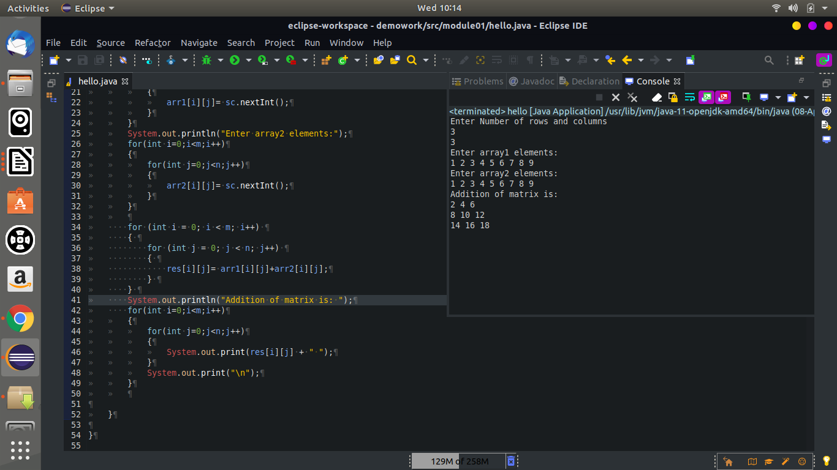

3> Write a program to display inverse of a matrix.

Code:
package module01;

import java.util.Scanner;

public class inverse {

public static void main(String[] args) {
int i, j;
float det, temp;
float mat[][] = new float[2][2];

Scanner sc = new Scanner(System.in);

System.out.println("Enter elements of matrix row wise:");
for(i = 0; i < 2; ++i)
for(j = 0; j < 2; ++j)
mat[i][j] = sc.nextFloat();

det = (mat[0][0] * mat[1][1]) - (mat[0][1] * mat[1][0]);

System.out.println("\ndeterminant = " + det);

temp = mat[0][0];
mat[0][0] = mat[1][1];
mat[1][1] = temp;

mat[0][1] = - mat[0][1];
mat[1][0] = - mat[1][0];

System.out.println("\nInverse of matrix is:");
for(i = 0; i < 2; ++i) {
for(j = 0; j < 2; ++j)
System.out.print((mat[i][j]/det) + " ");

System.out.print("\n");

}

}

}

output:

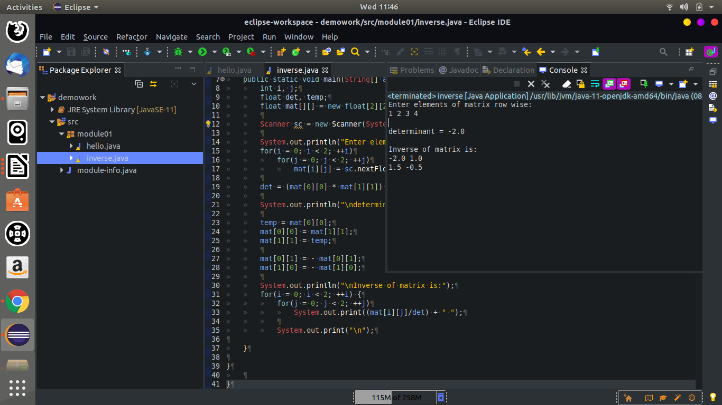

4>Write a program to display transpose of a matrix.

Code:
package module01;

import java.util.*;

public class hello {

public static void main(String[] args) {
int m,n;
Scanner sc = new Scanner(System.in);
System.out.println("Enter Number of rows and columns");
m= sc.nextInt();
n=sc.nextInt();
int[][] arr1 = new int[m][n];
int[][] res= new int[m][n];

System.out.println("Enter array1 elements:");
for(int i=0;i<m;i++)
{
for(int j=0;j<n;j++)
{
arr1[i][j]= sc.nextInt();
}
}
for(int i=0;i<m;i++)
{
for(int j=0;j<n;j++)
{
res[i][j]= arr1[j][i];
}
}

System.out.println("transpose of matrix is: ");
for(int i=0;i<m;i++)
{
for(int j=0;j<n;j++)
{
System.out.print(res[i][j] + " ");
}
System.out.print("\n");
}

}

}

output:

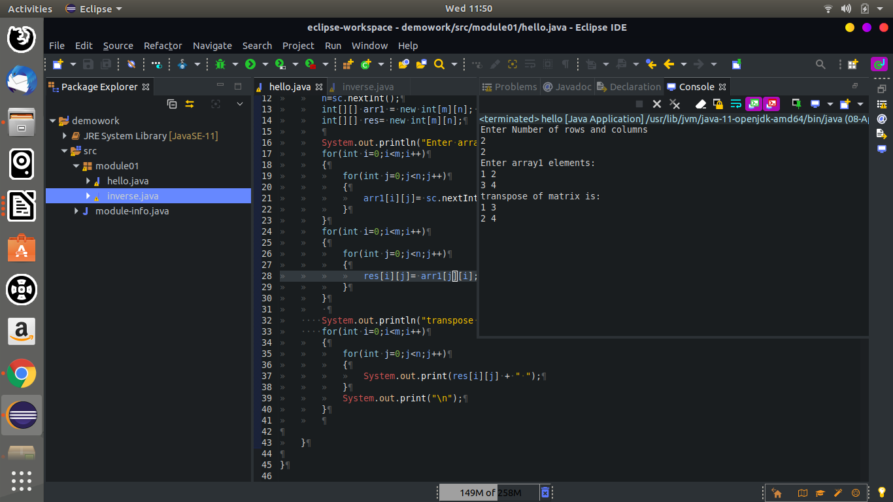

5> Write a program to calculate addition of diagonal elements of a
matrix

code:
package module01;

import java.util.*;

public class hello {

public static void main(String[] args) {
int m,n;
Scanner sc = new Scanner(System.in);
System.out.println("Enter Number of rows and columns");
m= sc.nextInt();
n=sc.nextInt();
int[][] arr1 = new int[m][n];
int[][] res= new int[m][n];
int principal=0,secondary=0;
System.out.println("Enter array1 elements:");
for(int i=0;i<m;i++)
{
for(int j=0;j<n;j++)
{
arr1[i][j]= sc.nextInt();
}
}
for (int i = 0; i < m; i++) {
for (int j = 0; j < n; j++) {

// Condition for principal diagonal
if (i == j)
principal += arr1[i][j];

// Condition for secondary diagonal
if ((i + j) == (n - 1))
secondary += arr1[i][j];
}

}

System.out.println("principal diagonal addition is:" +principal);
System.out.println("secondary diaginal addition is:" +secondary);

}
}

output:
