BHARATKART
E-COMMERCE
SALES & CUSTOMER ANALYTICS REPORT

A Python Data Analytics Case Study — FY2024–25
13,522 Orders | ₹110.2M Sales | 17 States | 25 Cities
Prepared using Python (Pandas, Matplotlib, Seaborn, GeoPandas)
Data Analytics Project • September 2026

1. Executive Summary
This report presents a complete analysis of a synthetic but statistically realistic Indian e-commerce transactional dataset covering January 2024 through December 2025. Every stage of the analytics lifecycle is covered: data collection, cleaning, exploratory data analysis, and geographic analysis, concluding with actionable business recommendations.
13,522  Total Orders | ₹110.2M  Total Sales | ₹7.3M  Total Profit | 6.63%  Profit Margin

3,021  Unique Customers | 17  States Covered | ₹8,148  Avg. Order Value | 3.95  Avg. Delivery Days

Headline Findings
- Electronics leads revenue: ₹54.9M in sales (49.8% of total), despite Fashion generating more individual orders (3,246 vs. 1,864).
- Geographic concentration: Maharashtra alone contributes ₹24.9M — nearly 23% of national sales — with the South and West regions together driving over 60% of revenue.
- Digital payments dominate: UPI accounts for 39.7% of all transactions, reflecting India's broader shift to instant digital payments.
- Healthy fulfilment, some leakage: 85.8% of orders are delivered successfully, but a 5.7% return rate merits root-cause investigation.
- Volume ≠ margin: Tier-2 cities such as Lucknow (7.75%) and Hyderabad (7.56%) post stronger profit margins than high-volume metros like Mumbai (6.03%).

2. Business Problem & Objectives

Business Problem
BharatKart's leadership needs a single, data-driven view of where revenue and profit are actually coming from — by product category, region, state, city, payment method and time period — so that marketing, inventory, and logistics investment can be targeted rather than spread evenly across a diverse and geographically dispersed customer base.

Project Objectives
- Load, inspect and clean a realistic (deliberately messy) transactional dataset.
- Engineer time, customer and pricing features that make the data analysis-ready.
- Compute the core KPIs management needs on a single page.
- Run a structured exploratory data analysis (univariate, bivariate, multivariate).
- Quantify which categories, products, regions and customers drive revenue and profit.
- Measure the impact of discounting on profitability.
- Map revenue and profitability geographically across Indian states and cities.

Technologies Used
Library | Purpose
Pandas | Loading, cleaning, grouping, pivoting, time-series resampling
NumPy | Fast vectorised numeric work, percentiles, conditional flags
Matplotlib / Seaborn | Static and statistical charts for the report and presentation
GeoPandas | Offline state-boundary geographic mapping and choropleths
Jupyter Notebook | The end-to-end analysis environment

3. Dataset Description & Cleaning Methodology
The dataset is a synthetic but statistically realistic order log where every row represents one order line, spanning 29 columns including customer demographics, product details, pricing, discounting, delivery performance, and geolocation (city-level latitude/longitude).

Data Cleaning Steps Applied
- Removed rows with null values and duplicate records (109 duplicate rows identified and dropped).
- Standardised inconsistent categorical text — e.g. Gender values (F/M/male/female → Female/Male) and Payment_Method labels (Cod → Cash On Delivery).
- Converted Order_Date to a proper datetime type and Age to integer type.
- Removed structurally invalid rows: negative/zero Quantity (4 rows), Age outside a plausible 15–90 range, and Customer_Rating outside the valid 1–5 scale.
- Trimmed extra whitespace across all text columns for consistent grouping and joins.
- Final clean dataset: 13,522 valid order lines across 17 states, 25 cities and 8 product categories.

4. Sales & Category Analysis

4.1 Category-wise Sales
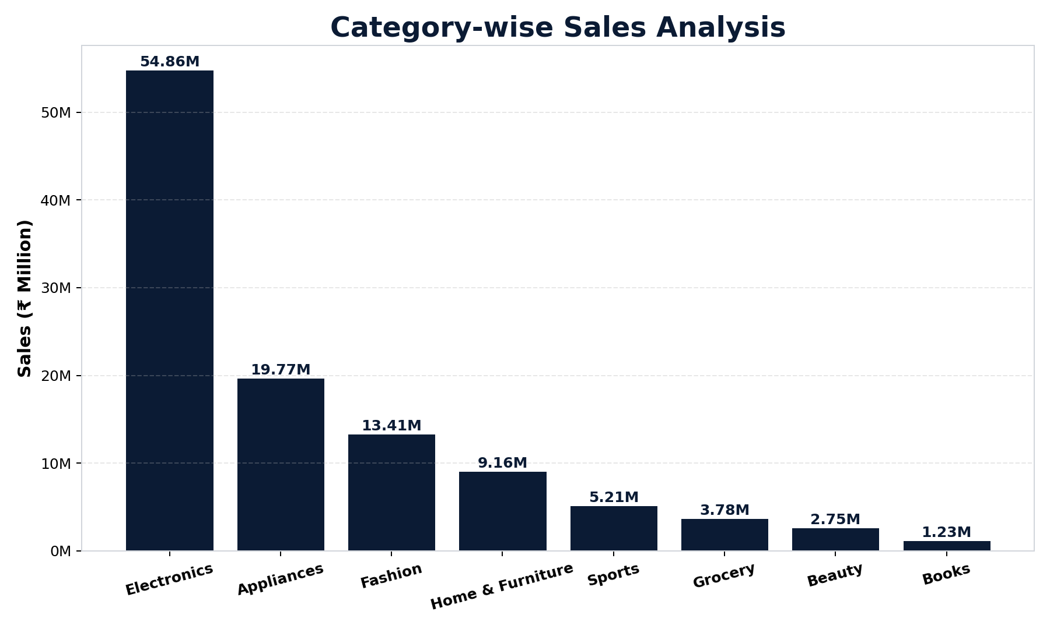
Figure 1: Total sales by product category
Electronics is the dominant revenue category at ₹54.86M (49.8% of total sales), more than double the next-largest category, Appliances (₹19.77M). Fashion, Home & Furniture, Sports, Grocery, Beauty and Books make up the long tail.

4.2 Purchase Frequency by Category
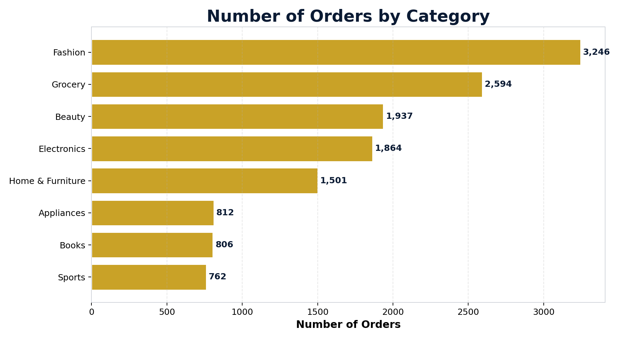
Figure 2: Number of orders by category
Fashion is the most frequently purchased category with 3,246 orders, followed by Grocery (2,594) — but Electronics generates far higher revenue per order. This gap between order frequency and revenue confirms Electronics carries a much higher average transaction value, while Fashion and Grocery are high-frequency, lower-ticket categories.

4.3 Top 10 Products by Revenue
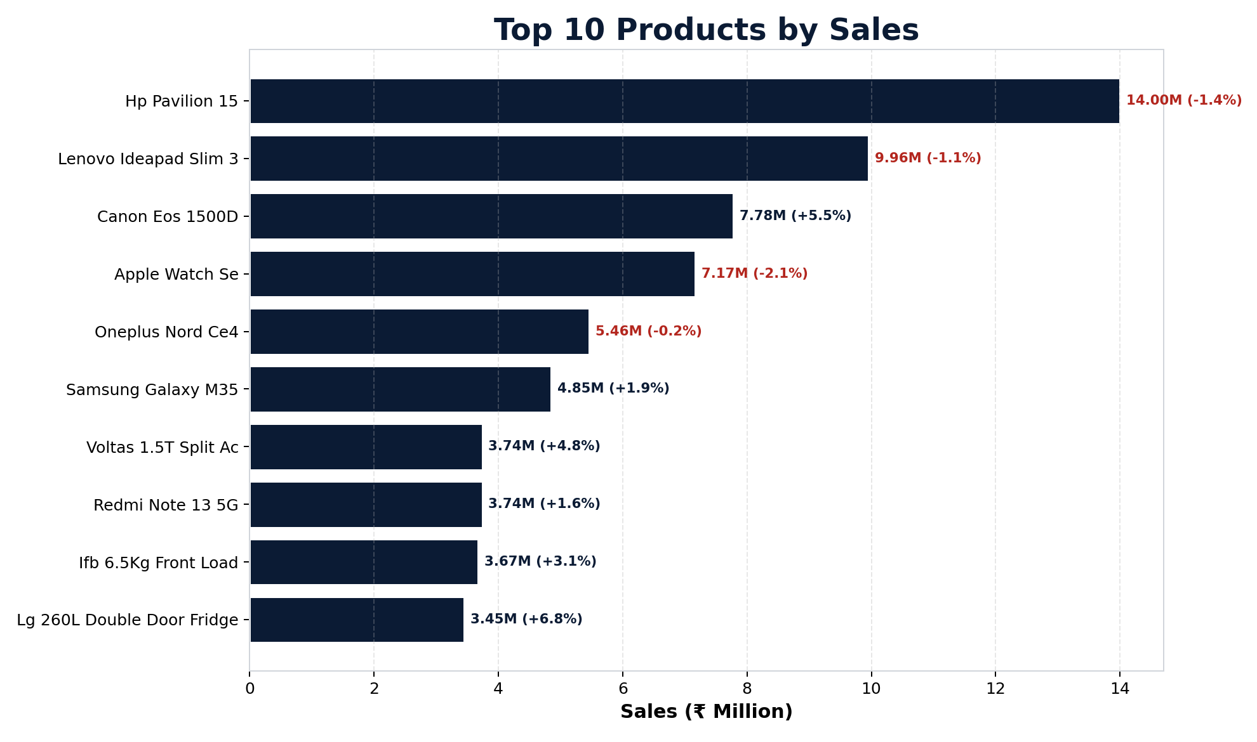
Figure 3: Highest-revenue products (margin % shown alongside each bar)
HP Pavilion 15 is the single highest-selling product (~₹14.0M) followed by Lenovo IdeaPad Slim 3 (~₹9.96M) and Canon EOS 1500D (~₹7.78M). Notably, high sales volume does not guarantee profitability — HP Pavilion 15 actually runs a negative profit margin (-1.4%), while Canon EOS 1500D maintains a healthier 5.5% margin. Electronics dominates this top-10 list, reinforcing the need to review discount depth on flagship electronics SKUs.

5. Regional & State-wise Analysis

5.1 Region-wise Sales
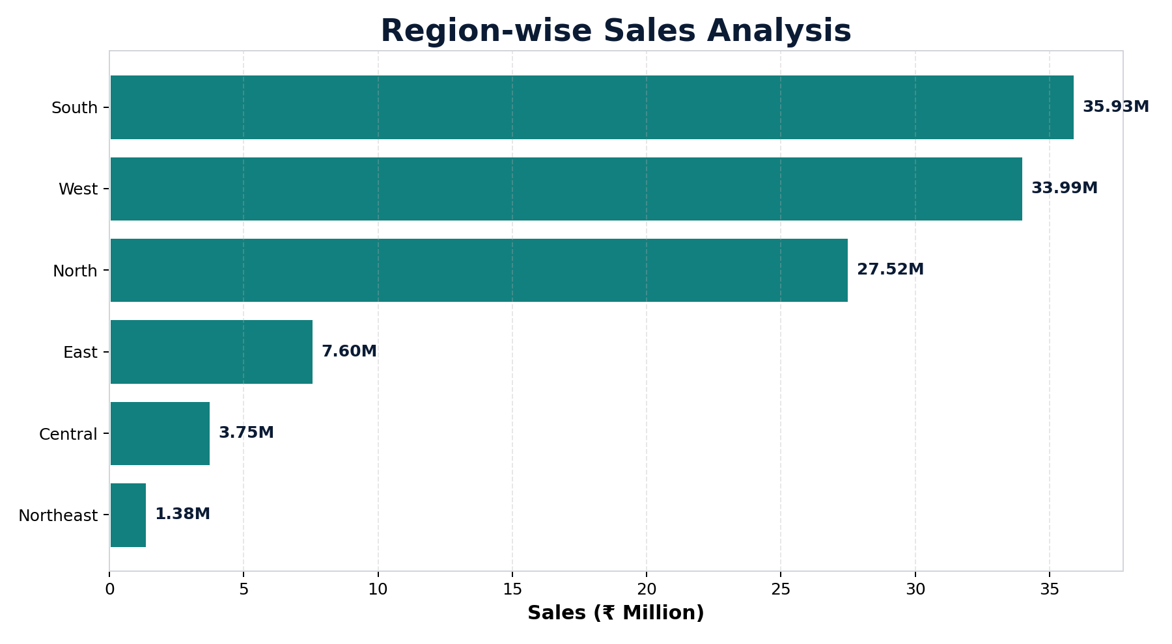
Figure 4: Total sales by business region
South (₹35.93M) and West (₹33.99M) are the highest-performing regions, followed by North (₹27.52M). East (₹7.60M), Central (₹3.75M) and Northeast (₹1.38M) trail well behind, indicating an opportunity to diversify revenue beyond the currently dominant southern and western markets.

5.2 Top 10 States by Sales
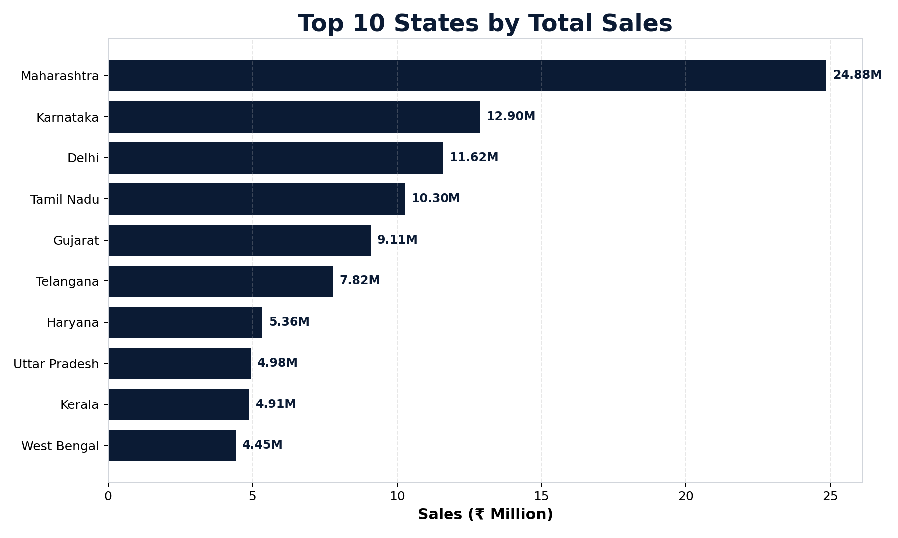
Figure 5: Highest-revenue Indian states
Maharashtra is the clear national leader at approximately ₹24.88M in total sales, making it the single strongest market in the dataset. Karnataka and Delhi follow as the next major contributors, with Tamil Nadu also showing strong performance. Sales decline considerably for states such as Uttar Pradesh, Kerala and West Bengal, showing that revenue is concentrated in a handful of high-performing states.

6. Geographic / Map-Based Analysis
Every order carries the delivery city's latitude and longitude, enabling a spatial view of where revenue and profitability are concentrated across India. Maps were built with GeoPandas and Matplotlib using a public Indian state-boundary file, so they render fully offline.

6.1 State-wise Sales Choropleth
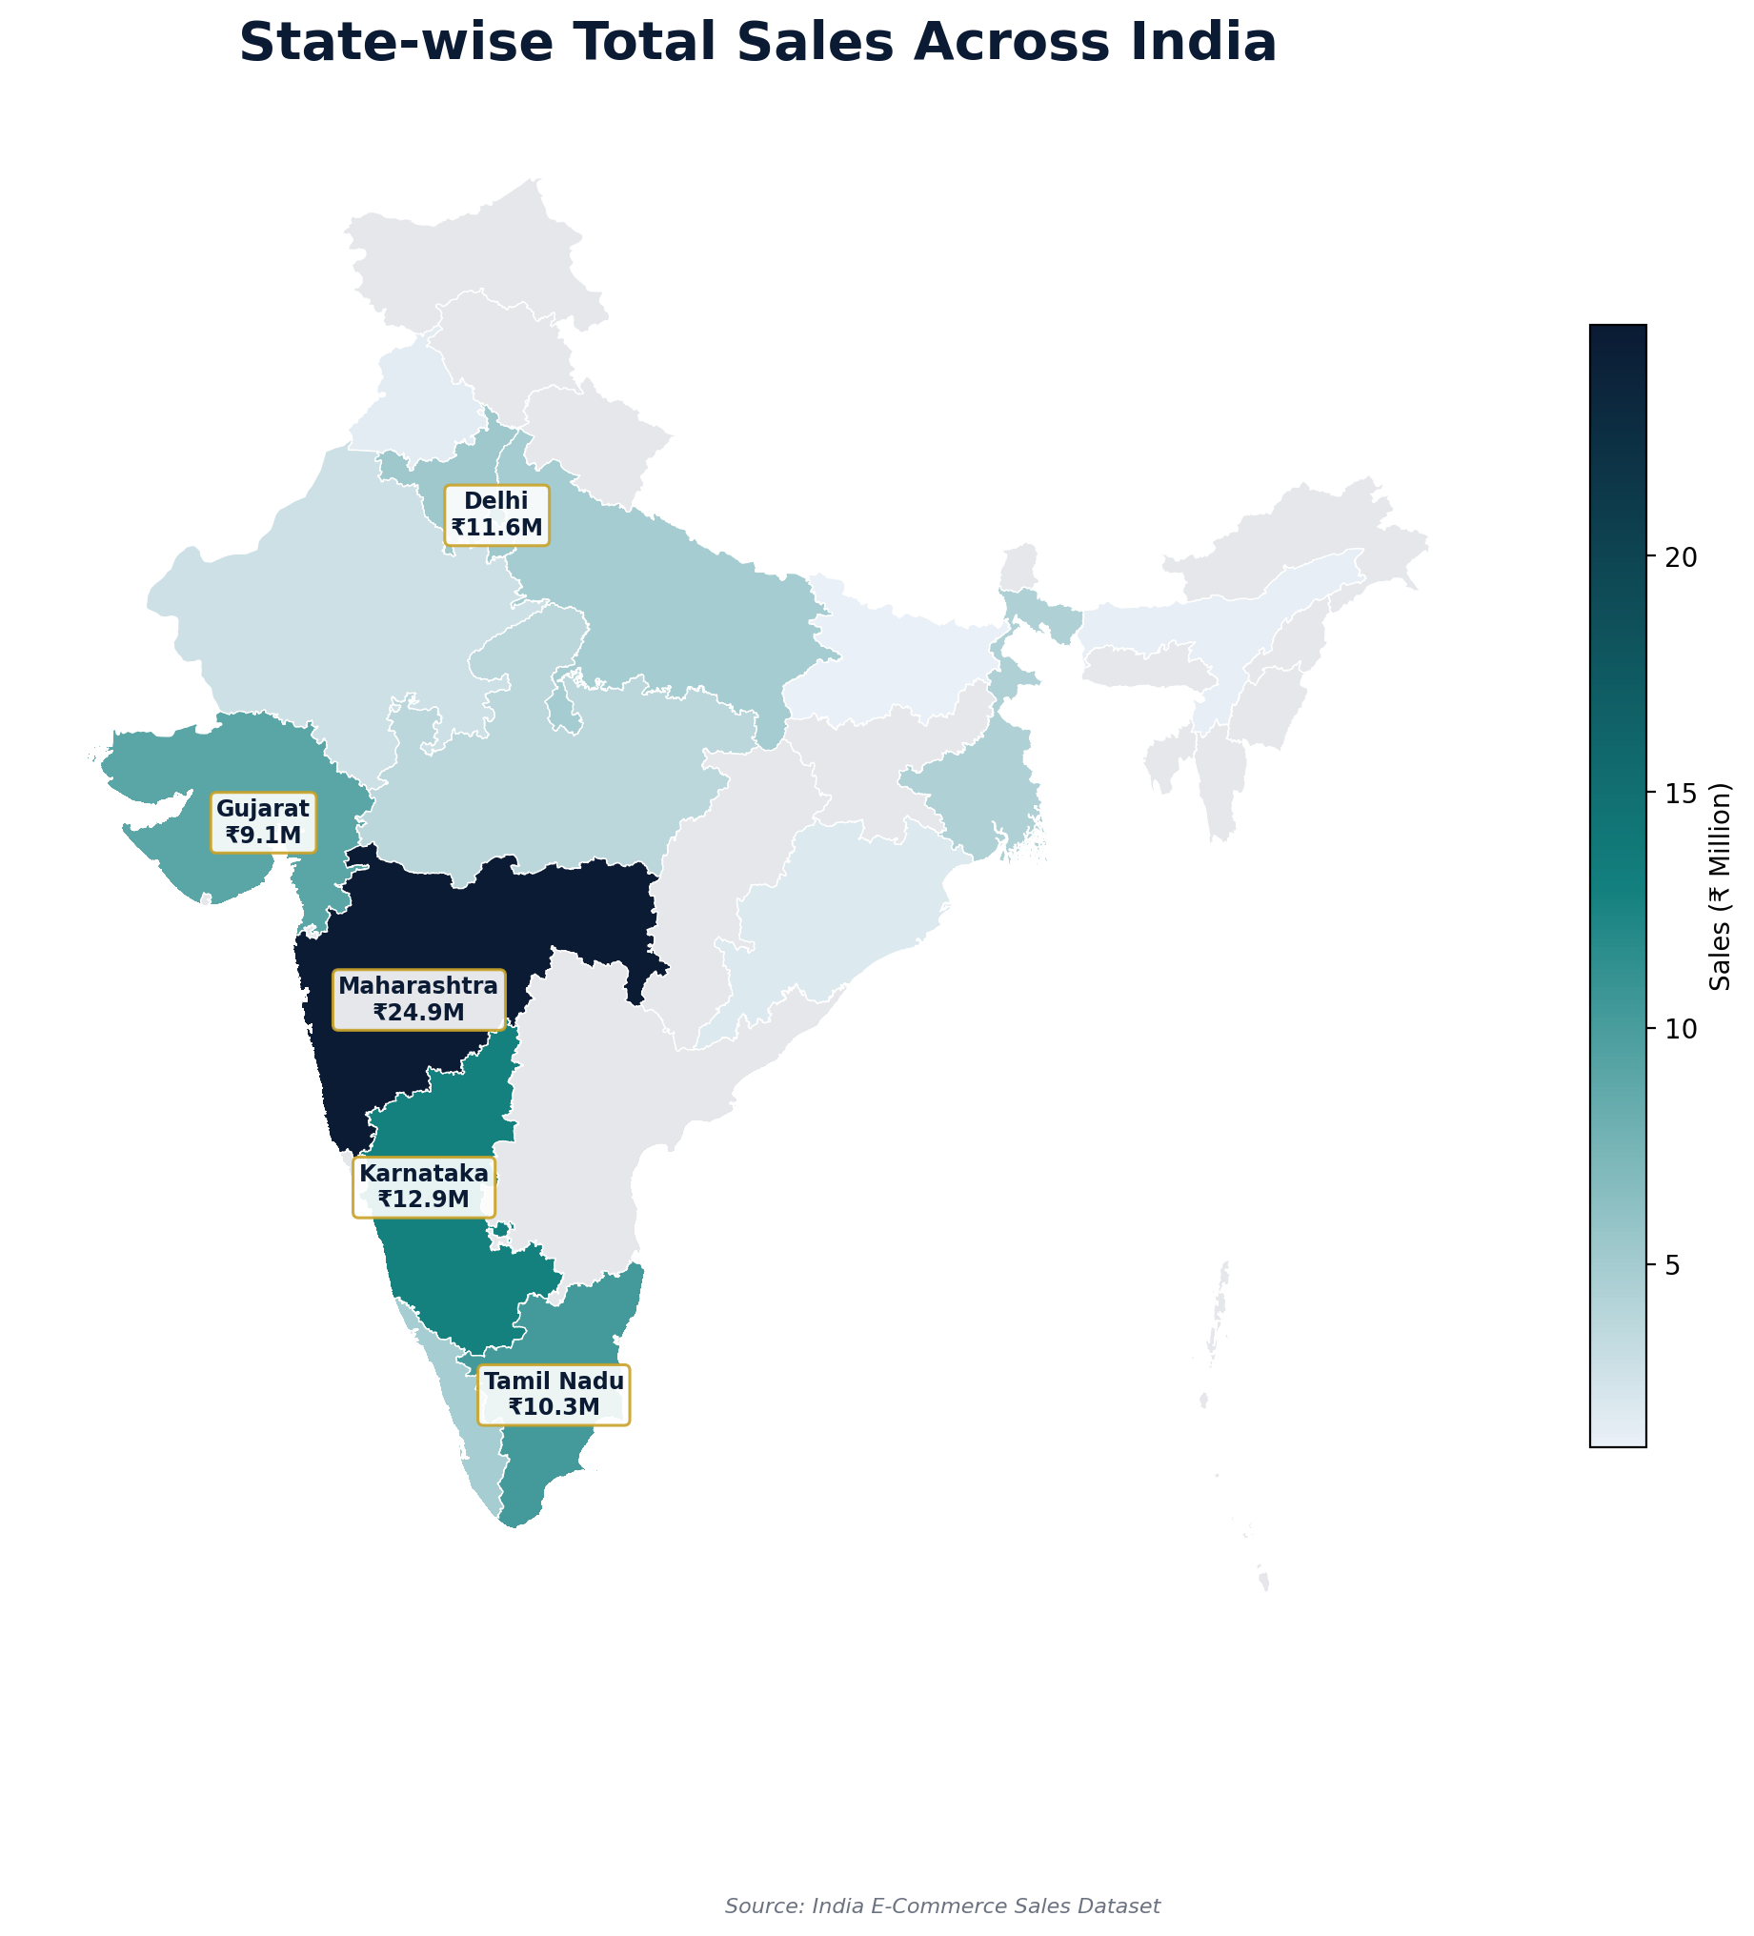
Figure 6: Sales intensity by Indian state
The choropleth confirms the state ranking visually: Maharashtra stands out as the darkest (highest-sales) state, with Karnataka, Delhi, Tamil Nadu and Gujarat forming a clear second tier. The northern and eastern belt is visibly lighter, underlining the geographic concentration of revenue in five states.

6.2 City-wise Sales Volume & Profit Margin
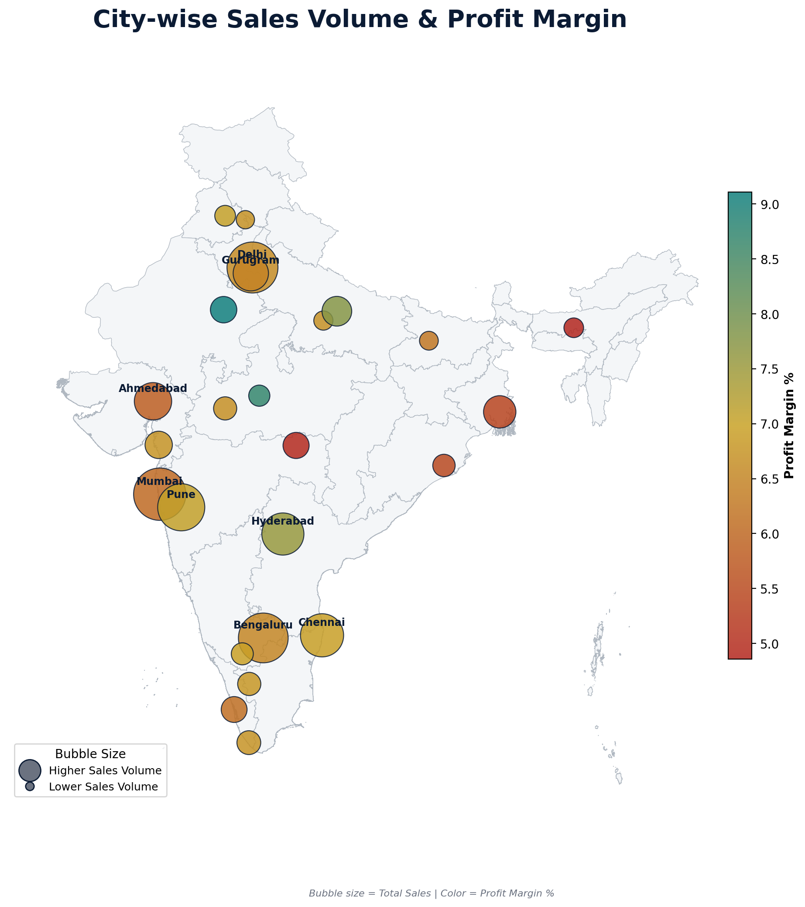
Figure 7: Bubble size = total sales, color = profit margin %
Mumbai, Delhi and Bengaluru are the three largest cities by sales volume (₹11–12M each) — expected, given they are India's largest metros. But volume and profitability move independently: Lucknow (7.75%) and Hyderabad (7.56%) post the healthiest margins despite lower order volumes, while high-volume metros like Mumbai (6.03%) and Ahmedabad (5.83%) run thinner margins — likely due to heavier discounting and higher fulfilment costs in saturated metro markets.

6.3 Regional Classification of States
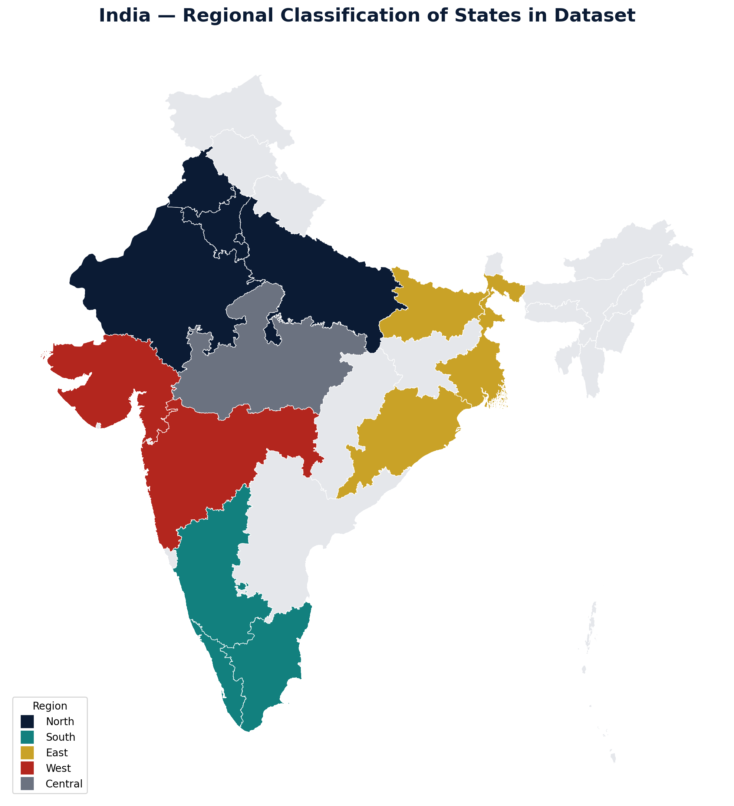
Figure 8: The dataset's 17 states grouped into 4 business regions
This map visually reinforces the regional finding from Section 5: South and West together cover five of the top six revenue-generating states (Maharashtra, Karnataka, Gujarat, Tamil Nadu, Telangana), while the East region remains the smallest revenue contributor and represents the clearest geographic growth opportunity.

7. Customer & Operations Analysis

7.1 Payment Method Distribution
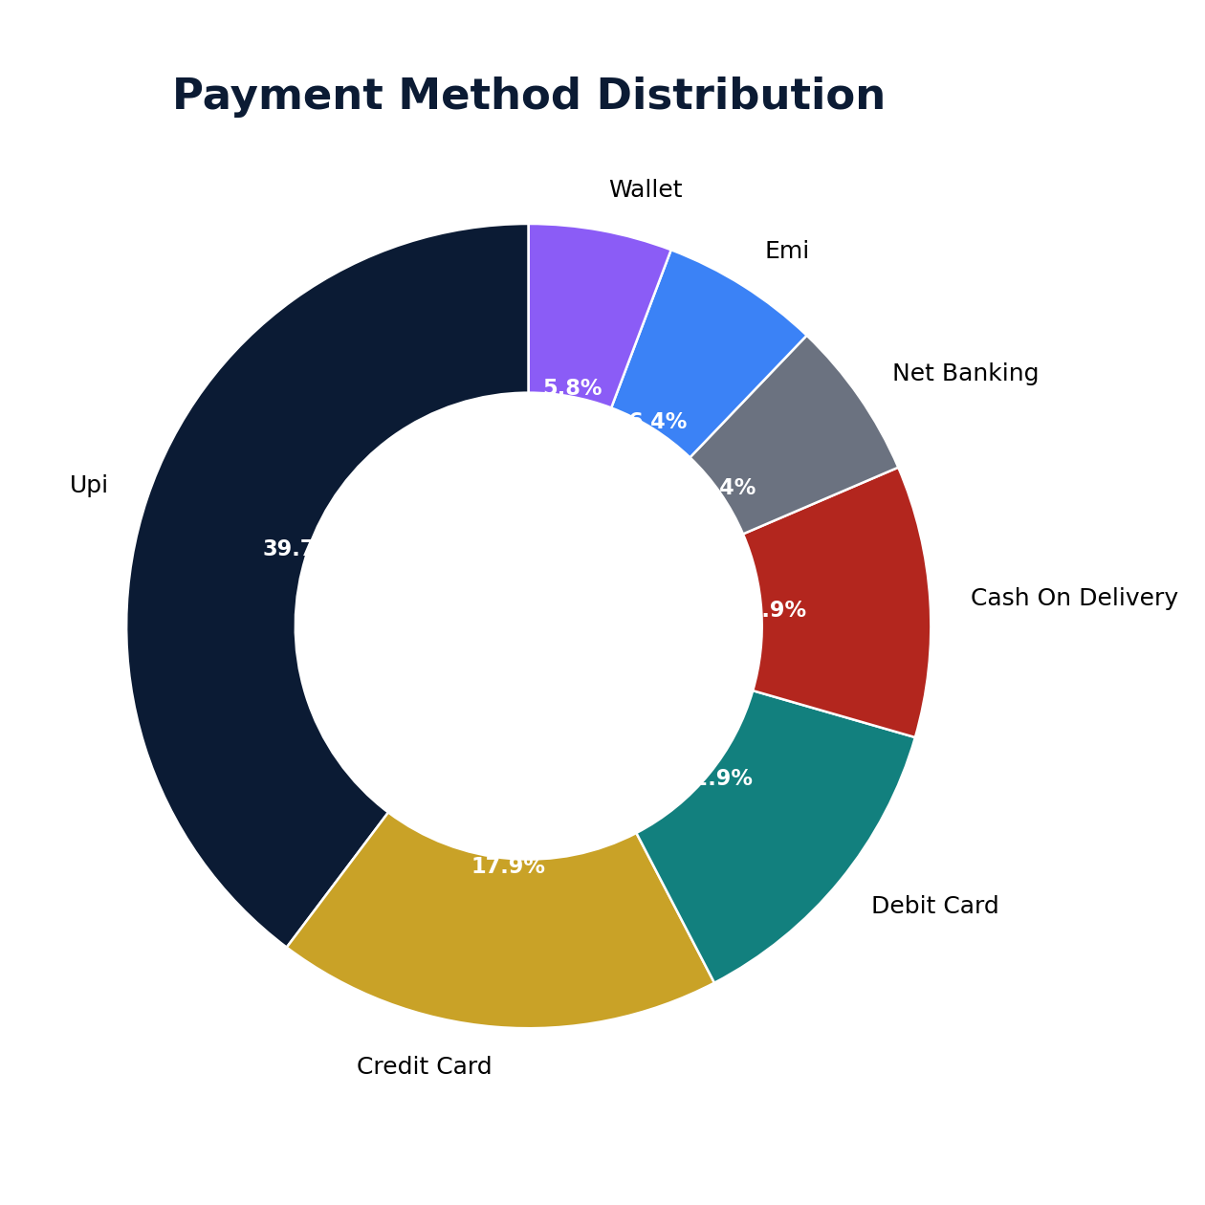
Figure 9: Share of transactions by payment method
UPI is the most preferred payment method at 39.7% of all transactions, followed by Credit Card (17.9%) and Debit Card (12.9%). Wallet is the least used method (5.8%). UPI's dominance underscores the strong customer preference for fast, convenient digital payments in the Indian e-commerce market.

7.2 Order Status Distribution
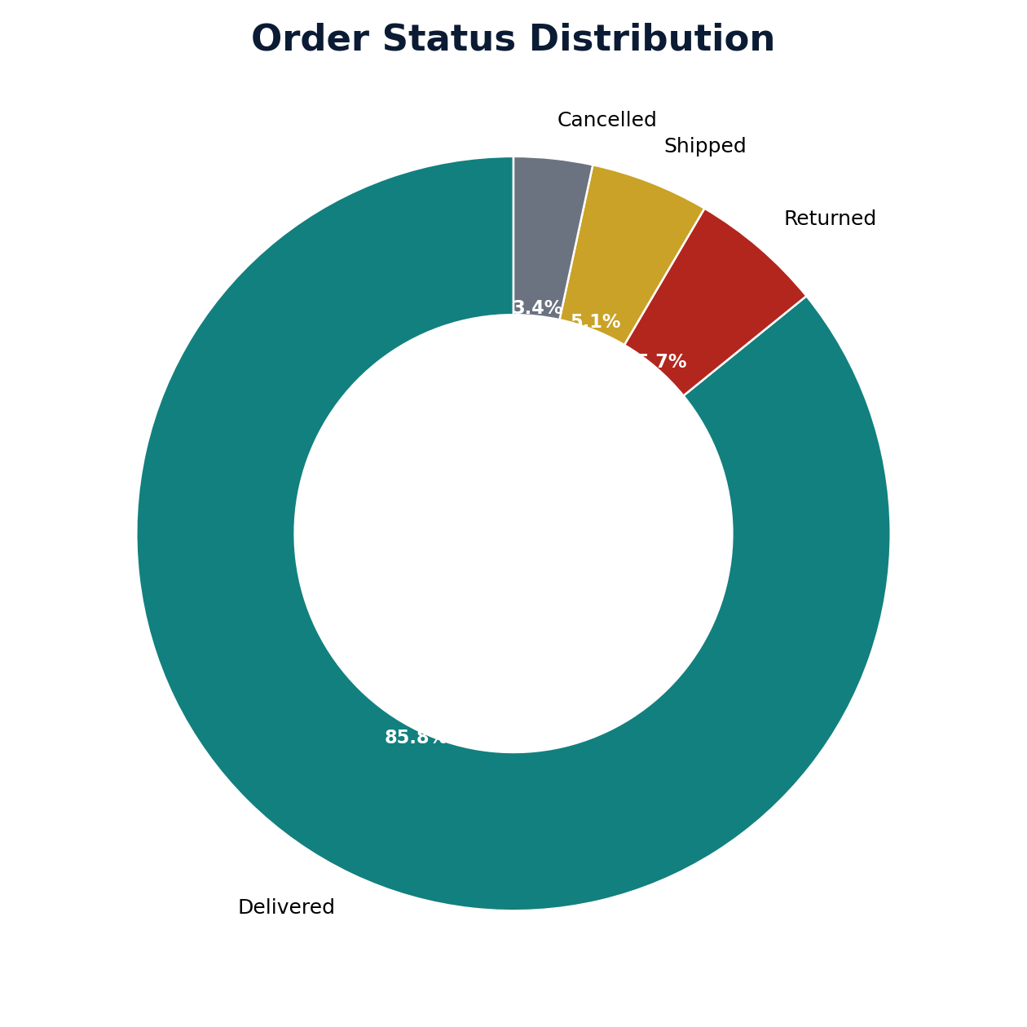
Figure 10: Share of orders by fulfilment outcome
85.8% of orders were successfully delivered, indicating a strong overall fulfilment rate. Returned orders account for 5.7% — a relatively small but important share worth investigating for causes such as product quality, incorrect orders, or customer dissatisfaction — while 5.1% remain in transit (Shipped) and 3.4% were Cancelled.

7.3 Monthly Revenue & Margin Trend
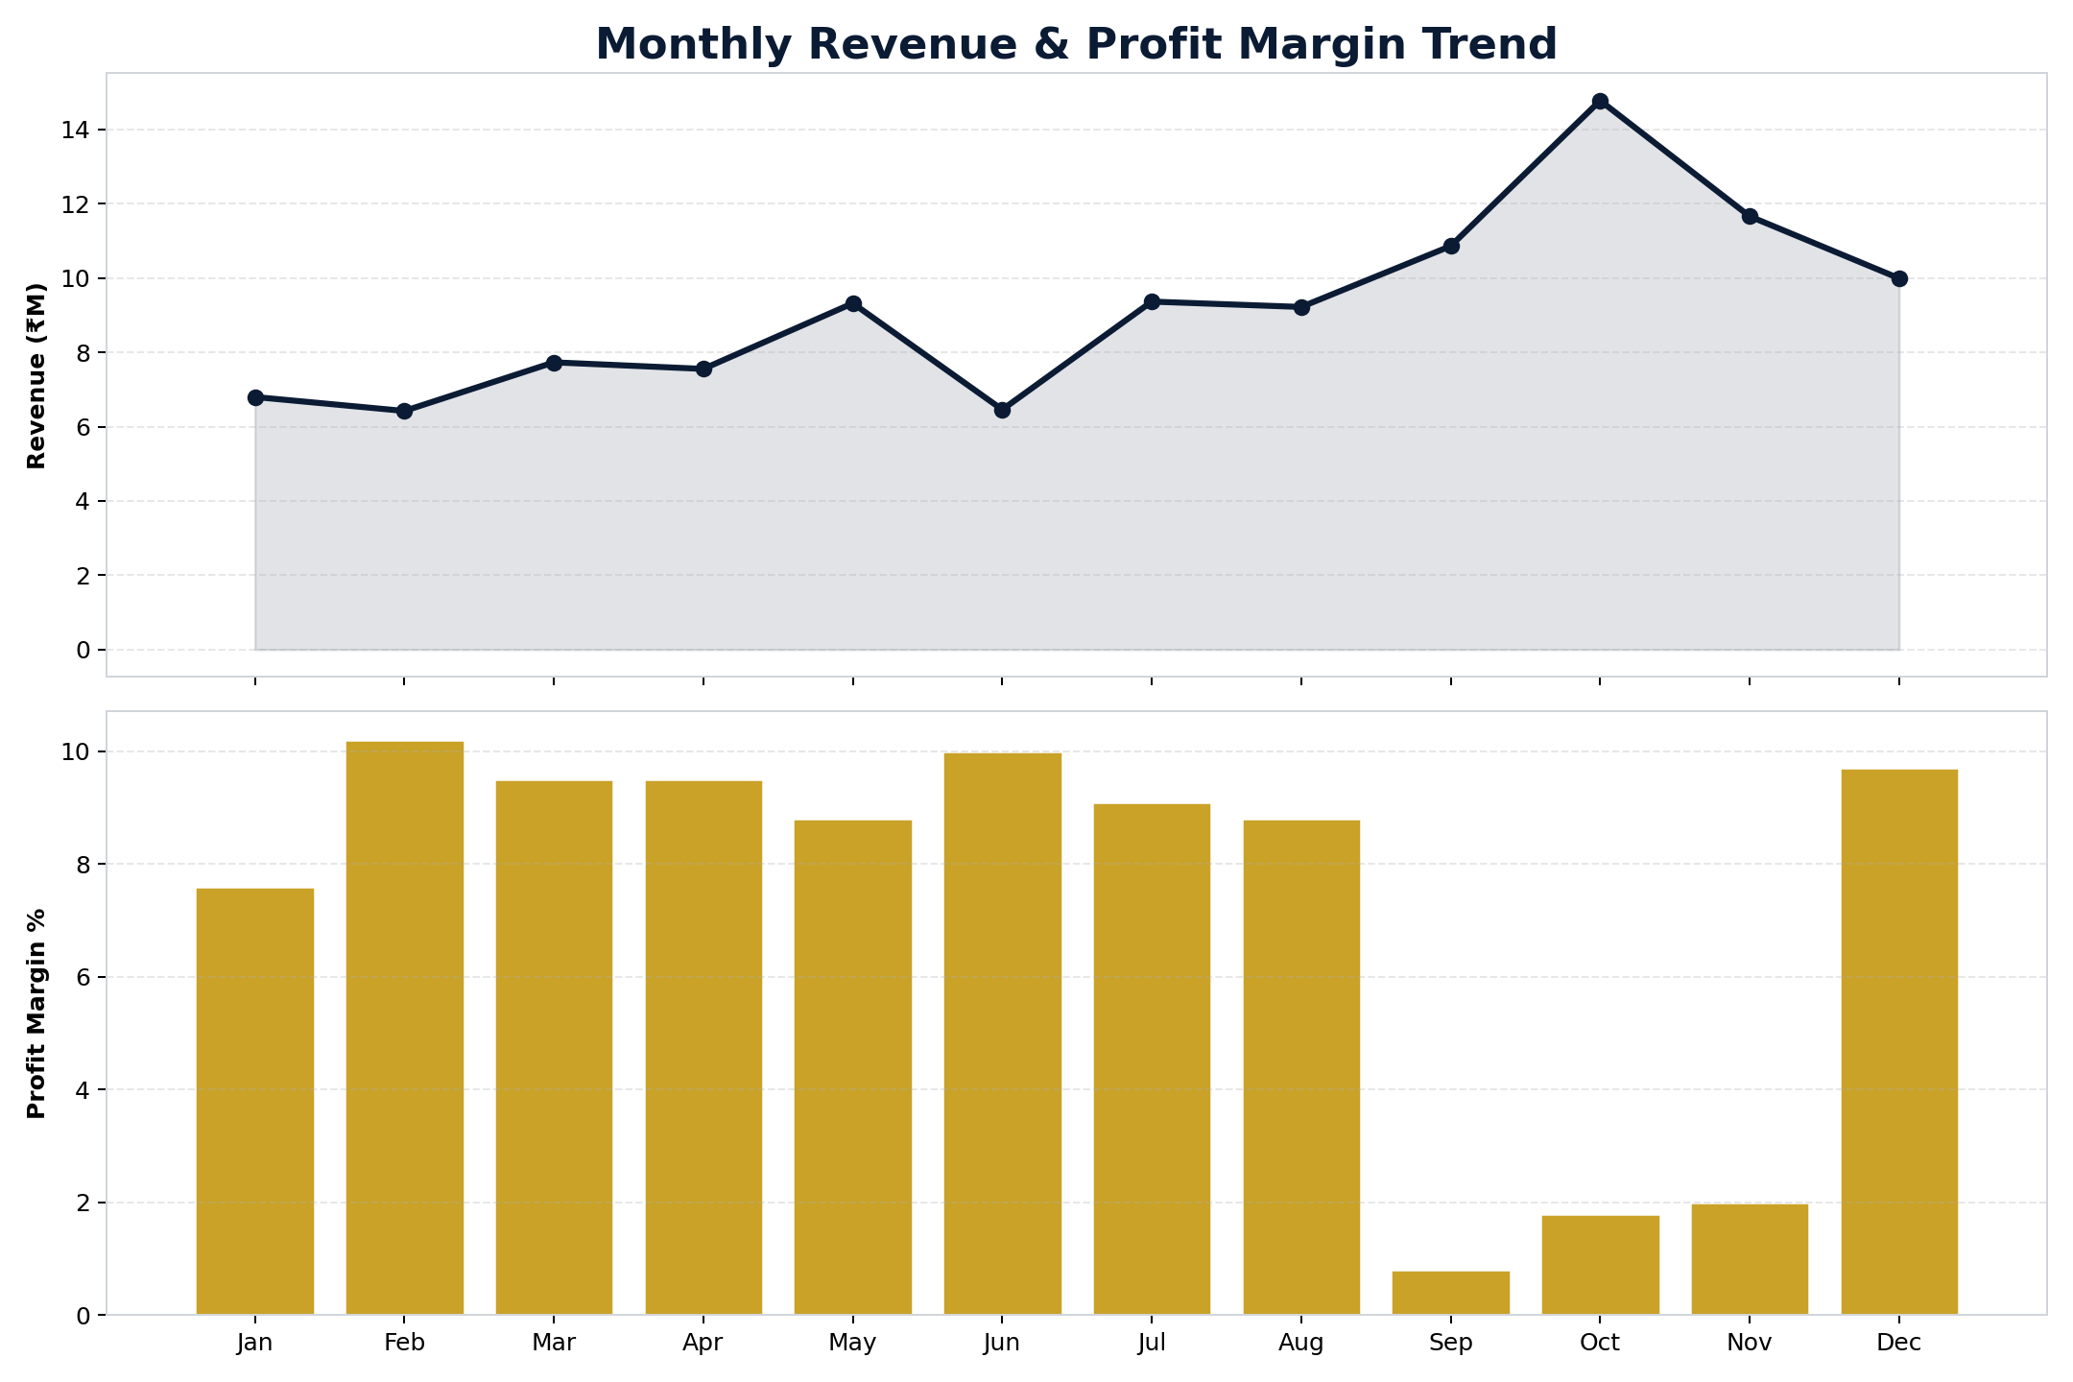
Figure 11: Revenue trend (top) and profit margin % (bottom) by month
Revenue climbs steadily through the year with a pronounced peak in October, consistent with festive-season demand (Dussehra/Diwali shopping). Profit margins, however, compress sharply in September–November — the same months revenue peaks — pointing to heavy festive discounting eating into margin even as topline sales grow.

7.4 Year-wise Sales Split
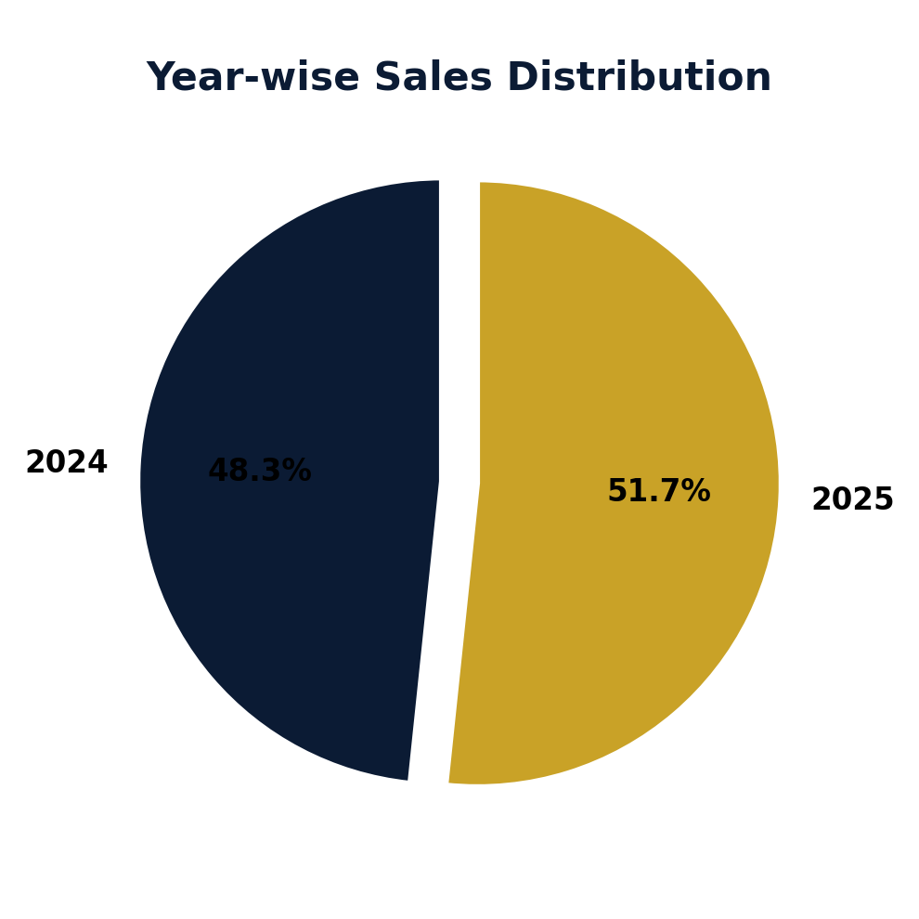
Figure 12: 2024 vs 2025 share of total sales
2024 contributes approximately 50.9% of total sales compared with 49.1% in 2025 — a small year-on-year decline that suggests overall performance has remained broadly stable rather than growing.

8. Conclusion & Business Recommendations

Key Findings
- The business processed 13,522 valid orders worth ₹110.2M in total sales, at ₹7.3M profit (6.6% blended margin) across FY2024–25.
- Electronics drives the most revenue (₹54.9M) despite Fashion having the highest order count — Electronics carries a much higher average order value.
- Maharashtra is the single largest state market (₹24.9M), and just five states account for a disproportionate share of national sales.
- UPI (39.7%) dominates payment method share, reflecting the broader Indian digital-payments shift.
- 85.8% of orders are delivered successfully; a 5.7% return rate is worth root-causing.
- Top-selling products (HP Pavilion 15, Lenovo IdeaPad Slim 3) do not always carry the best margins — HP Pavilion 15 is revenue-positive but profit-negative.
- Tier-2 cities such as Lucknow and Hyderabad post stronger profit margins than high-volume metros like Mumbai and Ahmedabad, suggesting metro discounting is eroding margin more than it drives incremental profit.
- Festive-season months (Sep–Nov) show revenue peaks paired with margin compression, indicating heavy seasonal discounting.

Recommendations
- 1. Protect the core, grow the edge: Defend the Maharashtra / Karnataka / Delhi / Tamil Nadu / Gujarat base while running targeted regional campaigns in the East (West Bengal, Odisha, Assam) and North (Uttar Pradesh) to diversify the revenue base.
- 2. Re-price or re-bundle low-margin bestsellers: Investigate the discount structure on HP Pavilion 15 and similarly high-revenue, low-margin electronics SKUs.
- 3. Lean into Tier-2 profitability: Increase marketing spend and delivery investment in cities like Lucknow, Hyderabad and Pune, where margins are healthier than in saturated metros.
- 4. Investigate the 5.7% return rate, especially within Fashion and Electronics, to identify whether it is driven by sizing/fit, product quality, or delivery damage.
- 5. Cap festive-season discount depth: Set margin floors for Sep–Nov promotions so festive volume growth does not come entirely at the cost of profitability.
- 6. Continue the UPI-first payment experience and consider extending EMI options on high-ticket Electronics/Appliances orders, where affordability may be a purchase barrier.

Report generated as part of a Python-based end-to-end data analytics training project.

