**Step 4:****DATA VISUALIZATION**

To visualize Data we go to power BI desktop and login with our fabric account

And connect to Azure SQL server and select all five tables to analysis reports

For tables and build relations among them and also publish them to fabric workspace

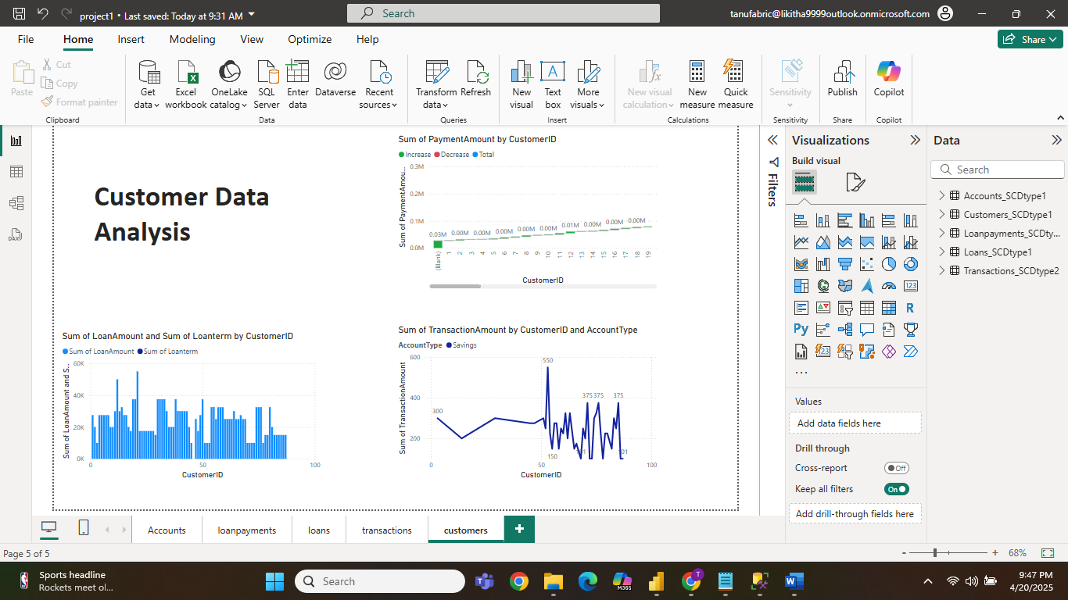

we do the reports here and publish to fabric

