Akash and Vishal are quite fond of travelling. They mostly travel by railways. They were travelling in a train one day and they got interested in the seating arrangement of their compartment. The compartment looked something like   
f  
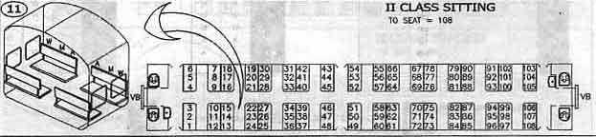   
So they got interested to know the seat number facing them and the seat type facing them. The seats are denoted as follows :

* Window Seat : WS
* Middle Seat : MS
* Aisle Seat : AS

You will be given a seat number, find out the seat number facing you and the seat type, i.e. WS, MS or AS.  
  
INPUT  
First line of input will consist of a single integer T denoting number of test-cases. Each test-case consists of a single integer N denoting the seat-number.  
  
OUTPUT  
For each test case, print the facing seat-number and the seat-type, separated by a single space in a new line.  
  
CONSTRAINTS

* 1<=T<=105
* 1<=N<=108

SAMPLE INPUT

2

18

40

SAMPLE OUTPUT

19 WS

45 AS