**Assignment 11.5**

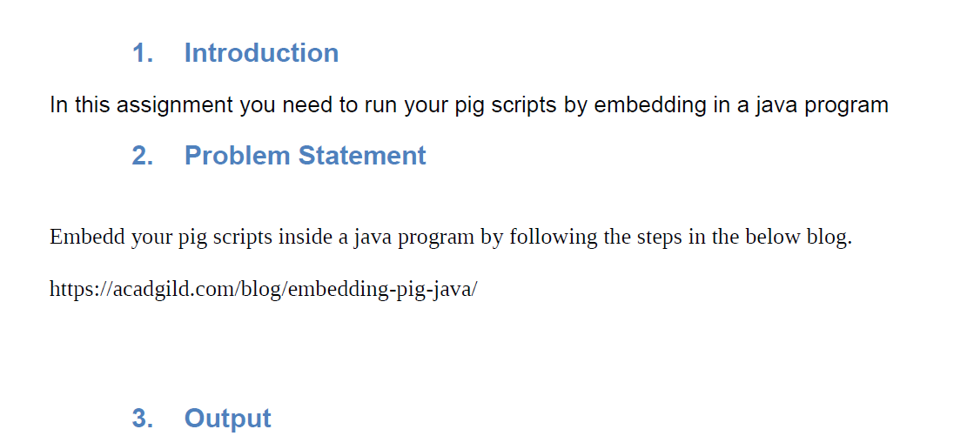

**What is Embedded Pig?**

Embedded Pig lets you enable the control flow in Pig scripts. Pig can be embedded in Java, Python, and JavaScript scripting languages using a JDBC- like compile, bind run model.

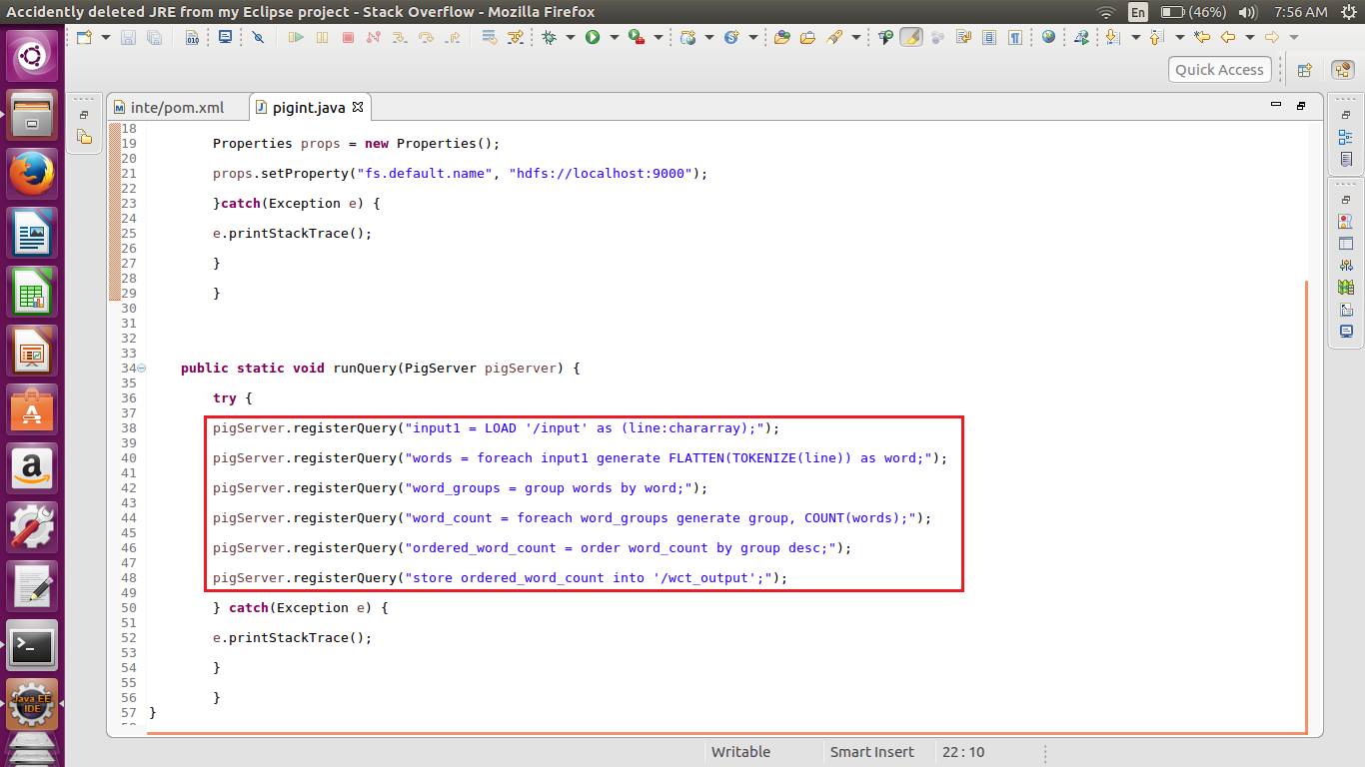

**How to Run the Embedded Pig**

To run an embedded Pig, you need to convert your Java project into a Maven project.

To convert into Maven Project, Right Click on the Project–>Configure–>Convert to Maven Project.

After converting, you can see a target file created and inside the target file, you can see pom.xml files. In that file, add the below dependencies:

<dependencies>

<dependency>

<groupId>org.apache.hadoop</groupId>

<artifactId>hadoop-hdfs</artifactId>

<version>2.7.1</version>

</dependency>

<dependency>

<groupId>org.apache.hadoop</groupId>

<artifactId>hadoop-client</artifactId>

<version>2.7.1</version>

</dependency>

<dependency>

<groupId>commons-io</groupId>

<artifactId>commons-io</artifactId>

<version>2.4</version>

</dependency>

<dependency>

<groupId>log4j</groupId>

<artifactId>log4j</artifactId>

<version>1.2.16</version>

</dependency>

<dependency>

<groupId>org.apache.pig</groupId>

<artifactId>pig</artifactId>

<version>0.15.0</version>

</dependency>

<dependency>

<groupId>org.antlr</groupId>

<artifactId>antlr-runtime</artifactId>

<version>3.4</version>

</dependency>

</dependencies>



