**Assignment 22.1**

1. **Write a Wordcount program and Store the result in Mysql db.**

The DBInputFormat and DBOutputFormat component provided in Hadoop 0.19 finally allows easy import and export of data between Hadoop and many relational databases, allowing relational data to be more easily incorporated into your data processing pipeline.

Program:

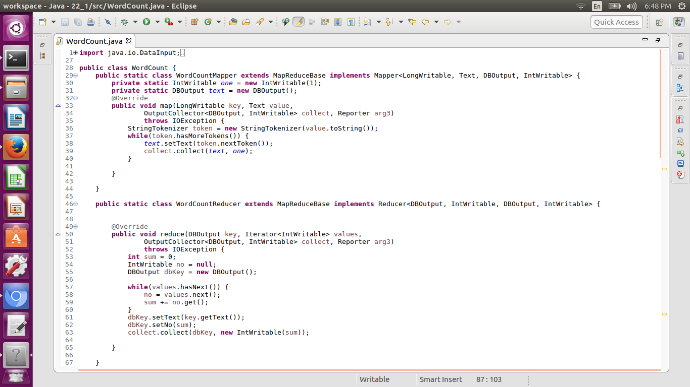

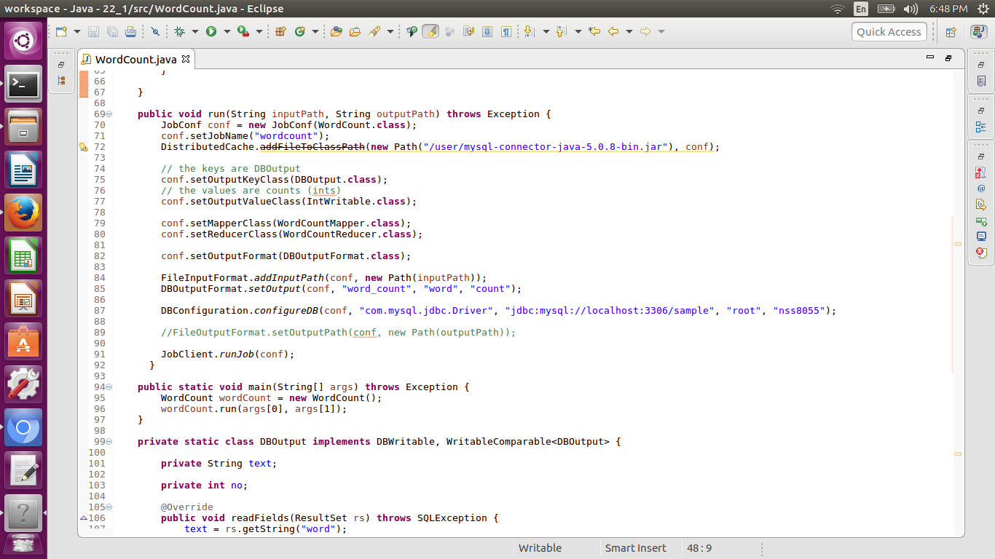

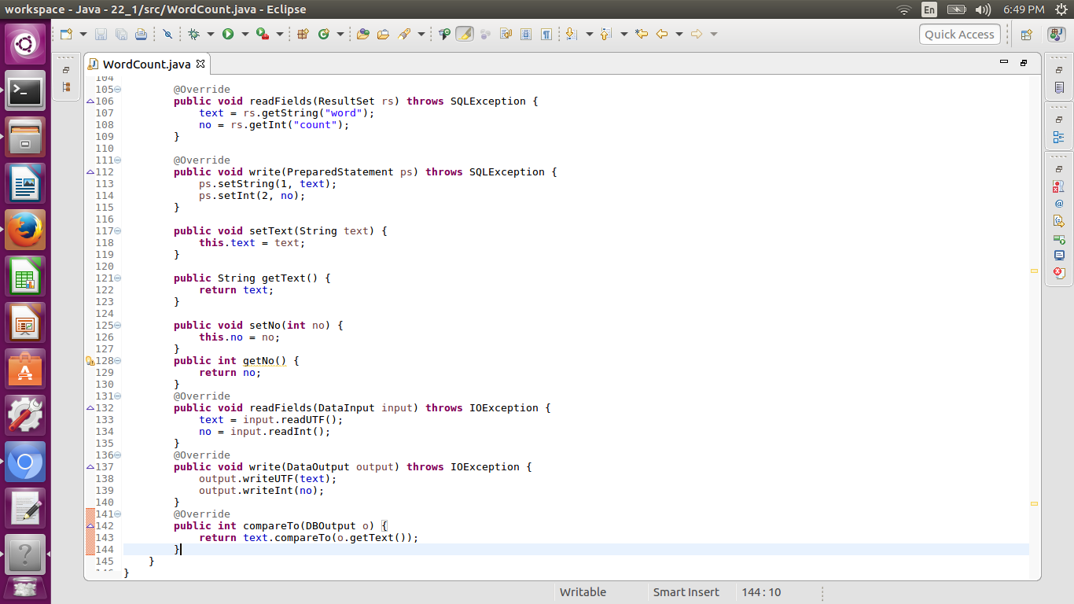

**Result:**



