**Assignment 22.2**

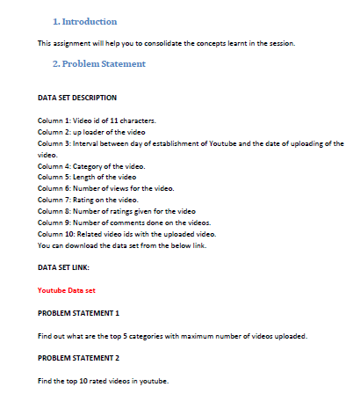

Here in this question we are supposed to find the top categories where the number of videos uploaded is more for this we have implemented driver, mapper and the reducer

Driver class is used to set the configurations as well as the classes for this program. In mapper we have passed category as the key and the intwritable as the value. We are counting the category specified in front of the video. So that the number of videos uploaded can be counted in the specified category.

To do this we have implemented the driver class where we have counted(summed) the number of values to get the number of videos in the given category.

**Driver Class:**

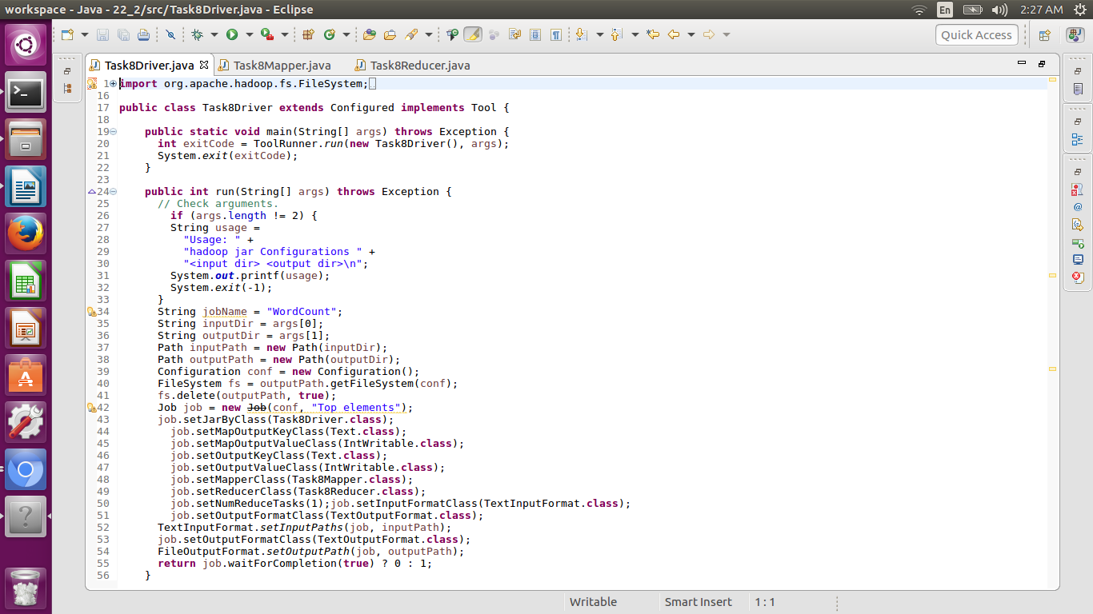

**Mapper:**

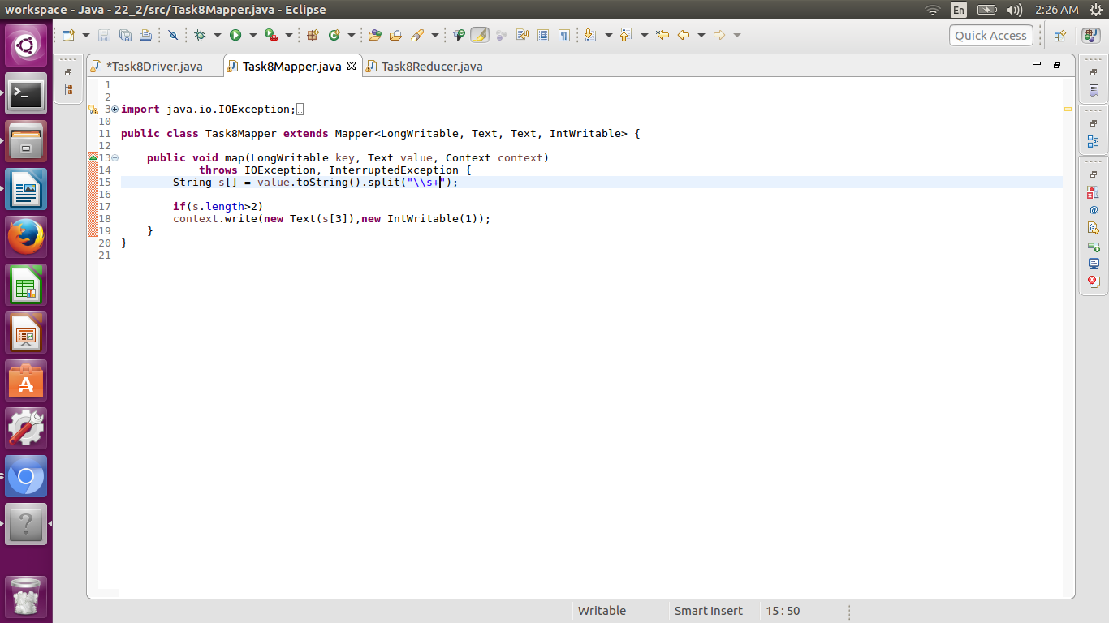

**Reducer:**

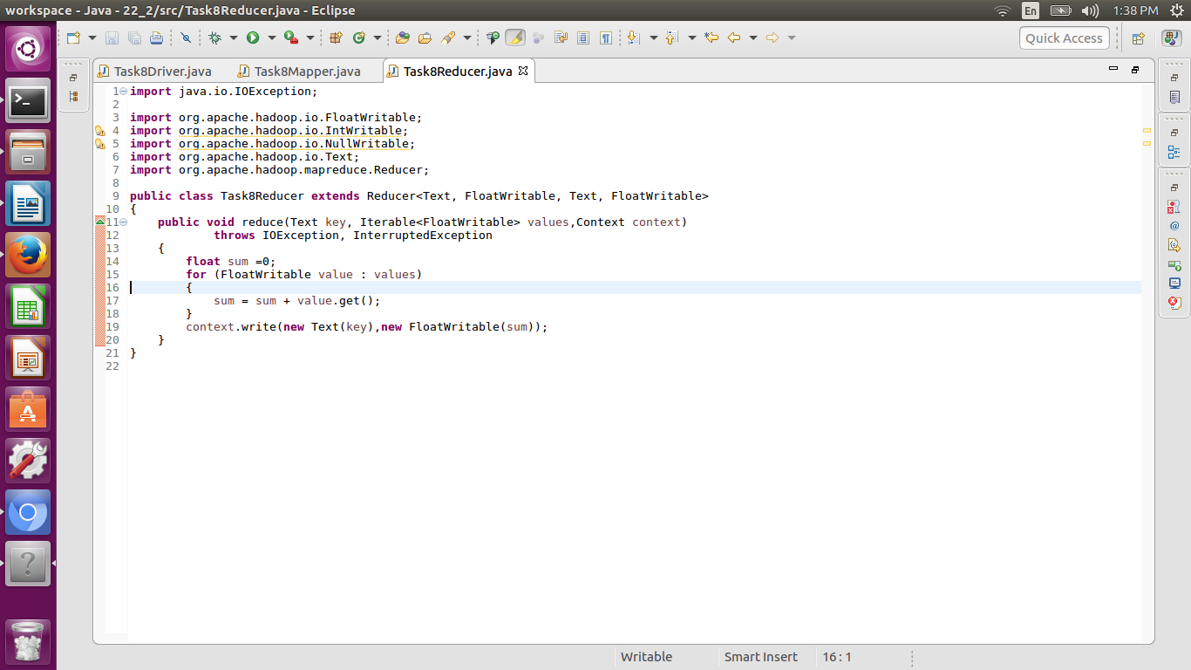

**Answer:**

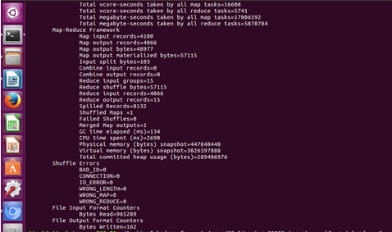





**PROBLEM STATEMENT 2**

Find the top 10 rated videos in youtube.

