**Assignment 30.3**

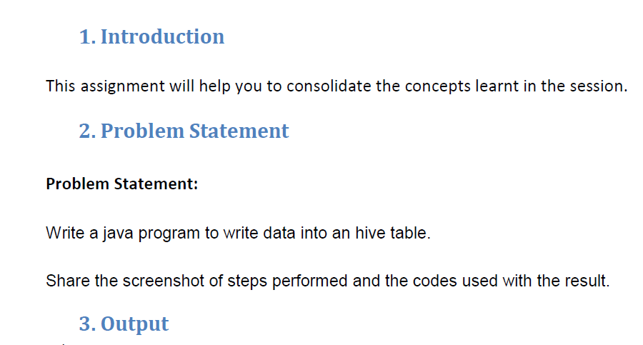

**Here to write the data into the hive table we followed the following steps:**

**Step I:**

We first created the hive table customers

**Step II:**

Then we wrote the java program where the insert command is executed to insert the data helloworld into the table

**Step III:**

Here we open the hive shell and the select command is used to check whether the data is being written into the data

**Before executing this steps we need to start the hiveserver using the command hiveserver2 start.**



