**Assignment 33.3**

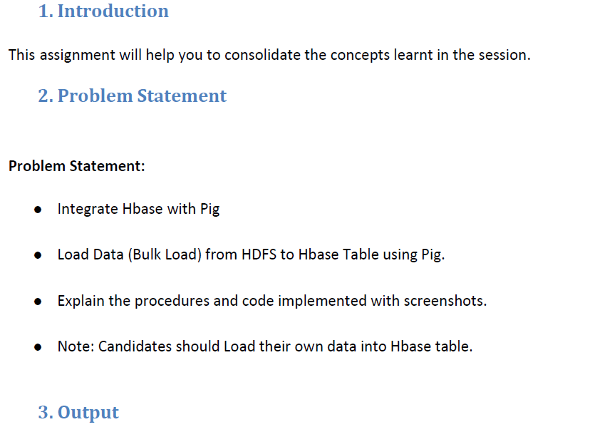

Here we have uploaded the data custs.txt into the hdfs and then we used the pig script to write the data into the hbase table using pig commands.

The file uploaded into the hdfs is as follows:

**$ hadoop fs –put /home/acadgild/Desktop/custs.txt /user**

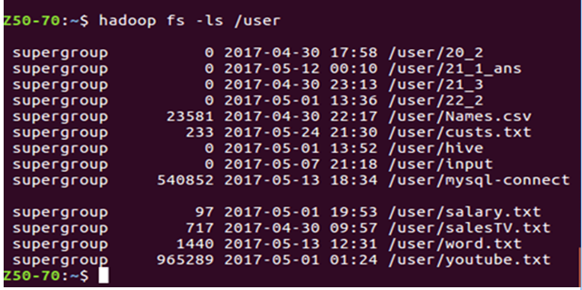

We created the cust table into the hbase so that the data could be written into it.

