**Assignment 34.2**

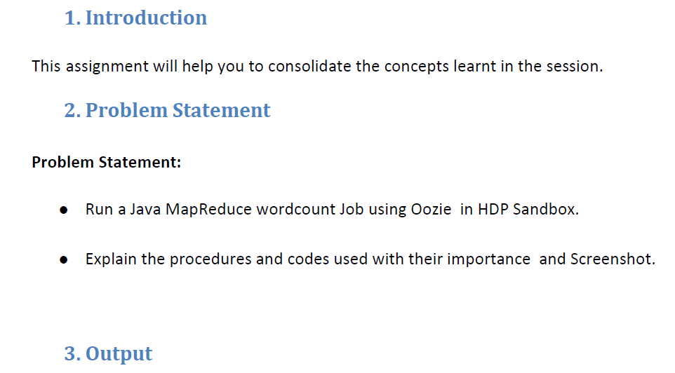

1. **Untar the jar hadoop-mapreduce-examples.jar.**

You can find this jar under /usr/lib/gphd/hadoop-mapreduce directory on a Pivotal Hadoop cluster.

[hadoop@hdm1 test]$ jar xf hadoop-mapreduce-examples.jar  
[hadoop@hdm1 test]$ ls  
hadoop-mapreduce-examples.jar META-INF org

**2) Navigate to the directory to see the list of class files associated with WordCount**.

[hadoop@hdm1 test]$ cd org/apache/hadoop/examples/  
[hadoop@hdm1 examples]$ ls WordCount*  
WordCount.class WordCount$IntSumReducer.class WordCount$TokenizerMapper.class

In the WordCount program, name of the mapper class is WordCount$TokenizerMapper.class and reducer class is WordCount$TokenizerMapper.class. We will use these file when defining the oozie workflow.xml

**3) Create a job.properties file. The parameters for the Oozie job are provided in a Java properties file (.properties) or a Hadoop configuration xml (.xml), in this situation we use a .properties file.**

nameNode=hdfs://phdha  
jobTracker=hdm1.phd.local:8032  
queueName=default  
examplesRoot=examplesoozie

oozie.wf.application.path=${nameNode}/user/${user.name}/${examplesRoot}/map-reduce  
outputDir=map-reduce  
  
where:  
namenode = Variable to define the namenode path by which HDFS can be accessed. Format: hdfs://<nameservice> or hdfs://<namenode_host>:<port>  
jobTracker = Variable to define the resource manager address in case of Yarn implementation. Format: <resourcemanager_hostname>:<port>  
queueName = Name of the queue as defined by Capacity Scheduler, Fail Scheduler etc. By default, it's "default".  
examplesRoot = Environment variable for the workflow.  
oozie.wf.application.path = Environment variable which defines the path on HDFS which holds the workflow.xml to be executed.  
outputDir = Variable to define the output directory

Note: You can define the parameter, oozie.libpath under which all the libraries required for the MapReduce program can be stored. However, this is not applied in this example.

Example:

oozie.libpath=${nameNode}/$(user.name)/share/lib

**4) Create a workflow.xml. workflow.xml defines a set of actions to be performed as a sequence or in Control Dependency DAG (Direct Acyclic Graph).**

"control dependency" from one action to another means that the second action cannot run until the first action has been completed.

Refer to the documentation:

<http://oozie.apache.org/docs/3.3.2/WorkflowFunctionalSpec.html>.

<workflow-app xmlns="uri:oozie:workflow:0.1" name="map-reduce-wf">  
 <start to="mr-node"/>  
 <action name="mr-node">  
 <map-reduce>  
 <job-tracker>${jobTracker}</job-tracker>  
 <name-node>${nameNode}</name-node>  
 <prepare>  
 <delete path="${nameNode}/user/${wf:user()}/${examplesRoot}/output-data/${outputDir}"/>  
 </prepare>  
   
 <configuration>  
 <property>  
 <name>mapred.mapper.new-api</name>  
 <value>true</value>  
 </property>  
 <property>  
 <name>mapred.reducer.new-api</name>  
 <value>true</value>  
 </property>  
 <property>  
 <name>mapred.job.queue.name</name>  
 <value>${queueName}</value>  
 </property>  
 <property>  
 <name>mapreduce.map.class</name>  
 <value>org.apache.hadoop.examples.WordCount$TokenizerMapper</value>  
 </property>  
 <property>  
 <name>mapreduce.reduce.class</name>  
 <value>org.apache.hadoop.examples.WordCount$IntSumReducer</value>  
 </property>  
 <property>  
 <name>mapreduce.combine.class</name>  
 <value>org.apache.hadoop.examples.WordCount$IntSumReducer</value>  
 </property>  
 <property>  
 <name>mapred.output.key.class</name>  
 <value>org.apache.hadoop.io.Text</value>  
 </property>  
 <property>  
 <name>mapred.output.value.class</name>  
 <value>org.apache.hadoop.io.IntWritable</value>  
 </property>  
 <property>  
 <name>mapred.input.dir</name>  
 <value>/user/${wf:user()}/${examplesRoot}/input-data/text</value>  
 </property>  
 <property>  
 <name>mapred.output.dir</name>  
 <value>/user/${wf:user()}/${examplesRoot}/output-data/${outputDir}</value>  
 </property>  
 </configuration>  
 </map-reduce>  
 <ok to="end"/>  
 <error to="fail"/>  
 </action>  
 <kill name="fail">  
 <message>Map/Reduce failed, error message[${wf:errorMessage(wf:lastErrorNode())}]</message>  
 </kill>  
 <end name="end"/>  
</workflow-app>

**5. Create a directory on HDFS under which all the files related to the Oozie job will be kept. In this directory, push the workflow.xml created in the previous step.**

[hadoop@hdm1 map-reduce]$ hdfs dfs -mkdir -p /user/hadoop/examplesoozie/map-reduce

[hadoop@hdm1 map-reduce]$ hdfs dfs -copyFromLocal workflow.xml /user/hadoop/examplesoozie/map-reduce/workflow.xml

**6. Now under the directory created for the Oozie job, create a folder named lib in which the required library / jar files are kept.**

[hadoop@hdm1 map-reduce]$ hdfs dfs -mkdir -p /user/hadoop/examplesoozie/map-reduce/lib

**7. Once the directory is created, copy Hadoop MapReduce examples jar under this directory.**

[hadoop@hdm1 map-reduce]$ hdfs dfs -copyFromLocal /usr/lib/gphd/hadoop-mapreduce/hadoop-mapreduce-examples.jar /user/hadoop/examplesoozie/map-reduce/lib/hadoop-mapreduce-examples.jar

**8. Now you can execute the workflow created, and use it to run Hadoop MapReduce program for WordCount**

[hadoop@hdm1 ~]$ oozie job -oozie http://localhost:11000/oozie -config examplesoozie/map-reduce/job.properties -run

**9. You can view the status of the job as shown below:**

[hadoop@hdm1 ~]$ oozie job -oozie http://localhost:11000/oozie -info 0000009-140529162032574-oozie-oozi-W

Job ID : 0000009-140529162032574-oozie-oozi-W

------------------------------------------------------------------------------------------------------------------------------------

Workflow Name : map-reduce-wf

App Path : hdfs://phdha/user/hadoop/examplesoozie/map-reduce

Status : SUCCEEDED

Run : 0

User : hadoop

Group : -

Created : 2014-05-30 00:31 GMT

Started : 2014-05-30 00:31 GMT

Last Modified : 2014-05-30 00:32 GMT

Ended : 2014-05-30 00:32 GMT

CoordAction ID: -

Actions

------------------------------------------------------------------------------------------------------------------------------------

ID Status Ext ID Ext Status Err Code

------------------------------------------------------------------------------------------------------------------------------------

0000009-140529162032574-oozie-oozi-W@:start: OK - OK -

------------------------------------------------------------------------------------------------------------------------------------

0000009-140529162032574-oozie-oozi-W@mr-node OK job_1401405229971_0022 SUCCEEDED -

------------------------------------------------------------------------------------------------------------------------------------

0000009-140529162032574-oozie-oozi-W@end OK - OK -

------------------------------------------------------------------------------------------------------------------------------------

**10. Once the job is completed, you can review the output in the directory as specified by workflow.xml.**

[hadoop@hdm1 ~]$ hdfs dfs -cat /user/hadoop/examplesoozie/output-data/map-reduce/part-r-00000

SSH:/var/empty/sshd:/sbin/nologin 1

Server:/var/lib/pgsql:/bin/bash 1

User:/var/ftp:/sbin/nologin 1

Yarn:/home/yarn:/sbin/nologin 1

adm:x:3:4:adm:/var/adm:/sbin/nologin 1

bin:x:1:1:bin:/bin:/sbin/nologin 1

console 1

daemon:x:2:2:daemon:/sbin:/sbin/nologin 1

ftp:x:14:50:FTP 1

games:x:12:100:games:/usr/games:/sbin/nologin 1

gopher:x:13:30:gopher:/var/gopher:/sbin/nologin 1

gpadmin:x:500:500::/home/gpadmin:/bin/bash 1

hadoop:x:503:501:Hadoop:/home/hadoop:/bin/bash 1

halt:x:7:0:halt:/sbin:/sbin/halt 1