

Faculty of Computing and Informatics (FCI)

Multimedia University

Cyberjaya

**TCP1101 - PROGRAMMING FUNDAMENTALS**

Trimester 1, 2020/2021

**Lecture Session: TC02**

**Tutorial Session: TT05**

**Group Number: Group 19**

**Assignment: Basic Data Analysis Application**

|  |  |  |  |  |
| --- | --- | --- | --- | --- |
| No. | Name | Student ID | Phone no. | Email |
| 1 | Adeline Fong Li Ling | 1191100708 | 019-2620596 | 1191100708@student.mmu.edu.my |
| 2 | Kong Wan Er | 1191100695 | 019-3030698 | 1191100695@student.mmu.edu.my |
| 3 | Ong Ai Li | 1191302589 | 011-27035198 | 1191302589@student.mmu.edu.my |

Functions List

|  |  |  |
| --- | --- | --- |
| Adeline Fong Li Ling | Kong Wan Er | Ong Ai Li |
| * main * main_menu_action * file_op_choice * chk_format1 * chk_format2 * file_operation * read_file * show_data * readTitles * readData * report_choice * html_txt * statistical_report_txt * statistical_report_html * compute_data_menu * switch_compute * sort_data_menu * sub_sort * html_upper * statistic_table_html * alltable_html * column_menu * column_option * table_above_below_mean * result_mean_table * mean_table_html * distinct_frequency * result_distinct_frequency * distinct_frequency_html * move_to_histogram * histogram * result_histogram * histogram_html * pearson_th * pearson_correlation_html * linear_regression_html * case2 * case3 | * main * calmean * maximum * minimum * median * variance * standardDeviation * column_stats * push_cols_vector * dimensional * statistic_option * statistic_table * alltable | * ascending * descending * sort_data_ascending * sort_data_descending * sort_data_result * sort_data_html * column_menu * column_linearAndPearson * dependentVal * linear_regression * result_linear_regression * pearson_steps * pearson_correlation * result_pearson_correlation |

Structured Chart

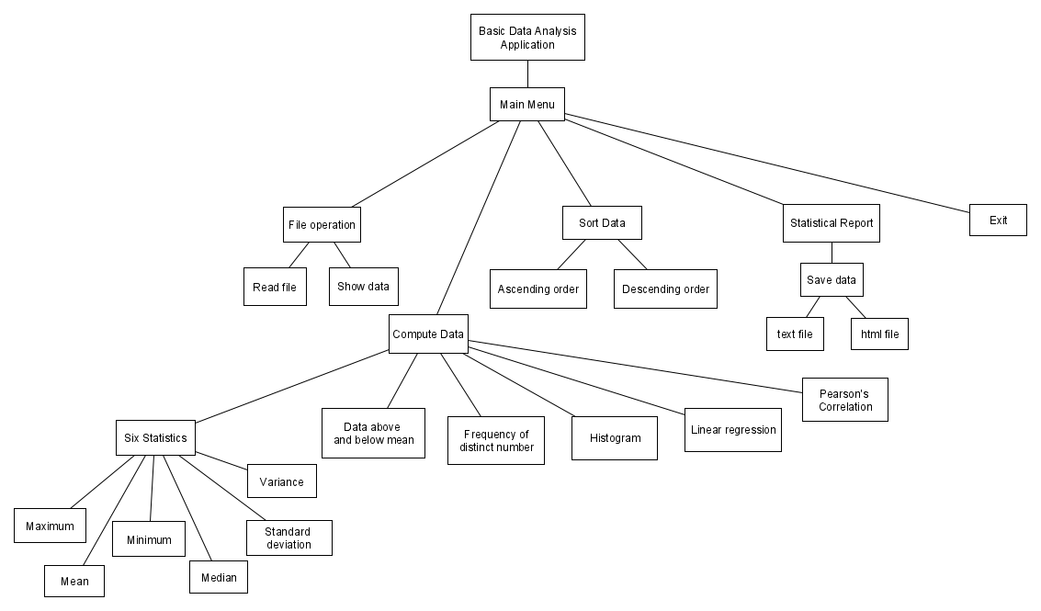

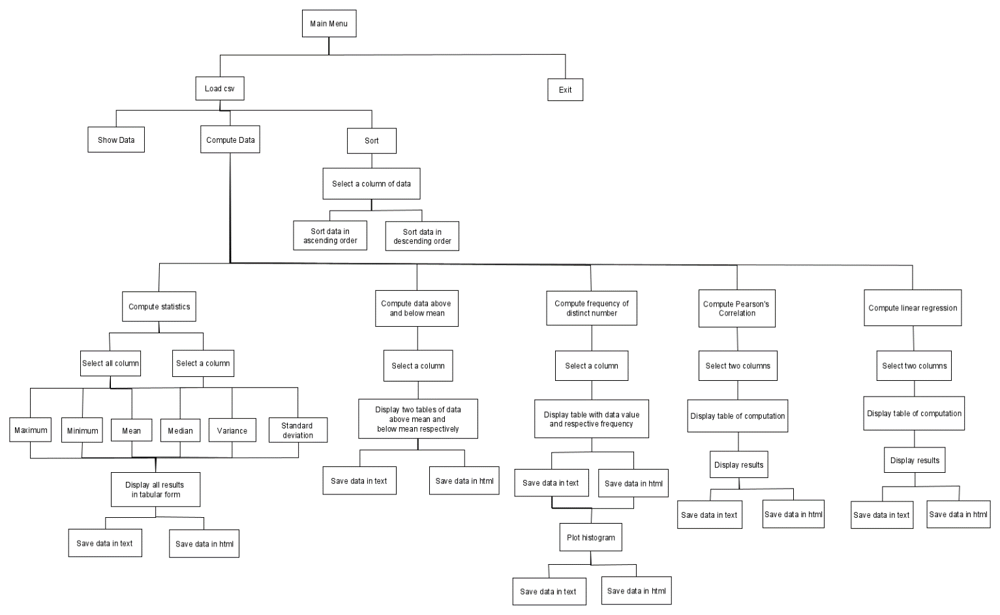

Instruction on how to compile our program

1. IDE used: Code::Blocks 20.03
2. System: Windows 10 (64-bit)
3. Make sure that all source files and data files are in the same directory: assignment.cpp, style_table.css, data.txt
4. Open assignment.cpp, build and run code.
5. After compilation finish, press a key to dismiss the console window.

Instruction on how to use our program

1. 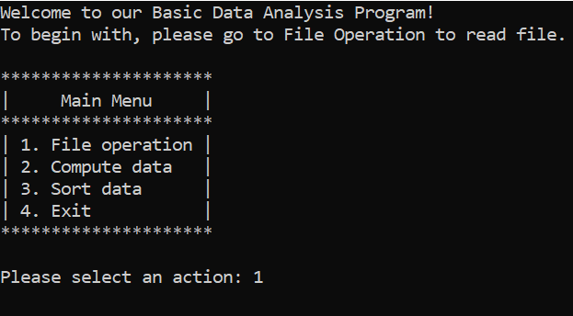Firstly, on the main menu, please navigate to “File operation>>Read file” to open a desired csv file. The program only can proceed with data operations after reading a file.
2. Type a file name as such:

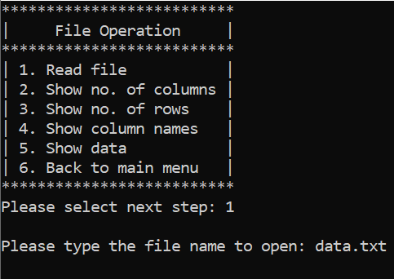

1. 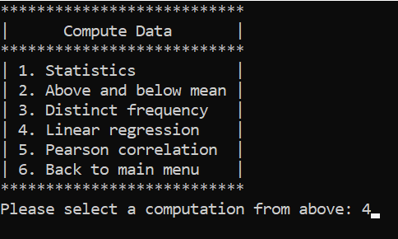After that, feel free to do any computation or sorting for multiple times.
2. For every computation, select column (data).

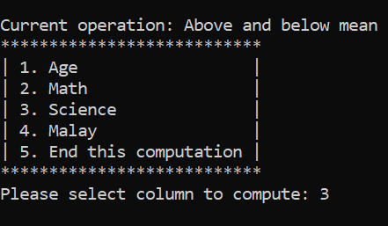

1. 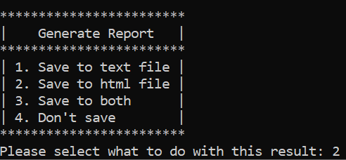After result is printed, please choose options below for the report of result.

Error situations

* If user tries to compute or sort data before reading a file, an error is prompt to ask user to read file first.

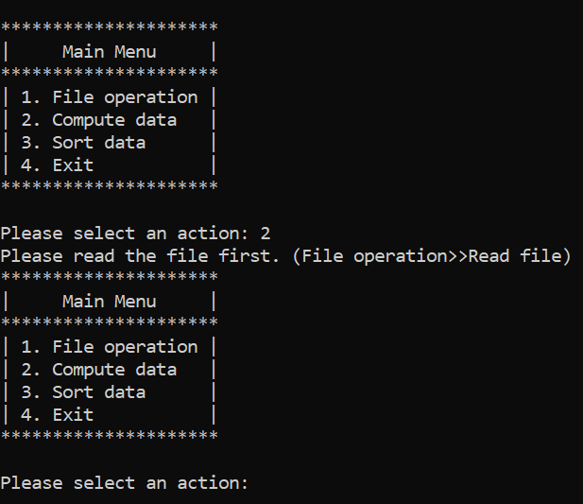

* If the filename entered does not exist or failed to open, error is prompted.

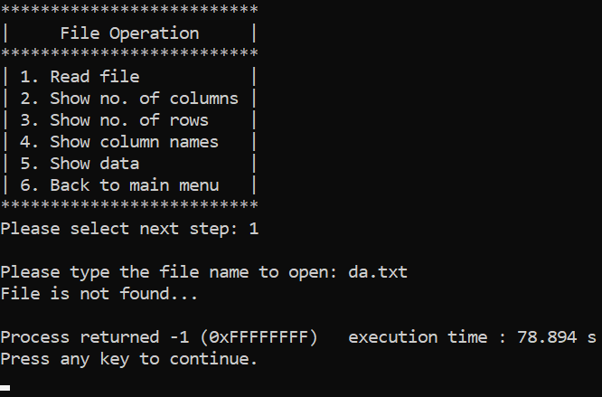

* If input for the menu choice is not within the given range, error is prompted.

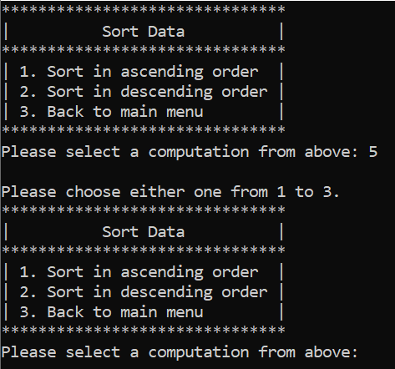

* 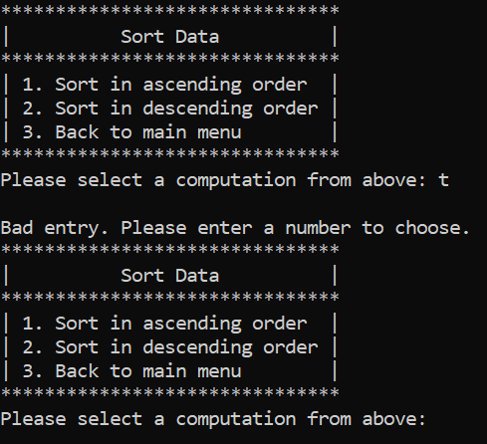If input for the menu choice is not a number, error is prompted.
* For linear regression and pearson correlation, when the dependent variable selected is same as the independent variable, error is prompted.

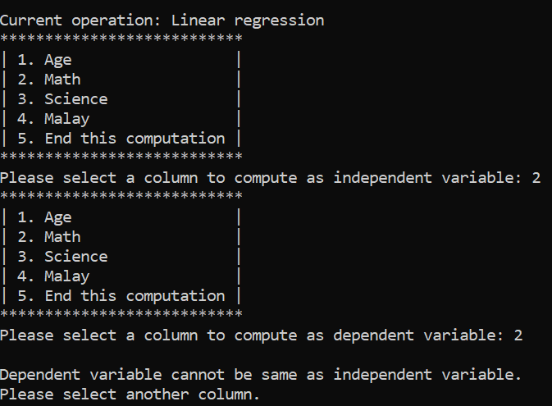

* If the text file or html file cannot be created (due to space or permission issue), error is also prompted

Conclusion

In our program, Basic Data Analysis Application, we used C++ as the programming language. The main tasks done are analysing data in a file, printing results and generating reports. Through the implementation of program, we have learned a lot of things. Firstly, our program is designed to automatically read data from a csv file. We had opportunity to learn to read the file correctly, manage and compute those data. Other than that, we split our functions into smaller and manageable pieces to be called by multiple functions, so we needed to learn deeply about passing the variables accurately, creating structs and so on.

For the design of menu system, we discuss among the members to come up with the decision on how to arrange the main menu and sub menus. For example, we decided to separate sort data menu from other computation because they are different in functionality. For the real integration of menu, we used multiple loops and conditions to enable the menu to either repeat or back to previous, which provide flexibility to our system. We had to check multiple times in order to ensure the accuracy of function.

Furthermore, we learned a lot from generating reports of HTML and text file. We use HTML and CSS together with C++, so that we can achieve our objectives, which is to format the report nicely. Also, for every computation, we learned to format table by using iomanip library. For example, we test multiple times to ensure that the formatting suits.

In overall, we learned the importance of team work in writing a program. We divide works so that we managed to finish this project within a given period. We gained some experience from this project so that we are able to applicate what we have learned and link to a more improved work in future. Some improvement that we could have been done includes adding the function of sign in and log in, which enables only authorised people to use the system. In future, we could also build graphical user interface for C++ program in order to improve the interface.