Advanced Data Analysis and Visualization in Logistics
Week 3 Task Report
Exploratory analysis of a simulated dataset of 2,000 shipments using Python (pandas, NumPy, SciPy, matplotlib, seaborn)
November 2026

Contents

1. Executive Summary
This report analyses 2,000 simulated shipments moved during 2025 across four transport modes (road, rail, air, sea), five regions and four carriers. The goal is to show how exploratory data analysis (EDA) and well-chosen visualizations expose operational efficiency, cost drivers and bottlenecks that summary averages alone would hide.
Headline findings
- Overall on-time delivery is 83.8%, but this hides a sharp seasonal gap: 58.2% in the peak quarter (Oct–Dec) versus 92.2% for the rest of the year (Welch t-test, p < 0.001).
- Distance is the dominant driver of transit time (r = 0.83), but only a moderate driver of cost (r = 0.36); the transport mode matters more for cost than distance does.
- Air freight costs roughly 17× more per kg than road (median $19.78/kg vs $1.13/kg), and is the main source of cost outliers.
- A single lane is a clear bottleneck: Road shipments to the East region have only 56.8% on-time delivery versus 86–91% on other road lanes.
- Carrier differences are statistically detectable (ANOVA p = 0.006) but small in practical terms (82–85% on-time), so mode and region matter far more than carrier choice.

2. Data Simulation and Structure
Because real operational data was not available, a hypothetical dataset was generated with NumPy using a fixed random seed (42) so that results are reproducible. Relationships were deliberately built in to mirror real logistics behaviour: transit time grows with distance and varies by mode speed and handling time; costs depend on distance, mode rate and weight; the last quarter has a peak-season surcharge and slowdown; and road shipments into the East region suffer extra delays (e.g. congestion). A few missing values and cost outliers were injected to practise data cleaning.
Variable | Type | Description
shipment_id | Identifier | Unique shipment code (SH00000–SH01999)
ship_date | Date | Dispatch date in 2025
mode | Categorical | Road, Rail, Air or Sea
region | Categorical | Destination region: North, South, East, West, Central
carrier | Categorical | FastTrans, QuickMove, SafeHaul, EcoShip
distance_km | Numeric | Route distance in kilometres
weight_kg / volume_m3 | Numeric | Shipment weight and volume
promised_hours | Numeric | Delivery time promised to the customer (SLA)
transit_hours | Numeric | Actual transit time
delay_hours | Numeric | transit − promised (positive = late)
cost_usd | Numeric | Total transportation cost
on_time | Binary | 1 if delay_hours ≤ 0
cost_per_kg, cost_per_km | Derived | Unit-cost KPIs

Simulation code (excerpt)
import numpy as np, pandas as pd
np.random.seed(42)
N = 2000

modes = np.random.choice(["Road","Rail","Air","Sea"], N, p=[0.55,0.15,0.12,0.18])
regions = np.random.choice(["North","South","East","West","Central"], N)
dates = pd.to_datetime("2025-01-01") + pd.to_timedelta(np.random.randint(0,365,N), unit="D")

speed = {"Road":55, "Rail":40, "Air":600, "Sea":25} # km/h
handling = {"Road":4, "Rail":12, "Air":8, "Sea":36} # hours
rate = {"Road":0.9,"Rail":0.5,"Air":4.5, "Sea":0.25} # $/km

base_hours = distance / np.vectorize(speed.get)(modes)
transit = base_hours + np.vectorize(handling.get)(modes)
transit = transit * (1 + 0.25*peak) + np.random.gamma(2, 2, N) # Q4 peak slowdown
transit = transit * np.where((regions=="East") & (modes=="Road"), 1.2, 1.0) # lane bottleneck

cost = distance*np.vectorize(rate.get)(modes)*(0.6 + weight/1500) + 50 \
+ 120*peak*np.random.uniform(0.5,1.5,N) + np.random.normal(0,60,N)

3. Exploratory Data Analysis

3.1 Data quality checks
The dataset has 2000 rows and 16 columns. 25 weight values (1.25%) were missing; they were imputed with the median weight of the same transport mode, which is robust to the strong right skew in weights. Five cost values were inflated fourfold to simulate data-entry errors. The IQR rule flags 263 shipments as high-cost outliers (13%), but most of these are legitimate air shipments rather than errors, so they were retained and a log scale was used for plotting instead of deleting them.
df = pd.read_csv("logistics_data.csv", parse_dates=["ship_date"])
print(df.shape, df.isna().sum())

# median imputation within transport mode
df["weight_kg"] = df["weight_kg"].fillna(df.groupby("mode")["weight_kg"].transform("median"))

# IQR outlier rule for cost
q1, q3 = df.cost_usd.quantile([.25, .75]); iqr = q3 - q1
outliers = (df.cost_usd > q3 + 1.5*iqr).sum()

3.2 Central tendency and dispersion
Variable | Mean | Median | Std dev | Min | Max | Skewness
Distance (km) | 1,383.8 | 951.2 | 1,309.9 | 21.7 | 5,980 | 1.59
Weight (kg) | 686.7 | 498.4 | 647.6 | 19.1 | 5,900 | 3.01
Volume (m³) | 3.8 | 2.7 | 3.8 | 0.1 | 38 | 3.35
Transit (h) | 53.0 | 24.9 | 67.2 | 5.7 | 350 | 2.16
Delay (h) | -8.8 | -4.7 | 14.1 | -68.1 | 13 | -2.29
Cost (USD) | 1,991.4 | 719.7 | 4,103.6 | 30.0 | 46,420 | 4.29

Every variable has a mean well above its median and positive skewness (except delay, which is negative because most shipments arrive early). Mean cost is $1,991 against a median of only $720, so the average is pulled up by a small number of expensive air shipments; the median is the more honest "typical" cost. The same pattern holds for transit time (mean 53.0 h vs median 24.9 h), driven by slow sea freight.

3.3 Performance by transport mode
Mode | Shipments | Avg transit (h) | Avg cost (USD) | Median cost/kg | On-time %
Air | 243 | 16.6 | 11,212 | $19.78 | 85.0%
Rail | 316 | 46.9 | 659 | $1.23 | 91.0%
Road | 1,089 | 20.6 | 658 | $1.13 | 83.0%
Sea | 352 | 183.8 | 947 | $1.67 | 80.0%

Road carries 54% of shipments at the lowest cost per kg. Air is the fastest but costs about 17 times more per kg. Sea has the longest transit and the lowest on-time rate (80%), while rail is the most reliable (91%).

3.4 Correlation analysis
Pearson correlations were computed on the numeric variables (see Figure 4). Key results: distance–transit r = 0.83; weight–volume r = 0.96; distance–cost r = 0.36; weight–cost r = 0.17. A simple linear regression of cost on distance gives a slope of $1.125/km but an R² of only 0.129, confirming that distance alone explains just 13% of cost variance and that mode must be included in any cost model.
num = ["distance_km","weight_kg","volume_m3","transit_hours","delay_hours","cost_usd"]
desc = df[num].describe().T
desc["median"] = df[num].median(); desc["skew"] = df[num].skew()

corr = df[num + ["cost_per_kg"]].corr()

from scipy import stats
slope, intercept, r, p, se = stats.linregress(df.distance_km, df.cost_usd)
print("R² =", r**2)

# peak vs off-peak delay (Welch t-test) and carrier comparison (ANOVA)
peak = df[df.month.isin([10,11,12])]; off = df[~df.month.isin([10,11,12])]
t, p = stats.ttest_ind(peak.delay_hours, off.delay_hours, equal_var=False)
F, p_anova = stats.f_oneway(*[g.delay_hours for _, g in df.groupby("carrier")])

4. Visualizations, Justification and Interpretation
Eight visualizations were produced. Each subsection states why that chart type was chosen, shows the code, and interprets the result.

4.1 Histogram with KDE: transit-time distribution
Why this chart: A histogram shows the full shape of a continuous variable, and the density curve smooths it. Marking mean and median makes skewness visible, which matters because averages are misleading for lead-time planning.
sns.histplot(df.transit_hours.clip(upper=df.transit_hours.quantile(.98)), bins=40, kde=True)
plt.axvline(df.transit_hours.mean(), color="red", ls="--", label="Mean")
plt.axvline(df.transit_hours.median(), color="green", ls="--", label="Median")

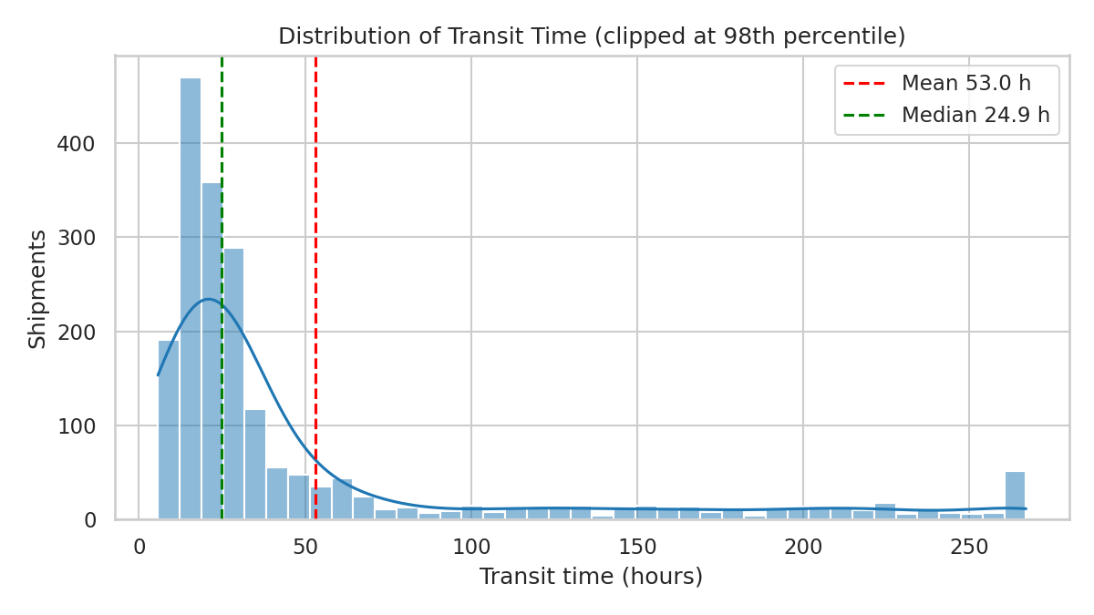
Figure 1: Distribution of transit time
Interpretation: The distribution is multi-modal and right-skewed: a large cluster below 30 hours (road and air) and a long tail from rail and sea. The mean (53.0 h) sits far to the right of the median (24.9 h). The peaks correspond to different modes, which signals that a single network-wide lead-time target is not meaningful; targets should be set per mode.

4.2 Box plot: cost by transport mode
Why this chart: Box plots compare the median, spread and outliers across categories in one view. A log scale is needed because air costs are an order of magnitude above the other modes.
sns.boxplot(data=df, x="mode", y="cost_usd", order=["Road","Rail","Air","Sea"])
plt.yscale("log")

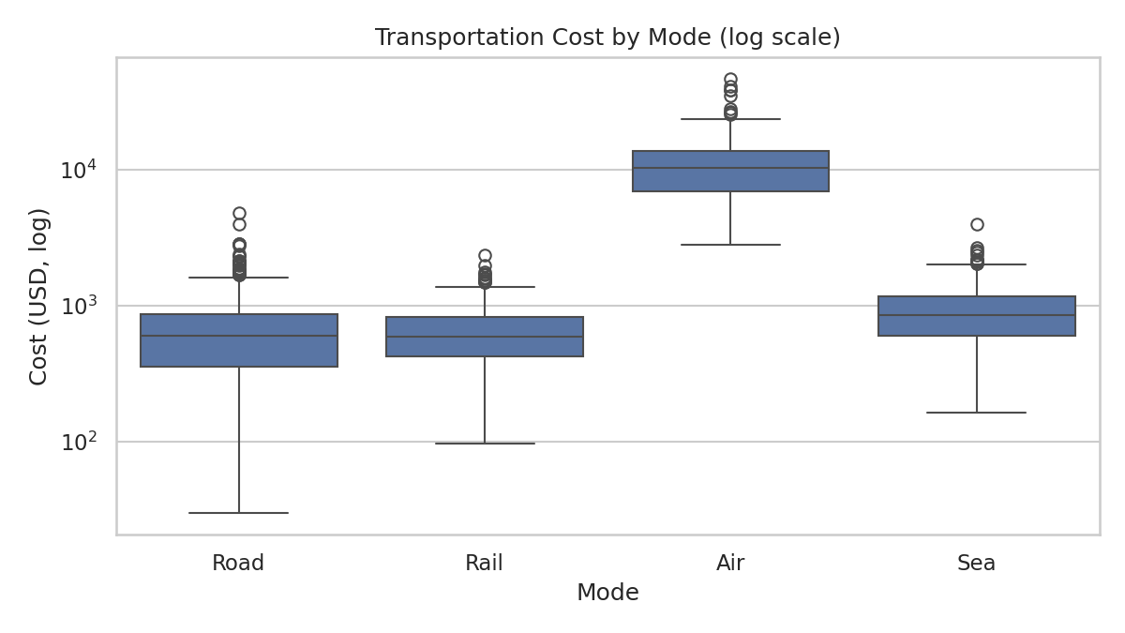
Figure 2: Transportation cost by mode (log scale)
Interpretation: Air has a median cost many times higher than the others and the widest spread. Road and rail overlap heavily, with similar average costs (about $658), while sea sits slightly higher because of its long distances. The numerous points above the whiskers for road and rail are mostly long-distance or heavy shipments plus the peak-season surcharge. The finding is that mode selection is the primary cost lever.

4.3 Scatter plot: distance vs cost, coloured by mode
Why this chart: A scatter plot reveals the form of a relationship between two numeric variables, and colouring by mode adds a third dimension that separates distinct cost structures.
sns.scatterplot(data=df[df.cost_usd < df.cost_usd.quantile(.995)],
x="distance_km", y="cost_usd", hue="mode", alpha=.5, s=18)

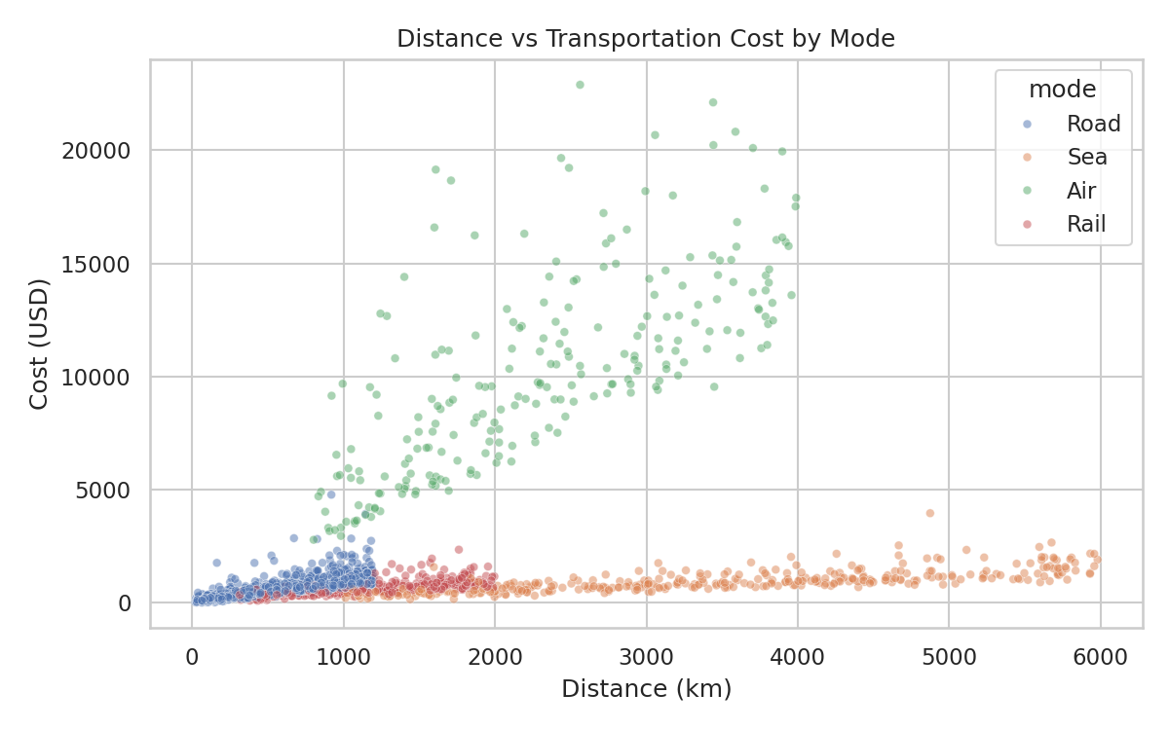
Figure 3: Distance vs cost by mode
Interpretation: Cost rises roughly linearly with distance within each mode, but each mode has its own slope: air is steepest, sea and rail are the flattest. This explains the weak overall correlation (r = 0.36): pooling all modes mixes four different cost structures. Any cost-estimation model should be built per mode.

4.4 Correlation heatmap
Why this chart: A heatmap summarises all pairwise correlations at once, so redundant variables and likely drivers can be spotted quickly.
sns.heatmap(corr, annot=True, fmt=".2f", cmap="coolwarm", center=0, square=True)

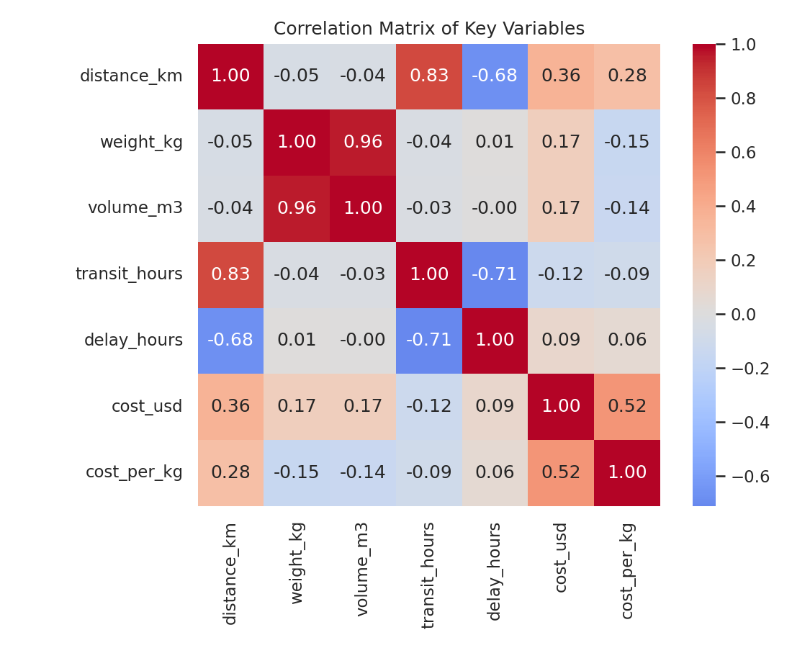
Figure 4: Correlation matrix
Interpretation: Distance and transit time are strongly correlated (0.83), and weight and volume are almost collinear (0.96), so only one of the two should be used in a predictive model to avoid multicollinearity. Delay is only weakly related to cost (0.09), which means that paying more per shipment does not by itself buy better punctuality.

4.5 Dual-axis chart: monthly volume and on-time rate
Why this chart: A time-series view is needed to detect seasonality. Bars show shipment count and a line shows on-time performance so that demand and service level can be read together.
mon = df.groupby("month").agg(ship=("shipment_id","count"), ot=("on_time","mean")).reset_index()
ax.bar(mon.month, mon.ship)
ax2 = ax.twinx(); ax2.plot(mon.month, mon.ot*100, color="crimson", marker="o")

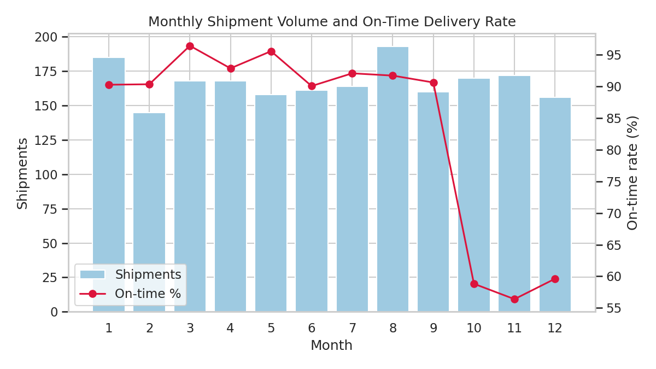
Figure 5: Monthly volume and on-time delivery rate
Interpretation: On-time performance is stable (about 90–96%) from January to September and collapses in October–December. The quarter average falls to 58.2% from 92.2%, and the mean delay moves from -11.6 h (early) to -0.2 h (on the limit). A Welch t-test confirms the difference is highly significant (t = 27.2, p < 0.001). Shipment volume itself is roughly flat, so the deterioration reflects reduced capacity and slower handling, not simply more demand.

4.6 Heatmap: on-time rate by region and mode
Why this chart: A two-way pivot heatmap with a diverging red–green scale helps to locate bottlenecks in the region × mode grid that single-variable charts would hide.
pv = df.pivot_table(index="region", columns="mode", values="on_time", aggfunc="mean")*100
sns.heatmap(pv, annot=True, fmt=".0f", cmap="RdYlGn", vmin=40, vmax=100)

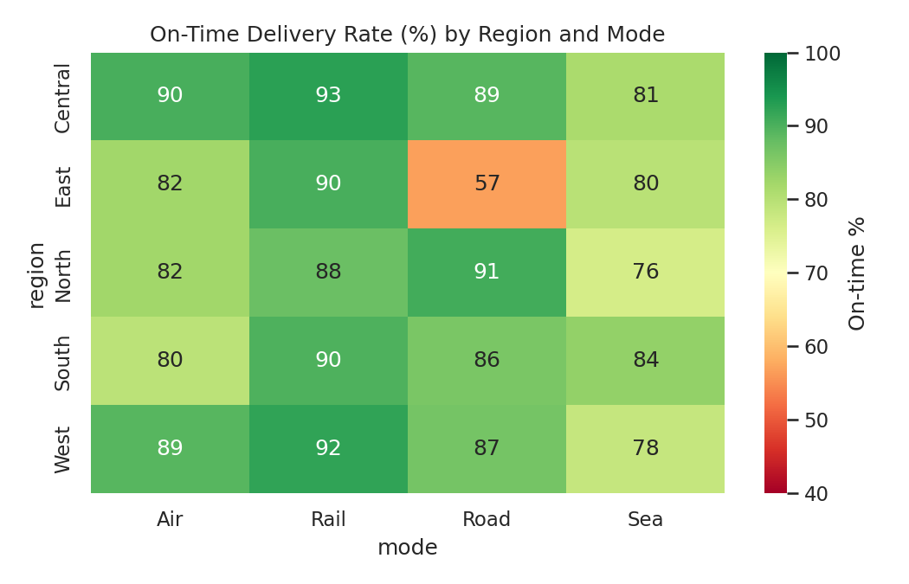
Figure 6: On-time delivery rate by region and mode
Interpretation: One cell stands out: Road–East at 56.8%, more than 25 percentage points below the other road lanes (86–91%). Since road accounts for over half of all shipments, this lane has a large effect on the network. Sea performance is moderately weak everywhere (76–84%).

4.7 Bar charts: carrier comparison
Why this chart: Side-by-side bars are the simplest way to compare a small number of categories on service (on-time %) and cost, helping to judge value for money.
cs = df.groupby("carrier").agg(ot=("on_time","mean"), cost=("cost_usd","mean")).reset_index()
sns.barplot(data=cs, x="carrier", y=cs.ot*100) # service
sns.barplot(data=cs, x="carrier", y="cost") # cost

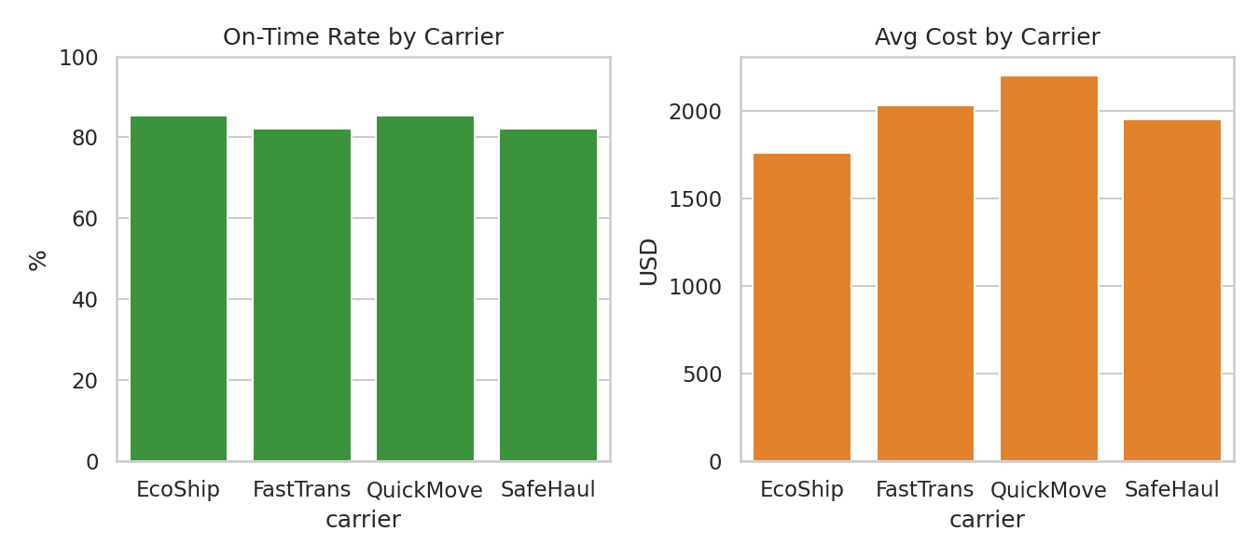
Figure 7: On-time rate and average cost by carrier
Interpretation: EcoShip combines the lowest average cost ($1,761) with the best on-time rate (85.3%), while QuickMove is equally punctual but the most expensive ($2,203). FastTrans and SafeHaul are the weakest on punctuality (about 82%). The differences are statistically significant (ANOVA p = 0.006) but small, and the average costs partly reflect each carrier's mode mix because shipments were assigned randomly, so carrier decisions should follow like-for-like lane comparisons.

4.8 Violin plot: delay distribution by mode
Why this chart: A violin plot combines a box plot with a density estimate, showing the full distribution of delay, including where most shipments fall relative to the SLA (0 line).
sns.violinplot(data=df, x="mode", y="delay_hours", order=["Road","Rail","Air","Sea"],
inner="quartile", cut=0)
plt.axhline(0, color="k", ls="--")

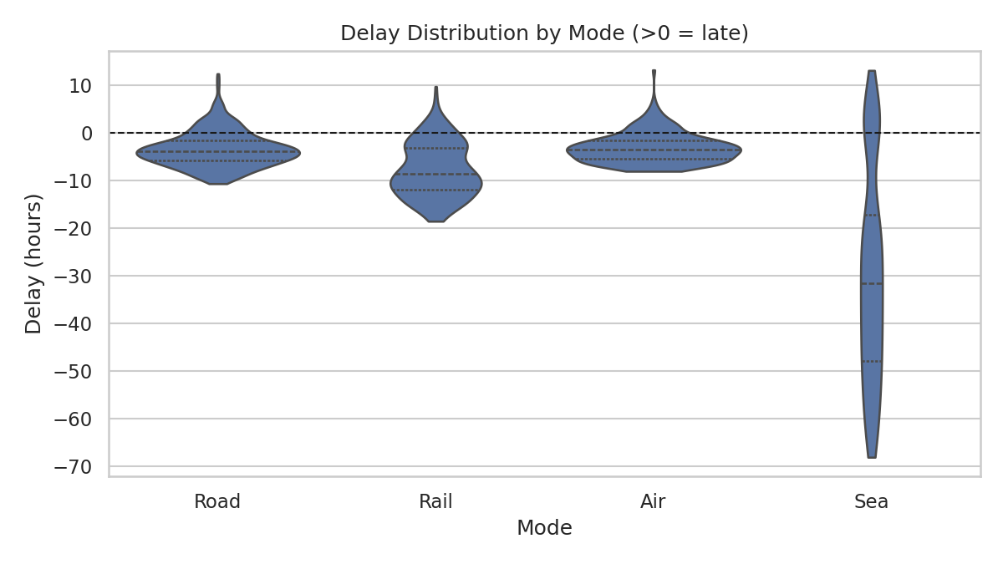
Figure 8: Delay distribution by mode
Interpretation: Most shipments finish before their promised time (negative delay), and every mode has a tail reaching or crossing the zero line. Air and road are tightly clustered just below zero (median about -3 to -4 h), so small disturbances such as the East-region and peak-season effects push them over the SLA. Sea has by far the widest spread (median about -32 h, standard deviation about 22 h): it usually has a very large buffer, yet still misses about 20% of its promises, which points to inconsistent port handling and variable promised times rather than uniformly slow transit.

5. Analytical Insights

5.1 Operational efficiency
- Road delivers 54% of volume at the lowest cost per kg and a good 83% on-time rate; it is the network backbone, and its performance in one region (East) is the largest single drag on service.
- Rail is the most reliable mode (91% on-time) and cost-competitive, but only handles 16% of shipments, a potential for modal shift on long, non-urgent lanes.
- Seasonality is the largest efficiency problem: a 34-point on-time drop in Q4 without a change in volume.

5.2 Cost drivers
- Mode is the dominant cost driver: air costs ~17× more per kg than road. Distance explains only 13% of cost variance when modes are pooled.
- Weight has a modest effect (r = 0.17) and is nearly collinear with volume.
- The peak season barely changes average cost ($2,011 vs $1,985), so the company pays roughly the same price for much worse service in Q4.

5.3 Bottlenecks
- Road to the East region (56.8% on-time) is a clear lane-level bottleneck.
- Q4 peak season, with 58.2% on-time across the network.
- Sea freight: the slowest mode with the lowest on-time rate (80%), likely due to port handling (36 h modelled) and over-promised SLAs.

6. Recommendations
# | Recommendation | Rationale / expected impact
1 | Investigate the Road–East lane: check routing, congestion windows, driver hours and consider adding a second carrier or a rail leg. | Fixing this one lane to the 86–91% level of other road lanes would lift network on-time by about 3 points.
2 | Build a peak-season plan: pre-book capacity from September, add buffer stock, and set peak-specific SLAs. | On-time falls from 92% to 58% in Q4 with no cost saving; capacity planning targets the biggest service gap.
3 | Shift suitable long-distance, non-urgent shipments from road/air to rail. | Rail is the most reliable mode and its cost per kg is close to road and far below air.
4 | Reserve air freight for genuinely urgent or high-value goods via an approval rule. | Air is ~17× the cost per kg and drives most of the high-cost outliers.
5 | Recalibrate SLAs per mode (especially sea) and track on-time by lane, not network average. | Single averages hide bottlenecks; sea misses 20% of overly optimistic promises.
6 | Use per-mode cost models (not one pooled regression) for quoting and budgeting; drop one of weight/volume in models. | Pooled R² is only 0.13; weight and volume are collinear (r = 0.96).
7 | Compare carriers on matched lanes before reallocating volume. | Carrier effects are small, and mode and region dominate.

7. Methodology Summary and Limitations
The workflow was: (1) simulate a structured dataset with realistic relationships; (2) clean it (imputation, outlier review); (3) compute descriptive statistics, correlations, a regression, a t-test and an ANOVA; (4) visualize with matplotlib and seaborn, choosing each chart type to suit the question; (5) translate patterns into operational recommendations.
Limitations: the data is synthetic, so the effects found (such as the East-road bottleneck and Q4 slowdown) were built into the simulation and the analysis shows that they can be recovered, not that they exist in real networks. Correlation does not imply causation, shipments were assigned to carriers at random (real assignment is not random), and the analysis does not include variables such as weather, fuel price or customer type. In a real project, the same code could be applied to ERP/TMS exports. Interactive plotly dashboards would be a natural extension for operational use.

Appendix: Complete Python Script
The full script is below. It generates the dataset, performs the EDA and creates all eight figures. Run with: python analysis.py (requires pandas, numpy, scipy, matplotlib, seaborn).
import numpy as np, pandas as pd, matplotlib
matplotlib.use("Agg")
import matplotlib.pyplot as plt, seaborn as sns, json
from scipy import stats

np.random.seed(42)
N = 2000
sns.set_theme(style="whitegrid", palette="deep")

# ---------- 1. DATA SIMULATION ----------
modes = np.random.choice(["Road","Rail","Air","Sea"], N, p=[0.55,0.15,0.12,0.18])
regions = np.random.choice(["North","South","East","West","Central"], N, p=[0.2,0.22,0.18,0.2,0.2])
carriers = np.random.choice(["FastTrans","QuickMove","SafeHaul","EcoShip"], N)
dates = pd.to_datetime("2025-01-01") + pd.to_timedelta(np.random.randint(0,365,N), unit="D")
distance = np.where(modes=="Air", np.random.uniform(800,4000,N),
np.where(modes=="Sea", np.random.uniform(1000,6000,N),
np.where(modes=="Rail", np.random.uniform(300,2000,N), np.random.uniform(20,1200,N))))
weight = np.random.lognormal(6.2, 0.8, N).round(1) # kg
volume = (weight/np.random.uniform(120,250,N)).round(2) # m3
speed = {"Road":55,"Rail":40,"Air":600,"Sea":25}
base_hours = distance/np.vectorize(speed.get)(modes)
handling = {"Road":4,"Rail":12,"Air":8,"Sea":36}
transit = base_hours + np.vectorize(handling.get)(modes)
month = dates.month.values
peak = np.isin(month,[10,11,12]).astype(int)
transit = transit*(1+0.25*peak) + np.random.gamma(2,2,N)
# weather/congestion: heavier delays for Road in East region
transit = transit*np.where((regions=="East")&(modes=="Road"),1.2,1.0)
transit = transit.round(1)
rate = {"Road":0.9,"Rail":0.5,"Air":4.5,"Sea":0.25}
cost = (distance*np.vectorize(rate.get)(modes)*(0.6+weight/1500) + 50 + 120*peak*np.random.uniform(0.5,1.5,N)
+ np.random.normal(0,60,N)).clip(30).round(2)
promised = (base_hours*1.25 + np.vectorize(handling.get)(modes)*1.1 + 6).round(1)
delay = (transit - promised)
on_time = (delay<=0).astype(int)
df = pd.DataFrame(dict(shipment_id=[f"SH{i:05d}" for i in range(N)], ship_date=dates, mode=modes, region=regions,
carrier=carriers, distance_km=distance.round(1), weight_kg=weight, volume_m3=volume,
promised_hours=promised, transit_hours=transit, delay_hours=delay.round(1),
cost_usd=cost, on_time=on_time))
df["cost_per_kg"]=df.cost_usd/df.weight_kg
df["cost_per_km"]=df.cost_usd/df.distance_km
df["month"]=df.ship_date.dt.month
# inject a few missing values & outliers for realism
df.loc[np.random.choice(N,25,replace=False),"weight_kg"]=np.nan
df.loc[np.random.choice(N,5,replace=False),"cost_usd"]*=4
df.to_csv("logistics_data.csv",index=False)

out={}
out["shape"]=df.shape
out["missing"]=df.isna().sum()[lambda s:s>0].to_dict()
df["weight_kg"]=df["weight_kg"].fillna(df.groupby("mode")["weight_kg"].transform("median"))
df["cost_per_kg"]=df.cost_usd/df.weight_kg

# ---------- 2. EDA ----------
num=["distance_km","weight_kg","volume_m3","transit_hours","delay_hours","cost_usd"]
desc=df[num].describe().T
desc["median"]=df[num].median(); desc["skew"]=df[num].skew()
desc.round(2).to_csv("desc.csv")
out["desc"]=desc.round(2).reset_index().to_dict("records")
out["on_time_rate"]=round(df.on_time.mean()*100,1)
out["mode_stats"]=df.groupby("mode").agg(shipments=("shipment_id","count"),avg_transit=("transit_hours","mean"),
avg_cost=("cost_usd","mean"),cpk=("cost_per_kg","median"),on_time=("on_time","mean")).round(2).reset_index().to_dict("records")
corr=df[["distance_km","weight_kg","volume_m3","transit_hours","delay_hours","cost_usd","cost_per_kg"]].corr()
out["corr_dist_cost"]=round(corr.loc["distance_km","cost_usd"],2)
out["corr_dist_transit"]=round(corr.loc["distance_km","transit_hours"],2)
out["corr_wt_cost"]=round(corr.loc["weight_kg","cost_usd"],2)
out["corr_wt_vol"]=round(corr.loc["weight_kg","volume_m3"],2)
out["corr_delay_cost"]=round(corr.loc["delay_hours","cost_usd"],2)
# outliers IQR
q1,q3=df.cost_usd.quantile([.25,.75]); iqr=q3-q1
out["cost_outliers"]=int(((df.cost_usd>q3+1.5*iqr)).sum())
# peak vs off-peak
peak_df=df[df.month.isin([10,11,12])]; off=df[~df.month.isin([10,11,12])]
t,p=stats.ttest_ind(peak_df.delay_hours,off.delay_hours,equal_var=False)
out["peak_delay"]=round(peak_df.delay_hours.mean(),1); out["off_delay"]=round(off.delay_hours.mean(),1)
out["peak_ot"]=round(peak_df.on_time.mean()*100,1); out["off_ot"]=round(off.on_time.mean()*100,1)
out["ttest_p"]=float(p); out["ttest_t"]=round(t,2)
out["peak_cost"]=round(peak_df.cost_usd.mean(),1); out["off_cost"]=round(off.cost_usd.mean(),1)
# region x mode
rm=df[df["mode"]=="Road"].groupby("region").agg(ot=("on_time","mean"),delay=("delay_hours","mean")).round(3)
out["road_region"]=rm.reset_index().to_dict("records")
out["carrier"]=df.groupby("carrier").agg(ot=("on_time","mean"),cost=("cost_usd","mean")).round(3).reset_index().to_dict("records")
# ANOVA carriers
out["anova_p"]=float(stats.f_oneway(*[g.delay_hours for _,g in df.groupby("carrier")]).pvalue)
# regression
sl,ic,r,pv,se=stats.linregress(df.distance_km,df.cost_usd)
out["reg"]=dict(slope=round(sl,3),intercept=round(ic,1),r2=round(r**2,3))

# ---------- 3. VISUALS ----------
def save(n): plt.tight_layout(); plt.savefig(f"fig/{n}.png",dpi=150); plt.close()

# F1 histogram+KDE transit
fig,ax=plt.subplots(figsize=(8,4.5))
sns.histplot(df.transit_hours.clip(upper=df.transit_hours.quantile(.98)),bins=40,kde=True,ax=ax,color="#1f77b4")
ax.axvline(df.transit_hours.mean(),color="red",ls="--",label=f"Mean {df.transit_hours.mean():.1f} h")
ax.axvline(df.transit_hours.median(),color="green",ls="--",label=f"Median {df.transit_hours.median():.1f} h")
ax.set(title="Distribution of Transit Time (clipped at 98th percentile)",xlabel="Transit time (hours)",ylabel="Shipments"); ax.legend(); save("f1_hist")

# F2 boxplot cost by mode (log)
fig,ax=plt.subplots(figsize=(8,4.5))
sns.boxplot(data=df,x="mode",y="cost_usd",order=["Road","Rail","Air","Sea"],ax=ax)
ax.set_yscale("log"); ax.set(title="Transportation Cost by Mode (log scale)",xlabel="Mode",ylabel="Cost (USD, log)"); save("f2_box")

# F3 scatter distance vs cost w/ mode
fig,ax=plt.subplots(figsize=(8,5))
sns.scatterplot(data=df[df.cost_usd<df.cost_usd.quantile(.995)],x="distance_km",y="cost_usd",hue="mode",alpha=.5,s=18,ax=ax)
ax.set(title="Distance vs Transportation Cost by Mode",xlabel="Distance (km)",ylabel="Cost (USD)"); save("f3_scatter")

# F4 heatmap
fig,ax=plt.subplots(figsize=(7.5,6))
sns.heatmap(corr,annot=True,fmt=".2f",cmap="coolwarm",center=0,ax=ax,square=True)
ax.set_title("Correlation Matrix of Key Variables"); save("f4_corr")

# F5 monthly trend
mon=df.groupby("month").agg(vol=("weight_kg","sum"),ot=("on_time","mean"),ship=("shipment_id","count")).reset_index()
fig,ax=plt.subplots(figsize=(8,4.5))
ax.bar(mon.month,mon.ship,color="#9ecae1",label="Shipments")
ax.set_xlabel("Month"); ax.set_ylabel("Shipments"); ax.set_xticks(range(1,13))
ax2=ax.twinx(); ax2.plot(mon.month,mon.ot*100,color="crimson",marker="o",label="On-time %"); ax2.set_ylabel("On-time rate (%)"); ax2.grid(False)
ax.set_title("Monthly Shipment Volume and On-Time Delivery Rate")
h1,l1=ax.get_legend_handles_labels(); h2,l2=ax2.get_legend_handles_labels(); ax.legend(h1+h2,l1+l2,loc="lower left"); save("f5_trend")

# F6 heatmap on-time by region x mode
pv=df.pivot_table(index="region",columns="mode",values="on_time",aggfunc="mean")*100
fig,ax=plt.subplots(figsize=(7,4.5))
sns.heatmap(pv,annot=True,fmt=".0f",cmap="RdYlGn",vmin=40,vmax=100,ax=ax,cbar_kws={"label":"On-time %"})
ax.set_title("On-Time Delivery Rate (%) by Region and Mode"); save("f6_heat")
out["ot_pivot"]=pv.round(1).to_dict()

# F7 carrier bars
cs=df.groupby("carrier").agg(ot=("on_time","mean"),cost=("cost_usd","mean")).reset_index()
fig,axs=plt.subplots(1,2,figsize=(9,4))
sns.barplot(data=cs,x="carrier",y=cs.ot*100,ax=axs[0],color="#2ca02c"); axs[0].set(title="On-Time Rate by Carrier",ylabel="%",ylim=(0,100))
sns.barplot(data=cs,x="carrier",y="cost",ax=axs[1],color="#ff7f0e"); axs[1].set(title="Avg Cost by Carrier",ylabel="USD")
save("f7_carrier")

# F8 mode share pie? use bar of cost-per-kg & delay violin
fig,ax=plt.subplots(figsize=(8,4.5))
sns.violinplot(data=df,x="mode",y="delay_hours",order=["Road","Rail","Air","Sea"],ax=ax,inner="quartile",cut=0)
ax.axhline(0,color="k",ls="--",lw=1); ax.set(title="Delay Distribution by Mode (>0 = late)",xlabel="Mode",ylabel="Delay (hours)"); save("f8_violin")

json.dump(out,open("stats.json","w"),indent=1,default=str)
print(json.dumps(out,indent=1,default=str))

