YUVA INTERN | LOGISTICS STRATEGIC PLANNING
Week 3 Task Report
Advanced Data Analysis and Visualization in Logistics
Simulated 1,500-shipment dataset • Exploratory analysis • 11 visualizations • Statistical tests • What-if scenarios • Recommendations
Item | Details
Prepared by | Tanu Kumari Sharma
Programme | Yuva Intern, Logistics Data Analysis
Date | 06 November 2026
Tools | Python 3 (pandas, numpy, scipy, matplotlib, seaborn)
Companion files | logistics_analysis.py (full code), logistics_dataset.csv (simulated data)

1. Executive Summary
This report analyses a simulated year (2025) of 1,500 shipments moving from five warehouses (Delhi, Mumbai, Kolkata, Chennai, Bengaluru) to five destination regions by Road, Rail or Air. The aim is to find out where the network loses time and money and what to do about it. Every figure quoted below is computed by the Python script in Appendix A, so the analysis is fully reproducible.
Headline: The network delivers 71.6% of shipments on time (1,074 of 1,500). The 426 late shipments lost 1,728 hours in total, an average of 4.1 hours per late shipment. Two origin warehouses, a seasonal weather effect and one service-design flaw explain most of it.
- Warehouse bottleneck. Mumbai and Delhi handle 49.8% of shipments but cause 66.6% of delay hours. Average processing is 9.65 h (Mumbai) and 8.23 h (Delhi) against 5.06 to 5.93 h elsewhere; on-time is 60% and 64% against 80% to 82%.
- Monsoon effect. Between July and September on-time falls to 46% (84% in January to June). Road delivery averages 35.0 h in monsoon against 30.6 h otherwise (+4.4 h, p < 0.001).
- Cost concentration. Air is only 13.4% of shipments but 50.8% of freight spend (about ₹49 lakh of ₹97.2 lakh), at ₹141 per kg against ₹25 for Road and ₹19 for Rail.
- Cost drivers. A regression on mode, distance, weight and priority explains 86.3% of cost variation: ₹6.82 per km, ₹1,635 Express premium, Air +₹17,258 and Rail -₹2,253 relative to Road. Sub-100 kg loads cost 12x more per kg (Road) than loads above 1,000 kg.
- Express paradox. Express shipments are on time only 37% of the time (Standard 86%) and are not delivered any faster (32.8 h vs 33.2 h) despite an 18% higher cost. Express is 29.5% of volume but 65% of all late shipments (278 of 426).
- What-if result. Cutting Mumbai and Delhi processing to 5.5 h lifts on-time from 71.6% to 81.3%; adding a Monday-backlog fix takes it to 82.7%. Shifting short-haul Rail to Road gains only 0.3 points for about ₹1.8 lakh extra cost, so it is not recommended.

2. Deliverables Checklist
The table maps every requirement of the Week 3 brief to the place where it is addressed in this document.
Requirement in the brief | Where it is covered
DOC file with detailed analysis, visualization outputs and interpretations | Sections 5 to 9; 11 embedded figures, each followed by a numeric interpretation
Python scripts or pseudocode used to generate the visualizations | Code excerpt under every figure (Section 6) and the complete script in Appendix A; also submitted as logistics_analysis.py
Explanation of how visualizations help interpret logistics performance metrics | Section 7 (KPI to chart mapping and chart-selection logic)
Data simulation: structure and key variables (delivery times, volumes, costs) | Section 4 (design rules, data dictionary, sample rows, quality checks)
EDA: central tendency, distributions, correlations | Section 5 (descriptive statistics, segment summaries, correlations, hypothesis tests)
Multiple visualizations for trends, distributions and relationships, with justification of each | Section 6: 11 charts, each with a “Why this chart” justification
Insights on operational efficiency, cost drivers and bottlenecks | Section 8, supported by the what-if analysis in Section 9
Documentation: methodology, code excerpts, narrative, recommendations | Sections 3, 4, 6 and 10; limitations in Section 11

3. Objective, KPIs and Methodology

3.1 Business context
The hypothetical company is a multi-warehouse distributor serving customers across India. Management wants to know why roughly one shipment in four misses its promised delivery time, what drives freight cost, and which fixes deliver the most improvement for the least effort. The dataset is simulated, but its structure and parameters mimic Indian logistics conditions: congested metro hubs, monsoon disruption, festive-season peaks and a Monday backlog.

3.2 KPIs used
KPI | Definition | Why it matters
On-time rate (%) | Shipments with delivery_time_hrs ≤ sla_hrs ÷ all shipments | Primary service-level measure; 71.6% overall
Delivery time (hrs) | processing_hrs + transit_hrs | Customer-facing speed; analysed with mean, median and P90
Processing time (hrs) | Hours from order release until the vehicle leaves the warehouse | Controllable internal efficiency measure
Transit time (hrs) | Hours on the road, rail or air leg | Depends on mode, distance and weather
Delay hours | max(0, delivery_time_hrs - sla_hrs) | Severity of lateness; used in the Pareto analysis
Cost per shipment / per kg / per km | transport_cost_inr, ÷ shipment_kg, ÷ distance_km | Cost efficiency at different levels

3.3 Methodology
- Simulate a reproducible dataset (random seed 42) with realistic business rules built in (Section 4).
- Validate data quality: missing values, duplicates, ranges, internal consistency.
- Explore with descriptive statistics, segment summaries and correlations (Section 5).
- Test the visible patterns statistically: Welch t-tests, ANOVA, chi-square, Spearman correlation.
- Visualize with 11 charts, each chosen for the question it answers (Section 6).
- Explain cost with an OLS regression and rank bottlenecks with a Pareto analysis (Section 8).
- Simulate scenarios (what-if) to estimate the benefit of each improvement before recommending it (Section 9).
Python tools: pandas (data handling and aggregation), numpy (simulation and regression algebra), scipy.stats (hypothesis tests), matplotlib and seaborn (charts).

4. Data Simulation

4.1 Dataset structure
The dataset has 1,500 rows (one per shipment) dispatched on random days between 1 January and 31 December 2025. Categorical variables describe the lane (warehouse, destination region, mode, priority); numeric variables capture volume, time and cost. Derived columns (delivery time, SLA, delay, on-time flag, cost per kg) are calculated from the base variables.
Variable | Type | Description | Range / values
shipment_id | text | Unique shipment code | SH1000 to SH2499
ship_date, month, day_of_week | date / int / text | Dispatch date and its parts | Jan to Dec 2025
warehouse | category | Origin warehouse | Delhi, Mumbai, Kolkata, Chennai, Bengaluru
dest_region | category | Destination region | North, South, East, West, Central
transport_mode | category | Mode of transport | Road 56.6%, Rail 30.0%, Air 13.4%
priority | category | Service level | Standard 70.5%, Express 29.5%
distance_km | numeric | Route distance | 98 to 3,500 km (median 910)
shipment_kg | numeric | Shipment volume (weight) | 18.2 to 1,893 kg (median 199)
processing_hrs | numeric | Warehouse processing / dwell time | 1.0 to 19.4 h (mean 7.2)
transit_hrs | numeric | Time on the transport leg | 1.0 to 118.6 h (mean 25.8)
delivery_time_hrs | numeric | processing_hrs + transit_hrs | 2.5 to 124.9 h (mean 33.0)
sla_hrs | numeric | Promised delivery time | Depends on distance, mode, priority
delay_hrs, on_time | numeric / 0-1 | Hours beyond SLA; 1 if delivered within SLA | 0 to 23.6 h
transport_cost_inr, cost_per_kg | numeric | Freight cost (₹) and cost per kg | ₹300 to ₹71,885
is_monsoon, monsoon_factor | 0-1 / numeric | Jul to Sep Road/Rail flag and transit multiplier | 1.15 to 1.40

4.2 Business rules built into the simulation
Real logistics data would contain such patterns naturally. In a simulation they have to be written in deliberately; the EDA in the next sections then tries to rediscover them from the numbers alone, which doubles as a validity check of the analysis.
Rule | Parameters used | Real-world reasoning
Mode mix | Road 55%, Rail 30%, Air 15% | Road dominates domestic freight
Distance | Gamma(shape 4, scale 220) km; ×1.2 for Rail, ×1.6 for Air | Air and Rail serve longer hauls
Weight | Lognormal(μ 5.3, σ 0.7) kg | Most parcels are light, a few are very heavy (right skew)
Processing time | Normal by warehouse: Mumbai 9.0, Delhi 7.5, Kolkata 5.5, Chennai 5.0, Bengaluru 4.5 h; σ 1.8 | Big metro hubs are congested
Transit speed | Road 38, Rail 30, Air 450 km/h; noise N(0, 2) h | Effective door-to-door speeds
Monsoon (Jul to Sep) | Road and Rail transit × U(1.15, 1.40) | Flooding and diversions
Festive peak (Oct to Dec) | Processing × U(1.10, 1.30) | Order surge strains warehouses
Monday backlog | +U(1.0, 2.5) h processing on Mondays | Weekend orders released together
Cost | 0.35 × km × rate/km (Road ₹11, Rail ₹7, Air ₹45) + 0.6 × kg × rate/kg (₹2.2, ₹1.5, ₹9.0) + N(0, 400); Express ×1.25; floor ₹300 | Distance, weight, mode and urgency set the price
SLA | (8 h + km ÷ planned speed [Road 40, Rail 32, Air 500]) × 1.25 Standard or × 1.00 Express | Promise = handling budget + planned travel + buffer

4.3 Simulation code (excerpt)
np.random.seed(42) # reproducible results
N = 1500
df = pd.DataFrame({
'shipment_id': [f'SH{1000+i}' for i in range(N)],
'ship_date': pd.to_datetime('2025-01-01') + pd.to_timedelta(np.random.randint(0, 365, N), unit='D'),
'warehouse': np.random.choice(warehouses, N, p=[0.24, 0.26, 0.16, 0.18, 0.16]),
'transport_mode': np.random.choice(modes, N, p=[0.55, 0.30, 0.15]),
'priority': np.random.choice(priorities, N, p=[0.7, 0.3]),
})
df['shipment_kg'] = np.random.lognormal(mean=5.3, sigma=0.7, size=N).round(1).clip(10, 5000)
df['processing_hrs'] = [max(1, np.random.normal(proc_mean[w], 1.8)) for w in df.warehouse]
df['delivery_time_hrs'] = (df.processing_hrs + df.transit_hrs).round(1)

4.4 Sample rows
Shipment | Warehouse | Mode | Priority | Km | Kg | Proc h | Transit h | Deliv h | Cost ₹ | On time
SH1000 | Mumbai | Rail | Express | 1044.0 | 336.4 | 8.0 | 34.3 | 42.3 | 3,580 | 0
SH1001 | Bengaluru | Road | Standard | 563.0 | 81.3 | 6.0 | 15.2 | 21.2 | 1,821 | 1
SH1002 | Delhi | Road | Standard | 825.0 | 160.3 | 6.2 | 28.1 | 34.3 | 3,524 | 1
SH1003 | Delhi | Road | Standard | 1014.0 | 202.8 | 9.0 | 28.9 | 37.9 | 4,624 | 1
SH1004 | Delhi | Rail | Express | 401.0 | 149.7 | 6.0 | 15.7 | 21.7 | 1,474 | 0

4.5 Data quality checks
Check | Result | Action
Rows and columns | 1,500 rows, 20 columns | None
Missing values | 0 | None needed
Duplicate shipment IDs | 0 | None needed
Plausible ranges | Distance 98 to 3,500 km; weight 18 to 1,893 kg; processing ≥ 1 h; transit ≥ 1 h | Clipped at simulation stage
Internal consistency | delivery_time_hrs = processing_hrs + transit_hrs for every row | None
Cost outliers (IQR rule, fence ₹10,636) | 189 shipments (12.6%), of which 185 are Air | Kept: genuine high-value air freight, not data errors; analysed by mode instead

5. Exploratory Data Analysis

5.1 Central tendency and spread
The mode of a continuous variable is not meaningful on raw values, so the table reports the modal bin: the midpoint of the tallest of 30 histogram bins.
Variable | Mean | Median | Modal bin | Std dev | Min | Max | Skew
Distance (km) | 1003.67 | 909.50 | 721.70 | 540.26 | 98.00 | 3500.00 | 1.20
Weight (kg) | 251.48 | 199.00 | 111.96 | 192.18 | 18.20 | 1893.40 | 2.32
Processing (h) | 7.21 | 7.00 | 5.60 | 2.76 | 1.00 | 19.40 | 0.24
Transit (h) | 25.83 | 23.40 | 2.96 | 18.09 | 1.00 | 118.60 | 1.11
Delivery time (h) | 33.03 | 30.25 | 29.02 | 18.32 | 2.50 | 124.90 | 1.04
Cost (₹) | 6481.82 | 3708.50 | 3879.25 | 8602.36 | 300.00 | 71885.00 | 3.29
Cost per kg (₹) | 38.80 | 18.50 | 18.24 | 65.72 | 0.98 | 1036.63 | 6.44
Delay (h) | 1.15 | 0.00 | 0.39 | 2.64 | 0.00 | 23.60 | 3.11

How to read it:
- Cost is heavily right-skewed (skew 3.29). The mean (₹6,482) is 75% above the median (₹3,709), so “average cost” overstates what a typical shipment costs. A minority of Air shipments pulls the mean up.
- Delivery time is moderately skewed (1.04). The median is 30.25 h but 1 shipment in 10 takes longer than 56.5 h (2.4 days) and 1 in 20 longer than 66.5 h. Quartiles: P25 19.8 h, P75 42.6 h.
- Processing time is almost symmetric (skew 0.24, mean 7.21 ≈ median 7.00). It looks stable at network level, yet that hides a warehouse split: the share of shipments taking over 10 h is 39.1% in Mumbai, 17.4% in Delhi and under 4% elsewhere.
- Delay hours are zero-inflated. The median is 0 and the mean 1.15 h, so the mean is a poor summary. On-time rate (71.6%) and the average miss of late shipments (4.06 h; median 3.2 h; maximum 23.6 h) describe it better.
- Weight is right-skewed (2.32): median 199 kg, but a few shipments exceed 1,000 kg.

5.2 Segment summaries
By transport mode
Mode | Shipments | Avg delivery (h) | Avg cost (₹) | Cost per kg (₹) | On-time
Road | 849 | 31.7 | 3,991 | 24.96 | 73%
Rail | 450 | 45.7 | 3,094 | 19.13 | 68%
Air | 201 | 10.3 | 24,588 | 141.28 | 75%

By origin warehouse
Warehouse | Shipments | Avg processing (h) | Avg delivery (h) | On-time
Mumbai | 368 | 9.65 | 36.03 | 60%
Delhi | 379 | 8.23 | 33.17 | 64%
Kolkata | 260 | 5.93 | 31.72 | 80%
Chennai | 267 | 5.44 | 30.96 | 81%
Bengaluru | 226 | 5.06 | 31.86 | 82%

By service level, season and destination region
Segment | Shipments | Avg delivery (h) | Avg processing (h) | On-time | Note
Standard | 1,058 | 33.15 | - | 86% | Avg cost ₹6,154
Express | 442 | 32.75 | - | 37% | Avg cost ₹7,267 (+18%)
Jan-Jun (normal) | 753 | 31.1 | 6.8 | 84%
Jul-Sep (monsoon) | 370 | 36.8 | 7.0 | 46%
Oct-Dec (festive) | 377 | 33.1 | 8.2 | 72%
Central region | 300 | 32.5 | - | 69%
East region | 306 | 33.8 | - | 71%
North region | 311 | 31.6 | - | 74%
South region | 289 | 33.9 | - | 72%
West region | 294 | 33.6 | - | 71%

Reading: Destination region is a weak driver: delivery time varies only between 31.6 h (North) and 33.9 h (South) and on-time between 69% and 74%. By contrast on-time varies by 22 points across warehouses and by 38 points across seasons (84% vs 46%). Origin and season matter; destination does not.

5.3 Correlations
Pair | Pearson r | Interpretation
Transit time vs delivery time | 0.99 | Transit dominates total time; processing adds a roughly constant offset
Distance vs cost (all shipments) | 0.60 | Moderate overall because the three modes have different slopes
Distance vs cost within mode | Air 0.97, Road 0.94, Rail 0.93 | Almost perfectly linear once mode is controlled; Spearman gives identical values, so outliers are not driving it
Cost vs transit time | -0.27 | Misleading sign: Air is fast and expensive, so mixing modes creates a negative relation (a Simpson-type effect)
Processing time vs delay hours | 0.26 | The strongest controllable correlate of lateness
Distance vs delay hours | 0.09 | SLA already scales with distance; long trips are not more often late
Weight vs cost / time | 0.06 / 0.04 | Weak linearly; weight matters mainly through cost per kg (Figure 8) and has a small but significant regression effect

Why this matters: A manager reading only the overall correlation table might conclude “faster transport lowers cost”. The within-mode view shows the opposite relationship at the level where decisions are made. Always segment before concluding.

5.4 Hypothesis tests
Visible patterns can be chance. Because the data are simulated with 1,500 rows, p-values are extremely small, so the effect size is the more important column.
Question | Test | Result | Conclusion
Is Mumbai processing slower than Bengaluru? | Welch t-test | t = 26.23, p < 0.001; 9.65 h vs 5.06 h | Yes, by 4.6 h (about 90% longer)
Do the five warehouses differ in processing time? | One-way ANOVA | F = 281.3, p < 0.001 | Yes, strongly
Is Road slower in the monsoon? | Welch t-test | t = 3.92, p = 0.0001; 35.0 h vs 30.6 h | Yes, +4.4 h (+14%)
Is on-time rate related to priority? | Chi-square | χ² = 364.3, p < 0.001; 37% vs 86% | Yes, Express is far less reliable
Is distance-cost relation robust to outliers? | Spearman | ρ = 0.97 Air, 0.94 Road, 0.93 Rail | Yes, monotonic and strong

from scipy import stats
t, p = stats.ttest_ind(df[df.warehouse=='Mumbai'].processing_hrs,
df[df.warehouse=='Bengaluru'].processing_hrs, equal_var=False) # Welch
F, p = stats.f_oneway(*[g.processing_hrs.values for _, g in df.groupby('warehouse')])
chi, p, _, _ = stats.chi2_contingency(pd.crosstab(df.priority, df.on_time))

6. Visualizations: Choice, Code and Interpretation
Eleven charts follow, grouped by the question they answer: distributions (Figures 1, 2), relationships (Figures 3, 4, 8), trends (Figures 5, 11), and comparisons and bottlenecks (Figures 6, 7, 9, 10). For each chart the report states why that chart type was chosen, shows the code, reports what it shows with numbers, and draws the operational conclusion.

6.1 Figure 1: Distribution of Delivery Time and Transportation Cost
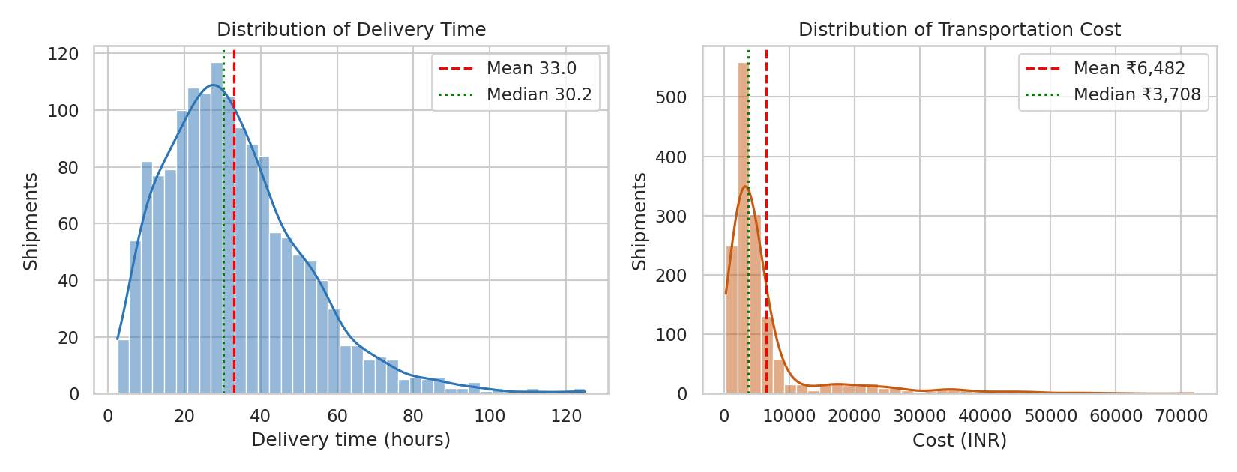
Figure 1. Distribution of Delivery Time and Transportation Cost
Why this chart: A histogram with a KDE curve is the standard way to see the shape of one continuous variable: where most shipments sit, how long the tail is and whether the data are skewed. Drawing the mean and the median as vertical lines turns skewness into something visible: the further apart the two lines, the more an average misleads.
Code:
sns.histplot(df.delivery_time_hrs, bins=40, kde=True, ax=ax[0])
ax[0].axvline(df.delivery_time_hrs.mean(), color='red', ls='--')
ax[0].axvline(df.delivery_time_hrs.median(), color='green', ls=':')
What it shows:
- Delivery time peaks at roughly 29 hours (modal bin) and has a long right tail reaching 124.9 hours. Mean 33.0 h vs median 30.25 h; P90 is 56.5 h and P95 is 66.5 h.
- Transportation cost clusters at about ₹3,900 (modal bin) but runs out to ₹71,885. Mean ₹6,482 is 75% higher than the median ₹3,709.
So what: Promise dates should be set from percentiles (for example P90 = 56.5 h), not from the 33-hour average, which would leave about 4 in 10 shipments (43.5%) late. The cost tail is not random noise; Figure 2 shows it is almost entirely Air freight.

6.2 Figure 2: Delivery Time and Cost by Transport Mode
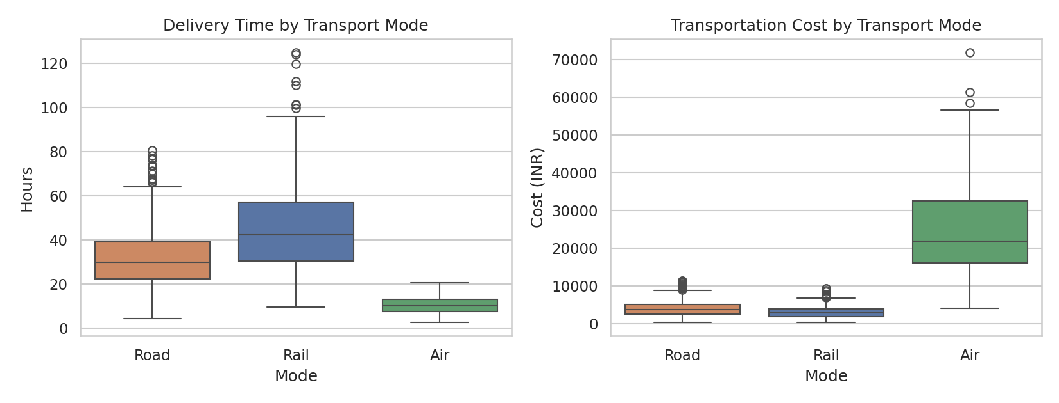
Figure 2. Delivery Time and Cost by Transport Mode
Why this chart: A boxplot compares the median, spread (IQR) and outliers of a numeric variable across categories in one glance. It is ideal for the mode comparison because the question is not only which mode is faster on average but also which one is more predictable.
Code:
sns.boxplot(data=df, x='transport_mode', y='delivery_time_hrs', order=modes, ax=ax[0])
sns.boxplot(data=df, x='transport_mode', y='transport_cost_inr', order=modes, ax=ax[1])
What it shows:
- Air averages 10.3 h with a very tight box; Road averages 31.7 h; Rail is slowest at 45.7 h and has the widest spread.
- Air costs ₹24,588 per shipment on average versus ₹3,991 for Road and ₹3,094 for Rail. 185 of the 189 cost outliers (IQR rule, upper fence ₹10,636) are Air shipments.
So what: Air is 3.1x faster than Road but 6.2x more expensive per shipment (7.4x vs Rail per kg). The speed-versus-cost trade-off is steep, so Air must be used deliberately and not as the default fix for lateness.

6.3 Figure 3: Correlation Matrix of Key Logistics Variables
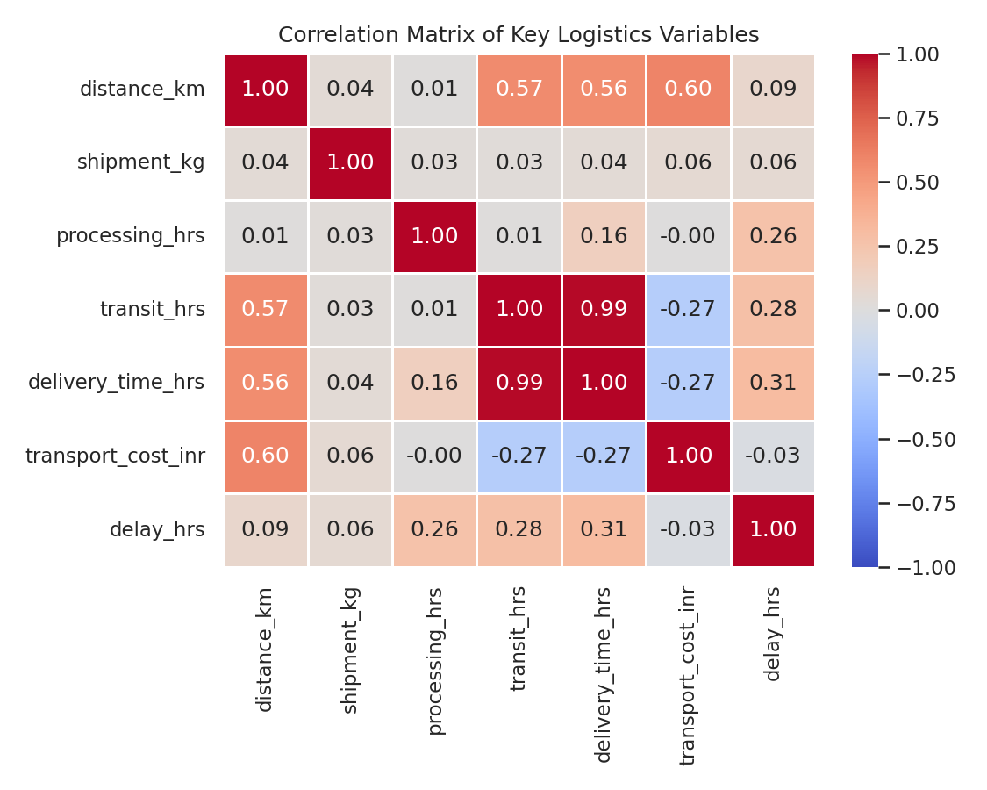
Figure 3. Correlation Matrix of Key Logistics Variables
Why this chart: A correlation heatmap summarises all pairwise linear relationships in a single picture. It quickly shows which variables move together (candidate drivers) and which are redundant. Diverging colours (blue negative, red positive) make strong relationships stand out.
Code:
corr = df[['distance_km','shipment_kg','processing_hrs','transit_hrs',
'delivery_time_hrs','transport_cost_inr','delay_hrs']].corr()
sns.heatmap(corr, annot=True, cmap='coolwarm', vmin=-1, vmax=1, fmt='.2f')
What it shows:
- transit vs delivery time r = 0.99, distance vs cost r = 0.60, distance vs transit r = 0.57. Shipment weight is weakly related to everything (|r| ≤ 0.06).
- delay hours correlate with processing time (0.26) and transit time (0.28) but hardly at all with distance (0.09): the SLA already scales with distance, so long trips are not more often late.
- cost vs transit time is negative (r = -0.27). That looks absurd until you realise Air is fast and expensive: the negative sign is a mode mix effect, not a law of nature.
So what: Lateness is driven by warehouse processing and operating conditions, not by distance. Correlations across the whole network must be re-checked within each mode (see Section 5.3) before drawing conclusions.

6.4 Figure 4: Distance vs Transportation Cost by Mode (bubble size = weight)
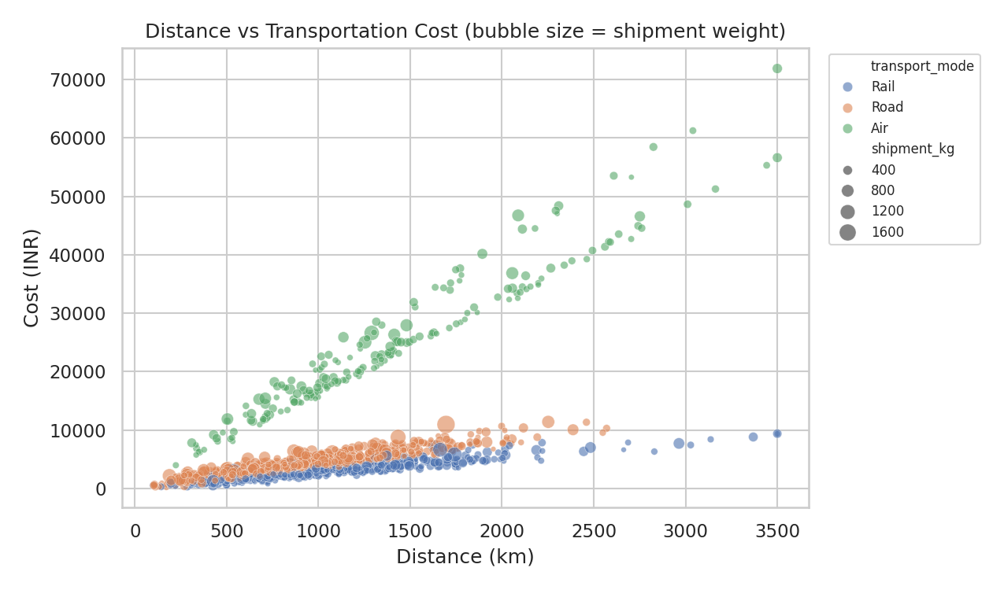
Figure 4. Distance vs Transportation Cost by Mode (bubble size = weight)
Why this chart: A scatter plot is the right tool for the relationship between two numeric variables. Colour (mode) and bubble size (weight) add two more dimensions, so one chart answers: does cost rise with distance, does the slope differ by mode, and does weight matter?
Code:
sns.scatterplot(data=df, x='distance_km', y='transport_cost_inr',
hue='transport_mode', size='shipment_kg', sizes=(10, 120), alpha=.6)
What it shows:
- Three clearly separated bands with different slopes. Within each mode, distance and cost are almost perfectly linear (Pearson r = 0.97 Air, 0.94 Road, 0.93 Rail).
- Average cost per km: Air ₹18.10, Road ₹4.67, Rail ₹2.92. Larger bubbles sit higher inside each band, confirming that weight adds cost.
So what: Cost is highly predictable once mode is known, so a simple quotation and budgeting model is feasible (Section 8.2). Mode choice moves cost far more than distance does.

6.5 Figure 5: Monthly Trend: Average Delivery Time vs On-Time Rate
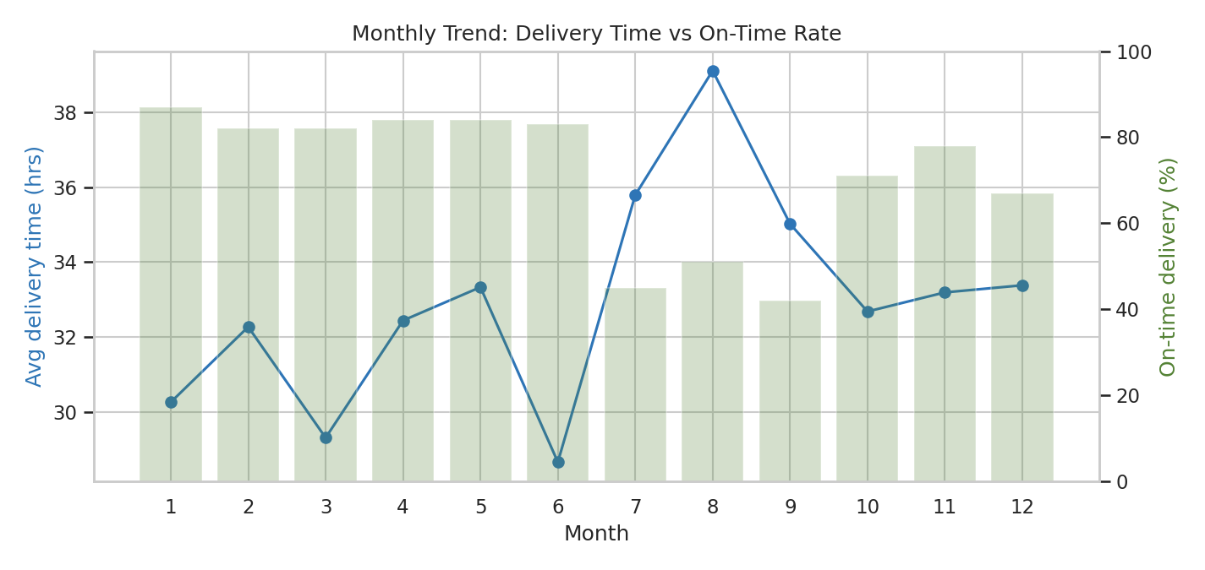
Figure 5. Monthly Trend: Average Delivery Time vs On-Time Rate
Why this chart: A line chart is the natural choice for change over time. Overlaying on-time % as bars on a second axis shows whether speed and reliability move together, and makes seasonality obvious in a way a table of 12 months never does.
Code:
ax1.plot(monthly.index, monthly.avg_delivery, marker='o')
ax2 = ax1.twinx()
ax2.bar(monthly.index, monthly.on_time * 100, alpha=.25)
What it shows:
- January to June: 28.7 to 33.3 h and 82 to 87% on-time. July to September: delivery time rises to 35.8 / 39.1 / 35.0 h and on-time collapses to 45% / 51% / 42%.
- October to December: transit recovers but average processing time jumps to 8.2 to 8.3 h (against 6.6 to 7.0 h in H1) and on-time stays at 71% / 78% / 67%.
So what: There are two different seasonal problems: monsoon is a transit problem (Jul to Sep) and the festive peak is a warehouse-capacity problem (Oct to Dec). They need different fixes.

6.6 Figure 6: Warehouse Processing Time and On-Time Rate
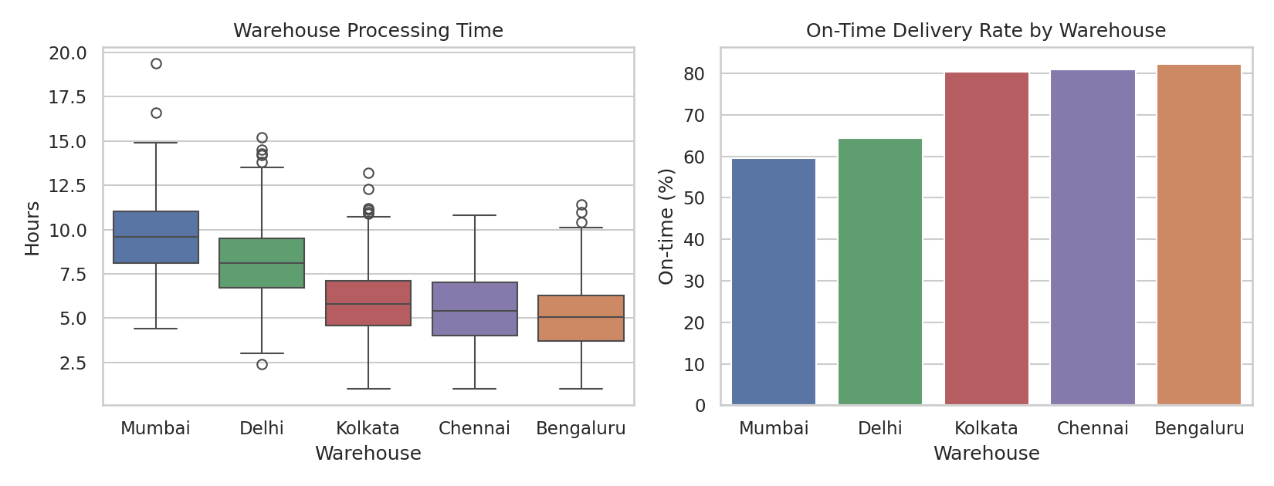
Figure 6. Warehouse Processing Time and On-Time Rate
Why this chart: A boxplot (spread of processing time) next to a bar chart (on-time rate) with the same warehouse order lets the reader link cause to effect directly: slower warehouses should sit under lower bars.
Code:
order = by_wh.sort_values('avg_proc', ascending=False).index
sns.boxplot(data=df, x='warehouse', y='processing_hrs', order=order, ax=ax[0])
sns.barplot(data=df, x='warehouse', y=df.on_time*100, order=order, ax=ax[1], errorbar=None)
What it shows:
- Average processing time: Mumbai 9.65 h, Delhi 8.23 h, Kolkata 5.93 h, Chennai 5.44 h, Bengaluru 5.06 h.
- On-time rate: Mumbai 60%, Delhi 64% against 80% to 82% at the other three. 39.1% of Mumbai shipments and 17.4% of Delhi shipments need more than 10 h to leave the warehouse, versus under 4% elsewhere.
So what: The warehouse is the biggest controllable bottleneck: a 22-point on-time gap (60% vs 82%) between the worst and best origin, confirmed statistically (Welch t = 26.2, p < 0.001, Section 5.4).

6.7 Figure 7: On-Time Delivery % by Warehouse and Mode
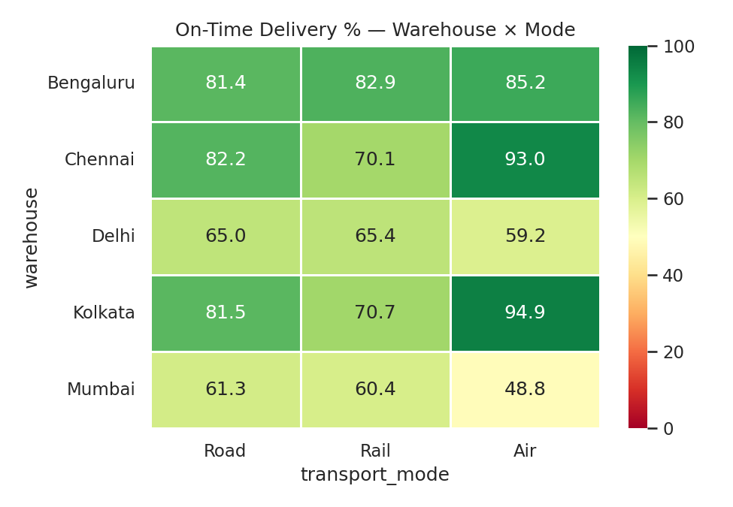
Figure 7. On-Time Delivery % by Warehouse and Mode
Why this chart: A heatmap compares one metric across two categorical dimensions at once. The red-yellow-green scale directs the eye to hotspots without reading 15 numbers one by one.
Code:
pivot = df.pivot_table(index='warehouse', columns='transport_mode',
values='on_time', aggfunc='mean') * 100
sns.heatmap(pivot[modes], annot=True, fmt='.1f', cmap='RdYlGn', vmin=0, vmax=100)
What it shows:
- Air from Kolkata is 94.9% on-time and from Chennai 93.0%, but Air from Mumbai only 48.8% and Delhi 59.2%. The aircraft are equally fast; the difference is on the ground.
- Every Mumbai and Delhi cell is 65.4% or lower. Rail is also weak at otherwise good warehouses (Chennai 70.1%, Kolkata 70.7%), pointing to transit-side variability.
So what: Buying faster transport out of Mumbai or Delhi would not fix the problem; processing time at those hubs must be fixed first.

6.8 Figure 8: Cost per kg by Weight Band and Mode
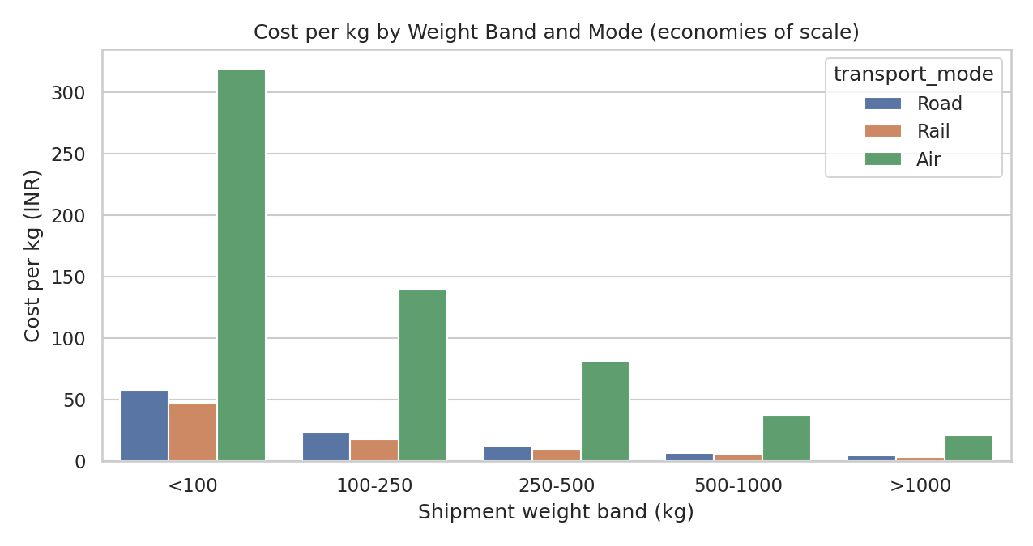
Figure 8. Cost per kg by Weight Band and Mode
Why this chart: A grouped bar chart compares a ratio metric (cost per kg) across two categories. Binning weight shows economies of scale, which a raw scatter of cost against weight hides.
Code:
df['weight_band'] = pd.cut(df.shipment_kg, [0,100,250,500,1000,5000],
labels=['<100','100-250','250-500','500-1000','>1000'])
sns.barplot(data=df, x='weight_band', y='cost_per_kg', hue='transport_mode', errorbar=None)
What it shows:
- Road cost per kg falls from ₹57.8 (under 100 kg) to ₹24.0, ₹12.5, ₹7.0 and ₹4.7 (over 1,000 kg): a 12x difference. Air falls from ₹319 to ₹21 (15x).
- 243 shipments (16.2%) weigh under 100 kg. Only 13 shipments exceed 1,000 kg, so that last bar is indicative only.
So what: Small shipments are expensive per kg. Consolidating them to the 100 to 250 kg cost level would save up to about ₹8.1 lakh (8.4% of total freight spend); this is an upper bound that assumes they can actually be combined.

6.9 Figure 9: Pareto Chart of Delay Hours by Mode | Warehouse Segment
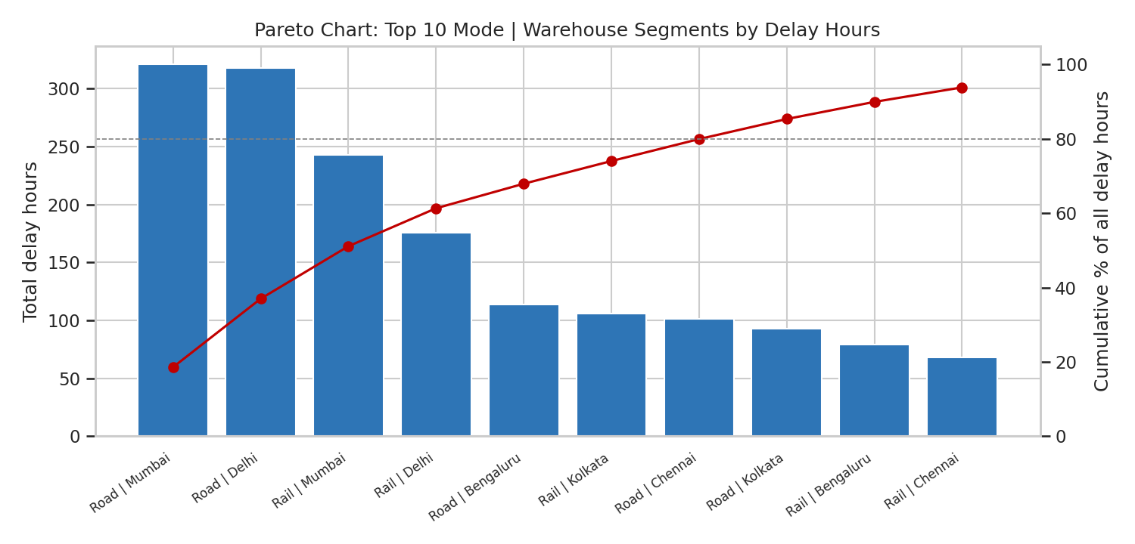
Figure 9. Pareto Chart of Delay Hours by Mode | Warehouse Segment
Why this chart: A Pareto chart ranks causes by size and adds a cumulative-percentage line. It is the right tool for prioritisation: it shows the vital few segments that deserve management attention first (the 80/20 idea).
Code:
seg = df.groupby('segment').agg(delay_total=('delay_hrs','sum')).sort_values('delay_total', ascending=False)
seg['cum_pct'] = (seg.delay_total / seg.delay_total.sum() * 100).cumsum()
ax.bar(range(10), top.delay_total); ax2.plot(range(10), top.cum_pct, marker='o')
What it shows:
- Road|Mumbai 18.6%, Road|Delhi 18.4%, Rail|Mumbai 14.1% and Rail|Delhi 10.2% together generate 61.3% of all 1,728 delay hours while carrying 43.7% of shipments (655 of 1,500).
- 8 of the 15 segments are needed to reach 80% of delay hours.
So what: Start with four lanes (Road and Rail out of Mumbai and Delhi). Fixing them addresses most of the delay without touching the other eleven segments.

6.10 Figure 10: Where Does Delivery Time Go? Processing vs Transit
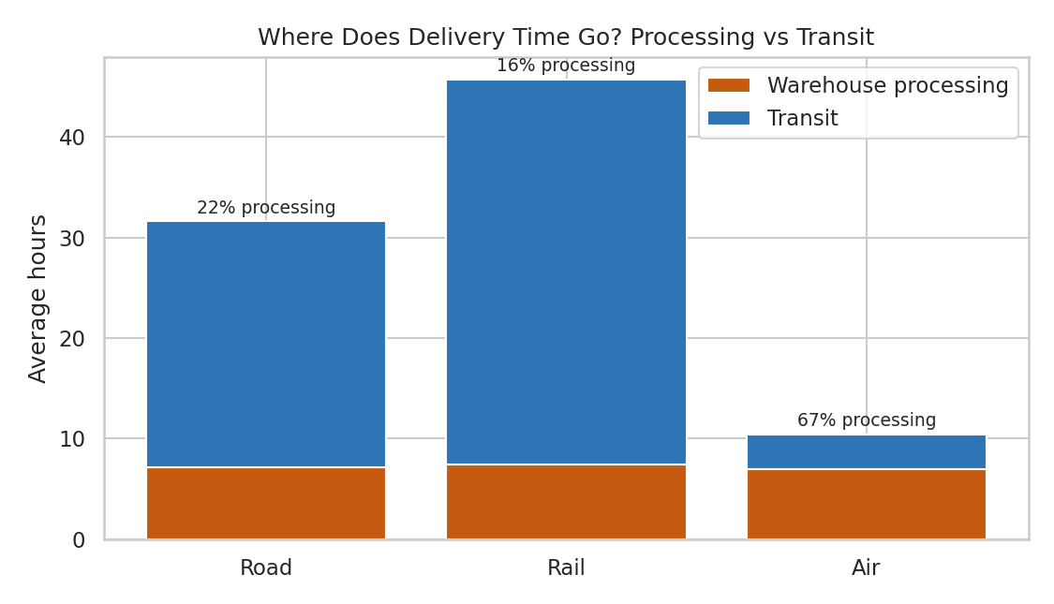
Figure 10. Where Does Delivery Time Go? Processing vs Transit
Why this chart: A stacked bar splits a total into additive components. Since delivery time = processing + transit exactly, this shows which part of the process each mode spends its time in.
Code:
ax.bar(dd.index, dd.processing_hrs, label='Warehouse processing')
ax.bar(dd.index, dd.transit_hrs, bottom=dd.processing_hrs, label='Transit')
What it shows:
- Air: 10.3 h in total, of which 7.0 h (67%) is warehouse processing and only 3.4 h in the air. Road: 7.1 h of 31.7 h (22.5%). Rail: 7.4 h of 45.7 h (16.2%).
So what: For Air (and short hauls) the warehouse is the dominant lever; for Rail the lever is transit speed and reliability. Processing is a flat 7 hours regardless of mode, a fixed overhead that every shipment pays.

6.11 Figure 11: Processing Time and On-Time Rate by Dispatch Day
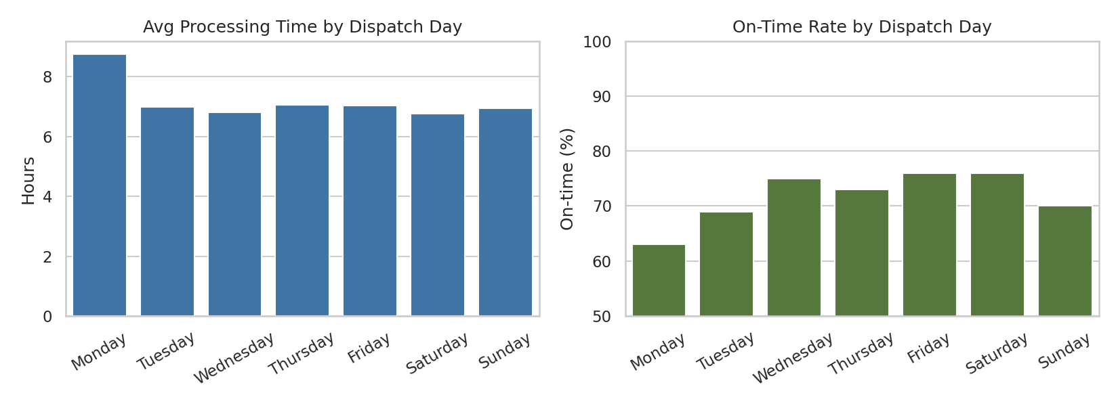
Figure 11. Processing Time and On-Time Rate by Dispatch Day
Why this chart: Bars by weekday expose cyclical operating patterns (weekly rhythm) that a monthly chart averages away. It is a quick test for backlog and staffing problems.
Code:
dow = df.groupby('day_of_week').agg(proc=('processing_hrs','mean'), on_time=('on_time','mean')).reindex(dow_order)
sns.barplot(x=dow.index, y=dow.proc, ax=ax[0], order=dow_order)
What it shows:
- Monday processing averages 8.76 h against 6.76 to 7.06 h on every other day, a gap of about 1.83 h. Monday on-time is 63% versus 69% to 76% for the rest of the week. Monday carries 223 shipments (14.9%).
So what: A weekend backlog is released on Monday. A Sunday half-shift or an order cut-off rule would remove a recurring, predictable delay.

7. How the Visualizations Help Interpret Logistics Performance
A table of averages answers “how are we doing?”; a chart answers “where, when and why?”. The mapping below shows which chart supports which logistics KPI and the decision it informs.
Performance metric | Chart(s) | What the chart reveals that a number cannot | Decision supported
On-time rate | Fig 5, 6, 7, 11 | Where (warehouse × mode cell), when (month, weekday) the 28.4% failures concentrate | Where to add capacity or buffer
Average delivery time | Fig 1, 2, 10 | Skew and tail: mean 33 h hides P90 of 56.5 h; stacked bars split time into processing and transit | Setting realistic promise dates; choosing which stage to speed up
Warehouse processing time | Fig 6, 10, 11 | Spread within each hub, not only the mean; the weekly Monday spike | Staffing, shift design, layout fixes
Transport cost | Fig 2, 4 | Three separate cost curves by mode; Air outliers | Mode policy; quotation model
Cost per kg | Fig 8 | Economies of scale by weight band | Consolidation and minimum-load rules
Delay severity | Fig 9 | Which segments hold most delay hours (Pareto) | Prioritising improvement projects
Seasonality | Fig 5 | Monsoon and festive peaks as distinct shapes with distinct causes | Seasonal buffers and contingency plans

Chart-selection logic used in this report: histogram/KDE and boxplot for distributions; scatter and heatmap for relationships between two variables; line and bar for time patterns; stacked bar for composition; Pareto for prioritisation. Choosing the chart by the question keeps each figure readable and avoids decorative visuals.

8. Analytical Insights

8.1 Operational efficiency
- Fixed overhead, variable transit. Every shipment pays about 7 hours of warehouse processing regardless of mode (Figure 10). That is 67% of Air delivery time and 22% of Road, so warehouse efficiency is the lever with the widest reach.
- Service-level reliability is uneven. On-time ranges from 48.8% (Mumbai Air) to 94.9% (Kolkata Air). The gap sits entirely in warehouse performance, since the vehicles are identical.
- Weather versus capacity. Monsoon cuts on-time to 35% (Rail) and 46% (Road); the festive peak cuts it to 72% by lengthening processing 22% (6.77 h to 8.24 h). Both effects are seasonal and predictable, so both can be planned for.
- Express does not behave like Express. Mean delivery time is nearly identical (32.75 h vs 33.15 h) because there is no priority lane; Express simply carries a tighter SLA. It has a 37% on-time rate (Air 45%, Road 39%, Rail 31%) and customers pay about ₹1,635 extra for it.
- Rail is the least reliable mode: 68% on-time, 45.7 h average and 38.8% of all delay hours from 30% of shipments.

8.2 Cost drivers
An ordinary least squares regression of cost on distance, weight, mode (Road as base) and priority gives the following (n = 1,500, R² = 0.863):
Term | Coefficient (₹) | Std error | t-value
Intercept | -2916.66 | 212.17 | -13.7
Distance (per km) | 6.82 | 0.16 | 42.3
Weight (per kg) | 1.74 | 0.43 | 4.1
Mode = Rail (vs Road) | -2252.85 | 188.92 | -11.9
Mode = Air (vs Road) | 17257.84 | 263.08 | 65.6
Priority = Express | 1634.68 | 180.82 | 9.0

X = pd.DataFrame({'intercept': 1.0, 'distance_km': df.distance_km, 'shipment_kg': df.shipment_kg,
'mode_Rail': (df.transport_mode=='Rail').astype(float),
'mode_Air': (df.transport_mode=='Air').astype(float),
'express': (df.priority=='Express').astype(float)})
beta, *_ = np.linalg.lstsq(X.values, df.transport_cost_inr.values, rcond=None)
r2 = 1 - ((y - X.values @ beta)**2).sum() / ((y - y.mean())**2).sum() # 0.863
Interpretation. Holding the other factors constant, each additional kilometre adds ₹6.82; choosing Air adds about ₹17,258 and choosing Rail saves about ₹2,253 against Road; Express adds ₹1,635; each kg adds ₹1.74. Mode and priority are decisions, distance and weight are given, so the controllable cost levers are mode, priority and load size.
Worked example (model prediction for a 1,000 km, 200 kg shipment): Road Standard = -2,916.66 + 6.82 × 1,000 + 1.74 × 200 = ₹4,251. Express adds ₹1,635 (₹5,886). Rail Standard = 4,251 - 2,253 = ₹1,998. Air Standard = 4,251 + 17,258 = ₹21,509. The linear model slightly understates Air because Air’s per-km rate is steeper (an interaction term would capture it).
Cost concentration: Air = 13.4% of shipments, 50.8% of spend (about ₹49 lakh). Road = 34.9% (about ₹34 lakh); Rail = 14.3% (about ₹14 lakh). Halving unnecessary Air usage would matter more than any distance-based optimisation.

8.3 Bottlenecks ranked by size
# | Bottleneck | Evidence | Size of the problem
1 | Mumbai and Delhi warehouse processing | 9.65 h and 8.23 h vs 5.06 to 5.93 h; 39% and 17% of shipments over 10 h; Fig 6, 7, 9 | 49.8% of volume, 66.6% of delay hours, on-time 60% / 64%
2 | Monsoon transit delays (Jul to Sep) | Road 35.0 h vs 30.6 h; Rail on-time 35%; Fig 5 | On-time 46% vs 84% in Jan to Jun
3 | Express service design | Same speed as Standard but 37% on-time; chi-square p < 0.001 | 65% of late shipments (278 of 426) from 29.5% of volume
4 | Festive-season processing surge (Oct to Dec) | Processing 8.24 h vs 6.77 h (+22%); Dec on-time 67% | Adds about 1.5 h to every shipment in Q4
5 | Monday backlog | 8.76 h vs about 6.9 h; Monday on-time 63%; Fig 11 | 14.9% of shipments; gap 1.83 h
6 | Rail reliability | 68% on-time, 45.7 h average | 38.8% of delay hours from 30% of shipments

8.4 Worked example: one late shipment traced end to end
Shipment SH1009 (dispatched 3 August 2025) shows how the pieces combine. It moved 356 kg over 338 km by Rail from Mumbai to the North region at Standard priority, during the monsoon.
Step | Calculation | Result
Warehouse processing | Mumbai (mean 9.65 h) took | 8.3 h
Transit | 338 km ÷ 30 km/h = 11.3 h, × monsoon factor 1.38, plus noise | 15.0 h
Delivery time | 8.3 + 15.0 | 23.3 h
Promised SLA | (8 + 338 ÷ 32) × 1.25 (Standard) | 23.2 h
Delay | 23.3 - 23.2 | 0.1 h late
Cost | 0.35 × 338 × ₹7 + 0.6 × 355.7 × ₹1.5 + noise | ₹1,229

Lesson: The shipment missed its SLA by only 0.1 h. Had the Mumbai warehouse matched the 5.5 h of the better-performing sites, the shipment would have been delivered in 20.5 h, 2.7 h inside the SLA. A small warehouse delay turned a monsoon-affected shipment from on-time into late. This is how Mumbai’s processing time converts directly into the 60% on-time rate.

9. What-If Scenario Analysis
To estimate the value of each fix before recommending it, the same 1,500 shipments were re-scored under four scenarios (counterfactual simulation: only the stated factor changes, everything else stays as observed). Baseline on-time = 71.6%.
Scenario | Change applied | On-time after | Gain | Other effects | Verdict
S1 Warehouse fix | Mumbai and Delhi processing cut from 8.93 h to 5.5 h (the average of the other three sites) | 81.3% | +9.7 pts | Only internal process change | Do first
S2 Mode shift | 190 Rail shipments under 900 km moved to Road | 71.9% | +0.3 pts | Delivery 28.7 h → 24.5 h; cost about +₹940 per shipment (≈ ₹1.8 lakh a year) | Not worth it
S3 Monday fix | Monday processing reduced by 1.83 h (Sunday half-shift or cut-off rule) | 73.3% | +1.7 pts | Low cost, quick to implement | Do
S4 Combined | S1 and S3 together | 82.7% | +11.1 pts | Closes more than a third of the gap to 100% | Target

Takeaway: Fixing the warehouse (S1) delivers about 30 times the on-time gain of the mode shift (S2) and costs nothing in freight. It confirms the diagnosis of Section 8: the biggest lever is inside the building, not on the road.
target = df[~df.warehouse.isin(['Mumbai','Delhi'])].processing_hrs.mean() # 5.5 h
s1 = df.copy(); m = s1.warehouse.isin(['Mumbai','Delhi'])
s1.loc[m,'processing_hrs'] -= s1.loc[m].groupby('warehouse').processing_hrs.transform('mean') - target
s1['delivery_time_hrs'] = s1.processing_hrs + s1.transit_hrs
print((s1.delivery_time_hrs <= s1.sla_hrs).mean()) # 0.813

10. Recommendations
Ranked by evidence-based impact. Each action has a KPI and target so progress can be tracked.
Priority | Action | Evidence | Expected impact | KPI and target
1 | Cut processing time at Mumbai and Delhi: add a second shift or wave picking, cross-docking for Express, dock-appointment scheduling; rebalance some Mumbai volume to Chennai or Bengaluru (368 vs 267 and 226 shipments) | Fig 6, 7, 9; S1; t-test | On-time 71.6% → 81.3% (+9.7 pts); removes most of the 66.6% delay share | Processing ≤ 5.5 h; share of shipments over 10 h: Mumbai 39% → under 5%
2 | Create a real Express lane: first-in-first-out priority at the dock, dedicated vehicles, or else relax the Express SLA and reduce the premium | Express 37% vs 86% on-time; same speed as Standard; +₹1,635 premium | Express is 65% of late shipments; fixing it addresses most of the remaining lateness | Express on-time ≥ 75%; Express delivery at least 20% faster than Standard
3 | Monsoon playbook (Jul to Sep): add a monsoon buffer to Road and Rail promises (Road runs +4.4 h on average), pre-position stock nearer destinations, use alternate routes and dispatch early | Fig 5; on-time 46% vs 84%; Rail 35% | Restores credibility of promises in the worst quarter | Monsoon on-time ≥ 70%
4 | Peak-season capacity plan (Oct to Dec): temporary staff and extended hours from October | Processing +22%; Dec on-time 67% | Removes about 1.5 h of Q4 processing time | Q4 processing ≤ 7 h
5 | Fix the Monday backlog: Sunday half-shift or Friday evening cut-off | Fig 11; S3 | +1.7 pts on-time at low cost | Monday processing ≤ 7 h
6 | Consolidate small loads and govern Air use: minimum-load rules or weekly consolidation for sub-100 kg shipments; approve Air only for Express or long-distance cases | Fig 8; Air = 50.8% of spend | Up to ₹8.1 lakh (8.4% of spend) from consolidation (upper bound) | Share of shipments under 100 kg: 16% → under 8%; Air share of spend below 40%
7 | Do not pursue a broad Rail-to-Road shift | S2: +0.3 pts for about ₹1.8 lakh extra | Avoids low-return spend | Revisit only if Rail on-time stays under 70%
8 | Track KPIs weekly with the charts in this report (Fig 5, 7, 9 as a standing dashboard) | Section 7 | Early warning of drifts | Weekly on-time, processing by hub, delay Pareto

Suggested rollout
- First 30 days: Monday fix, Express SLA review, begin Mumbai and Delhi process mapping.
- 30 to 90 days: shift and wave-picking changes at Mumbai and Delhi, volume rebalancing, consolidation rules.
- Before July and October: monsoon playbook and peak-season staffing plan ready.

11. Limitations and Next Steps
- Simulated data. The effects were built in, so the EDA recovering them validates the method rather than proving how a real network behaves. With real data, effect sizes would be smaller and noisier.
- Very small p-values are partly a product of simulation and n = 1,500; effect sizes (hours, points) are the meaningful numbers.
- Linear regression without interactions slightly understates Air cost; an interaction model (mode × distance) would fit better.
- Scenarios are static. They do not model warehouse capacity limits or queueing; consolidation savings are an upper bound.
- Next steps: replace the simulation with actual shipment logs; add a logistic-regression or gradient-boosting model to predict which shipments will be late at dispatch; build an interactive Plotly dashboard for weekly monitoring.

12. Conclusion
The analysis shows that logistics performance in this network is determined less by distance and more by what happens inside the warehouse and when the shipment is dispatched. Mumbai and Delhi processing, the monsoon quarter, a weekend backlog and an Express service that is not operationally prioritised explain most late deliveries, while Air freight and small loads explain most of the cost. A focused programme on these items is projected to lift on-time delivery from 71.6% to about 83% without any major capital investment. The visualizations are what made these diagnoses possible: they separated seasonal from structural problems, located the hotspots in the warehouse-by-mode grid, and ranked the lanes that matter first.

Appendix A. Complete Python Script
Saved as logistics_analysis.py. Run with: python logistics_analysis.py - it creates the dataset (logistics_dataset.csv), all figures (figs/) and the numeric results used in this report. Requires pandas, numpy, scipy, matplotlib and seaborn.
"""
Week 3 Task - Advanced Data Analysis and Visualization in Logistics
Simulates a hypothetical logistics dataset, performs EDA and creates visualizations.
Run: python logistics_analysis.py
"""
import json
import numpy as np
import pandas as pd
import matplotlib
matplotlib.use("Agg")
import matplotlib.pyplot as plt
import seaborn as sns

np.random.seed(42)
sns.set_theme(style="whitegrid", palette="deep")
OUT = "figs/"

# ------------------------------------------------------------------
# 1. DATA SIMULATION
# ------------------------------------------------------------------
N = 1500
warehouses = ["Delhi", "Mumbai", "Kolkata", "Chennai", "Bengaluru"]
regions = ["North", "South", "East", "West", "Central"]
modes = ["Road", "Rail", "Air"]
priorities = ["Standard", "Express"]

df = pd.DataFrame({
"shipment_id": [f"SH{1000+i}" for i in range(N)],
"ship_date": pd.to_datetime("2025-01-01") + pd.to_timedelta(np.random.randint(0, 365, N), unit="D"),
"warehouse": np.random.choice(warehouses, N, p=[0.24, 0.26, 0.16, 0.18, 0.16]),
"dest_region": np.random.choice(regions, N),
"transport_mode": np.random.choice(modes, N, p=[0.55, 0.30, 0.15]),
"priority": np.random.choice(priorities, N, p=[0.7, 0.3]),
})

# distance depends on mode (air used for longer trips)
base_dist = np.random.gamma(shape=4, scale=220, size=N) # ~880 km average
df["distance_km"] = np.where(df.transport_mode == "Air", base_dist * 1.6,
np.where(df.transport_mode == "Rail", base_dist * 1.2, base_dist)).round(0).clip(50, 3500)

# shipment volume (kg): right-skewed
df["shipment_kg"] = np.random.lognormal(mean=5.3, sigma=0.7, size=N).round(1).clip(10, 5000)

# warehouse processing time (hours) -- Mumbai & Delhi congested
proc_mean = {"Delhi": 7.5, "Mumbai": 9.0, "Kolkata": 5.5, "Chennai": 5.0, "Bengaluru": 4.5}
df["processing_hrs"] = [max(1, np.random.normal(proc_mean[w], 1.8)) for w in df.warehouse]
df["processing_hrs"] = df.processing_hrs.round(1)

# speed by mode (km/h effective)
speed = {"Road": 38, "Rail": 30, "Air": 450}
df["transit_hrs"] = df.apply(lambda r: r.distance_km / speed[r.transport_mode]
+ np.random.normal(0, 2), axis=1)
# seasonal monsoon delay (Jul-Sep) for road & rail
df["month"] = df.ship_date.dt.month
monsoon = df.month.isin([7, 8, 9]) & df.transport_mode.isin(["Road", "Rail"])
df["monsoon_factor"] = 1.0
df.loc[monsoon, "monsoon_factor"] = np.random.uniform(1.15, 1.40, monsoon.sum())
df["transit_hrs"] *= df["monsoon_factor"]
df["is_monsoon"] = monsoon.astype(int)
# festive season peak load (Oct-Dec) adds handling delay
festive = df.month.isin([10, 11, 12])
df.loc[festive, "processing_hrs"] *= np.random.uniform(1.10, 1.30, festive.sum())
# Monday backlog: weekend orders pile up and are processed on Monday
df["day_of_week"] = df.ship_date.dt.day_name()
df.loc[df.day_of_week == "Monday", "processing_hrs"] += np.random.uniform(1.0, 2.5, (df.day_of_week == "Monday").sum())
df["transit_hrs"] = df.transit_hrs.clip(lower=1).round(1)
df["processing_hrs"] = df.processing_hrs.round(1)

df["delivery_time_hrs"] = (df.processing_hrs + df.transit_hrs).round(1)

# cost (INR): distance, weight, mode, priority
rate = {"Road": 11, "Rail": 7, "Air": 45} # INR per km base
kg_rate = {"Road": 2.2, "Rail": 1.5, "Air": 9.0} # INR per kg
df["transport_cost_inr"] = (
df.distance_km * df.transport_mode.map(rate) * 0.35 +
df.shipment_kg * df.transport_mode.map(kg_rate) * 0.6 +
np.random.normal(0, 400, N)
)
df.loc[df.priority == "Express", "transport_cost_inr"] *= 1.25
df["transport_cost_inr"] = df.transport_cost_inr.clip(lower=300).round(0)
df["cost_per_kg"] = (df.transport_cost_inr / df.shipment_kg).round(2)

# promised SLA = (8 hr handling budget + distance / planned speed) x service factor
planned_speed = {"Road": 40, "Rail": 32, "Air": 500}
df["sla_hrs"] = ((8 + df.distance_km / df.transport_mode.map(planned_speed)) *
np.where(df.priority == "Express", 1.00, 1.25)).round(1)
df["delay_hrs"] = (df.delivery_time_hrs - df.sla_hrs).clip(lower=0).round(1)
df["on_time"] = (df.delay_hrs == 0).astype(int)

df.to_csv("logistics_dataset.csv", index=False)

# ------------------------------------------------------------------
# 2. EXPLORATORY DATA ANALYSIS
# ------------------------------------------------------------------
num_cols = ["distance_km", "shipment_kg", "processing_hrs", "transit_hrs",
"delivery_time_hrs", "transport_cost_inr", "cost_per_kg", "delay_hrs"]
desc = df[num_cols].describe().T
desc["median"] = df[num_cols].median()
desc["skew"] = df[num_cols].skew()
def modal_bin(x, bins=30):
c, e = np.histogram(x, bins=bins); i = c.argmax(); return (e[i] + e[i+1]) / 2
desc["mode"] = [modal_bin(df[c]) for c in num_cols] # midpoint of the tallest histogram bin
desc = desc[["count", "mean", "median", "mode", "std", "min", "max", "skew"]].round(2)
desc.to_csv("descriptive_stats.csv")

corr = df[["distance_km", "shipment_kg", "processing_hrs", "transit_hrs",
"delivery_time_hrs", "transport_cost_inr", "delay_hrs"]].corr().round(2)

by_mode = df.groupby("transport_mode").agg(
shipments=("shipment_id", "count"), avg_delivery=("delivery_time_hrs", "mean"),
avg_cost=("transport_cost_inr", "mean"), avg_cost_kg=("cost_per_kg", "mean"),
on_time=("on_time", "mean")).round(2)
by_wh = df.groupby("warehouse").agg(
shipments=("shipment_id", "count"), avg_proc=("processing_hrs", "mean"),
avg_delivery=("delivery_time_hrs", "mean"), on_time=("on_time", "mean")).round(2)
by_region = df.groupby("dest_region").agg(
avg_delivery=("delivery_time_hrs", "mean"), on_time=("on_time", "mean")).round(2)
monthly = df.groupby("month").agg(
shipments=("shipment_id", "count"), avg_delivery=("delivery_time_hrs", "mean"),
avg_proc=("processing_hrs", "mean"), on_time=("on_time", "mean"),
avg_cost=("transport_cost_inr", "mean")).round(2)
by_pri = df.groupby("priority").agg(on_time=("on_time", "mean"),
avg_delivery=("delivery_time_hrs", "mean"),
avg_cost=("transport_cost_inr", "mean")).round(2)

# outliers via IQR on cost
q1, q3 = df.transport_cost_inr.quantile([.25, .75]); iqr = q3 - q1
n_out = int(((df.transport_cost_inr < q1 - 1.5*iqr) | (df.transport_cost_inr > q3 + 1.5*iqr)).sum())

# ------------------------------------------------------------------
# 3. VISUALIZATIONS
# ------------------------------------------------------------------
# Fig 1: distribution of delivery time
fig, ax = plt.subplots(1, 2, figsize=(11, 4.2))
sns.histplot(df.delivery_time_hrs, bins=40, kde=True, ax=ax[0], color="#2E75B6")
ax[0].axvline(df.delivery_time_hrs.mean(), color="red", ls="--", label=f"Mean {df.delivery_time_hrs.mean():.1f}")
ax[0].axvline(df.delivery_time_hrs.median(), color="green", ls=":", label=f"Median {df.delivery_time_hrs.median():.1f}")
ax[0].set(title="Distribution of Delivery Time", xlabel="Delivery time (hours)", ylabel="Shipments"); ax[0].legend()
sns.histplot(df.transport_cost_inr, bins=40, kde=True, ax=ax[1], color="#C55A11")
ax[1].axvline(df.transport_cost_inr.mean(), color="red", ls="--", label=f"Mean ₹{df.transport_cost_inr.mean():,.0f}")
ax[1].axvline(df.transport_cost_inr.median(), color="green", ls=":", label=f"Median ₹{df.transport_cost_inr.median():,.0f}")
ax[1].set(title="Distribution of Transportation Cost", xlabel="Cost (INR)", ylabel="Shipments"); ax[1].legend()
plt.tight_layout(); plt.savefig(OUT + "fig1_distributions.png", dpi=150); plt.close()

# Fig 2: delivery time & cost by mode (boxplots)
fig, ax = plt.subplots(1, 2, figsize=(11, 4.2))
sns.boxplot(data=df, x="transport_mode", y="delivery_time_hrs", order=modes, ax=ax[0], hue="transport_mode", legend=False)
ax[0].set(title="Delivery Time by Transport Mode", xlabel="Mode", ylabel="Hours")
sns.boxplot(data=df, x="transport_mode", y="transport_cost_inr", order=modes, ax=ax[1], hue="transport_mode", legend=False)
ax[1].set(title="Transportation Cost by Transport Mode", xlabel="Mode", ylabel="Cost (INR)")
plt.tight_layout(); plt.savefig(OUT + "fig2_mode_boxplots.png", dpi=150); plt.close()

# Fig 3: correlation heatmap
plt.figure(figsize=(7.5, 6))
sns.heatmap(corr, annot=True, cmap="coolwarm", vmin=-1, vmax=1, fmt=".2f", linewidths=.5)
plt.title("Correlation Matrix of Key Logistics Variables")
plt.tight_layout(); plt.savefig(OUT + "fig3_correlation.png", dpi=150); plt.close()

# Fig 4: distance vs cost scatter by mode
plt.figure(figsize=(8.5, 5))
sns.scatterplot(data=df, x="distance_km", y="transport_cost_inr", hue="transport_mode", size="shipment_kg",
sizes=(10, 120), alpha=.6)
plt.title("Distance vs Transportation Cost (bubble size = shipment weight)")
plt.xlabel("Distance (km)"); plt.ylabel("Cost (INR)")
plt.legend(bbox_to_anchor=(1.02, 1), loc="upper left", fontsize=8)
plt.tight_layout(); plt.savefig(OUT + "fig4_distance_cost.png", dpi=150); plt.close()

# Fig 5: monthly trend (dual axis)
fig, ax1 = plt.subplots(figsize=(9.5, 4.5))
ax1.plot(monthly.index, monthly.avg_delivery, marker="o", color="#2E75B6", label="Avg delivery time (hrs)")
ax1.set_xlabel("Month"); ax1.set_ylabel("Avg delivery time (hrs)", color="#2E75B6"); ax1.set_xticks(range(1, 13))
ax2 = ax1.twinx()
ax2.bar(monthly.index, monthly.on_time * 100, alpha=.25, color="#548235", label="On-time %")
ax2.set_ylabel("On-time delivery (%)", color="#548235"); ax2.set_ylim(0, 100); ax2.grid(False)
plt.title("Monthly Trend: Delivery Time vs On-Time Rate")
fig.tight_layout(); plt.savefig(OUT + "fig5_monthly_trend.png", dpi=150); plt.close()

# Fig 6: warehouse bottleneck - processing time
fig, ax = plt.subplots(1, 2, figsize=(11, 4.2))
order = by_wh.sort_values("avg_proc", ascending=False).index
sns.boxplot(data=df, x="warehouse", y="processing_hrs", order=order, ax=ax[0], hue="warehouse", legend=False)
ax[0].set(title="Warehouse Processing Time", xlabel="Warehouse", ylabel="Hours")
sns.barplot(data=df, x="warehouse", y=df.on_time * 100, order=order, ax=ax[1], errorbar=None, hue="warehouse", legend=False)
ax[1].set(title="On-Time Delivery Rate by Warehouse", xlabel="Warehouse", ylabel="On-time (%)")
plt.tight_layout(); plt.savefig(OUT + "fig6_warehouse.png", dpi=150); plt.close()

# Fig 7: heatmap - on-time % by warehouse x mode
pivot = df.pivot_table(index="warehouse", columns="transport_mode", values="on_time", aggfunc="mean") * 100
plt.figure(figsize=(6.5, 4.5))
sns.heatmap(pivot[modes], annot=True, fmt=".1f", cmap="RdYlGn", vmin=0, vmax=100, linewidths=.5)
plt.title("On-Time Delivery % — Warehouse × Mode")
plt.tight_layout(); plt.savefig(OUT + "fig7_heatmap_ontime.png", dpi=150); plt.close()

# Fig 8: cost per kg by mode & weight band
df["weight_band"] = pd.cut(df.shipment_kg, [0, 100, 250, 500, 1000, 5000],
labels=["<100", "100-250", "250-500", "500-1000", ">1000"])
plt.figure(figsize=(8.5, 4.5))
sns.barplot(data=df, x="weight_band", y="cost_per_kg", hue="transport_mode", hue_order=modes, errorbar=None)
plt.title("Cost per kg by Weight Band and Mode (economies of scale)")
plt.xlabel("Shipment weight band (kg)"); plt.ylabel("Cost per kg (INR)")
plt.tight_layout(); plt.savefig(OUT + "fig8_cost_per_kg.png", dpi=150); plt.close()

# ------------------------------------------------------------------
# 3b. ADVANCED ANALYSIS: tests, regression, Pareto, scenarios
# ------------------------------------------------------------------
from scipy import stats

adv = {}
# (a) Is Mumbai's processing time really higher than Bengaluru's? (Welch t-test)
t, p = stats.ttest_ind(df[df.warehouse == "Mumbai"].processing_hrs,
df[df.warehouse == "Bengaluru"].processing_hrs, equal_var=False)
adv["ttest_mum_blr"] = [round(t, 2), float(p)]
# (b) Do warehouses differ overall? (one-way ANOVA)
F, pa = stats.f_oneway(*[g.processing_hrs.values for _, g in df.groupby("warehouse")])
adv["anova_wh"] = [round(F, 1), float(pa)]
# (c) Monsoon effect on Road delivery time (Welch t-test)
road = df[df.transport_mode == "Road"]
t2, p2 = stats.ttest_ind(road[road.is_monsoon == 1].delivery_time_hrs,
road[road.is_monsoon == 0].delivery_time_hrs, equal_var=False)
adv["ttest_monsoon"] = [round(t2, 2), float(p2),
round(road[road.is_monsoon == 1].delivery_time_hrs.mean(), 1),
round(road[road.is_monsoon == 0].delivery_time_hrs.mean(), 1)]
# (d) Express vs Standard on-time (chi-square)
ct = pd.crosstab(df.priority, df.on_time)
chi, pc, _, _ = stats.chi2_contingency(ct)
adv["chi_priority"] = [round(chi, 1), float(pc)]
# (e) Spearman correlation (robust to skew): distance vs cost, within each mode
adv["spearman_dist_cost"] = {m: round(stats.spearmanr(g.distance_km, g.transport_cost_inr)[0], 2)
for m, g in df.groupby("transport_mode")}
adv["pearson_dist_cost_within"] = {m: round(g[["distance_km", "transport_cost_inr"]].corr().iloc[0, 1], 2)
for m, g in df.groupby("transport_mode")}

# (f) OLS regression: cost drivers
X = pd.DataFrame({"intercept": 1.0, "distance_km": df.distance_km, "shipment_kg": df.shipment_kg,
"mode_Rail": (df.transport_mode == "Rail").astype(float),
"mode_Air": (df.transport_mode == "Air").astype(float),
"express": (df.priority == "Express").astype(float)})
y = df.transport_cost_inr.values
beta, *_ = np.linalg.lstsq(X.values, y, rcond=None)
pred = X.values @ beta
r2 = 1 - ((y - pred) ** 2).sum() / ((y - y.mean()) ** 2).sum()
n, k = X.shape
sigma2 = ((y - pred) ** 2).sum() / (n - k)
se = np.sqrt(np.diag(sigma2 * np.linalg.inv(X.values.T @ X.values)))
adv["ols"] = [[c, round(b, 2), round(e, 2), round(b / e, 1)] for c, b, e in zip(X.columns, beta, se)]
adv["ols_r2"] = round(r2, 3)

# (g) Delivery-time decomposition by mode (processing vs transit)
decomp = df.groupby("transport_mode")[["processing_hrs", "transit_hrs"]].mean().round(1)
decomp["proc_share_pct"] = (decomp.processing_hrs / (decomp.processing_hrs + decomp.transit_hrs) * 100).round(1)
adv["decomp"] = decomp.reset_index().values.tolist()

# (h) Delay Pareto: which segments generate the most delay hours?
df["segment"] = df.transport_mode + " | " + df.warehouse
seg = df.groupby("segment").agg(ships=("shipment_id", "count"), delay_total=("delay_hrs", "sum"),
late=("on_time", lambda x: (1 - x).sum())).sort_values("delay_total", ascending=False)
seg["share_pct"] = (seg.delay_total / seg.delay_total.sum() * 100).round(1)
seg["cum_pct"] = seg.share_pct.cumsum().round(1)
adv["pareto_top"] = seg.head(6).reset_index().round(1).values.tolist()
adv["pareto_n_for_80"] = int((seg.cum_pct < 80).sum() + 1)
adv["pareto_n_segments"] = len(seg)
adv["total_delay_hrs"] = round(df.delay_hrs.sum(), 0)
adv["late_n"] = int((1 - df.on_time).sum())
mode_delay = df.groupby("transport_mode").agg(share_ships=("shipment_id", "count"), delay=("delay_hrs", "sum"))
mode_delay["ship_pct"] = (mode_delay.share_ships / N * 100).round(1)
mode_delay["delay_pct"] = (mode_delay.delay / mode_delay.delay.sum() * 100).round(1)
adv["mode_delay"] = mode_delay.reset_index().values.tolist()

# (i) Day-of-week effect
dow_order = ["Monday", "Tuesday", "Wednesday", "Thursday", "Friday", "Saturday", "Sunday"]
dow = df.groupby("day_of_week").agg(n=("shipment_id", "count"), proc=("processing_hrs", "mean"),
on_time=("on_time", "mean")).reindex(dow_order).round(2)
adv["dow"] = dow.reset_index().values.tolist()

# (j) Monsoon / festive season summary
season = pd.cut(df.month, [0, 6, 9, 12], labels=["Jan-Jun (normal)", "Jul-Sep (monsoon)", "Oct-Dec (festive)"])
sea = df.groupby(season, observed=True).agg(n=("shipment_id", "count"), deliv=("delivery_time_hrs", "mean"),
proc=("processing_hrs", "mean"), on_time=("on_time", "mean")).round(2)
adv["season"] = sea.reset_index().values.tolist()

# (k) What-if scenarios (counterfactual, same shipments)
def on_time_rate(d): # d must have delivery_time_hrs and sla_hrs
return round(((d.delivery_time_hrs <= d.sla_hrs).mean()) * 100, 1)
base_ot = on_time_rate(df)
# S1: bring Mumbai & Delhi processing down to the average of the other three warehouses
target = df[~df.warehouse.isin(["Mumbai", "Delhi"])].processing_hrs.mean()
s1 = df.copy(); m = s1.warehouse.isin(["Mumbai", "Delhi"])
s1.loc[m, "processing_hrs"] = (s1.loc[m, "processing_hrs"] - (s1.loc[m].groupby("warehouse").processing_hrs.transform("mean") - target)).clip(lower=1)
s1["delivery_time_hrs"] = s1.processing_hrs + s1.transit_hrs
adv["s1"] = [round(target, 2), base_ot, on_time_rate(s1),
round(df.loc[m, "processing_hrs"].mean(), 2), round(s1.loc[m, "processing_hrs"].mean(), 2)]
# S2: shift Rail shipments under 900 km to Road (faster, cost difference estimated by OLS betas)
s2 = df.copy(); r = (s2.transport_mode == "Rail") & (s2.distance_km < 900)
road_t = s2.loc[r, "distance_km"] / 38 * s2.loc[r, "monsoon_factor"]
s2.loc[r, "transit_hrs"] = road_t
s2.loc[r, "delivery_time_hrs"] = s2.loc[r, "processing_hrs"] + road_t
s2.loc[r, "sla_hrs"] = ((8 + s2.loc[r, "distance_km"] / 40) * np.where(s2.loc[r, "priority"] == "Express", 1.00, 1.25))
d_cost_per_ship = (0.35 * (11 - 7) * df.loc[r, "distance_km"] + 0.6 * (2.2 - 1.5) * df.loc[r, "shipment_kg"]).mean()
adv["s2"] = [int(r.sum()), base_ot, on_time_rate(s2), round(df.loc[r, "delivery_time_hrs"].mean(), 1),
round(s2.loc[r, "delivery_time_hrs"].mean(), 1), round(d_cost_per_ship, 0)]
# S3: Monday backlog removal (extra staffing on Monday)
s3 = df.copy(); mon = s3.day_of_week == "Monday"
gap = df[mon].processing_hrs.mean() - df[~mon].processing_hrs.mean()
s3.loc[mon, "processing_hrs"] = (s3.loc[mon, "processing_hrs"] - gap).clip(lower=1)
s3["delivery_time_hrs"] = s3.processing_hrs + s3.transit_hrs
adv["s3"] = [round(gap, 2), base_ot, on_time_rate(s3)]
# S4: both S1 + S3 combined
s4 = s1.copy(); mon4 = s4.day_of_week == "Monday"
s4.loc[mon4, "processing_hrs"] = (s4.loc[mon4, "processing_hrs"] - gap).clip(lower=1)
s4["delivery_time_hrs"] = s4.processing_hrs + s4.transit_hrs
adv["s4"] = [base_ot, on_time_rate(s4)]

# worked example row: pick a Rail shipment from Mumbai in monsoon
ex = df[(df.warehouse == "Mumbai") & (df.transport_mode == "Rail") & (df.is_monsoon == 1) & (df.on_time == 0)].iloc[0]
adv["example"] = {k: (str(v) if k == "ship_date" else v) for k, v in
ex[["shipment_id", "ship_date", "warehouse", "dest_region", "transport_mode", "priority",
"distance_km", "shipment_kg", "processing_hrs", "transit_hrs", "monsoon_factor",
"delivery_time_hrs", "sla_hrs", "delay_hrs", "transport_cost_inr"]].to_dict().items()}
adv["example"] = {k: (float(v) if isinstance(v, (np.floating, np.integer)) else v) for k, v in adv["example"].items()}

# ---- Extra figures ----
# Fig 9: Pareto of delay hours by Mode|Warehouse segment
top = seg.head(10)
fig, ax = plt.subplots(figsize=(10, 4.8))
ax.bar(range(len(top)), top.delay_total, color="#2E75B6")
ax.set_xticks(range(len(top))); ax.set_xticklabels(top.index, rotation=35, ha="right", fontsize=8)
ax.set_ylabel("Total delay hours")
ax2 = ax.twinx(); ax2.plot(range(len(top)), top.cum_pct, color="#C00000", marker="o"); ax2.set_ylim(0, 105)
ax2.set_ylabel("Cumulative % of all delay hours"); ax2.grid(False)
ax2.axhline(80, color="grey", ls="--", lw=.8)
ax.set_title("Pareto Chart: Top 10 Mode | Warehouse Segments by Delay Hours")
plt.tight_layout(); plt.savefig(OUT + "fig9_pareto.png", dpi=150); plt.close()

# Fig 10: stacked bar processing vs transit by mode
fig, ax = plt.subplots(figsize=(7.5, 4.3))
dd = decomp.loc[modes]
ax.bar(dd.index, dd.processing_hrs, label="Warehouse processing", color="#C55A11")
ax.bar(dd.index, dd.transit_hrs, bottom=dd.processing_hrs, label="Transit", color="#2E75B6")
for i, (p_, t_, sh) in enumerate(zip(dd.processing_hrs, dd.transit_hrs, dd.proc_share_pct)):
ax.text(i, p_ + t_ + 0.8, f"{sh:.0f}% processing", ha="center", fontsize=9)
ax.set(title="Where Does Delivery Time Go? Processing vs Transit", ylabel="Average hours"); ax.legend()
plt.tight_layout(); plt.savefig(OUT + "fig10_decomposition.png", dpi=150); plt.close()

# Fig 11: Day of week processing time & on-time rate
fig, ax = plt.subplots(1, 2, figsize=(11, 4))
sns.barplot(x=dow.index, y=dow.proc, ax=ax[0], color="#2E75B6", order=dow_order)
ax[0].set(title="Avg Processing Time by Dispatch Day", xlabel="", ylabel="Hours"); ax[0].tick_params(axis="x", rotation=30)
sns.barplot(x=dow.index, y=dow.on_time * 100, ax=ax[1], color="#548235", order=dow_order)
ax[1].set(title="On-Time Rate by Dispatch Day", xlabel="", ylabel="On-time (%)", ylim=(50, 100)); ax[1].tick_params(axis="x", rotation=30)
plt.tight_layout(); plt.savefig(OUT + "fig11_dayofweek.png", dpi=150); plt.close()

# ------------------------------------------------------------------
# 4. SAVE RESULTS FOR REPORT
# ------------------------------------------------------------------
res = {
"n": N,
"desc": desc.reset_index().values.tolist(),
"corr": corr.reset_index().values.tolist(),
"by_mode": by_mode.reset_index().values.tolist(),
"by_wh": by_wh.reset_index().values.tolist(),
"by_region": by_region.reset_index().values.tolist(),
"by_pri": by_pri.reset_index().values.tolist(),
"monthly": monthly.reset_index().values.tolist(),
"overall_on_time": round(df.on_time.mean() * 100, 1),
"n_cost_outliers": n_out,
"adv": adv,
"pivot": pivot.round(1).reset_index().values.tolist(),
"head": df.head(5)[["shipment_id","ship_date","warehouse","dest_region","transport_mode","priority",
"distance_km","shipment_kg","processing_hrs","transit_hrs","delivery_time_hrs",
"transport_cost_inr","on_time"]].astype(str).values.tolist(),
}
json.dump(res, open("results.json", "w"), default=str, indent=1)
print(desc.to_string()); print(); print(corr.to_string()); print()
print(by_mode.to_string()); print(); print(by_wh.to_string()); print(); print(by_region.to_string()); print()
print(by_pri.to_string()); print(); print(monthly.to_string()); print(); print(pivot.round(1).to_string())
print(json.dumps(adv, indent=1, default=str)); print("Overall on-time:", res["overall_on_time"], "| cost outliers:", n_out)
print(df.isna().sum().sum(), "missing values")

Appendix B. Reproducibility
- Random seed is fixed (np.random.seed(42)), so the same dataset and numbers are generated on every run.
- Install: pip install pandas numpy scipy matplotlib seaborn
- Outputs: logistics_dataset.csv, descriptive_stats.csv, results.json, figs/fig1 to fig11 (PNG, 150 dpi).

