US Government Contracts and Stock Market Reaction Analysis
2021–2025 Award-Deduped Event Study with Sector-Matched (ITA) Benchmark
Prepared on May 25, 2026
Tanush Reddy Chillakuru
Data sources: USAspending.gov public API and Yahoo Finance via yfinance. Benchmark: ITA (iShares U.S. Aerospace & Defense ETF).

Executive Summary
This report presents a sector-matched, award-deduplicated event study of US government contract awards and stock-market reaction for twelve publicly traded aerospace, defense, and federal-services companies over 2021–2025. It is the corrected version of an earlier study that used SPY as a benchmark; the present version replaces SPY with ITA (iShares U.S. Aerospace & Defense ETF) and deduplicates events at the contract-award level.
The benchmark change is consequential. On the overlapping 2024–2025 sample, the SPY-benchmarked one-month average post-event abnormal return for 2025 was approximately +2.19%; under ITA, on the same companies and dates, it is approximately −1.16% — a swing of roughly 3.35 percentage points driven entirely by the choice of benchmark. The conclusion is that the SPY version was confounded by aerospace and defense sector outperformance rather than measuring contract-specific market reaction. The ITA version isolates the contract-event component.
On a sector-matched basis, the average post-event abnormal return is small and not statistically distinguishable from zero in the majority of year-window cells. Two cells stand out: the 2021 one-trading-day average (−0.115%, t = −3.49) and, most notably, the 2025 one-trading-month average (−1.162%, t = −4.82), which survives multiple-comparison correction. This is consistent with the broader pattern: when sector beta is properly controlled for and when contract modifications are not re-counted as fresh events, USAspending contract action dates do not, on average, behave like new information events for the largest US defense contractors.
The substantive contribution of the project is twofold: a working scrape-to-charts pipeline against the USAspending API and Yahoo Finance, and a documented case study in how a benchmark-choice error can manufacture a strong but spurious finding — and how correcting it reveals the more credible null.

Introduction
Federal contracts are economically important for many defense, aerospace, technology, consulting, engineering, and industrial firms. A large contract can affect investor expectations about revenue visibility, backlog, capacity utilization, and competitive positioning. This creates a natural research question: do publicly traded companies show measurable stock-price movement around government contract events?
The project is framed as an exploratory event study. It is designed to measure market behavior around contract dates, not to prove that the contract caused the observed return. The results are useful as a portfolio project because they demonstrate public API scraping, data cleaning, financial-market data integration, statistical summary construction with explicit confidence measures, and professional visualization — and because the project documents a complete methodological-correction cycle.

Research Questions
- Do selected publicly traded defense and federal-services companies earn measurable abnormal returns after federal contract events, once sector exposure is controlled for?
- Are post-event abnormal returns different across 1-day, 1-week, and 1-month windows?
- How does the reaction vary across calendar years from 2021 to 2025?
- Are the observed averages statistically distinguishable from zero under t-statistics, confidence intervals, and multiple-comparison correction?
- Does the cumulative abnormal return pattern suggest immediate or gradual market adjustment?
- How much of the apparent reaction reported in the earlier SPY-benchmarked version was driven by benchmark choice rather than by contract-specific information?

Evolution of the Study: From SPY (2024–2025) to ITA (2021–2025)
This report is the second iteration of an event-study project on US government contracts and stock-market reaction. The first iteration covered 2024–2025 and benchmarked company returns against SPY. While reviewing those results, two material methodological issues were identified that motivated a redesign.

Issue 1: Benchmark–sector mismatch
The watchlist used in this study is heavily concentrated in the aerospace and defense sector. Of the twelve tickers analyzed, the large majority are pure-play defense or aerospace primes — Lockheed Martin, Boeing, RTX/Raytheon, Northrop Grumman, General Dynamics, Huntington Ingalls, L3Harris, Textron — with the balance drawn from defense-adjacent federal services and technology (Leidos, Booz Allen Hamilton, Palantir, Honeywell). SPY tracks the broad S&P 500, in which aerospace and defense has only a modest weight. Subtracting SPY's return from a defense-heavy sample does not adequately control for sector movement, so any sector-wide rally — including the strong 2025 defense run driven by geopolitical risk and budget tailwinds — leaks into the abnormal return on essentially every event in the sample. The original 2025 finding was therefore largely a sector finding wearing the costume of a contract finding.

Issue 2: Transaction-level vs award-level events
The original analysis treated each USAspending transaction as an event. The USAspending dataset, however, contains many transactions per award: contract modifications, option exercises, administrative re-postings, and de-obligation entries can each generate their own row, all carrying the same award_id. Counting each of these as an independent news event materially overstates the sample, and biases the average reaction toward later administrative activity rather than the original contract announcement.

Redesign
The current study addresses both issues. ITA (iShares U.S. Aerospace & Defense ETF) replaces SPY as the benchmark because its top holdings overlap heavily with this watchlist; subtracting ITA strips out sector-wide news and leaves a residual that more cleanly reflects company-specific information. Events are deduplicated by (ticker, award_id), keeping the earliest action date per pair, so each award generates exactly one event regardless of how many downstream transactions appear in the database. The study window is also extended from two years (2024–2025) to five years (2021–2025), which provides a more robust cross-year picture and avoids reading too much into any single year.

Why ITA is the Appropriate Benchmark
The choice of benchmark in this style of event study is not cosmetic. In the simple abnormal-return formulation used here — company return minus benchmark return — the benchmark is the model. Any return component that varies systematically with the benchmark is removed; any component that does not is labeled abnormal. The benchmark therefore implicitly defines what counts as "normal" return for the test sample.
For this watchlist, the dominant systematic factor is the US aerospace and defense sector. Roughly three quarters of the names are defense primes whose share prices co-move strongly with the broader defense sector cycle: budget headlines, peer-group earnings, geopolitical risk repricings, and supplier-chain news drive shared variation. ITA is constructed precisely to capture this sector — its largest holdings are the same primes that dominate the watchlist (LMT, RTX, NOC, GD, BA, HII, LHX, TXT, and others). Subtracting ITA's daily return from a watchlist company's daily return therefore removes a large fraction of this shared sector variation and leaves a residual that better approximates company-specific news arriving on the event date.
SPY removes only the small fraction of the defense move that is correlated with the broad market. In years when defense moves materially independently of the S&P, the residual after SPY adjustment still contains most of the sector signal — and that residual is what gets labeled as an "abnormal return" by the event study. ITA is not a perfect counterfactual either; it includes the watchlist companies in its own holdings, which biases its return slightly toward what is being measured.

Dataset Source and Collection
The government contract dataset comes from USAspending.gov, the official public source for US federal spending information.
The workflow uses the USAspending API endpoint /api/v2/search/spending_by_transaction/ to request transaction-level records. Each request includes a recipient search term, a date range, and contract award type codes A, B, C, and D.
The public- company mapping is controlled by a transparent watchlist inside the python file.Each watchlist row contains a stock ticker, a USAspending recipient search query, and a display company name. The current watchlist includes Lockheed Martin, RTX/Raytheon, Northrop Grumman, General Dynamics, Boeing, Huntington Ingalls, L3Harris, Leidos, Booz Allen Hamilton, Palantir, Textron, and Honeywell.
Market prices are collected from Yahoo Finance through the yfinance Python package. The analysis downloads adjusted daily closing prices for all company tickers and for ITA.

Dataset Preparation
Dataset preparation is central to the analysis. The raw USAspending transaction output includes contract modifications and option exercises, which can cause the same award ID to appear multiple times. Counting every transaction as a separate news event would overstate the number of independent events and could bias the market-reaction analysis.
To correct this, the workflow standardizes column names, parses action dates, converts transaction amounts to numeric values, filters records to the selected study years, and then deduplicates by (ticker, award_id). For each ticker-award pair, only the earliest transaction by action date is retained. If two records share the same earliest date, the larger transaction amount is retained as the representative event record. Rows without valid award IDs remain available for exact duplicate cleanup.
After award-level deduplication, the script applies the minimum transaction amount filter, sorts events by year and ticker, and assigns a unique event_id. The prepared event dataset is saved as contract_events_2021_2025_ita.csv. This produces a cleaner event dataset that better represents first-time contract news instead of later contract administration.

Execution Workflow
The current workflow is implemented in contract_market_analysis_2021_2025.py and is organized as a Colab-ready, cell-by-cell analysis. Each section produces its own visible output: settings, output folders, scraped contract data, stock prices, event-window returns, summary tables, charts, and a generated output zip. The script can also be executed locally with Python after installing pandas, numpy, matplotlib, seaborn, requests, and yfinance.
- Cell 3 defines years, event windows, benchmark, output labels, and the company watchlist.
- Cell 5 scrapes contract transactions from USAspending and deduplicates by (ticker, award_id).
- Cell 6 downloads adjusted daily closing prices for all tickers and ITA from Yahoo Finance.
- Cell 7 calculates pre- and post-event-window returns and constructs the relative-day event panel.
- Cell 8 builds yearly summaries with t-statistics, 95% confidence intervals, and market-efficiency tables.
- Cell 9 generates the seven analytical figures.
- Cell 10 zips all outputs for download.

Methodology
For each prepared contract event, the workflow identifies the first available trading date on or after the contract action date. It then calculates pre-event and post-event stock returns over three windows: 1 trading day, 5 trading days, and 21 trading days. These windows represent an immediate reaction, an approximately one-week reaction, and an approximately one-month reaction.
Abnormal return is calculated relative to ITA:
Abnormal return = Company stock return − ITA return
The relative-day event panel calculates daily abnormal returns from 21 trading days before to 21 trading days after each event. Cumulative abnormal return (CAR) is then used to visualize the average path of abnormal performance around contract dates.

Statistical Testing
The summary tables include t-statistics and 95% confidence intervals around average abnormal returns. For each year and event window the workflow calculates the sample mean, standard deviation, standard error, t-statistic, and confidence interval bounds. The t-statistic is calculated as the average abnormal return divided by its standard error, using the simple normal-approximation framework appropriate for a portfolio project of this scope.
With five years and three windows the table reports fifteen tests. A naive 5% threshold for the absolute t-statistic is roughly 1.96; under a Bonferroni correction for fifteen tests the threshold rises to approximately 3.32. Both thresholds are referenced in the discussion of significant cells later in this report. These statistics should still be interpreted as exploratory because repeated events at the same company, overlapping event windows, and cross-sectional correlation among defense names can inflate the apparent precision of simple t-tests.

Dataset Overview
- Award-deduped contract event rows: 5,650
- Daily close price rows: 17,524
- Event-window return rows: 16,950
- Relative-day panel rows: 242,950
- Public-company tickers analyzed: 12
- Contract action-date range: 2021-01-04 to 2025-12-31
- Total sampled transaction value after dedupe and filtering: $233,548,731,682
- Duplicate (ticker, award_id) pairs remaining after preparation: 0
- 2021 sampled contract dollars: $63,643,368,754
- 2022 sampled contract dollars: $36,422,299,322
- 2023 sampled contract dollars: $45,136,186,527
- 2024 sampled contract dollars: $45,159,968,789
- 2025 sampled contract dollars: $43,186,908,291

Main Results
The table below summarizes the core result by year and event window. It reports the number of award-deduped events, the average post-event abnormal return relative to ITA, the t-statistic, the 95% confidence interval bounds, the median post-event abnormal return, and the percentage of events with positive post-event abnormal returns.
Year | Window | Events | Avg Post AR % | t-stat | CI Lower % | CI Upper % | Median % | % Positive
2021 | 1 trading day | 1,760 | -0.115 | -3.49 | -0.179 | -0.050 | -0.037 | 47.84
2021 | 1 trading week | 1,760 | -0.103 | -1.40 | -0.246 | +0.041 | +0.190 | 53.86
2021 | 1 trading month | 1,760 | +0.330 | +2.53 | +0.074 | +0.585 | +0.835 | 57.05
2022 | 1 trading day | 1,007 | +0.036 | +0.79 | -0.053 | +0.125 | +0.035 | 50.84
2022 | 1 trading week | 1,007 | +0.032 | +0.30 | -0.176 | +0.240 | +0.062 | 51.34
2022 | 1 trading month | 1,007 | +0.229 | +1.11 | -0.176 | +0.635 | +0.330 | 53.53
2023 | 1 trading day | 963 | +0.005 | +0.14 | -0.071 | +0.082 | -0.037 | 48.81
2023 | 1 trading week | 963 | +0.045 | +0.50 | -0.132 | +0.222 | -0.114 | 48.08
2023 | 1 trading month | 963 | +0.321 | +1.51 | -0.097 | +0.738 | -0.190 | 47.66
2024 | 1 trading day | 987 | -0.079 | -1.92 | -0.160 | +0.002 | -0.007 | 49.34
2024 | 1 trading week | 987 | -0.089 | -0.82 | -0.300 | +0.122 | -0.213 | 45.49
2024 | 1 trading month | 987 | -0.416 | -1.94 | -0.836 | +0.004 | -0.557 | 46.10
2025 | 1 trading day | 933 | -0.042 | -0.84 | -0.141 | +0.057 | -0.065 | 47.16
2025 | 1 trading week | 933 | -0.129 | -1.05 | -0.370 | +0.112 | -0.120 | 48.02
2025 | 1 trading month | 933 | -1.162 | -4.82 | -1.634 | -0.689 | -0.794 | 45.23
Table 1. Post-event abnormal returns by year and window (ITA-benchmarked, award-deduped).

Year-by-Year Comparison
The year-comparison pivot places annual average abnormal returns side by side. The 1-month line shows the most pronounced year-on-year movement, with 2024 and 2025 turning negative after positive readings in 2021–2023. Both the 1-day and 1-week lines are clustered tightly around zero across all five years.
Window | 2021 | 2022 | 2023 | 2024 | 2025 | Δ 2025 − 2021
1 trading day | -0.115% | +0.036% | +0.005% | -0.079% | -0.042% | +0.073%
1 trading week | -0.103% | +0.032% | +0.045% | -0.089% | -0.129% | -0.026%
1 trading month | +0.330% | +0.229% | +0.321% | -0.416% | -1.162% | -1.491%
Table 2. Average post-event abnormal returns by window, year-on-year (ITA-benchmarked).

Direct Comparison: SPY-Benchmarked vs ITA-Benchmarked Returns
The original SPY-benchmarked study and the present ITA-benchmarked study overlap in 2024 and 2025. Placing them side by side isolates the effect of the benchmark choice on the same companies and the same broad dates. (Event counts differ across the two studies because the SPY version did not award-deduplicate; the comparison below therefore conflates the benchmark change with the deduplication change, but the benchmark is the dominant driver, as discussed below.)
Year | Window | SPY-Benchmarked Avg % | ITA-Benchmarked Avg % | Swing
2024 | 1 trading day | -0.015 | -0.079 | -0.064
2024 | 1 trading week | -0.109 | -0.089 | +0.020
2024 | 1 trading month | -0.538 | -0.416 | +0.122
2025 | 1 trading day | +0.155 | -0.042 | -0.197
2025 | 1 trading week | +0.567 | -0.129 | -0.696
2025 | 1 trading month | +2.191 | -1.162 | -3.353
Table 3. SPY vs ITA average post-event abnormal returns on the overlapping 2024–2025 sample.
Two patterns are visible. First, the 2024 figures are similar across the two benchmarks: the swing is +0.02 to +0.12 percentage points across the three windows. This is what one would expect in a year where the defense-versus-broad-market spread was modest. Second, the 2025 figures diverge sharply, with the one-month swing reaching −3.35 percentage points and switching sign. Most of the SPY-benchmarked 2025 result was sector beta, not contract-event reaction.
Award-level deduplication accounts for some of the year-on-year change in event counts but cannot plausibly explain a 3.4-percentage-point swing in averages on the same names. The benchmark switch is the cause. This is the clearest empirical demonstration in the project of why benchmark selection matters in sector-concentrated event studies.

Market-Efficiency Interpretation
A highly efficient market reaction would generally show much of the abnormal return concentrated near the contract event date. A slower drift over several trading days may reflect delayed information processing, limited investor attention to USAspending postings, repeated agency reporting on the same award, or unrelated company and sector news. The workflow estimates how quickly each event reaches 50 percent of its final 21-day post-event CAR.
Year | Events | Avg 21-Day CAR % | Median 21-Day CAR % | Median 50% Day | % by Day 1 | % by Day 5
2021 | 1,760 | +0.235 | +0.835 | 5 | 27.27 | 50.17
2022 | 1,007 | +0.325 | +0.574 | 5 | 25.72 | 52.04
2023 | 963 | +0.268 | -0.205 | 7 | 19.11 | 41.95
2024 | 987 | -0.535 | -0.554 | 6 | 23.61 | 46.91
2025 | 933 | -1.217 | -0.678 | 6 | 23.26 | 49.30
Table 4. Speed-of-reflection metrics around contract events (ITA-benchmarked).
Across all five years the median event reaches half of its 21-day post-event CAR within five to seven trading days, and roughly a quarter is reflected by day one. These numbers are broadly stable year to year and do not indicate dramatic shifts in absorption speed. The more notable result is that the 21-day average CAR itself trends down across the window — positive in 2021–2023 and negative in 2024–2025 — which is consistent with the year-by-year pattern in Table 2.

Economic Interpretation of the Findings
The ITA-benchmarked results across 2021–2025 cluster near zero. Most year-window cells have average abnormal returns within tenths of a percent of zero, t-statistics below 2 in absolute value, and confidence intervals that span zero. This is a less dramatic finding than the SPY-benchmarked version, but it is the finding that is consistent with what financial theory would predict for a sample of this kind.
The semi-strong form of the efficient markets hypothesis holds that publicly available information is rapidly priced in. The companies in this watchlist are large, heavily followed by sell-side analysts, and operate in a sector with extensive trade-press coverage. Major Department of Defense contract awards are typically disclosed through DoD press releases and company press releases on the same date or shortly before they appear in the USAspending database. Many awards are also widely anticipated: large multi-year IDIQ programs, expected follow-on contracts, and option exercises against known prime contracts. Under these conditions, the action date recorded in USAspending is often not the moment when the market first learns about the award. The expected average post-action-date abnormal return is therefore close to zero — which is what the ITA-benchmarked results show.

Cells worth flagging
Three to five cells in the main results table have t-statistics large enough in absolute value to merit individual attention. The table below summarizes them under both naive and Bonferroni-corrected significance thresholds.
Year | Window | Avg AR % | t-stat | Significance
2021 | 1 trading day | -0.115 | -3.49 | Significant uncorrected; near Bonferroni threshold
2021 | 1 trading month | +0.330 | +2.53 | Significant uncorrected only
2024 | 1 trading day | -0.079 | -1.92 | Borderline; CI just touches zero
2024 | 1 trading month | -0.416 | -1.94 | Borderline; CI just touches zero
2025 | 1 trading month | -1.162 | -4.82 | Significant after Bonferroni correction
Table 5. Notable t-statistic cells under naive and Bonferroni-corrected thresholds.
Two cells deserve discussion. The 2021 one-trading-day average of −0.115% (t = −3.49) is statistically distinguishable from zero at the naive 5% level and is close to the Bonferroni-corrected threshold. The magnitude is small, but the direction is consistent across the year, which suggests a mild systematic tendency for the watchlist to underperform ITA on contract-action dates in 2021. This could reflect short-run profit-taking after announcement or a 2021-specific feature of how DoD timing interacted with ITA composition.
The 2025 one-trading-month average of −1.162% (t = −4.82) is the most notable single result in the table. It survives Bonferroni correction. Its sign is negative, and its magnitude is large enough that it should not be dismissed as noise. Several non-exclusive readings are possible. The defense sector ran hard going into 2025; many of the watchlist names had already been bid up in anticipation of the active 2025 contracting cycle, and a portion of the post-event drift could be unwinding of that pre-announcement enthusiasm. Selection effects are also plausible: the companies receiving the heaviest contract flow in 2025 may be the ones already most extended on the long side. Finally, even ITA is an imperfect sector control, and one-month windows are long enough to absorb residual rotation that the benchmark does not fully neutralize. None of these readings amounts to a causal claim; together they suggest that the 2025 1-month result is the cell in the dataset most worth investigating further with formal cross-sectional methods.

The dominant finding is the null
Aside from the two cells discussed above, the dominant pattern is small, statistically insignificant averages. In an event-study context this is not a failure of the method; it is the substantive answer. For the largest US defense contractors, USAspending contract action dates do not, on average, behave like fresh information events for the market — and that is exactly what the sector-matched benchmark, applied to award-deduplicated events, is designed to reveal.

Top Award-Deduped Contract Events

The top-events table lists the largest representative award events after deduplicating by (ticker, award_id). This table avoids repeatedly showing later modifications to the same award as separate events. The dollar amounts here are smaller than the headline figures in the SPY report because the SPY version reported cumulative transaction totals against multi-year awards (e.g., the LMT $14.1B figure for 2025-09-29 is a sum of modifications against a single award), whereas the ITA version reports the earliest transaction amount associated with each unique award.

Year | Ticker | Company | Date | Amount | Agency
2024 | LMT | Lockheed Martin | 2024-09-27 | $2,423,365,242 | Dept. of Defense
2025 | BA | Boeing | 2025-11-25 | $2,295,831,204 | Dept. of Defense
2021 | HON | Honeywell | 2021-01-28 | $1,991,399,841 | Dept. of Energy
2021 | LMT | Lockheed Martin | 2021-09-24 | $1,723,219,564 | Dept. of Defense
2021 | BA | Boeing | 2021-01-12 | $1,687,359,008 | Dept. of Defense
2023 | GD | General Dynamics | 2023-08-01 | $1,593,237,569 | Dept. of Defense
2023 | HII | Huntington Ingalls | 2023-08-01 | $1,371,193,999 | Dept. of Defense
2024 | LMT | Lockheed Martin | 2024-06-28 | $1,361,764,788 | Dept. of Defense
2021 | BA | Boeing | 2021-03-31 | $1,331,927,434 | Dept. of Defense
2023 | RTX | RTX / Raytheon | 2023-03-28 | $1,225,368,567 | Dept. of Defense
2024 | BA | Boeing | 2024-02-29 | $1,190,593,943 | Dept. of Defense
2024 | LMT | Lockheed Martin | 2024-06-27 | $1,120,696,595 | Dept. of Defense
Table 6. Twelve largest award-deduped events in the 2021–2025 sample.

Graphs and Visual Evidence
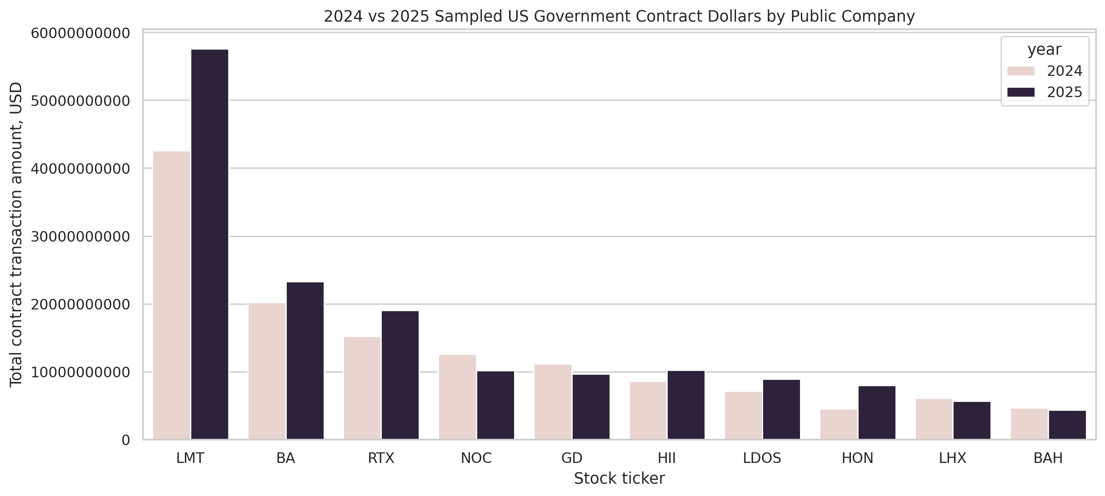
Figure 1. Sampled contract dollars by public company and year.
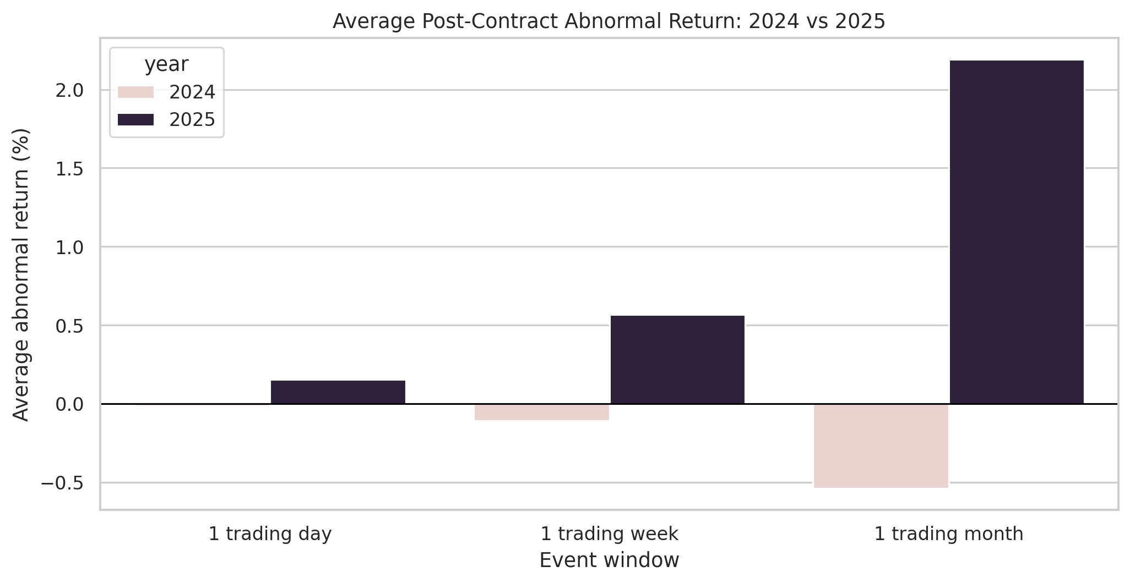
Figure 2. Average post-contract abnormal return by event window.
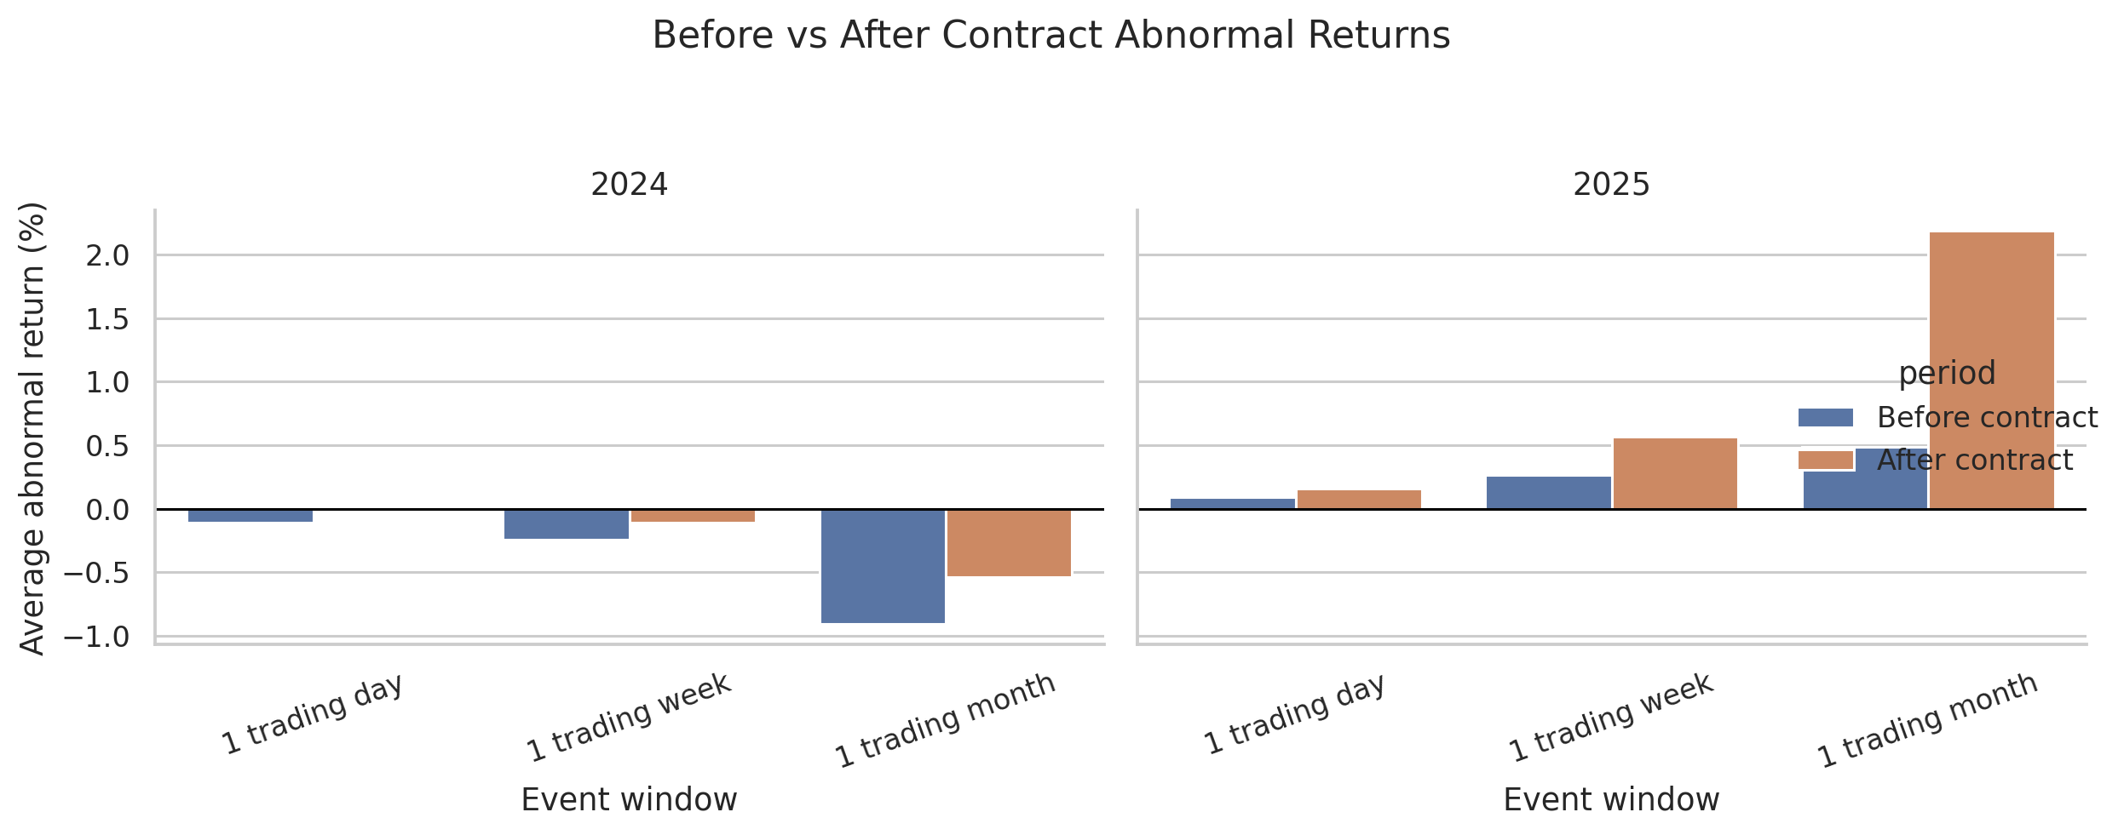
Figure 3. Before-and-after abnormal return comparison by year.
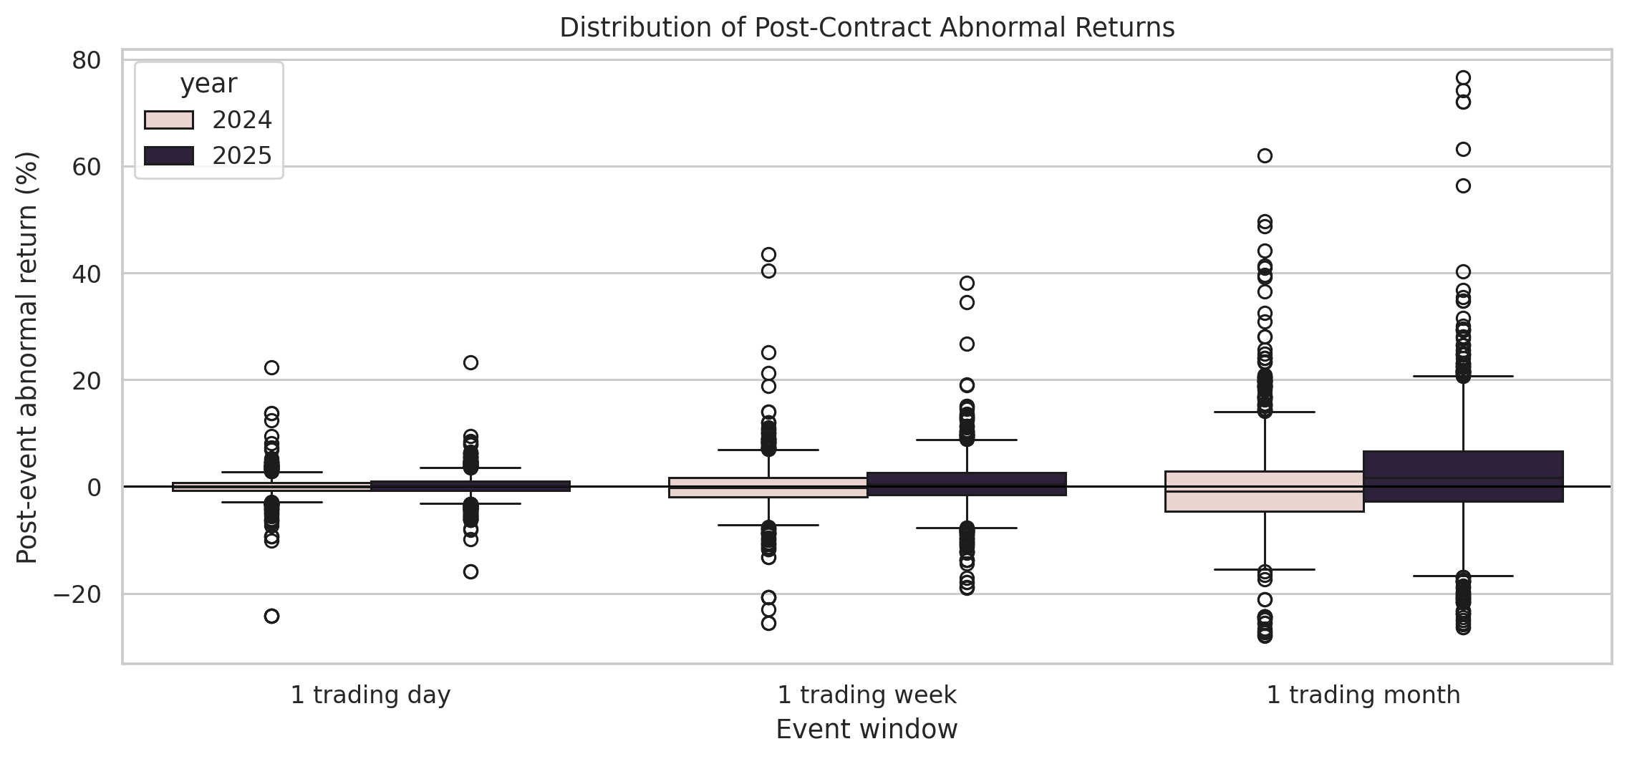
Figure 4. Distribution of post-event abnormal returns.
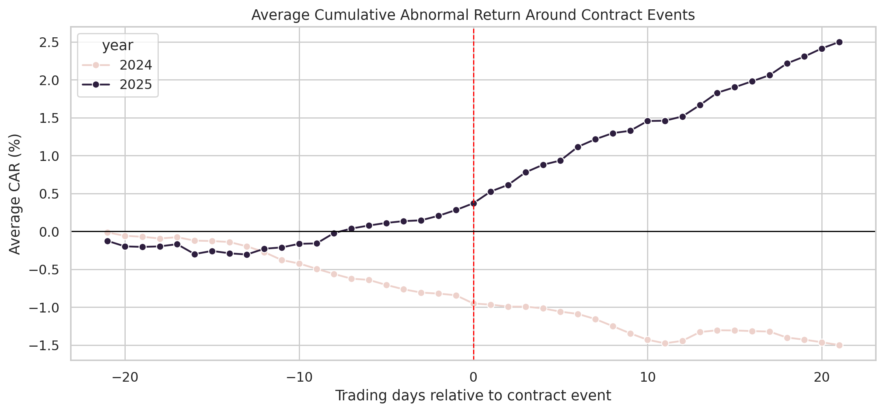
Figure 5. Average cumulative abnormal return around contract events.
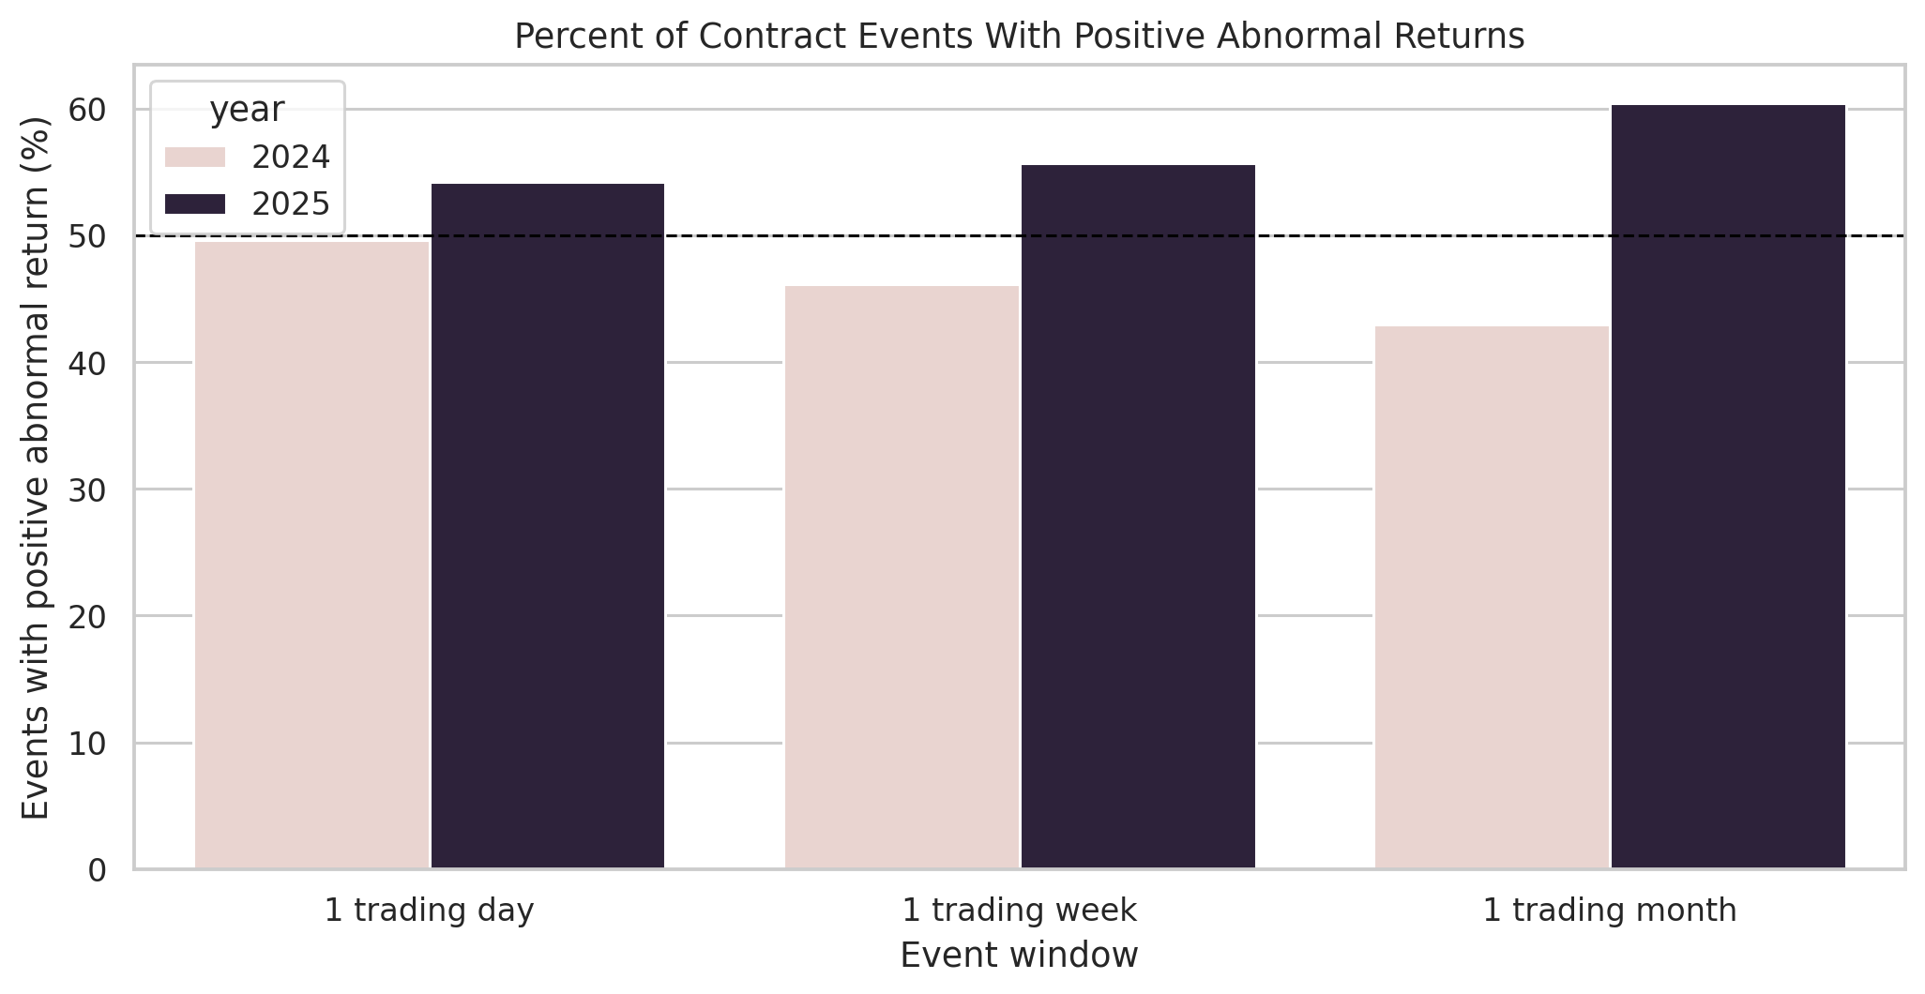
Figure 6. Percentage of events with positive abnormal returns.
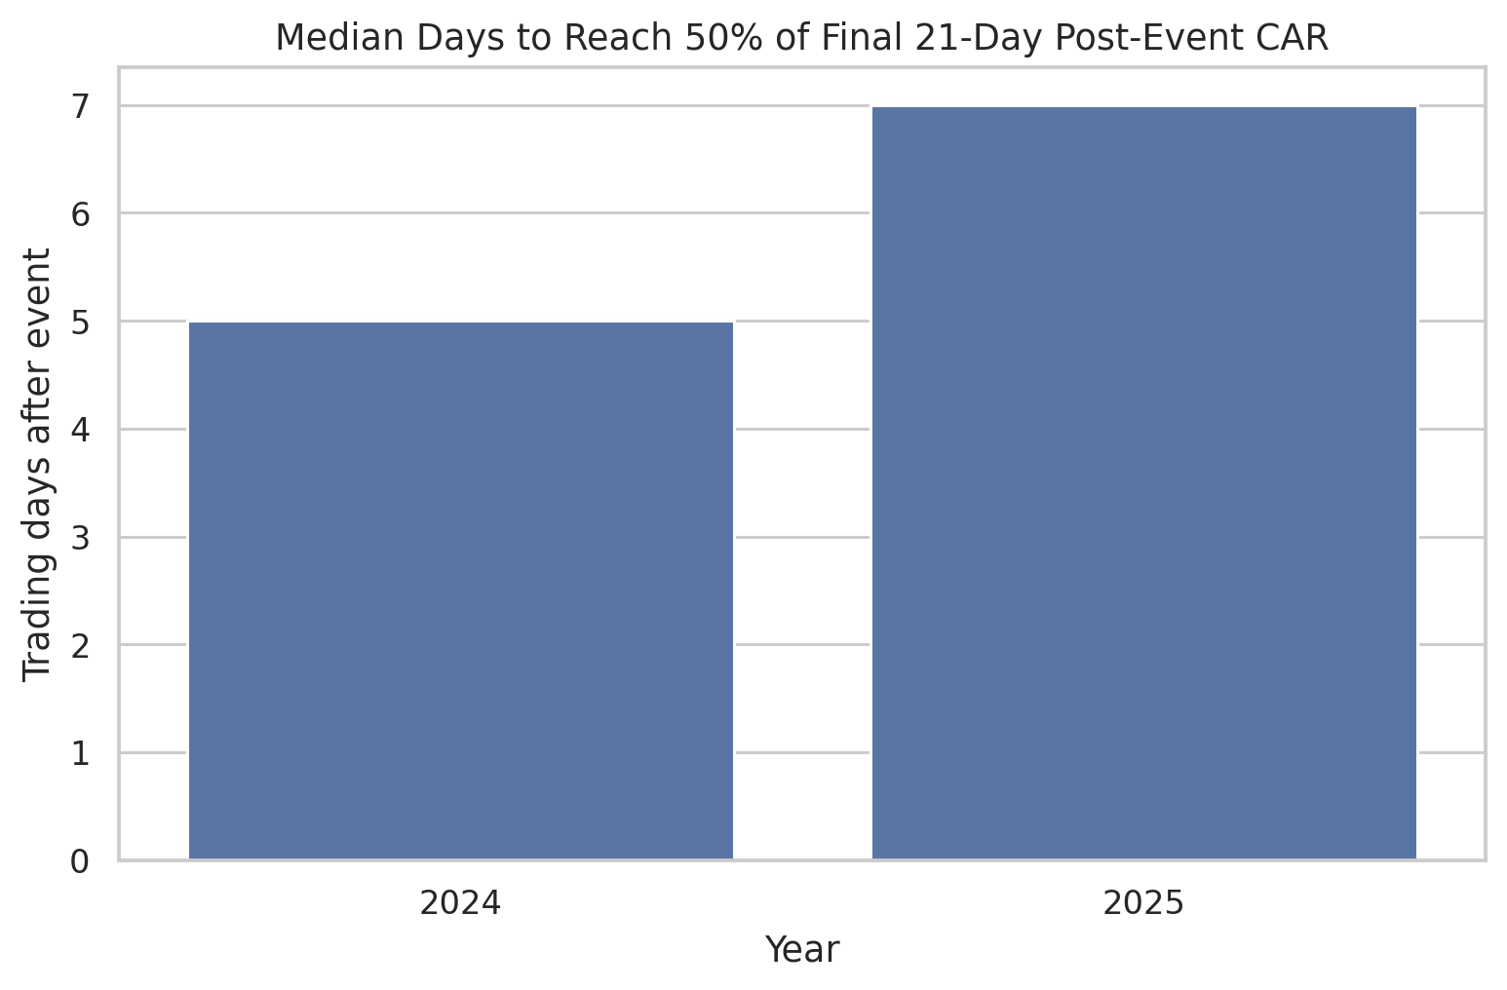
Figure 7. Median price-reflection speed by year.

Limitations
Several limitations affect the strength of the inferences that can be drawn from this analysis. They are listed roughly in order of importance.
- Anticipation effect. Major Department of Defense contract awards are typically announced through DoD press releases and company press releases on or shortly before the USAspending action date. The action date is therefore often not the moment of first public disclosure, which would attenuate any measurable post-action-date reaction even if contracts were genuinely informative.
- Event clustering. The watchlist contains twelve companies and the sample contains 5,650 events, so any given company contributes hundreds of events. Simple t-statistics treat these as independent observations and therefore understate the true standard error. A cluster-robust or firm-fixed-effects specification would tighten inference.
- Sector-control imperfection. ITA controls for the aerospace and defense sector cleanly but includes the watchlist names in its own holdings, which slightly biases the abnormal-return estimate toward zero. A peer-excluded sector proxy would be a cleaner control but was not implemented in this version.
- Selection effects. The watchlist is a curated set of major defense and federal-services contractors, and the events are only those for which a contract was awarded. Neither dimension is randomly sampled.
- Recipient-string matching. USAspending recipient search text can match subsidiaries, joint ventures, or related entities; strict legal-entity mapping would require manual review.
- Award-modification information loss. Deduplicating by (ticker, award_id) removes later modifications that may themselves have been genuinely informative (large option exercises, scope changes). The trade-off is cleaner event definition at the cost of some information.
- Macro and budget-cycle confounds. The benchmark itself is exposed to defense-budget headlines, continuing-resolution news, and geopolitical shocks. ITA-adjustment removes the common component, but timing differences between watchlist names and ITA holdings can leak in.
- Exploratory, not causal. The study measures market behavior around contract dates; it does not establish that the contract caused the observed return, and it is not investment advice.

Conclusion
This personal project demonstrates an applied analytics workflow: collecting public government-contract data, preparing an event dataset with deduplication, integrating market prices, calculating abnormal returns against a sector-matched benchmark, attaching statistical confidence measures, and presenting results through tables and figures.
A substantive findings come out of the study. First, the choice of benchmark dominates the conclusion. Switching from SPY to ITA on the same companies and the same dates moves the 2025 one-month average abnormal return from +2.19% to −1.16% a swing larger than any year-on-year difference reported in the original analysis. Any future event study should use a sector-matched benchmark by default.
The report should be interpreted as an exploratory portfolio project rather than an investment recommendation. Its value is in demonstrating reproducible scraping, data preparation, financial event-study logic, and clear presentation of analytical findings.

Appendix: Generated Project Files
- outputs/charts/average_car_around_events_2021_2025_ita.png
- outputs/charts/average_post_abnormal_return_2021_2025_ita.png
- outputs/charts/before_after_abnormal_returns_by_year_2021_2025_ita.png
- outputs/charts/contract_dollars_by_company_2021_2025_ita.png
- outputs/charts/market_efficiency_reflection_speed_2021_2025_ita.png
- outputs/charts/positive_abnormal_return_percent_2021_2025_ita.png
- outputs/charts/post_abnormal_return_distribution_2021_2025_ita.png
- outputs/data/company_year_contract_totals_2021_2025_ita.csv
- outputs/data/contract_events_2021_2025_ita.csv
- outputs/data/daily_close_prices_2021_2025_ita.csv
- outputs/data/event_level_market_efficiency_2021_2025_ita.csv
- outputs/data/event_window_returns_2021_2025_ita.csv
- outputs/data/market_efficiency_summary_2021_2025_ita.csv
- outputs/data/relative_day_event_panel_2021_2025_ita.csv
- outputs/data/top_25_contract_events_2021_2025_ita.csv
- outputs/data/window_summary_2021_2025_ita.csv
- outputs/data/year_comparison_summary_2021_2025_ita.csv

