2024 vs 2025 US Government Contracts and Stock Market Reaction Analysis
Tanush Reddy
May 24, 2026

Data sources: USAspending.gov public API and Yahoo Finance market data via yfinance

Executive Summary
This portfolio project studies whether publicly traded companies show measurable stock price movement around US government contract announcements. The analysis compares 2024 and 2025 contract events, evaluates stock returns before and after each event, and benchmarks company returns against SPY as a broad US equity market proxy.
- The scraped dataset contains 4,429 contract events from 2024-01-02 through 2025-12-31.
- The sample covers 12 publicly traded companies mapped to stock tickers.
- Total sampled contract transaction value is approximately $298,349,443,960.
- The analysis calculates 13,287 event-window return rows and 190,447 relative-day panel rows.
- The strongest post-event comparison in the generated results is the 2025 one-month window, which is higher than the comparable 2024 result.

Introduction
Government contracts can be economically meaningful for public companies, particularly in defense, aerospace, technology, consulting, engineering, and federal services. When a contract is announced or recorded, investors may reassess expected revenue, backlog, competitive position, or future cash flows. This report evaluates whether such contract events are followed by abnormal stock returns and whether market reaction patterns differ between 2024 and 2025.
This project is designed as an event-study style analysis. It does not attempt to prove causality; instead, it measures market behavior around contract dates and summarizes whether the price reaction appears immediate or gradual.

Project Objectives
- Scrape US government contract transaction data for selected public companies.
- Identify the stock ticker associated with each contract recipient search query.
- Download adjusted daily stock prices for the same companies and for SPY.
- Calculate pre-event and post-event returns over 1 trading day, 1 trading week, and 1 trading month.
- Compute abnormal returns as company stock return minus SPY return.
- Compare 2024 and 2025 results using tables and graphs suitable for a portfolio presentation.

Dataset Source and Collection
The government contract dataset was collected from USAspending.gov, the official public source for US federal spending data. The Python workflow uses the USAspending public API endpoint `/api/v2/search/spending_by_transaction/` to retrieve transaction-level contract records. For market data, the workflow uses Yahoo Finance through the `yfinance` Python package to download adjusted daily closing prices for each stock ticker and SPY.
The contract scrape is controlled by a transparent public-company watchlist in the Python file. Each watchlist entry contains a ticker, a recipient search query, and a company name. The script submits API POST requests with recipient search text, a calendar-year time period, and USAspending contract award type codes A, B, C, and D. The returned records include award ID, recipient name, action date, transaction amount, awarding agency, award type, and transaction description.

Dataset Preparation
After scraping, the workflow standardizes column names, converts action dates into date objects, converts transaction amounts into numeric values, filters out records below the minimum transaction threshold, removes duplicate transaction records when identifier columns are available, and assigns a unique event ID to every contract event. The final contract event dataset is then saved as `contract_events_2024_2025.csv`.
The stock-price dataset is prepared by downloading adjusted closing prices over a date range that extends before and after the earliest and latest contract dates. The data is reshaped into a consistent long format with `date`, `ticker`, and `close` columns. This format supports event-window return calculations and relative-day panel construction.

Execution Workflow
The analysis file is organized as a Colab-ready workflow. Each cell section produces its own output: settings, output folders, scraped data tables, daily price tables, event-return tables, summary tables, charts, and a downloadable output zip. The workflow can also be run as a regular Python script. The primary execution steps are:
- Install required libraries: pandas, numpy, matplotlib, seaborn, requests, and yfinance.
- Define the years, event windows, benchmark ticker, output folders, and public-company watchlist.
- Scrape contract transactions from USAspending by company and year.
- Download adjusted daily closing prices from Yahoo Finance.
- Calculate returns before and after each contract event.
- Build comparison summaries for 2024 and 2025.
- Generate charts and save all CSV and PNG outputs.

Methodology
For each contract event, the script identifies the first available trading date on or after the contract action date. It then calculates stock returns before and after the event using three windows: 1 trading day, 5 trading days, and 21 trading days. SPY is used as a simple market benchmark. Abnormal return is calculated as:
Abnormal return = Company stock return - SPY return
The workflow also builds a relative-day event panel from 21 trading days before the event to 21 trading days after the event. This panel is used to calculate cumulative abnormal return (CAR) and to estimate whether the market reaction appears immediate or gradual.

Dataset Overview
- Contract event rows: 4,429
- Daily close price rows: 7,735
- Event-window return rows: 13,287
- Relative-day event panel rows: 190,447
- 2024 sampled contract dollars: $136,719,398,389
- 2025 sampled contract dollars: $161,630,045,571

Main Results
The main summary table compares average and median post-contract abnormal returns across the three event windows. It also reports the percentage of events with positive post-event returns.
Year | Plain English Window | Number Of Events | Avg Pre Return Percent | Avg Post Return Percent | Median Post Return Percent | Percent Events With Positive Post Return
2024 | 1 trading day | 2191 | -0.109 | -0.015 | -0.010 | 49.658
2024 | 1 trading week | 2191 | -0.246 | -0.109 | -0.214 | 46.143
2024 | 1 trading month | 2191 | -0.911 | -0.538 | -0.850 | 42.994
2025 | 1 trading day | 2238 | 0.089 | 0.155 | 0.172 | 54.245
2025 | 1 trading week | 2238 | 0.263 | 0.567 | 0.416 | 55.719
2025 | 1 trading month | 2238 | 0.484 | 2.191 | 1.728 | 60.456

2024 vs 2025 Comparison
The direct comparison table shows that 2025 produced stronger average post-contract abnormal returns than 2024 across the 1-day, 1-week, and 1-month event windows in this sample. The 1-month window shows the largest difference between years.
Plain English Window | Avg Post Abnormal Return Percent 2024 | Avg Post Abnormal Return Percent 2025 | Median Post Abnormal Return Percent 2024 | Median Post Abnormal Return Percent 2025 | Avg Post Abnormal Return Percent Change 2025 Minus 2024
1 trading day | -0.015 | 0.155 | -0.010 | 0.172 | 0.170
1 trading week | -0.109 | 0.567 | -0.214 | 0.416 | 0.677
1 trading month | -0.538 | 2.191 | -0.850 | 1.728 | 2.729

Market-Efficiency Analysis
A more efficient market reaction would generally show much of the abnormal return close to the contract event date. A slower drift over several trading days can indicate delayed reaction, continued information processing, overlapping news, or broader sector effects. The workflow estimates the median trading day on which events reached 50 percent of their final 21-day post-event cumulative abnormal return.
Year | Number Of Events | Avg 21 Day Post Car Percent | Median 21 Day Post Car Percent | Median First 50Pct Reflection Day | Percent Reflected By Day 1 | Percent Reflected By Day 5
2,024.000 | 2,191.000 | -0.658 | -0.768 | 5.000 | 25.650 | 50.662
2,025.000 | 2,238.000 | 2.219 | 1.817 | 7.000 | 22.252 | 45.710

Top Contract Events
The table below lists the largest contract events in the scraped sample. These large transactions are useful for presentation because they make the economic scale of the dataset clear.
Year | Ticker | Company Name | Action Date | Transaction Amount | Awarding Agency | Award Id
2025 | LMT | Lockheed Martin | 2025-09-29 | $14,145,203,547 | Department of Defense | N0001923C0003
2024 | LMT | Lockheed Martin | 2024-12-20 | $7,384,655,472 | Department of Defense | N0001923C0003
2025 | HII | Huntington Ingalls | 2025-05-09 | $2,522,463,215 | Department of Defense | N0002423C2307
2025 | BA | Boeing | 2025-11-25 | $2,469,937,348 | Department of Defense | FA862511C6600
2024 | LMT | Lockheed Martin | 2024-09-27 | $2,423,365,242 | Department of Defense | FA868224CB001
2024 | BA | Boeing | 2024-11-21 | $2,389,323,828 | Department of Defense | FA862511C6600
2025 | BA | Boeing | 2025-11-25 | $2,295,831,204 | Department of Defense | W58RGZ26C0002
2024 | BA | Boeing | 2024-07-30 | $2,223,793,610 | Department of Defense | FA863423F0048
2025 | RTX | RTX / Raytheon | 2025-07-15 | $2,144,246,724 | Department of Defense | HQ085120C0002
2025 | LMT | Lockheed Martin | 2025-09-17 | $1,952,893,441 | Department of Defense | N0001920C0032

Graphs and Visual Evidence
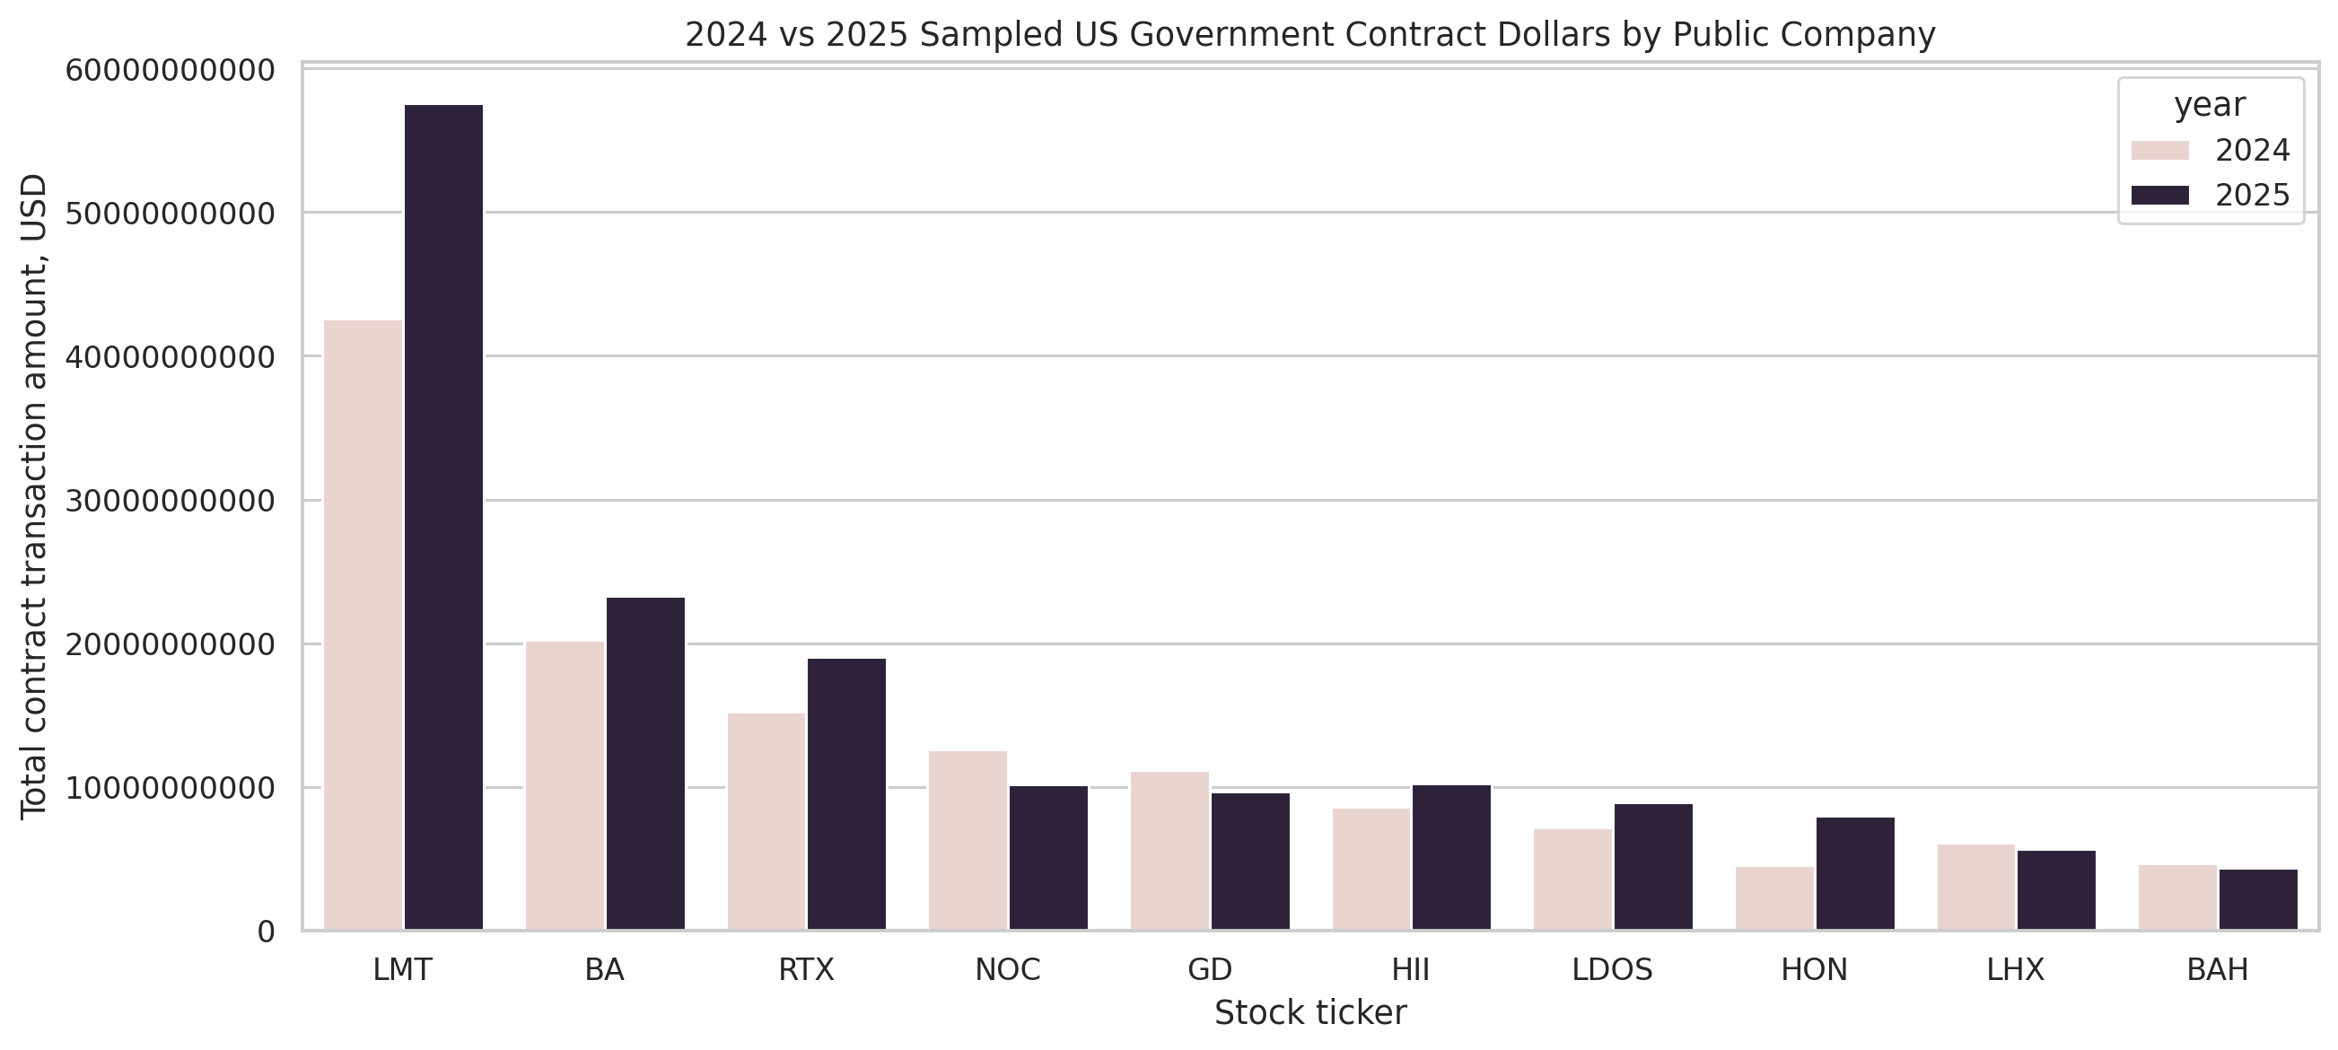
Figure 1. Sampled contract dollars by public company and year.
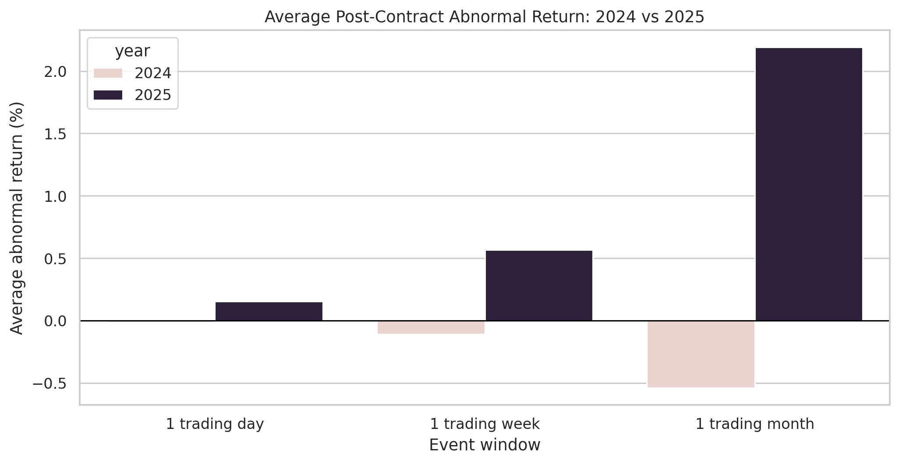
Figure 2. Average post-contract abnormal return by event window.
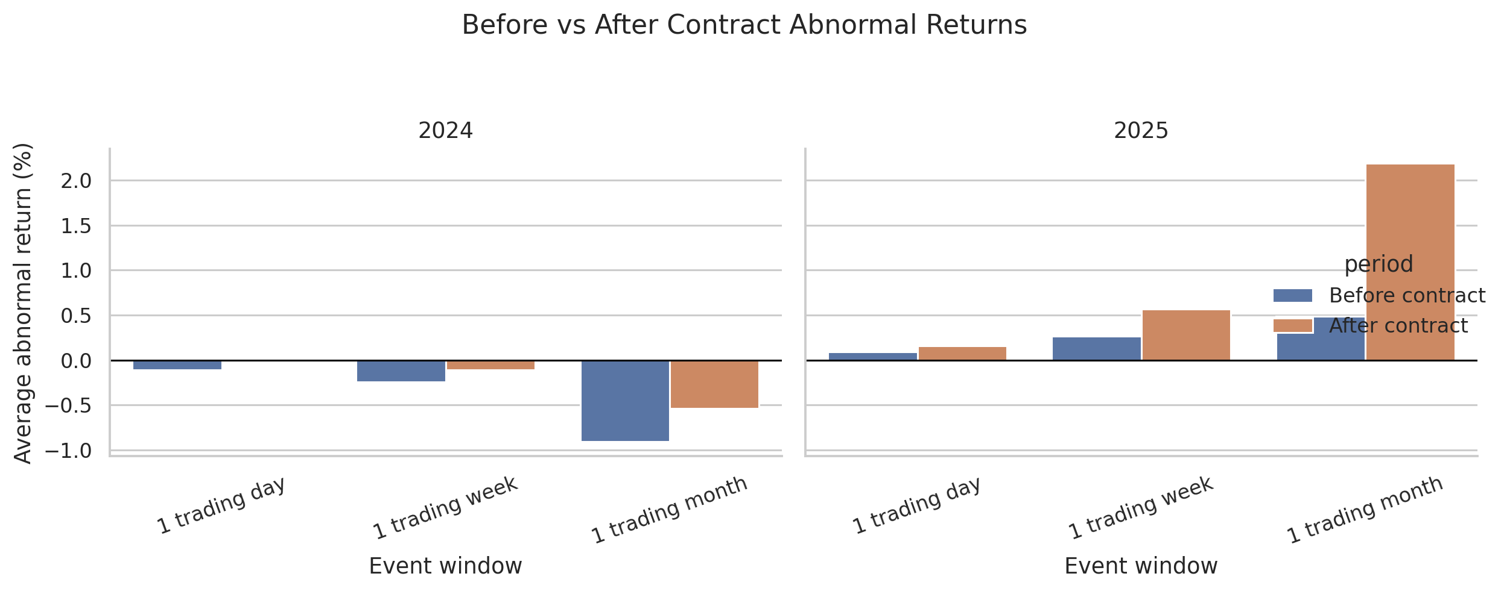
Figure 3. Before-and-after abnormal return comparison by year.
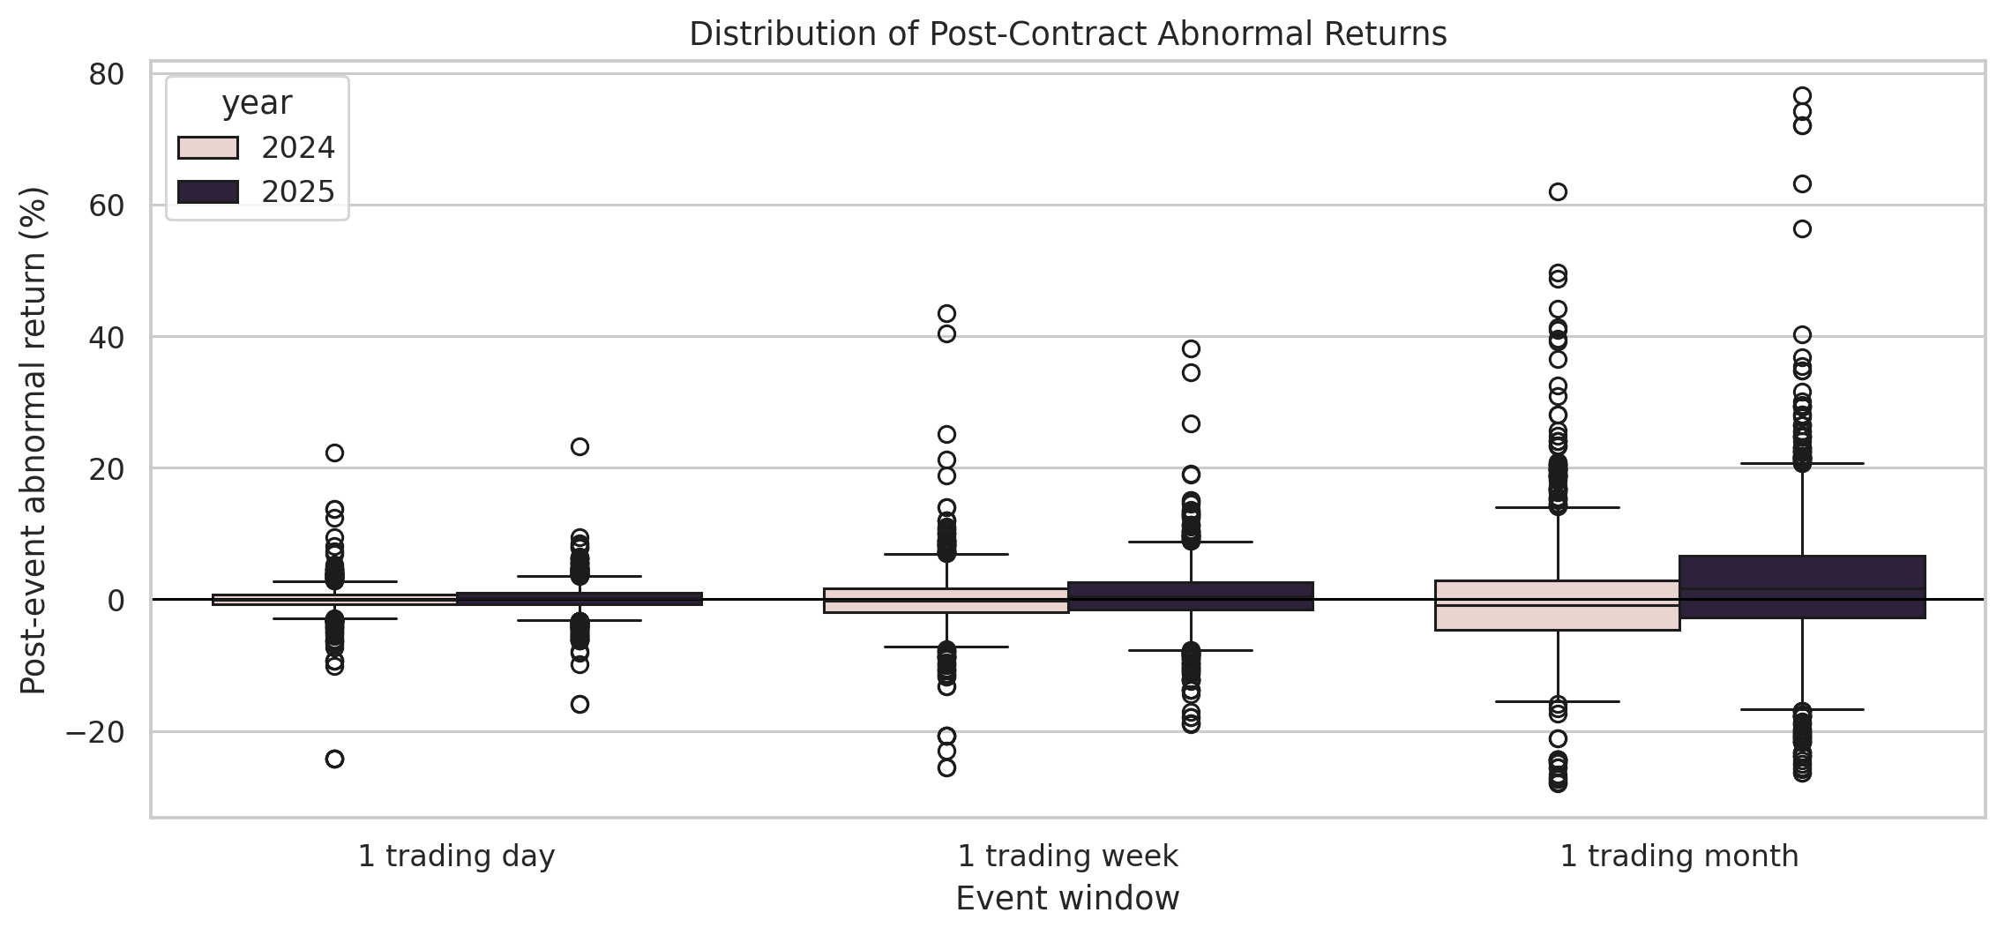
Figure 4. Distribution of post-event abnormal returns.
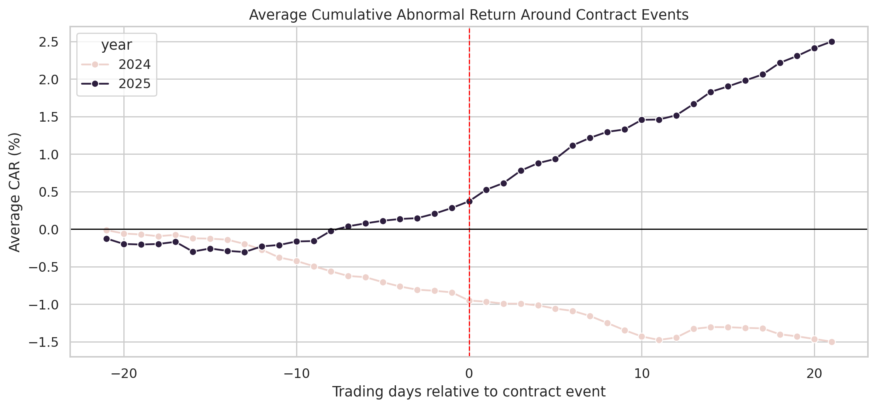
Figure 5. Average cumulative abnormal return around contract events.
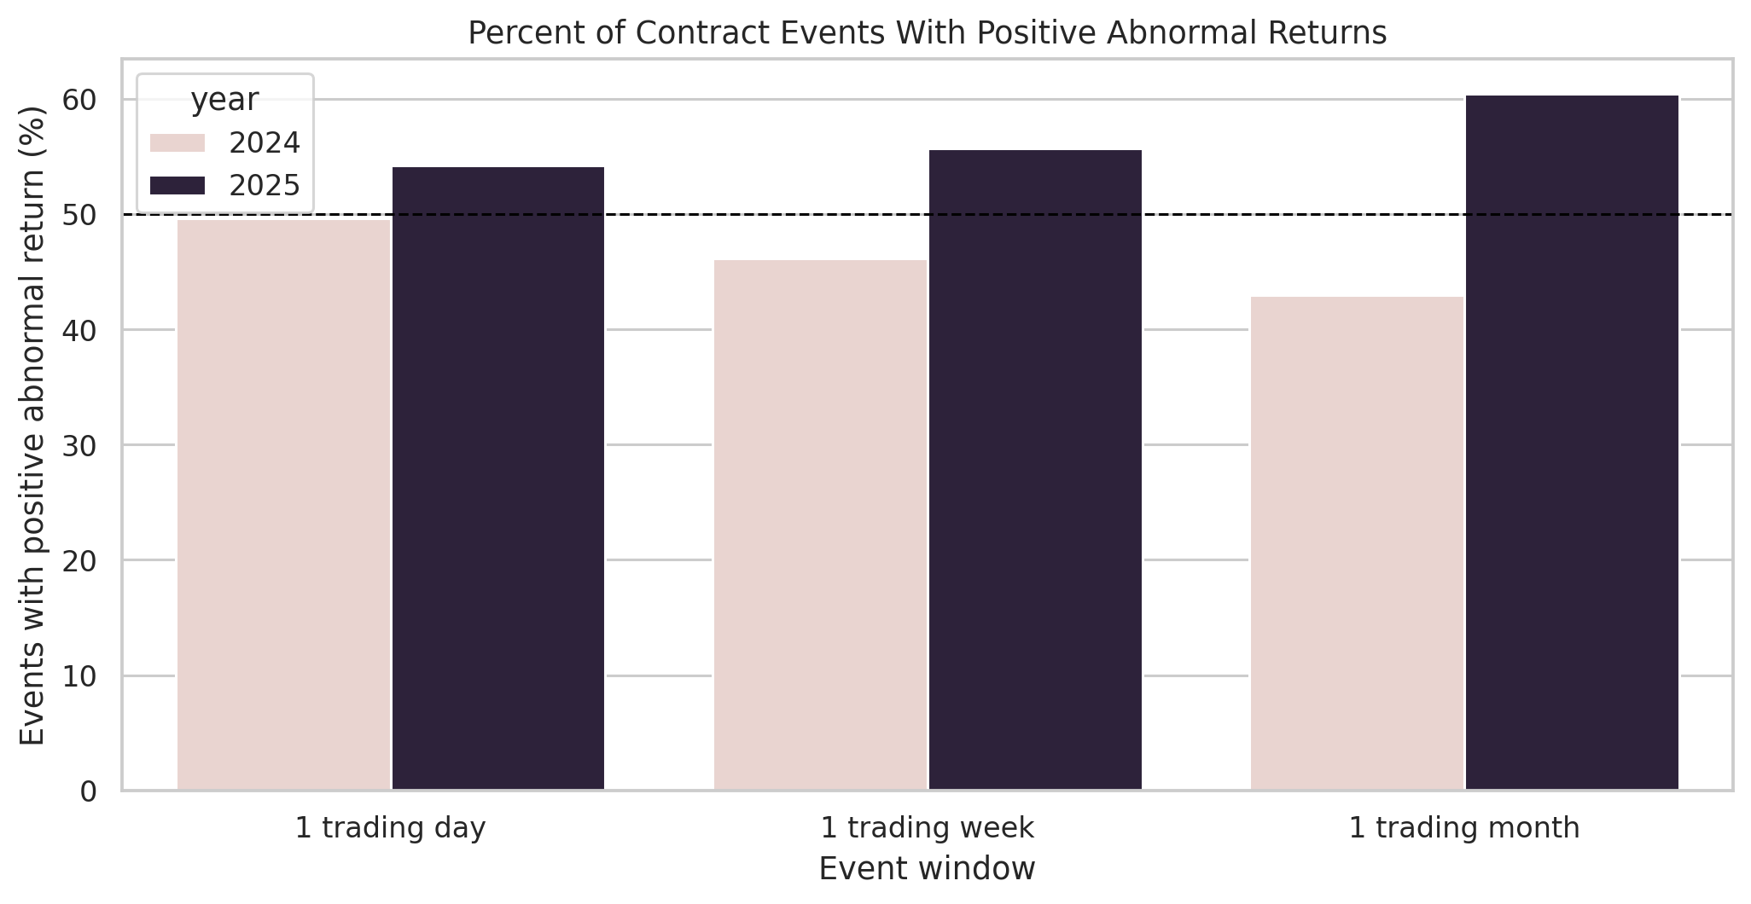
Figure 6. Percentage of events with positive abnormal returns.
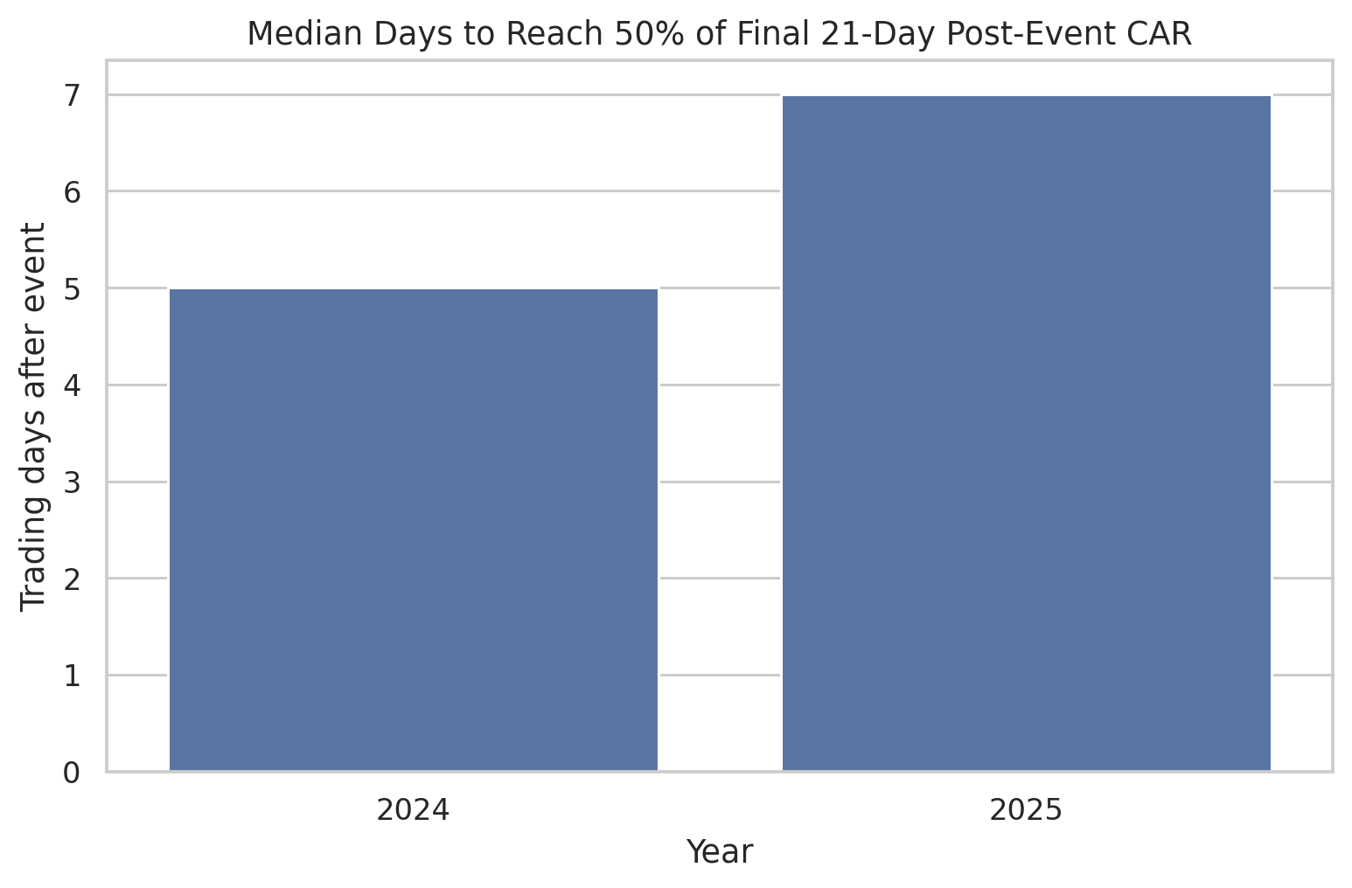
Figure 7. Median price-reflection speed by year.

Limitations
- The sample is based on a selected public-company watchlist, not every public company receiving federal contracts.
- Recipient search text can match subsidiaries, divisions, or related entities and may require manual review for strict corporate mapping.
- The study uses SPY as a simple market benchmark rather than a multi-factor model.
- The analysis is exploratory and does not prove that contracts caused the observed stock-price movement.
- Other events such as earnings, macroeconomic news, defense-budget news, or company announcements may overlap with contract dates.

Conclusion
This project demonstrates a full data-analysis workflow: public API data collection, dataset preparation, financial market data integration, event-window return calculation, market-benchmark adjustment, comparative analysis, and professional visualization. In the generated results, 2025 shows stronger positive post-contract abnormal returns than 2024 across the measured event windows, especially over the 21-trading-day period. The market-efficiency metrics suggest that a portion of the reaction occurs after the event date rather than immediately, which supports the interpretation that the market response may be gradual in this sample.
The report should be interpreted as an exploratory portfolio project rather than an investment recommendation. Its value is in demonstrating reproducible scraping, data preparation, financial event-study logic, and clear presentation of analytical findings.

Appendix: Generated Project Files
- outputs/charts/average_car_around_events_2024_vs_2025.png
- outputs/charts/average_post_abnormal_return_2024_vs_2025.png
- outputs/charts/before_after_abnormal_returns_by_year.png
- outputs/charts/contract_dollars_by_company_2024_vs_2025.png
- outputs/charts/market_efficiency_reflection_speed_2024_vs_2025.png
- outputs/charts/positive_abnormal_return_percent_2024_vs_2025.png
- outputs/charts/post_abnormal_return_distribution_2024_vs_2025.png
- outputs/data/company_year_contract_totals_2024_2025.csv
- outputs/data/contract_events_2024_2025.csv
- outputs/data/daily_close_prices_2024_2025.csv
- outputs/data/event_level_market_efficiency_2024_2025.csv
- outputs/data/event_window_returns_2024_2025.csv
- outputs/data/market_efficiency_summary_2024_2025.csv
- outputs/data/relative_day_event_panel_2024_2025.csv
- outputs/data/top_25_contract_events_2024_2025.csv
- outputs/data/window_summary_2024_2025.csv
- outputs/data/year_comparison_summary_2024_vs_2025.csv

