**CHEKKAPALLI TANUSHA**

**20EM1A0515**

**SWARNANDHRA INSTITUTE OF ENG& TECHNOLOGY**



**Initializing the Spring Boot Application :**

1.Go to the <https://start.spring.io/> this website.

2.Then choose lang, and Add Dependencies as shown below;

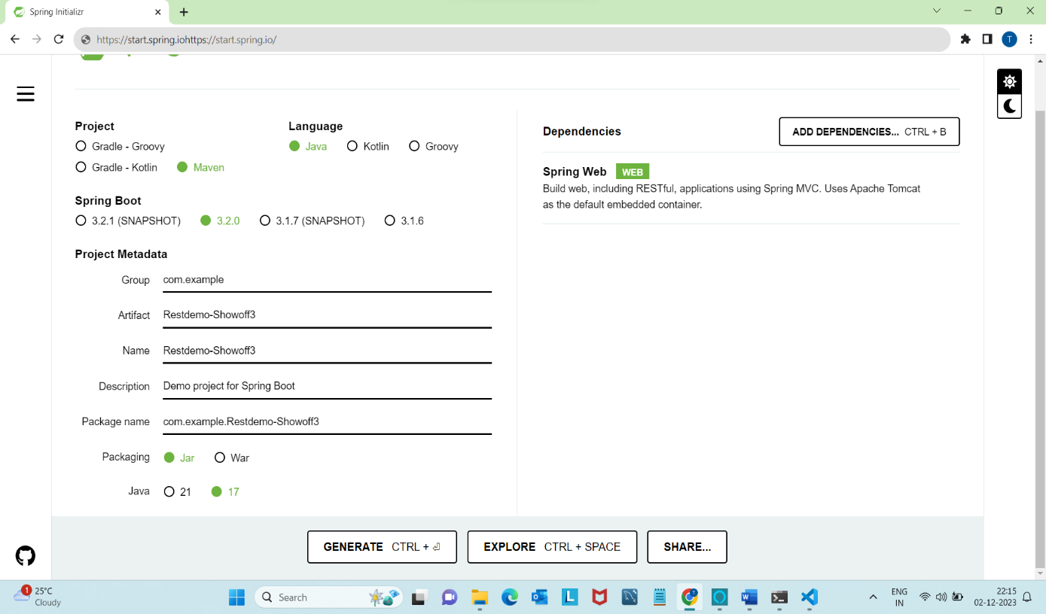

3. After Generate this ,and open the downloaded zip file and right click on it,,,,,

Then tap Extract all and click “**EXTRACT**”.

4. And go to search bar, then select the COPY ADD and REMOVE IT

And type “*CMD”.*

5. and COMMAND PROMPT app will open, then type **<<<** code .

6. It directly goes to **VSCODE APP.**

7.And the selected folder will directly Opened…

As Shown below…and next click on RUN and “START DEBBUGGING”.

This shows a TOMCAT webserver started at port **8080.**

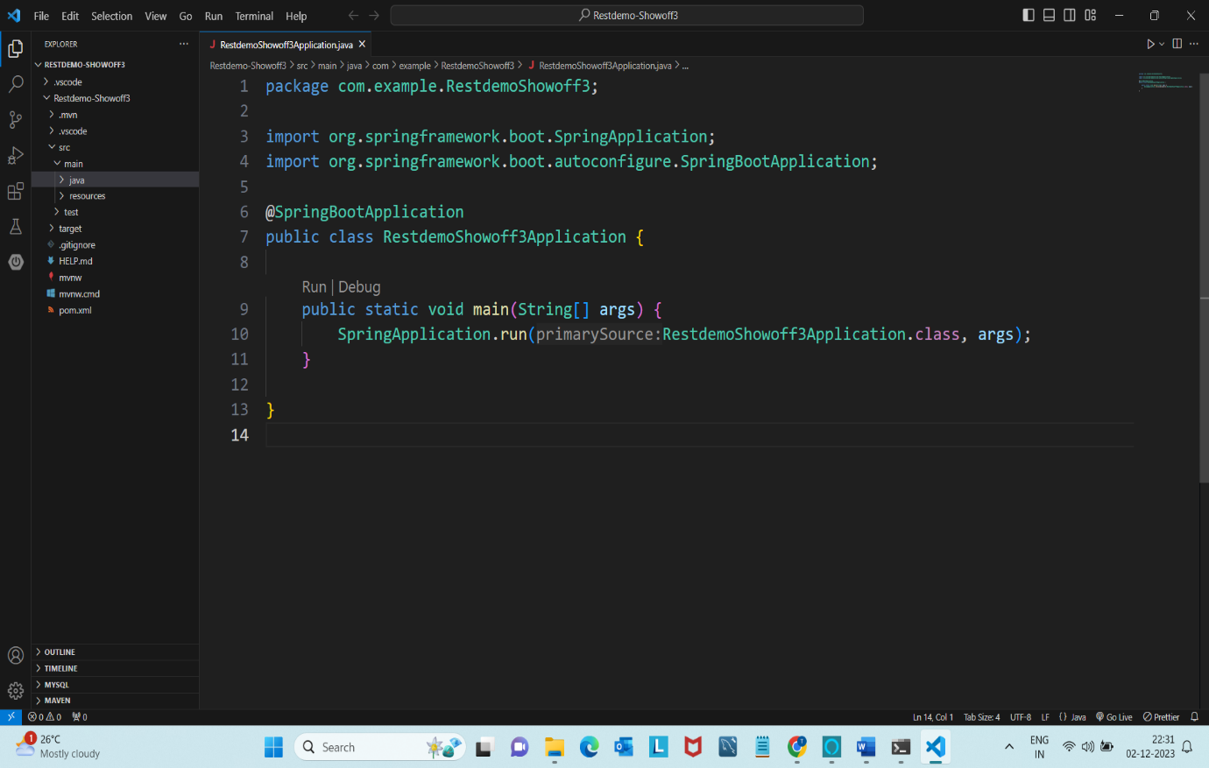

8.It shows a Whitelabel Error Page

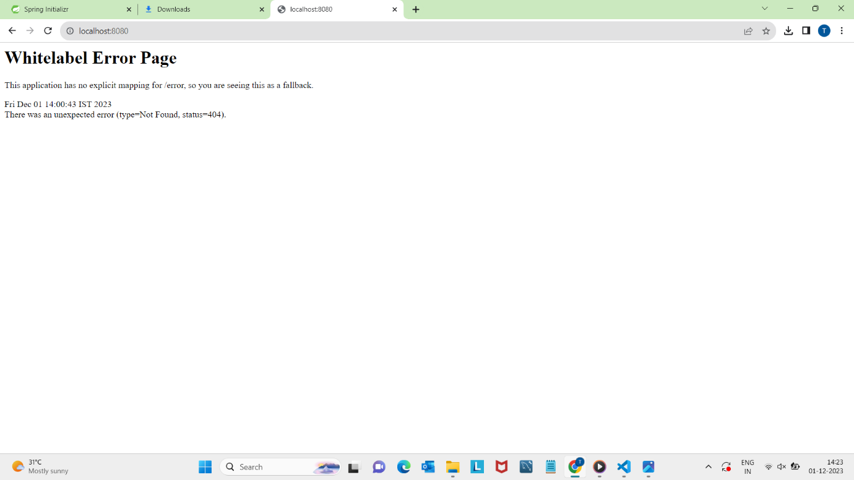

9. go to src < main < java/com/ example/ RestdemoShowoff3 , and click that highlighted one .

10. In that That RestdemoShowoff3 create a new folder named as “Model”,

11. In that folder create a File named as “CloudVendor.java” as shown below….

12. And create a another Folder named as “Controller”..

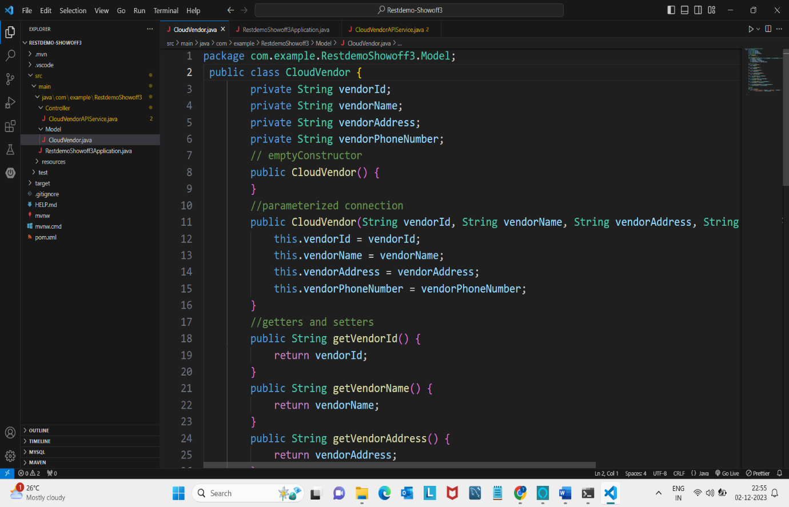

13. And In that folder create one File named as “CloudVendorAPIService.java”

Aftr completion of the code

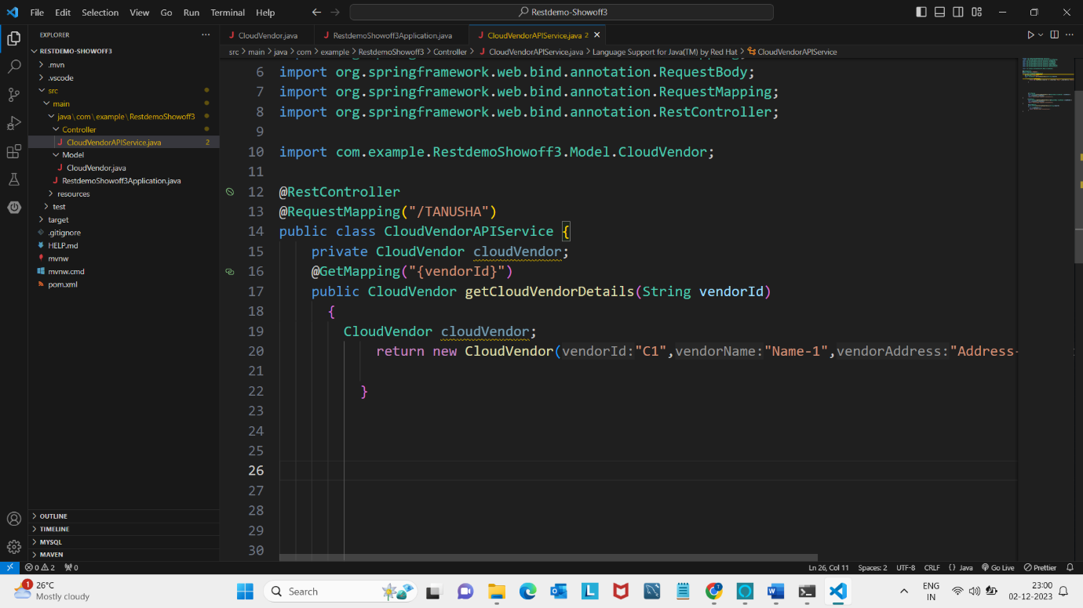

14. and next click on RUN and “START DEBBUGGING”. This shows a TOMCAT webserver strtd at port **8080.**

And IT SHOWS THE OUTPUT OF **VENDOR DETAILS**……AS BELOW

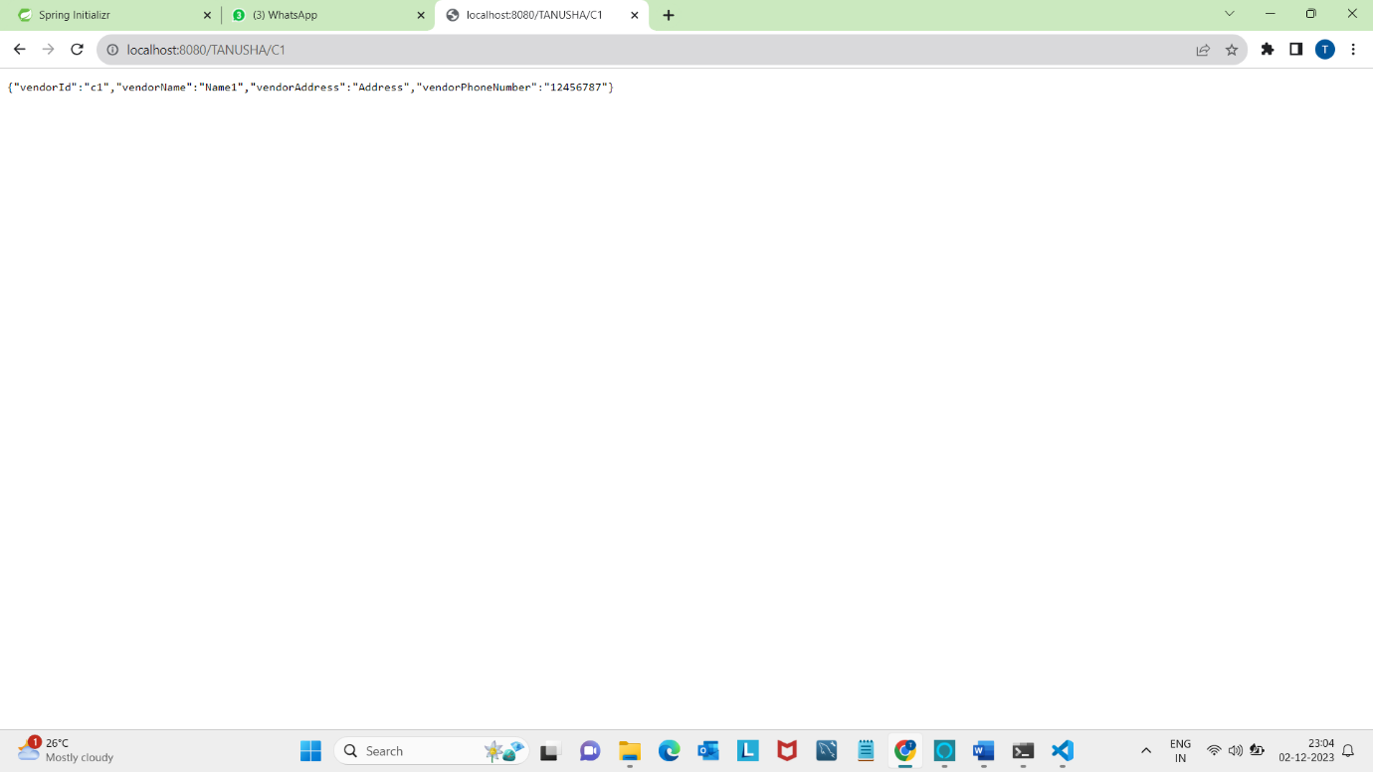

**1**. Lets continue the process of showoff3 ,, first download the App of **Postman**

**2**.Go to this url <https://www.postman.com/downloads/> to download the App..

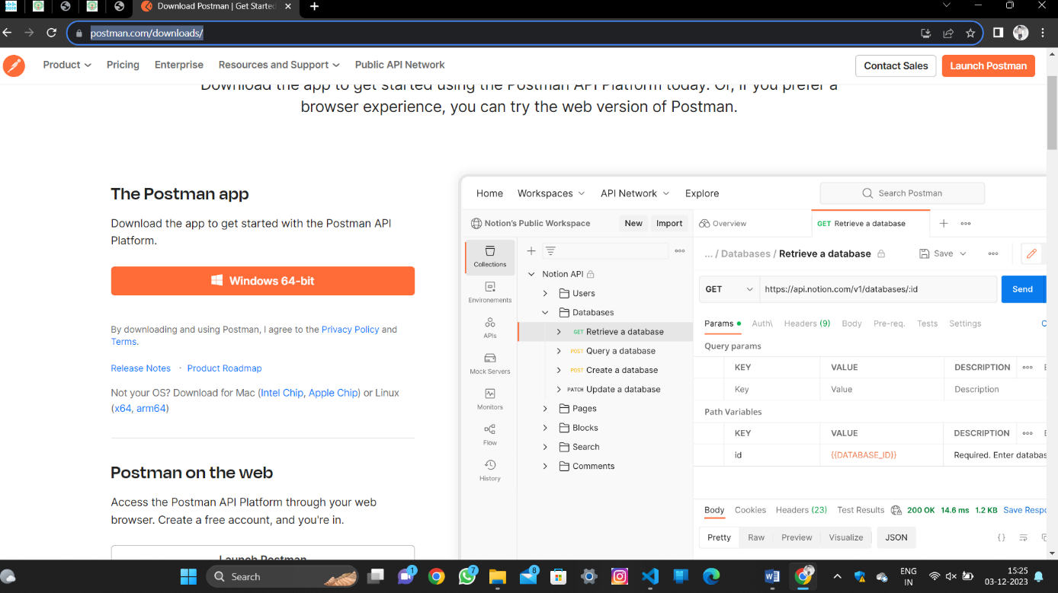

**3. Now open previous code in Visualstudioapp, and open** CloudVendorAPIService.java module.



4.Open postman app and create Blank collection and give name to that blankcollection as *******.

5. In the ********** collection add a request and assign the name to that request as Get and save it.

6.Copy the url ************ from the browser and past it in postman and click Send button.

7.It will display the following details…..

8.Again go to VScode and this methods

> @PostMapping

> @PutMapping

> @DeleteMapping

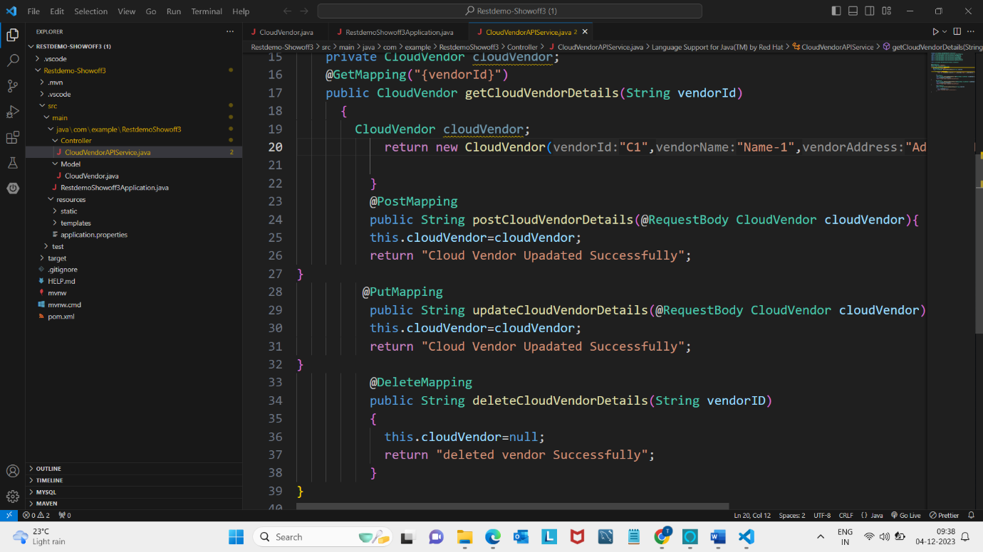

9.get output:

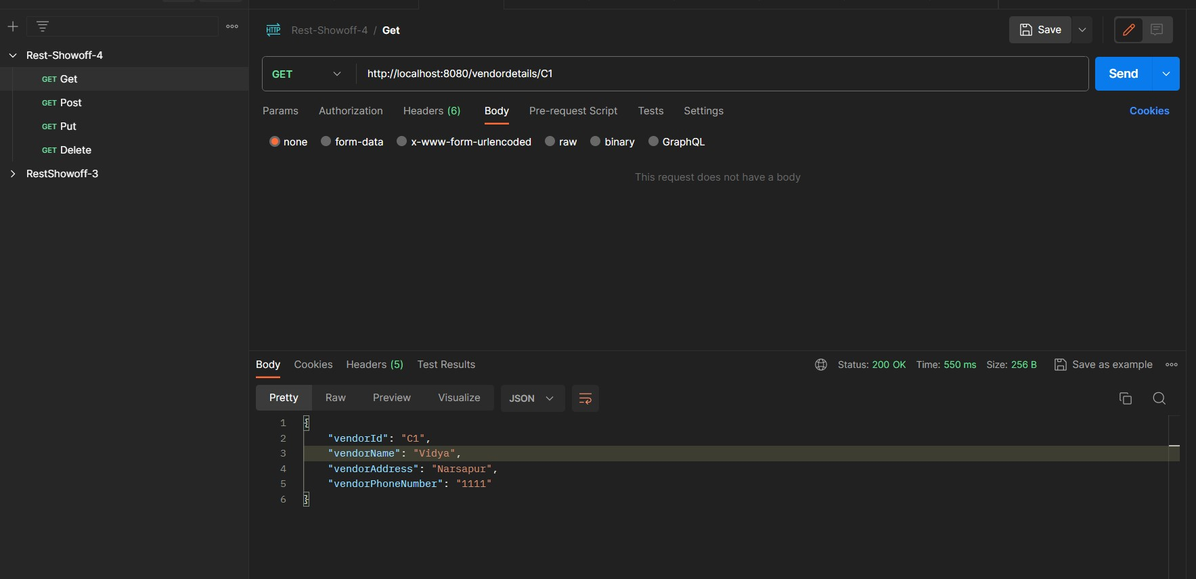

10. And past the copied url ********* in postrequest , Enter the details and click Body -> raw->Text-> JSON. click Send button.

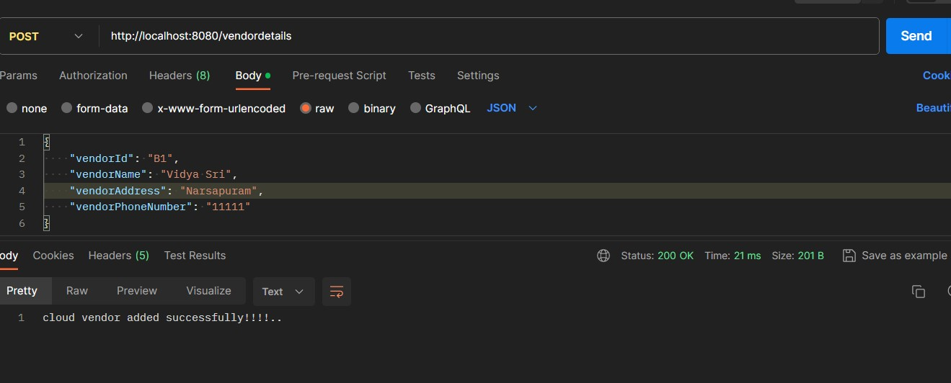

**@GetMapping after performing @PostMapping:**

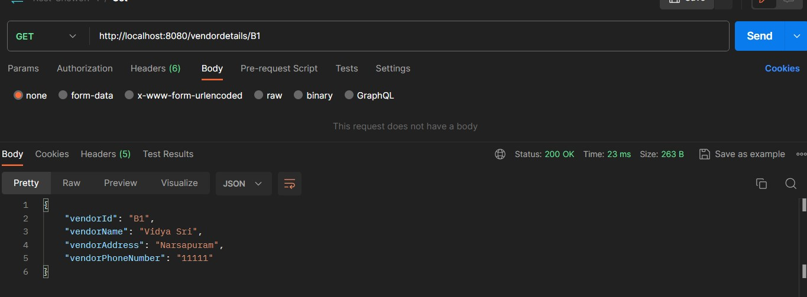

11. Create a newrequest file in ****** and name it as Put .Then the details are updated.

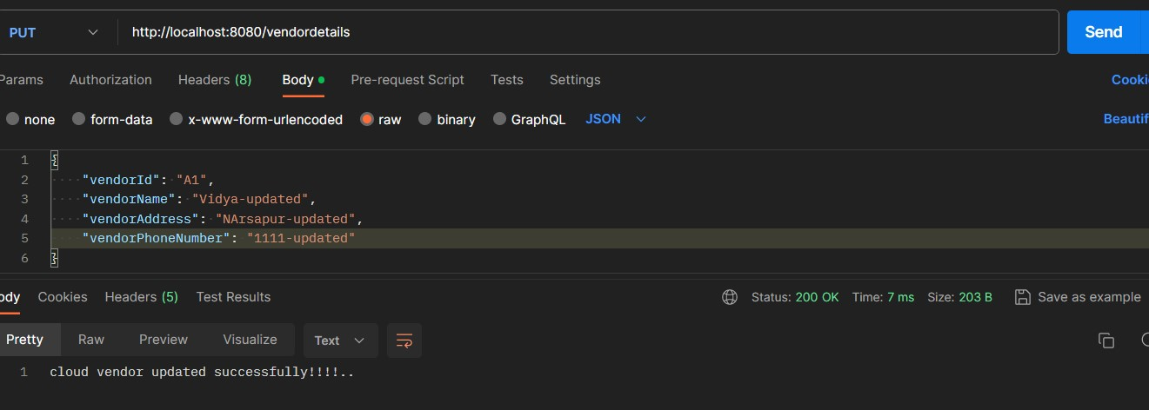

**@GetMapping after performing @PutMapping :**

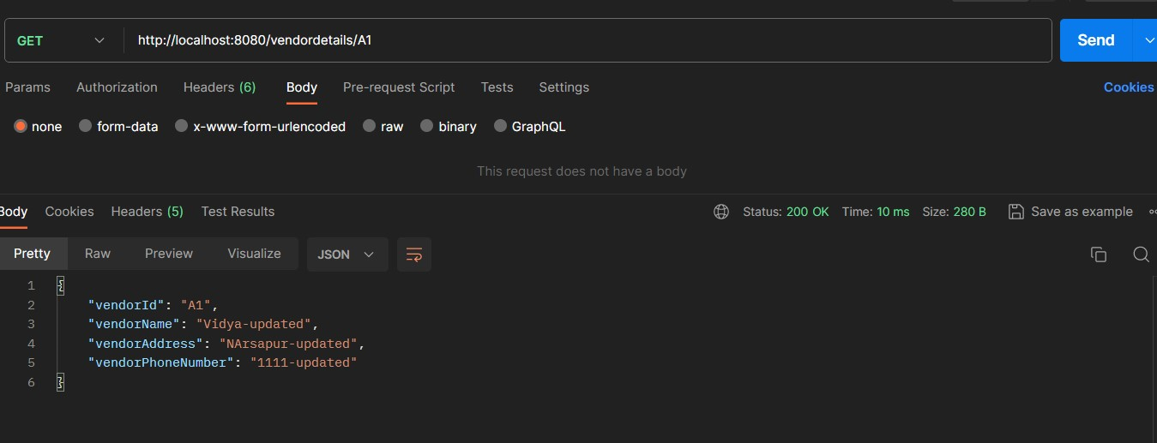

**@DeleteMapping :**

* An HTTP DELETE method that deletes the cloud vendor details associated with the provided vendorId path variable. The method sets the class variable to null and returns a success message.
* **OUTPUT:**

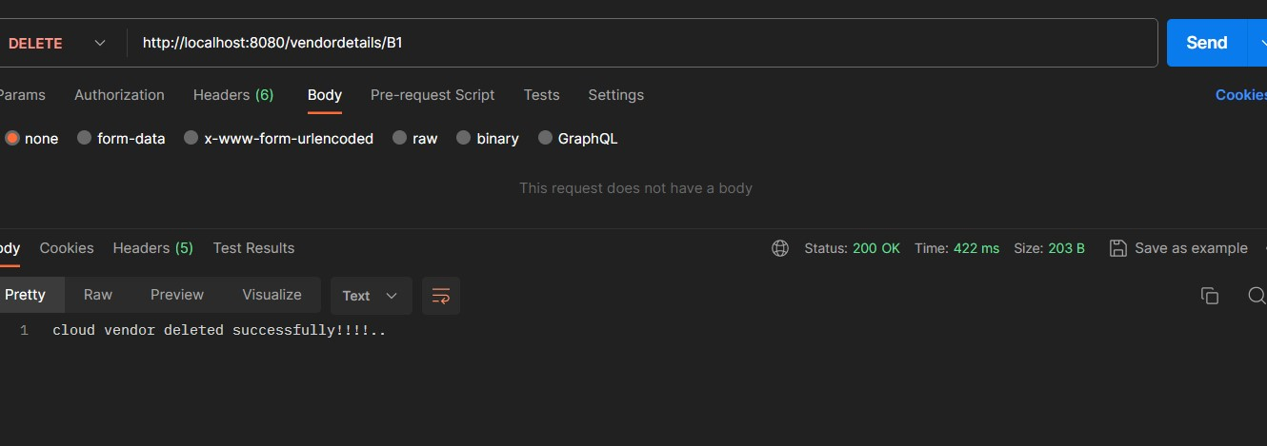

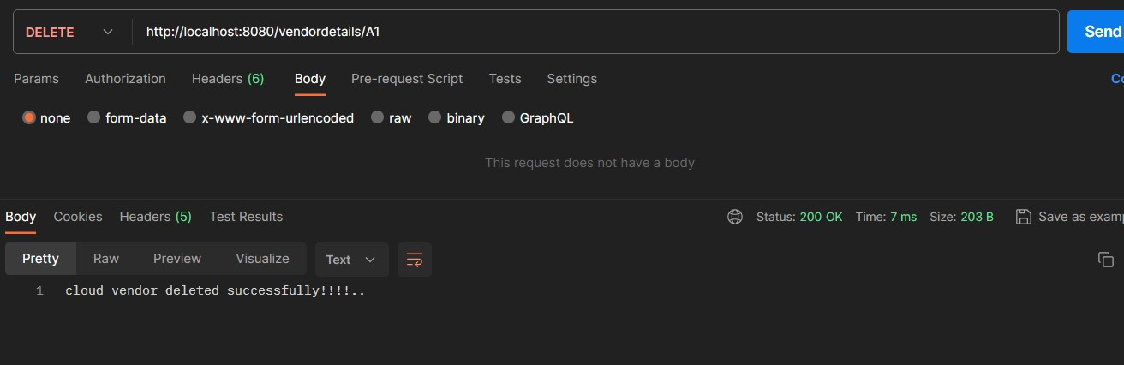

14. Check in the Get request to confirm whether the details or deleted or not.

**@GetMapping after performing DeleteMapping :**

**OUTPUT :**

