FairML — Cross-Dataset Results Report
Mapping the group-vs-individual fairness trade-off across six datasets · September 2026

At a glance
- Method works on every dataset with a real disparity. The fair model cuts group disparity (DPD2) by 71–93% on COMPAS, Adult, ACS Public Coverage and ACS Employment, for 0–1.5 accuracy points.
- RQ1 – the two objectives pull apart. Training for group fairness makes individual fairness worse, and training for individual fairness does not fix group disparity, on 3 of 4 datasets.
- RQ2 – the trade-off is common but not universal. It replicates on COMPAS, Adult and ACS Public Coverage for both models; ACS Employment shows no trade-off. German fails because 1,000 rows are too few to tune on; Taiwan has almost no disparity to fix.
- RQ3 – competitive, not superior. The fair MLP sits on the accuracy–fairness frontier on every main dataset; dedicated baselines sometimes reach lower disparity at slightly lower accuracy.
- Strongest new dataset: ACS Public Coverage. Largest gains, cleanest trade-off, and the most reliable measurements of all six.

1. What we are testing
One training loss with two dials:
Loss = α·BCE + (1 − α)·[ β·SoftDP + (1 − β)·SoftGE ]
- α — how much weight goes to accuracy (α = 1: plain model, no fairness).
- β — how the fairness weight is split: β = 1 all group fairness, β = 0 all individual fairness.
- DPD2 (group fairness) — gap in positive-prediction rate between the two groups compared. Lower = fairer.
- GE(2) (individual fairness) — inequality in how much benefit each person gets from the model (generalized entropy, α = 2). Lower = fairer.
- Protocol — 7×7 α×β grid, logistic regression (LR) and a 64-64 MLP, 10 random splits (60/20/20). The ‘fair model’ is picked on the validation split. Significance = paired Wilcoxon test over the 10 seeds, Holm-corrected (** p < 0.01, * p < 0.05).

2. The datasets
Dataset | Role | Domain | Predicts (positive = 1) | Groups compared | Rows | Positive rate | Label gap
COMPAS | Main | Criminal justice | Re-offends within 2 years | African-American vs Caucasian | 6,172 | 46% | 13.2 pts
Adult | Main | Income (1994 census) | Income > $50K | Male vs Female | 45,222 | 25% | 19.9 pts
ACS Public Coverage | Main | Public health benefits (2018 census) | Has public health coverage | White vs Black | 50,000 | 37% | 16.4 pts
ACS Employment | Boundary case | Employment (2018 census) | Is employed | female vs male | 50,000 | 57% | 9.7 pts
Taiwan Credit | Discussion | Credit card default | Defaults next month | female vs male | 30,000 | 22% | 3.4 pts
German Credit | Discussion | Credit risk | Bad credit risk | male vs female | 1,000 | 30% | 7.5 pts

Label gap = difference in the true positive-outcome rate between the two groups. It is the disparity a model can inherit, so it predicts how much room the method has to work.
COMPAS, Adult, and ACS Public Coverage start with more group disparity, so there is more room for the fairness intervention to reduce DPD2. Taiwan and German start with low disparity, so there is less room for improvement.

Features used
Dataset | # | Features
COMPAS | 8 | age, sex, race, prior convictions count, juvenile felony / misdemeanor / other counts, charge degree (felony vs misdemeanor)
Adult | 12 | age, work class, education level, marital status, occupation, relationship, race, sex, capital gain, capital loss, hours per week, native country
ACS Public Coverage | 18 | age, schooling, marital status, sex, race, disability, employment status of parents, citizenship, moved last year, military service, ancestry, nativity, hearing / vision / cognitive difficulty, personal income, employment status, gave birth last year
ACS Employment | 17 | age, schooling, marital status, sex, race, disability, employment status of parents, moved last year, citizenship, military service, ancestry, nativity, relationship to household head, hearing / vision / cognitive difficulty, grandparent caring for grandchild
Taiwan Credit | 23 | credit limit, sex, education, marriage, age, repayment status for 6 months, bill amount for 6 months, payment amount for 6 months
German Credit | 9 | age, sex, job type, housing, savings account, checking account, credit amount, loan duration, loan purpose

All numeric features are standardized and categorical ones one-hot encoded. The sensitive attribute is kept as an input feature on every dataset.

Where the data comes from
- COMPAS — ProPublica’s public release, with their standard row filters (n = 6,172). The ‘duration’ feature used in earlier versions leaked the label and was removed.
- Adult — OpenML ‘adult’ v2, rows with missing values dropped; the census sampling weight is excluded.
- ACS Public Coverage / Employment — Folktables (Ding et al., NeurIPS 2021), California 2018 census, a fixed random 50,000-row sample. Public Coverage keeps only White and Black respondents (age < 65, income ≤ $30K) so every metric compares exactly that pair.
- Taiwan Credit — UCI ‘default of credit card clients’ via OpenML (n = 30,000).
- German Credit — UCI Statlog German Credit (n = 1,000).

3. RQ1 — Does each fairness objective only help its own metric?
At the selected α, we put all fairness weight on one term (β = 1 group only, or β = 0 individual only) and compare with the plain model. If the two notions are in tension, each objective should improve its own metric and leave the other unchanged or worse — a ‘double dissociation’.
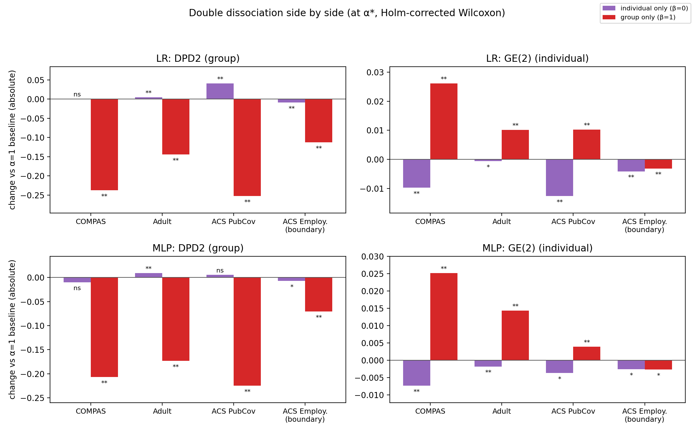
Figure 1. Change versus the plain model when all fairness weight goes to the group term (red) or the individual term (purple). Below zero = fairer.
For COMPAS, Adult, and ACS Public Coverage, there is a clear separation. Group-only training strongly reduces DPD2, but GE(2) gets worse. Individual-only training improves GE(2), but has very little improvement in DPD2, and sometimes DPD2 gets worse. So optimizing one fairness notion does not automatically give us the other one
Dataset | Model | Group only: DPD2 | Group only: GE(2) | Indiv. only: GE(2) | Indiv. only: DPD2
COMPAS | LR | −0.237** | +0.026** | −0.010** | +0.001 (ns)
COMPAS | MLP | −0.207** | +0.025** | −0.007** | −0.010 (ns)
Adult | LR | −0.144** | +0.010** | −0.001* | +0.004**
Adult | MLP | −0.173** | +0.014** | −0.002** | +0.009**
ACS Public Coverage | LR | −0.252** | +0.010** | −0.013** | +0.041**
ACS Public Coverage | MLP | −0.225** | +0.004** | −0.004* | +0.006 (ns)
ACS Employment | LR | −0.113** | −0.003** | −0.004** | −0.009**
ACS Employment | MLP | −0.071** | −0.003* | −0.003* | −0.007*

Answer: yes on COMPAS, Adult and ACS Public Coverage; no on ACS Employment.
- Group-only training cuts DPD2 by 0.14–0.25 and always worsens GE(2) on the three main datasets (both models, all significant).
- Individual-only training improves GE(2) but never meaningfully fixes group disparity. On ACS Public Coverage (LR) it makes it worse: 0.285 → 0.326.
- The effects are lopsided: the group term moves its own metric by 73–93%, the individual term by only ~1–7%.
- ACS Employment: both objectives improve both metrics, so there is no tension to measure there.

4. RQ2 — Is the trade-off consistent across datasets and models?
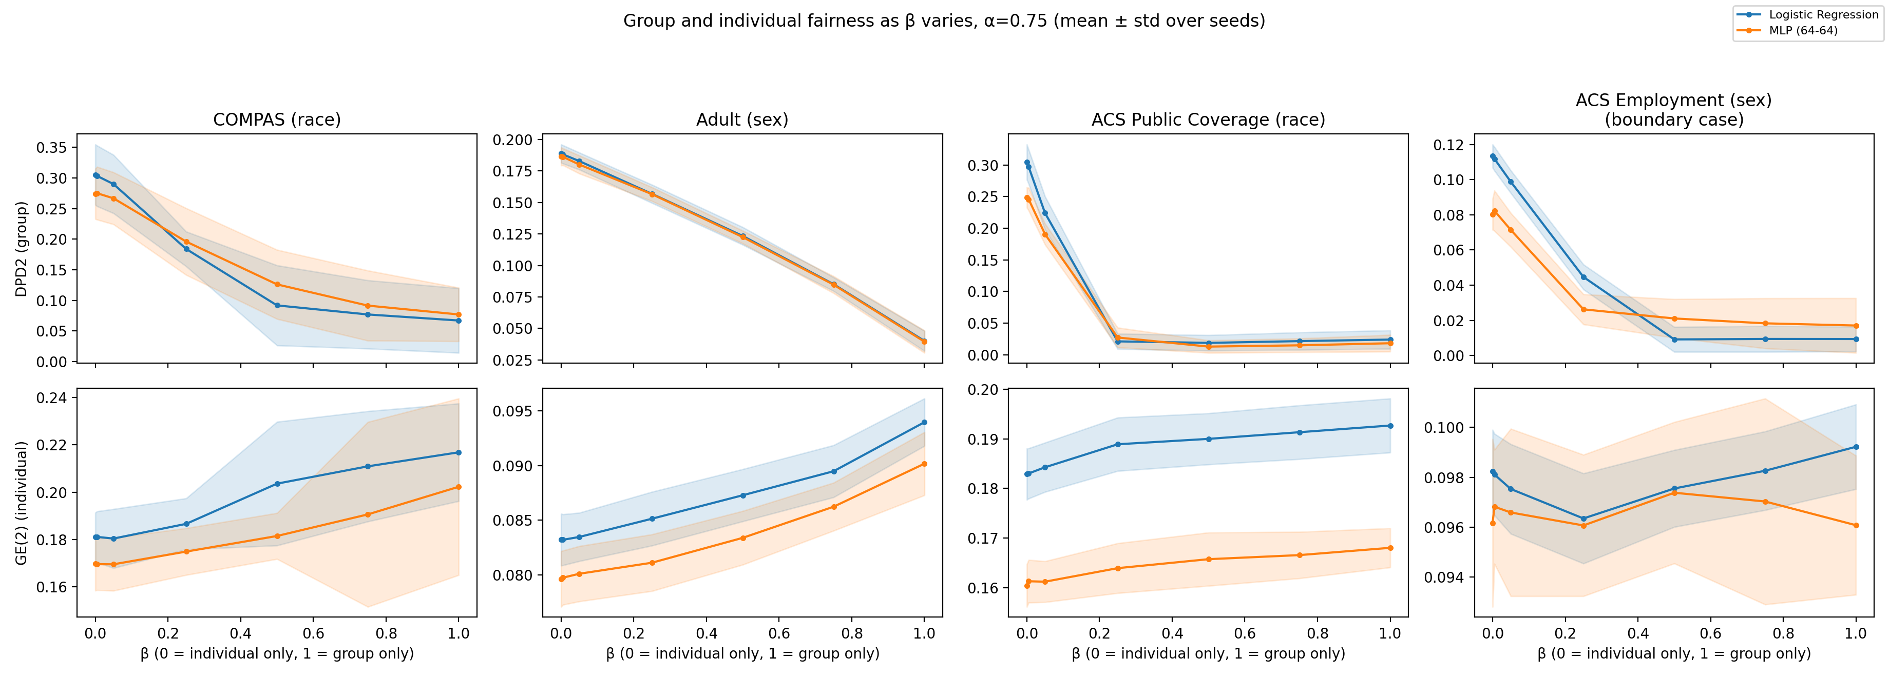
Figure 2. Group fairness (top) and individual fairness (bottom) as β moves from individual-only (0) to group-only (1), at α = 0.75. Bands = ±1 std over 10 seeds.
Here β controls how much weight goes to each fairness objective. β = 0 is individual-only, and β = 1 is group-only. The top row is group disparity, DPD2, and the bottom row is individual inequality, GE(2). Lower is better for both metrics
For COMPAS, that's exactly what happens. Moving β from 0 to 1 makes DPD2 drop substantially, while GE(2) increases. So improving group fairness comes at a cost to individual fairness.
Adult gives an even smoother pattern. DPD2 steadily decreases while GE(2) steadily increases as β increases
Public Coverage shows the strongest pattern. DPD2 drops very quickly, especially by around β = 0.25, while GE(2) continues increasing.
Dataset | Trade-off? | LR and MLP agree? | Verdict
COMPAS | Yes – DPD2 ↓, GE(2) ↑ | Yes | Replicates
Adult | Yes – smooth, near-linear | Yes | Replicates
ACS Public Coverage | Yes – DPD2 drops by β ≈ 0.25, GE(2) keeps rising | Yes | Replicates (strongest)
ACS Employment | No – GE(2) flat | Yes | Boundary case
Taiwan Credit | Direction holds, but tiny (DPD2 already ≈ 0.01) | Partly | Low-disparity control
German Credit | No detectable effect | — | Too small to tune

Why German fails and Taiwan doesn’t
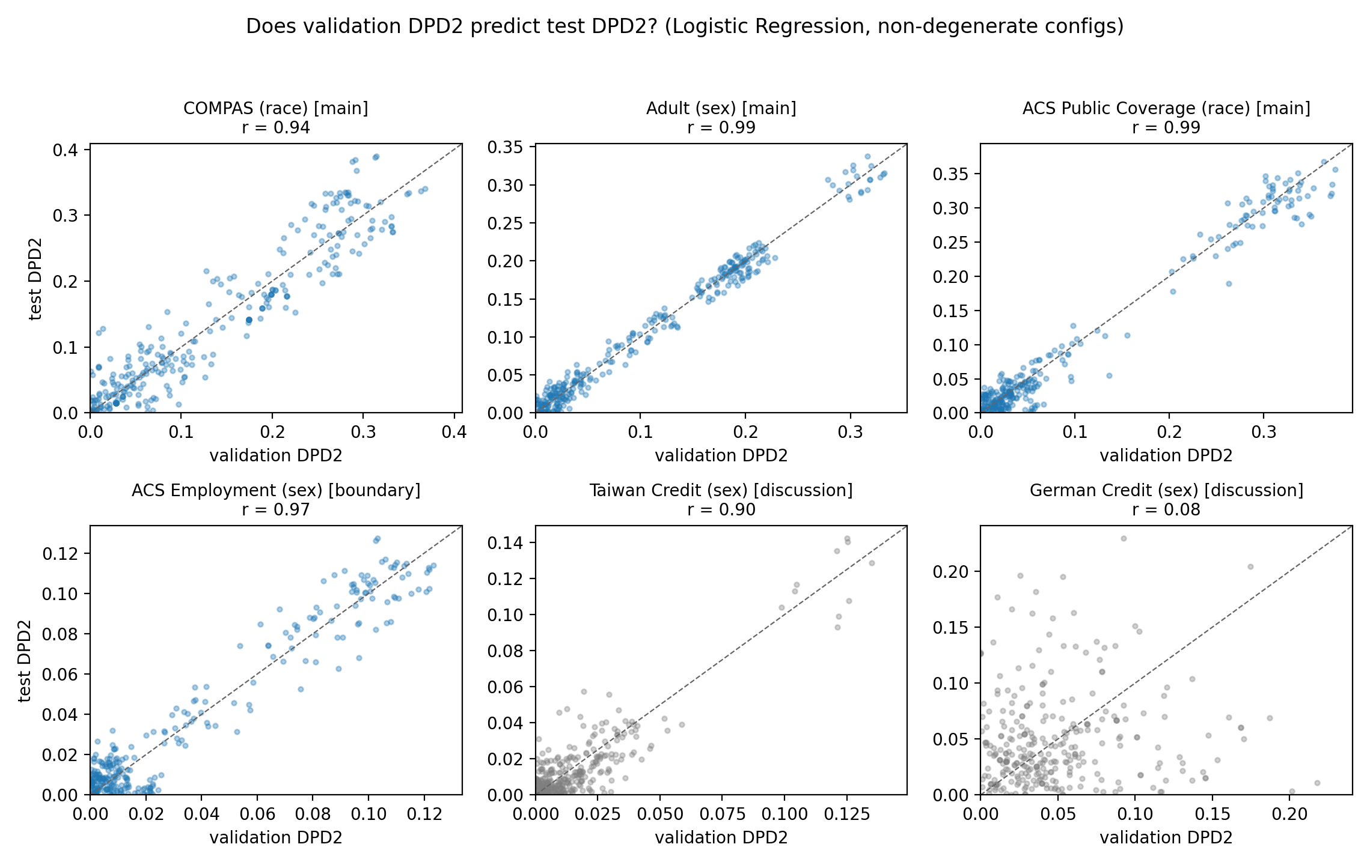
Figure 3. Validation vs. test DPD2 for every sweep configuration (logistic regression). Points on the dashed line mean validation-based tuning can be trusted.
- German: r = 0.08. With ~60 women in the validation split, measured disparity is mostly noise, so the tuning step picks configurations at random. Under a fixed, pre-chosen setting the method does reduce disparity on German (−48%).
- Taiwan: r = 0.90. Its disparity is as small as German’s, but with 30× the data tuning works fine. So German’s failure is caused by sample size, not by small disparity.
- Practical rule: fairness tuning on a validation set needs enough people in the smallest group — hundreds, not dozens.
Taiwan: small disparity + lots of data → validation works (r = 0.90).
German: small disparity + very small subgroup → validation is noisy (r = 0.08).
German shows a sample-size limitation of fairness tuning, rather than evidence that low baseline disparity itself prevents the method from working.

5. RQ3 — How does it compare with established methods?
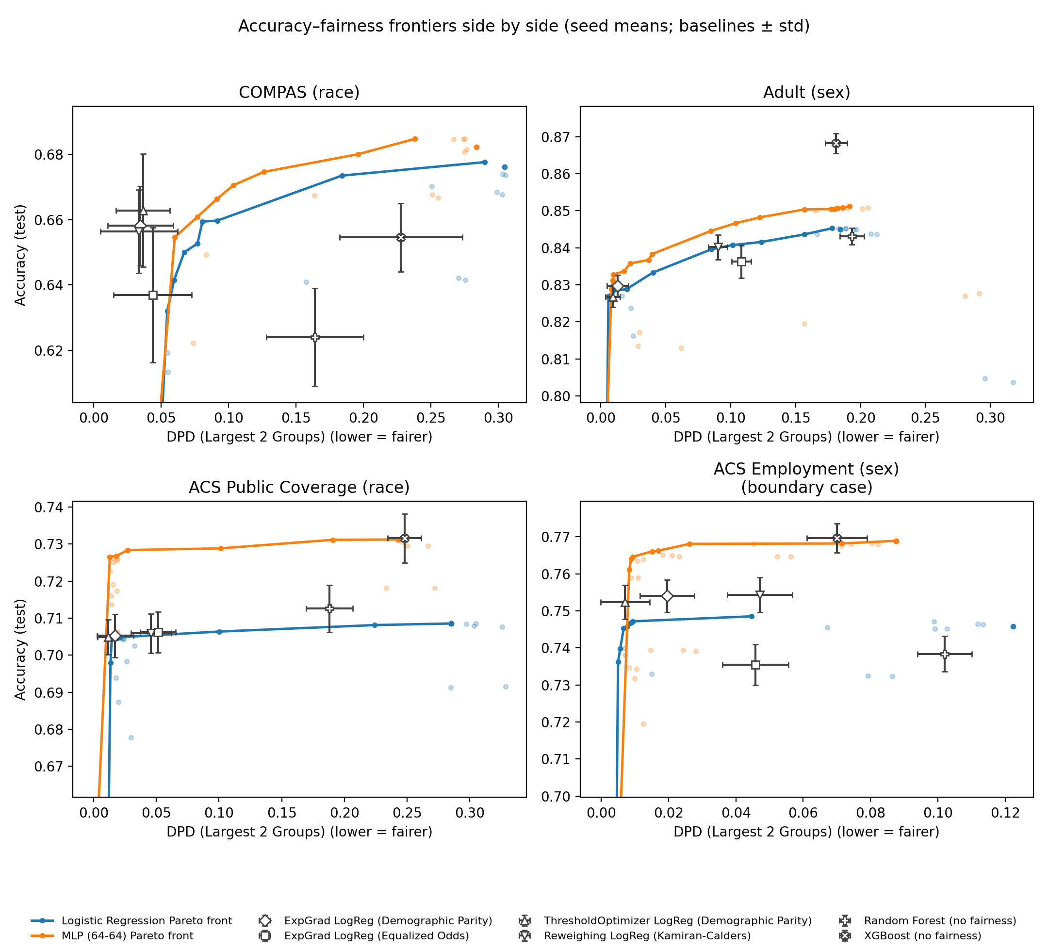
Figure 4. Accuracy vs. DPD2. Lines = best reachable trade-off for our loss (LR blue, MLP orange); markers = baselines (±1 std). Up and to the left is better.
Dataset | Fair LR | Fair MLP | Best fairness baseline | XGBoost (no fairness)
COMPAS | 0.661 / 0.061 | 0.669 / 0.082 | 0.656 / 0.034 (Reweighing) | 0.655 / 0.228
Adult | 0.830 / 0.021 | 0.836 / 0.026 | 0.827 / 0.009 (ThresholdOptimizer) | 0.868 / 0.181
ACS Public Coverage | 0.705 / 0.019 | 0.727 / 0.020 | 0.705 / 0.012 (ThresholdOptimizer) | 0.732 / 0.248
ACS Employment | 0.747 / 0.009 | 0.766 / 0.016 | 0.752 / 0.007 (ThresholdOptimizer) | 0.770 / 0.070

COMPAS shows a clear accuracy–fairness trade-off. We can substantially reduce disparity, but pushing DPD very close to zero eventually costs accuracy.
Adult shows a similar pattern. As we reduce DPD, accuracy decreases, so again we can select different operating points depending on the desired fairness–accuracy balance
For Public Coverage, the MLP frontier maintains relatively high accuracy while reaching very low DPD, so the orange frontier gives several strong fairness–accuracy combinations.
Each cell is accuracy / DPD2 (mean of 10 seeds).
Answer: competitive, not superior.
- The fair MLP is on the accuracy–fairness frontier on all four result datasets.
- ACS Public Coverage is the best showing: the fair MLP nearly matches the baselines’ disparity (0.020 vs 0.012–0.017) while being 2 points more accurate (0.727 vs 0.705).
- On COMPAS and Adult, dedicated baselines reach lower disparity (e.g. COMPAS 0.034 vs 0.061) at similar accuracy.
- The most accurate model (XGBoost) is usually among the least fair.
- Side effect to report: forcing equal selection rates can worsen equalized odds. On Adult it rises from 0.107 to 0.279 (LR), and the parity-constrained baselines (ExpGrad, ThresholdOptimizer) show the same jump — the two group-fairness definitions conflict when base rates differ. On ACS Public Coverage both improve together.
- Unique value: no baseline offers a continuous dial between group and individual fairness — that dial is what makes RQ1 and RQ2 measurable.

6. Things to need to know
- ‘Theil Index’ in the code is GE(2). The column name is historical; the metric is generalized entropy with α = 2, and the paper calls it GE(2). Training uses the same α, so the numbers are consistent.
- The Gini coefficient was dropped. On yes/no predictions it equals 1 − selection rate and carries no fairness information.
- COMPAS equalized odds is unreliable. It is computed over all six race groups, including groups with only ~2–6 test rows, so it is mostly noise.
- DPD2 compares the two largest groups. COMPAS: African-American vs Caucasian. For ACS Public Coverage the data is restricted to White and Black respondents, because in California ‘Some other race’ would otherwise be the second-largest group.
- ‘***’ can never appear. With 10 seeds the smallest possible Wilcoxon p-value is ≈ 0.002 (0.008 after Holm correction), so ‘**’ is the strongest result reachable.
- Report tiny effects in absolute terms. When a baseline disparity is near zero (Taiwan), percentages explode (e.g. +224%) while the real change is 0.02.
- ACS positive class is not ‘good’ or ‘bad’. Having public coverage is a benefit received, unlike COMPAS and German where the positive class is the adverse outcome — keep this in mind when describing direction.
- One paper table value is unverified. The ‘acc:DPD term’ column (1.1× / 34.9× / 0.7×) could not be reproduced from the result files; the correlation and signal-to-noise columns reproduce exactly.
- Data not in git. adult.csv and the Folktables census download (~255 MB) are fetched automatically on the first run and cached under data/.

7. How to reproduce
.venv/bin/python new_experiment/run_experiment.py --dataset <name> --seeds 0-9
.venv/bin/python new_experiment/analysis/run_analysis.py --dataset all
Dataset names: compas, adult, acs_pubcov, acs_employment, taiwan, german. Figures are rewritten into reports/fig/; full tables are in new_experiment/RESULTS/paper/cross_dataset/.

Replication
I replicated the Exponentiated Gradient fairness method from Agarwal et al. 2018 on the Adult dataset. I followed the paper's setup as closely as possible: Adult income prediction, sex as the protected attribute, logistic regression as the base classifier, demographic parity as the fairness constraint, and a 75/25 train-test split. I varied epsilon from 0.001 to 0.1 to reproduce the fairness–accuracy tradeoff. I ran it across 10 random seeds and averaged the results.
You tested both(preserve the mssing ? value in adult datset and excluding the missing) because the original Agarwal paper says it used 48,842 Adult examples but doesn't clearly specify how the missing ? values were handled.

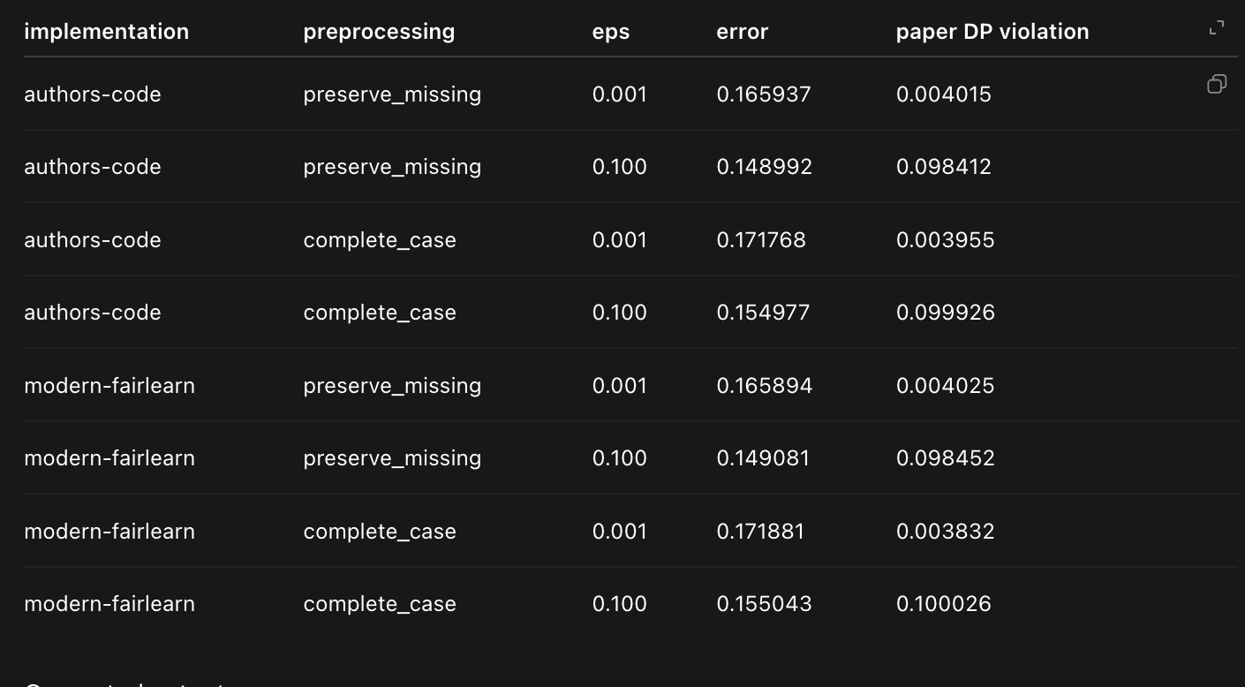

This figure shows my replication of the Exponentiated Gradient demographic-parity experiment on Adult. The x-axis is demographic-parity violation, where closer to zero is fairer, and the y-axis is classification error, where lower is better. Epsilon controls the fairness constraint. At small epsilon, the model has very low demographic-parity violation but somewhat higher prediction error. As epsilon increases, we allow more disparity and classification error decreases. I tested two reasonable missing-value treatments because the original paper doesn't specify that preprocessing detail. I also compared the historical implementation with modern Fairlearn, and those results almost completely overlap. The points are averaged over ten random seeds.
