Detecting Abnormal Heartbeats in ECG Signals
Classifying heartbeats from the MIT-BIH Arrhythmia Database into the five AAMI classes, tested on patients the models never saw.
17 September 2026

1. The problem
An ECG records every heartbeat. Most beats are normal, but a small number are abnormal and those are the ones that matter clinically. The task is to label each beat as one of five types: N (normal), S (supraventricular, an early beat), V (ventricular), F (fusion) and Q (unclassifiable).
Two things make this hard. First, the classes are extremely unbalanced: in our training data 89% of beats are normal while class S has 863 examples and class Q has only 8. Second, we test on patients that were never used in training, so the model cannot rely on having seen a particular person's heartbeat shape before. This is the standard inter-patient protocol (DS1/DS2) and it produces much lower scores than the beat-shuffled evaluation used in many papers.
Class | Meaning | Training beats | Test beats
N | Normal | 35,501 | 44,196
S | Supraventricular (early) | 863 | 1,836
V | Ventricular | 3,080 | 3,219
F | Fusion | 388 | 388
Q | Unclassifiable | 8 | 7

2. What was done
The work ran in three stages. Each stage was tested once on the same 22 held-out patients, so the numbers are directly comparable.
- Stage 1 — Classical baseline. Signal filtering, beat segmentation and hand-designed features (heartbeat timing plus beat shape), classified with a Random Forest. This set the score every later method had to beat.
- Stage 2 — Neural network. A two-branch network: a 1-D convolutional network reads the shape of each beat while a second branch reads its timing. Class imbalance was handled with focal loss, which reduces the influence of the abundant normal beats during training.
- Stage 3 — Ensemble. Cross-validation already produced five models, each trained on a different group of patients. Instead of discarding four of them, all five predictions are averaged. This required no additional training.

3. Results
All figures below are measured on 49,646 heartbeats from 22 patients that appear in no training set.
Method | Overall score | S found | S correct | V found
Random Forest (classical) | 0.506 | 0.271 | 0.200 | 0.844
Neural network | 0.545 | 0.693 | 0.294 | 0.961
Neural network + ensemble | 0.590 | 0.736 | 0.388 | 0.947

Overall score is the macro-averaged F1 over classes N, S, V and F. Class Q is excluded from this average because 8 training beats cannot support a meaningful score; it is still reported separately. Accuracy is deliberately not used as the headline: predicting “normal” for every beat scores about 0.89 while finding no arrhythmia at all.
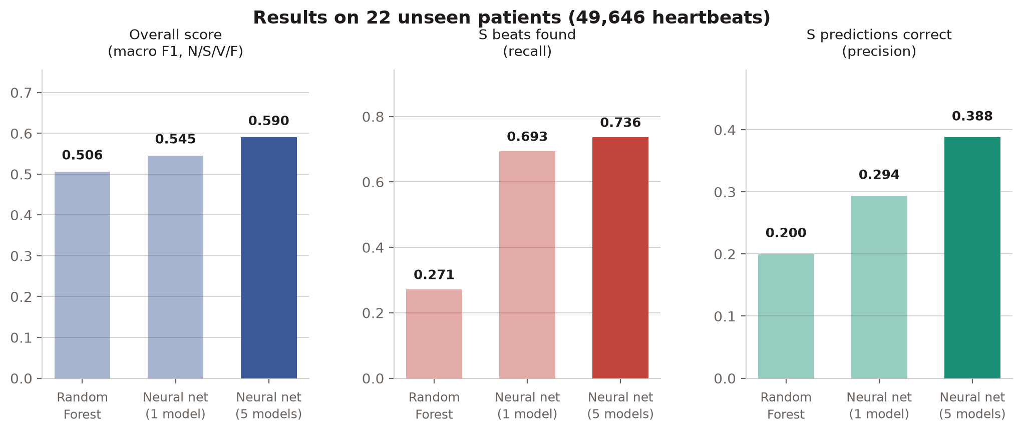
Figure 1. Results across the three stages. The overall score improved from 0.506 to 0.590. The largest change was in class S.

3.1 The main result
Detection of class S improved from 27.1% with the Random Forest to 73.6% with the final model. In absolute terms, of the 1,836 S beats in the test set the classical method found 497, while the final model found 1,352.
Precision on class S also improved, from 20.0% to 38.8%. This matters because false alarms were the main weakness of the intermediate model: it found many more S beats but produced a large number of incorrect S predictions.
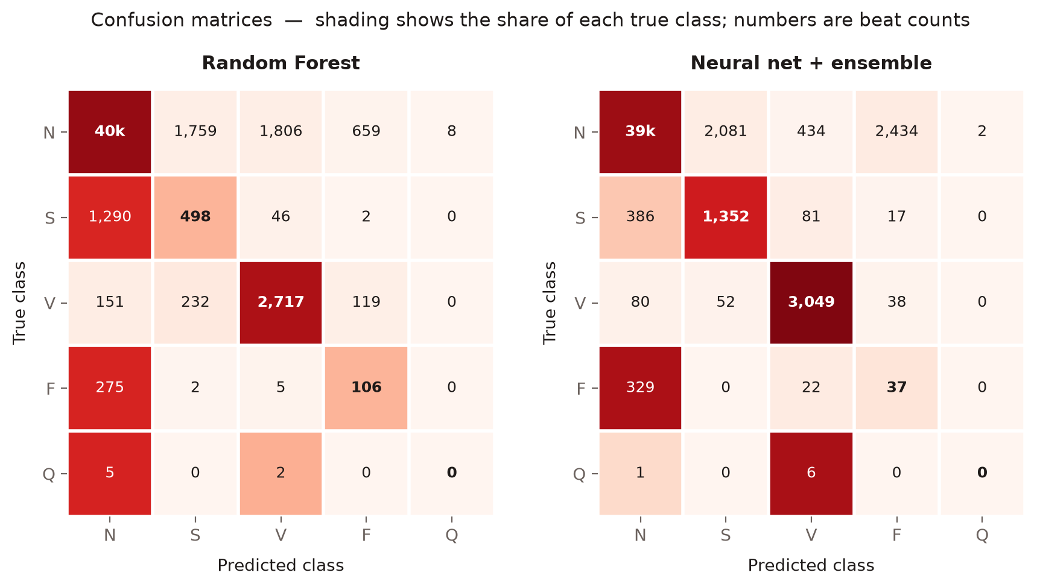
Figure 2. Confusion matrices. Rows are the true class, columns the predicted class. In the S row, correct predictions rise from 498 to 1,352 and missed beats fall from 1,290 to 386.
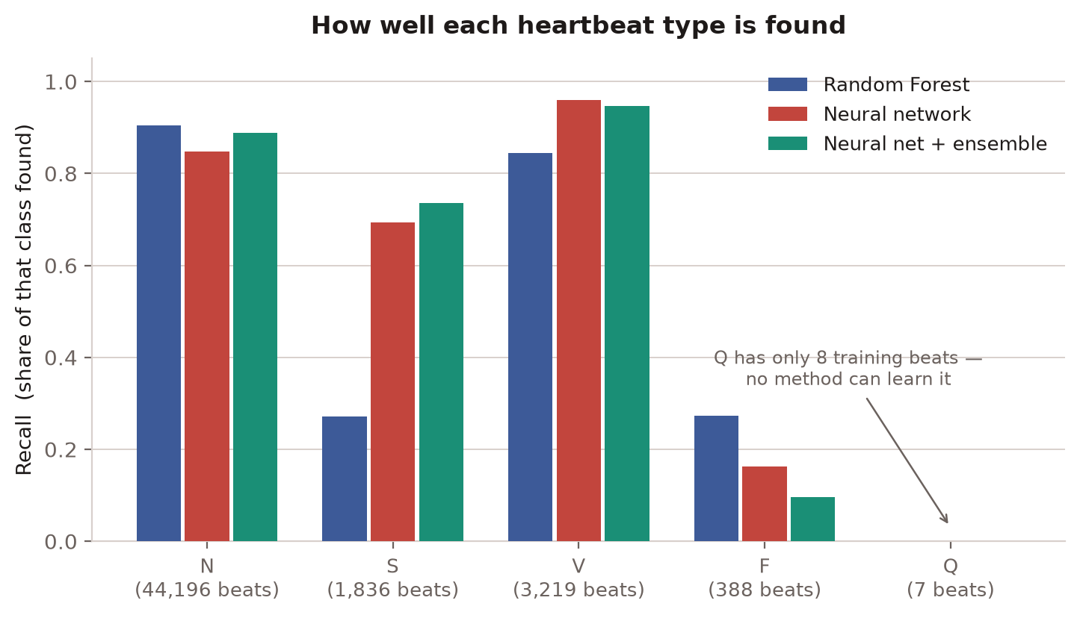
Figure 3. Detection rate by heartbeat type. N and V are handled well by every method. S improves substantially. F becomes worse, and Q cannot be learned from 8 training examples.

4. Was the improvement real?
A classifier does two separate things. It ranks heartbeats by how suspicious they look, and it draws a line deciding which side of that ranking counts as abnormal. The scores in section 3 measure both at once, so they cannot tell the two apart. A model that became more willing to guess “abnormal” scores better on them without having learned anything.
The two were therefore measured separately. The second column below tries every possible decision line and averages the result, so moving one line cannot improve it.
Training method | Score with a fixed line | Score with no line
Plain (no imbalance handling) | 0.379 | 0.565
Weighted | 0.492 | 0.558
Focal — the method kept | 0.545 | 0.567
Oversampling | 0.484 | 0.565
Ensemble of five | 0.590 | 0.593

Focal loss beats the plain model by +0.167 in the first column and by +0.002 in the second. Almost the entire advantage reported earlier came from where the decision line sits, not from the model recognising heartbeats any better. The ensemble is the one change on this table that improves both columns.
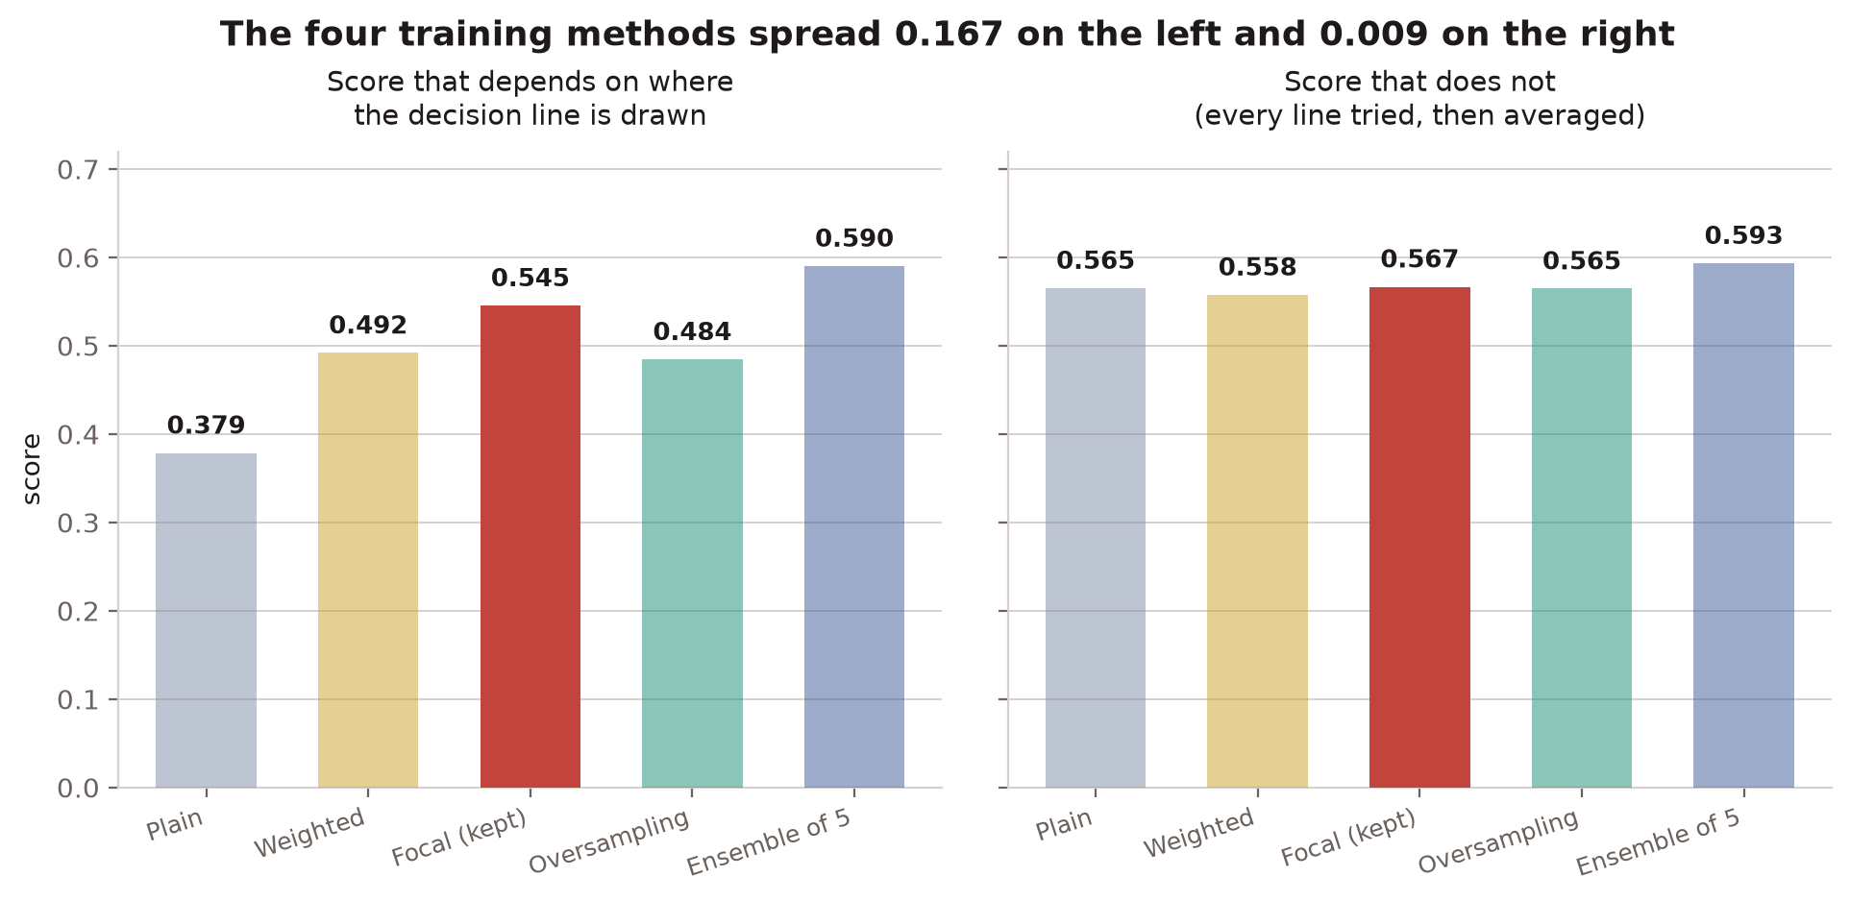
Figure 4. The same four training methods, scored two ways. The spread on the left is what earlier sections reported; the spread on the right is what the models actually learned.

4.1 On class S, the chosen method was the worse one
Training method | Ranking quality on S | Times better than chance | Place in earlier comparison
Ensemble of five | 0.393 | 10.6x | not tested then
Oversampling | 0.388 | 10.5x | 4th of 5
Plain (no imbalance handling) | 0.340 | 9.2x | 5th of 5
Focal — the method kept | 0.285 | 7.7x | 1st of 5
Weighted | 0.256 | 6.9x | 2nd of 5

Read against the last column, the earlier ranking is close to upside down for class S. The method that finished fourth ranks S beats best; the method that was carried forward ranks them second worst. Focal loss traded class S away for class V, where it is genuinely better (0.966 against 0.921).
Since retired. Section 6 repeated this comparison with five models per method rather than one, and the ordering did not survive. The paragraph above is kept because the reasoning it illustrates is sound and the numbers were real; the conclusion drawn from them was not.
This also explains a result that had been puzzling. Precision on class S has sat between 0.27 and 0.39 through every method tried. Figure 5 shows why: the achievable trade-off is flat. There is no threshold setting that buys better precision, so tuning one cannot help.
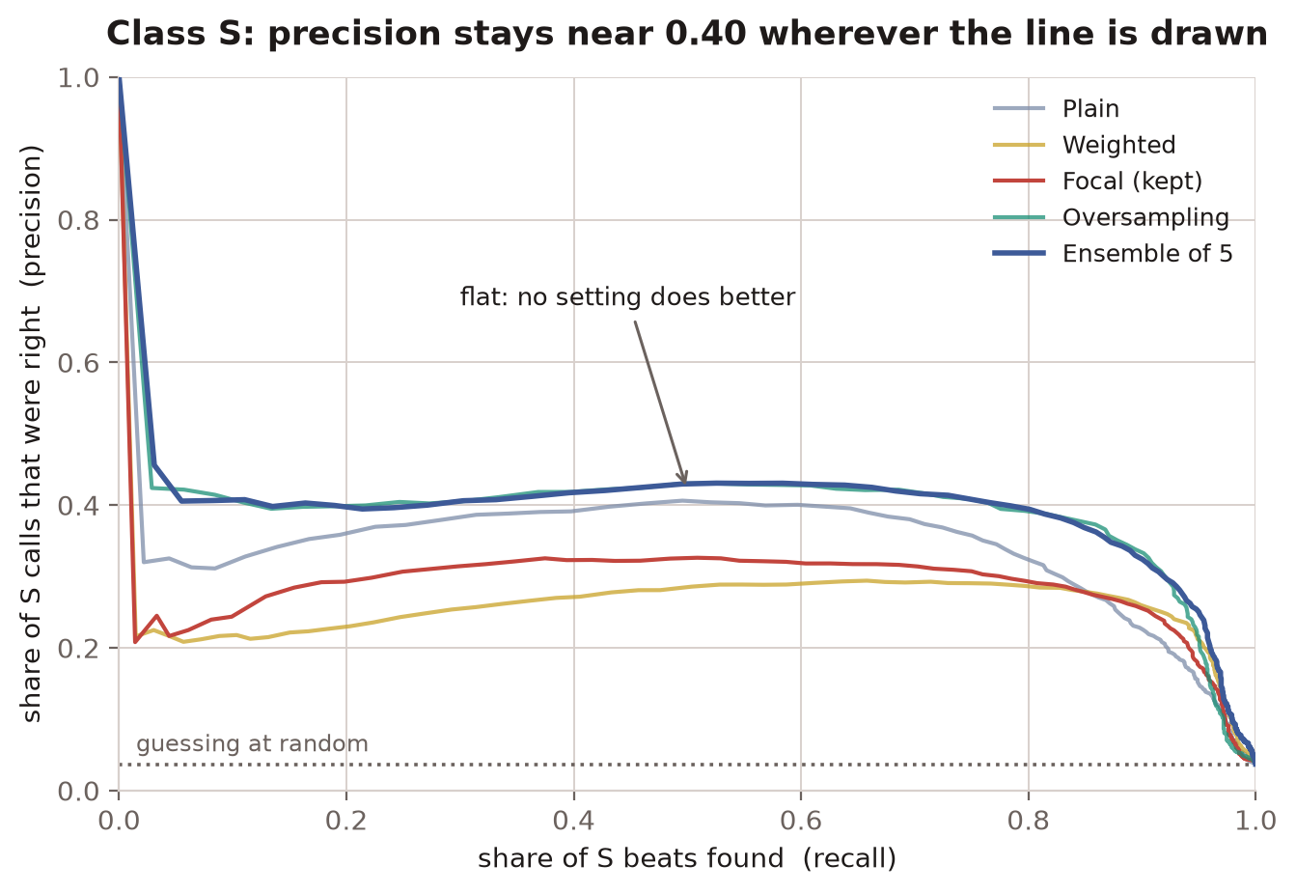
Figure 5. Class S. Moving left to right means catching more S beats; height is how often an S call was correct. A model with room to improve curves downward from the left. These lines are flat.

5. Can the predicted probabilities be trusted?
Everything above treats the model as something that outputs a label. If a later stage of the system instead reads the model's confidence and reasons with it, that number has to be honest. This had never been checked, and it is not.
The cause is known: training uses class weights to counteract the imbalance, and weighting tilts the output. A calibrated model's average predicted probability for a class equals how often that class actually occurs.
Heartbeat type | How often it occurs | What the model says | Model ÷ reality (1.0 = honest)
N (normal) | 89.02% | 64.00% | 0.7x
S (supraventricular) | 3.70% | 11.98% | 3.2x
V (ventricular) | 6.48% | 11.73% | 1.8x
F (fusion) | 0.78% | 11.35% | 14.5x
Q (unclassifiable) | 0.01% | 0.93% | 66.0x

The four rare classes are overstated and normal beats are understated, which is the tilt the class weights were always going to introduce. When the model reports a beat as 50% likely to be class S, it is not. Anything reading these numbers directly would raise roughly three times too many alerts on class S and fourteen times too many on class F. This is a systematic tilt rather than a broken model, and a correction fitted on held-out data removes it without retraining.
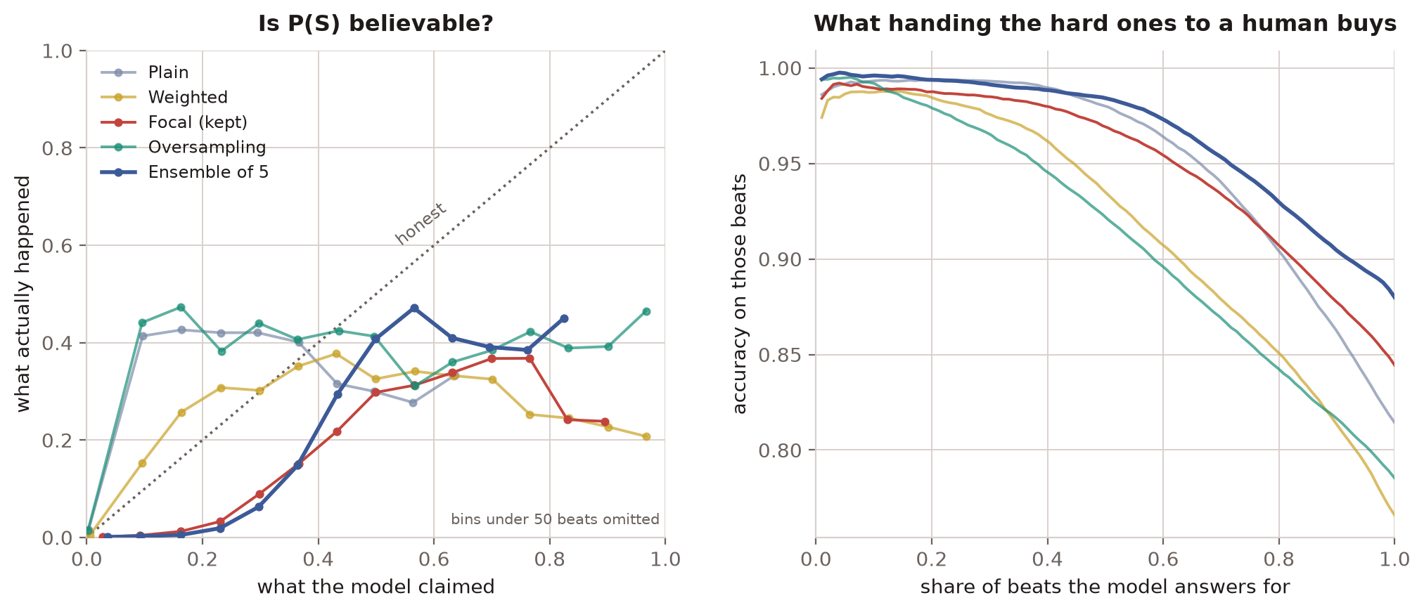
Figure 6. Left: what the model claimed against what happened, for class S. A trustworthy model follows the dotted line. Right: accuracy when the least confident beats are handed to a person instead.
The left panel separates three failures. The plain and oversampling models are flat: whether they say 30% or 90%, the answer is about 40% likely, so the number carries no information. Focal and weighted bend downwards at the right-hand end, meaning their most confident calls on class S are less reliable than their middling ones. Only the ensemble rises the whole way. It sits below the dotted line, understating its own confidence, which is the one failure a calibration step is designed to correct.
The ensemble is therefore the model to carry forward. It ranks best on every class that counts, and ranking is the part a calibration step cannot repair. The right panel shows the practical consequence: letting the model decline the beats it is least sure about raises accuracy on the rest from 0.88 to about 0.975, against a 0.89 baseline for calling every beat normal.

6. Was mixing the training methods better?
Section 4.1 found that the training method carried forward was not the best at class S — two methods that had lost on the earlier score ranked S beats better. The obvious follow-up is to stop using five copies of one method and build the ensemble from all four instead, on the reasoning that members which make different mistakes help each other. That was tested rather than assumed.
Twenty models were trained: four methods across the same five patient folds. Five candidate ensembles were fixed in writing before the run, and the winner was chosen on held-out training data before the test set was scored once. The script enforces that order rather than trusting whoever runs it.
Ensemble | Models | Ranking, all classes | Ranking, class S | Overall score
Focal only (the ensemble in use) | 5 | 0.599 | 0.405 | 0.612
Focal + plain | 10 | 0.594 | 0.388 | 0.569
Focal + plain + oversampling | 15 | 0.576 | 0.324 | 0.537
All four methods — chosen | 20 | 0.584 | 0.352 | 0.555
Plain + oversampling | 10 | 0.562 | 0.282 | 0.503

Mixing did not help. The ensemble already in use scored best on every ranking measure, and the candidate the procedure selected came in 0.015 lower across all classes and 0.053 lower on class S. Every mixture was worse than the arrangement it was meant to improve on.
This is the most trustworthy form a negative result can take. The procedure was committed to in advance and it chose against the existing ensemble; the existing ensemble won anyway. There is no room here for having picked the flattering answer after the fact.

6.1 The selection step was measuring the wrong thing
The more useful finding is why the procedure chose badly. Ranked by the held-out score used to choose, the candidates line up almost exactly by how many models they contain.
Ensemble | Models | Score used to choose | Score on unseen patients
Focal only (the ensemble in use) | 5 | 0.521 | 0.599
Focal + plain | 10 | 0.555 | 0.594
Plain + oversampling | 10 | 0.557 | 0.562
Focal + plain + oversampling | 15 | 0.557 | 0.576
All four methods | 20 | 0.583 | 0.584

The correlation between number of models and the choosing score is +0.97; against the score that matters it is -0.46. The procedure was ranking ensembles by size, not by quality.
The cause is a flaw in the design, and it is worth recording plainly. Each model stops training at its best epoch as judged on the fold of patients held out from it — and that same fold supplies the predictions used to score it. An ensemble with more members therefore gets more independent attempts at the very data it is being measured on. Twenty models tuned against a fold will flatter themselves on that fold more than five will, whatever their real quality.
The design document claimed this optimism was even across the candidates and so could not tip the choice. That was wrong: it is even across training methods but not across ensembles of different sizes. Any future comparison of this kind needs a fixed training budget, a separate selection split, or nested cross-validation before its choices can be believed.
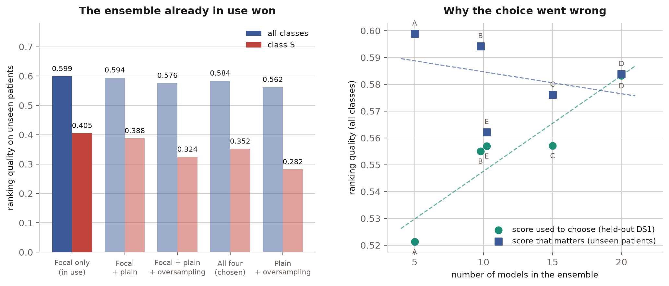
Figure 7. Left: every mixture scored below the ensemble already in use. Right: the score used to choose rises with ensemble size while the score that matters does not — the two dashed trends run in opposite directions.

6.2 What this retires
Section 8 flagged the class S result in section 4.1 as resting on one trained model per method and needing repetition before anything was built on it. This run was that repetition, with five models per method instead of one, and it did not hold: focal-only now ranks class S best (0.405) and plain plus oversampling ranks it worst (0.282). The earlier ordering was a property of single models fitted on the whole training set, not something that survives into an ensemble.
The finding that section 4 rests on is unaffected. That the four training methods barely differ once the decision line is taken out of the score is measured across every method and every candidate here too.
Retraining also improved the ensemble itself. Letting each model stop at its own best epoch, rather than at the median epoch borrowed from cross-validation, raised class S detection from 73.6% to 84.1% at similar precision.

6.3 The one thing mixing did do
Mixing improved the honesty of the probabilities substantially. Adding the plain method to the focal ensemble cut the Brier score from 0.238 to 0.142 and the calibration error from 0.143 to 0.084 — a reduction of roughly 40% in both.
That is not a reason to adopt it. Section 5 established the rule: calibration is the part a later correction can repair and ranking is the part it cannot. Paying in class S ranking for calibration that can be fitted afterwards is the wrong way round.

7. What did not work
Three further changes were tested and measured against the same reference on identical data splits. Two produced no measurable effect and are reported here rather than omitted.
Change tested | Runs won | Mean change | Verdict
Rhythm context (model reads neighbouring beats) | 7 of 15 | -0.038 | No effect
Robust rhythm reference (median instead of mean) | 9 of 15 | -0.000 | No effect
Ensemble of five models | — | +0.062 | Improved the result

The rhythm-context model was the most promising idea on paper: it lets the network compare a beat against the beats around it, which is how a clinician judges whether a beat arrived early. It won 7 of 15 comparison runs, which is indistinguishable from chance. The robust rhythm reference had no effect at all.
These comparisons were only readable because each change was tested against the reference on the same patients, run by run. Comparing average scores would not have worked: performance varied between 0.35 and 0.71 depending on which patients were held out, a spread far larger than any difference between the methods.

8. Limitations
- Precision on class S is 38.8%, and section 4 shows this is a ceiling rather than a setting: the trade-off between finding S beats and being right about them is flat, so no threshold choice improves it. The model is suitable for flagging beats for a clinician to review, not for automatic decisions.
- Class F became worse, not better. The classical Random Forest still has the best F1 on that class (0.166 against 0.025).
- Class Q cannot be evaluated here. With 8 training beats and 7 test beats, every method scores zero, and no conclusion should be drawn.
- Results are reported from a single pass over the test set, which is correct practice but means each number is one measurement rather than a range.
- The class S ordering in section 4.1 has been retired. It rested on one trained model per method; repeated with five models per method in section 6, it did not hold. The broader finding it sits inside — that the line-free scores barely differ between methods — survives.
- Ensembles of different sizes cannot be compared on held-out training data under the current procedure, because each model stops at its best epoch on the very fold used to score it. Section 6.1 measures the resulting bias. A fixed training budget, a separate selection split or nested cross-validation is needed before any such comparison is trusted again.
- The predicted probabilities are not yet calibrated. Section 5 measures the tilt but does not correct it; that correction is the next piece of work and must be fitted on held-out data only.
- The remaining limit appears to be data rather than model design. Two architectural changes produced no improvement, while 863 training examples of class S remains the binding constraint.

9. Method details
Item | Value
Dataset | MIT-BIH Arrhythmia Database v1.0.0, 48 records
Split | Inter-patient DS1/DS2 (de Chazal et al., 2004)
Excluded | 4 paced records, per AAMI recommendation
Training set | 22 patients, 50,955 beats
Test set | 22 patients, 49,646 beats
Sampling rate | 360 Hz, single lead (MLII where available)
Preprocessing | 0.5–40 Hz bandpass, z-score normalisation, 300-sample beat windows
Model | 1-D CNN (4 convolutional blocks) + dense timing branch, 60,101 parameters
Training | Adam, focal loss, early stopping on validation macro-F1
Model selection | 5-fold cross-validation grouped by patient; the test set was never used for any choice
Software | Python 3.13.15, PyTorch 2.11.0+cu128

