MIT-BIH + MIMIC-III Integration Report
Project: SmartHealthcare-Agentic, an agentic cardiac-AI research system
Summary in four sentences. The ECG model (MIT-BIH) is trained and evaluated: on 22 held-out test recordings it reaches a macro-F1 of 0.555, against 0.506 for a classical baseline. The clinical pipeline (MIMIC-III) is built and tested, but it has only run on the 100-patient open Demo, so its model results mean nothing clinically. The two are integrated in software: one interface runs either or both models, and a fusion network is implemented and tested on synthetic data. No multimodal model has been trained or evaluated on real data, because no dataset available here has ECG and clinical records for the same patients.
Nothing in this project is a medical device or clinically validated. All numbers below come from files in the repository; each one names its source. Section 8 lists what is complete, partial and blocked.

1. Project overview

What the project is about
The project builds the data and model foundation for a cardiac AI system that could one day look at a patient’s heart rhythm and clinical record together. It uses two public research datasets, which answer two different questions:
- From the ECG: what kind of heartbeat is this? Each heartbeat is labelled normal or one of four abnormal types.
- From the clinical record: how likely is this ICU patient to die before leaving hospital? The prediction is made 24 hours after ICU admission.

Why MIT-BIH
The MIT-BIH Arrhythmia Database is the standard benchmark for heartbeat classification. It has 48 half-hour ECG recordings from 47 people, sampled 360 times per second, and cardiologists labelled every one of its roughly 110,000 heartbeats. A published patient split (de Chazal et al., 2004, “DS1/DS2”) lets results be compared with other work. It is freely downloadable.

Why MIMIC-III
MIMIC-III is the standard research database for intensive-care prediction: de-identified records of ICU stays at a Boston hospital from 2001-2012, with vital signs, lab tests, diagnoses and outcomes. The full database needs credentialed access; a 100-patient Demo is open. This project currently has the Demo only.

Why integrate them
A clinician looks at the heart rhythm and the chart together. An ECG shows rhythm problems; vital signs and lab tests show how sick the patient is. A system that uses both could, in principle, know more than either alone. The first step is software that can take both inputs; the second step, which needs suitable data, is a model trained on both.

ECG classification versus clinical prediction
 | ECG classification (MIT-BIH) | Clinical prediction (MIMIC-III)
What is predicted | The type of each heartbeat (N, S, V, F, Q) | In-hospital death (yes/no)
Unit of prediction | One heartbeat (0.83 s of signal) | One ICU stay
Input | A signal: voltage over time | Tables: vital signs, lab results, demographics
Time scale | Milliseconds to seconds | The first 24 hours of an ICU stay
Labels come from | Cardiologists annotating each beat | The hospital record (discharge status)
Patients | 47 people, recorded 1975-79 | ICU patients, 2001-2012 (Demo: 100)
Because the targets, units and patients differ, the two models’ scores cannot be compared with each other or simply added together.

System architecture
MIT-BIH ECG recordings MIMIC-III clinical tables
(48 records, 360 Hz) (Demo: 100 patients)
| |
[1] load, check integrity [1] load, check every table
[2] filter, cut beats, label [2] join safely, pick cohort,
[3] waveform + 6 timing features clean, convert units
[4] patient split (DS1 / DS2) [3] 24 h summaries, 113 inputs
| [4] split by patient
[5] ECG model |
20-network ensemble [6] clinical model
(trained, evaluated) logistic regression
| (runs; Demo only)
| |
ECG encoder Clinical encoder
per-beat classes + 13-value summary 119-value vector + risk score
\ /
+------ [7] shared inference interface --+
| checks each input, runs what applies, |
| returns each answer separately |
+----------------------------------------+
|
[7] fusion network (ConcatFusion)
built and tested on synthetic data;
training BLOCKED: no paired patients
|
[8] tests, end-to-end run, report

Integration status in one table
Part of the integration | Implemented | Tested | Trained on real data | Evaluated on real data
Shared inference interface | Yes | Yes (unit + real ECG record) | not applicable | Smoke-tested
ECG encoder | Yes | Yes | uses the trained ECG model | ECG model: yes
Clinical encoder | Yes | Yes | uses the Demo-trained model | Demo only
Fusion network | Yes | Yes, on synthetic data | No | No

2. The project in 8 steps

Step 1: Data collection and loading
- Purpose. Get the raw data onto the machine and prove it is complete and readable before anything is built on it.
- Input. MIT-BIH: 48 WFDB records from PhysioNet (a header .hea, a signal .dat and an annotation .atr file each). MIMIC-III: eight tables of the Demo v1.4 (PATIENTS, ADMISSIONS, ICUSTAYS, DIAGNOSES_ICD, D_ITEMS, D_LABITEMS, CHARTEVENTS, LABEVENTS).
- Process. MIT-BIH is downloaded once and every record’s size and sampling rate are checked. The signal lead is chosen by name (MLII), not by position, because some records store a different lead first. For MIMIC-III, every table and required column is checked before reading; the readers accept both the Demo’s format (lower-case .csv) and the full release’s (upper-case .csv.gz). The two largest tables are read in chunks of one million rows, keeping only the rows needed, so the full 330-million-row CHARTEVENTS would fit in memory.
- Output. Raw data in ~/physionet-data/mitdb/ and ~/physionet-data/mimiciii-demo/, outside the repository so patient data never enters version control.
- Files. src/mit_bih/acquire.py, src/mit_bih/io.py, scripts/mit_bih/download_mitbih.py, src/mimic_iii/ingestion.py.
- Status. Complete for MIT-BIH and the MIMIC-III Demo. Full MIMIC-III: Blocked (credentialed access needed).
- Result. 48 of 48 MIT-BIH records verify (93.9 MB). All 8 Demo tables and all 47 configured measurement codes (31 vital-sign, 16 lab) are present in the code dictionaries. In the Demo, 758,355 chart rows and 76,074 lab rows were read.
- Verification. scripts/validate_setup.py reports both as OK. Tests: tests/mit_bih/test_download.py, tests/mit_bih/test_io.py, tests/mimic_iii/test_ingestion.py. That last file includes a check that reading in small chunks gives exactly the same result as reading at once, and checks that missing tables, missing columns, bad dates and duplicate IDs are rejected with a clear error.

Step 2: Data cleaning and preprocessing
- Purpose. Remove noise and errors, and put both datasets in a clean, consistent form.
- Input. The raw records and tables from Step 1.
- Process, ECG.
  - A band-pass filter (0.5-40 Hz) removes slow baseline drift and high-frequency noise. It is zero-phase, so heartbeats are not shifted in time.
  - Each annotated heartbeat is cut into a 300-sample window: 100 samples before the R peak (the tall spike of a heartbeat) and 200 after, which is 0.83 seconds.
  - Cardiologists’ beat symbols are mapped to the five AAMI classes: N normal, S supraventricular ectopic, V ventricular ectopic, F fusion, Q unknown/paced. 3,153 non-beat annotations (rhythm and noise markers) are excluded, and 48 beats whose window runs past the end of a recording are dropped and counted.
  - Each beat is scaled (z-score) using a mean and standard deviation computed from training records only.
  - The four recordings with pacemakers (102, 104, 107, 217) are excluded from the splits, following the AAMI standard.
- Process, clinical.
  - Tables are joined with checks: an ICU stay must belong to an admission of the same patient, or the program stops with an error.
  - Cohort: adults, each patient’s first adult ICU stay, a cardiac diagnosis code, still in the ICU and alive 24 hours after admission.
  - Rows marked as errors are dropped. Temperatures recorded in Fahrenheit are converted to Celsius (331 readings in the Demo). Lab rows with an unexpected unit are dropped, never rescaled by guesswork. Physically impossible values are dropped (one respiratory rate in the Demo).
  - Missing values are kept as missing at this stage, together with a flag saying “not measured”. They are filled in later, from training data only (Step 4).
- Output. ~/physionet-data/processed/mitdb-ds12/beats/<record>.npz, one file per record with the beats, labels and R-peak positions (109,446 beats in total), plus a per-record accounting file. For MIMIC-III, ~/physionet-data/processed/mimiciii-demo/cohort.csv.gz (51 ICU stays).
- Files. src/mit_bih/filters.py, segment.py, labels.py, normalize.py, pipeline.py; src/mimic_iii/cohort.py, features.py.
- Status. Complete.
- Result. The MIT-BIH counts match the published totals: 112,647 annotations = 109,446 kept + 48 dropped at the edges + 3,153 non-beat. The MIMIC cohort goes 136 → 135 → 99 → 66 → 51 stays (Figure 5).
- Verification. Tests in tests/mit_bih/ (filters, segmentation, labels, normalization, pipeline) and tests/mimic_iii/test_cohort.py. The tests check, for example, that an under-18 patient, a non-cardiac admission, a death before 24 hours and a patient’s second ICU stay are each excluded.

Step 3: Feature extraction
- Purpose. Describe each example with the numbers a model can learn from.
- Input. Clean beats; clean clinical measurements.
- Process, ECG. The network reads the 300-sample beat shape directly. Separately, six RR-interval features describe timing. The RR interval is the time between two heartbeats, and the six features are: the interval before the beat, the interval after it, the local average, the recording average, and the before/after intervals divided by that average. Supraventricular beats are defined by arriving early, which a cropped waveform cannot show, so the timing features matter.
- Process, clinical. For 18 variables in the 24-hour window (7 vital signs: heart rate, systolic/diastolic/mean blood pressure, respiratory rate, oxygen saturation, temperature; 11 lab tests: troponin T, troponin I, CK-MB, creatinine, potassium, sodium, BNP, lactate, glucose, hemoglobin, white cells), five summaries are computed: mean, minimum, maximum, last value and number of measurements. A missing-value flag is added for each variable, plus age, an over-89 flag, sex, admission type and first ICU unit. That gives 113 inputs.
- Output. ECG: per beat, a 300-number waveform and 6 timing numbers. Clinical: features.csv.gz, 51 rows × 113 model inputs (plus identifiers and the label, which never reach the model).
- Files. src/mit_bih/features.py, src/mit_bih/dataset.py; src/mimic_iii/features.py, src/mimic_iii/config.py (variable list, measurement codes, units, valid ranges).
- Status. Complete.
- Result. In the Demo cohort, every vital sign is present for every stay, while troponin I and BNP are missing for 94% of stays (Figure 6). Vitals have about 27 readings per stay in 24 hours, and labs 1-3 (Figure 7).
- Verification. tests/mimic_iii/test_features.py checks hand-computed values on a synthetic database (for example, a heart-rate mean of exactly 90 from the readings 80, 90 and 100), the unit conversion, and that readings at or after the 24-hour mark are ignored.

Step 4: Dataset splitting and preparation
- Purpose. Separate data for learning, for choosing settings, and for the final test, so the test is honest.
- Input. The beats and features from Step 3.
- Process, ECG. The standard inter-patient split: 22 recordings for development (DS1) and 22 different recordings for testing (DS2). Inside DS1, 5-fold cross-validation groups beats by recording, so beats from one person are never on both sides. This means training on 4/5 of the recordings, checking on the rest, and rotating five times. The scaling statistics come from DS1 recordings only.
- Process, clinical. Patients (by SUBJECT_ID) are split 70% / 15% / 15% into training, validation and test, keeping the proportion of deaths similar in each. Missing-value filling (median), scaling and category encoding are fitted on training patients only, inside one combined model object.
- Leakage prevention. Data leakage means information from the test set, or from the future, reaching training, which makes results look better than they are. The rules:
  - Rule 1. Split by patient, never by beat or row.
  - Rule 2. Learn statistics from training data only.
  - Rule 3. Choose settings on validation data and score the test set once.
  - Rule 4. For clinical data, use only measurements taken before the prediction time. Diagnosis codes, discharge information and length of stay are never inputs.
  - Rule 5. Record a fingerprint (SHA-256 hash) of the feature table in the split file, so training refuses to run if the table changed after splitting.
- Output. ~/physionet-data/processed/mitdb-ds12/splits.json (record lists); ~/physionet-data/processed/mimiciii-demo/splits.json (patient lists).
- Files. src/mit_bih/splits.py, src/mit_bih/folds.py; src/mimic_iii/dataset.py, src/mimic_iii/preprocessing.py.
- Status. Complete, with one disclosed exception. MIT-BIH records 201 (DS1) and 202 (DS2) come from the same person; record 202’s header says it “was taken from the same analog tape as record 201”. This is part of the published DS1/DS2 split that the field uses, and it is kept for comparability. Without record 202, the ECG model’s test macro-F1 is 0.567 (47,513 beats), slightly higher than with it, so the shared patient did not inflate the reported score.
- Result. ECG: 22 / 22 records (DS1 / DS2); 49,646 test beats. Clinical: 37 / 7 / 7 patients with 11 / 2 / 2 deaths.
- Verification. tests/mit_bih/test_splits.py (no record in two splits; DS1/DS2 checked against two independent published sources), tests/mit_bih/test_folds.py, tests/mimic_iii/test_dataset.py, tests/mimic_iii/test_preprocessing.py (the fitted median and mean equal the training-only values). I also broke the code on purpose, by letting the training split contain every row and by including the 24-hour moment itself, and confirmed that tests fail.

Step 5: MIT-BIH ECG model
- Purpose. Classify every heartbeat into N, S, V, F or Q.
- Input. Per beat: the 300-sample waveform, shape (1, 300), and the 6 timing features.
- Process.
  - Baseline: a Random Forest on timing features plus a 30-number summary of the shape (Phase 1b).
  - Network (HybridBeatNet, 60,101 parameters): a 1-D convolutional branch (4 layers, 32 → 128 filters) reads the shape, a small dense branch reads the 6 timing features, and both are joined to output 5 class scores.
  - Class imbalance: 89% of test beats are normal, and F and S are rare. Five treatments were compared: plain cross-entropy, class weights, focal loss (a loss that focuses training on hard, rare examples), oversampling, and tuned thresholds.
  - Training: on a Google Colab GPU with the Adam optimiser (learning rate 0.001, batch 256), stopping when validation macro-F1 had not improved for 8 epochs.
  - Selection: the final model, D_all_four, averages 20 networks (4 losses × 5 folds). It was chosen on DS1 cross-validation results before the test set was scored.
- Output. models/ holds 36 checkpoint files. The 20 used by the final model are models/mix_{focal,plain,weighted,oversample}_fold{0-4}.pt. models/mit_bih_inference_bundle.json records the preprocessing settings and the checksum of every member, so the model can be applied to a new signal.
- Files. src/mit_bih/nn/model.py, nn/losses.py, nn/train.py, ensemble.py, evaluate.py, inference.py; scripts/mit_bih/train_ensemble_mix.py, scripts/mit_bih/evaluate_bundle.py.
- Status. Complete: trained and evaluated. Score calibration is not done.
- Result (test set DS2, 49,646 beats):
  - Macro-F1 over N/S/V/F: 0.555, against 0.506 for the Random Forest.
  - Recall (share of each class found): N 0.92, S 0.42, V 0.94, F 0.01.
  - Accuracy 0.895, which is not informative here: labelling every beat “normal” would already score 0.89.
  - See Figures 2-4.
- Verification. Re-scored on this laptop’s CPU after the integration work: 0.5554, identical to the original GPU result (results/2026-10-14-bundle-eval-ds1_ds2.json). Re-scored again starting from the raw recordings through the new inference code: also 0.5554, with an identical confusion matrix (results/2026-10-14-bundle-eval-raw-ds1_ds2.json). Four slow tests re-train small networks to check the imbalance handling still works; all pass.

Step 6: MIMIC-III clinical model
- Purpose. Predict in-hospital death from the first 24 hours of an ICU stay.
- Input. 113 features per ICU stay, which become 119 numbers after categories are encoded.
- Process. A logistic regression with L2 regularisation and balanced class weights. Missing-value filling, scaling and encoding sit inside the same model object, so they are fitted on training patients only. The regularisation strength C (0.01, 0.1, 1 or 10) is chosen on the validation patients by AUPRC, and the decision threshold by Youden’s index. Test patients are scored once. AUROC is the probability that a random death gets a higher score than a random survivor: 0.5 is chance, 1.0 is perfect. AUPRC summarises precision across thresholds, and its chance level equals the death rate. Both come with 95% bootstrap confidence intervals.
- Output. model.pkl and model_meta.json (the model, task definition, input columns and checksum) plus report.md / report.json, all in ~/physionet-data/processed/mimiciii-demo/. An aggregate copy of the report is in results/2026-10-14-mimic-demo-pipeline.md.
- Files. src/mimic_iii/preprocessing.py, train.py, evaluate.py; scripts/mimic_iii/build_features.py, make_splits.py, train.py; settings in configs/mimic_iii.toml.
- Status. Partial. The software is complete and tested. A meaningful model is Blocked, because it needs full MIMIC-III.
- Result (Demo; pipeline verification only): C = 1, threshold 0.70.
  - Test: AUROC 0.40 (95% CI 0.00-0.83), AUPRC 0.33 (0.14-0.92), on 7 patients with 2 deaths.
  - Training AUROC is 1.00, because the model memorises 37 patients with 113 inputs.
  - The Demo’s 100 patients were drawn from people who had all died by the time PhysioNet selected them.
  - These numbers show the code runs; they do not describe a model (Figure 8).
- Verification. tests/mimic_iii/test_train_evaluate.py and tests/mimic_iii/test_cli.py run the three scripts end to end on a synthetic database. Four real-Demo tests pin the cohort (51 stays, 15 deaths).

Step 7: MIT-BIH + MIMIC-III integration
- Purpose. Let one system accept ECG data, clinical data or both, and prepare for a model that combines them.
- Input. An ECG signal (360 Hz, single lead, optional R-peak positions) and/or one ICU stay’s 113 features.
- Process.
  - ECG encoder: runs the ECG model and condenses any length of recording into 13 named numbers: the mean score per class, the share of beats predicted per class, mean and spread of the RR interval, and the log of the beat count.
  - Clinical encoder: turns the features into the model’s 119-number vector and its risk score. It rejects any field that would be leakage, such as the outcome or length of stay.
  - Shared interface (run_inference): validates each input, runs what applies, and returns each answer in its own labelled section. A bad ECG does not stop the clinical answer, and vice versa. It never merges the two answers into one score.
  - Fusion network (ConcatFusion): projects each modality to 32 numbers, zeroes out a missing modality, adds two “present” flags, and outputs one score. During training it randomly hides one input so that it learns to work with either alone.
  - Pairing check (validate_pairs): refuses training data in which the ECG and clinical rows are not the same patient, the ECG was recorded after the prediction time, or MIT-BIH is paired with MIMIC-III.
- Output. A JSON result (Section 3). The fusion section reports BLOCKED.
- Files. src/multimodal/ecg_encoder.py, clinical_encoder.py, inference.py, fusion.py; scripts/multimodal/infer.py, scripts/multimodal/train_fusion.py.
- Status. Shared inference: Complete. Fusion architecture: Complete, synthetic data only. Real multimodal training and evaluation: Blocked.
- Has real multimodal training happened? No. MIT-BIH and MIMIC-III contain different people, and the two models predict different things. Training a fusion model on them would mean inventing patients.
- Result. On synthetic data where the label depends on both inputs, the fusion network reaches AUROC 0.897 using both, against 0.770 (ECG part only) and 0.778 (clinical part only). This shows the network can use both inputs. It is not a medical result.
- Verification. 59 tests in tests/multimodal/. One of them checks that the content of a missing input cannot change the output; when that safeguard was removed on purpose, the test failed. The inference smoke test ran on real MIT-BIH record 100 (Section 11).

Step 8: Final testing, results and inference
- Purpose. Show that the whole system works and record what it produces.
- Input. The full repository and data folder.
- Process. Automated test suites; a setup check; one script that runs every step in order.
- Output. The files in PlanDoc/integration_results/: verification_tests.txt, validate_setup.json, verification_end_to_end.md, demo_output_example.json and the figures.
- Files. tests/, scripts/validate_setup.py, scripts/run_end_to_end.py.
- Status. Complete.
- Result.
  - 633 of 633 offline tests pass, 15 of 15 real-data tests and 4 of 4 slow training tests.
  - The setup check finds 16 OK, 1 missing (ECG calibration), 3 blocked (full MIMIC-III, paired data, fusion training) and 0 failures.
  - The end-to-end run finishes steps 1-7 in 70 seconds; step 8 (fusion training) correctly reports BLOCKED.
- Verification. Command outputs are saved verbatim in PlanDoc/integration_results/verification_tests.txt and verification_end_to_end.md.

Summary table
Step | Input | Process | Output | Status | Main file
1. Load | 48 WFDB records; 8 MIMIC tables | Integrity and schema checks; chunked reading | Raw data on disk, verified | Complete (full MIMIC Blocked) | src/mimic_iii/ingestion.py, src/mit_bih/io.py
2. Clean | Raw signals and tables | Filter, cut beats, label; validated joins, cohort, units, ranges | 109,446 beats; 51-stay cohort | Complete | src/mit_bih/pipeline.py, src/mimic_iii/cohort.py
3. Features | Clean beats and measurements | Waveform + 6 RR features; 24 h summaries + flags | Beat tensors; 113 clinical inputs | Complete | src/mit_bih/features.py, src/mimic_iii/features.py
4. Split | Features | Patient-level splits; train-only fitting | DS1/DS2; 37/7/7 patients | Complete (201/202 disclosed) | src/mit_bih/splits.py, src/mimic_iii/dataset.py
5. ECG model | Beats + RR | 2-branch CNN, 20-model ensemble | Checkpoints, bundle, DS2 metrics | Complete | src/mit_bih/nn/model.py, src/mit_bih/inference.py
6. Clinical model | 113 features | Logistic regression, choose on validation | Model, report | Partial (Demo only) | src/mimic_iii/train.py
7. Integration | ECG and/or clinical | Encoders, shared interface, fusion network | Labelled JSON; fusion BLOCKED | Software complete; training Blocked | src/multimodal/inference.py, src/multimodal/fusion.py
8. Testing | Repository | Tests, setup check, end-to-end run | Evidence files, figures | Complete | scripts/run_end_to_end.py

3. Inputs and outputs

MIT-BIH (ECG)
Item | Format and shape
Raw input | WFDB record: 2 leads, 360 samples/s, 650,000 samples per lead (about 30 minutes), plus an annotation per beat (sample position + symbol). Only lead MLII is used.
After preprocessing | Per record, beats/<record>.npz: X (n, 300) float32 scaled beats, y (n,) class 0-4, r_peaks (n,) sample positions
Model input | beat tensor (batch, 1, 300) and RR tensor (batch, 6)
Classes | N normal · S supraventricular ectopic · V ventricular ectopic · F fusion · Q unknown/paced
Output per beat | 5 scores summing to 1 (averaged over the 20 networks); the predicted class is the largest. The scores are not calibrated probabilities: Phase 1f found the average predicted chance of S to be 3.2 times the true rate, and of F 14.5 times (Figure 10).
Saved artifacts | models/mix_*_fold*.pt (20 networks), models/mit_bih_inference_bundle.json (preprocessing + scaling statistics mean 0.0072, std 0.380 + checksums)
Example output (real, MIT-BIH record 100, first 60 seconds, from PlanDoc/integration_results/demo_output_example.json): 74 R peaks given → 2 dropped at the window edges and 2 without a neighbour for timing → 70 beats classified: 69 N, 1 S, 0 V, 0 F, 0 Q. Mean scores: N 0.913, S 0.057, V 0.002, F 0.012, Q 0.016.

MIMIC-III (clinical)
Item | Content
Input tables and columns | PATIENTS (subject, sex, date of birth) · ADMISSIONS (admission type, death time, discharge time, hospital_expire_flag) · ICUSTAYS (ICU in/out time, first unit) · DIAGNOSES_ICD (ICD-9 codes: cohort selection only) · CHARTEVENTS (vital signs: item code, time, value) · LABEVENTS (lab results: item code, time, value, unit) · D_ITEMS, D_LABITEMS (code dictionaries)
Generated features | 18 variables × {mean, min, max, last, count} + 18 missing flags + age, age-over-89 flag, sex, admission type, first ICU unit = 113 inputs
Processed table | features.csv.gz: one row per ICU stay, 3 IDs + label + 113 inputs (51 rows on the Demo)
Model input | 113 columns → 119 numbers after encoding categories
Target | hospital_expire_flag: death before hospital discharge, after the 24-hour prediction time
Output | Risk score from 0 to 1, the decision threshold (0.70), and whether the score is above it
Saved artifacts | model.pkl + model_meta.json (with checksum), splits.json, build_summary.json, report.md/json, in ~/physionet-data/processed/mimiciii-demo/ (outside the repository: they derive from patient rows)
Example input (invented, not a patient), from PlanDoc/integration_results/example_clinical_input.json:
Field | Value | Field | Value
age | 72 | heart_rate_mean | 96
gender | M | sbp_min | 82
admission_type | EMERGENCY | spo2_min | 89
first_careunit | CCU | lactate_max | 3.6
creatinine_last | 1.8 | troponin_t_max | 0.55
Example output for that invented input, from the Demo-trained model: risk score 0.250, threshold 0.700, above threshold: false. 78 unspecified fields were filled in and listed. The output carries the warning “PIPELINE VERIFICATION ONLY”. The score is meaningless as medicine; it shows the format.

Integration
Component | Input | Output
ECG encoder | signal (1-D array), sampling rate (must be 360), optional R-peak positions | per-beat classes and scores, plus a 13-number summary
Clinical encoder | a dictionary of up to 113 features | 119-number vector and a risk score; lists filled-in and ignored fields; rejects outcome and ID fields
Fusion network | ECG summary (batch, 13), clinical vector (batch, 119), two presence flags (batch,) | one score per patient, from 0 to 1
Final output | — | JSON with sections ecg, clinical, fusion, patient_linkage, disclaimer
Shortened real output from scripts/multimodal/infer.py:
{
"modalities_received": ["ecg", "clinical"],
"patient_linkage": "not asserted: the ECG and clinical outputs below are independent and must not be combined",
"ecg": {"status": "ok", "model": {"ensemble": "D_all_four", "n_models": 20},
"summary": {"n_beats_classified": 70,
"predicted_class_counts": {"N": 69, "S": 1, "V": 0, "F": 0, "Q": 0}}},
"clinical": {"status": "ok", "risk_score": 0.24985, "threshold": 0.700553,
"above_threshold": false, "is_demo_model": true},
"fusion": {"status": "BLOCKED",
"reason": "No fusion model trained on genuinely paired ECG + clinical data exists. ..."}
}

4. Before integration vs after integration
Before means the project as it stood before the integration work of 14 October 2026: commit 156d81a plus the same-day reorganisation into three packages. After means the end of 14 October 2026.
Before integration.
- MIT-BIH could classify beats that the Phase 1 pipeline had already saved to disk. It scored macro-F1 0.555 on DS2. There was no way to apply the model to a new ECG signal, because the scaling statistics it needs lived in a data folder outside the repository.
- MIMIC-III had one exploration script (scripts/mimic_iii/explore_demo.py) with no tests, no splits and no model.
- Outputs: per-beat class scores from the ECG model; aggregate tables from the MIMIC exploration.
- Limitations: no clinical model, no common interface, no fusion code, and the ECG scores were (and are) uncalibrated.
After integration.
- Software architecture: four packages (mit_bih, mimic_iii, multimodal, common) with one-way dependencies. mimic_iii became a tested pipeline, and the ECG model gained an inference bundle and a raw-signal path.
- One interface: yes. run_inference calls either or both models.
- Features actually fused: no. The fusion network exists and has run on synthetic data; no real ECG and clinical features have been fused.
- Fused model trained: no.
- Combined system evaluated: only as software (tests and smoke runs). Not as a predictor.
- New capability demonstrated:
  - Classify a raw ECG signal end to end.
  - Turn MIMIC-III tables into a leakage-checked prediction.
  - Query both through one call, with labelled, separate answers.
  - Refuse unsafe pairings.
Feature | Before integration | After integration | Evidence
ECG classification | From saved beats only; DS2 macro-F1 0.555 | Also from a raw signal; DS2 macro-F1 unchanged, 0.5554 by both routes | results/2026-10-14-bundle-eval-ds1_ds2.json, ...-raw-ds1_ds2.json
Clinical prediction | None (exploration script, no tests) | Tested pipeline and model; runs on the Demo; results not clinically meaningful | src/mimic_iii/, results/2026-10-14-mimic-demo-pipeline.md
Shared inference | None | One function for ECG, clinical or both | src/multimodal/inference.py, demo_output_example.json
Feature fusion | None | Architecture implemented; tested on synthetic pairs only | src/multimodal/fusion.py, tests/multimodal/test_fusion.py
Model training | ECG trained (Colab GPU) | ECG unchanged; clinical trains on the Demo; fusion not trained | scripts/multimodal/train_fusion.py → BLOCKED
Evaluation | ECG on DS2 | ECG re-verified; clinical on 7 Demo test patients; fusion not evaluated | Figures 2, 8
Patient-level prediction | Per heartbeat only | Per heartbeat (ECG) and per ICU stay (clinical), separately; no combined patient-level prediction | Section 3
Automated tests | 414 offline, 9 real-data | 633 offline, 15 real-data | Figure 9, verification_tests.txt
The integration is architectural. It connects the two systems in software and prepares for a combined model, but it does not combine predictions, and no performance change can be attributed to it. A before-versus-after performance graph is therefore not available because the required experiment (ECG-only vs clinical-only vs fused models on the same patients and task) has not been completed. Figure 9 compares the only thing that is directly comparable: the automated tests.

5. Results and graphs
All figures were drawn by scripts/make_integration_figures.py from the result files named under each one. The exact numbers plotted are in PlanDoc/integration_results/figure_data.json.

Figure 1: one training run, epoch by epoch
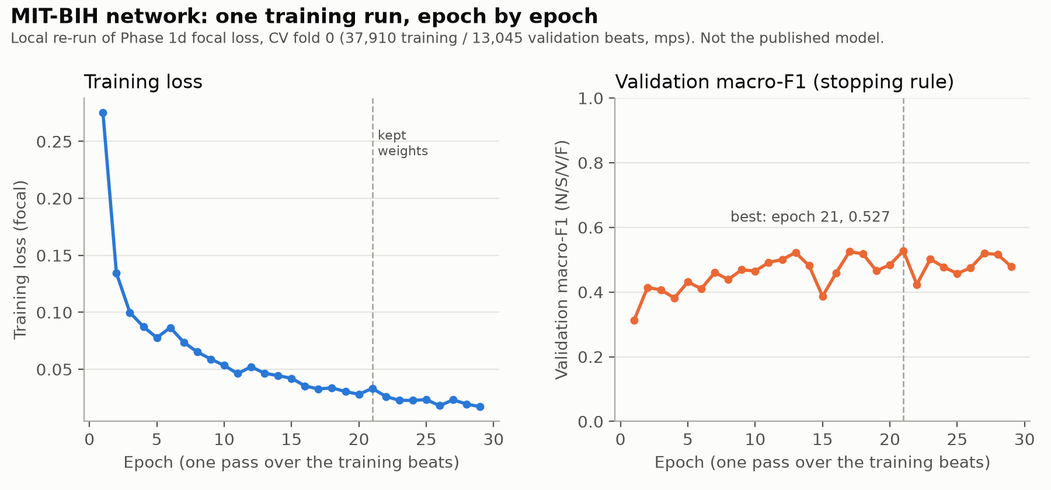
Figure 1. Training loss and validation macro-F1 per epoch, one local re-run
- What it shows. How one network learns. The left panel is the training loss, the right panel the validation macro-F1, both per epoch (one pass over the training data).
- Data. A local re-run of one cross-validation fold (focal loss, fold 0, 37,910 training and 13,045 validation beats) made for this report, because the original GPU runs saved no epoch-by-epoch history. Source: PlanDoc/integration_results/mitbih_learning_curve_fold0_focal.json, produced by scripts/mit_bih/record_learning_curve.py.
- Axes. x: epoch. y: focal loss (lower is better) / macro-F1 (higher is better).
- What it tells us. Training loss falls steadily, but validation macro-F1 rises until about epoch 11 and then swings between 0.39 and 0.53. The model keeps fitting the training patients without generalising better to new ones. Early stopping kept epoch 21 (0.527). The original GPU run of the same fold scored 0.534 at epoch 12; the difference comes from different hardware and random variation.
- Verdict. Inconclusive about the final model (this is one of the original 5 folds, re-run); informative about behaviour: noisy, with patient-level variation larger than epoch-to-epoch gains.
- Limitation. Training-versus-validation accuracy and validation loss are not available: the training code never recorded them, and accuracy is uninformative here (Section 6).

Figure 2: confusion matrix of the selected ECG model
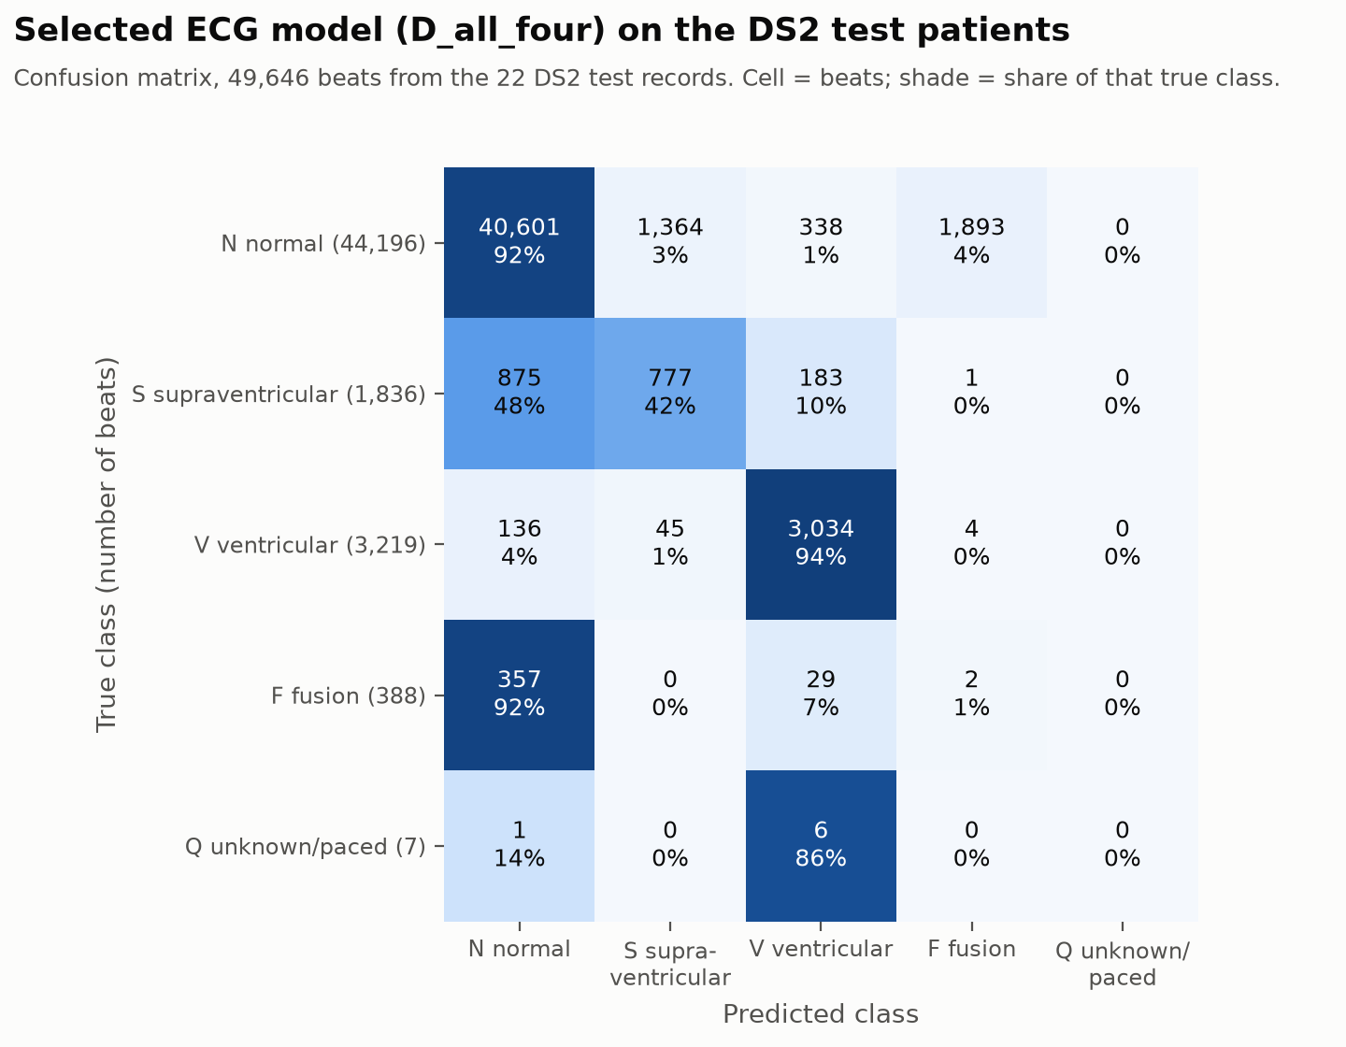
Figure 2. Confusion matrix, D_all_four on DS2
- What it shows. For each true class (rows), how the 49,646 test beats were classified (columns). The diagonal is correct.
- Data. results/2026-10-14-bundle-eval-ds1_ds2.json.
- What it tells us. 92% of normal and 94% of ventricular beats are correct. 42% of supraventricular beats are found, but 48% are called normal. Fusion beats are almost never recognised: 357 of 388 are called normal, and 1,893 normal beats are wrongly called fusion. 6 of the 7 Q beats are called
- Verdict. Good for N and V, weak for S, failing for F.
- Limitation. One dataset of 1970s recordings; 22 test recordings, one of which (202) shares a patient with training.

Figure 3: precision, recall and F1 per class
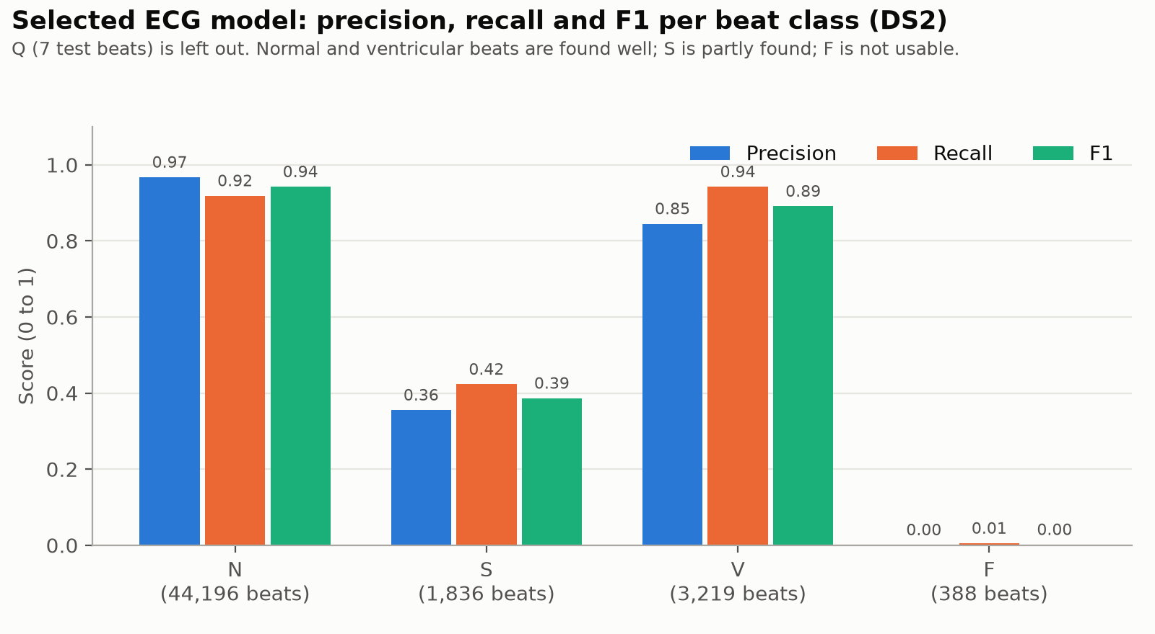
Figure 3. Per-class precision, recall and F1
- What it shows. Precision: of the beats predicted as a class, the share that really are. Recall: of the beats of a class, the share found. F1: their harmonic mean.
- Data. results/2026-10-14-bundle-eval-ds1_ds2.json.
- What it tells us. N: precision 0.97, recall 0.92. V: 0.85 / 0.94. S: 0.36 / 0.42. F: about 0.00. Q is left out (7 test beats).
- Verdict. Good for N and V, weak for S, unusable for F.
- Limitation. Across every model tried, S precision has stayed between 0.26 and 0.41.

Figure 4: every ECG model on the same test set
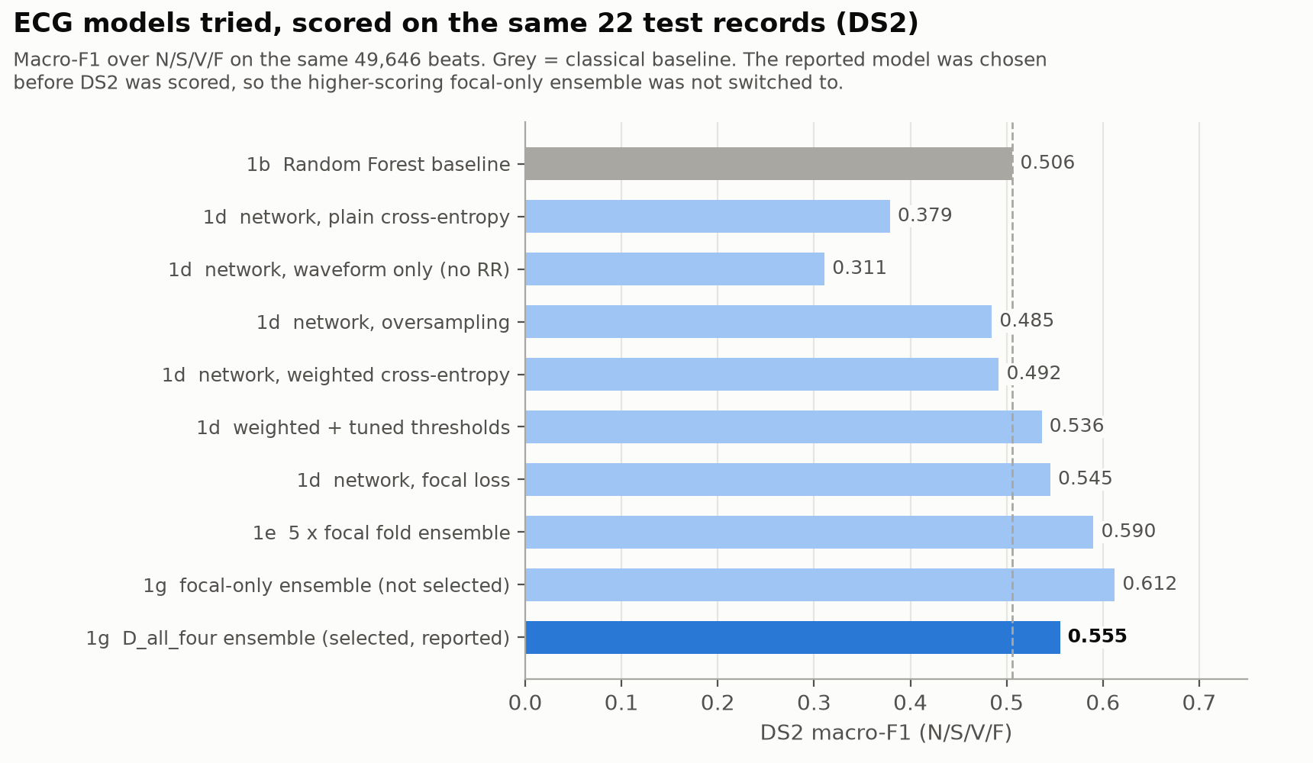
Figure 4. DS2 macro-F1 of each ECG model tried
- What it shows. Macro-F1 over N/S/V/F (the average F1 of the four classes, so rare classes count as much as common ones) for every model tried, on the same 49,646 beats.
- Data. results/2026-08-27-baseline-ds1_ds2.json, results/2026-09-16-nn-ds1_ds2.json, results/2026-09-17-nn-v2-ds1_ds2.json, results/2026-09-17-ensemble-mix-ds1_ds2.json.
- What it tells us.
  - The network needs the timing branch: without it, 0.311.
  - It also needs the right loss: with plain, weighted or oversampled training it scores below the Random Forest (0.506). Only focal loss (0.545), tuned thresholds (0.536) and the ensembles beat it.
  - The selected ensemble scores 0.555. A focal-only ensemble scored higher (0.612), but it was not selected beforehand; switching after seeing the test score would be choosing on the test set.
- Verdict. A real but modest improvement over the classical baseline: +0.049.
- Limitation. While preparing this figure, an error in the project README came to light: it had listed the baseline at 0.405, which is a different average (over all five classes). It has been corrected (see PlanDoc/IMPLEMENTATION.md, Problem 23).

Figure 5: MIMIC-III Demo cohort
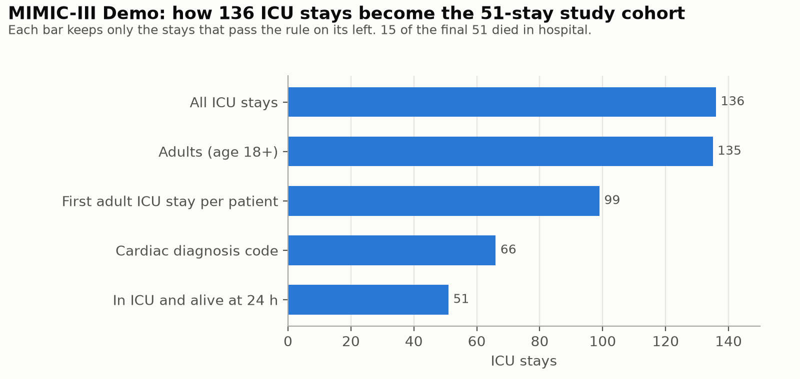
Figure 5. Cohort selection on the MIMIC-III Demo
- What it shows. How many ICU stays remain after each selection rule.
- Data. results/2026-10-14-mimic-demo-pipeline.json.
- What it tells us. 136 stays → 51. The largest cut is the cardiac diagnosis rule (99 → 66). 15 of the 51 died in hospital (29%).
- Verdict. Works as designed.
- Limitation. 51 stays is far too few for modelling.

Figure 6: missing values
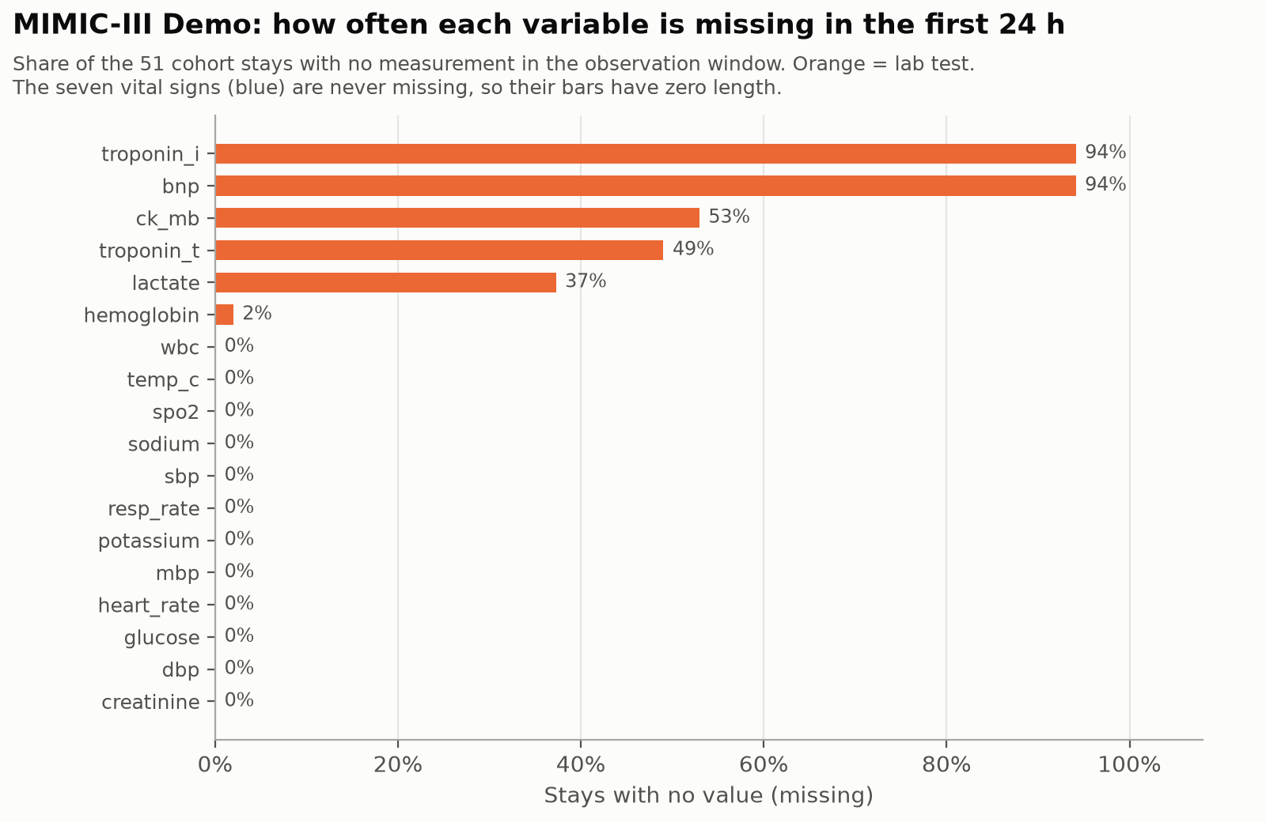
Figure 6. Share of stays with no measurement, per variable
- What it shows. For each variable, the share of the 51 stays with no measurement in the first 24 hours.
- Data. ~/physionet-data/processed/mimiciii-demo/build_summary.json (aggregate).
- What it tells us. Vital signs are never missing. Troponin I and BNP are missing for 94% of stays, CK-MB for 53%, troponin T for 49% and lactate for 37%. Lab tests are ordered when a doctor suspects something, so whether a test was done carries information. That is why each variable has a “missing” flag rather than only a filled-in value.
- Verdict. Informative.
- Limitation. Demo patients only; missingness on full MIMIC-III will differ.

Figure 7: how often variables are measured
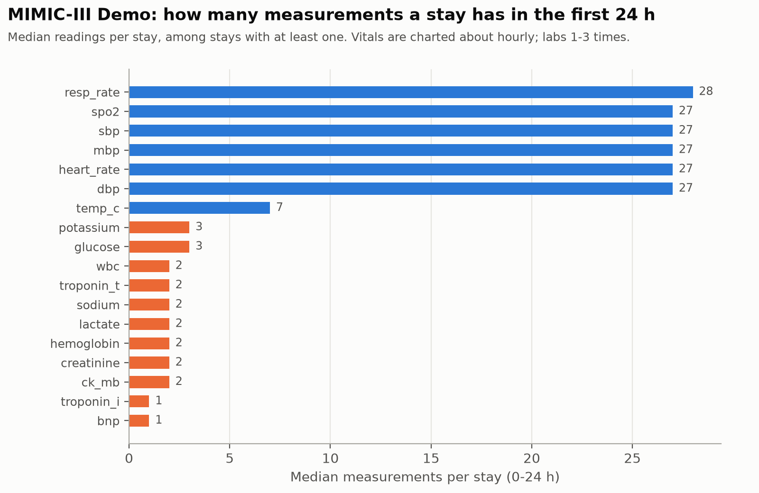
Figure 7. Median measurements per stay
- What it shows. The median number of readings per stay, among stays with at least one.
- Data. ~/physionet-data/processed/mimiciii-demo/features.csv.gz (aggregated).
- What it tells us. Vital signs about 27 times in 24 hours (about hourly), temperature 7, labs 1-3. This explains why “count” is a feature and why “last value” for a lab may be many hours old.
- Verdict. Informative.
- Limitation. Demo only.

Figure 8: Demo model metrics with confidence intervals
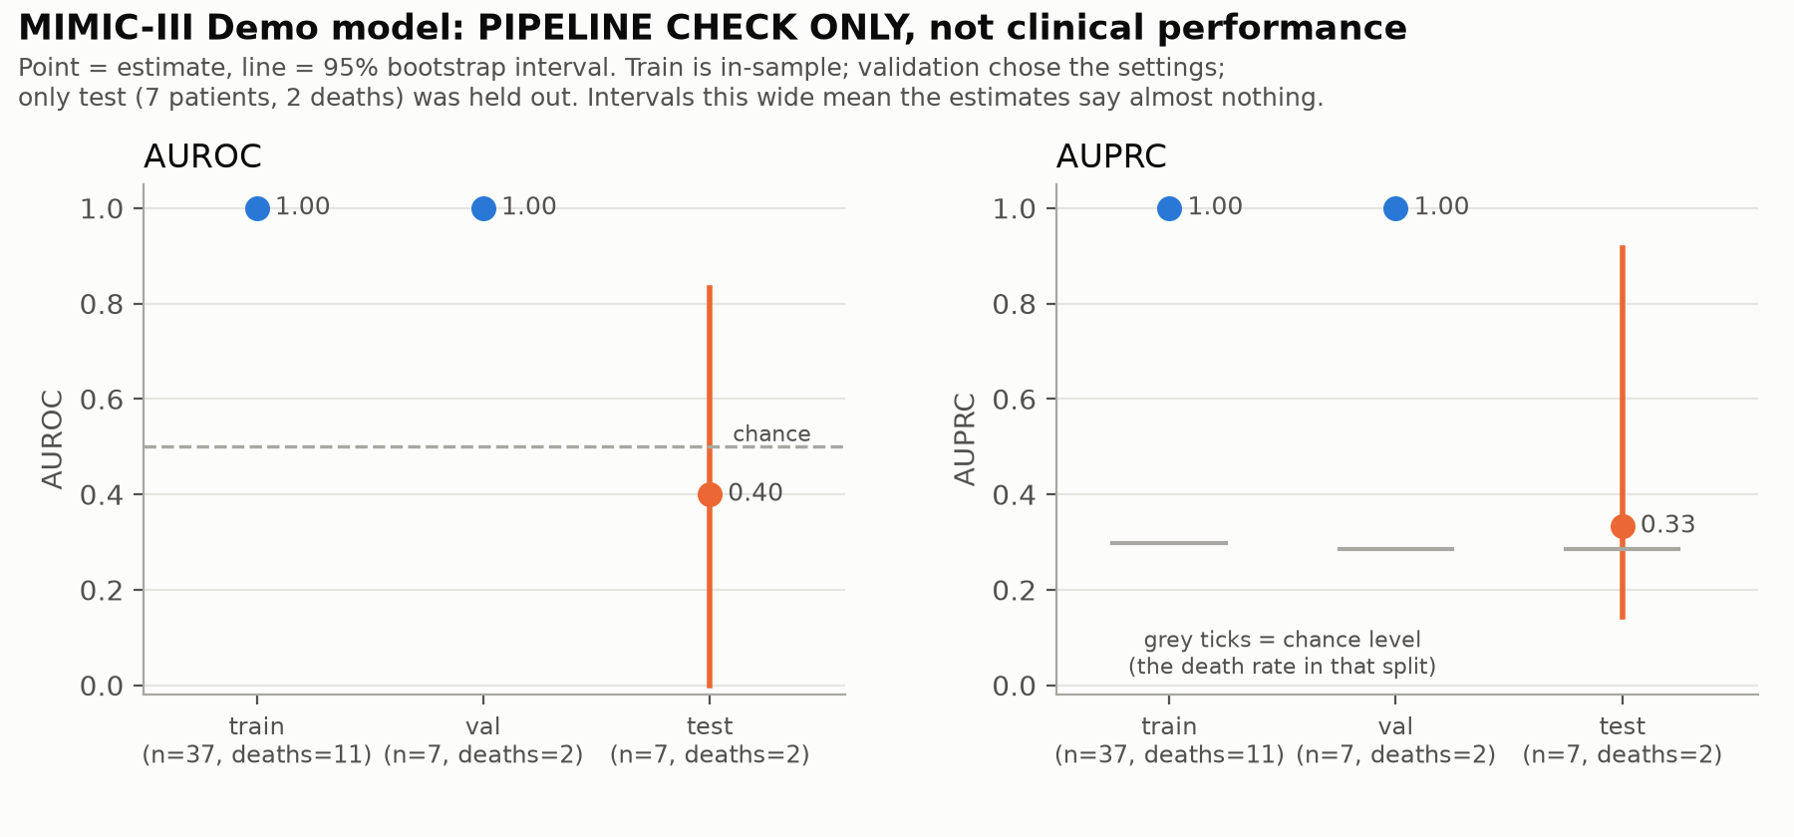
Figure 8. AUROC and AUPRC per split, MIMIC-III Demo
- What it shows. AUROC and AUPRC on the training, validation and test patients, with 95% bootstrap confidence intervals. A confidence interval is the range in which the true value plausibly lies.
- Data. results/2026-10-14-mimic-demo-pipeline.json.
- What it tells us.
  - Training and validation are perfect (1.00) because the model memorised 37 patients, and validation was used to choose the settings.
  - Test AUROC is 0.40, with an interval from 0.00 to 0.83 on 7 patients.
- Verdict. Inconclusive by design. This verifies the software; it is not model performance.
- Limitation. Needs full MIMIC-III.

Figure 9: automated tests before and after
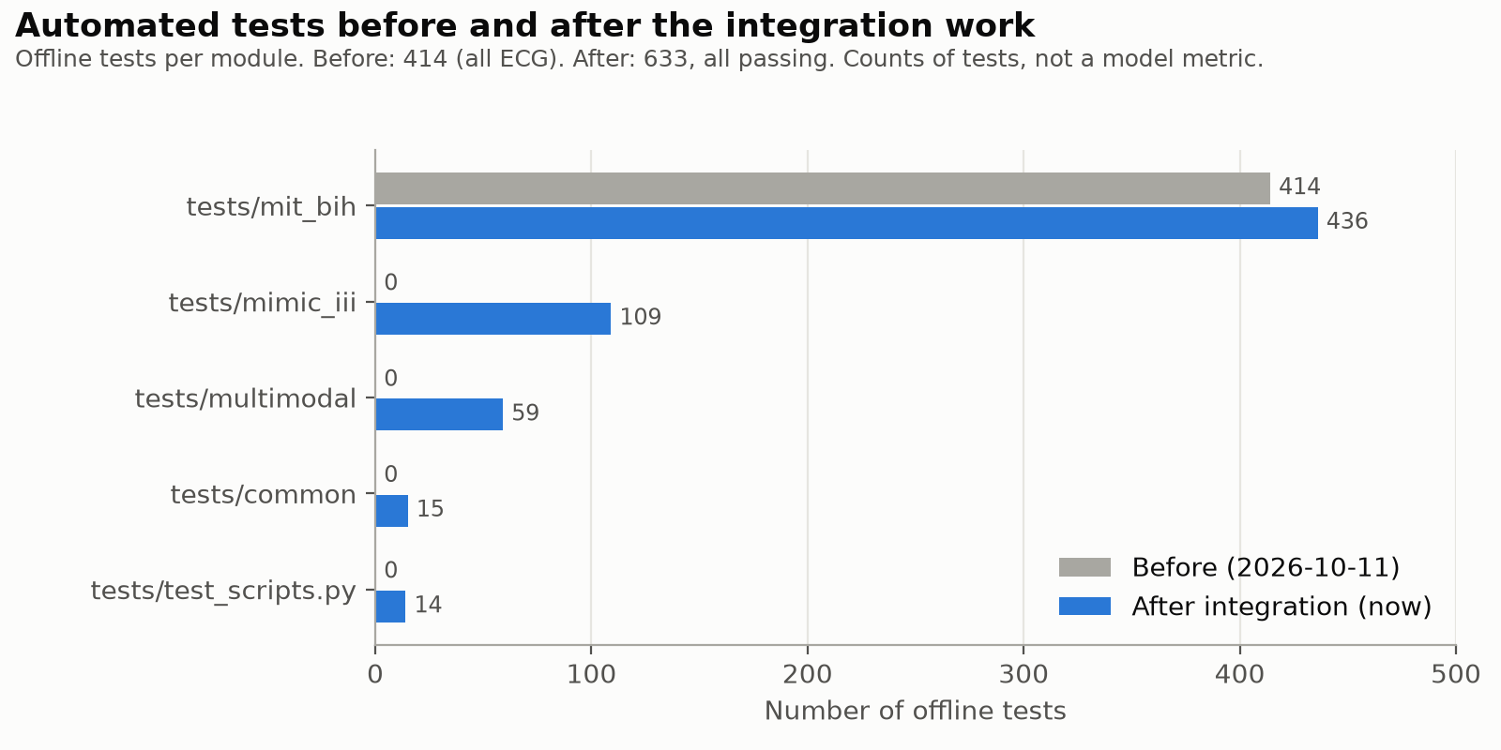
Figure 9. Offline tests per module, before and after
- What it shows. The number of automated tests per module before (11 October) and after (14 October) the integration work.
- Data. Before: PlanDoc/IMPLEMENTATION.md (414). After: counted live by pytest (633, all passing).
- What it tells us. The new MIMIC-III, multimodal and shared code is covered by 197 new tests, and the ECG module gained 22 (the inference path).
- Verdict. Good. This is the valid “before vs after” comparison.
- Limitation. These are counts of tests, not a quality measure.

Figure 10: ECG scores are not probabilities (from Phase 1f)
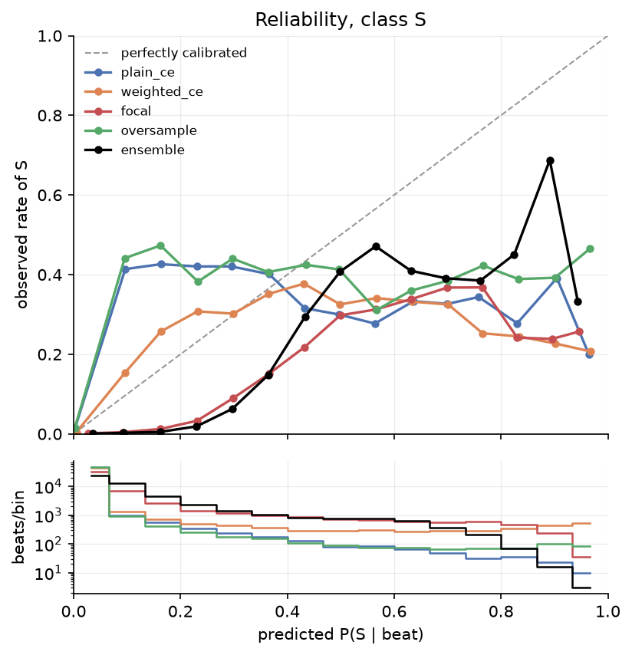
Figure 10. Reliability of the S score, Phase 1f
- What it shows. For beats given a certain predicted chance of being S (x-axis), the share that really were S (y-axis). A perfectly calibrated model follows the diagonal. Each coloured line is one Phase 1d model; “ensemble” is the five-model focal ensemble of Phase 1e, not the selected D_all_four.
- Data. Existing figure results/figures/2026-09-17-reliability-S.png, from results/2026-09-17-calibration-diagnosis-ds1_ds2.json.
- What it tells us. The curves are far from the diagonal, so a score of 0.8 does not mean an 80% chance. The scores are good for ranking beats, not as probabilities.
- Verdict. A known weakness; the calibration fix (Phase 1f Stage B) is not done.

Graphs not available
Graph | Reason
Training vs validation accuracy | Graph not available because the required experiment has not been completed or verified: no run recorded accuracy per epoch (and accuracy is uninformative here)
Validation loss per epoch | Graph not available because the training code does not compute it
Before vs after integration: model performance | Graph not available because no comparable experiment exists (no fused model; different tasks and patients)
Fusion model results on real data | Graph not available because no paired ECG + clinical data exists
MIMIC-III model on full data | Graph not available because full MIMIC-III is not yet accessible

6. Results summary
Model / component | Metric | Actual result | Status
MIT-BIH ECG classifier (D_all_four) | Accuracy, DS2 (49,646 beats) | 0.895 (labelling everything “normal” would score 0.890) | Verified 2026-10-14
MIT-BIH ECG classifier | Macro-F1, N/S/V/F | 0.555 (5-class average: 0.444) | Verified, identical to original
MIT-BIH ECG classifier | Macro-F1 without record 202 (shares a patient with training) | 0.567 (47,513 beats) | Measured 2026-10-14
MIT-BIH ECG classifier | Recall N / S / V / F | 0.92 / 0.42 / 0.94 / 0.01 | Verified
Random Forest baseline | Macro-F1, N/S/V/F (same beats) | 0.506 (5-class: 0.405) | From frozen results
MIMIC-III clinical model (Demo) | Test AUROC (95% CI) | 0.40 (0.00-0.83), n = 7 | Pipeline verification only
MIMIC-III clinical model (Demo) | Test AUPRC / Brier score | 0.33 / 0.367 | Pipeline verification only
Multimodal fusion model | Any real metric | Not trained on real data | Blocked
Fusion network (synthetic check) | AUROC, both inputs vs one | 0.897 vs 0.770 / 0.778 | Synthetic only; not a result
Integration tests | Passed / total | 59 / 59 (tests/multimodal) | Complete
All automated tests | Passed / total | 633 / 633 offline; 15 / 15 real-data; 4 / 4 slow | Complete
What the numbers mean.
- Macro-F1 averages the F1 of the four beat classes, so finding rare arrhythmias counts as much as finding normal beats. It is the fair headline for unbalanced data, while accuracy mostly measures the 89% of normal beats.
- AUROC of 0.5 is guessing and 1.0 is perfect.
What can and cannot be compared.
- The ECG rows can be compared with each other: same beats, same task.
- The ECG and clinical numbers cannot be compared with each other. One scores heartbeat types on 1970s recordings; the other scores in-hospital death for 7 Demo ICU patients. A higher number on one side does not make that model “better”.
- There is no fused-model row to compare with either.

7. Files to show the professor
File path | Purpose | What to show
README.md | Project overview | The diagram and the status table
src/mit_bih/pipeline.py | ECG preprocessing orchestration | Load → filter → segment → label → normalise
src/mit_bih/filters.py | ECG filtering | Zero-phase band-pass
src/mit_bih/segment.py | Beat cutting | 100/200-sample window, edge beats dropped and counted
src/mit_bih/nn/model.py | ECG network | The two branches (shape + timing)
src/mit_bih/nn/train.py, nn/losses.py | ECG training | Early stopping, focal loss
src/mit_bih/inference.py | Raw signal → beat scores | prepare_beats reuses the Phase 1 functions
models/mit_bih_inference_bundle.json | Saved ECG preprocessing + 20 checksums | Normalisation statistics, calibration note
src/mimic_iii/ingestion.py | MIMIC loading | Schema checks, chunked reading
src/mimic_iii/cohort.py | Cohort and label | Validated joins, exclusion flow
src/mimic_iii/features.py | Clinical features | 24 h windows, unit handling, leakage guard
src/mimic_iii/config.py | Task definition | Index time, windows, measurement codes
src/mimic_iii/train.py, evaluate.py | Clinical model and report | Selection on validation, Demo banner
configs/mimic_iii.toml | Task settings | Index time, windows, seed
src/multimodal/inference.py | Shared interface | Separate labelled sections, no merging
src/multimodal/fusion.py | Fusion network and pairing check | ConcatFusion, validate_pairs
scripts/multimodal/infer.py | Inference command | The demo in Section 11
scripts/run_end_to_end.py | Whole workflow | 8 steps, one command
tests/mimic_iii/test_features.py | Leakage test | test_events_after_the_index_time_cannot_change_any_feature
tests/multimodal/test_fusion.py | Fusion tests | Missing-modality and pairing tests
results/2026-10-14-bundle-eval-ds1_ds2.json | ECG test result | Confusion matrix, per-class metrics
results/2026-10-14-mimic-demo-pipeline.md | Clinical Demo report | Banner, cohort, metrics with CIs
PlanDoc/integration_results/ | Figures and verification outputs | Figures 1-9, test logs
PlanDoc/IMPLEMENTATION.md | Full record of what was done | Problems discovered, deviations
The best files to open in a demonstration, in this order:
Order | File | Why
1 | README.md | Overview and architecture
2 | src/mit_bih/nn/model.py | The ECG network fits on one screen
3 | src/mimic_iii/config.py | The clinical task, stated in plain words at the top
4 | src/mimic_iii/features.py | How the 24-hour features are built
5 | src/multimodal/inference.py | The integration
6 | src/multimodal/fusion.py | The fusion network and the pairing check
7 | tests/mimic_iii/test_features.py | The leakage test
8 | PlanDoc/integration_results/fig02_mitbih_confusion_matrix.png, fig04_mitbih_model_progression.png | The main ECG results

8. What is done and what is not done

Completed (with evidence)
Item | Evidence
MIT-BIH download, integrity check and preprocessing | 48/48 records verify; counts match published totals; tests in tests/mit_bih/
ECG baseline and neural classifier, trained and evaluated | DS2 macro-F1 0.555 vs baseline 0.506; results/
ECG inference from a raw signal | Reproduces 0.5554 from raw records; tests/mit_bih/test_inference.py
MIMIC-III pipeline (load, cohort, features, split, preprocessing, model, report) | 109 offline + 4 real-Demo tests; runs end to end on the Demo
Leakage protection in both pipelines | Tests, plus deliberate-bug checks that make them fail
Shared inference interface | 58 multimodal tests; real smoke run
Fusion architecture | Tested on synthetic pairs
One-command workflow and setup check | scripts/run_end_to_end.py (70 s), scripts/validate_setup.py (0 failures)

Partially completed
Item | What is missing | Why it matters | What needs to be done | Resources | Next step
MIMIC-III clinical model | Training and evaluation on real-size data | Demo results are meaningless (7 test patients) | Run the same three scripts with --source full | Credentialed full MIMIC-III; tens of minutes of compute | Complete PhysioNet credentialing
ECG score calibration (Phase 1f Stage B) | A correction so scores are probabilities | A fusion model or a clinician needs trustworthy probabilities | Fit temperature or prior correction on out-of-fold predictions | None beyond the repository | Implement and test Stage B
ECG performance on S and F | S F1 0.39; F F1 0.00 | These are clinically important rhythms | Better features (e.g. a second lead), more data, other architectures | GPU time; possibly other ECG datasets | Error analysis of the S/N confusions
Fusion network | Training and evaluation on real data | It is the point of the integration | Paired data, a common target, a patient-level split | See below | Choose and obtain a paired dataset

Not completed / blocked
Item | What is missing | Why it matters | What needs to be done | Data or resources required | Suggested next step
Full MIMIC-III | Access | Needed for any meaningful clinical result | CITI training, PhysioNet credentialing, a signed data use agreement | Your personal application (days to weeks) | Start the application
Paired ECG + clinical data | A dataset with both for the same patients | Without it, fusion cannot be trained honestly | Use the MIMIC-III Waveform Database Matched Subset (linked by subject_id) | Full MIMIC-III access; terabyte-scale storage or a selective download; resampling from 125 Hz to 360 Hz or retraining at 125 Hz | Estimate storage for only the cohort’s ECG segments
Multimodal training and evaluation | Experiments | Answers whether combining helps | Train ECG-only, clinical-only and fused models on the same patients, task and split | The paired dataset | Define the common task (e.g. in-hospital mortality)
MIMIC waveform / signal-quality layer (Phase 3) | Not started | Planned stage | Design | Terabyte-scale data | After paired data
Agentic layer (Phase 4) | Not started | Planned stage | Design | — | After fusion

9. What can be done next
Short term (days, no new data needed)
- Fit the ECG calibration correction (Phase 1f Stage B) and add it to the inference bundle.
- Save per-epoch training histories in future runs, so learning curves exist for the published models.
- Report ECG results both with and without record 202.
- Commit the current work (the code is complete but not yet committed).
Medium term (weeks)
- Complete PhysioNet credentialing and run the clinical pipeline on full MIMIC-III. Add a stronger baseline there (for example gradient-boosted trees) next to the logistic regression.
- Improve S detection: error analysis of S beats called normal, a second ECG lead, rhythm context.
- Test the unified inference on more recordings and on detected (not annotated) R peaks.
Long term (months)
- Obtain genuinely paired ECG + clinical data (MIMIC-III Waveform Matched Subset).
- Train a real fusion model.
- Compare ECG-only, clinical-only and fused models on the same task, the same patients and the same split, with confidence intervals.
- Evaluate generalisation on a second hospital’s data and check calibration before any clinical claim.

10. What to say to the professor

A. 30-second introduction
“My project builds the data and model foundation for a cardiac AI system from two public research datasets. MIT-BIH gives me heartbeat-level ECG recordings, and I trained a neural network that labels each heartbeat as normal or as one of four abnormal types. MIMIC-III gives me intensive-care records, and I built a tested pipeline that turns them into a prediction of in-hospital death 24 hours after ICU admission. I then connected the two behind one software interface and designed a fusion model to combine them. That fusion model is built and tested, but it is not trained yet, because the two datasets contain different patients and I do not have data where both exist for the same person.”

B. 2-minute project explanation
“The project has eight steps.
One, loading the data. I download the 48 MIT-BIH ECG recordings and check their integrity. For MIMIC-III I read eight tables from the open Demo version and check every table and column before using it.
Two, cleaning. ECG signals are filtered to remove baseline drift and noise, and every annotated heartbeat is cut into a 0.83-second window. Clinical tables are joined with checks, and values outside physical limits are removed.
Three, features. For the ECG, the network sees the heartbeat shape plus six timing features that describe how early or late each beat arrived. For the clinical data, I summarise 7 vital signs and 11 lab tests over the first 24 hours: 113 inputs per ICU stay.
Four, splitting. Training and test data never share a recording or a patient, apart from one known case in the standard ECG benchmark split that I report openly. Anything learned from data, such as scaling or filling in missing values, is learned from the training part only.
Five, the ECG model. A two-branch neural network with about 60,000 parameters. I compared five ways of handling rare classes, and the final model is an ensemble of 20 networks. On the 22 test recordings its macro-F1 is 0.555, against 0.506 for a Random Forest baseline on the same beats.
Six, the clinical model. A logistic regression for in-hospital death. It runs end to end, but on the 100-patient Demo the test set has only 7 patients, so its numbers say nothing about real performance.
Seven, integration. One function accepts an ECG, clinical data, or both, and returns each model’s answer separately and clearly labelled. A fusion network is implemented and passes its tests on synthetic data.
Eight, testing. 633 automated tests pass, plus 15 tests on the real data, and one command runs the whole workflow in about a minute.”

C. 5-minute technical walkthrough
Minute 1: architecture. Show the diagram in Section 1. “Two independent pipelines feed one inference layer. The ECG side works per heartbeat, the clinical side works per ICU stay. The integration layer validates inputs, runs whichever models apply, and returns labelled outputs. The fusion network sits behind it, but it stays switched off until paired data exists.”
Minute 2: ECG model. Show Figure 4 and Figure 2. “Every model was scored on the same 49,646 test beats. The network only beat the classical baseline when the RR-timing branch was combined with focal loss or tuned thresholds; with plain, weighted or oversampled training it scored below it. Without timing it drops to 0.311. Normal and ventricular beats are recognised well: recall 0.92 and 0.94. Supraventricular beats are partly found (recall 0.42, precision 0.36). Fusion beats are not recognised: 357 of 388 are called normal. I do not quote accuracy (0.895), because predicting ‘normal’ for every beat already scores about 0.89.”
Minute 3: clinical pipeline. Show Figures 5 and 6. “136 ICU stays become 51 after the cohort rules: adults, first stay, a cardiac diagnosis, still in the ICU and alive at 24 hours. Vital signs are always present; troponin I and BNP are missing for 94% of stays, so every variable gets a ‘was it measured’ flag. The pipeline is tested against leakage: a test changes everything recorded after the 24-hour mark and checks that no feature moves.”
Minute 4: integration and its limit. Show src/multimodal/inference.py and the output of scripts/multimodal/infer.py. “The output has separate ECG and clinical sections, each stating what it predicts and what data trained it. It never merges them into one score, because they answer different questions about different people. The fusion network is tested on synthetic data where the answer depends on both inputs: fused AUROC 0.90 against about 0.77 for either input alone. That shows the code works. It is not a medical result.”
Minute 5: limitations and next steps. Show Section 8. “Three things block a real multimodal result: credentialed access to full MIMIC-III, a dataset with ECG and clinical data for the same patients (the MIMIC-III Waveform Matched Subset), and calibrated ECG scores. With those, the plan is to train ECG-only, clinical-only and fused models on the same patients, task and split, and compare them.”

D. Likely questions and answers
1. Why MIT-BIH and MIMIC-III? MIT-BIH is the standard benchmark for heartbeat classification: every beat was labelled by cardiologists, and a published patient split (DS1/DS2) lets me compare with other work. MIMIC-III is the standard research database for ICU prediction, with vital signs, lab tests and outcomes. Its Demo is open, and the full version needs credentialed access.
2. What is the difference between the datasets? MIT-BIH is 48 half-hour ECG recordings from 47 people, recorded 1975-79, at 360 samples per second, labelled heartbeat by heartbeat. MIMIC-III is a relational database of ICU stays at one Boston hospital from 2001-2012, labelled per hospital admission, for example whether the patient died. One is a signal, the other is tables, and they contain different people.
3. How did you preprocess the data? ECG: a 0.5-40 Hz zero-phase band-pass filter, 300-sample windows around each annotated R peak, standard AAMI class labels, z-score scaling with statistics from the training records only, and six RR-interval features. Clinical: validated joins, a cohort definition, a 24-hour window ending at the prediction time, unit conversion, removal of impossible values, missingness flags, and imputation and scaling fitted on training patients only.
4. What models did you use? For ECG, a two-branch 1-D convolutional network (waveform branch plus a timing branch), trained with five imbalance strategies and combined into a 20-model ensemble, compared against a Random Forest. For clinical data, an L2-regularised logistic regression with balanced class weights.
5. How did you integrate the models? At the software level. Each model has an encoder that turns its input into a fixed-length vector (13 values for ECG, 119 for clinical). One function, run_inference, takes either or both inputs and returns both answers. A fusion network, ConcatFusion, can combine the two vectors, and it handles a missing modality. It is implemented and tested on synthetic data only.
6. Are the patients in both datasets the same? No. MIT-BIH and MIMIC-III share no patients. That is why I did not train the fusion model, and the pairing check in my code rejects any attempt to pair an MIT-BIH record with a MIMIC-III patient.
7. What was the performance before integration? The ECG model scored macro-F1 0.555 on the test recordings, and the Random Forest baseline 0.506. There was no clinical model before, only an exploration script.
8. Did accuracy improve after integration? No improvement can be claimed, and none is claimed. Integration did not change either model: I re-scored the ECG model after integration and got the same 0.5554. The fusion model was not trained, so there is nothing to compare. A fair comparison needs ECG-only, clinical-only and fused models on the same patients and task.
9. What is the final output? A structured result with an ECG section (the class of every heartbeat, with a summary) and a clinical section (a mortality risk score with its caveats). The fusion section says BLOCKED until a paired dataset exists.
10. What remains to be completed? Training the clinical model on full MIMIC-III (needs credentialing), calibrating the ECG scores, improving the S and F classes, and training and evaluating the fusion model on genuinely paired data.
11. How did you prevent data leakage? Splits by patient: by record for ECG, by SUBJECT_ID for MIMIC. Statistics fitted on training data only. Model choices made on validation data, and the test set scored once. Time windows that end before the prediction time. Every rule is backed by an automated test, and I deliberately broke the code to confirm the tests catch it. One known exception: the standard ECG split puts records 201 and 202, which come from the same person, on opposite sides. Without record 202 the score is 0.567, slightly higher, so that overlap did not inflate the result.
12. What is the main contribution? Two tested, leakage-safe pipelines for very different medical data; an ECG classifier that beats a classical baseline on an inter-patient test set and is reproducible from the raw signal; and an integration layer and fusion design that are ready for paired data and refuse to fake it.
13. Why is the MIMIC result so poor, and why is training AUROC 1.0? The Demo has 51 eligible stays. With 113 inputs and 37 training patients, the model memorises the training set (training AUROC 1.0), and the 7-patient test set gives an interval from 0.00 to 0.83. These numbers verify the code, not the model.
14. Why not use full MIMIC-III? It requires PhysioNet credentialing: CITI human-subjects training and a signed data use agreement. That is a personal legal step I have to complete. The pipeline already accepts the full database with --source full.

11. End-to-end demonstration guide
Every command below was run on 2026-10-14 and produced the output described. Run them from the project folder after activating the environment:
cd "/Users/tanushreenepal/Desktop/Smart Healthcare"
source venv/bin/activate
Step 1. Open the project. Open the folder in VS Code and show README.md (the project overview and the architecture diagram) and the src/ folder with its four packages: mit_bih, mimic_iii, multimodal, common.
Step 2. Show that everything is in place.
python scripts/validate_setup.py
- Input: none (it reads the data folder ~/physionet-data).
- Expected output: a list of checks ending with {'OK': 16, 'MISSING': 1, 'BLOCKED': 3, 'FAIL': 0}. MISSING is the ECG calibration step; BLOCKED are full MIMIC-III, the paired dataset and fusion training.
- Say: “Nothing is broken. What is missing or blocked is listed with the reason.”
Step 3. Run the tests.
python -m pytest -q
- Expected output: 633 passed, 19 deselected in about 30 seconds.
- Say: “These tests use synthetic ECG and synthetic MIMIC-shaped tables, so no patient data is needed. They include the leakage tests.”
Step 4. Run the whole workflow.
python scripts/run_end_to_end.py
- Expected output, after about 70 seconds: seven steps OK and BLOCKED 8. fusion training.
- Saved to: ~/physionet-data/processed/end_to_end/report.md.
- Say: “This rebuilds the MIMIC features, splits by patient, trains and evaluates the clinical model, re-prepares the ECG beats, checks the ECG model, runs the shared inference, and confirms that fusion training refuses to run without paired data.”
Step 5. Show the shared inference on real ECG plus an example clinical record.
python scripts/multimodal/infer.py --ecg-record 100 \
--clinical-json PlanDoc/integration_results/example_clinical_input.json
- Input: the first 60 seconds of MIT-BIH record 100, and the invented clinical example in PlanDoc/integration_results/example_clinical_input.json (clearly marked as not a patient).
- Expected output (JSON): "ecg" section with "status": "ok", 70 beats classified (69 N, 1 S); "clinical" section with "status": "ok", "risk_score": 0.24985, "above_threshold": false and the warning that the model was trained on the Demo; "fusion" with "status": "BLOCKED"; "patient_linkage" stating the two are not linked.
- Saved copy: PlanDoc/integration_results/demo_output_example.json.
- Say: “One call, two independent answers, each labelled. No combined score, because these are different people and different questions.”
Step 6. Show the ECG result and graphs. Open PlanDoc/integration_results/fig02_mitbih_confusion_matrix.png and fig04_mitbih_model_progression.png.
- Say: “On the 22 test recordings the selected model reaches macro-F1 0.555 against 0.506 for the Random Forest. Normal and ventricular beats are found well, supraventricular partly, fusion beats not at all.”
Optional live check (about 1 minute; 3 records, so not comparable to the full number):
python scripts/mit_bih/evaluate_bundle.py --records 100 208 232
Step 7. Show the clinical pipeline result. Open fig05_mimic_cohort_flow.png, fig06_mimic_missingness.png and fig08_mimic_demo_metrics.png.
- Say: “The pipeline runs end to end on the Demo. With 7 test patients the interval goes from 0.00 to 0.83, so this proves the software, not the model.”
Step 8. Show the leakage protection in code. Open tests/mimic_iii/test_features.py and find test_events_after_the_index_time_cannot_change_any_feature. Then open src/multimodal/fusion.py and find validate_pairs.
- Say: “This test rewrites every measurement after the prediction time and checks that no feature changes. And this function refuses to pair an MIT-BIH ECG with a MIMIC-III patient.”
Commands that cannot run yet (show only to explain the blockers):
Command | What happens now | Why
python scripts/mimic_iii/build_features.py --source full | Prints BLOCKED, exit code 3 | Full MIMIC-III needs PhysioNet credentialing
python scripts/multimodal/train_fusion.py | Prints BLOCKED, exit code 3 | No paired ECG + clinical dataset

12. Final conclusion
The project shows that heartbeat-level ECG classification and ICU outcome prediction can be built as rigorous, tested pipelines and connected behind a single, careful interface.
- The MIT-BIH model contributes a working heartbeat classifier. On 22 test recordings it reaches macro-F1 0.555, a modest but real gain over a classical baseline (0.506). It is strong on normal and ventricular beats, weak on supraventricular beats, and it fails on fusion beats. Its result reproduces exactly from the raw signal.
- The MIMIC-III work contributes a leakage-checked clinical pipeline: a clearly defined task, validated joins, time-safe features, patient-level splits, and memory-safe reading of the full database. It is ready for real data, but it has only been run on a 100-patient Demo, so it has no performance result yet.
- The integration contributes one interface for both kinds of data, a fusion network tested on synthetic data, and safeguards that refuse to combine unrelated patients or merge incomparable scores.
- The results show a verified ECG classifier and working software. They do not show that combining ECG and clinical data improves prediction; that question has not been tested yet.
- What would make the project stronger: full MIMIC-III, a genuinely paired ECG + clinical dataset, calibrated ECG scores, better S and F detection, and a direct comparison of ECG-only, clinical-only and fused models on the same patients.

Appendix A: terms used
Term | Meaning
ECG | Electrocardiogram: the heart’s electrical activity recorded over time
R peak | The tallest spike of each heartbeat; used to locate beats
RR interval | Time between two consecutive R peaks
AAMI classes | Standard beat groups: N normal, S supraventricular ectopic, V ventricular ectopic, F fusion, Q unknown/paced
DS1 / DS2 | The standard MIT-BIH split into 22 training and 22 test recordings (de Chazal et al., 2004)
Cross-validation | Training on part of the data and checking on the rest, rotating several times
Precision / recall / F1 | Correctness of predictions / share of true cases found / their harmonic mean
Macro-F1 | The average of per-class F1, giving rare classes equal weight
AUROC | The chance a random positive case scores higher than a random negative one (0.5 = chance)
AUPRC | The area under the precision-recall curve; its chance level equals the positive rate
Confidence interval | A range that plausibly contains the true value
Data leakage | Test or future information reaching training, which inflates results
Encoder | Code that turns raw input into a fixed-length vector of numbers
Fusion | Combining two kinds of input in one model
Calibration | Whether a score of 0.8 really means an 80% chance
Ensemble | Several models whose outputs are averaged

Appendix B: how this report was produced
- Commands run on 2026-10-14:
  - python -m pytest -q (633 passed)
  - python -m pytest -q -m requires_data (15 passed)
  - python scripts/validate_setup.py
  - python scripts/run_end_to_end.py
  - python scripts/mit_bih/evaluate_bundle.py (all of DS2, and all of DS2 except record 202)
  - python scripts/mit_bih/record_learning_curve.py
  - python scripts/multimodal/infer.py
  - python scripts/make_integration_figures.py
- Outputs are in PlanDoc/integration_results/.
- Figures: regenerate with python scripts/make_integration_figures.py.
- Not included: no patient identifiers and no row-level data from MIMIC-III appear in this report. The clinical input example is invented.
- Word versions: PlanDoc/Integration_Documentation.doc has the same content as this Markdown file.

