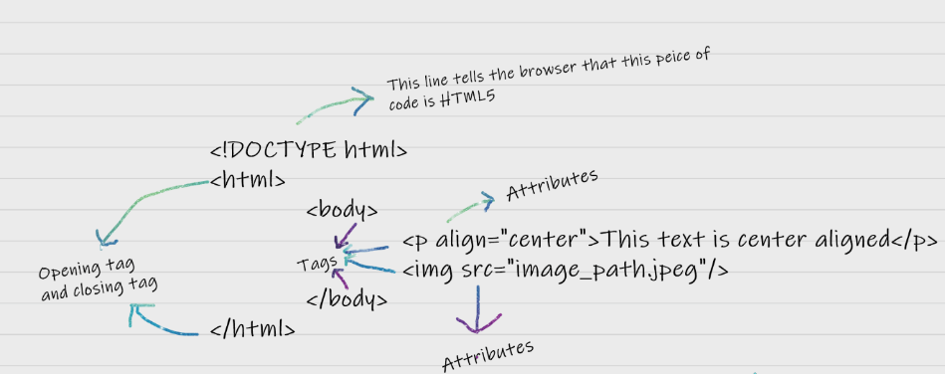

The latest version of HTML is HTML5. There are two main components in HTML language, Tags and Attributes.

* We can display a web page inside another HTML web page. HTML provides a tag <iframe> using which we can achieve this functionality. <**iframe** src=”url of the web page to embed” />
* Tags are the primary component of the HTML that defines how the content will be structured/ formatted.
* Attributes are used along with the HTML tags to define the characteristics of the element.

<p align=” center”>Interview questions</p>

* In HTML some characters are reserved like ‘<’, ‘>’, ‘/’, etc. To use these characters in our webpage we need to use the character entities called HTML Entities.

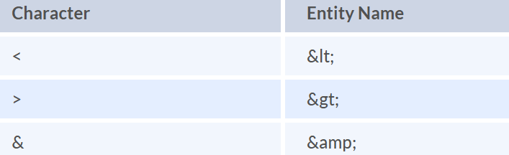

* The class attribute is used to specify the class name for an HTML element.  Multiple elements in HTML can have the same class value.
* <head> tag provides the information about the document.
* HTML has various formatting tags:
* **<b>** - makes text bold
* **<i>** - makes text italic
* **<big>**
* **<small>**
* **<mark> - highlights the text**
* HTML provides two table attributes “rowspan” and “colspan” to make a cell span to multiple rows and columns respectively
* It is possible using the “display” property with its value as “block”, to change the inline element into a block-level element.
* HTML provides a <form> tag to create forms. There are different input types like ‘button’, ‘checkbox’, ‘number’, ‘text’, ‘password’, ‘submit’ etc.