**Complex Queries**

* 1. **DDL/DML Operations**

**3.1.1 Adding Books**

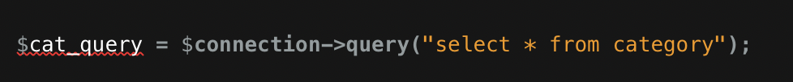

-DDL (Data Definition Language) - It retrieves data from the database without modifying it.

-Operation : Select operation.

-Work: Retrieves all categories from the "category" table to populate a dropdown menu in the form for adding books.

**3.1.2 Inserting Books**



- Operation: Insert operation.

- Work: Inserts a new book entry into the "book" table with provided details.

- DDL/DML: DML (Data Manipulation Language) - It modifies data in the database.

**3.1.3 Inserting Borrow Record**

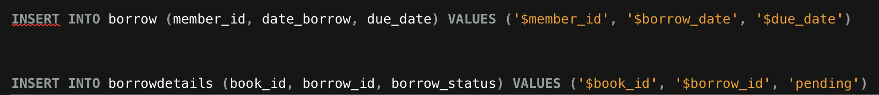

*- Operation: Insert operation.*

*- Work: Inserts borrow record into the "borrow" table and borrow details into the "borrowdetails" table.*

*- DDL/DML: DML (Data Manipulation Language) - It modifies data in the database.*

* 1. **Trigger & Views Operations**

**3.2.1.Trigger Creation – Deleted Books:**

- Operation: Trigger Creation

- Work: Establishes a trigger to capture deleted book records and archive them into another table.

- DDL/DML: DDL (Data Definition Language)

**3.2.2 View Books**



-Operation: Query Execution

-Work: Executes a SELECT query to retrieve records from the 'view_book' view where the status is not 'Archive'.

-DDL/DML: DML (Data Manipulation Language)

* 1. ***JOINS AND UNIONS***

***3.3.1 Union Query - First Names***

Operation: Union Query

Work: Retrieves distinct first names from both the 'member' and 'users' tables.

DDL/DML: DML (Data Manipulation Language)

***3.3.2 Fetch Book Details***



- Operation: Selection, Update

- Work: Fetches book details based on the provided ID for editing, allows the user to update book information such

as title, author, etc., and updates the corresponding record in the database.

- DDL/DML: DML (Data Manipulation Language)

***3.3.3 Retrieve Borrowed Book Details***

-Operation: Retrieve borrowed book details from the database.

-Description: This query fetches information about borrowed books, including the book title, borrower details, borrowing and return dates.

- Category: DQL (Data Query Language)