Complex Queries
  - DDL/DML Operations
3.1.1 Adding Books

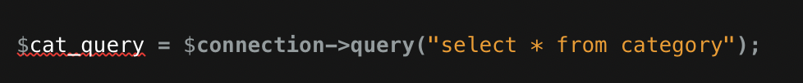
-DDL (Data Definition Language) - It retrieves data from the database without modifying it.
-Operation : Select operation.
-Work: Retrieves all categories from the "category" table to populate a dropdown menu in the form for adding books.

3.1.2 Inserting Books

- Operation: Insert operation.
- Work: Inserts a new book entry into the "book" table with provided details.
- DDL/DML: DML (Data Manipulation Language) - It modifies data in the database.

3.1.3 Inserting Borrow Record

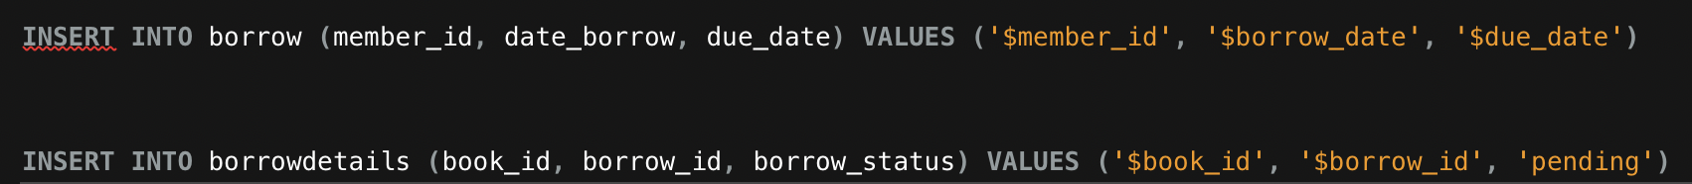

- Operation: Insert operation.
- Work: Inserts borrow record into the "borrow" table and borrow details into the "borrowdetails" table.
- DDL/DML: DML (Data Manipulation Language) - It modifies data in the database.

  - Trigger & Views Operations

3.2.1.Trigger Creation – Deleted Books:

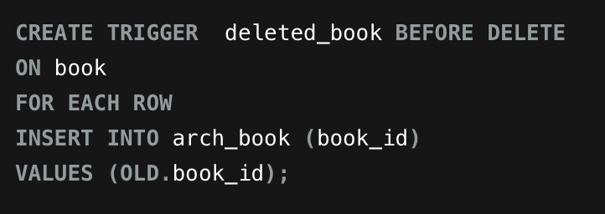

- Operation: Trigger Creation
- Work: Establishes a trigger to capture deleted book records and archive them into another table.
- DDL/DML: DDL (Data Definition Language)

3.2.2 View Books

-Operation: Query Execution
-Work: Executes a SELECT query to retrieve records from the 'view_book' view where the status is not 'Archive'.
-DDL/DML: DML (Data Manipulation Language)

  - JOINS AND UNIONS

3.3.1 Union Query - First Names

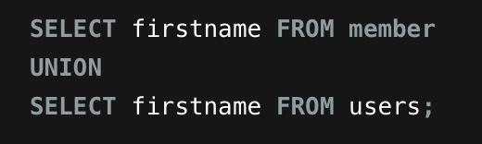

Operation: Union Query
Work: Retrieves distinct first names from both the 'member' and 'users' tables.
DDL/DML: DML (Data Manipulation Language)

3.3.2 Fetch Book Details

- Operation: Selection, Update
- Work: Fetches book details based on the provided ID for editing, allows the user to update book information such
as title, author, etc., and updates the corresponding record in the database.
- DDL/DML: DML (Data Manipulation Language)

3.3.3 Retrieve Borrowed Book Details

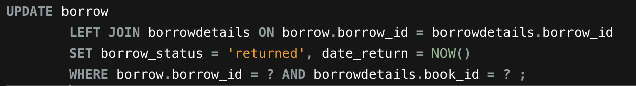

-Operation: Retrieve borrowed book details from the database.
-Description: This query fetches information about borrowed books, including the book title, borrower details, borrowing and return dates.
- Category: DQL (Data Query Language)

