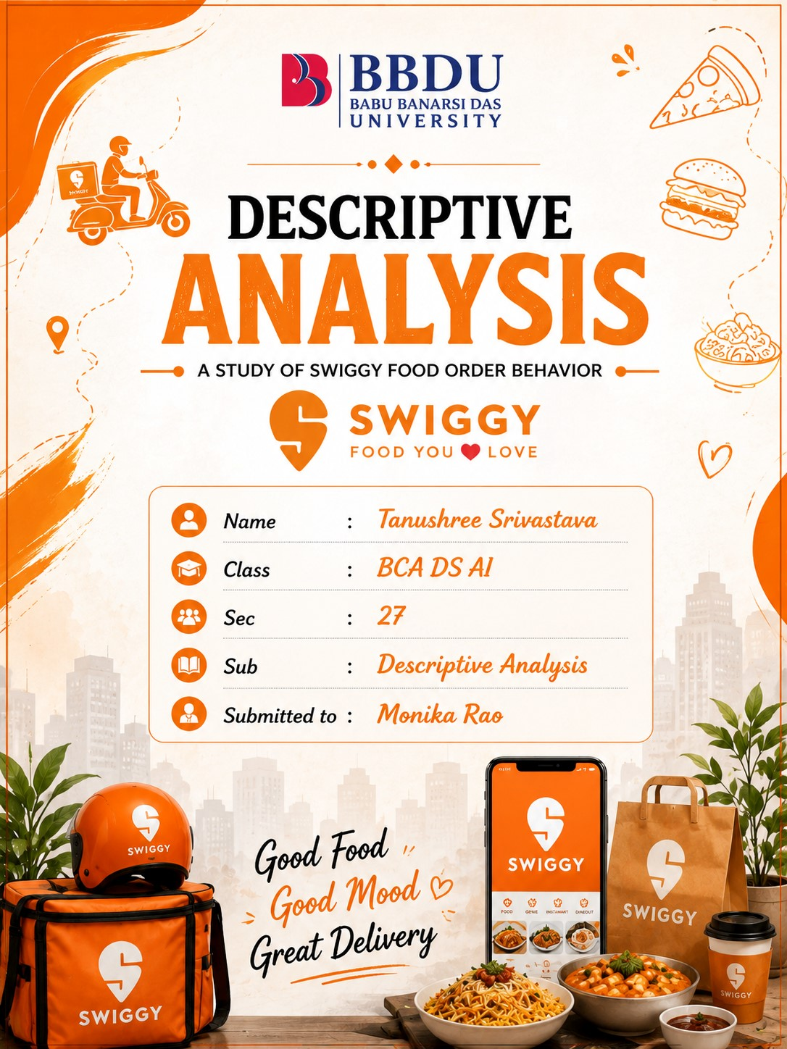

DESCRIPTIVE ANALYTICS REPORT

SWIGGY
Daily Food Order Behavior at Scale
Tracking Best-Sellers • Sales Trends • Ratings • Regional Demand • Delivery Performance
Data Note: Swiggy's complete live transaction-level data is proprietary and is not publicly available. Therefore, this academic report uses a synthetic dataset designed to represent realistic Swiggy food-delivery activity. The dataset contains simulated daily orders, food categories, restaurants, cities/regions, customer ratings, delivery times, and food availability indicators. The values are illustrative and are used only to demonstrate how a descriptive analytics pipeline would work at scale. The same analytical structure can be applied to real Swiggy data when authorized transaction data is available. The analysis focuses on identifying best-selling food items, daily order and revenue trends, customer rating patterns, regional demand, and the relationship between delivery performance, food availability, and customer satisfaction.

1. Objectives
- Which food items and restaurants are the best-selling on Swiggy each day?
- How do daily order volumes and revenue change over time on Swiggy?
- How do customer ratings vary across Swiggy restaurants and food categories?
- Which cities or regions generate the highest demand and sales on Swiggy?
- How do delivery performance and food availability affect customer satisfaction and overall Swiggy performance?
- Which food categories contribute the highest order volume and revenue, and how does their demand vary?
- How can order trends, ratings, regional demand, and delivery performance be analyzed together to understand overall customer experience and business performance?

2. How This Works at Real Scale
A food-delivery platform generates a large number of events from customers, restaurants, payments and delivery operations. At real scale, these events are collected, stored, processed and summarized before being presented through dashboards. The purpose of this pipeline is to turn millions of individual events into clear daily insights about demand, sales, food quality and delivery performance.
Stage | Purpose | Swiggy Example | Typical Tools
1. Data  Collection | Capture order and delivery events. | Orders, restaurant menus, payments, ratings, delivery status and locations. | Swiggy App
2. Data Storage | Store large volumes of historical and current data. | Order history, restaurant data, customer activity and delivery records. | Cloud storage..

3. Data Processing | Clean, validate and organize data. | Remove  duplicate orders, handle missing values, standardize cities/categories and calculate order totals. | SQL, Google
4. Descriptive  Analytics | Summarize  historical  Swiggy activity. | Daily orders, revenue, bestselling dishes, ratings, city  demand and delivery metrics. | Python, Google
5. Visualization | Present patterns through charts and dashboards. | Daily sales trend, best sellers, rating distribution, regional demand and delivery performance. | Tableau, Excel
6. Business  Decisions | Use insights to improve operations. | Restaurant promotion, delivery capacity, menu  availability, inventory planning and customer experience. | Report, Analytics reports
The following sections present the main descriptive findings. Each section combines a clear business question, explanation, visual analysis and concise key points, similar to a professional analytics report.

3. Top Food Items and Restaurants
The best-selling analysis identifies the food items that receive the highest number of completed orders. In the simulated Swiggy dataset, Paneer Momos is the leading item, followed by Farmhouse Pizza. The analysis is useful for understanding which menu items attract the strongest demand and which restaurants may require additional preparation and ingredient capacity. Units sold are used for the operational ranking, while revenue can be maintained as a separate financial ranking.

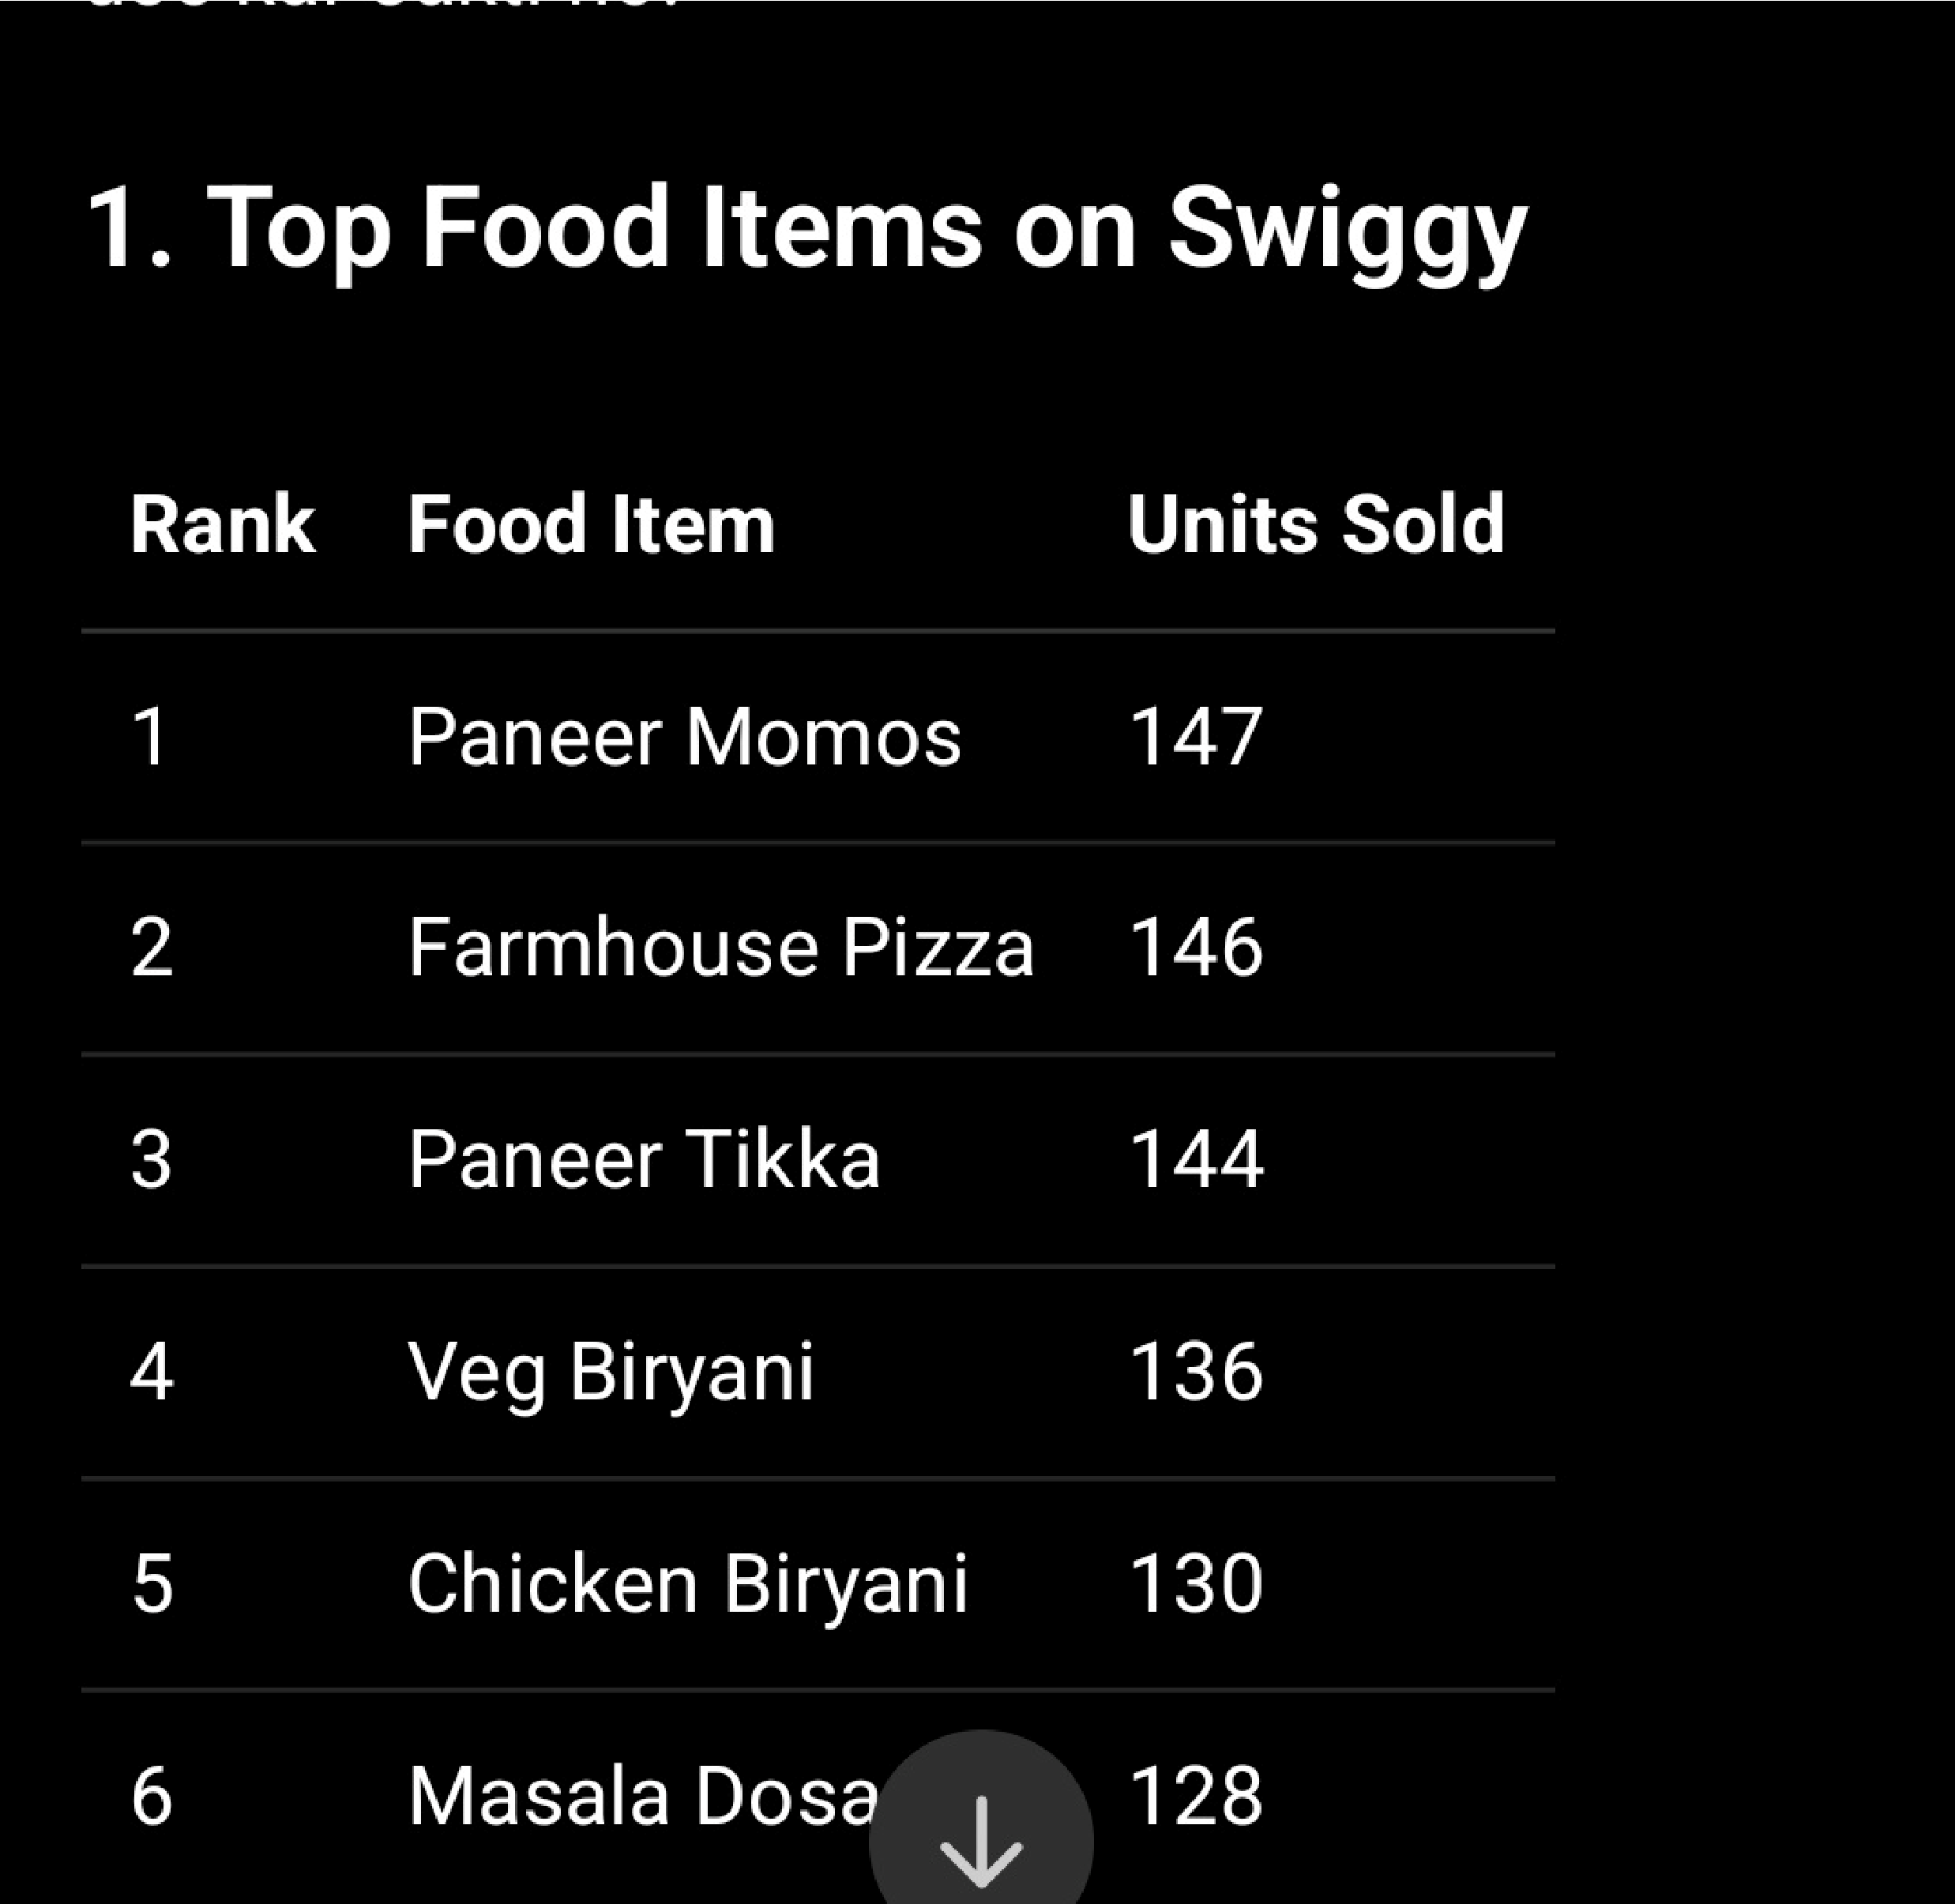

Interpretation
Paneer Momos is the highest-selling food item in the dataset.
Farmhouse Pizza is another major contributor to order volume.
North Indian is the strongest food category by units sold.
High-volume items should receive priority in menu availability and ingredient planning.
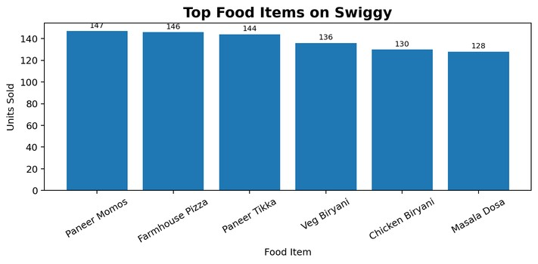
Restaurants selling consistently popular items can be considered for promotions and operational support.

4. Daily Sales Trend
Daily sales analysis shows how customer demand changes throughout the study period. The simulated data contains an average of approximately 31 completed orders per day. The highest-order day recorded 42 completed orders, while the lowest recorded 19. Tracking this pattern helps Swiggy plan delivery capacity, restaurant readiness, offers and peak-time
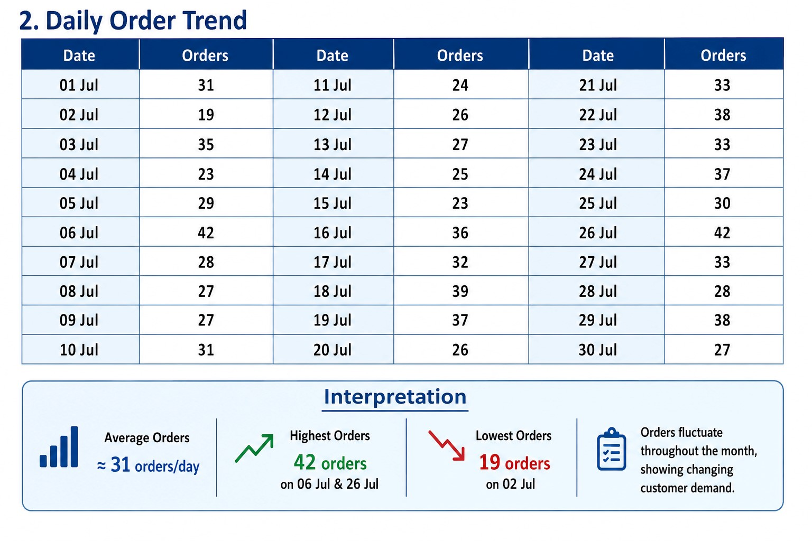
operations.

Interpretation
Peak daily demand reached 42 completed orders.
The lowest daily volume was 19 completed orders.
Daily demand should be compared with revenue because order volume and financial value can move differently.
Repeated high-demand periods require sufficient delivery-partner and restaurant capacity.
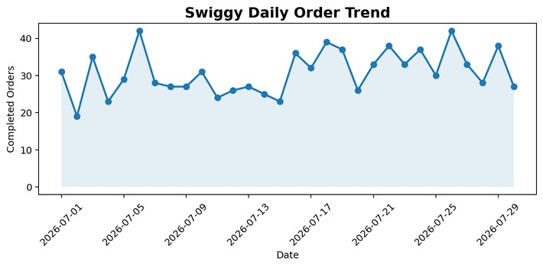
Sudden drops in orders can be investigated for cancellations, availability problems or demand changes.

5. Regional Demand
Regional analysis identifies the cities that contribute the greatest demand. In the simulated dataset, Pune records the highest item demand, followed by Jaipur. Regional demand helps Swiggy understand where customers are most active...

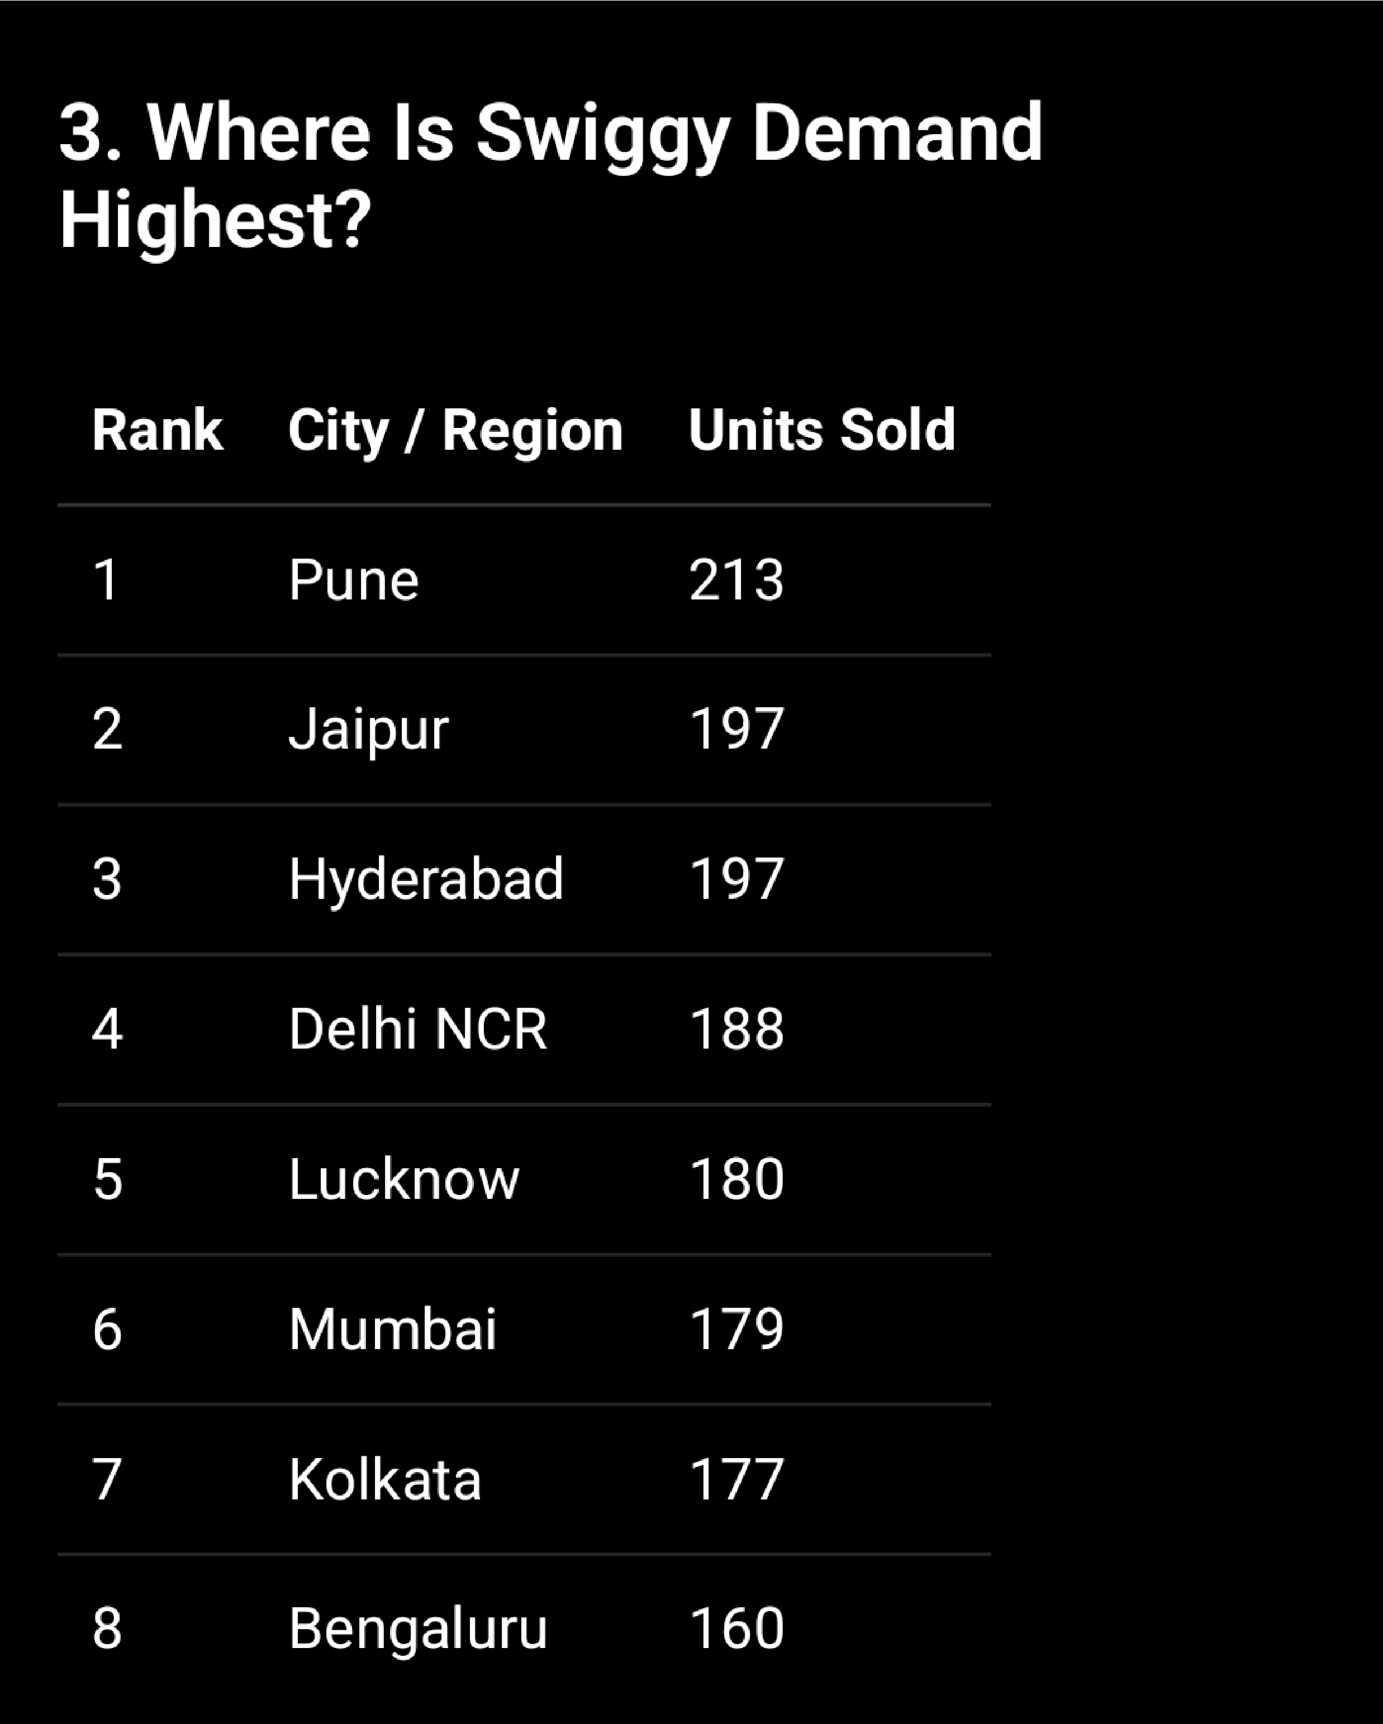

Interpretation
Pune is the highest-demand city in the simulated dataset.
Jaipur is another major contributor to order demand.
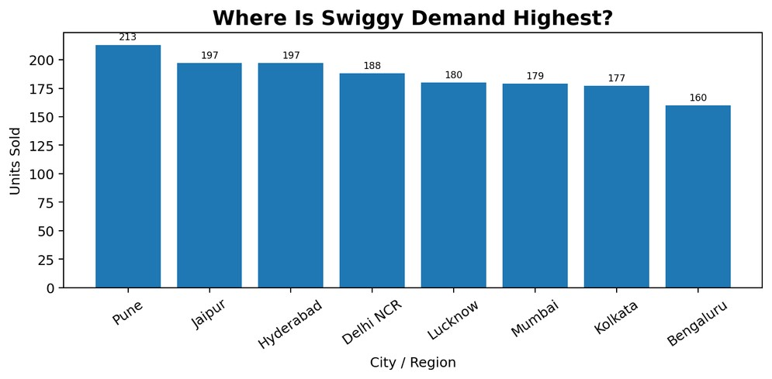
High-demand regions may need additional delivery capacity during peak periods.
Regional insights can support localized promotions and restaurant onboarding.
Demand should be reviewed with revenue, ratings and delivery performance before making business decisions.

6.Delivery Performance & Food Availability
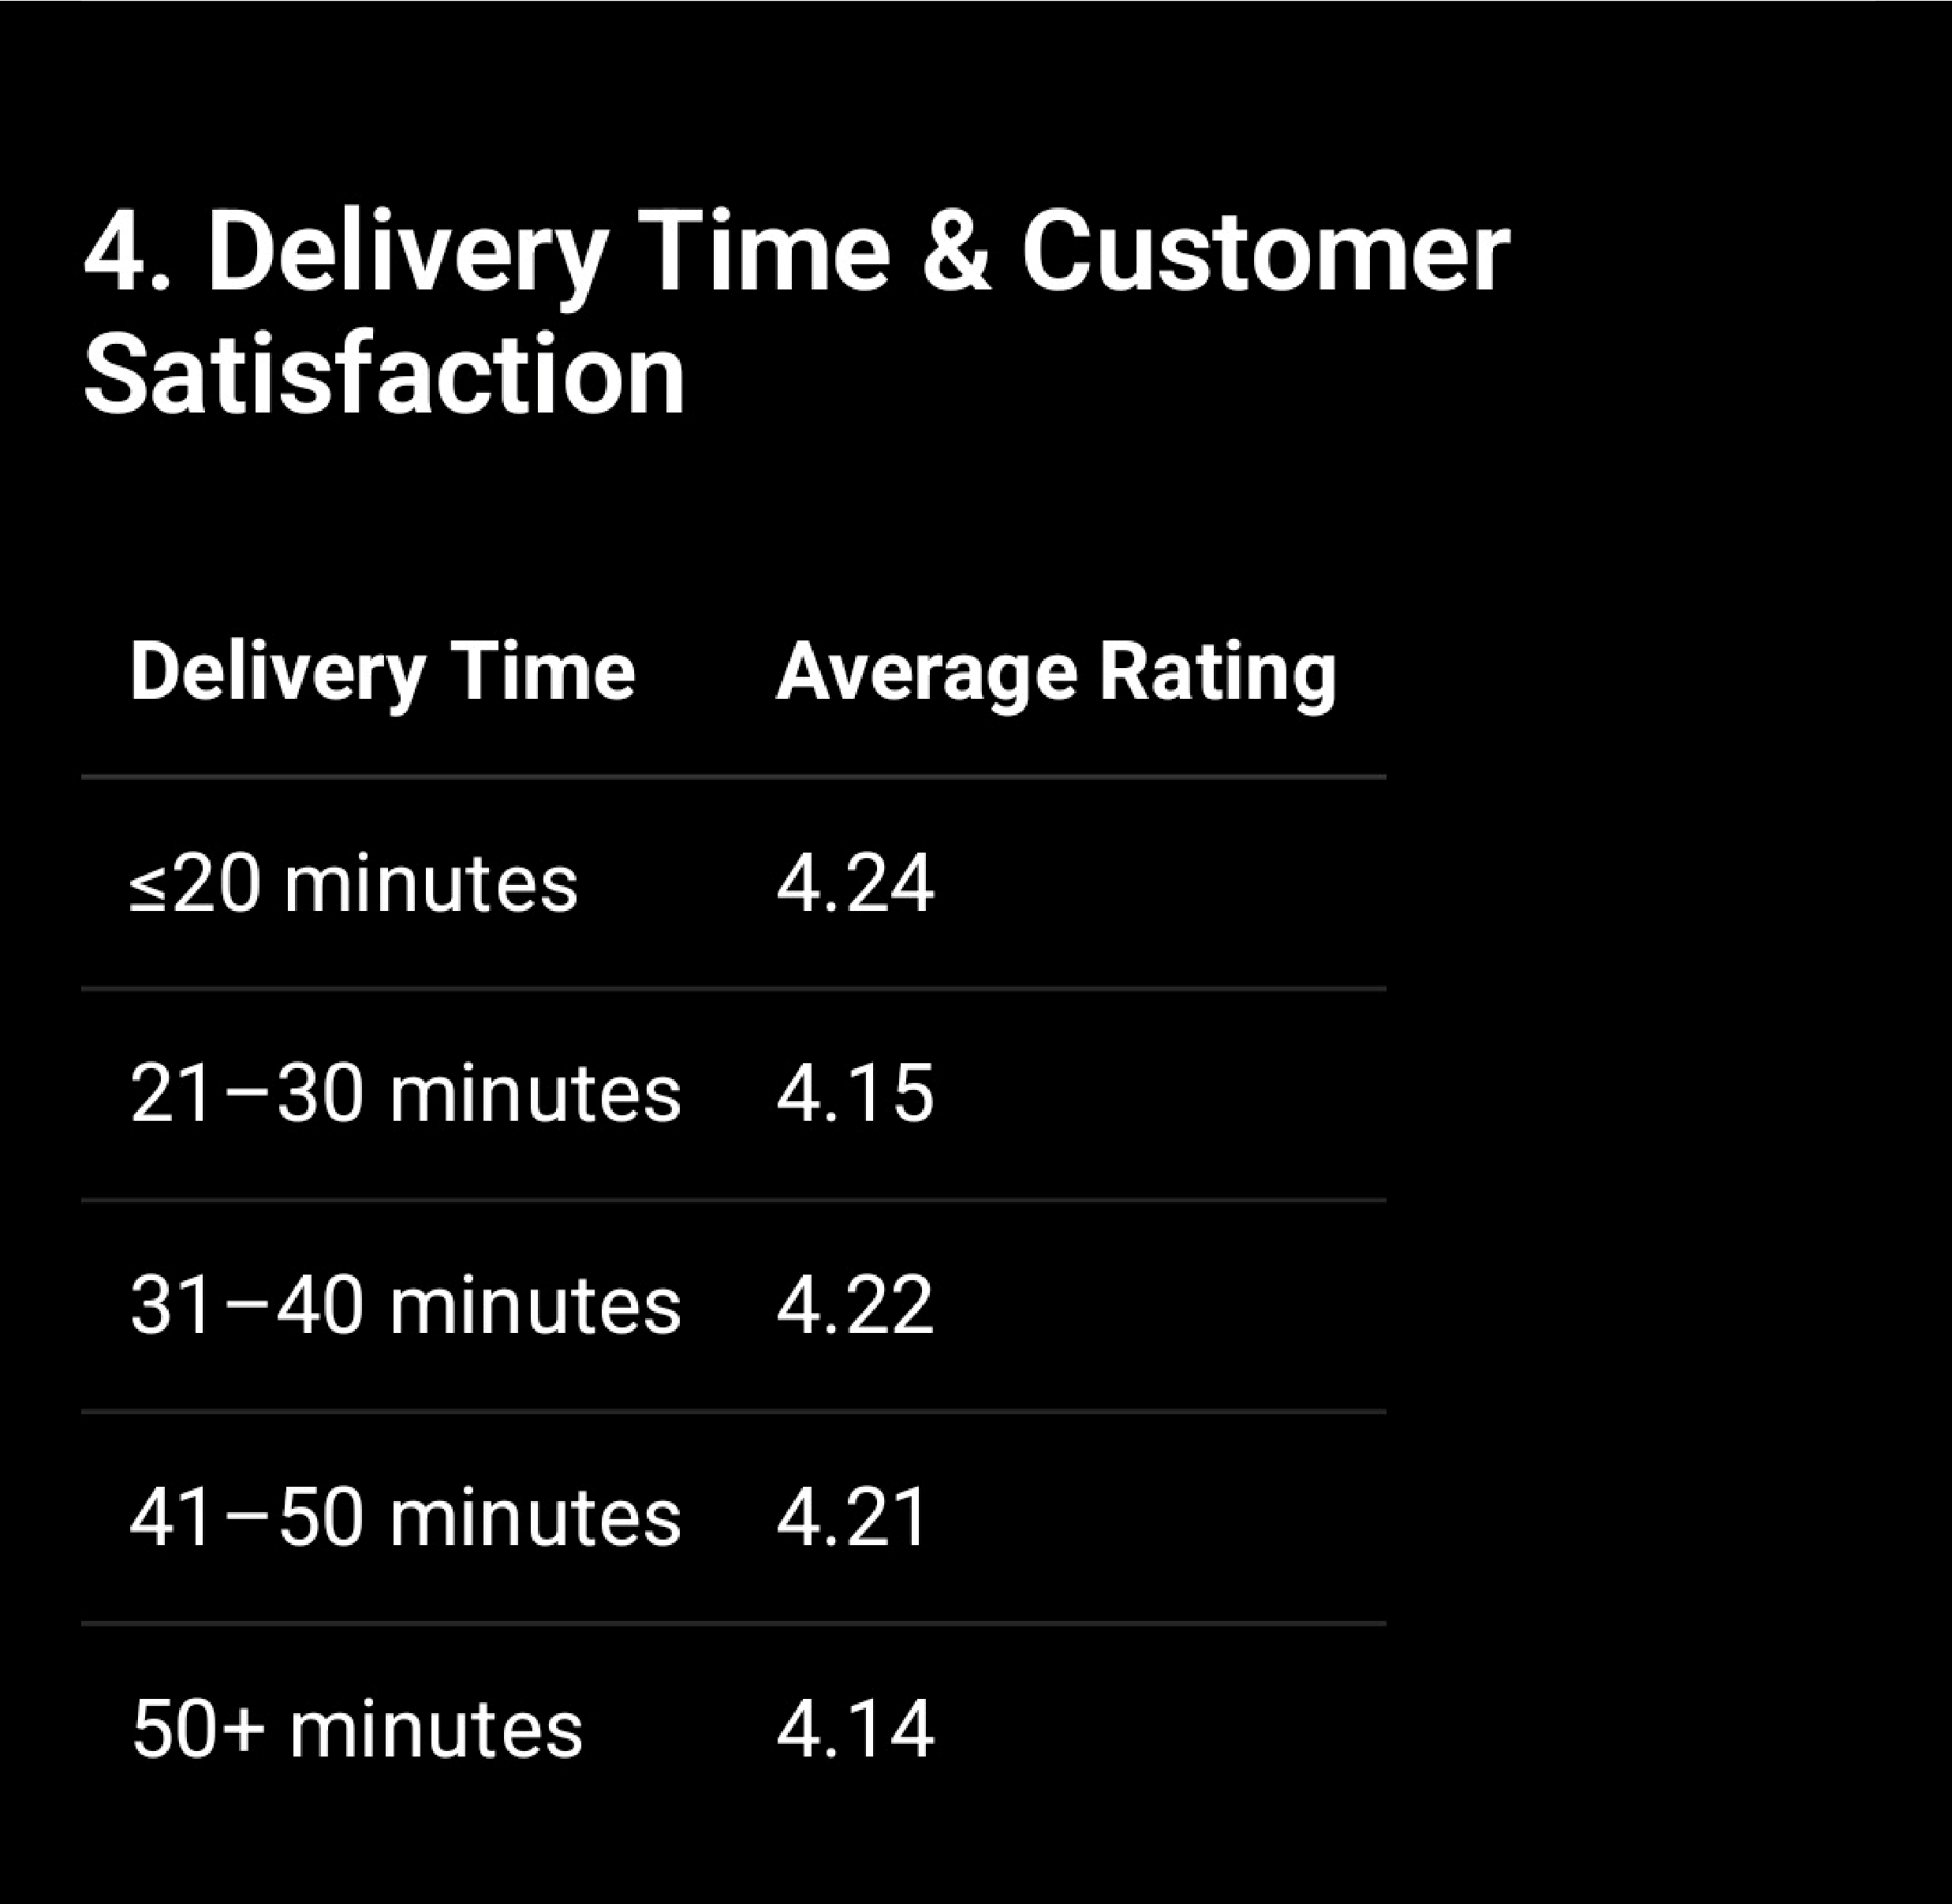
Delivery performance is closely connected with customer experience. The simulated average delivery time is 32.2 minutes. Comparing delivery-time ranges with ratings helps identify whether longer delivery times are associated with lower satisfaction. Food availability and cancellations should also be monitored because an unavailable or cancelled order can affect both customer satisfaction and restaurant performance.

Interpretation
Average simulated delivery time is 32.2 minutes.
Longer delivery-time bands should be monitored alongside customer ratings.
Frequent unavailable items or cancellations can indicate restaurant capacity or stock-related issues.
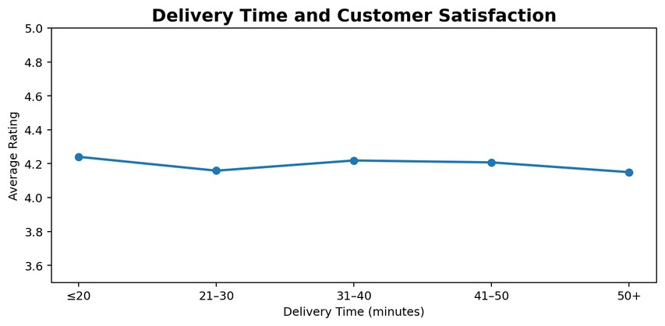
Better preparation and delivery coordination can improve consistency during peak demand.
Combining delivery, rating and availability data gives a stronger view of customer satisfaction.

7. Customer Rating Distribution
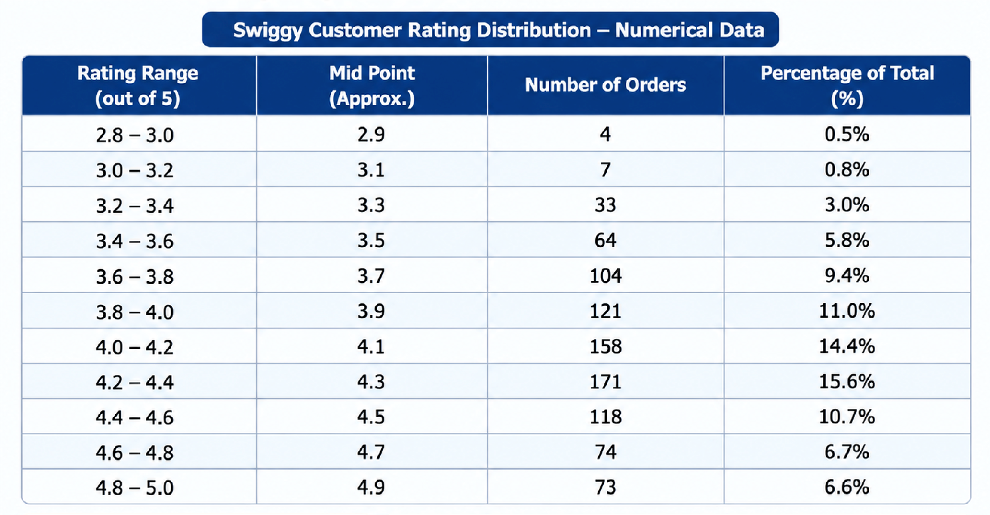
Customer ratings provide an important descriptive view of food quality, restaurant service and delivery experience. The overall simulated average is 4.20/5. Instead of relying only on the average, the rating distribution shows how many customers gave high, medium or low ratings. Segmenting ratings by restaurant, category and delivery time can reveal where customer satisfaction is improving or declining.

Interpretation
The overall average customer rating is 4.20 out of 5.
Ratings concentrated around 4 and 5 indicate generally positive customer experience.
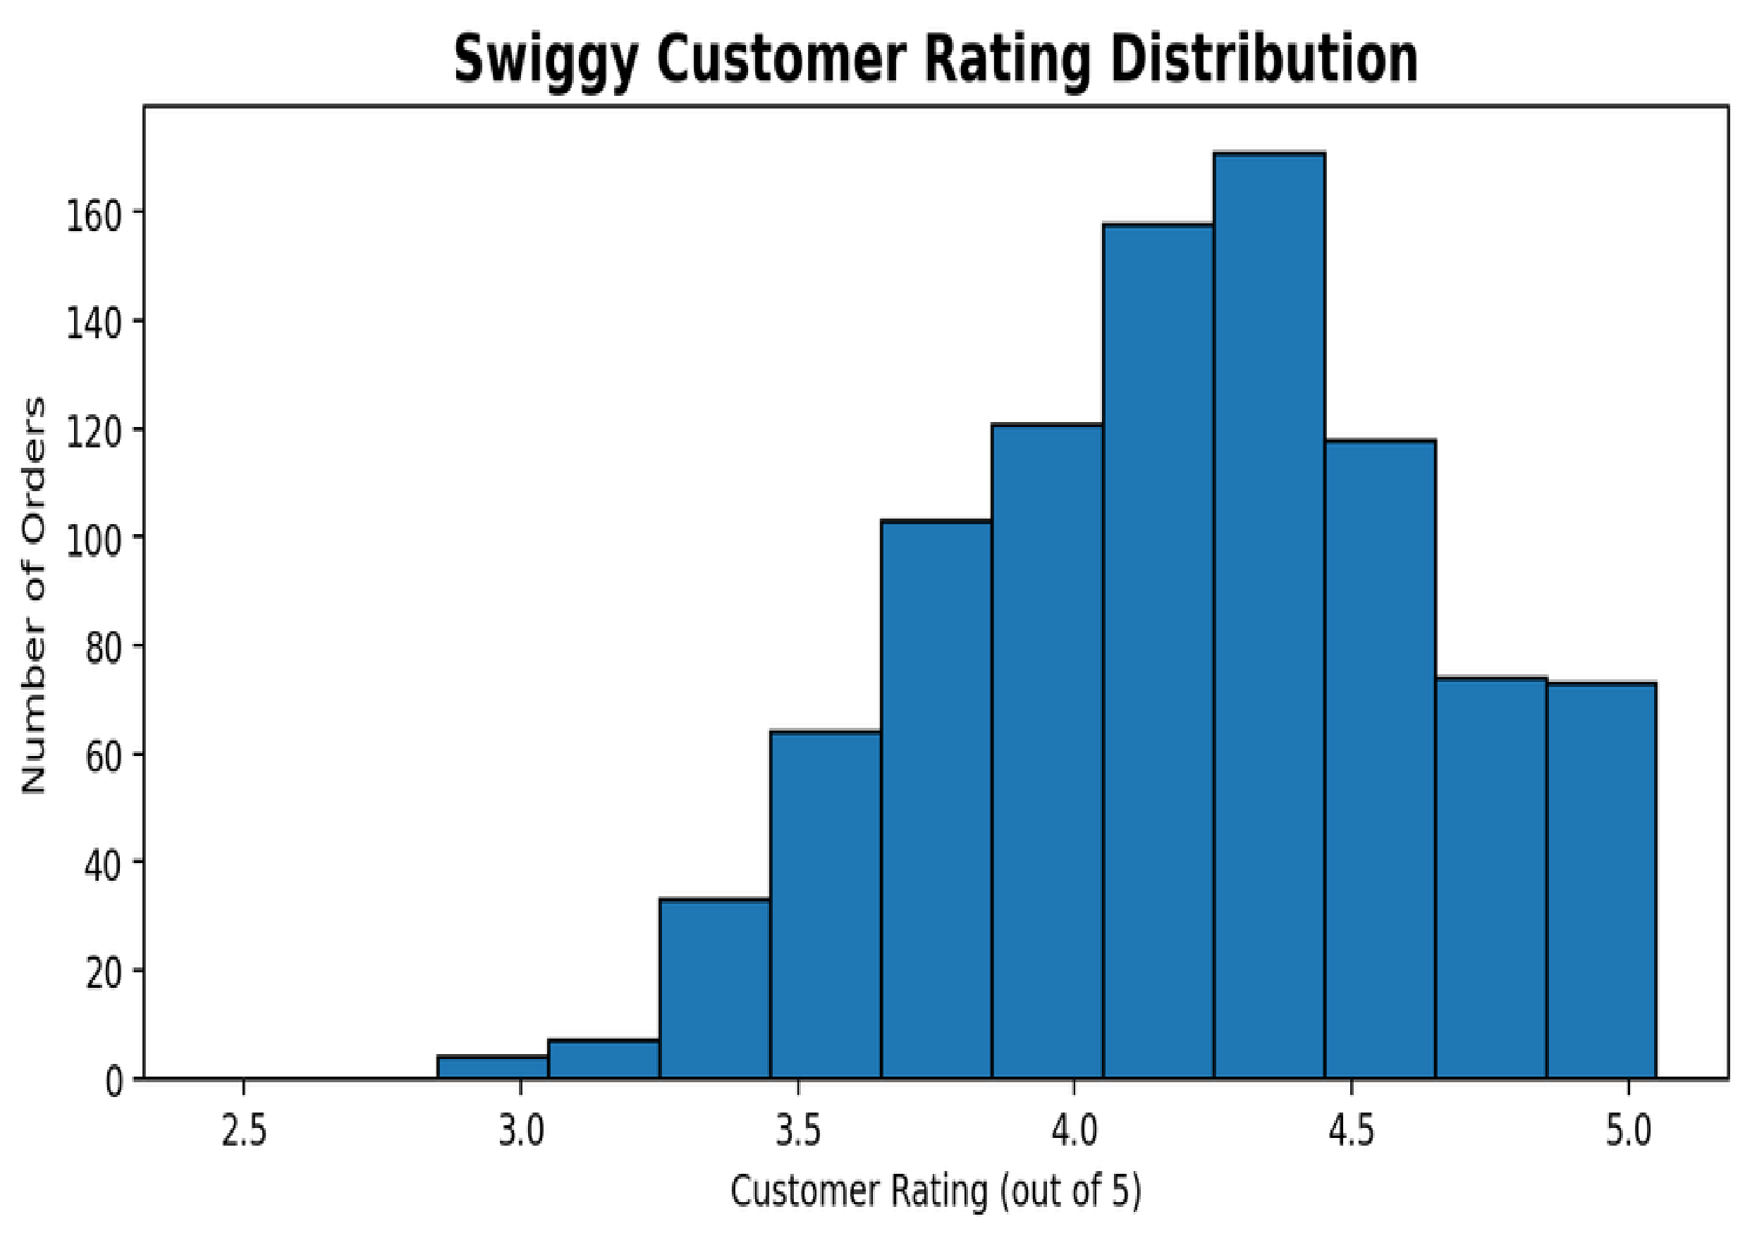
An increasing share of ratings below 4 can signal food-quality, packaging or service issues.
Rating trends are more useful when compared across restaurants and food categories.
Low ratings combined with long delivery times can indicate fulfillment-related dissatisfaction.

8. SUMMARY OF KEY METRICS
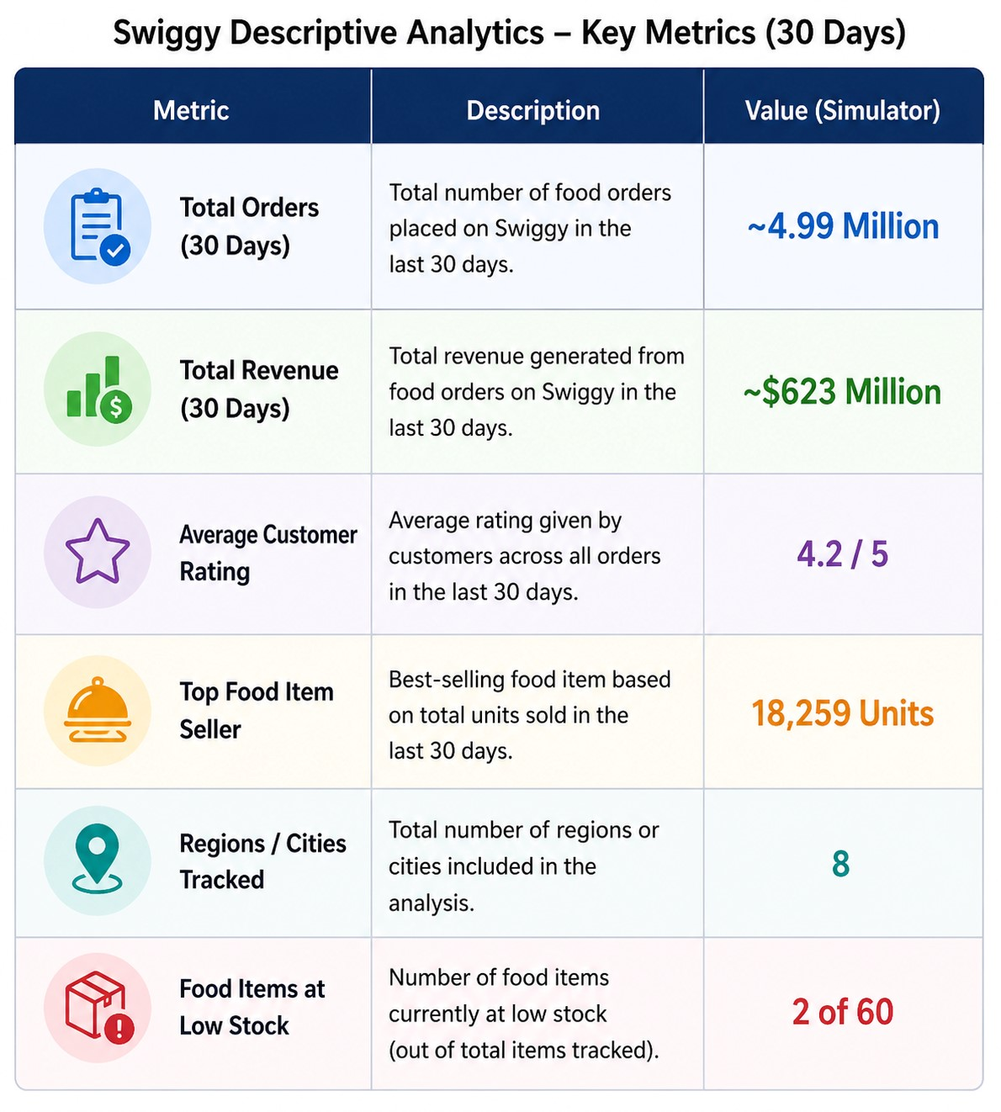
The following key metrics provide a concise summary of the major findings obtained from the simulated Swiggy food-order dataset. These indicators help evaluate order volume, revenue, customer satisfaction, product performance, regional coverage, and food availability.

Interpretation
- The dataset records approximately 4.99 million completed food-order units over the 30-day period, indicating high transaction activity across the Swiggy marketplace.
- Total simulated revenue of approximately $623 million shows the strong commercial value generated through food orders during the analysis period.
- The average customer rating of 4.2 out of 5 indicates generally positive customer satisfaction, while individual restaurant or food-item ratings should be monitored for downward trends.
- The top-performing food item reached 18,259 units in a single day, highlighting the importance of identifying highdemand food items for inventory and restaurant planning.
- Demand was tracked across 8 regions, allowing comparison of regional ordering patterns and helping identify areas with stronger customer activity.
- Only 2 of 60 food items were classified as low-stock or below, but these items require attention because stock shortages can affect order completion and customer satisfaction.

9.Next Steps: Moving from Descriptive → Predictive Analytics
This descriptive analysis explains what happened in
Swiggy's food-ordering data. The next stage can use these findings to predict future demand and improve operational decisions.
- Demand Forecasting: Predict future orders for food items, restaurants, cities and time periods using historical order trends.
- Delivery Time Prediction: Estimate expected delivery time using distance, traffic, restaurant preparation time and peak-hour demand.
- Rating Trend Analysis: Detect restaurants or food categories where ratings are continuously decreasing.
- Inventory & Availability Prediction: Identify food items likely to become unavailable during high-demand periods.
Regional Demand
- Forecasting: Predict which cities or regions will experience higher demand on weekends, holidays and special occasions.
Customer Behaviour
- Analysis: Study ordering frequency, preferred food categories and repeat-order patterns to understand customer demand.
•Anomaly Detection: Identify unusual increases or decreases in orders, revenue, ratings or delivery time.

Interpretation
- Demand Forecasting: Historical order data can be used to predict future demand for different food items, restaurants, and regions.
- Rating Prediction: Customer ratings can be analyzed with delivery time, food category, and restaurant performance to predict future customer satisfaction.
- Demand Spike Detection: Sudden increases or decreases in daily orders can be identified early to help prepare delivery capacity and restaurant operations.
- Inventory Planning: Predicted demand can help restaurants maintain sufficient ingredients for high-demand food items and reduce stock-out situations.
- Operational Improvement: Predictive analysis can help Swiggy anticipate delivery delays, high-demand periods, and customer-service issues before they occur.

