**Website Report**

On

**“Furnico Website”**

**Submitted by.**

MS. TANUSHREE KAKDE, Roll No. 20

MS. PRATIKSHA MANAPURE, ROLL NO. 11

MS. AAYUSHI SONKUSARE, ROLL NO. 01

MS. PRAJAKTA AOTE, ROLL NO. 10

MS. SAKSHI BANNAGARE, ROLL NO. 14

Guide

Prof. Bharti Karare



Department of Computer Science & Engineering

Yeshwantrao Chavan College of Engineering, Nagpur

(An Autonomous Institute, Affiliated to RTM Nagpur University, Nagpur.)

Session: 2023-2024



# Certificate

This is to certify that **Ms. AAYUSHI SONKUSARE** has successfully developed a Website titled “**FURNICO**”, towards the partial fulfillment of requirements for the Fifth Semester B.Tech. of Computer Science & Engineering.

MS. PRATIKSHA MANAPURE PROF. BHARTI KARARE

Submitted by Guide

Dr. L. B. Damahe

HOD (CSE)

## ABSTRACT

In the digital age, the furniture industry has witnessed a paradigm shift, with online platforms becoming the epicenter of exploration and purchase. This abstract delves into the essence of a sophisticated furniture website, illuminating the blend of technology, design, and user experience that creates an unparalleled virtual showroom.

The virtual realm of furniture shopping transcends traditional constraints, offering an extensive array of styles, materials, and designs at the fingertips of consumers. This abstract explores the meticulous curation of diverse furniture collections, meticulously categorized for easy navigation. From timeless classics to avant-garde designs, the website embodies a holistic fusion of aesthetics and functionality.

In conclusion, the abstract encapsulates the essence of a contemporary furniture website as more than just an online marketplace. It becomes a digital sanctuary where artistry meets technology, enabling consumers to explore, envision, and indulge in the world of furniture like never before. Through this innovative and immersive platform, the abstract underscores the evolution of furniture shopping into an enriching and delightful journey, where every click opens a door to elegance and sophistication.

## CONTENTS

|  |  |
| --- | --- |
| **CONTENTS** | **PAGE NO** |
| 1)INTRODUCTION | 1-2 |
| 2)LITERATURE  REVIEW | 2-4 |
| 3)TECHNOLOGIES | 5-10 |
| 4)IMPLEMENTATION | 11-18 |
| 5)SCREENDHOTS OF  WEBSITE | 16-24 |
| 6)CONCLUSION | 25-26 |
| 7)REFERENCES | 27-28 |
| 8)WEBSITE LINK | 29-30 |
| 9)PPT SCREENSHOTS | 31-34 |

**NO OF FIGURES:**

|  |  |
| --- | --- |
| **FIGURES** | **PAGE NO** |
| 1)HOME PAGE | 16 |
| 2)ABOUT PAGE | 17 |
| 3)PRODUCT PAGE | 18-19 |
| 4)REVIEW PAGE | 20 |
| 5)CONTACT PAGE | 21-22 |
| 6)LOGIN PAGE | 23 |
| 7)SIGN UP PAGE | 24 |

# Chapter 1

**INTRODUCTION**

**1. INTRODUCTION**

## 1.1 INTRODUCTION

In the vast landscape of online commerce, furniture websites stand as virtual emporiums, redefining the art of interior design and home decor. These platforms serve as digital canvases where craftsmanship, aesthetics, and innovation intertwine, offering a delightful experience to enthusiasts, homeowners, and interior designers alike. The evolution of these websites mirrors the transformation of the furniture industry itself, shifting from traditional brick-and-mortar stores to immersive online spaces where creativity knows no bounds.

In this digital realm, customers are no longer restricted by geographical boundaries or limited choices. The rise of online furniture stores has democratized design, enabling people from diverse backgrounds and tastes to access a global marketplace of furnishings. From the intricate detailing of vintage furniture to the minimalist elegance of modern pieces, these websites cater to a diverse audience, ensuring there's something for every discerning eye.

In essence, a furniture website is more than an online store; it's a portal to creativity, a source of inspiration, and a facilitator of dreams. It bridges the gap between imagination and reality, making it possible for individuals to curate spaces that reflect their personalities and aspirations. As we delve deeper into the intricacies of these websites, we uncover a world where design meets functionality, and where every click is a step toward transforming living spaces into expressions of art and style.

# Chapter 2 TECHNOLOGIES

**2. TECHNOLOGIES**

## 2.1 TECHNOLOGIES

**1)BOOTSTRAP**

Bootstrap, introduced by Twitter developers Mark Otto and Jacob Thornton in 2011, has become synonymous with responsive and streamlined web development. It is an open-source front-end framework that facilitates the creation of elegant, intuitive, and responsive websites and web applications. Bootstrap is built on HTML, CSS, and JavaScript, making it an ideal choice for developers aiming for efficiency, consistency, and flexibility in their projects.

Key Components and Features:

Responsive Grid System: Bootstrap’s responsive grid system allows developers to create layouts that automatically adapt to various screen sizes, ensuring a consistent user experience across devices such as desktops, tablets, and smartphones.

Pre-Designed UI Components: Bootstrap offers a plethora of predesigned UI components, including navigation bars, modals, carousels, forms, and more. These components are customizable and can be easily integrated into projects, saving developers significant time and effort.

CSS Classes and JavaScript Plugins: Bootstrap provides a wide range of CSS classes and JavaScript plugins that enhance the functionality and appearance of web elements. From typography and color schemes to interactive elements like tooltips and popovers, Bootstrap simplifies the implementation of complex features.

Theming Capabilities: Bootstrap allows developers to create custom themes using its built-in theming capabilities. This means that developers can tailor the visual style of their projects to match specific brand guidelines or design preferences.

Community Support and Documentation: Bootstrap boasts a large and active community of developers. The framework’s extensive documentation, along with numerous tutorials and forums, makes it accessible to both beginners and experienced developers. This support network accelerates the learning curve and problem-solving process.

Compatibility and Browser Support: Bootstrap is designed to be compatible with major modern browsers, ensuring a consistent user experience for visitors regardless of the platform or browser they are using.

**2)HTML**

HTML, or HyperText Markup Language, is the standard language used to create and design documents on the World Wide Web. It serves as the backbone of almost all web content, defining the structure and meaning of web content like text, images, links, forms, and multimedia. Developed by Tim Berners-Lee and his team in the early 1990s, HTML continues to evolve, with HTML5 being the latest and most advanced version.

Universal Language: HTML is universally supported by all web browsers, ensuring that content displays consistently across different platforms and devices.

Ease of Learning: HTML has a simple and intuitive syntax, making it accessible to beginners. Learning the basics of HTML is often the first step for aspiring web developers.

Interactivity: When combined with CSS for styling and JavaScript for interactivity, HTML enables the creation of dynamic and engaging web applications.

Key Components and Structure:

Elements and Tags: HTML documents are constructed using elements represented by tags enclosed in angle brackets, such as <div>, <p>, <h1>, and <a>. Tags define the structure of the content, indicating headings, paragraphs, lists, links, and other elements.

Attributes: HTML tags can have attributes that provide additional information about an element. Attributes are used to modify or provide metadata about an element. For example, the <a> tag can have an attribute called href to specify the link's destination.

**3)CSS**

CSS, or Cascading Style Sheets, is a fundamental technology used in web development to control the layout, design, and presentation of HTML documents. It acts as a styling language that defines how elements on a web page are displayed, ensuring consistency and aesthetic appeal across different devices and screen sizes. CSS was introduced to the web development community in the late 1990s and has since become an integral part of modern web design.

Key Concepts and Functions:

Selectors and Properties: CSS works by associating styles with HTML elements. Selectors are used to target specific HTML elements, and properties are used to define the visual characteristics of those elements. For instance, a CSS rule might change the color, font, or spacing of text.

Cascading and Specificity: The term "cascading" refers to the order in which styles are applied to HTML elements. Styles can be defined in multiple places, such as within the HTML document, in an external CSS file, or via inline styles. CSS also uses specificity rules to determine which styles should take precedence when multiple conflicting styles are applied to the same element.

Responsive Design: CSS plays a crucial role in creating responsive web designs. Media queries allow developers to apply different styles based on the characteristics of the device, enabling the creation of layouts that adapt to various screen sizes, orientations, and resolutions.

**4)JAVASCRIPT**

JavaScript, often abbreviated as JS, is a versatile, high-level programming language primarily known for its role in web development. Developed by Brendan Eich in 1995, JavaScript has become a cornerstone technology on the internet, enabling developers to create dynamic, interactive, and responsive web applications.

Key Characteristics and Functions:

Client-Side Scripting: JavaScript is executed on the client's browser, allowing for dynamic manipulation of web page content without needing to reload the entire page. This feature greatly enhances user interactivity and experience.

Object-Oriented: JavaScript is an object-oriented language, allowing developers to create and manipulate objects, making it highly flexible and adaptable for various tasks.

Asynchronous Programming: JavaScript supports asynchronous programming through mechanisms like callbacks, promises, and async/await, allowing tasks to be executed independently of the main program flow. This is essential for handling tasks such as fetching data from servers without freezing the user interface.

Event-Driven: JavaScript is event-driven, meaning it can respond to events triggered by users (such as clicks and keystrokes) or the browser (such as page load and mouse movements). This makes it ideal for creating interactive interfaces.

# Chapter 3 IMPLEMENTATION

## 1)HOME PAGE

Home page:

It mainly consist of three sections:

1.navbar

2.body

3.footer

The navbar help the user to navigate once he visit the page.It is important element of page.

The home page provide glimpse of our website main aim and userfriendliness.

In home page body you will see corousel which is focusing element to showcase the aesthetic beauty of products that we provide to customer in our website.

Next,we also have some of our best selled-products,so that customer can visit it and explore the area.

We also have included our social media and contact information so that user can connect to us.

The three components which are present are made with help of Html,css,bootstrap.

Bootstrap is used as it provide responsive web pages and it’s elements. **2)ABOUT PAGE**

About page:

It is consists of two section a) about us

b) our services

About us setion consists of furniture image and the information about the services which are provided by past year ie.

We have unbeatable service experience as well as a state-of-the art system, easily accessible portal, rules and procedures that insure we handle all services above and beyond expectations and exceed the requirements of our accounts and customers. We work very hard to make sure each experience turns into a great relationship so our clients can count on us when needed by providing honest and best answers to your questions along with the best possible service experience.our services section made up of cards in every cards we list the sevices which is provided..

1)Furniture Installation

2)Furniture Repairing

3)Sofa Reparing

4)Chair Repairing

5)Furniture Polishing

In each card we give our instagram,twitter,facebook handles for contact of services.

## 3)PRODUCT PAGE

This page defines the latest furniture products that we provide to our costumers. Different furniture are categorized here so that it will help our customer to find their interests easily.

Structure of the Product page :

The first section of product consists of cards in which Different products of furniture are mentioned such as beds , almirahs/wardrobes , dinning set, modular sofa sets and many more. Here we offer the latest and modern designes that are treanding in the world of furniture. The technologies we have used for making these product cards are html and css specifically. This card consist of image of the product also the button "view more" for more details about the category of the product.

The second section is also the card as this is the page full of products information so in this we have displayed the specifically more treanding products in the market along with their prices also. Also we have added the button to the card as "shop now" so that if the customer wants to buy the product or wanted to know more details about the particular product so they can check the whole details of the particular product.

The entire product page is well designed in order to attract our customers by taking a look at the elegance of each and every unique designes of the furniture. We have tried to satisfy the dream of our customers in making their home more pretty with the help of our cool furniture designes.

## 4)REVIEW PAGE

This is an html document for review page,in this page people review our products ,give ratings and share there reviews with us .this page is developed using html and css.

## 5)CONTACT PAGE

This is an HTML document for a contact page, presumably part of a website. It's designed for users to get in touch with a company called "Furnik" and gather information about their products and services. Below is a breakdown of the different sections and elements of this contact page:

HTML Structure:

The document starts with the standard <!DOCTYPE html> declaration, indicating that it's an HTML5 document.

It sets the document's language to English using the <html lang="en"> tag.

Head Section:The page title is set to "Contact Page" using the <title> tag.A link to an external stylesheet is included in the <head> section. The stylesheet is named "Contact.css" and is assumed to be in the same directory as this HTML file.

Navigation Bar:The navigation bar is contained in a <div> element with the class "navbar."

It includes links to various sections of the website, such as Home, About, Products, Review, and the Contact page.

There's also a "SignUp" button, which redirects users to a "Signin.html" page.

Content Container:

The main content of the page is organized into a container with two sections: "left" and "right."

The "left" section contains a heading, a brief paragraph introducing the company, and an input field for the user's email. There's also a "Contact Us" label.

The "right" section contains an image, which is presumably a visual representation of the company's products or services.

Contact Cards:Below the content container, there are three "cards" that provide different contact options.

Each card has an icon, a description, a contact detail (phone number or email address), and a button to initiate the contact method.

Contact Form:The contact form is contained within a separate <div> with the class "form-container."

It allows users to submit a message to the company.

The form includes fields for first name, last name, email, phone number, and a message. There's also a checkbox indicating acknowledgment of the company's privacy policy.

A "Get In Touch" button is provided to submit the form. It has an onclick attribute that seems to call a JavaScript function named "submitForm."

Additional Information:Below the contact form, there's an "infocontainer" with a brief message about the company's availability for customer support.

Social media icons are displayed, suggesting that users can connect with the company on platforms like Gmail, Instagram, LinkedIn, and Twitter.

Frequently Asked Questions (FAQ):

The FAQ section contains a list of frequently asked questions and answers.

Each question has a button that, when clicked, reveals the corresponding answer.

The answers are initially hidden with the "hidden" class, which can be toggled on and off by the JavaScript functions defined in "Contact.js." JavaScript:

A JavaScript file named "Contact.js" is included at the end of the HTML body.

It's assumed that this file contains functions to handle form submission and FAQ interaction, but the exact code is not shown in this HTML document.

Overall, this HTML contact page is well-structured and provides users with various ways to get in touch with the company, access information, and seek assistance through FAQs. It is also styled using an external CSS file ("Contact.css") to improve the visual presentation of the content.

# 

# Chapter 4

**SCREENSHOTS**

**Home Page:**

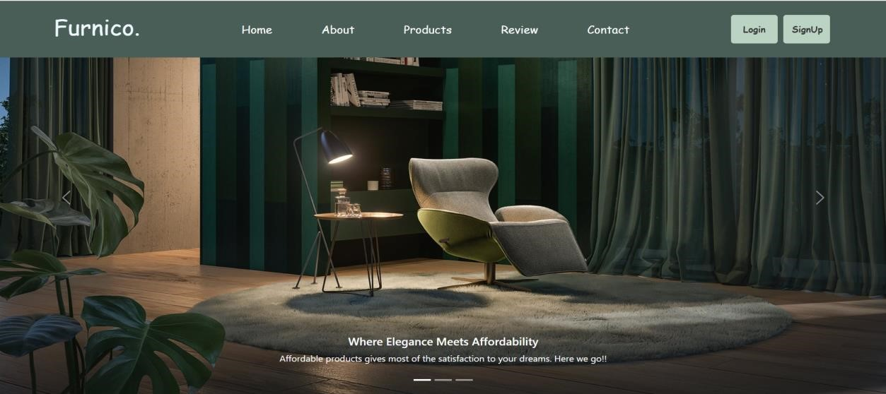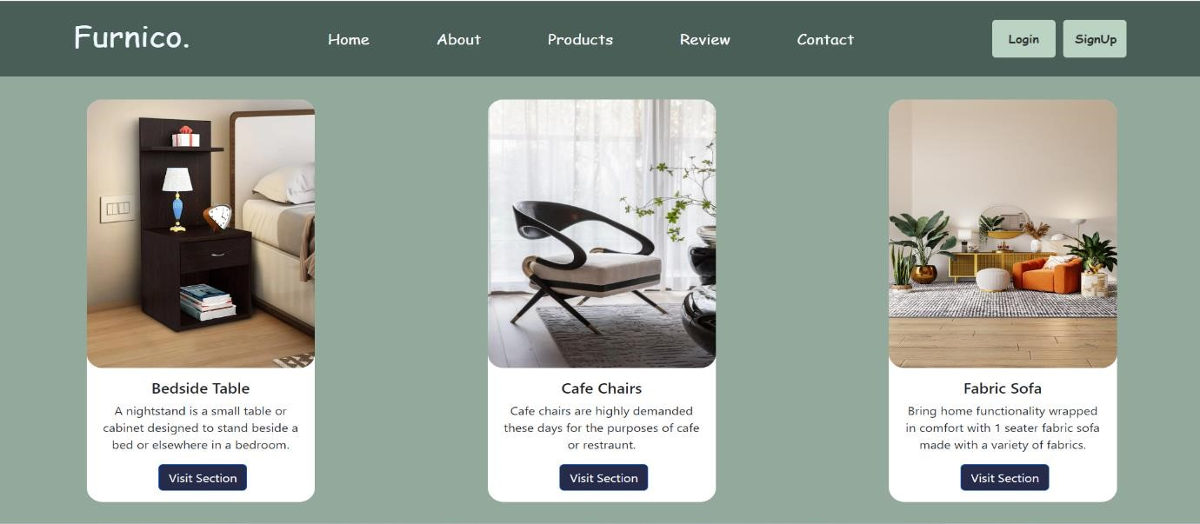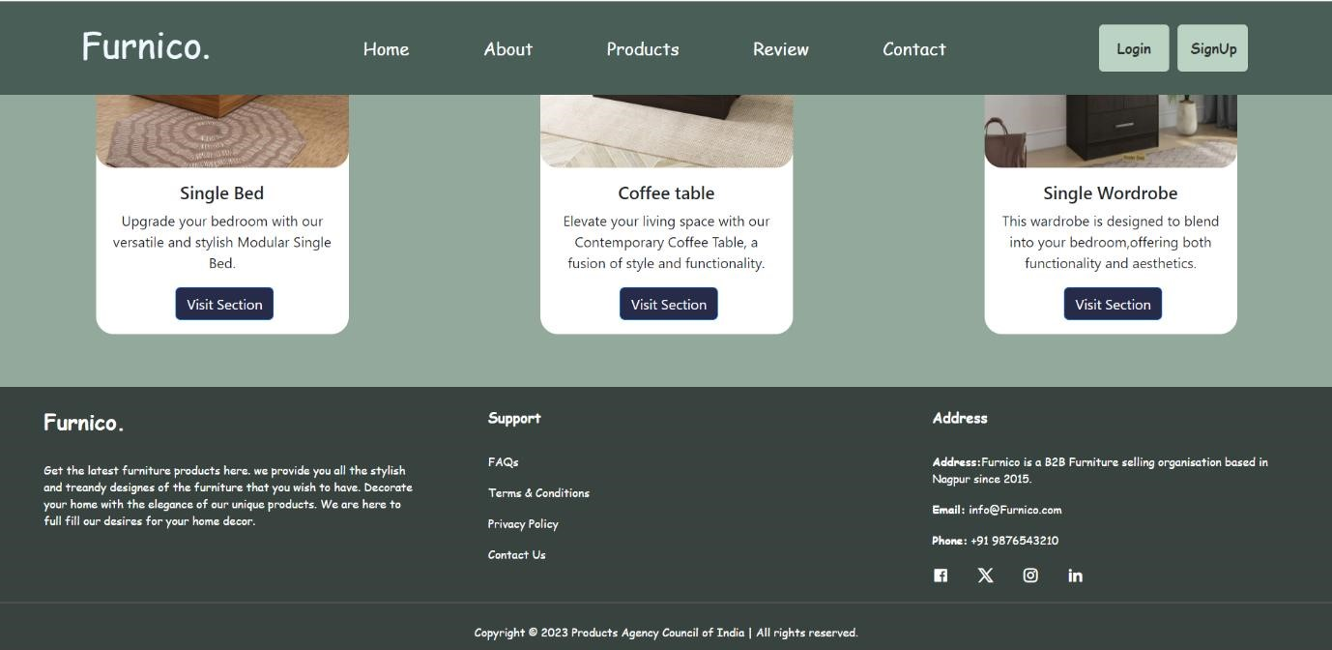

**About page:**

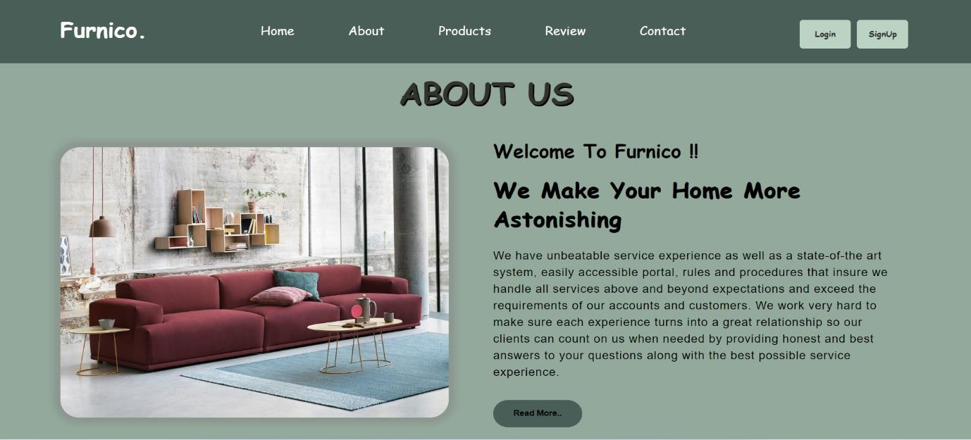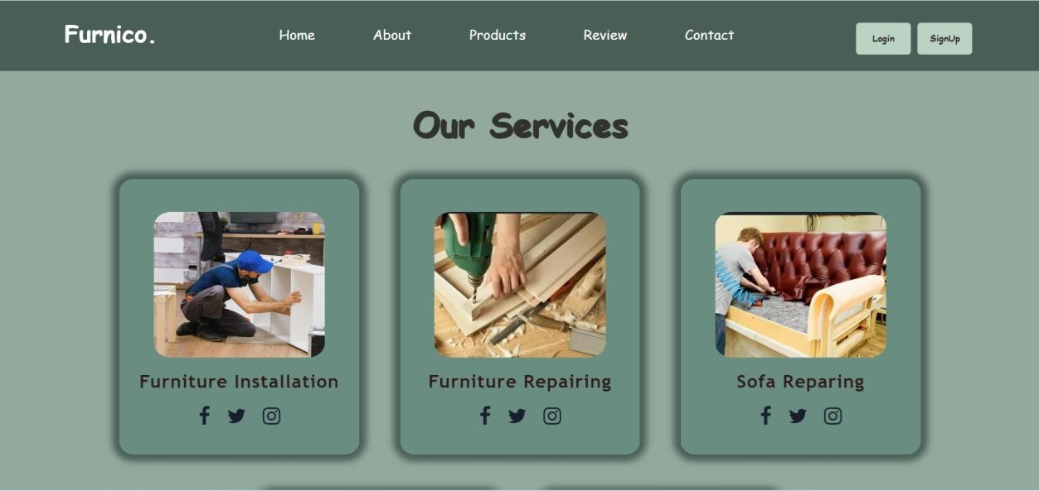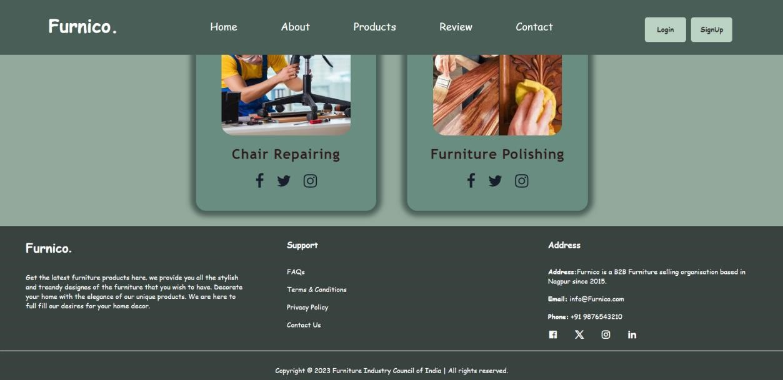

**Product page:**

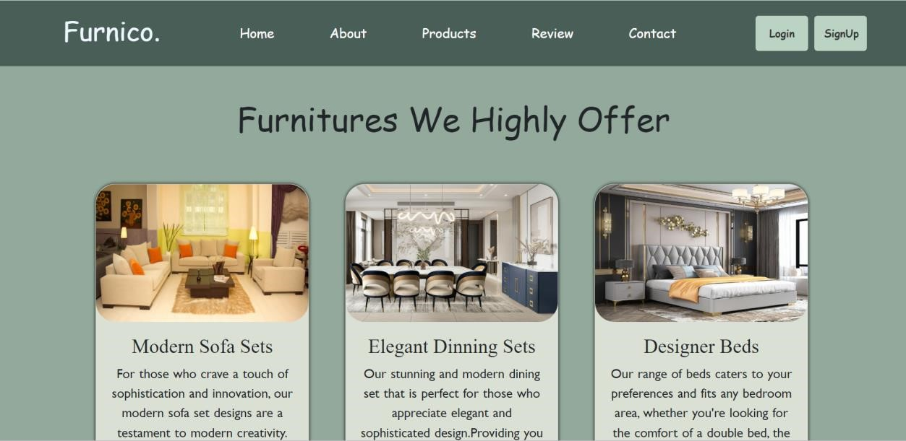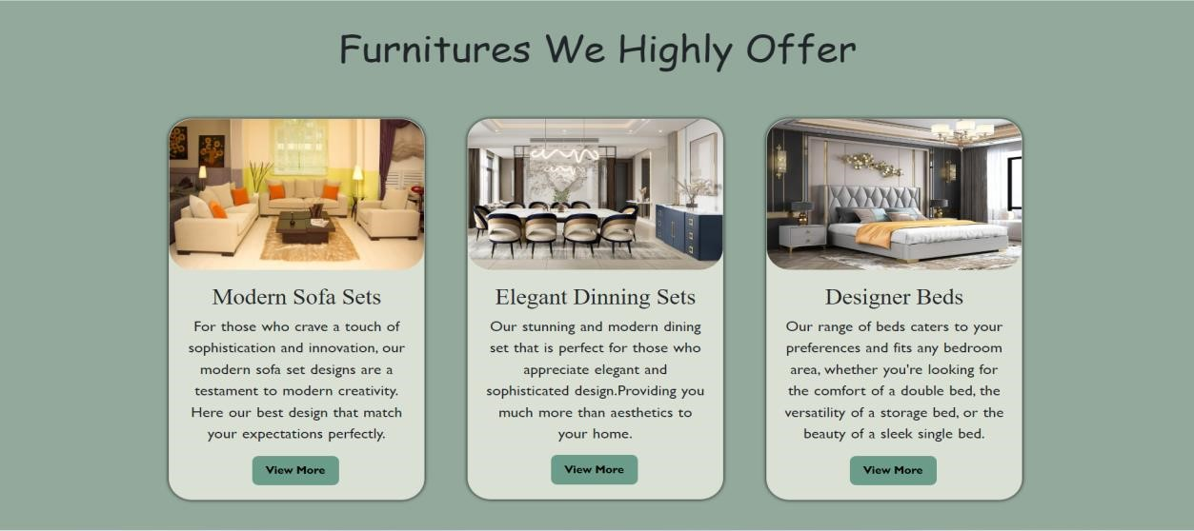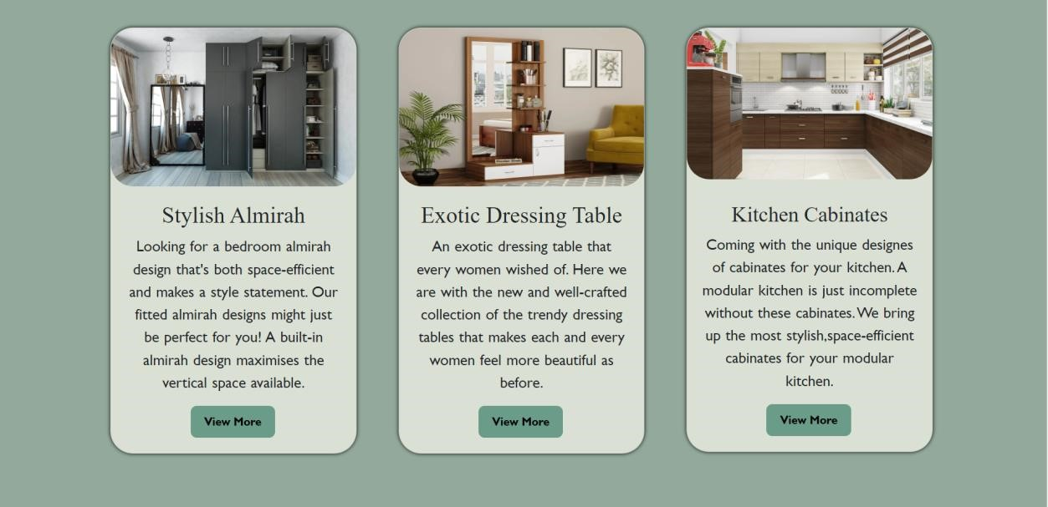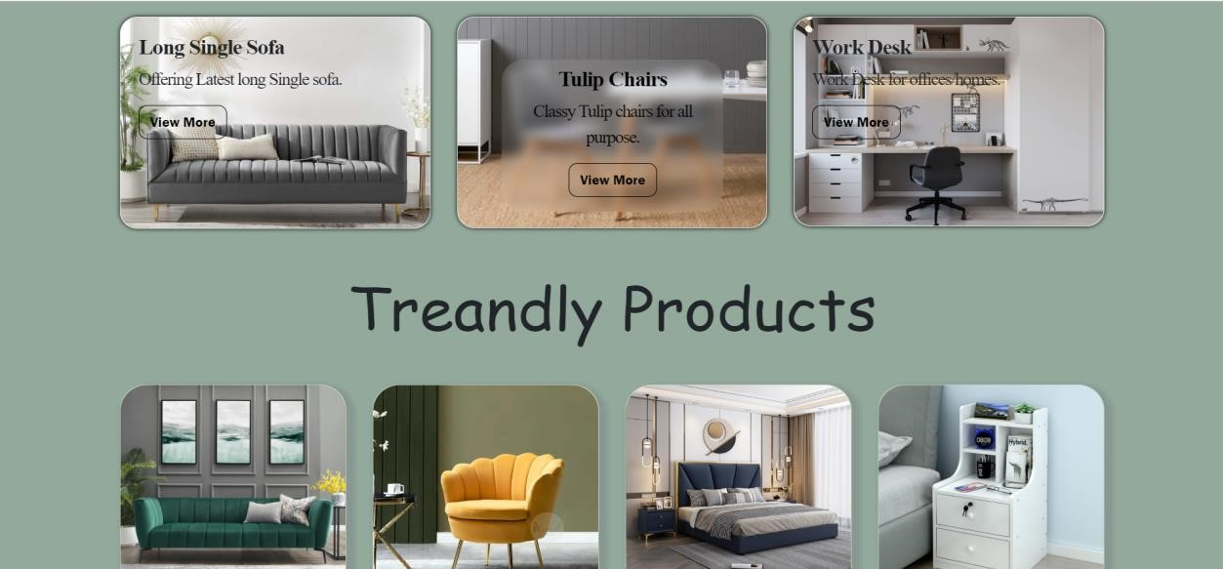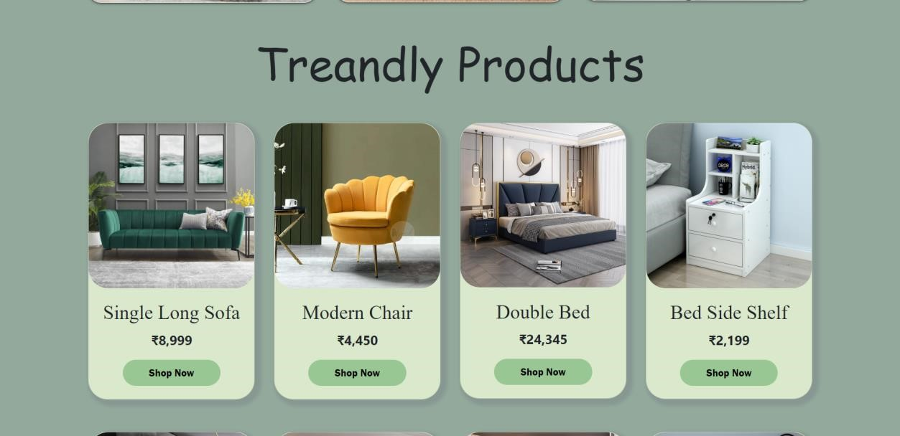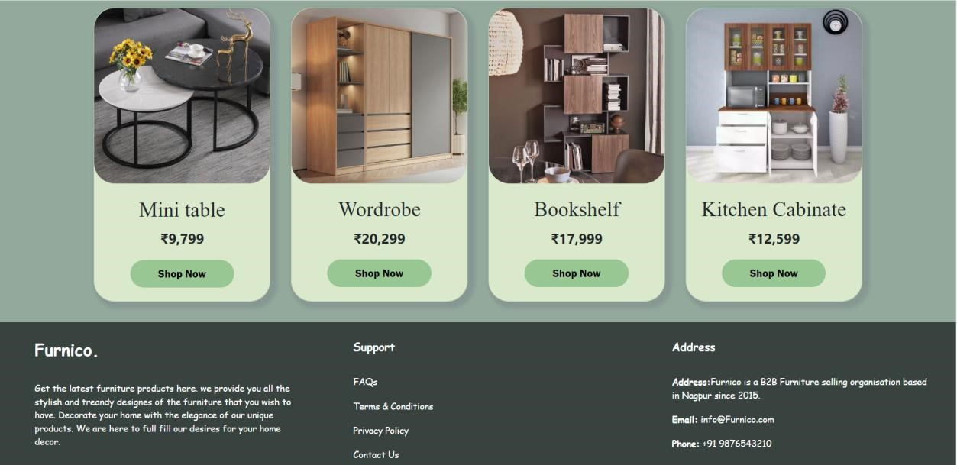

**Review page:**

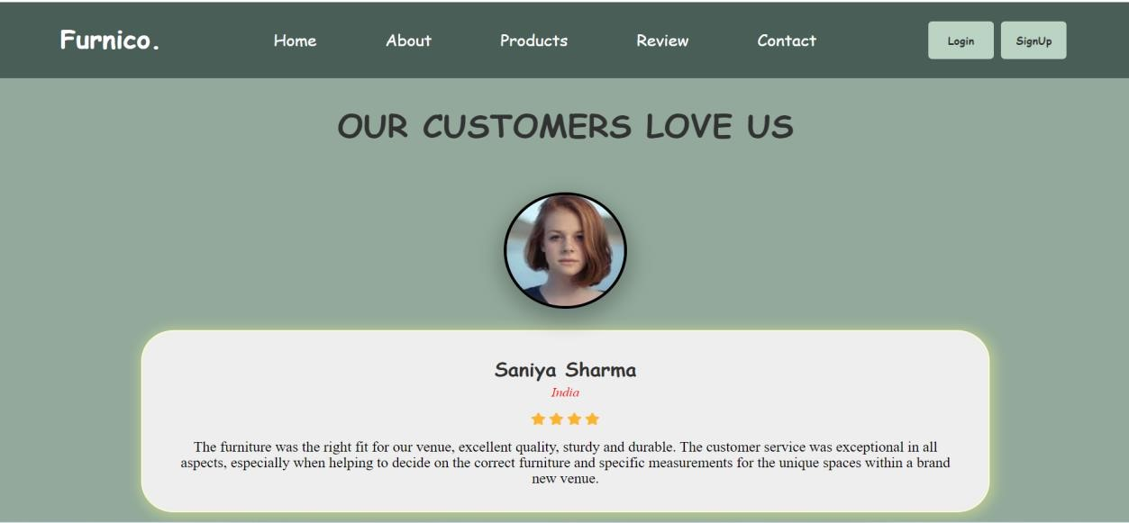

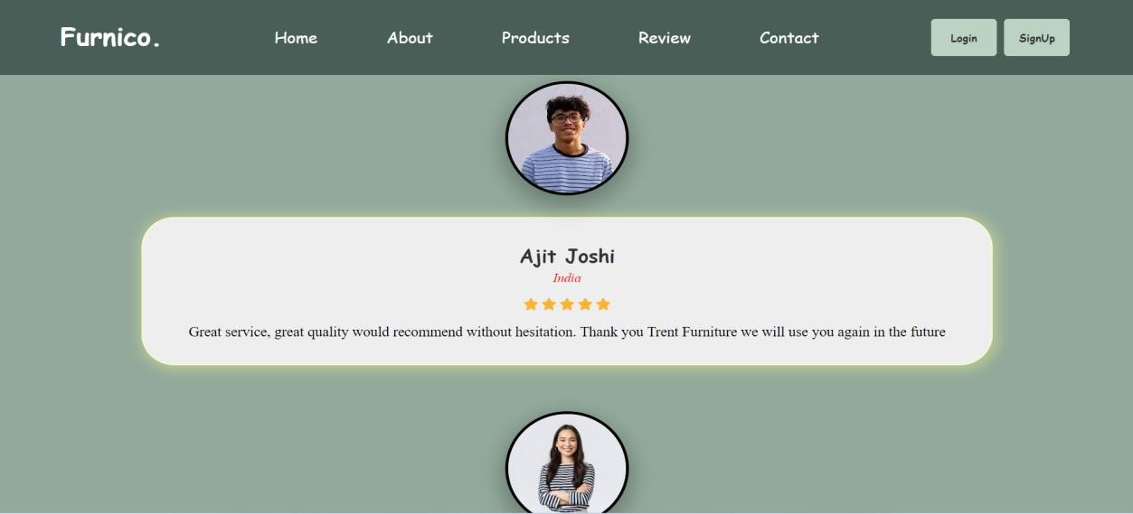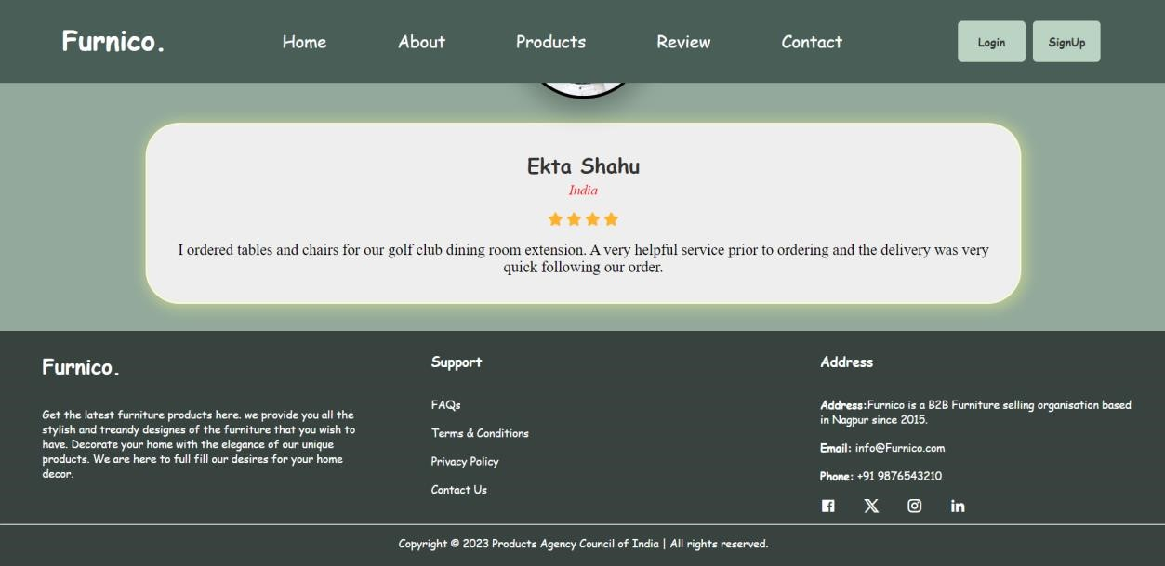

**Contact page:**

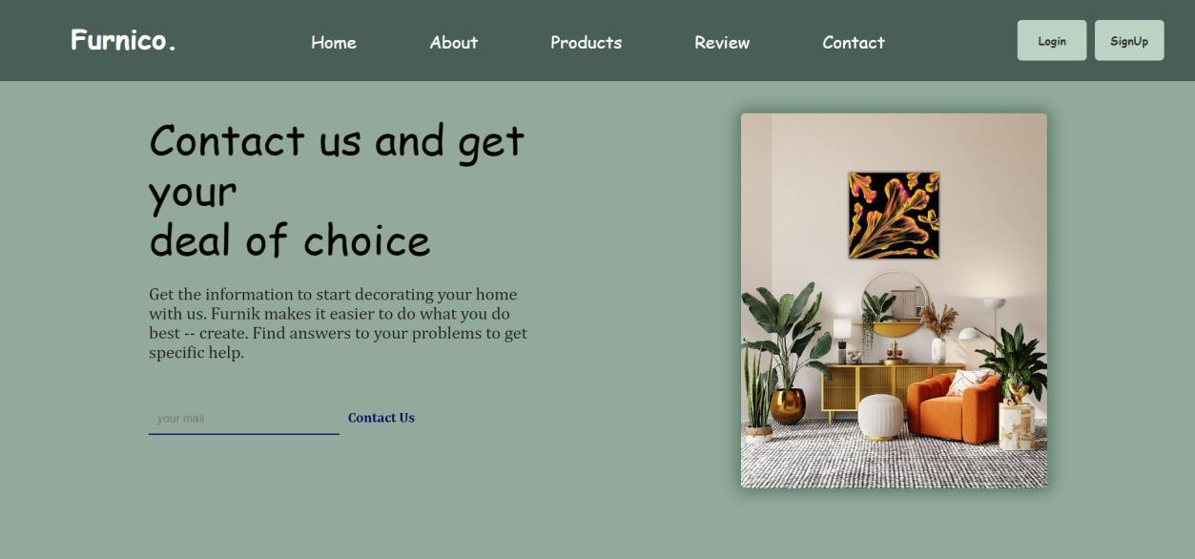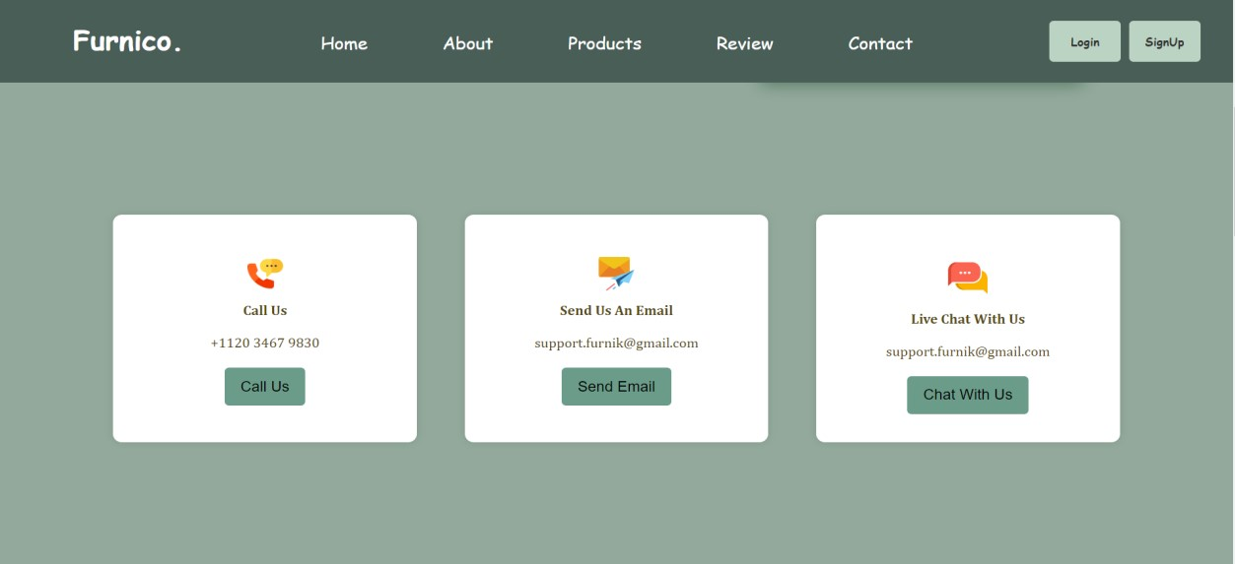

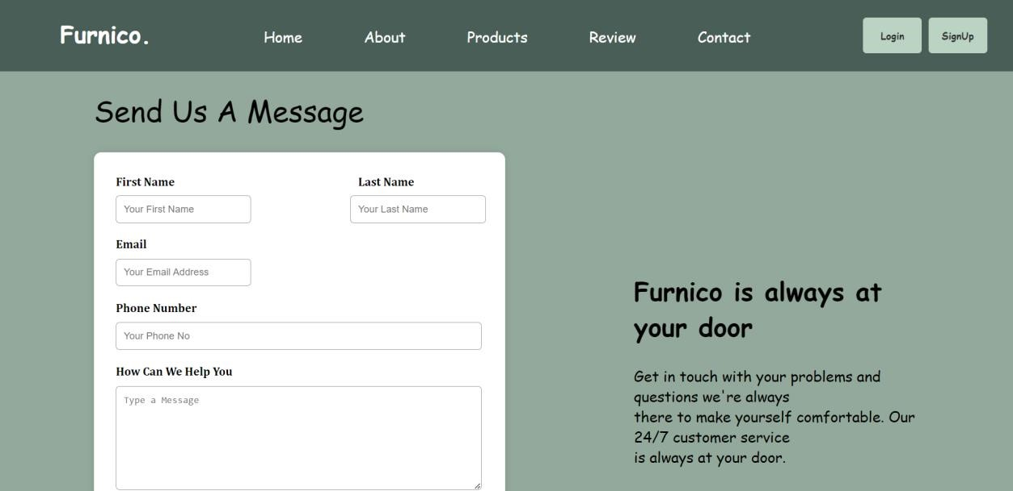

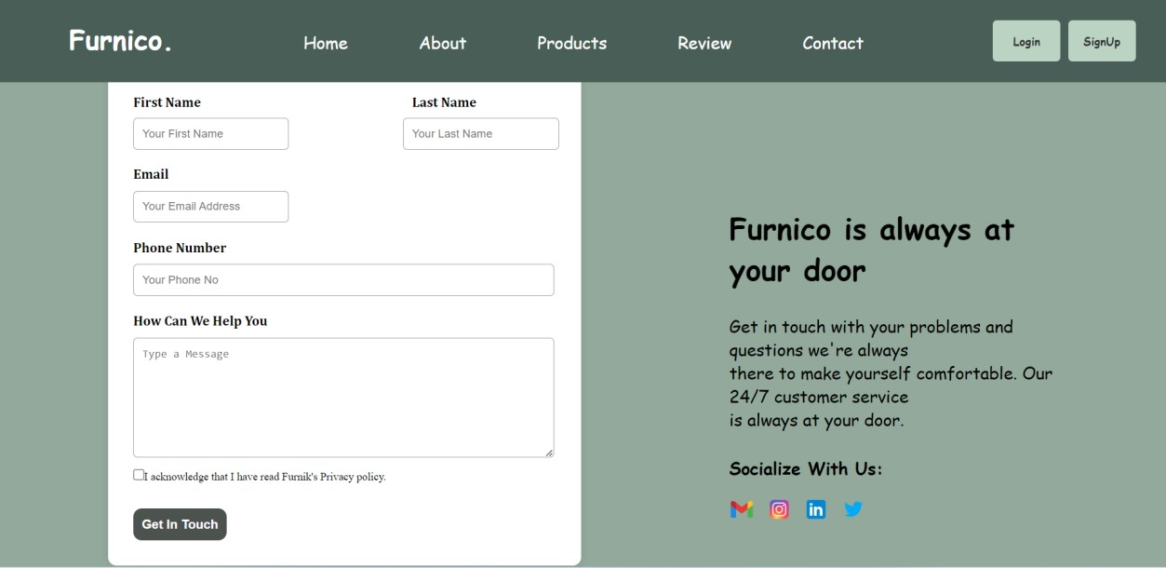

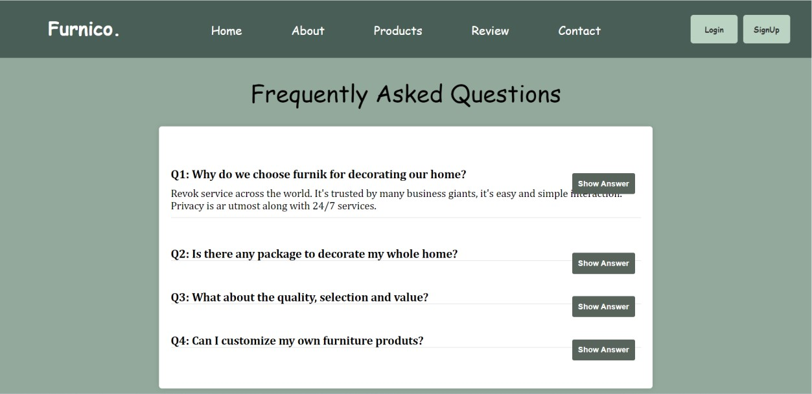

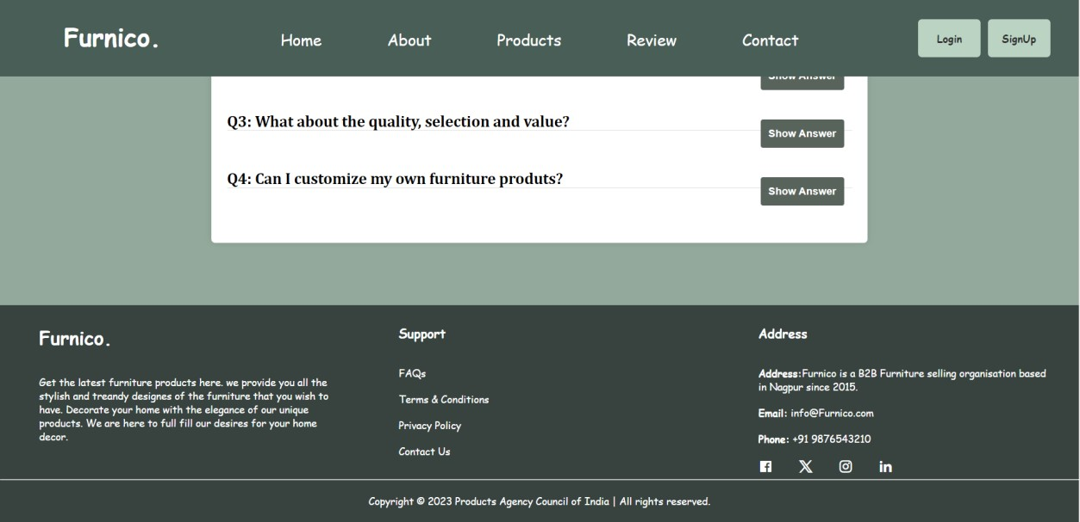

**Login page:**

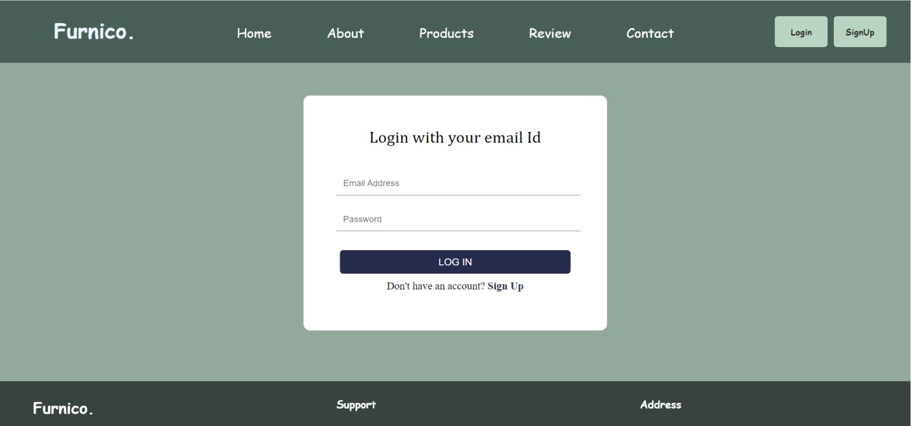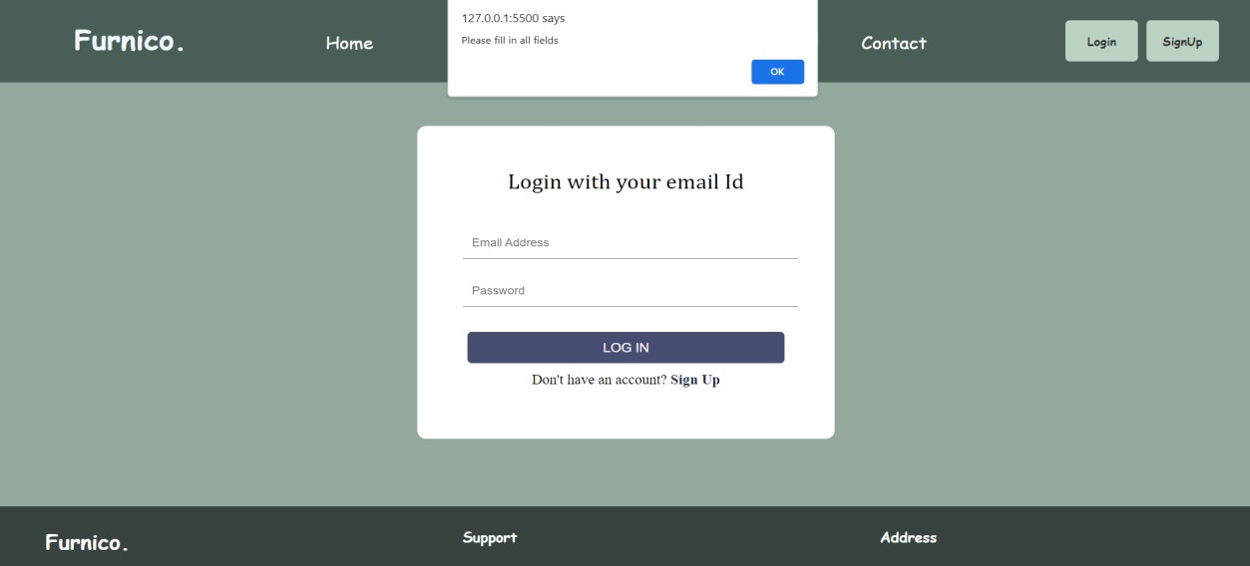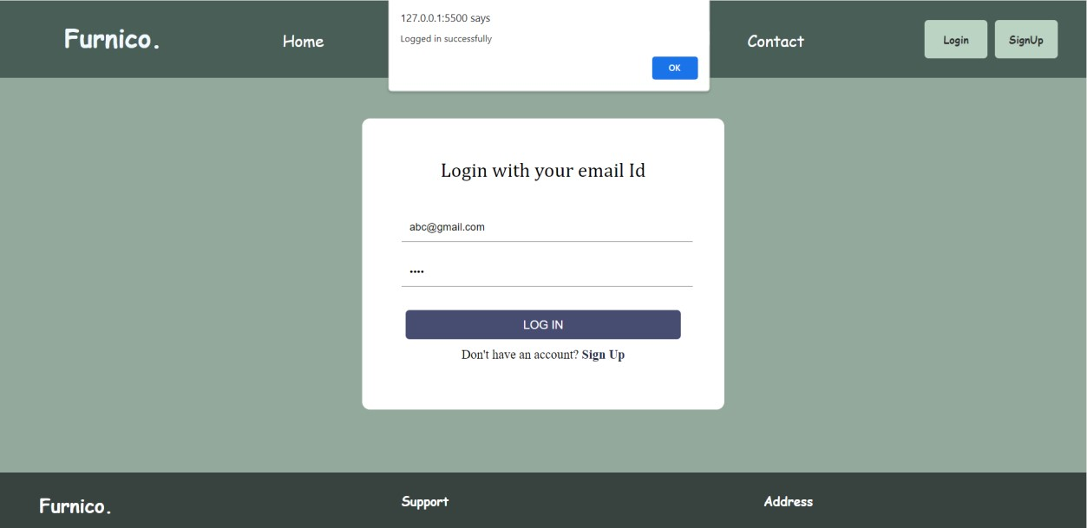

**Sign Up page:**

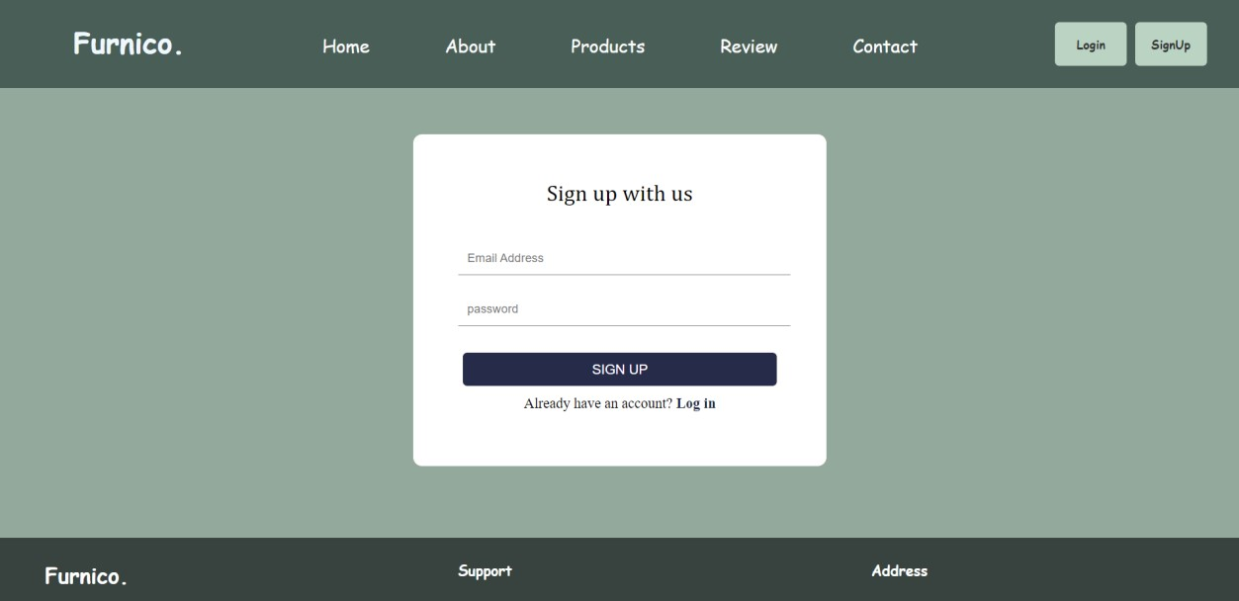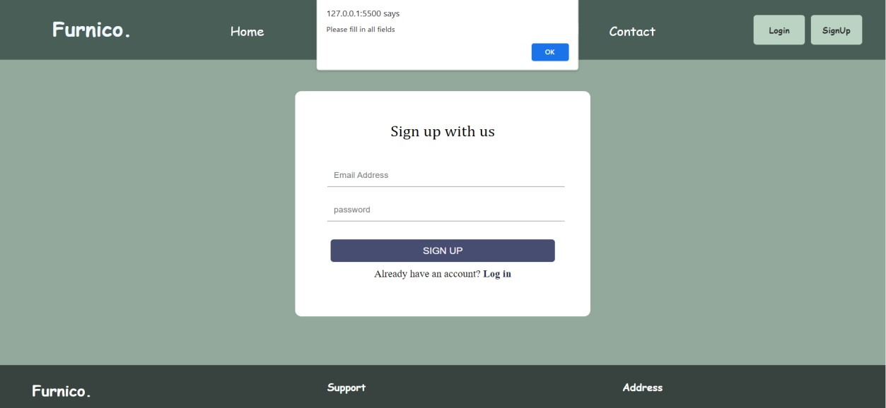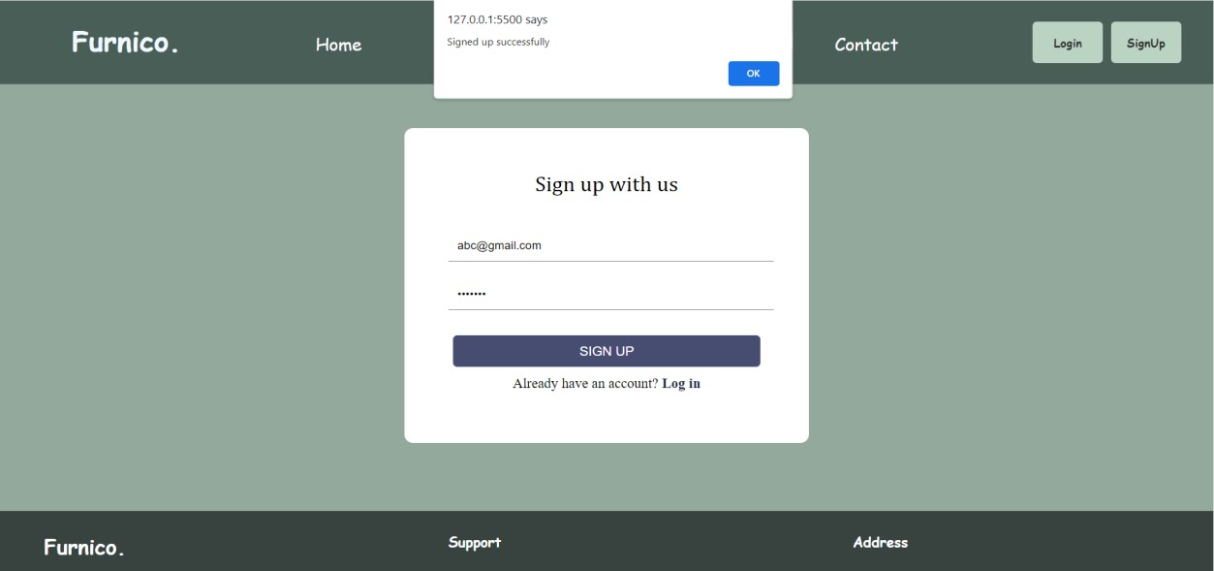

# Chapter 5

**CONCLUSION**

**5.CONCLUSION**

**5.1 CONCLUSION**

In the ever-expanding digital landscape, furniture websites have emerged as transformative platforms, redefining the way we envision, explore, and acquire pieces that adorn our living spaces. This journey into the realm of online furniture retailing illuminates the convergence of creativity, technology, and user experience, painting a vibrant picture of the future of interior design.

Moreover, the role of these websites extends beyond commerce; they foster communities of enthusiasts, architects, and interior designers. Social integration, user-generated content, and expert forums create ecosystems where ideas are shared, trends are born, and creativity knows no bounds. Customer reviews and ratings, alongside detailed product descriptions, instill trust, transforming virtual transactions into deeply satisfying experiences.

In this concluding reflection, it becomes evident that furniture websites are not mere online storefronts but digital sanctuaries where dreams of elegant living spaces come to life. They are the conduits through which tradition meets innovation, and where the artistry of artisans finds a global audience. As technology continues to advance and design sensibilities evolve, the future promises even more exciting possibilities for these platforms, ensuring that the journey of elevating interiors, one click at a time, will continue to enchant and inspire generations to come.

# Chapter 6

**REFERENCES**

**6.REFERENCES**

**6.1 REFERENCES**

* [**https://www.w3schools.com/**](https://www.w3schools.com/)
* [**https://en.wikipedia.org/wiki/Bootstrap_(frontend_framework)**](https://en.wikipedia.org/wiki/Bootstrap_(front-end_framework))
* **classroom notes**

# Chapter 7

**WEBSITE LINK**

1. **WEBSITE LINK**

**7.1 WEBSITE LINK**

* + [**https://pratikshamanapure.github.io/Furnico/**](https://pratikshamanapure.github.io/Furnico/)
  + [**https://splendid-liger-5f74d2.netlify.app/**](https://splendid-liger-5f74d2.netlify.app/)

# Chapter 8 PPT SCREENSHOTS

**8. PPT SCREENSHOTS**



